Supplementary Fig. 1
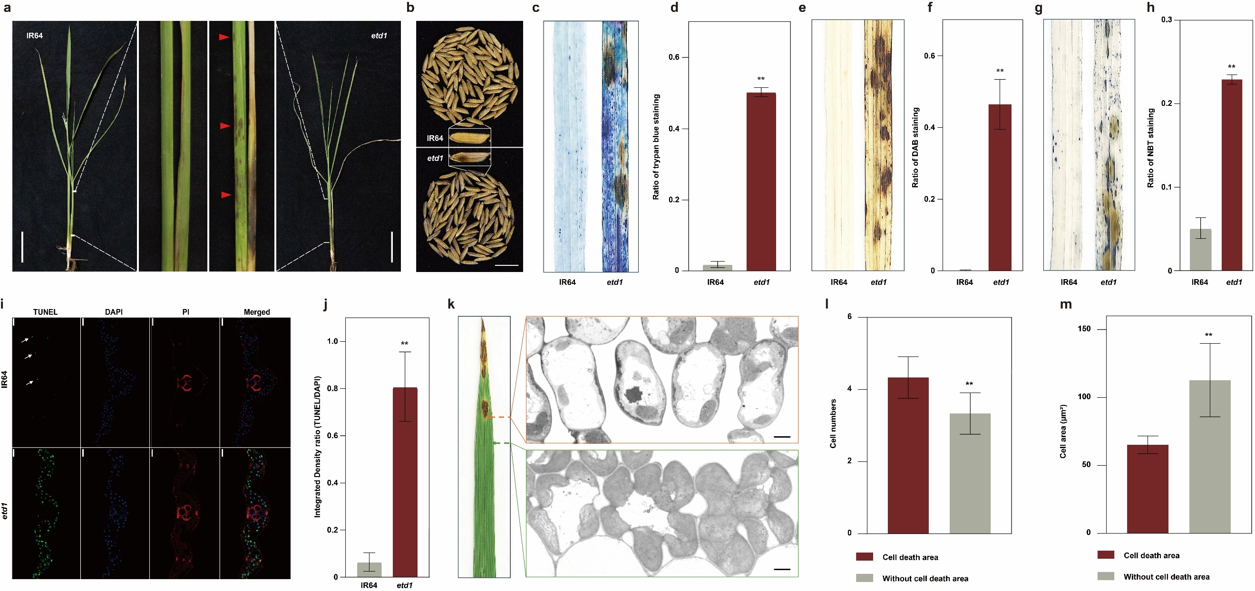
Supplementary Fig. 2
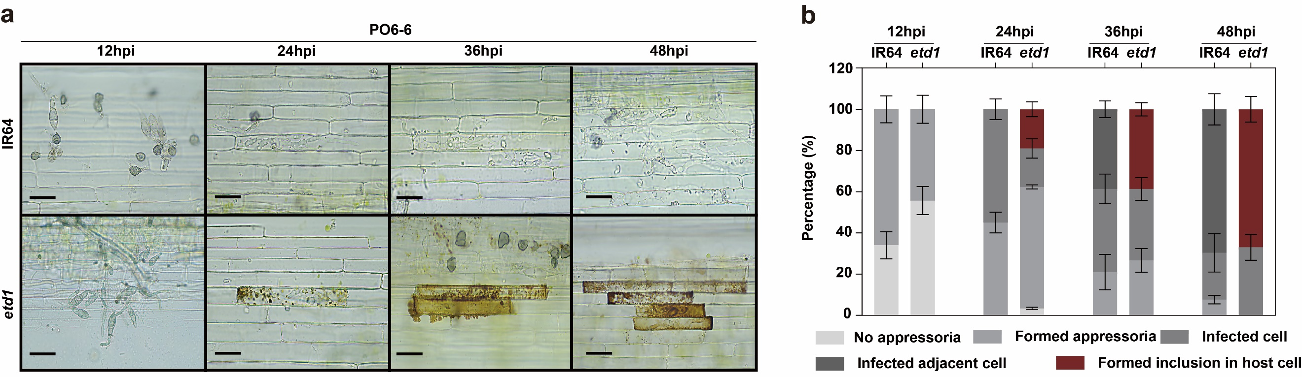
Supplementary Fig. 3
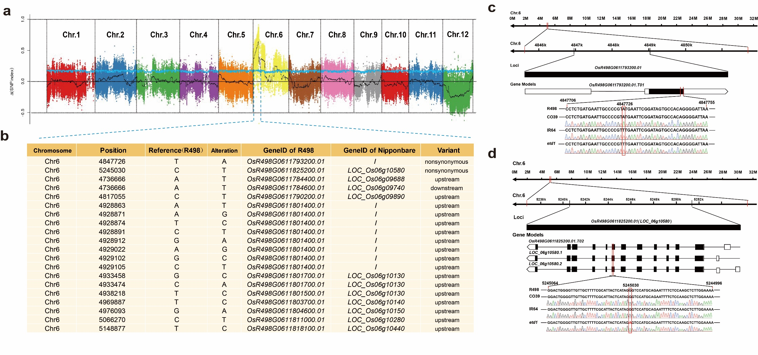
Supplementary Fig. 4
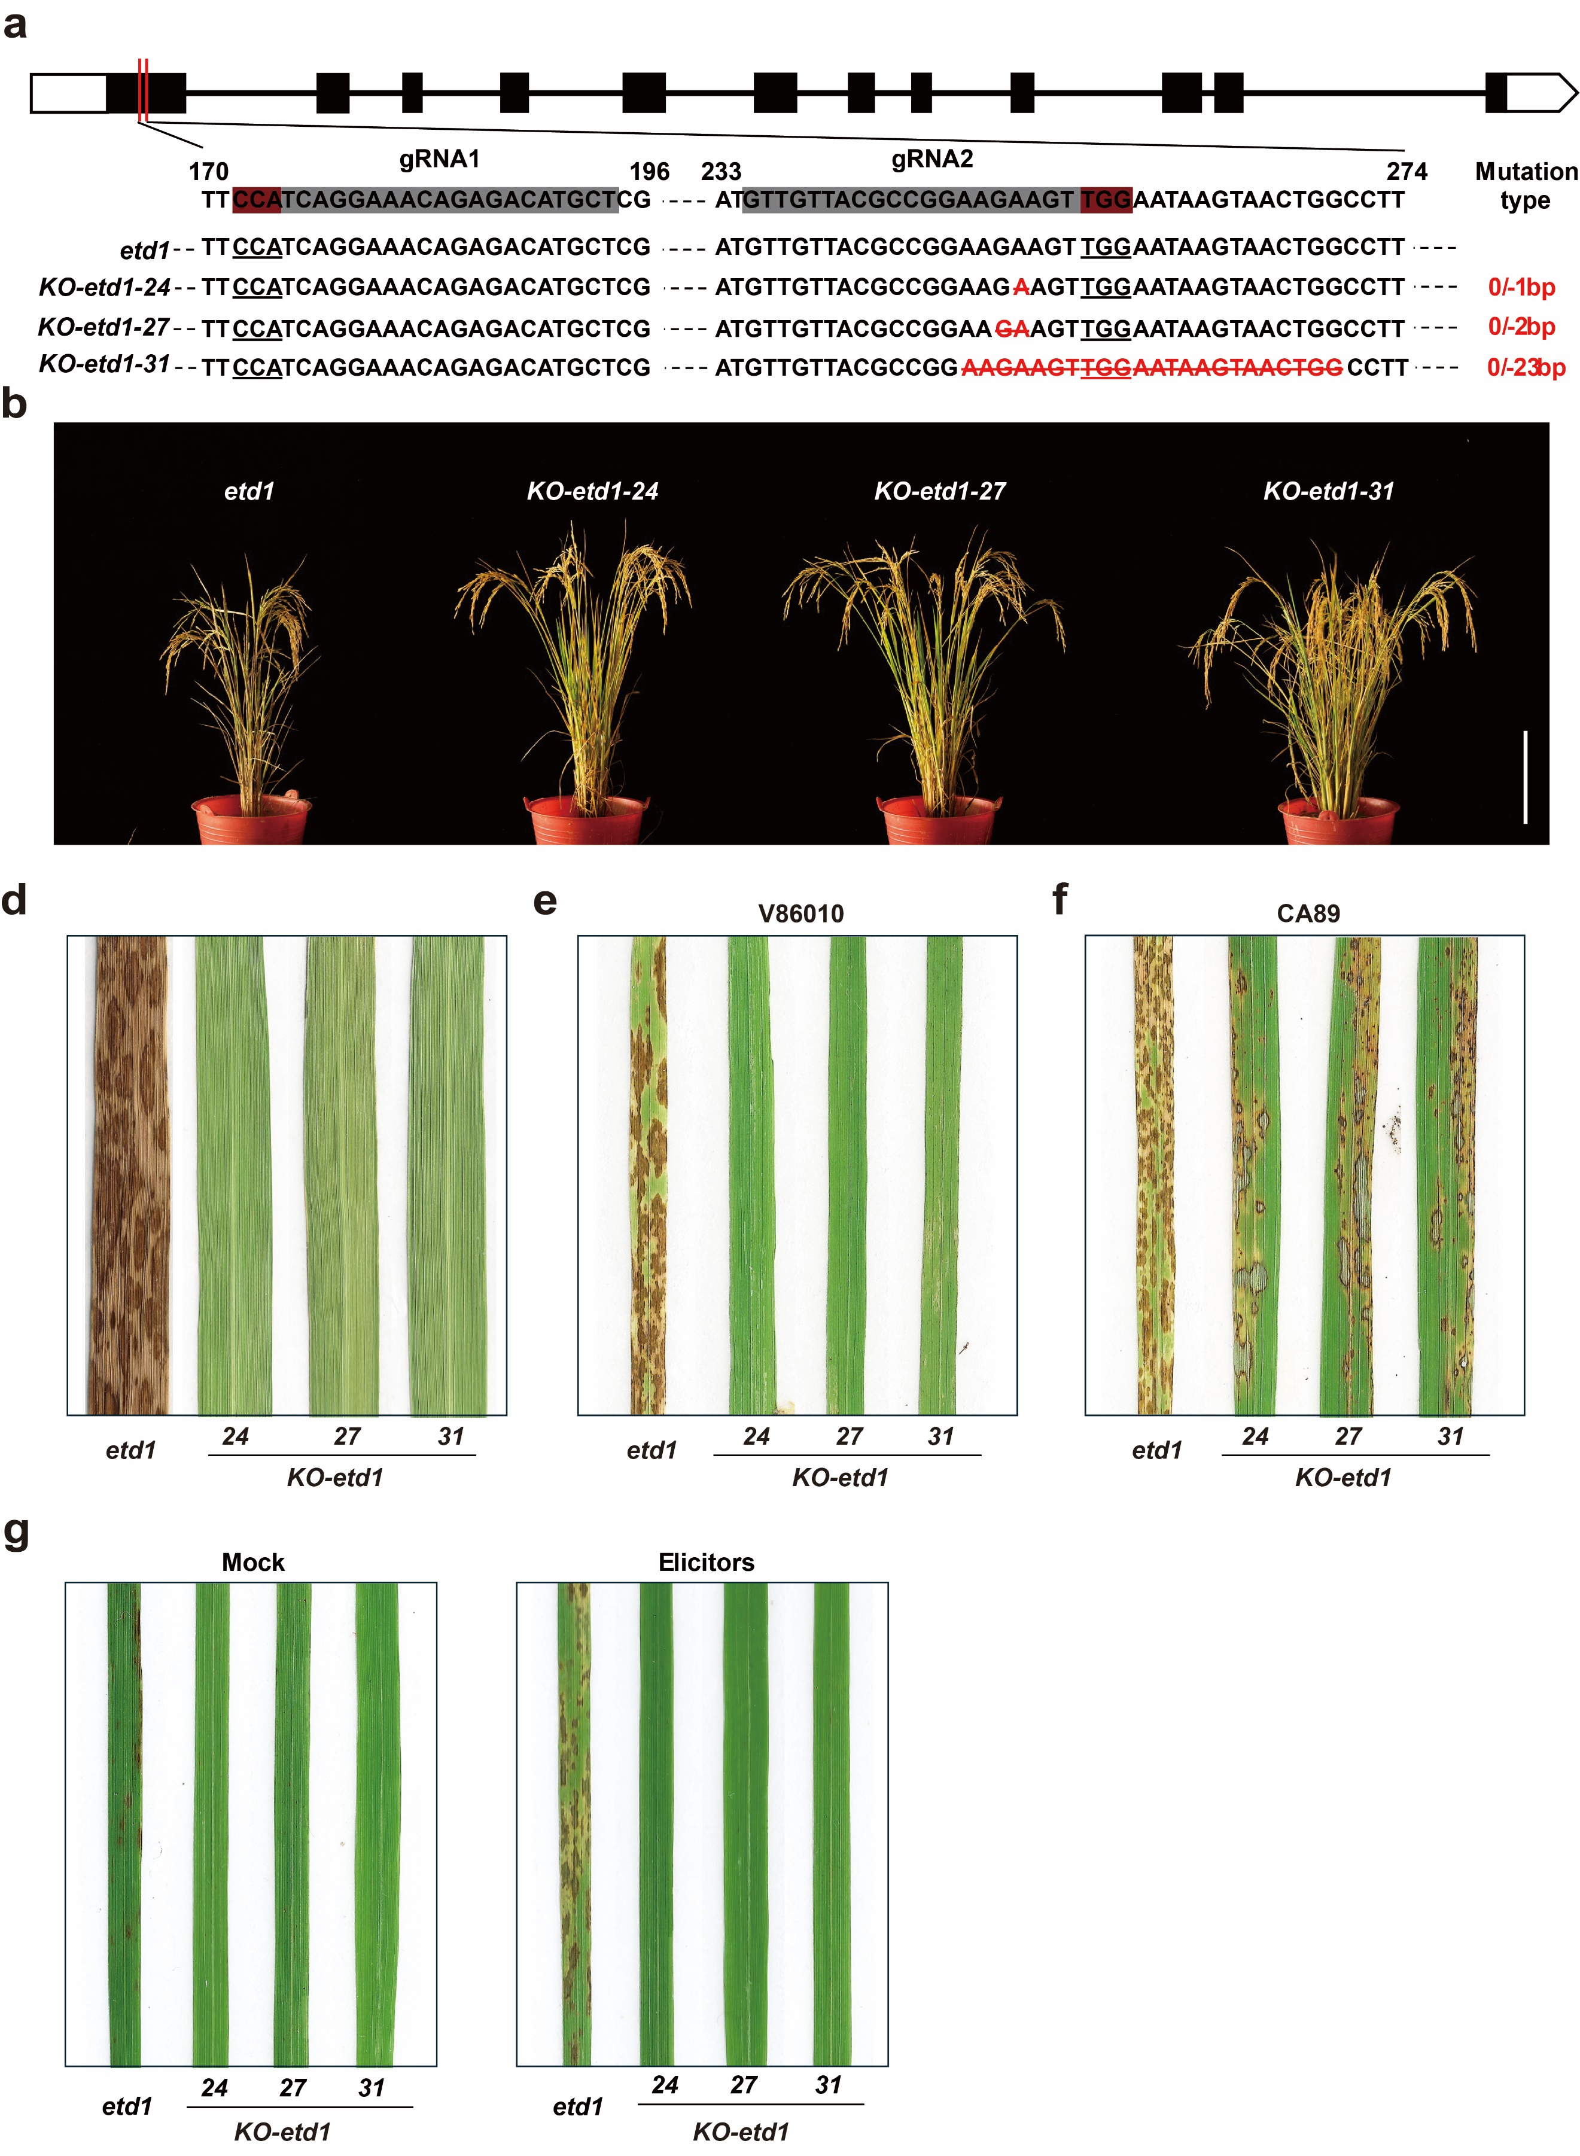

Supplementary Fig. 5
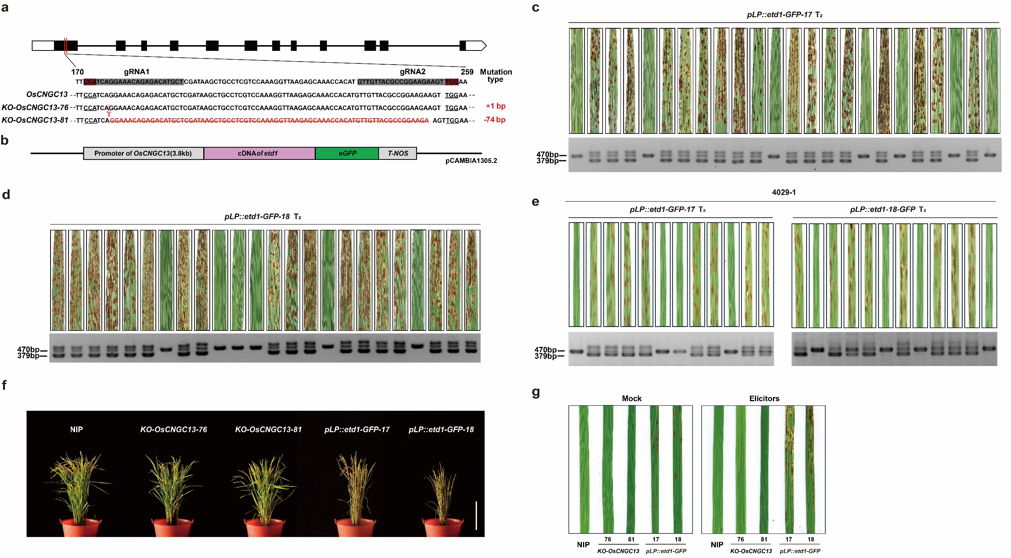
Supplementary Fig. 6
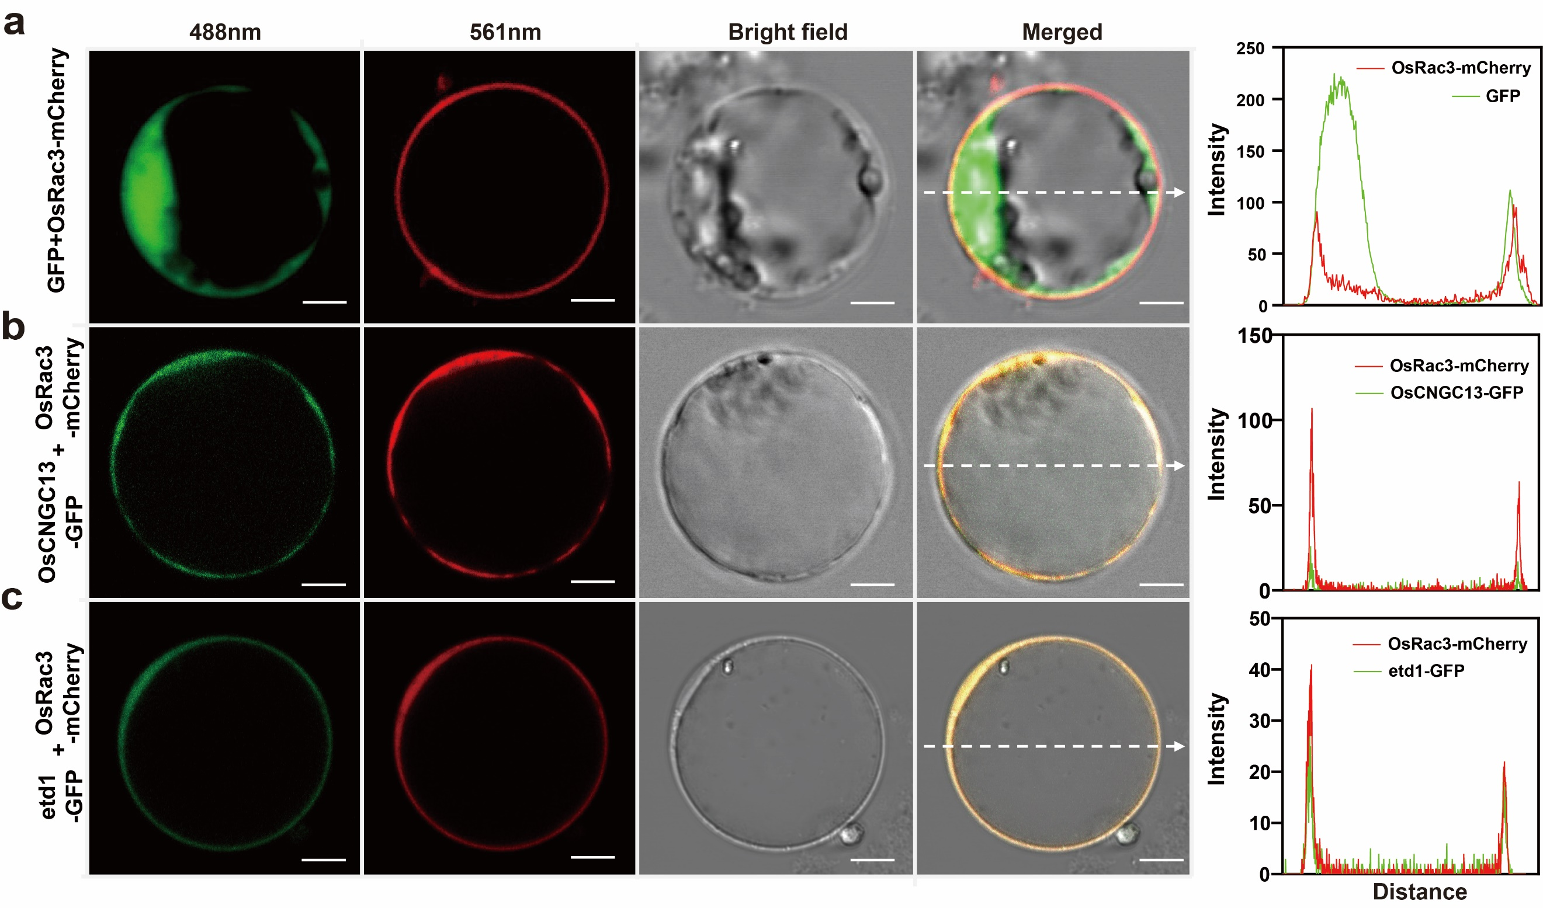

Supplementary Fig. 7
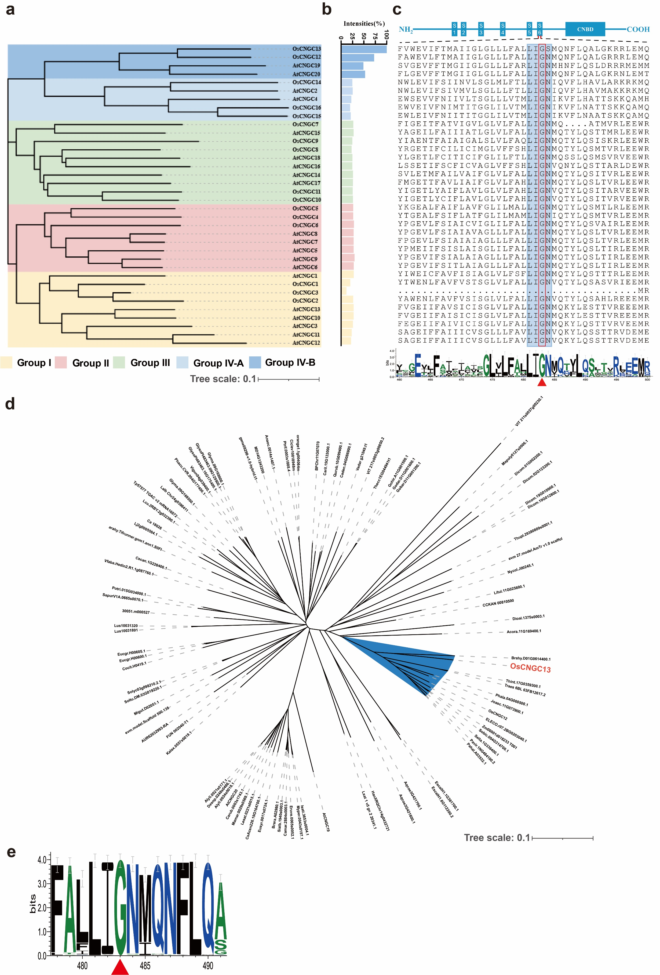
Supplementary Fig. 8
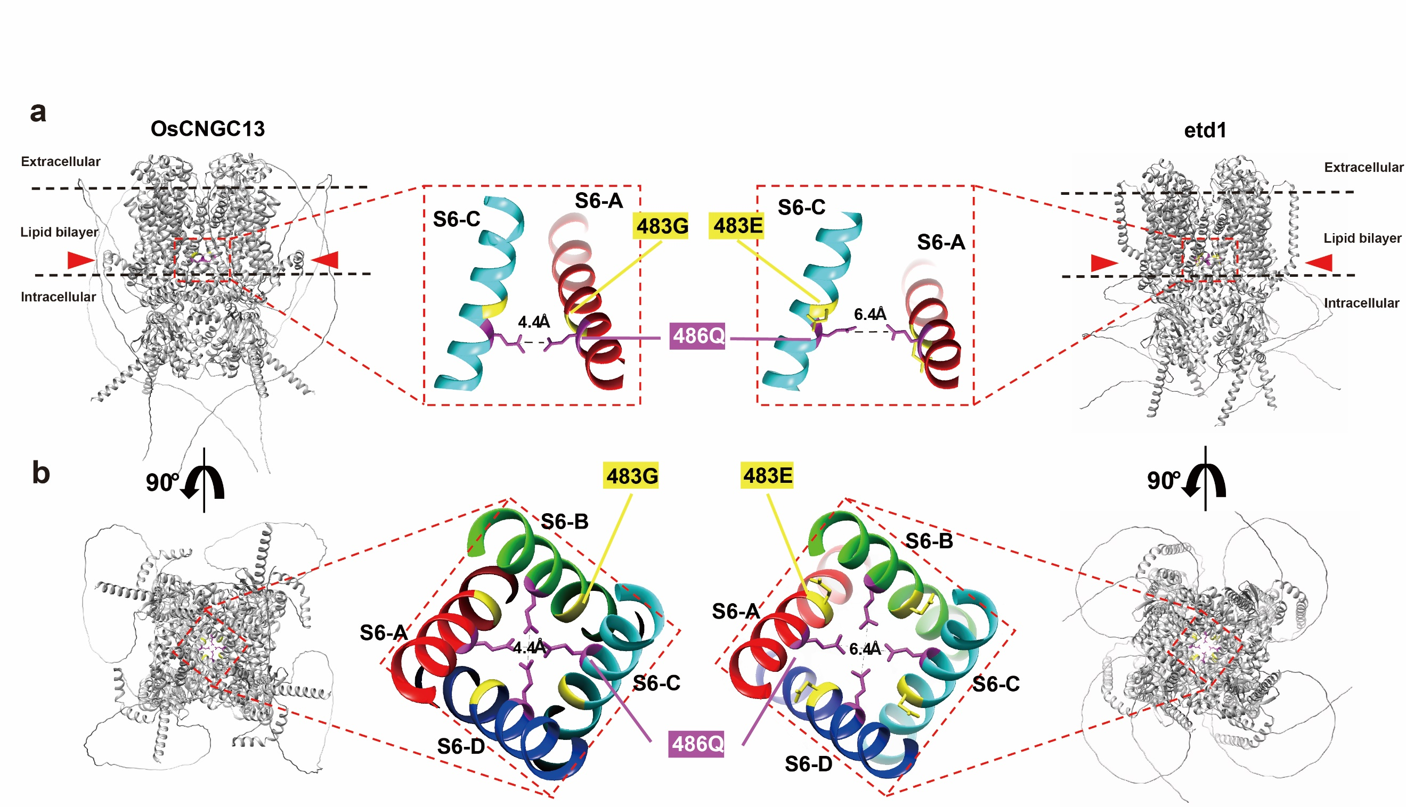

Supplementary Fig. 9
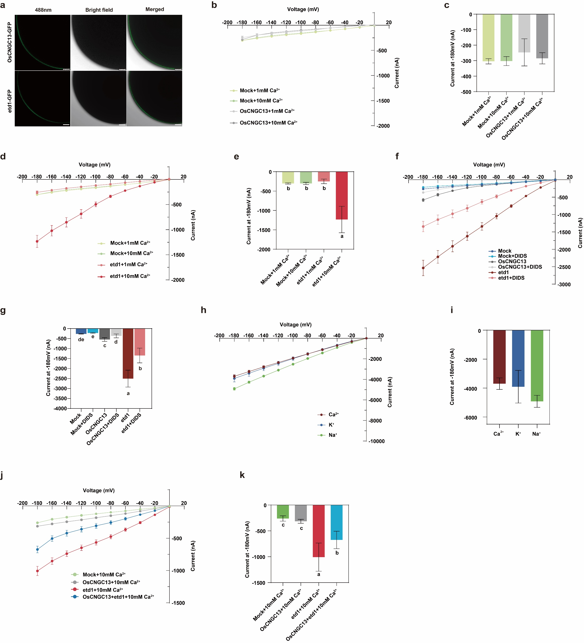

Supplementary Fig. 10
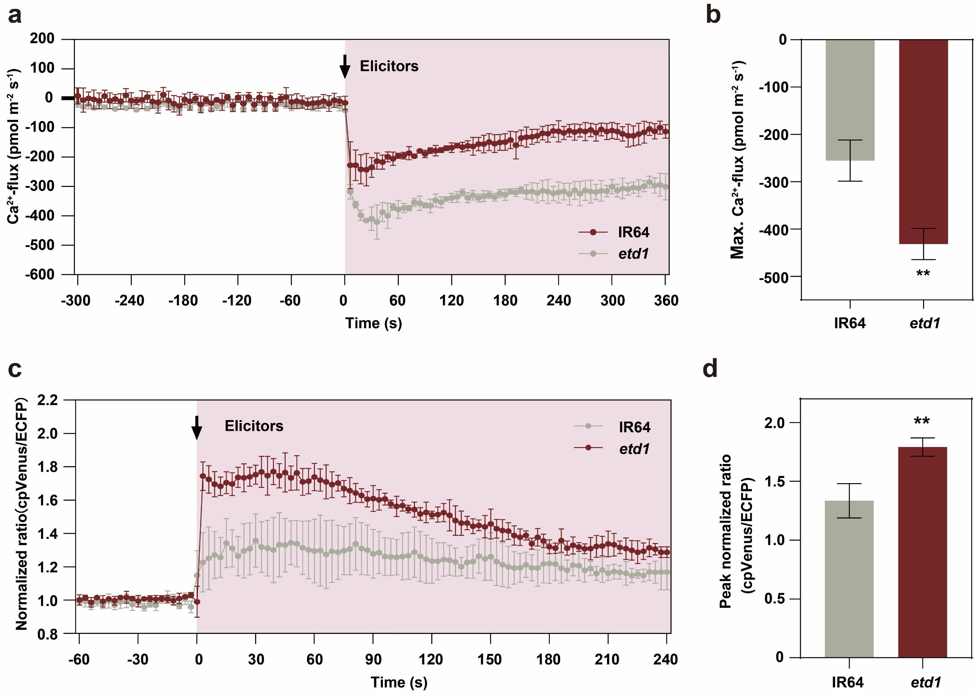
Supplementary Fig. 11
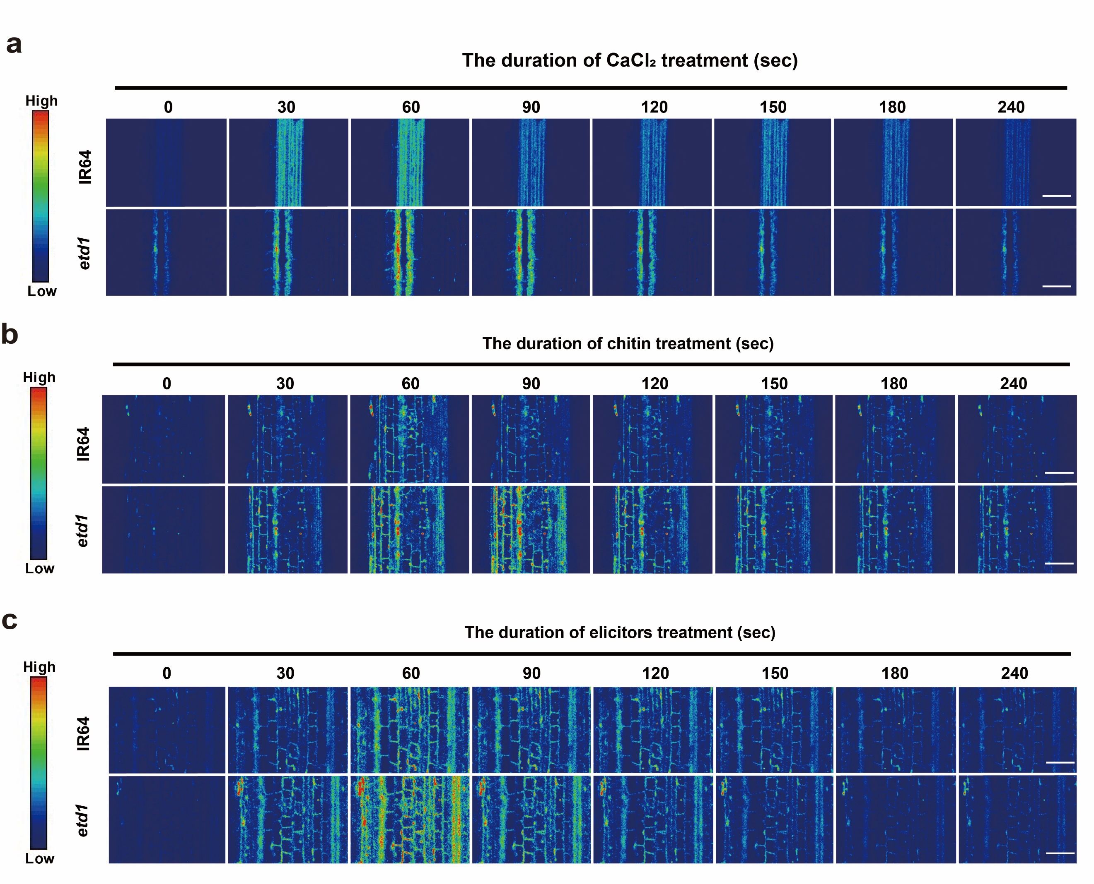
Supplementary Table 1
isolate | IR64 | etd1 | Triggers cell death  in etd1 | Origin | Collection year
16-1 | S | R | Yes | Guangdong | 2016
17-1-1 | R | R | Yes | Chongqing | 2017
17-2-1 | R | R | Yes | Chongqing | 2017
17-2-2 | R | R | Yes | Chongqing | 2017
17-3-1 | S | R | Yes | Chongqing | 2017
17-5-2 | S | R | Yes | Chongqing | 2017
17-5-4 | R | R | Yes | Chongqing | 2017
17-6-1 | S | R | Yes | Chongqing | 2017
17-6-2 | S | R | Yes | Chongqing | 2017
17-7-1 | R | R | Yes | Chongqing | 2017
17-8-2 | S | R | Yes | Hubei | 2017
17-8-7 | R | R | Yes | Hubei | 2017
17-8-8 | R | R | Yes | Hubei | 2017
17-9-7 | R | R | Yes | Sichuan | 2017
17-12-5 | S | R | Yes | Hunan | 2017
17-13-5 | MR | R | Yes | Hunan | 2017
17-13-9 | S | R | Yes | Hunan | 2017
17-14-3 | R | R | Yes | Jiangxi | 2017
17-15-1 | R | R | Yes | Guangdong | 2017
17-15-2 | R | R | Yes | Guangdong | 2017
17-15-4 | S | R | Yes | Guangdong | 2017
17-16-7 | R | R | Yes | Guangdong | 2017
18-1-1 | R | R | Yes | Hunan | 2018
18-1-2 | S | R | Yes | Hunan | 2018
18-2-1 | S | R | Yes | Hunan | 2018
18-2-2 | S | R | Yes | Hunan | 2018
18-3-2 | S | R | Yes | Hunan | 2018
18-4-1 | R | R | Yes | Hunan | 2018
18-4-2 | R | R | Yes | Hunan | 2018
18-5-1 | MR | R | Yes | Hunan | 2018
18-5-2 | S | R | Yes | Hunan | 2018
18-6-1 | R | R | Yes | Guangdong | 2018
18-6-2 | S | R | Yes | Guangdong | 2018
18-7-1 | S | R | Yes | Guangdong | 2018
18-7-2 | S | R | Yes | Guangdong | 2018
18-8-1 | MR | R | Yes | Guangdong | 2018
18-8-2 | MR | R | Yes | Guangdong | 2018
18-9-1 | S | R | Yes | Guangdong | 2018
18-9-2 | MR | R | Yes | Guangdong | 2018
18-10-1 | R | R | Yes | Sichuan | 2018
18-10-2 | R | R | Yes | Sichuan | 2018
18-11-1 | S | R | Yes | Sichuan | 2018
18-11-2 | S | R | Yes | Sichuan | 2018
18-11-3 | S | R | Yes | Sichuan | 2018
18-12-1 | S | R | Yes | Sichuan | 2018
18-13-1 | S | R | Yes | Sichuan | 2018
18-13-2 | S | R | Yes | Sichuan | 2018
18-15-1 | S | R | Yes | Fujian | 2018
18-15-2 | S | R | Yes | Fujian | 2018
18-15-3 | S | R | Yes | Fujian | 2018
S5 | R | R | Yes | Beijing | 2018
19-1-1 | R | R | Yes | Sichuan | 2019
19-1-2 | R | R | Yes | Sichuan | 2019
19-1-3 | R | R | Yes | Sichuan | 2019
19-2-1 | R | R | Yes | Sichuan | 2019
19-2-2 | S | R | Yes | Sichuan | 2019
19-3-3 | MR | R | Yes | Sichuan | 2019
19-5-2 | R | R | Yes | Guangxi | 2019
19-5-3 | R | R | Yes | Guangxi | 2019
19-6-1 | S | R | Yes | Anhui | 2019
19-7-1 | S | R | Yes | Yunnan | 2019
19-7-2 | R | R | Yes | Yunnan | 2019
19-8-2 | R | R | Yes | Zhejiang | 2019
19-8-3 | R | R | Yes | Zhejiang | 2019
19-9-1 | S | R | Yes | Guangdong | 2019
19-10-3 | S | R | Yes | Hunan | 2019
19-17-3 | R | R | Yes | Hunan | 2019
PS20-21 | R | R | Yes | Liaoning | 2020
PS20-22 | R | R | Yes | Liaoning | 2020
PS20-23 | MR | R | Yes | Liaoning | 2020
PS20-25 | R | R | Yes | Liaoning | 2020
PS20-26 | MR | R | Yes | Liaoning | 2020
PS20-41 | R | R | Yes | Liaoning | 2020
PS20-42 | MR | R | Yes | Liaoning | 2020
PS20-43 | R | R | Yes | Liaoning | 2020
PS20-44 | MR | R | Yes | Liaoning | 2020
PS20-45 | S | R | Yes | Liaoning | 2020
PS20-46 | R | R | Yes | Liaoning | 2020
PS20-47 | R | R | Yes | Liaoning | 2020
PS20-48 | R | R | Yes | Liaoning | 2020
PS20-49 | MR | R | Yes | Liaoning | 2020
SY20-83 | R | R | Yes | Liaoning | 2020
SY20-84 | R | R | Yes | Liaoning | 2020
SY20-88 | R | R | Yes | Liaoning | 2020
SY20-92 | R | R | Yes | Jiangsu | 2020
SY20-93 | R | R | Yes | Jiangsu | 2020
SY20-94 | R | R | Yes | Jiangsu | 2020
SY20-95 | S | R | Yes | Guizhou | 2020
SY20-96 | MR | R | Yes | Guizhou | 2020
SY20-97 | R | R | Yes | Guizhou | 2020
SY20-99 | MR | R | Yes | Guizhou | 2020
22-2-138 | R | R | Yes | Guizhou | 2022
22-2-177 | R | R | Yes | Guizhou | 2022
PO6-6 | S | R | Yes | Philippines | 2017
BZ64 | S | R | Yes | Philippines | 2017
CA41 | R | R | Yes | Philippines | 2017
4029-1 | R | R | Yes | Philippines | 2017
IK81-25 | R | R | Yes | Philippines | 2017
IK81-3 | R | R | Yes | Philippines | 2017
JMB840610 | R | R | Yes | Philippines | 2017
M15-11 | S | R | Yes | Philippines | 2017
M15-13 | R | R | Yes | Philippines | 2017
M15-15 | S | R | Yes | Philippines | 2017
M15-22 | S | R | Yes | Philippines | 2017
M15-24 | R | R | Yes | Philippines | 2017
M15-26 | S | R | Yes | Philippines | 2017
Resistance  frequencies（%） | 62.26 | 100 | - | - | -

Supplementary Table 2
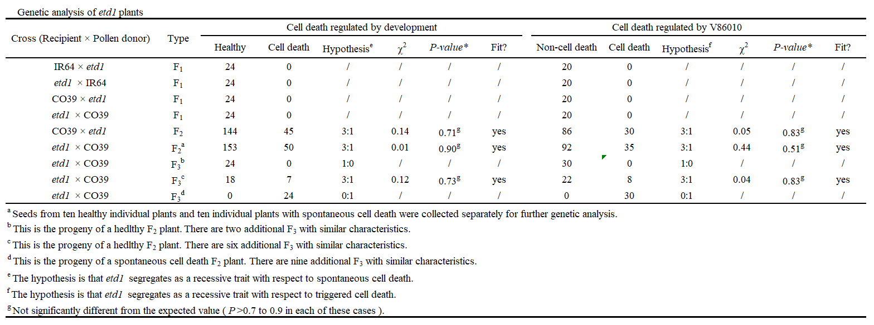
Supplementary Table 3
