Sedation and analgesia in post-cardiac arrest care: a post hoc analysis of the TTM2 trial

Supplement material

Supplement table 1. STROBE Statement—checklist of items that should be included in reports of observational studies

 | Item No. | Recommendation | Page  No. | Relevant text from manuscript
Title and abstract | 1 | (a) Indicate the study’s design with a commonly used term in the title or the abstract | 1
Title and abstract | 1 | (b) Provide in the abstract an informative and balanced summary of what was done and what was found | 3
Introduction
Background/rationale | 2 | Explain the scientific background and rationale for the investigation being reported | 4
Objectives | 3 | State specific objectives, including any prespecified hypotheses | 4
Methods
Study design | 4 | Present key elements of study design early in the paper | 5
Setting | 5 | Describe the setting, locations, and relevant dates, including periods of recruitment, exposure, follow-up, and data collection | 4-5
Participants | 6 | (a) Cohort study—Give the eligibility criteria, and the sources and methods of selection of participants. Describe methods of follow-up  Case-control study—Give the eligibility criteria, and the sources and methods of case ascertainment and control selection. Give the rationale for the choice of cases and controls  Cross-sectional study—Give the eligibility criteria, and the sources and methods of selection of participants | 4-5
Participants | 6 | (b) Cohort study—For matched studies, give matching criteria and number of exposed and unexposed  Case-control study—For matched studies, give matching criteria and the number of controls per case
Variables | 7 | Clearly define all outcomes, exposures, predictors, potential confounders, and effect modifiers. Give diagnostic criteria, if applicable | 5-7
Data sources/ measurement | 8* | For each variable of interest, give sources of data and details of methods of assessment (measurement). Describe comparability of assessment methods if there is more than one group | 5-7
Bias | 9 | Describe any efforts to address potential sources of bias | 8
Study size | 10 | Explain how the study size was arrived at | 4-5
Continued on next page
Quantitative variables | 11 | Explain how quantitative variables were handled in the analyses. If applicable, describe which groupings were chosen and why | 7-8
Statistical methods | 12 | (a) Describe all statistical methods, including those used to control for confounding | 7-8
Statistical methods | 12 | (b) Describe any methods used to examine subgroups and interactions | 8
Statistical methods | 12 | (c) Explain how missing data were addressed | 8
Statistical methods | 12 | (d) Cohort study—If applicable, explain how loss to follow-up was addressed  Case-control study—If applicable, explain how matching of cases and controls was addressed  Cross-sectional study—If applicable, describe analytical methods taking account of sampling strategy | 8
Statistical methods | 12 | (e) Describe any sensitivity analyses
Results
Participants | 13* | (a) Report numbers of individuals at each stage of study—eg numbers potentially eligible, examined for eligibility, confirmed eligible, included in the study, completing follow-up, and analysed | 8
Participants | 13* | (b) Give reasons for non-participation at each stage | 8
Participants | 13* | (c) Consider use of a flow diagram | 8
Descriptive data | 14* | (a) Give characteristics of study participants (eg demographic, clinical, social) and information on exposures and potential confounders | 8 (table 1 and 2)
Descriptive data | 14* | (b) Indicate number of participants with missing data for each variable of interest | 9
Descriptive data | 14* | (c) Cohort study—Summarise follow-up time (eg, average and total amount) | 7
Outcome data | 15* | Cohort study—Report numbers of outcome events or summary measures over time | 7
Outcome data | 15* | Case-control study—Report numbers in each exposure category, or summary measures of exposure
Outcome data | 15* | Cross-sectional study—Report numbers of outcome events or summary measures
Main results | 16 | (a) Give unadjusted estimates and, if applicable, confounder-adjusted estimates and their precision (eg, 95% confidence interval). Make clear which confounders were adjusted for and why they were included | 8-10
Main results | 16 | (b) Report category boundaries when continuous variables were categorized
Main results | 16 | (c) If relevant, consider translating estimates of relative risk into absolute risk for a meaningful time period
Continued on next page
Other analyses | 17 | Report other analyses done—eg analyses of subgroups and interactions, and sensitivity analyses | 10
Discussion
Key results | 18 | Summarise key results with reference to study objectives | 10
Limitations | 19 | Discuss limitations of the study, taking into account sources of potential bias or imprecision. Discuss both direction and magnitude of any potential bias | 13
Interpretation | 20 | Give a cautious overall interpretation of results considering objectives, limitations, multiplicity of analyses, results from similar studies, and other relevant evidence | 10-13
Generalisability | 21 | Discuss the generalisability (external validity) of the study results | 13
Other information
Funding | 22 | Give the source of funding and the role of the funders for the present study and, if applicable, for the original study on which the present article is based

*Give information separately for cases and controls in case-control studies and, if applicable, for exposed and unexposed groups in cohort and cross-sectional studies.

Note: An Explanation and Elaboration article discusses each checklist item and gives methodological background and published examples of transparent reporting. The STROBE checklist is best used in conjunction with this article (freely available on the Web sites of PLoS Medicine at http://www.plosmedicine.org/, Annals of Internal Medicine at http://www.annals.org/, and Epidemiology at http://www.epidem.com/). Information on the STROBE Initiative is available at www.strobe-statement.org.

Supplement table 2.
Richmond Agitation and Sedation Scale.
Score | Classification | Description
+4 | Combatative | Overtly combative, violent, danger to staff
+3 | Very agitated | Pulls or removes tube(s) or catheters; aggressive
+2 | Agitated | Frequent non-purposeful movement, fights ventilator
+1 | Restless | Anxious, apprehensive, but not aggressive
0 | Alert and calm
-1 | Drowsy | Awakens to voice (eye opening/contact) > 10 seconds
-2 | Light sedation | Briefly awakens to voice (eye opening/contant) < 10 seconds
-3 | Moderate sedation | Movement or eye opening. No eye contact
-4 | Deep sedation | No response to voice, but movement or eye opening to physical stimulation
-5 | Unarousable | No response to voice or physical stimulation

Supplement table 3.
Bedside shivering assessment scale.

Score | Severity | Description
0 | None | No shivering
1 | Mild | Shivering localized to neck/thorax, may be seen only as artifact on ECG or felt by palpation
2 | Moderate | Intermittent involvement of the upper extremities ±thorax
3 | Severe | Generalized shivering or sustained upper/lower extremity shivering

Supplement table 4.
Full Outline of Responsivness Score Motor response.

Score | Clinical findings
4 | Thumbs-up, fist, or peace sign
3 | Localizing to pain
2 | Flexion response to pain
1 | Extension response to pain
0 | No response to pain or generalized myoclonus status

Supplement table 5: Doses of sedatives and analgesics
Average doses of sedatives and analgesics up to 72 hours
 | Hypothermia | Normothermia | p
n | 930 | 931
Propofol (mg/kg) (mean (SD)) | 109.4 (75.1) | 102.8 (77.0) | 0.078
Propofol, n (%) | 792 (85.2) | 819 (88.0) | 0.088
Midazolam (mg/kg) (mean (SD)) | 3.0 (6.5) | 2.5 (3.0) | 0.167
Midazolam, n (%) | 364 (39.1) | 346 (37.2) | 0.407
Midazolam and propofol, n (%) | 273 (29.4) | 282 (30.3) | 0.696
Midazolam only, n (%) | 91 (9.8) | 64 (6.9) | 0.029
Dexmedetomidine (mcg/kg) (mean (SD)) | 0.02 (0.04) | 0.02 (0.03) | 0.876
Dexmedetomidine, n (%) | 66 (7.1) | 78 (8.4) | 0.343
Remifentanil mcg/kg (mean (SD)) | 0.8 (3.0) | 1.1 (3.5) | 0.311
Remifentanil, n (%) | 326 (35.1) | 317 (34.0) | 0.684
Fentanyl (mcg/kg) (mean (SD)) | 0.2 (2.8) | 0.4 (4.0) | 0.431
Fentanyl, n (%) | 495 (53.2) | 477 (51.2) | 0.416
Oxycodone (mg/kg), (mean (SD)) | 0.3 (0.4) | 0.3 (0.3) | 0.484
Oxycodone, n (%) | 50 (5.4) | 63 (6.8) | 0.247
Morphine (mg/kg), (mean (SD)) | 1.1 (1.8) | 0.9 (2.1) | 0.430
Morphine, n (%) | 98 (10.5) | 124 (13.3) | 0.075
Any neuromuscular blockade, n (%) | 614 (66.0) | 418 (44.9) | <0.001

Supplement figure 1. The relationship between cumulative propofol dose and good functional outcome.
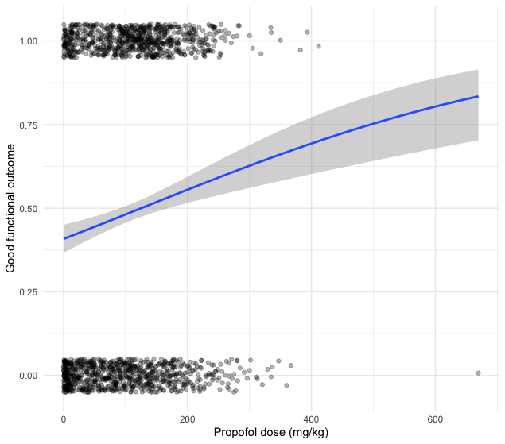
A logistic regression was applied to visualize the relationship between cumulative propofol dose (mg/kg) and the probability of a good neurological outcome. Each point represents an individual patient (jittered for visibility), with the blue line indicating the predicted probability and the shaded area representing the 95% confidence interval. The increasing curve suggests a non-linear association, with higher cumulative doses associated with a greater probability of good functional outcome across the observed range.

Supplement figure 2. The relationship between cumulative propofol dose and survival.
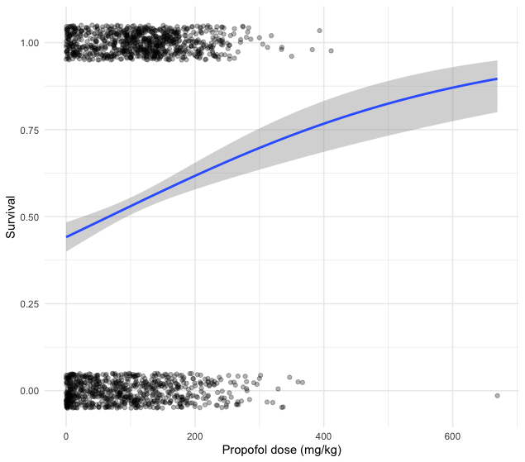
A logistic regression was applied to visualize the relationship between cumulative propofol dose (mg/kg) and the probability of a survival. Each point represents an individual patient (jittered for visibility), with the blue line indicating the predicted probability and the shaded area representing the 95% confidence interval. The increasing curve suggests a non-linear association, with higher cumulative doses associated with a greater probability of survival across the observed range.

Supplement figure 3. The relationship between cumulative propofol dose and clinical seizures.
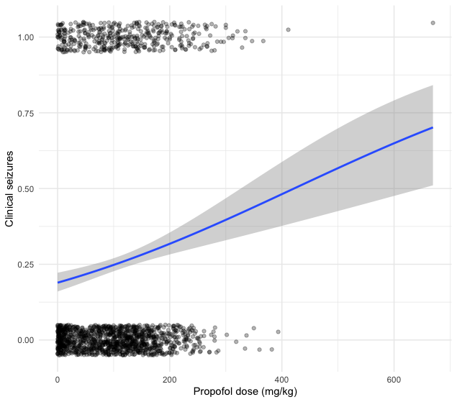
A logistic regression was applied to visualize the relationship between cumulative propofol dose (mg/kg) and the probability of a clinical seizures. Each point represents an individual patient (jittered for visibility), with the blue line indicating the predicted probability and the shaded area representing the 95% confidence interval. The increasing curve suggests a non-linear association, with higher cumulative doses associated with a greater probability of clinical seizure across the observed range.

Supplement figure 4. The relationship between cumulative propofol dose and late awakening.
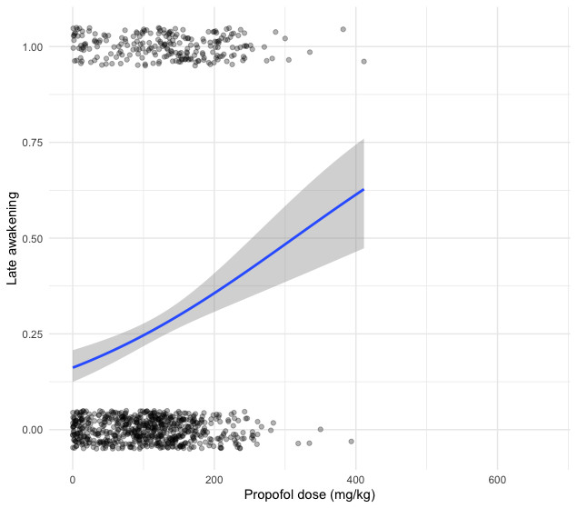
A logistic regression was applied to visualize the relationship between cumulative propofol dose (mg/kg) and the probability of a late awakening. Each point represents an individual patient (jittered for visibility), with the blue line indicating the predicted probability and the shaded area representing the 95% confidence interval. The increasing curve suggests a non-linear association, with higher cumulative doses associated with a greater probability of late awakening across the observed range.

Supplement table 6. Univariate regression model
Association of clinical factors, TTM, sedatives, and analgesics with good functional outcome (mRS 0-3 at 6 months follow up).
 | Good functional outcome |  |  | Survival
Variable | Odds ratio | Confidense interval | p-value | Odds ratio | Confidense interval | p-value
Propofol dose (mg/kg/h) | 1.5 | 1.1 - 2 | 0.008 | 1.6 | 1.2 - 2.1 | 0.002
Midazolam | 1.0 | 0.9 - 1.3 | 0.701 | 1.1 | 0.9 - 1.3 | 0.407
Fentanyl | 1.7 | 1.4 - 2 | <0.001 | 1.8 | 1.5 - 2.1 | <0.001
Remifentanil | 1.1 | 0.9 - 1.3 | 0.528 | 1.1 | 0.9 - 1.3 | 0.516
 | Clinical seizures |  |  | Late awakening
Variable | Odds ratio | Confidense interval | p-value | Odds ratio | Confidense interval | p-value
Propofol dose (mg/kg/h) | 1.2 | 0.9 - 1.7 | 0.204 | 1.2 | 0.9 - 1.7 | 0.204
Midazolam | 1.6 | 1.3 - 1.9 | 0.000 | 1.6 | 1.3 - 1.9 | 0.000
Fentanyl | 0.7 | 0.6 - 0.9 | 0.004 | 0.7 | 0.6 - 0.9 | 0.004
Remifentanil | 1.4 | 1.1 - 1.7 | 0.002 | 1.4 | 1.1 - 1.7 | 0.002

Supplement table 7: Doses of sedatives and analgesics in comatose patients at 96 hours without clinical seizures
Average doses of sedatives and analgesics up to 72 hours in patients with performed neurological prognostication (=with data on duration of sedation and total doses up to 72 hours)
Functional outcome (modified Rankin Scale) | Poor | Good
n | 446 | 375
Propofol (mg/kg/h) (mean (SD)) | 2.2 (3.8) | 2.5 (7.5)
Propofol, n (%) | 389 (87.2) | 325 (86.7)
Midazolam (mg/kg/h) (mean (SD)) | 2.7 (2.8) | 3.9 (3.5)
Midazolam, n (%) | 202 (45.3) | 183 (48.8)
Midazolam and propofol, n (%) | 156 (35.0) | 147 (39.2)
Midazolam only, n (%) | 46 (10.3) | 36 (9.6)
Dexmedetomidine (mcg/kg/h) (mean (SD)) | 0.0 (0.0) | 0.0 (0.0)
Dexmedetomidine, n (%) | 20 (4.5) | 59 (15.7)
Remifentanil mcg/kg/h (mean (SD)) | 0.01 (0.03) | 0.04 (0.15)
Remifentanil, n (%) | 172 (38.6) | 132 (35.2)
Fentanyl (mcg/kg/h) (mean (SD)) | 0.01 (0.06) | 0.00 (0.00)
Fentanyl, n (%) | 215 (48.2) | 214 (57.1)
Oxycodone (mg/kg/h), (mean (SD)) | 0.00 (0.01) | 0.01 (0.01)
Oxycodone, n (%) | 17 (3.8) | 22 (5.9)
Morphine (mg/kg/h), (mean (SD)) | 0.06 (0.22) | 0.02 (0.03)
Morphine, n (%) | 49 (11.0) | 34 (9.1)
Any neuromuscular blockade, n (%) | 288 (64.6) | 237 (63.2)

Supplement table 8: Multivariable logistic regression and chi-square analysis of clinical factors, sedation, and analgesics on functional outcome, survival, clinical seizures, and late awakening in comatose patients at 96 hours without seizures.

Chi-square analyses of propofol quartiles and outcomes and multivariable logistic regression model for association of clinical factors, targeted temperature management allocation, and total dose of propofol up to 72 hrs with good functional outcome (mRS 0-3) at six months follow up, survival at six months, clinical seizures, and late awakening in multivariate regression model.
 | Good functional outcome |  |  | Survival
Variable | OR | conf | p-value | OR | conf | p-value
Propofol dose (mg/kg/h)* |  |  | 0.060 |  |  | 0.020
Propofol quartile 1 (0.01 – 1.02 mg/kg) | - | - | - | - | - | -
Propofol quartile 2 (1.03 -1.85 mg/kg/hr) | 1.93 | 0.80 - 4.77 | 0.146 | 1.93 | 0.83 - 4.64 | 0.132
Propofol quartile 3 (1.86-2.55 mg/kg/hr) | 3.15 | 1.29 - 8.06 | 0.014 | 3.43 | 1.43 - 8.59 | 0.007
Propofol quartile 4 (2.56-38.86 mg/kg/hr) | 2.78 | 1.15 - 6.99 | 0.026 | 3.27 | 1.38 - 8 | 0.008
Midazolam | 1.77 | 0.92 - 3.42 | 0.088 | 1.77 | 0.93 - 3.41 | 0.082
Fentanyl | 2.16 | 1.10 - 4.39 | 0.029 | 2.65 | 1.35 - 5.4 | 0.006
Remifentanil | 2.25 | 1.14 - 4.52 | 0.02 | 2.25 | 1.15 - 4.49 | 0.019
The multivariable regression model is including variables: age, male sex, time to return of spontaneous circulation, witnessed arrest, shock on admission, shockable rhythm, normothermia, shivering or neuromuscular blockade, lowest glomerular filtration rate, and highest bilirubin. Abbreviations: OR= Odds ratio, conf= Confidence interval.
*Chi-square analyses

Supplemental data

The missing data for each outcome variable were as follows: neurological outcome, 32 cases (2%); survival, 11 cases (0.6%); clinical seizures, 13 cases (0.7%); and late awakening, 2 cases (1%). Additionally, 35 patients (2%) had missing data for the variable “shivering or neuromuscular blockade.” There were no missing values for the other variables included in the regression models.

