Supplemental Table 1: Three-dimensional indexes of Human Development Index (HDI)

Dimension | Indicator | Minimum | Maximum
Health | Life expectancy at birth (years) | 20 | 85
Education | Expected years of schooling (years) | 0 | 18
 | Mean years of schooling (years) | 0 | 15
Standard of living | GNI per capita (PPP$) | 100 | 75000

Supplemental Table 2: Associations of dietary iron deficiency with Dengue from 1990 to 2019 in 204 countries and territories, overall and stratified by sex

Prevalence | Dengue (per 100k)
Prevalence | Model 1 |  | Model 2 |  | Model 3 |  | Model 3
Prevalence | Crude coeff.(95%CI) |  | Adj. coeff.(95%CI) |  | Adj. coeff.(95%CI) |  | Adj. coeff.(95%CI)
Total
Dietary iron deficiency | 19.339*** (17.805, 20.872) |  | 31.253*** (29.224, 33.281) |  | 31.049*** (29.000, 33.098) |  | 21.483*** (19.578, 23.388)
HDI | -79.379*** (-89.614, -69.144) |  | 82.757*** (69.468, 96.045) |  | 79.963*** (66.525, 93.401) |  | 105.737*** (93.675, 117.799)
Population density | -0.002*** (-0.004, -0.001) |  |  |  | 0.006*** (0.003, 0.008) |  | -0.004*** (-0.006, -0.001)
Temperature | 3.365*** (3.158, 3.572) |  |  |  |  |  | 3.397*** (3.208, 3.586)
Sex
Female
Dietary iron deficiency | 22.662*** (20.900, 24.424) |  | 29.541*** (27.560, 31.522) |  | 29.280*** (27.278, 31.281) |  | 19.749*** (17.885, 21.613)
HDI | -82.087*** (-92.908, -71.265) |  | 55.373*** (42.804, 67.942) |  | 53.239*** (40.421, 66.057) |  | 86.981*** (75.314, 98.647)
Population density | -0.003*** (-0.004, -0.002) |  |  |  | 0.005*** (0.002, 0.007) |  | -0.005*** (-0.007, -0.002)
Temperature | 3.526*** （3.041， 4.011） |  |  |  |  |  | 3.425*** (3.219, 3.632)
Male
Dietary iron deficiency | 14.874*** (13.499, 16.250) |  | 25.430*** (23.367, 27.492) |  | 25.485*** (23.400, 27.570) |  | 18.443*** (16.584, 20.302)
HDI | -75.958*** (-85.598, -66.318) |  | 60.180*** (46.555, 73.805) |  | 58.190*** (44.489, 71.892) |  | 97.712*** (85.715, 109.709)
Population density | -0.002*** (-0.003, -0.001) |  | -0.010*** (-0.028, 0.008) |  | 0.007*** (-0.031, 0.009) |  | -0.003*** (-0.005, -0.001)
Temperature | 3.200*** (3.013, 3.387) |  |  |  |  |  | 3.495*** (3.320, 3.669)
**<0.05, ***<0.01
1-SD standardized coefficient, all models are mixed-effects model that treating the region as a fixed effect and time as a random effect.
Adj. coeff, adjusted coefficient.
Model 1: unadjusted
Model 2: adjusted for Human Development Index (HDI)
Model 3: adjusted for HDI, and population density
Model 4: adjusted for HDI, population density, and Temperature

Supplemental Table 3: Associations of dietary iron deficiency with dengue from 1990 to 2019 in 204 countries and territories, stratified by age groups
Prevalence | Dengue (per 100k)
Prevalence | Model 1 |  | Model 2 |  | Model 3 |  | Model 3
Prevalence | Crude coeff.(95%CI) |  | Adj. coeff.(95%CI) |  | Adj. coeff.(95%CI) |  | Adj. coeff.(95%CI)
Age category
<5 years
Dietary iron deficiency | 8.002*** (7.230, 8.775) |  | 9.795*** (8.600, 10.989) |  | 9.659*** (8.450, 10.868) |  | 3.441*** (2.340, 4.541)
HDI | -51.489*** (-56.780, -46.198) |  | -2.153 (-9.725, 5.419) |  | -4.301 (-11.941, 3.338) |  | 12.428*** (5.941, 18.914)
Population density | -0.001*** (-0.002, -0.001) |  |  |  | 0.005*** (0.003, 0.006) |  | -0.001** (-0.003, -0.0002)
Temperature | 1.868*** (1.761, 1.976) |  |  |  |  |  | 2.062*** (1.961, 2.163)
5-9 years
Dietary iron deficiency | 8.368*** (6.718, 10.019) |  | 11.875*** (9.461, 14.290) |  | 11.442*** (8.996, 13.889) |  | 1.472 (-0.711, 3.654)
HDI | -89.843*** (-100.198, -79.489) |  | -32.681*** (-47.504, -17.859) |  | -37.164*** (-52.206, -22.123) |  | 11.138* (-1.090, 24.186)
Population density | -0.003*** (-0.004, -0.001) |  |  |  | 0.008*** (0.005, 0.011) |  | -0.004*** (-0.006, -0.001)
Temperature | 3.489*** (3.254, 3.724) |  |  |  |  |  | 4.081*** (3.882, 4.281)
10-24 years
Dietary iron deficiency | 14.306*** (12.417, 16.196) |  | 17.906*** (15.582, 20.229) |  | 17.479*** (15.114, 19.843) |  | 9.792*** (7.631, 11.952)
HDI | -94.240*** (-106.913, -81.567) |  | -12.829 (-28.491, 2.833) |  | -17.017** (-32.946, -1.088) |  | 56.093*** (41.812, 70.374)
Population density | -0.003*** (-0.004, -0.002) |  |  |  | 0.008*** (0.004, 0.011) |  | -0.005*** (-0.008, -0.002)
Temperature | 3.988*** (3.690, 4.285) |  |  |  |  |  | 4.564*** (4.318, 4.811)
25-49 years
Dietary iron deficiency | 24.169*** (22.234, 26.104) |  | 23.589*** (21.533, 25.646) |  | 23.611*** (21.559, 25.662) |  | 18.431*** (16.544, 20.318)
HDI | -71.748*** (-81.142, -62.353) |  | 17.549*** (8.230, 26.869) |  | 16.145*** (6.690, 25.600) |  | 67.684*** (59.015, 76.353)
Population density | -0.002*** (-0.003, -0.001) |  |  |  | 0.007*** (0.005, 0.009) |  | -0.002* (-0.004, 0.00004)
Temperature | 3.192*** (3.001, 3.383) |  |  |  |  |  | 3.094*** (2.931, 3.257)
50-69 years
Dietary iron deficiency | 19.344*** (17.745, 20.943) |  | 30.114*** (28.193, 32.035) |  | 30.029*** (28.110, 31.947) |  | 23.789*** (22.082, 25.497)
HDI | -70.440*** (-80.042, -60.838) |  | 83.993*** (71.638, 96.347) |  | 82.383*** (69.875, 94.892) |  | 118.872*** (107.546, 130.199)
Population density | -0.002*** (-0.003, -0.001) |  |  |  | 0.005*** (0.003, 0.007) |  | -0.004*** (-0.006, -0.002)
Temperature | 3.102*** (2.921, 3.283) |  |  |  |  |  | 3.191*** (3.019, 3.363)
>=70 years
Dietary iron deficiency | 36.657*** (33.198, 40.115) |  | 63.962*** (60.398, 67.526) |  | 64.610*** (60.998, 68.222) |  | 55.347*** (51.707, 58.988)
HDI | -105.065*** (-122.261, -87.870) |  | 222.363*** (200.147, 244.580) |  | 225.921*** (203.061, 248.780) |  | 269.644*** (247.436, 291.852)
Population density | -0.003*** (-0.005, -0.001) |  |  |  | -0.001 (-0.006, 0.003) |  | -0.013*** (-0.017, -0.009)
Temperature | 4.548*** (4.198, 4.898) |  |  |  |  |  | 4.354*** (4.029, 4.680)
**<0.05, ***<0.01
1-SD standardized coefficient, all models are mixed-effects model that treating the region as a fixed effect and time as a random effect.
Adj. coeff, adjusted coefficient.
Model 1: unadjusted
Model 2: adjusted for Human Development Index (HDI)
Model 3: adjusted for HDI, and population density
Model 4: adjusted for HDI, population density, and Temperature
Supplemental Figure 1: Trends in age-standardized prevalence rate (ASPR) of dengue and dietary iron deficiency, stratified by economic region in the 204 countries and territories, from 1990 to 2019

A) Dengue prevalence
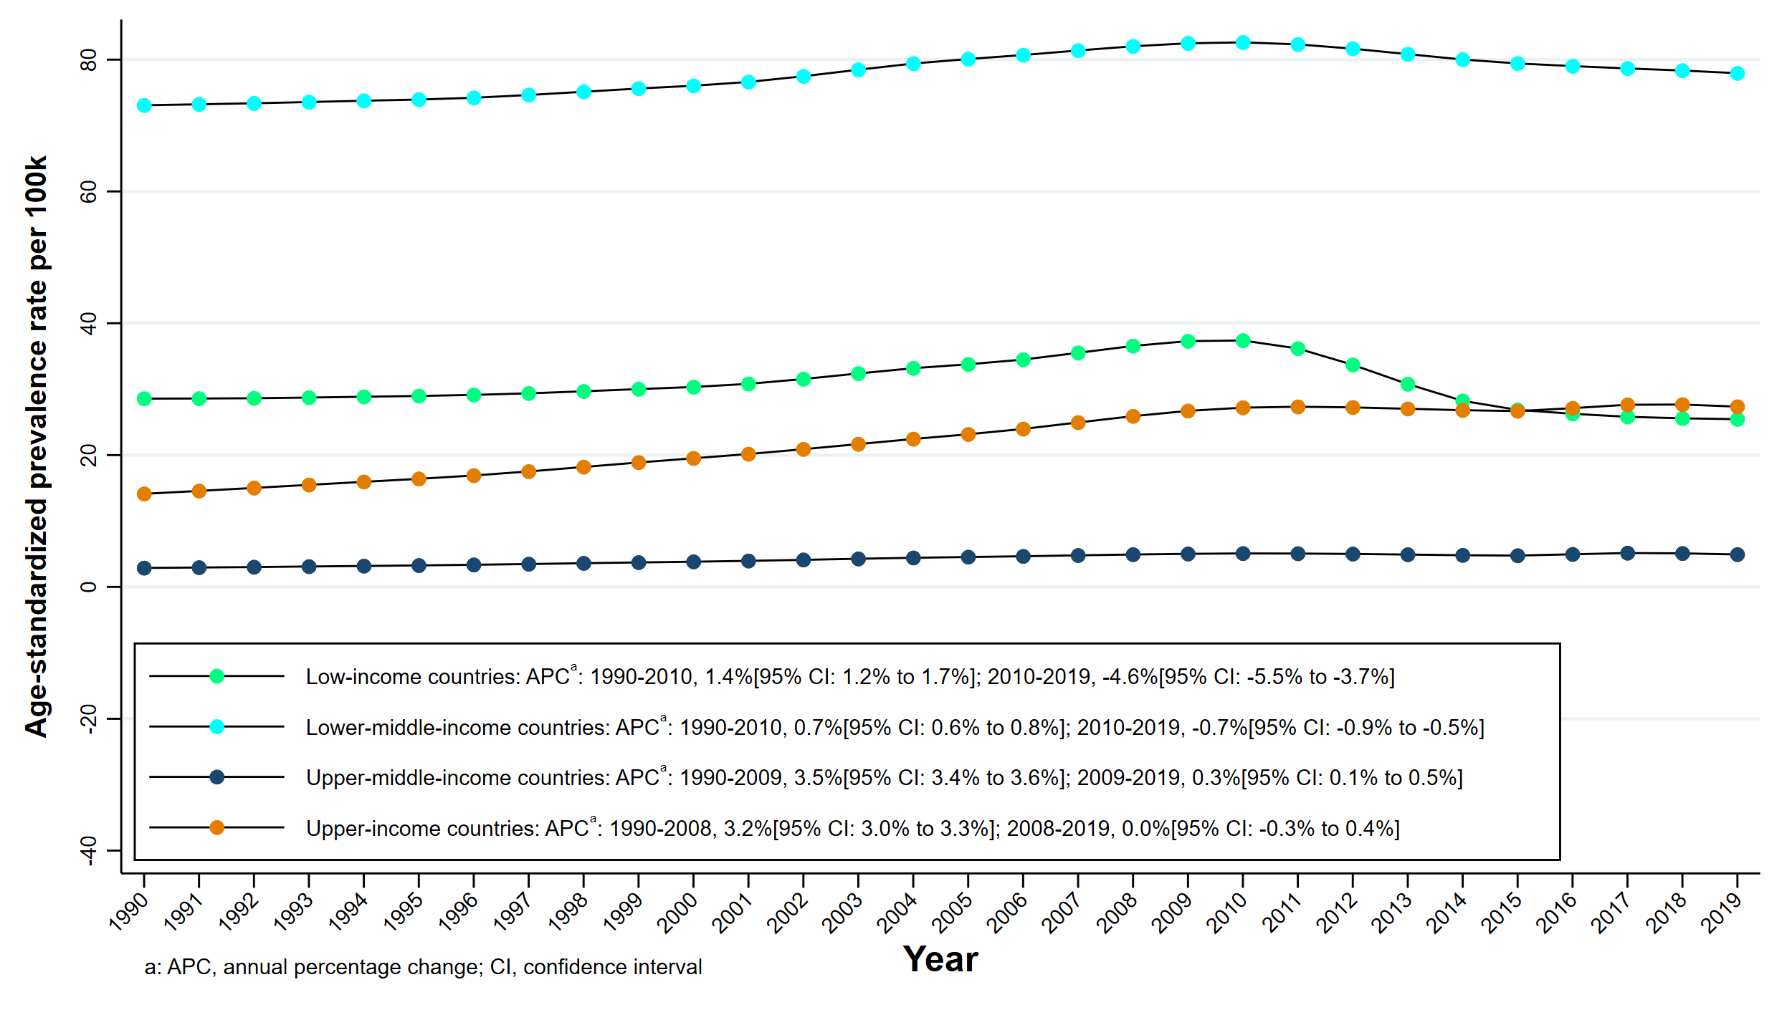
B) Dietary iron deficiency prevalence
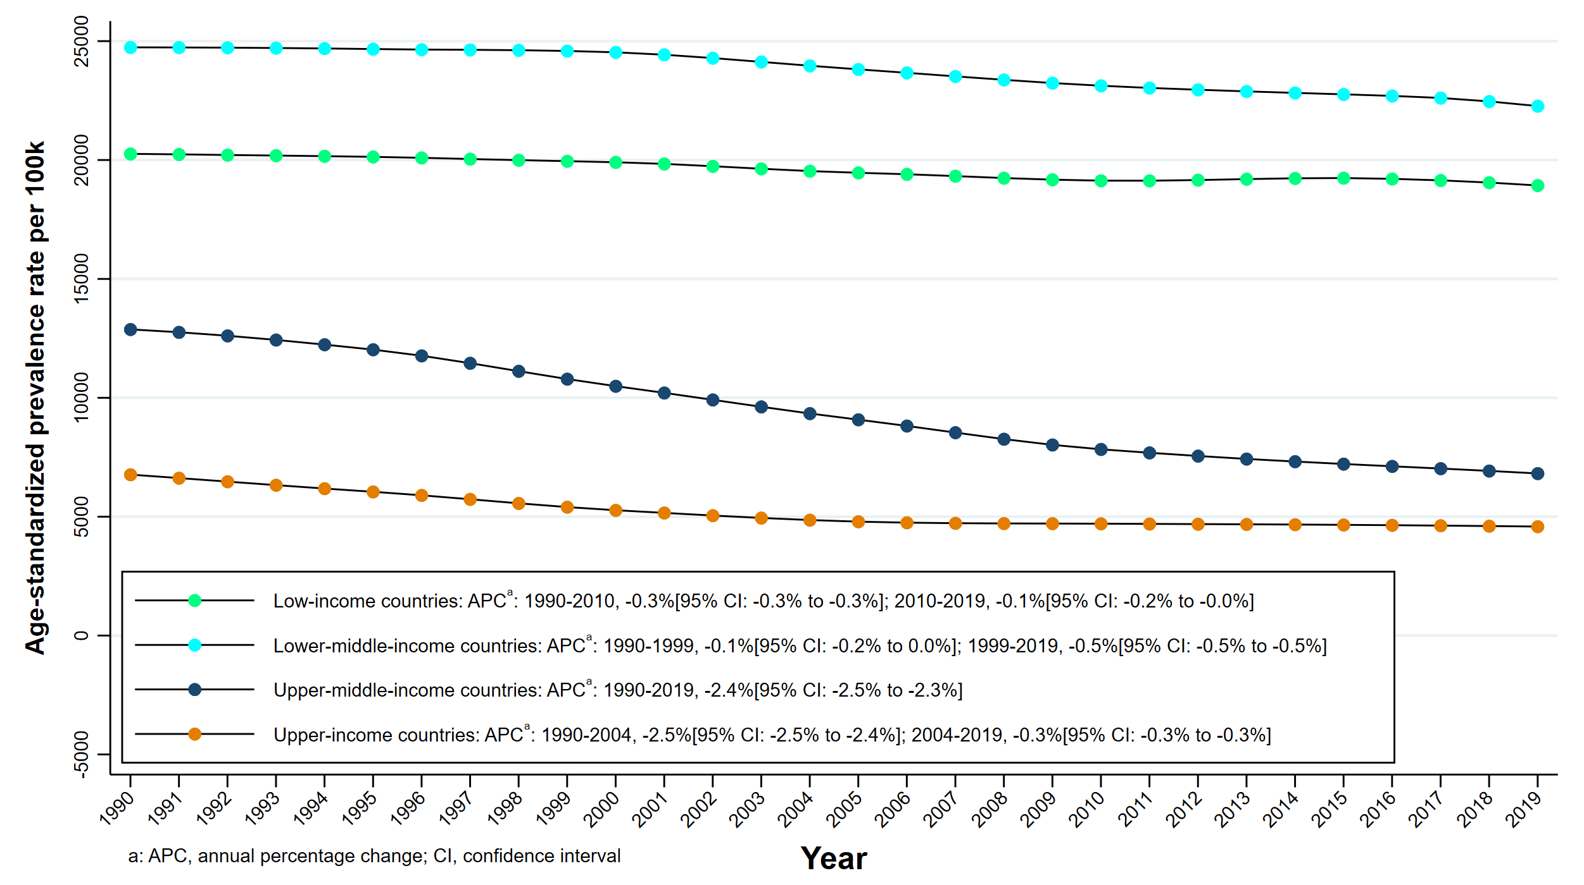

Supplemental Figure 2: Trends in global prevalence rates of dengue and dietary iron deficiency, stratified by age groups in the 204 countries and territories, from 1990 to 2019

A) Dengue prevalence
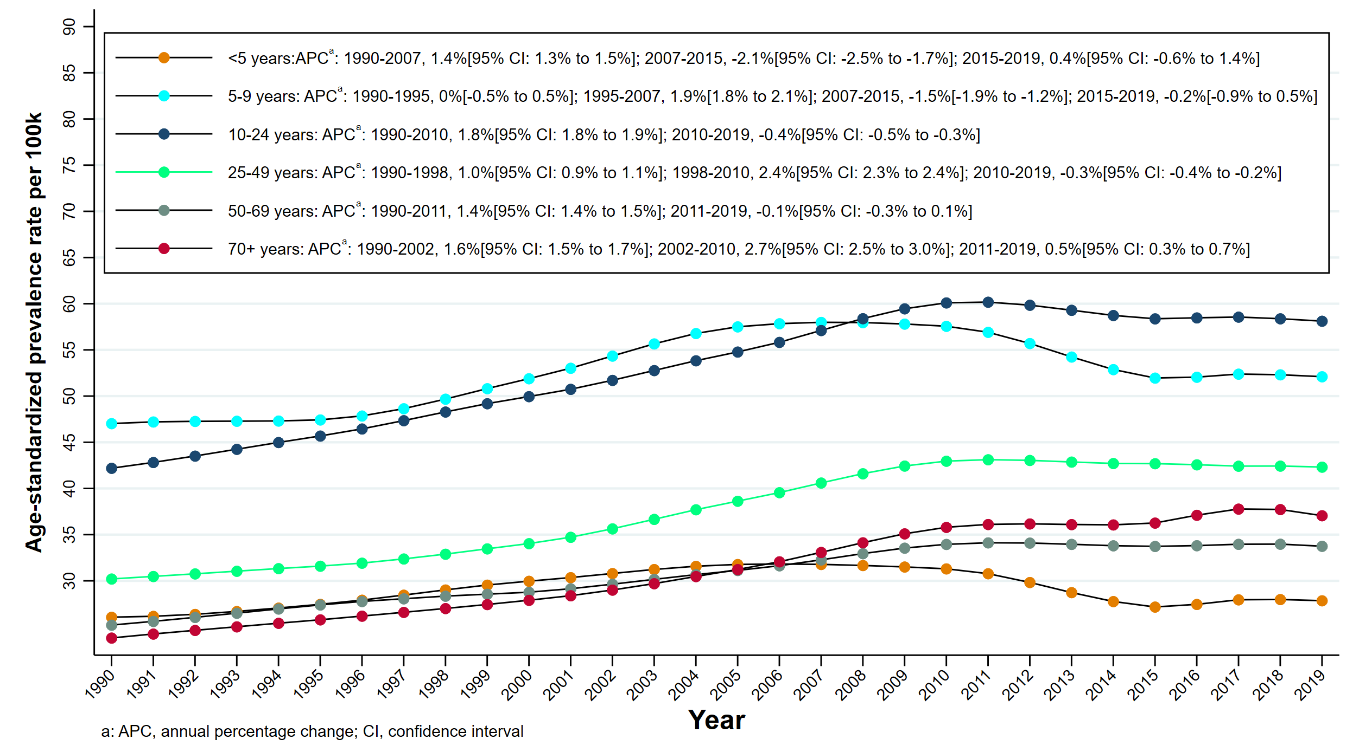
B) Dietary iron deficiency prevalence
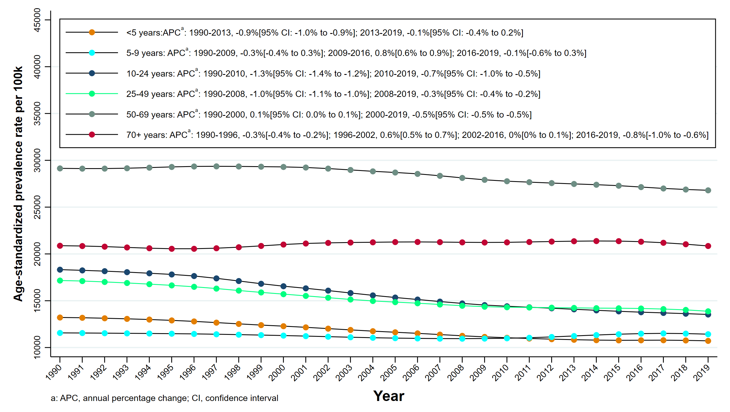

Supplemental Figure 3: Trends in age-standardized prevalence rate (ASPR) of dengue and dietary iron deficiency, overall and stratified by sex in the 204 countries and territories, 1999-2019

A) Dengue prevalence
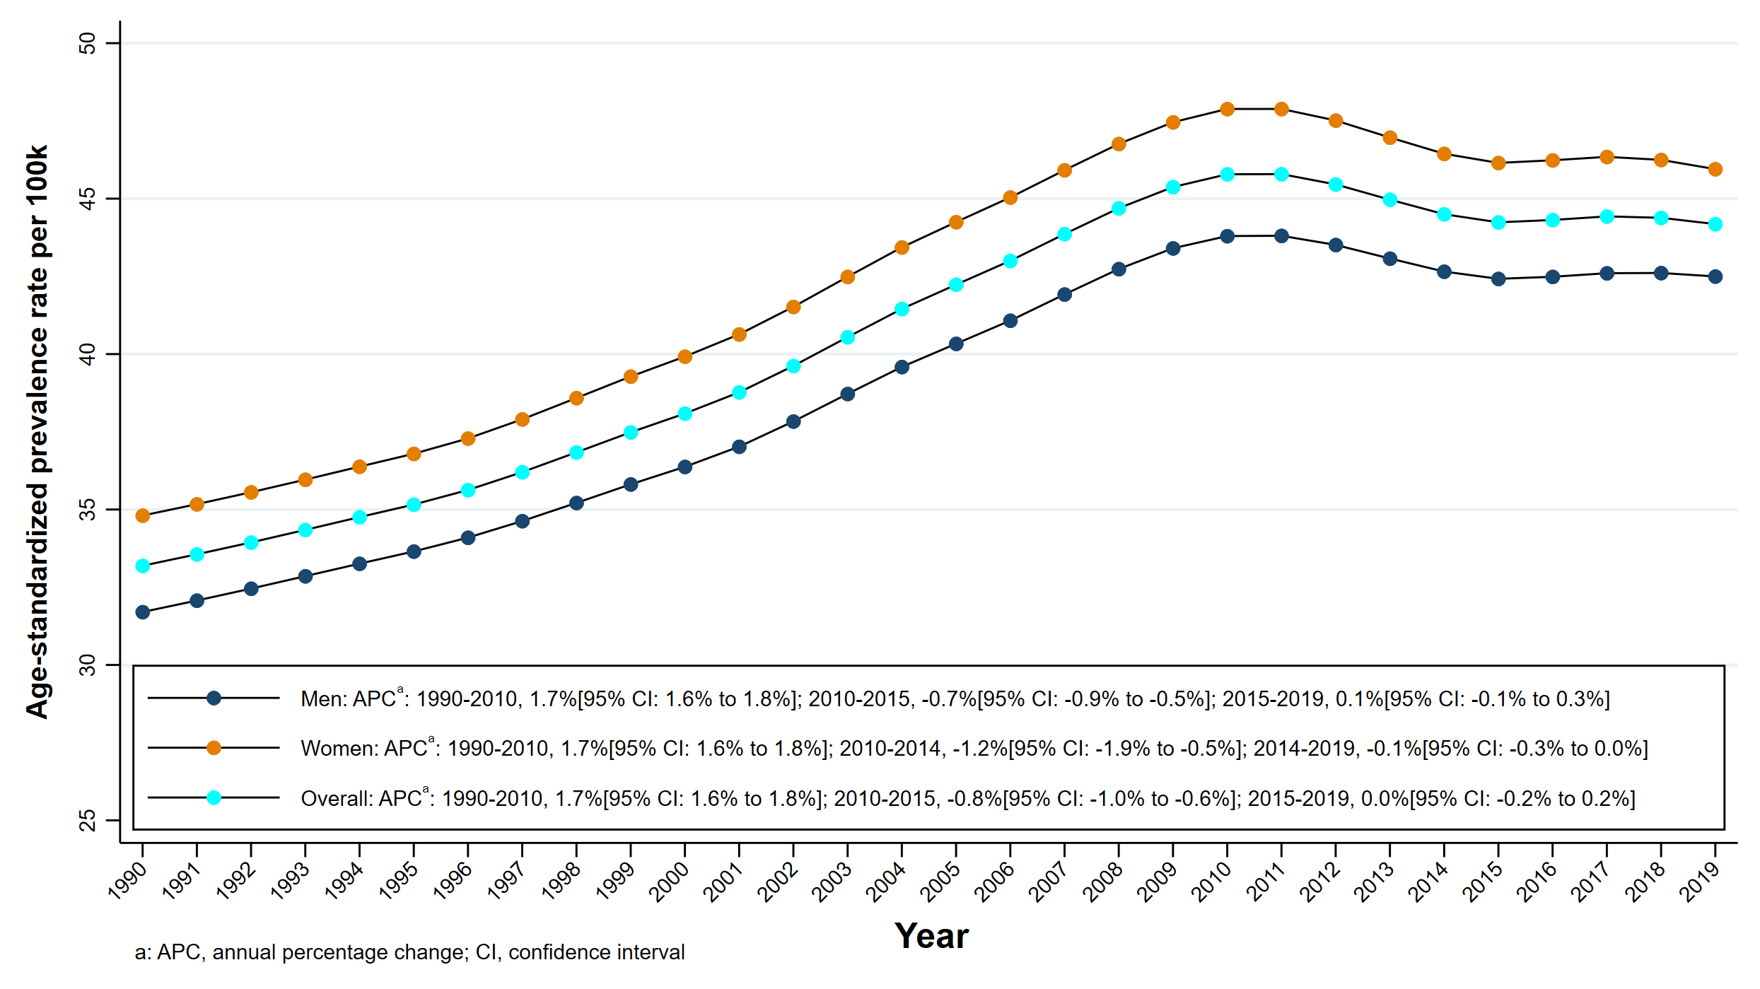
B) Dietary iron deficiency prevalence
