Figure S1. The relative SNHG12 knockdown and overexpression efficiencies were verified by qRT-PCR.

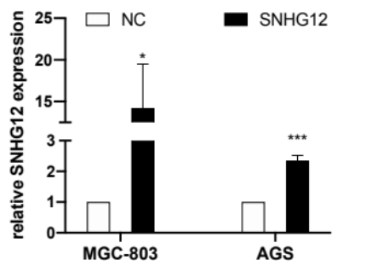
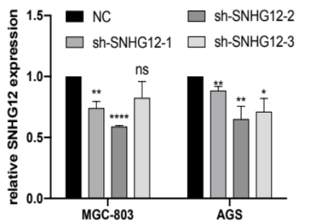

Figure S2. Bioinformatics analysis and experimental verification suggest that SNHG12 may regulate miR-218-5p: using bioinformatics databases (Starbase and miRcode), 14 miRNAs related to SNHG12 were identified. Of the 14 miRNAs, miR-199a-5p, miR-199b-5p, miR-195-5p and miR-218-5p were identified as negatively related to SNHG12 with low expression profile in GC. SNHG12 knockdown in MGC-803 and AGS revealed that the change in the expression of miR-218-5p was most significant among the 4 miRNAs.

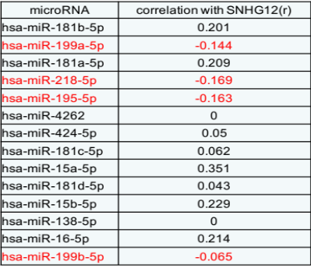
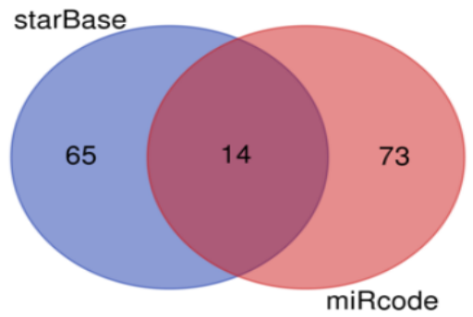

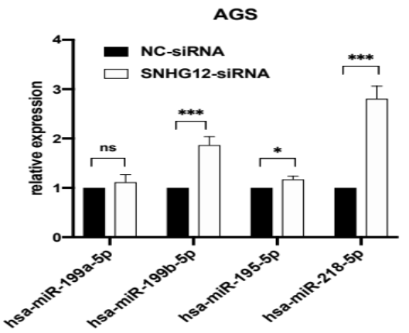
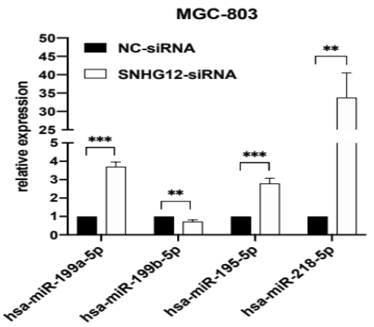

Figure S3. Bioinformatics analysis indicated the target gene of miR-218-5p and SNHG12: using the databases TargetScan Human 7.2 and Starbase, 6 mRNAs were identified as the putative downstream genes of SNHG12 and miR-218-5p: of the 6 identified genes, YWHAZ and RCC1 displayed high positive correlation with SNHG12, negative correlation with miR-218-5p, while YWHAZ was closely related with tumor metastasis.

