Supplemental Table S1
Correlation between the expression levels of miR-125b-2-3p and clinicopathological features in 82 OSCC patients
Feathers | Number | High | Low | P value
All cases | 82 | 41 | 41
Age, years  ＜60  ≥60 | 33  49 | 16  25 | 18  23 | 0.8228
Gender  Male  Female | 56  26 | 26  15 | 30  11 | 0.4769
TNM classification  ⅠandⅡ  ⅢandⅣ | 34  48 | 22  19 | 12  29 | 0.0429*
Lymphatic metastasis  N₀  N₁-N₃ | 37  45 | 24  17 | 13  28 | 0.0259*
Differentiation  Well/moderate  Poor | 51  31 | 28  13 | 23  18 | 0.3625
Abbreviations: OSCC oral squamous cell carcinoma, TNM tumor-nodes-metastases, * statistically significant
Supplemental Table S2
Correlation between the expression levels of Slug and clinicopathological features in 82 OSCC patients
Feathers | Total | High Slug expression | Low Slug expression | P value
Cases | 82 | 57 | 25
Age, years  ＜60  ≥60 | 33  49 | 22  35 | 11  14 | 0.8071
Gender  Male  Female | 56  26 | 38  19 | 18  7 | 0.7975
TNM classification  ⅠandⅡ  ⅢandⅣ | 34  48 | 19  38 | 15  10 | 0.0301*
Lymphatic metastasis  N₀  N₁-N₃ | 37  45 | 22  35 | 15  10 | 0.0306*
Differentiation  Well/moderate  Poor | 51  31 | 31  26 | 20  5 | 0.0465*
Abbreviations: OSCC oral squamous cell carcinoma, TNM tumor-nodes-metastases, * statistically significant

Supplemental Table S3
Prediction of the binding motifs of NF-κB in AC007271.3 core promoter region.
Transcription factor | Matrix ID | Predicted sequence | Score | Relative score | Start | End
NFKB1 | MA0105.3 | AGAAATTTCCA | 9.26642 | 0.884157159825 | -953 | -943
NFKB2 | MA0778.1 | AGGGGATTACTCT | 8.75264 | 0.856121652552 | -854 | -842
NFKB1 | MA0105.4 | AGGGGATTACTCT | 7.30992 | 0.839333491651 | -854 | -842
NFKB1 | MA0105.1 | GGGGATTACT | 8.23833 | 0.835067559571 | -853 | -844
NFKB1 | MA0105.3 | TGTAATTTTCT | 5.27985 | 0.825998998156 | -581 | -571
NFKB1 | MA0105.2 | GGGGATTACTC | 8.74924 | 0.811908132548 | -853 | -843
REL | MA0101.1 | GGGGATTACT | 6.51267 | 0.802215524335 | -853 | -844
Abbreviations: NFKB1 Nuclear Factor Kappa B Subunit 1 (p50), NFKB2 Nuclear Factor Kappa B Subunit 2 (p52), Rel REL Proto-Oncogene, NF-KB Subunit

Supplemental Data 1
The predicted binding sites between miR-125b-2-3p and 3’UTR of Slug mRNA on TargetScan database.

Supplemental Data 2
No significant change of Slug mRNA was observed after overexpressing or inhibiting miR-125b-2-3p in SCC9 and SCC15.
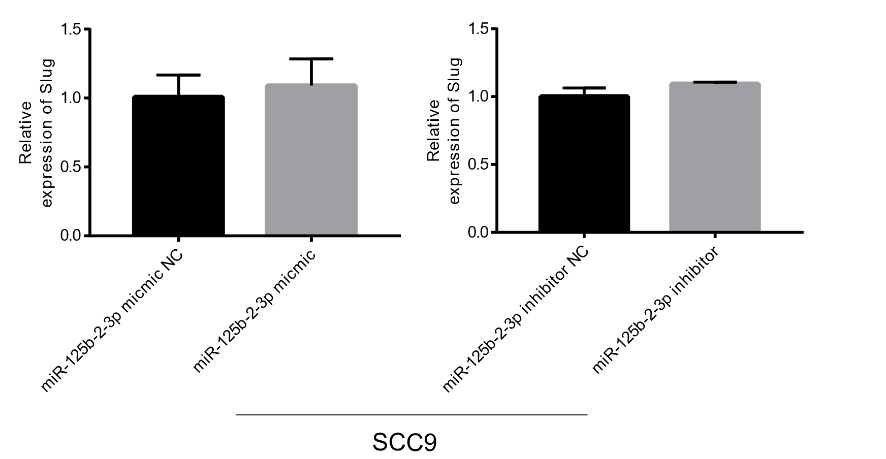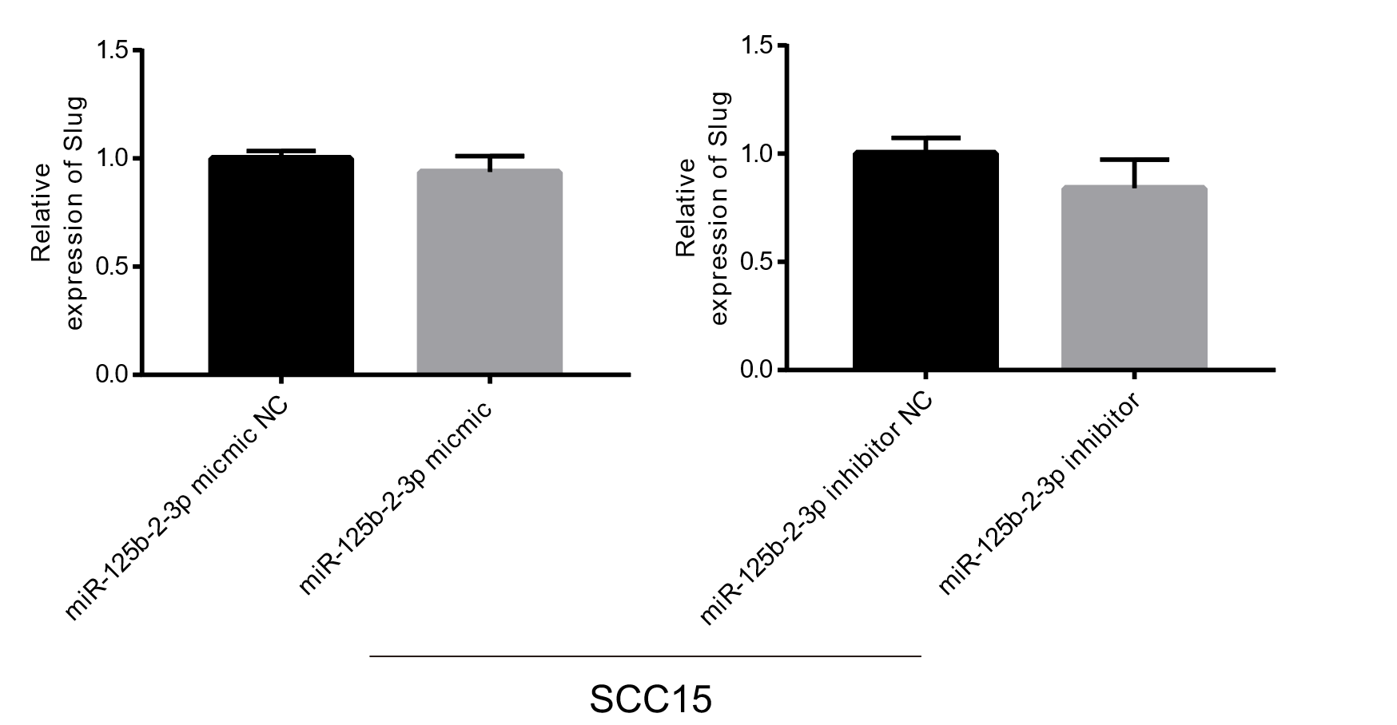

Supplemental Data 3
Primer information of construction of segment-by-segment deletion of the promoter region of AC007271.3 and qPCR (includes ChIP-qPCR) analysis.
Primer | Sequence (5’ to 3’)
AC007271.3-F | ACGTACTTTGAGCAGCCAAG
AC007271.3-R | ACCTTCTGCAGAGAGTTCTTCC
GADPH-F | TGAACGGGAAGCTCACTGG
GADPH-R | TCCACCACCCTGTTGCTGTA
Slug-F | TGTGACAAGGAATATGTGAGCC
Slug-R | TGAGCCCTCAGATTTGACCTG
U6-F | CTCGCTTCGGCAGCACA
U6-R | AACGCTTCACGAATTTGCGT
miR-125b-2-3p-F | CGCGTCACAAGTCAGGCTCT
miR-125b-2-3p-R | AGTGCAGGGTCCGAGGTATT
miR-1301-3p-F | TTGCAGCTGCCTGGGAGT
miR-1301-3p-R | AGTGCAGGGTCCGAGGTATT
miR-4801-F | GCGGCGGTACACAAGAAAACCAAG
miR-4801-R | AGTGCAGGGTCCGAGGTATT
AC007271.3(-1981)-F | GGGGTACCCCCTGAGTGCCAGAAATAC
AC007271.3(-1508)-F | GGGGTACCCCTCCTGGCTTCAAGTGAT
AC007271.3(-1000)-F | GGGGTACCCCTTTAGGTTGTGAAGTTATGGGTG
AC007271.3(-519)-F | GGGGTACCCCAAGTACGCTTGAGAACA
AC007271.3(-2)-R | GAAGATCTTCCAGGGTGAAGTTGATGAAGC
NFKB1-ChIP-S1-F | TTAGGTTGTGAAGTTATGGGTG
NFKB1-ChIP-S1-R | GAAAGCAATAATGGTTTGAGAG
NFKB1-ChIP-S2-F | AACCATTATTGCTTTCGTA
NFKB1-ChIP-S2-R | AGAAACACATTGATAGGGC
NFKB1-ChIP-S3-F | TCCAAATAGTTCAGTCA
NFKB1-ChIP-S3-R | AAAAGTGCTAACCAAG

