Supplementary information:

Size distribution of nanoplastics and tyre wear particles in human tonsils
Dušan Materić^{1†*}, Vaishnavi Rao Tokla^{1†}, Tommy Cedervall^{2,3}, Rupert Holzinger⁴, Mikael T. Ekvall^{2,3}, Maria Värendh^{5,6*}
¹ Helmholtz Centre for Environmental Research – UFZ, Department of Analytical Chemistry, Leipzig, Germany
² NanoLund, Lund University, Lund, Sweden
³ Biochemistry and Structural Biology, Department of Chemistry, Lund University, Lund, Sweden
⁴ Institute for Marine and Atmospheric Research Utrecht, Utrecht University, Princetonplein 5, 3584CC Utrecht, the Netherlands
⁵ School of Medical sciences, Faculty of Medicine and health, Örebro University and Dept. of Otorhinolaryngology, Örebro University hospital, Sweden
⁶Lund University, Department of Clinical Sciences Lund, Otorhinolaryngology, Head and Neck Surgery, Lund, Sweden
†Equal contribution
*Corresponding author: dusan.materic@ufz.de & maria.varendh@med.lu.se

Table S1: The plastic polymer values and the standard deviation of ng/mg of tonsils for all the filter replicas analyzed for each tonsil.
 |  | Plastic polymer (ng/mg)
Sample  Nr. | Size groups | Tyre | SD | PET | SD | PS | SD | PVC | SD | PP/PPC | SD | PE | SD | Total  Plastics | SD*
1 | 20-200 nm | 305 | 113 | 90 | 40 | 74 | 39 | 208 | 79 | 153 | 134 | 249 | 219 | 1079 | 297
1 | 200-1200 nm | 76 | 16 | 17 | 5 | 20 | 5 | 48 | 11 | 0 | 0 | 0 | 0 | 161 | 21
1 | 1.2-2.7μm | 0 | 0 | 0 | 0 | 0 | 0 | 0 | 0 | 0 | 0 | 0 | 0 | 0 | 0
1 | >2.7μm | 501 | 33 | 152 | 14 | 149 | 8 | 358 | 35 | 0 | 0 | 0 | 0 | 1160 | 51
2 | 20-200 nm | 0 | 0 | 0 | 0 | 20 | 10 | 23 | 22 | 27 | 29 | 36 | 39 | 106 | 54
2 | 200-1200 nm | 0 | 0 | 0 | 0 | 7 | 0 | 0 | 0 | 0 | 0 | 0 | 0 | 7 | 0
2 | 1.2-2.7 μm | 0 | 0 | 0 | 0 | 0 | 0 | 0 | 0 | 0 | 0 | 0 | 0 | 0 | 0
2 | >2.7 μm | 0 | 0 | 0 | 0 | 0 | 0 | 68 | 59 | 92 | 6 | 161 | 30 | 321 | 67
3 | 20-200 nm | 0 | 0 | 54 | 0 | 49 | 0 | 0 | 0 | 0 | 0 | 0 | 0 | 103 | 0
3 | 200-1200 nm | 52 | 15 | 32 | 11 | 33 | 9 | 0 | 0 | 0 | 0 | 0 | 0 | 117 | 20
3 | 1.2-2.7 μm | 0 | 0 | 0 | 0 | 0 | 0 | 0 | 0 | 0 | 0 | 0 | 0 | 0 | 0
3 | >2.7 μm | 0 | 0 | 44 | 0 | 29 | 0 | 0 | 0 | 0 | 0 | 0 | 0 | 73 | 0
4 | 20-200 nm | 60 | 84 | 65 | 34 | 25 | 0 | 0 | 0 | 0 | 0 | 0 | 0 | 150 | 91
4 | 200-1200 nm | 575 | 90 | 197 | 24 | 181 | 34 | 438 | 63 | 0 | 0 | 0 | 0 | 1391 | 117
4 | 1.2-2.7 μm | 153 | 47 | 145 | 18 | 0 | 0 | 61 | 105 | 95 | 38 | 162 | 45 | 618 | 131
4 | >2.7 μm | 847 | 466 | 332 | 284 | 277 | 257 | 509 | 443 | 174 | 302 | 262 | 455 | 2403 | 926
5 | 20-200 nm | 26 | 45 | 58 | 22 | 5 | 7 | 0 | 0 | 0 | 0 | 0 | 0 | 90 | 51
5 | 200-1200 nm | 0 | 0 | 63 | 19 | 0 | 0 | 0 | 0 | 0 | 0 | 0 | 0 | 63 | 19
5 | 1.2-2.7 μm | 125 | 77 | 72 | 67 | 19 | 32 | 99 | 61 | 0 | 0 | 0 | 0 | 315 | 123
5 | >2.7 μm | 1806 | 604 | 775 | 346 | 524 | 197 | 692 | 1198 | 0 | 0 | 0 | 0 | 3797 | 1399
6 | 20-200 nm | 269 | 233 | 97 | 24 | 78 | 8 | 0 | 0 | 332 | 61 | 475 | 95 | 1251 | 260
6 | 200-1200 nm | 5 | 8 | 5 | 1 | 1 | 1 | 0 | 0 | 0 | 0 | 0 | 0 | 10 | 8
6 | 1.2-2.7 μm | 0 | 0 | 0 | 0 | 0 | 0 | 0 | 0 | 0 | 0 | 0 | 0 | 0 | 0
6 | >2.7 μm | 254 | 53 | 95 | 26 | 84 | 32 | 0 | 0 | 117 | 20 | 173 | 29 | 723 | 76
7 | 20-200 nm | 321 | 64 | 163 | 24 | 214 | 42 | 385 | 58 | 88 | 39 | 244 | 56 | 1415 | 120
7 | 200-1200 nm | 55 | 14 | 31 | 10 | 25 | 8 | 0 | 0 | 26 | 13 | 14 | 25 | 151 | 34
7 | 1.2-2.7 μm | 0 | 0 | 0 | 0 | 7 | 7 | 0 | 0 | 0 | 0 | 0 | 0 | 7 | 7
7 | >2.7 μm | 3048 | 19 | 1544 | 34 | 1797 | 129 | 2571 | 20 | 505 | 25 | 0 | 0 | 9465 | 138
8 | 20-200 nm | 272 | 57 | 87 | 19 | 81 | 16 | 237 | 54 | 0 | 0 | 0 | 0 | 676 | 83
8 | 200-1200 nm | 0 | 0 | 40 | 19 | 15 | 7 | 0 | 0 | 0 | 0 | 0 | 0 | 55 | 20
8 | 1.2-2.7 μm | 0 | 0 | 30 | 51 | 0 | 0 | 0 | 0 | 0 | 0 | 0 | 0 | 30 | 51
8 | >2.7 μm | 565 | 35 | 162 | 5 | 189 | 16 | 527 | 49 | 0 | 0 | 0 | 0 | 1443 | 63
9 | 20-200 nm | 66 | 1 | 0 | 0 | 18 | 11 | 42 | 37 | 0 | 0 | 0 | 0 | 126 | 39
9 | 200-1200 nm | 13 | 11 | 0 | 0 | 6 | 5 | 8 | 13 | 0 | 0 | 0 | 0 | 27 | 18
9 | 1.2-2.7 μm | 0 | 0 | 0 | 0 | 3 | 6 | 0 | 0 | 0 | 0 | 0 | 0 | 3 | 6
9 | >2.7 μm | 1196 | 680 | 0 | 0 | 744 | 425 | 1076 | 606 | 0 | 0 | 0 | 0 | 3016 | 1005
10 | 20-200 nm | 20 | 18 | 8 | 14 | 9 | 5 | 0 | 0 | 14 | 23 | 19 | 32 | 70 | 46
10 | 200-1200 nm | 35 | 7 | 14 | 7 | 8 | 7 | 0 | 0 | 25 | 7 | 27 | 25 | 108 | 28
10 | 1.2-2.7 μm | 204 | 168 | 47 | 81 | 61 | 35 | 77 | 134 | 31 | 54 | 60 | 105 | 481 | 261
10 | >2.7 μm | 1794 | 72 | 902 | 82 | 759 | 10 | 2128 | 92 | 648 | 9 | 1665 | 124 | 7896 | 189
11 | 20-200 nm | 23 | 0 | 0 | 0 | 14 | 2 | 0 | 0 | 0 | 0 | 0 | 0 | 37 | 2
11 | 200-1200 nm | 42 | 3 | 32 | 15 | 17 | 8 | 0 | 0 | 12 | 10 | 10 | 18 | 113 | 27
11 | 1.2-2.7 μm | 0 | 0 | 0 | 0 | 3 | 5 | 0 | 0 | 0 | 0 | 0 | 0 | 3 | 5
11 | >2.7 μm | 550 | 35 | 233 | 28 | 196 | 19 | 347 | 331 | 255 | 12 | 501 | 57 | 2083 | 340
12 | 20-200 nm | 89 | 12 | 0 | 0 | 37 | 4 | 0 | 0 | 46 | 41 | 58 | 51 | 230 | 67
12 | 200-1200 nm | 43 | 1 | 20 | 2 | 15 | 1 | 0 | 0 | 27 | 1 | 41 | 2 | 145 | 4
12 | 1.2-2.7 μm | 158 | 273 | 86 | 149 | 18 | 16 | 0 | 0 | 45 | 43 | 27 | 46 | 334 | 318
12 | >2.7 μm | 638 | 198 | 197 | 188 | 232 | 68 | 497 | 173 | 262 | 81 | 522 | 173 | 2349 | 382
13 | 20-200 nm | 99 | 130 | 52 | 90 | 81 | 123 | 117 | 203 | 3 | 5 | 0 | 0 | 352 | 285
13 | 200-1200 nm | 0 | 0 | 7 | 0 | 1 | 1 | 0 | 0 | 0 | 0 | 0 | 0 | 8 | 1
13 | 1.2-2.7 μm | 127 | 110 | 54 | 47 | 54 | 32 | 98 | 85 | 90 | 90 | 125 | 118 | 548 | 211
13 | >2.7 μm | 848 | 38 | 378 | 25 | 387 | 7 | 905 | 132 | 183 | 17 | 336 | 295 | 3037 | 327
14 | 20-200 nm | 16 | 9 | 10 | 0 | 5 | 2 | 0 | 0 | 6 | 10 | 0 | 0 | 36 | 13
14 | 200-1200 nm | 17 | 16 | 7 | 1 | 10 | 4 | 0 | 0 | 21 | 11 | 16 | 16 | 71 | 26
14 | 1.2-2.7 μm | 0 | 0 | 0 | 0 | 6 | 11 | 10 | 18 | 0 | 0 | 5 | 9 | 22 | 23
14 | >2.7 μm | 250 | 98 | 50 | 38 | 158 | 21 | 292 | 268 | 108 | 67 | 165 | 87 | 1023 | 309
15 | 20-200 nm | 0 | 0 | 11 | 19 | 8 | 12 | 0 | 0 | 0 | 0 | 0 | 0 | 19 | 23
15 | 200-1200 nm | 41 | 31 | 6 | 9 | 16 | 12 | 0 | 0 | 34 | 34 | 38 | 35 | 134 | 60
15 | 1.2-2.7 μm | 7 | 6 | 0 | 0 | 2 | 4 | 0 | 0 | 0 | 0 | 0 | 0 | 9 | 7
15 | >2.7 μm | 112 | 103 | 0 | 0 | 71 | 62 | 0 | 0 | 16 | 28 | 27 | 47 | 226 | 132
* The square root of all the calculated standard deviations.

Table S1. Depicting baseline data on the study persons including some use of plastics in everyday life. Concerning sex, 60% were female.
Study person | Age | Sex (f/m) | BMI | City/  rural | Pacifier | Eat food stored in plastic container* | Drink from a plastic bottle
1 | 31 | m | 22.6 | Rural village | 1 | 2 | 3
2 | 15 | f | 20.0 | City | 1 | 0 | -
3 | 23 | m | 23.4 | City | 1 | 2 | -
4 | 3,5 | m | 15.5 | City | 1 | 0 | 3
5 | 22 | f | 30.5 | City | 1 | 0 | 2
6 | 44 | f | 42.0 | City | 1 | 3 | 0
7 | 31 | m | 27.0 | City | 0 | 2 | 3
8 | 3 | f | 17.4 | Rural village | 0 | 2 | 3
9 | 5 | m | 15.3 | City | 0 | 3 | 2
10 | 5 | m | 14.9 | Rural village | 1 | 2 | 2
11 | 25 | f | 26.2 | City | 1 | 3 | 3
12 | 5 | f | 16.5 | City | 1 | 2 | 0
13 | 17 | f | 25.3 | Rural | 1 | 3 | 3
14 | 24 | f | 23.7 | City | 1 | 3 | 2
15 | 17 | f | 19.5 | Rural | 1 | 3 | 0
Mean, (Min-max) when applicable | 18.0 (3-44 years) |  | 22.6 (14.9-42.0)
*Do you/your child eat food which has been stored in plastic containers? (Never=0, some times per month=1, some times during a week =2, daily=3)

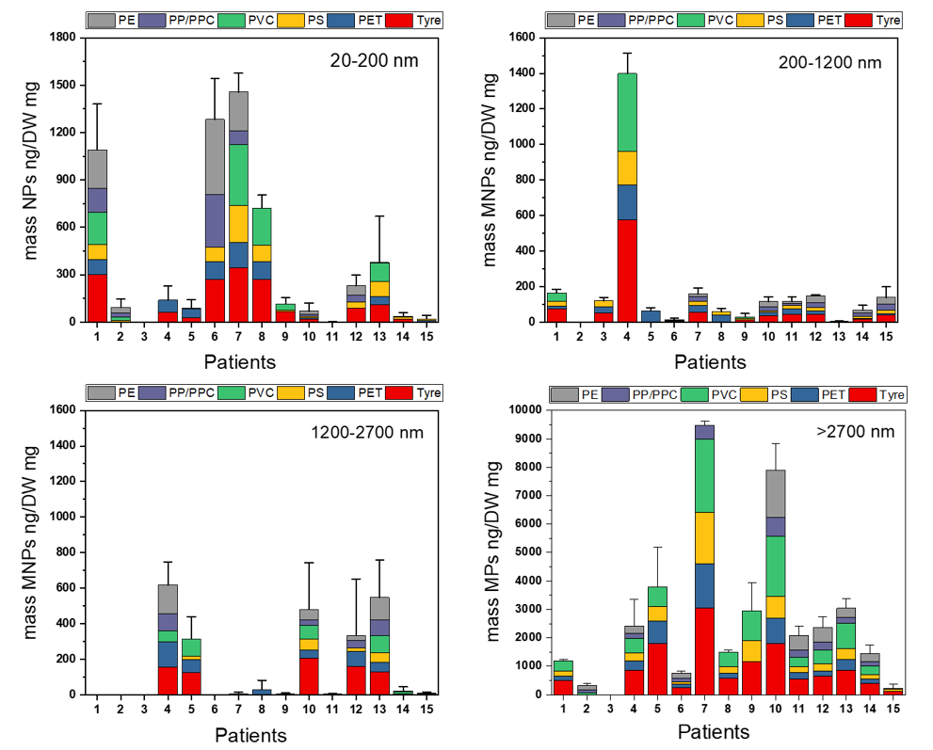
Figure S1. Nanoplastic and microplastic concentrations for each patient and plastic types. All values are corrected for measured blank contamination. The error bars represent the standard deviation of triplicates. The plastic types are Tyre, PET- Polyethylene terephthalate, PS - Polystyrene, PVC - Polyvinyl Chloride, PP – Polypropylene, PPC- Polypropylene Carbonate, and PE – Polyethylene.

Figure S2. Size distribution of micro- and nanoplastics for each patient
Patient:1

Patient:2

Patient:3

Patient:4

Patient:5

Patient:6

Patient:7

Patient:8

Patient:9

Patient:10

Patient:11
Patient:12

Patient:13

Patient:14

Patient:15

