Supplementary information
Zhuoxi Wu^{1†}, Qianqian Wang^{1†}, Yu Xiong^{1†}, Baohua Liu², Jiaxiong Zhu¹, Yanbo Wang¹, Qingshun Nian¹, Ze Chen³, Jun Fan¹, Qinghong Wang^{2*}, Donghong Wang^{4*}, Chunyi Zhi^{1,5,6,7*}
1 Department of Materials Science and Engineering, City University of Hong Kong, Kowloon, 999077, Hong Kong SAR, China.
2 School of Chemistry and Materials Science, Jiangsu Normal University, Xuzhou, Jiangsu 221116, P. R. China.
3 School of Interdisciplinary Studies, Lingnan University, Hong Kong, China.
4 School of Materials Science and Engineering, Anhui Province Key Laboratory of Efficient Conversion and Solid-State Storage of Hydrogen & Electricity, Anhui University of Technology, Ma'anshan 243032, Anhui, China.
5 Hong Kong Institute for Advanced Study, City University of Hong Kong, Kowloon, 999077, Hong Kong SAR, China.
6 Hong Kong Institute for Clean Energy, City University of Hong Kong, Kowloon, 999077, Hong Kong SAR, China.
7 Centre for Advanced Nuclear Safety and Sustainable Development, City University of Hong Kong, Kowloon, 999077, Hong Kong SAR, China.
† These authors contribute equally to this work.
Email: wangqh@jsnu.edu.cn, dhwang@ahut.edu.cn, cy.zhi@cityu.edu.hk
Experiment details
Electrolyte preparation
All the chemicals are bought from Aladdin and used directly without further purification. Active carbon (AC) is bought from KELUDE. Typically, ZnABL is formed by dissolving ZnSO₄ into H₂O/ABL (50%-50%) solution. The ZnABL used in the experiment was obtained by adding 4 M ZnSO₄ to the mixed solvent.
Preparation of Zn_{0.25}V₂O₅ · nH₂O (ZVO) cathode materials
Zn_{0.25}V₂O₅ · nH₂O were synthesized according to a previous study¹. Specifically, 3.492 g V₂O₅ was dispersed in 480 mL 15:1 (vol/vol) water/acetone mixture solution. 2.3 g zinc acetate anhydrous was added to the solution and stirred for 2 h. The mixed solution was then transferred to several sealed Teflon vessels and heated for 72 h. The obtained product was centrifuged and washed three times with water and isopropyl alcohol, respectively, and finally dried under vacuum for 24 hours to obtain a green solid, which is the ZVO material.
Electrode fabrications
Stainless steel cases of coin cells (CR2032) are bought from KELUDE. A stamping machine prepares electrodes for coin cells. To minimize the impact of the electrolyte on the corrosion of the stainless-steel battery cases, the Cu foil current collector in the Zn||Cu asymmetric cells is stamped into a diameter of 18 mm flakes to slow down the case corrosion from the electrolyte. The zinc metal anode was cut into 1 × 1 cm square pieces.
Carbon cloth is stamped into 12 mm diameter flakes to serve as the current collector. To prepare the ZVO electrode for the coin cell, ZVO powders are mixed with Ketjen Black and PTFE-H₂O (PTFE 10%) solution with a weight ratio of about 7:2:1 and then coated to the carbon cloth. For AC capacitors, AC powders are mixed with Ketjen Black, PVDF with a weight ratio of about 6:3:1, and NMP was added to be the solvent. The mixed slurry was then coated onto the carbon cloth. The obtained electrode was dried at 60 ℃ for 5 h.
For the electrode used in the pouch cell, the prepared ZVO powder and Ketjen black were first placed in a planetary ball mill with a weight ratio of 7:2 and milled for 30 minutes to obtain a uniformly mixed and dense powder. Subsequently, the mixed powder was mixed with 10% PTFE solution with a weight ratio of 9:1, ground for 30 minutes, and then coated on a 10 cm × 10 cm (electrode tabs: 3 cm × 1 cm)100-mesh thin titanium mesh. The electrode was vacuum-dried at 60 ℃ for 12 hours to remove moisture. The obtained dry electrode was first pressurized under an oil pump booster to make the coated electrode particles denser. Subsequently, the pressurized electrode was rolled to less than 150 microns using a roller press.
Similarly, 30 μm zinc foil was cut to the same size with a cutter (10 cm × 10 cm (electrode tabs: 3 cm × 1 cm)). The separator was Whatman GF-B, and the cut size was 10.5 cm × 10.5 cm. The packaging material used for the pouch cell is the thermoplastic film (size: 12 cm × 12 cm).
Characterization
The FTIR spectra were collected from PerkinElmer Spectrum II FT-IR Spectrometer. For the in-situ FTIR test, we used open cathode cases and placed them on the infrared device, connected to the electrode clip of the electrochemical station (CHI760, CH Instruments) through copper wire as a conductor. In order to better observe the ZnABL on the surface of the Zn anode, we coated a thin layer of zinc powder on the titanium mesh to make the test more accurate.² The SEM images were collected from the Environmental Scanning Electron Microscope (FEI/Philips XL30 Esem-FEG). Bruker Dimension Icon performed an atomic force microscope (AFM) test. KEYENCE VK-X150 performed a confocal laser scanning microscopy (CLSM) test. The ex-situ SEM samples were obtained by disassembling the cell, extracting the electrode, washing by DI water/ethanol 50% mixture 3 times, and drying at a vacuum (~25 °C) for 24 h.
Calculation of energy density
The energy density calculations in this work used the following formula:
E = $\frac{C×V}{v}$
Where E is the volumic energy density, C is the total capacity of the pouch cell, V is the average discharge voltage, and v is the volume of the total pouch cell.
In this work, the total volume of the pouch cell was calculated by measuring the size and thickness of each part, and finally, the energy density was calculated. Among them, the thickness of the cathode sheet, anode sheet, and packaging material of the pouch cell was obtained by direct measurement. Since the separator becomes thinner after the assembled pouch cell is compressed, the thickness of the separator is obtained by measuring the thickness of the entire pouch cell minus the thickness of the rest of the parts. Besides, we tested the thickness of the separator after compression and found that the two were not much different (Supplementary Fig.38). The volume reduction of the battery packaging material after hot pressing is not considered, so the actual energy density may be slightly higher than the calculated value.
Real-time observation with digital holographic microscopy (DHM)
The DHM system employs a CCD camera (Prosilica GT 1910) (Supplementary Fig.15), of which the max frame rate at full resolution is 57.5 fps. Herein, 50 fps and 20 ms real temporal resolution for DHM measurement are set. The cell was a cube with a side length of 5 cm. The volume of electrolytes was about 60 mL. The experiment was carried out with Zn||Zn symmetric cell with 100 μm thickness zinc foil. The distance between the cathode and anode was about 2 cm. The electrode was sealed with epoxy resin and punched into sheets with an area of 0.2 × 1 cm². In the real-time DHM observation system, zinc was plated for 1.5 min at 1 mA cm⁻² (the cells were connected to an electrochemical workstation (CHI660E, CH Instruments) at room temperature).³
Generally, the laser transmitter generates an incident wave, decomposed into a reflected wave and a refracted wave by a lens. The reflected wave will be a reference wave to travel through the optical path to the CCD camera, while the refracted wave will be an object wave to pass through the test region on the electrode surface. Since the concentration of different positions in the test area changes with time, their refractive index to the object wave will change. After refraction, the object wave will have a phase difference from the reference wave, meeting and interfering with the reference wave at the CCD camera. After digital processing, the concentration change in the observation area can be monitored in real time on the computer (Fig. 3a in main text). The technical principle of DHM is shown in the following formula:
ΔC = kΔn = k($\frac{λ_{0}}{2πd}$)Δϕ
where ΔC represents the change in the solution concentration. k refers to the concentrative refractivity. Δn is the change of the solution refractive index. λ₀ refers to the wavelength of the incident wave. d is the path length of the refractive index change. Δϕ refers to the phase difference. ⁴ The relationship between ΔC, Δϕ and the colors in the phase diagram is described below:
when Δϕ = 0, ΔC = 0, the phase map is green, indicating the concentration is unchanged;
when Δϕ < 0, ΔC < 0, the phase map is blue, indicating the concentration decreases;
when Δϕ > 0, ΔC > 0, the phase map is yellow or red, indicating the concentration increases.
Computation Methods
DFT calculation
The adsorption energies of the H₂O, SO₄²⁻, and the ZnABL molecule on the Zn surfaces, including (002), (100), (101), and (102) planes, were calculated by the Vienna Ab initio Simulation Package (VASP).⁵ For all calculations, the projector-augmented-wave (PAW) method was employed.⁶ The generalized gradient approximation with the Perdew−Burke−Ernzerhof (GGA-PBE) functional described the exchange-correlation energy.⁷ DFT-D3 dispersion correction was incorporated to account for the van der Waals interactions.⁸ The self-consistent field electronic calculation criterion was set to 10⁻⁶ eV. The force-based criterion of structural optimization was set to 0.02 eV Å⁻¹. A 520 eV cutoff energy and gamma point were used for the calculation. The simulation cells were constructed with Zn surfaces exposed in the z-direction and a vacuum thickness larger than 15 Å to prevent periodic interactions along the z-direction. Adsorbates were placed on the Zn surfaces, and the bottom layer of each Zn surface was fixed to simulate bulk-phase conditions. Specific configurations of the (002), (100), (101), and (102) surfaces are provided in Supplementary Fig.6-8. The isolated adsorbates were optimized in the box size of 3×3×3 nm³ with a single gamma k-point. The adsorption energy is calculated via:
$$E_{ads}=E_{Zn+mol}-E_{Zn}-E_{mol}$$
where the $E_{Zn+mol}$, the $E_{Zn}$, and the $E_{mol}$ represent the total energy of adsorbates on the Zn surface, the Zn surface, and the energy of the isolated adsorbates, respectively.

MD simulation
Molecular dynamics (MD) simulations were performed by the open-source code Large-scale Atomic/Molecular Massively Parallel Simulator (LAMMPS).⁹ The non-polarizable Optimized Potentials for liquid Simulation All Atom (OPLS-AA) force field¹⁰ was used to describe the interaction of SO₄²⁻ and ZnABL, coupling with the TIP4P/Ew water model.¹¹ The Zn²⁺ parameter was obtained from the work of Merz et al.¹² The geometric mean combining rule was utilized for mixing parameters. The particle-particle particle-mesh (PPPM) solver accounted for the long-range electrostatic interactions, considering the charge located at the massless fourth site of each TIP4P water molecule. A cutoff distance of 12 Å was applied for both van der Waals and long-range electrostatic interactions.
All the electrolyte systems were initially constructed based on the corresponding experimental conditions. Subsequently, the systems were equilibrated through an annealing process over 10 ns, followed by an NPT simulation conducted at 298 K for 50 ns to determine the bulk-phase density of the electrolytes. The equilibrium box dimensions are approximately 45 Å, sufficiently large to eliminate the effect introduced by periodic boundary conditions. The interface model includes a Zn electrode composed of roughly six Zn layers, ensuring an electrode thicker than 12 Å. The density of the electrolyte region is carefully maintained to match that of the bulk electrolyte, guaranteeing consistency with bulk phase properties. Atoms in the electrode were restricted by a spring of 1000 kcal mol⁻¹Å⁻². All initial simulation models in this work were constructed using the Moltemplate¹³ program and the Packmol package.¹⁴ The interface systems were equilibrated with an NVT ensemble (298K for 2 ns, heating to 500 K for 2 ns, maintaining at 500K for 2 ns, cooling to 298 K for 4 ns, and finally 298 K for 50 ns) and the time step is set as 1 fs. The simulation process was visualized using OVITO software.¹⁵

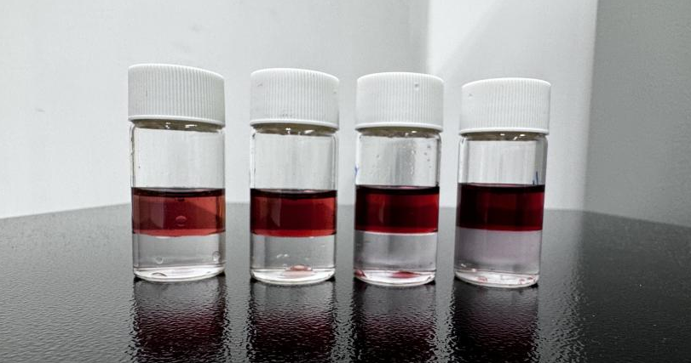
Supplementary Fig. 1. Images of ZnABL formed in different concentrations of ZnSO₄, from left to right, are 1M, 2M, 3M, 4M; as the concentration of ZnSO₄ increases, the color of the upper liquid gradually becomes darker.
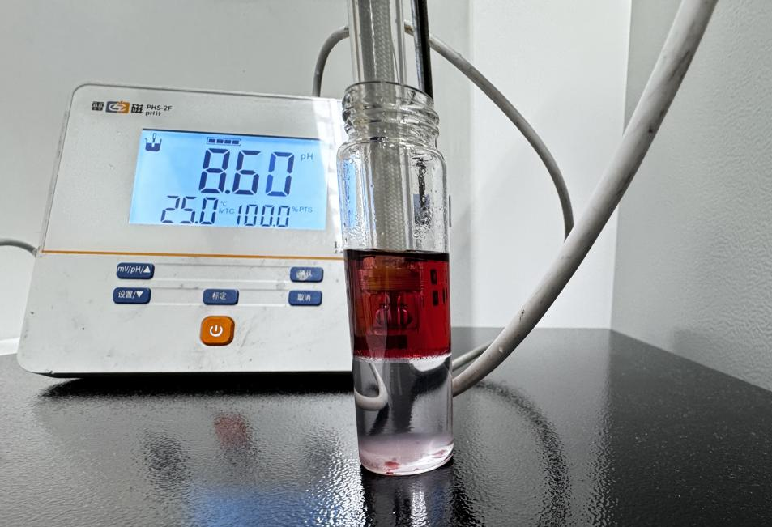
Supplementary Fig. 2. The pH value of the upper-part solution (ZnABL solution) shows it is roughly neutral.

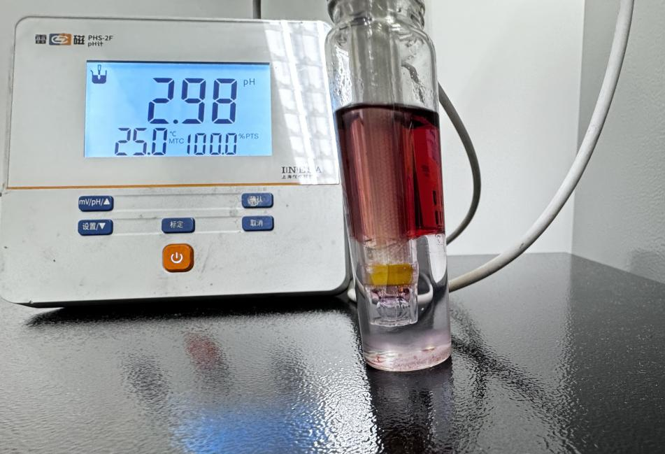
Supplementary Fig. 3. The lower-part solution's pH value shows that it is acid.
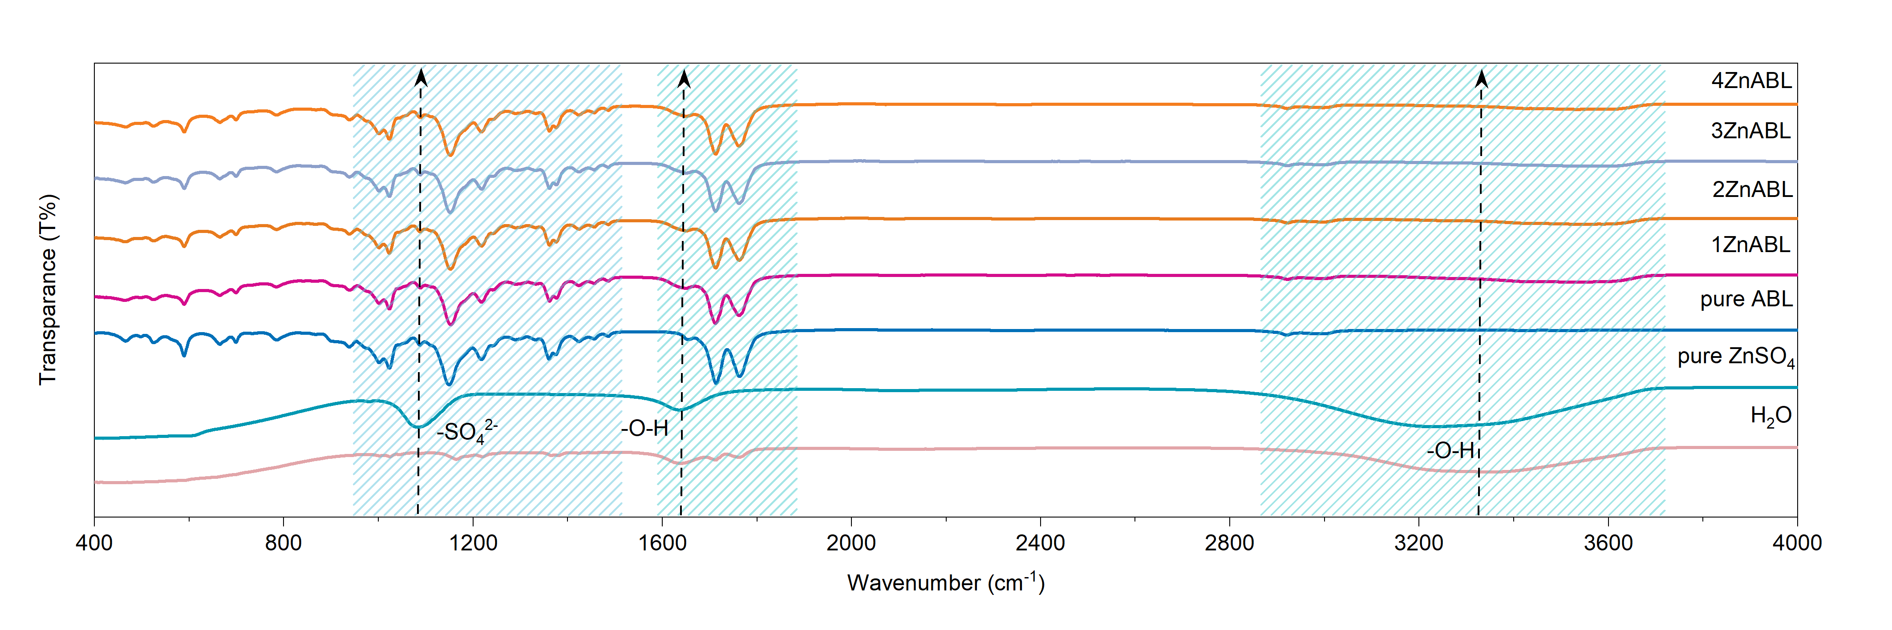
Supplementary Fig. 4. FTIR spectra of H₂O, pure ZnSO₄, pure ABL and ZnABL (xZnABL(x=1,2,3,4) means the ZnABL obtained by x mol L⁻¹ ZnSO₄ solution mixed with ABL in 50%-50% volume ratio).
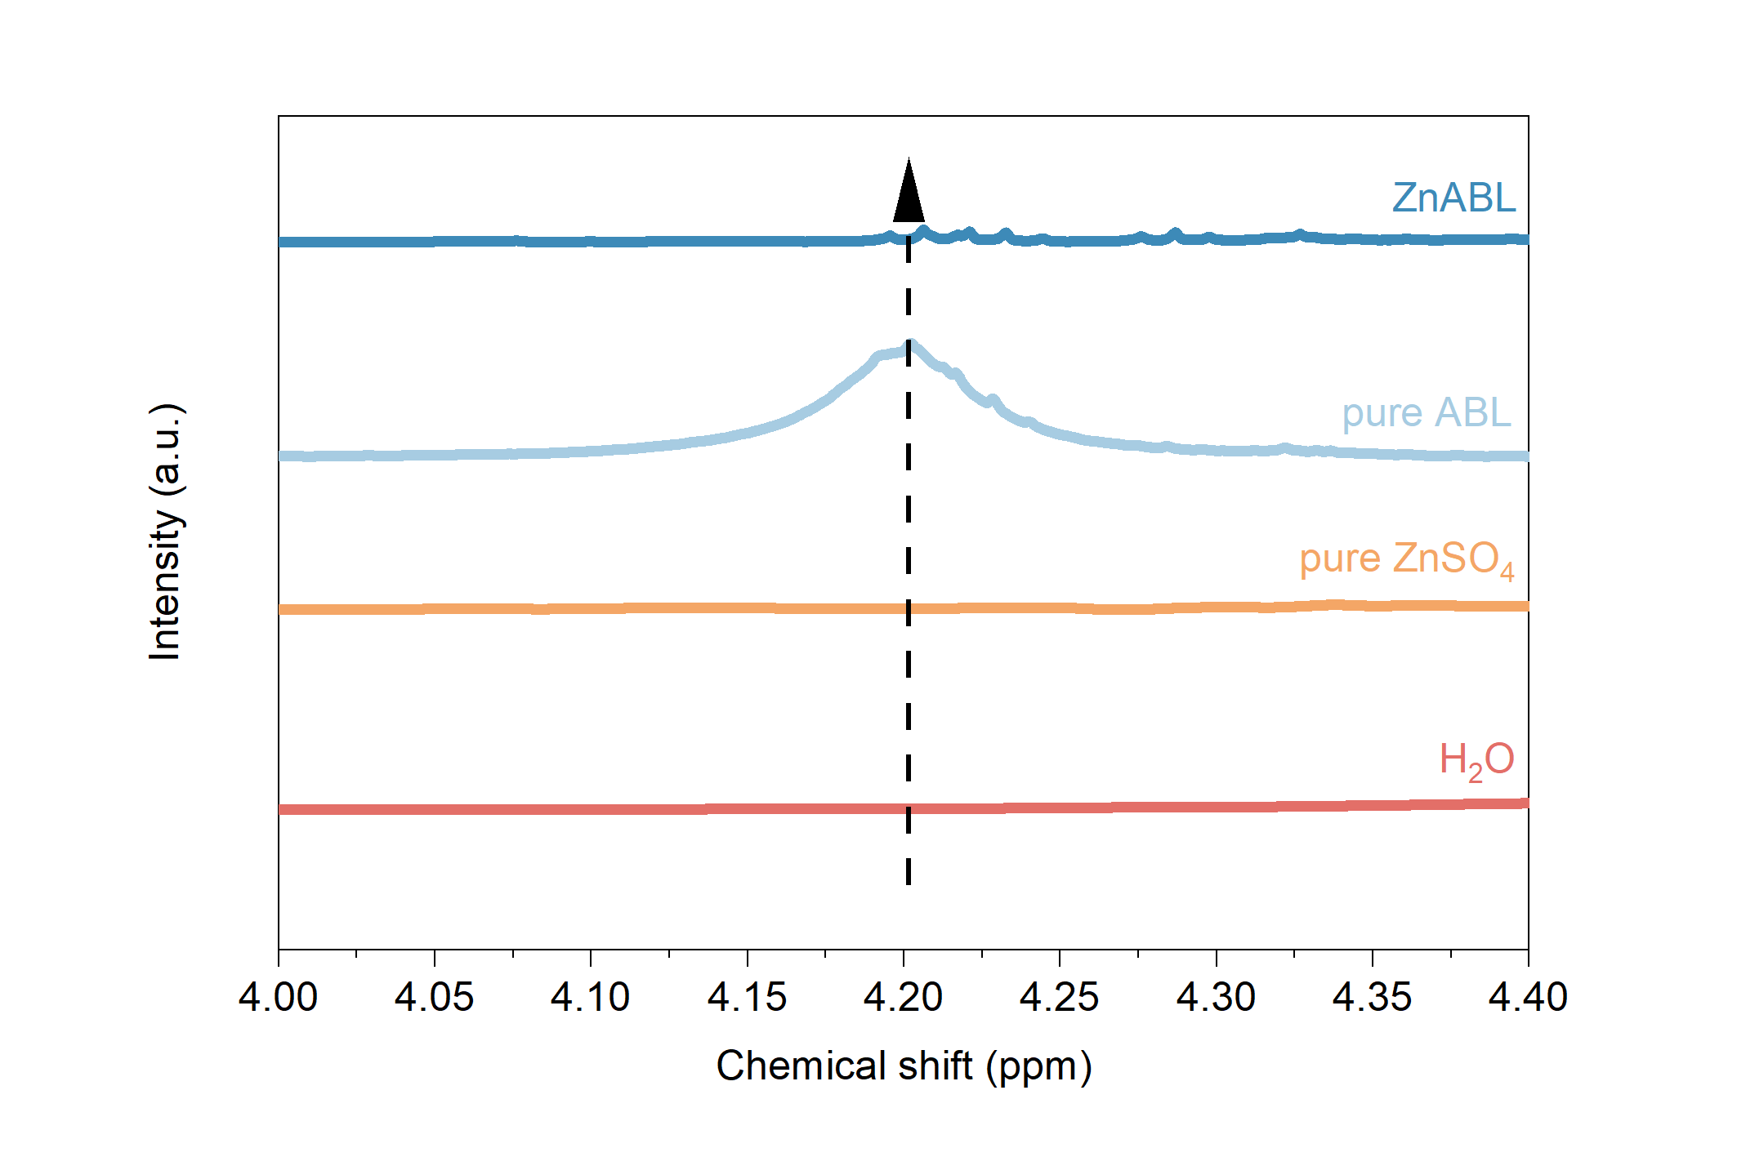
Supplementary Fig. 5. NMR spectra of H₂O, pure ZnSO₄, pure ABL and ZnABL.

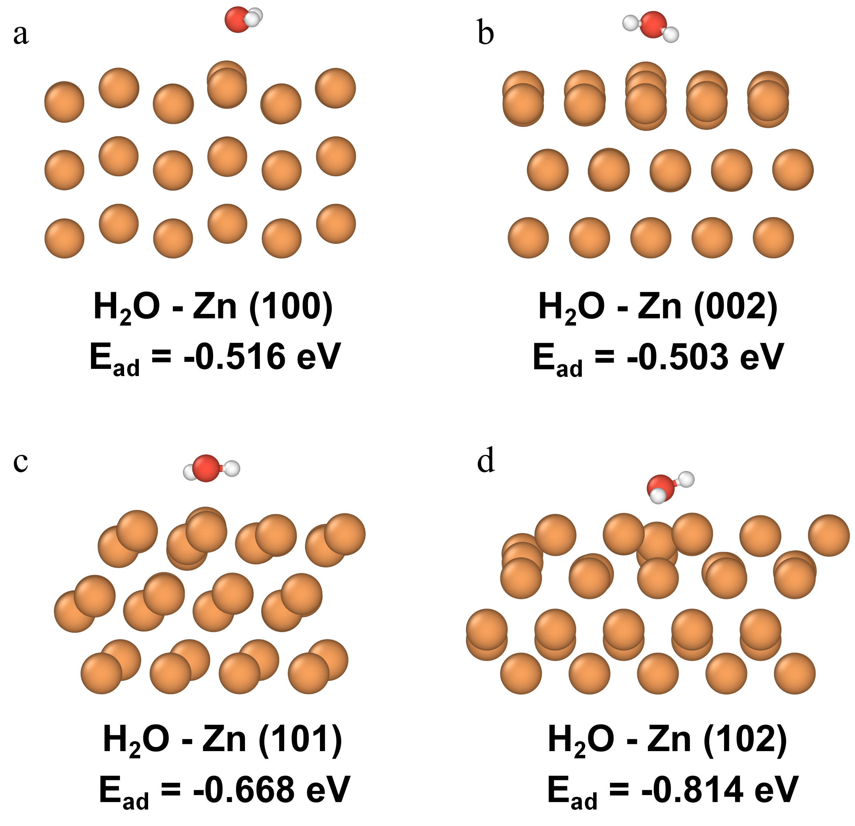

Supplementary Fig. 6. H₂O adsorption on (a) 100-oriented, (b) 002-oriented, (c) 101-oriented, (d) 102-oriented surface of Zn anode (upper is the H₂O molecule, and the bottom orange atoms represents the different cystal planes of Zn anode).
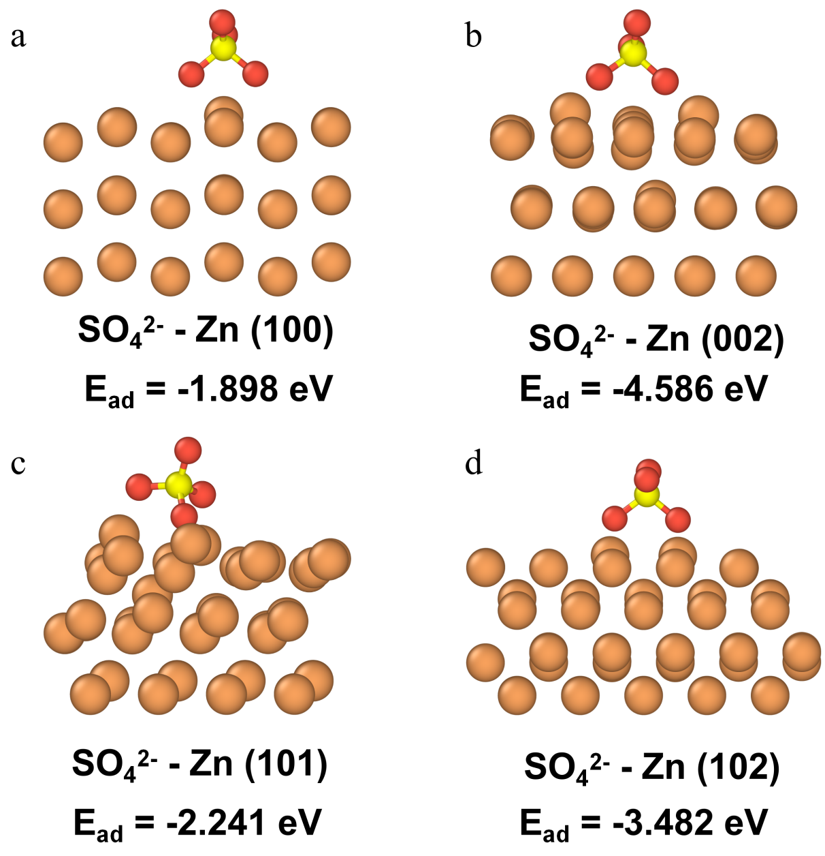
Supplementary Fig. 7. SO₄²⁻ adsorption on (a) 100-oriented, (b) 002-oriented, (c) 101-oriented, (d) 102-oriented surface of Zn anode (upper is the SO₄²⁻, and the bottom orange atoms represents the different cystal planes of Zn anode).
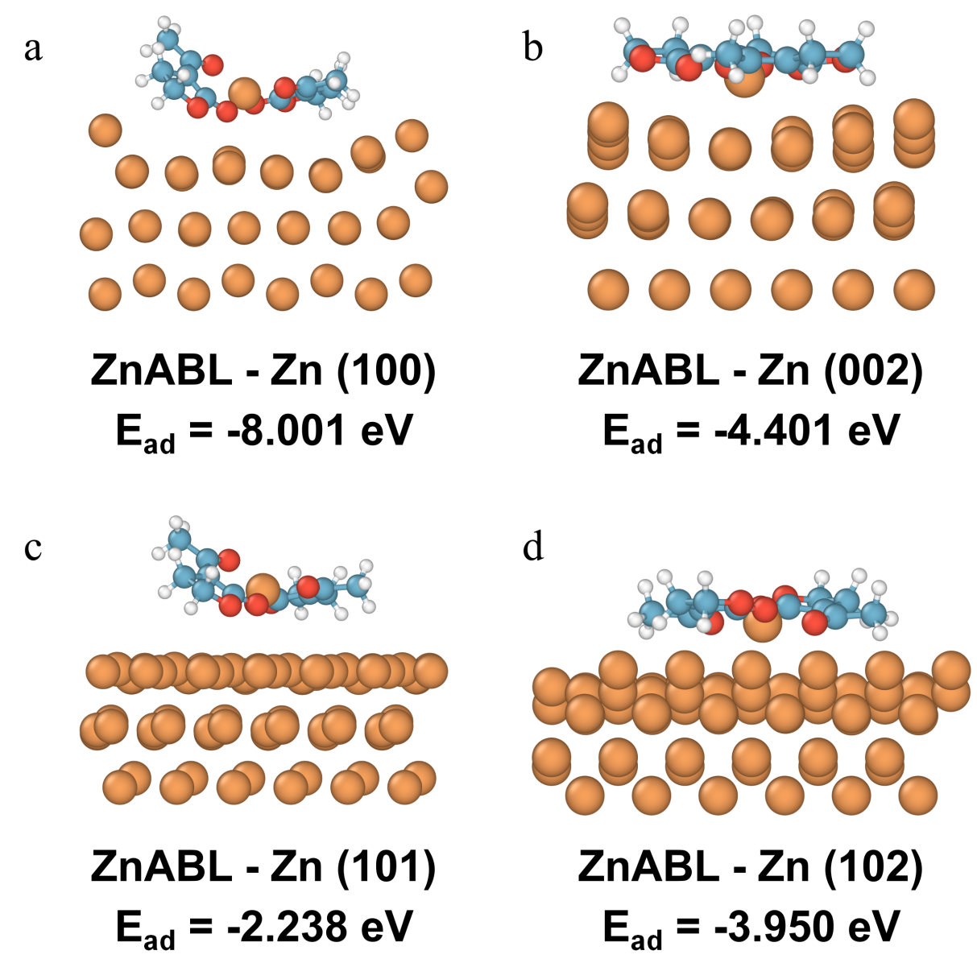
Supplementary Fig. 8. ZnABL adsorption on (a) 100-oriented, (b) 002-oriented, (c) 101-oriented, (d) 102-oriented surface of Zn anode (upper is the ZnABL molecule, and the bottom orange atoms represents the different cystal planes of Zn anode).
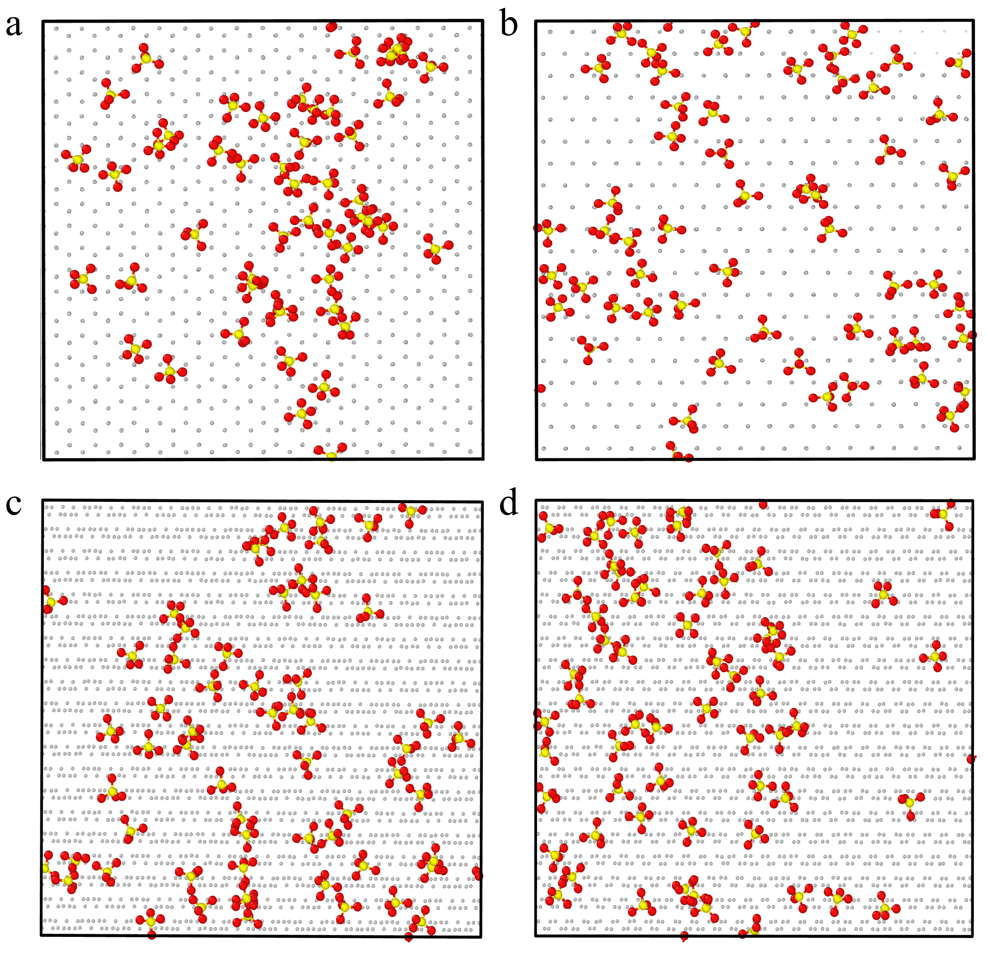
Supplementary Fig. 9. MD snapshot of the different planes of zinc, (a) 100-oriented, (b) 002-oriented, (c) 101-oriented, (d) 102-oriented Zn anode surface in baseline electrolyte (the background represents the different cystal planes of Zn anode).
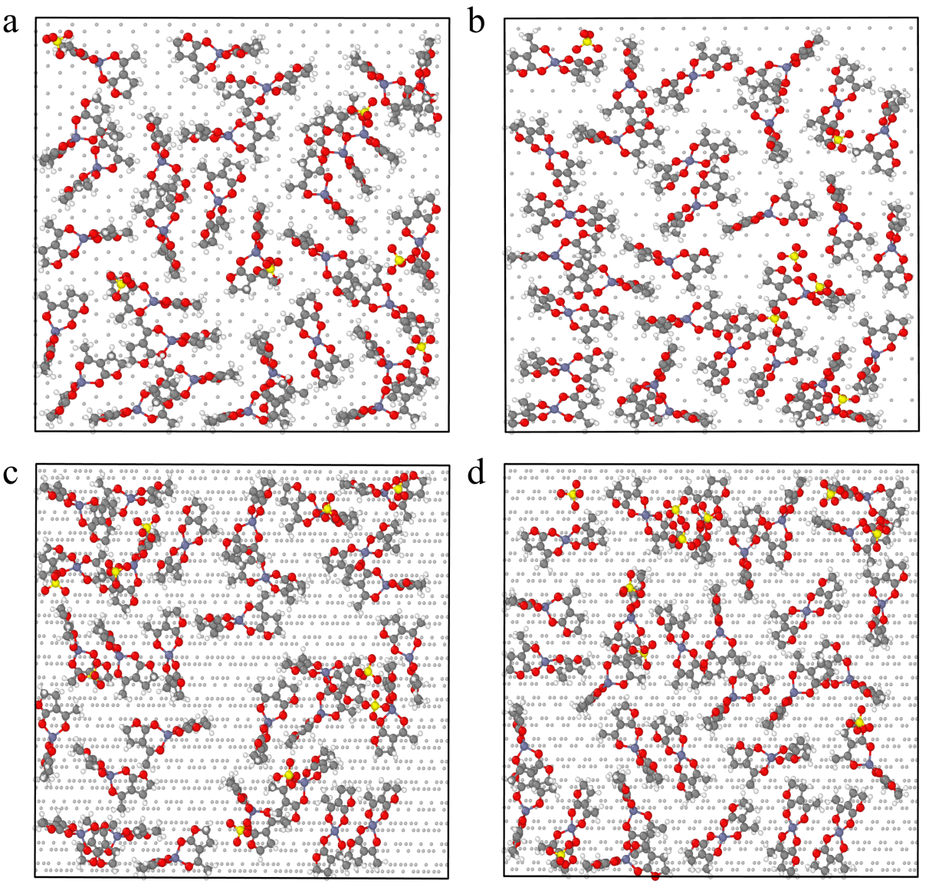
Supplementary Fig. 10. MD snapshot of the different planes of zinc, (a) 100-oriented, (b) 002-oriented, (c) 101-oriented, (d) 102-oriented Zn anode surface in 1% ZnABL electrolyte (the background represents the different cystal planes of Zn anode).
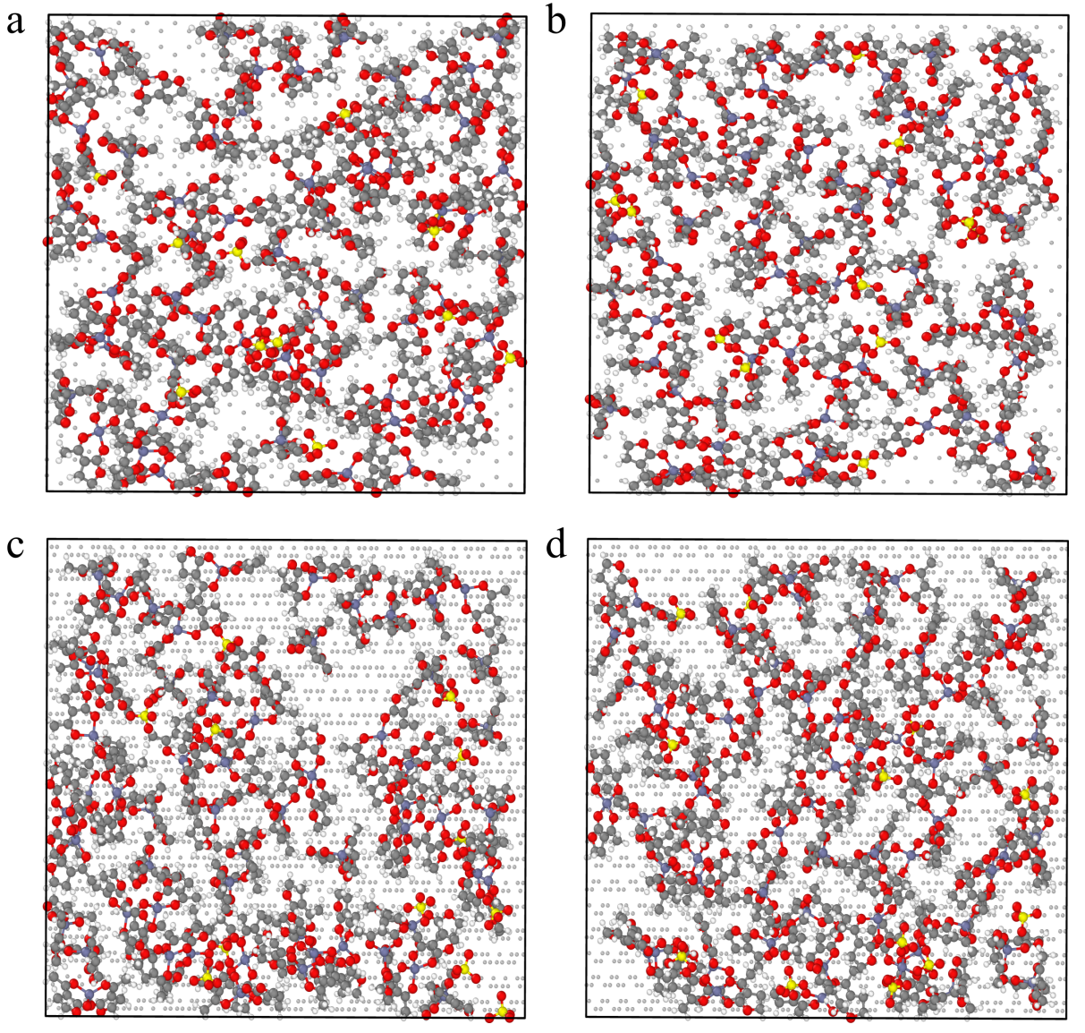
Supplementary Fig. 11. MD snapshot of the different planes of zinc, (a) 100-oriented, (b) 002-oriented, (c) 101-oriented, (d) 102-oriented Zn anode surface in 2% ZnABL electrolyte (the background represents the different cystal planes of Zn anode).
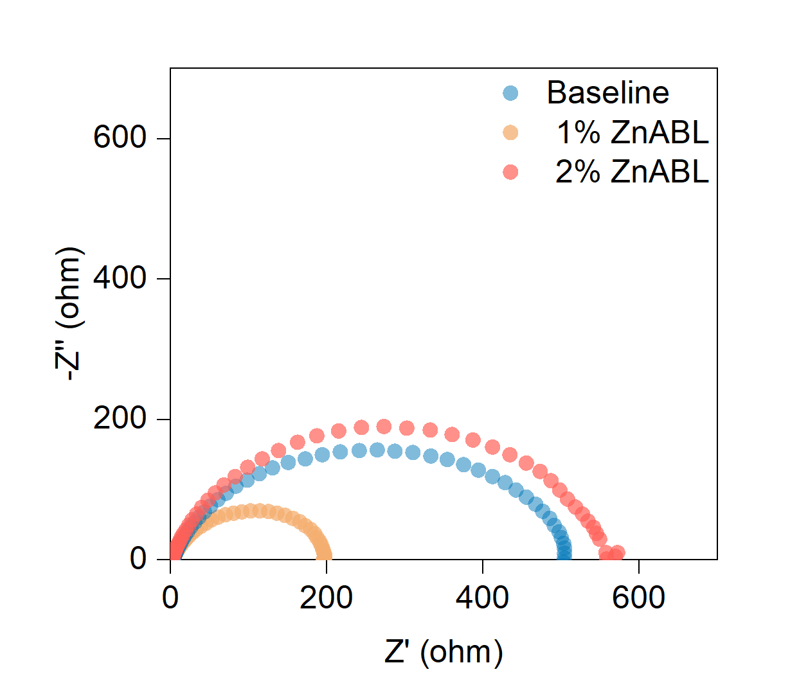
Supplementary Fig. 12. EIS results of Zn||Zn symmetric cells with different electrolytes.

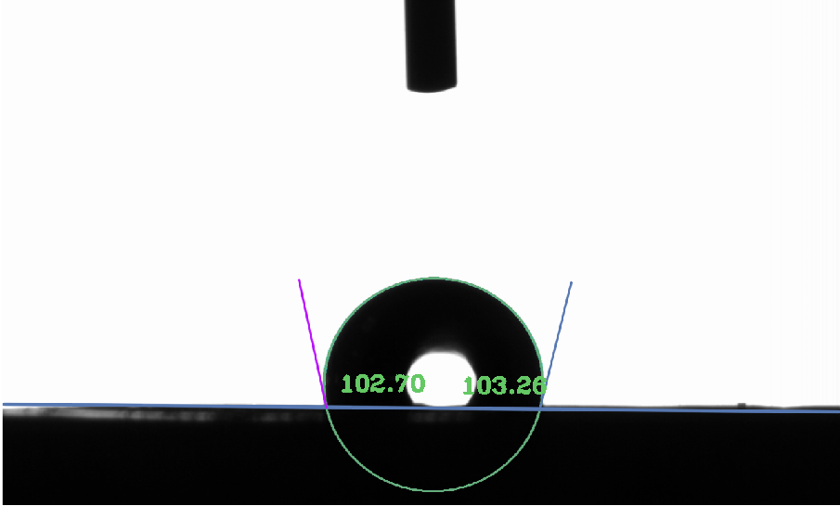
Supplementary Fig. 13. Contact angle of baseline electrolyte on the Zn anode.
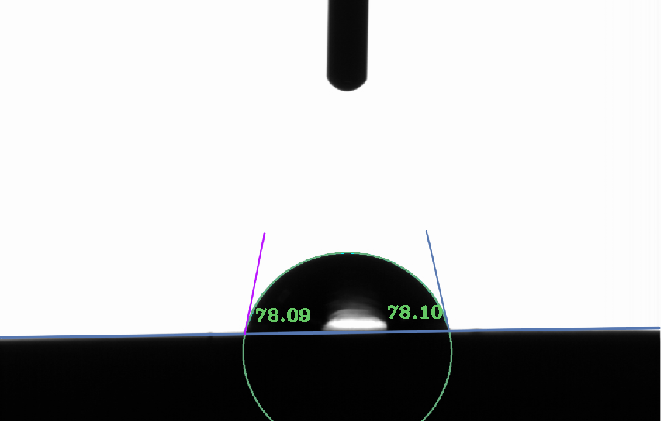
Supplementary Fig. 14. Contact angle of 1% ZnABL on the Zn anode.

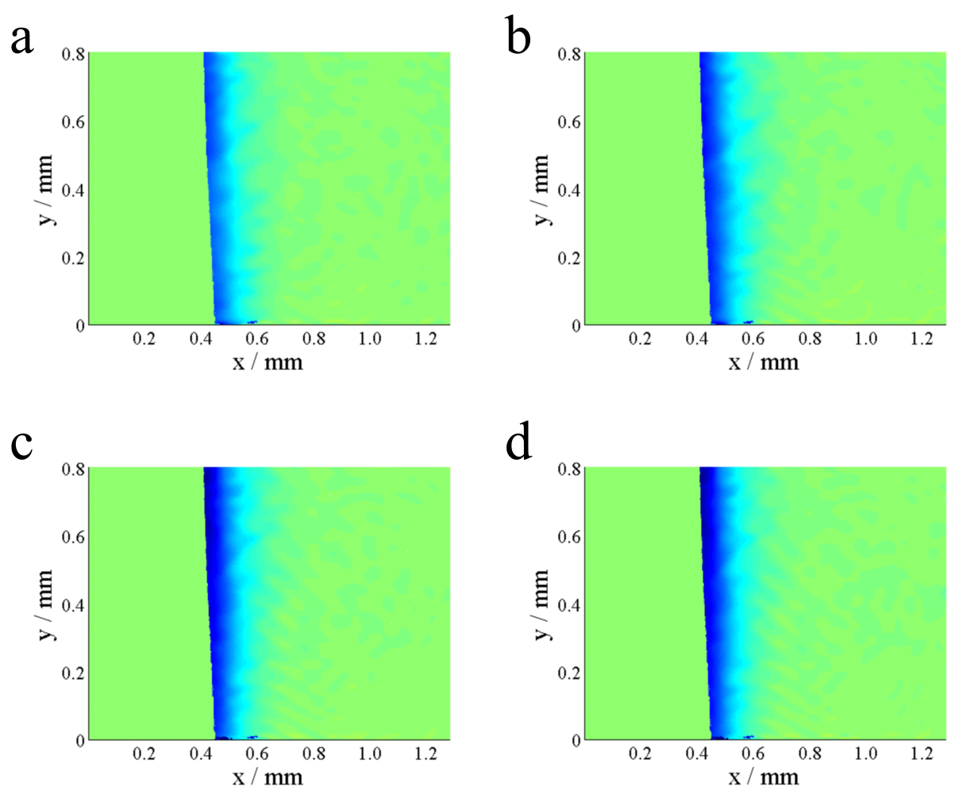
Supplementary Fig. 15. Holographic projection results of Zn||Zn symmetric cell in baseline electrolyte. (a-d) 30 s, 40 s, 60 s, 90 s.
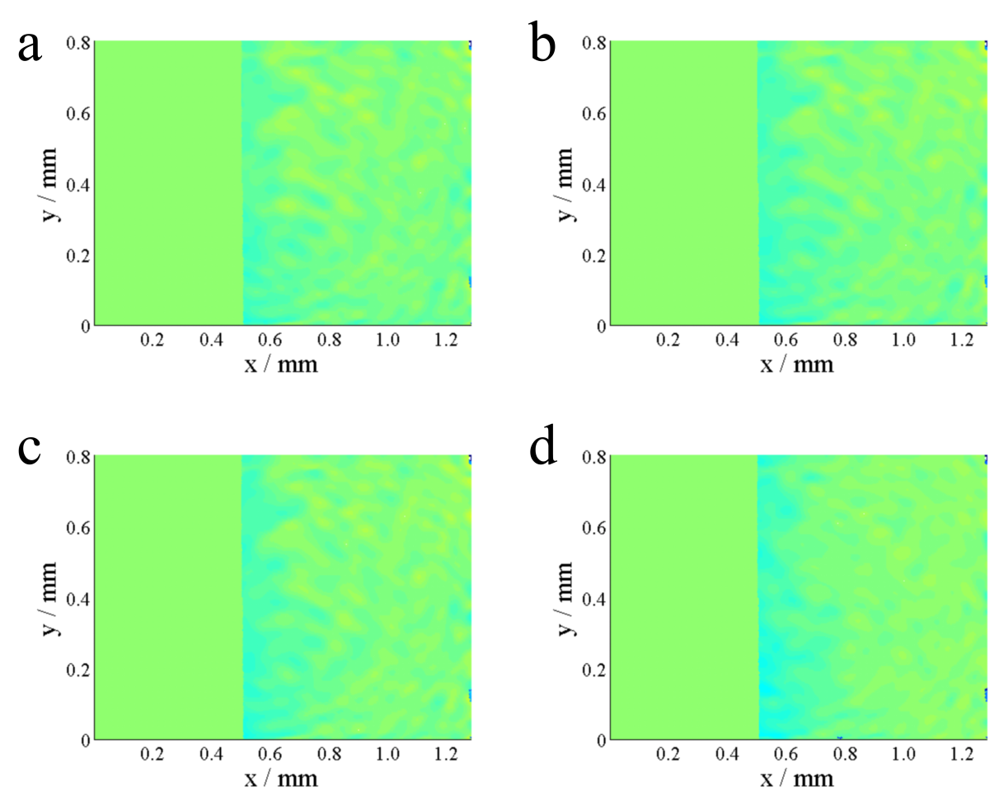
Supplementary Fig. 16. Holographic projection results of Zn||Zn symmetric cell in 1% ZnABL electrolyte. (a-d) 30 s, 40 s, 60 s, 90 s.
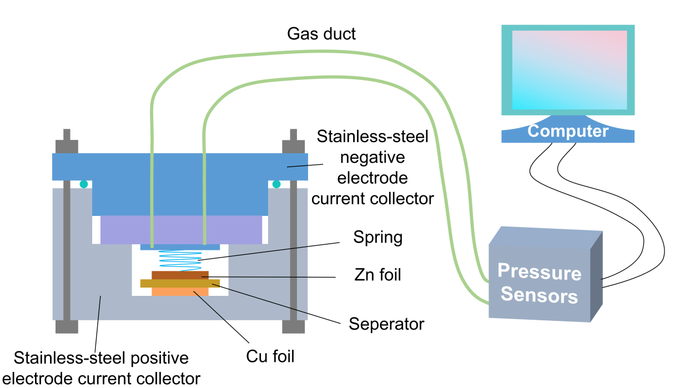
Supplementary Fig. 17. Scheme of gas production test device. The cell is placed in a closed space, and the pressure sensor is connected through a gas duct to monitor the gas pressure increase after gas production and obtain real-time gas evolution data.
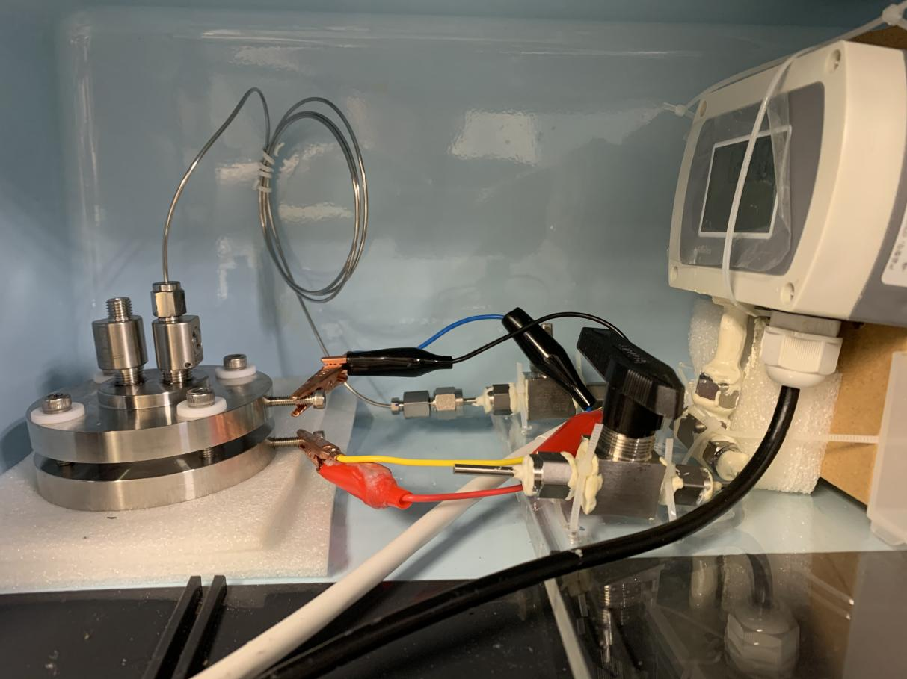
Supplementary Fig. 18. Image of gas production test device.

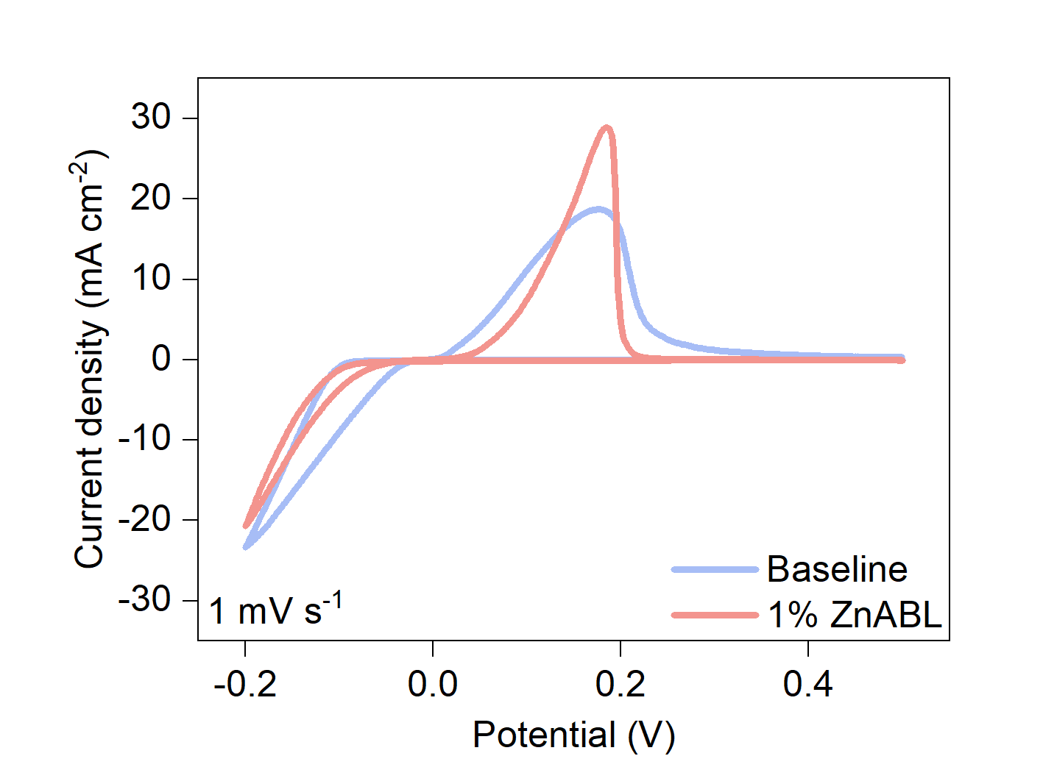
Supplementary Fig. 19. CV curves of Zn||Cu asymmetric batteries with pure ZnSO₄ and 1% ZnABL, respectively.

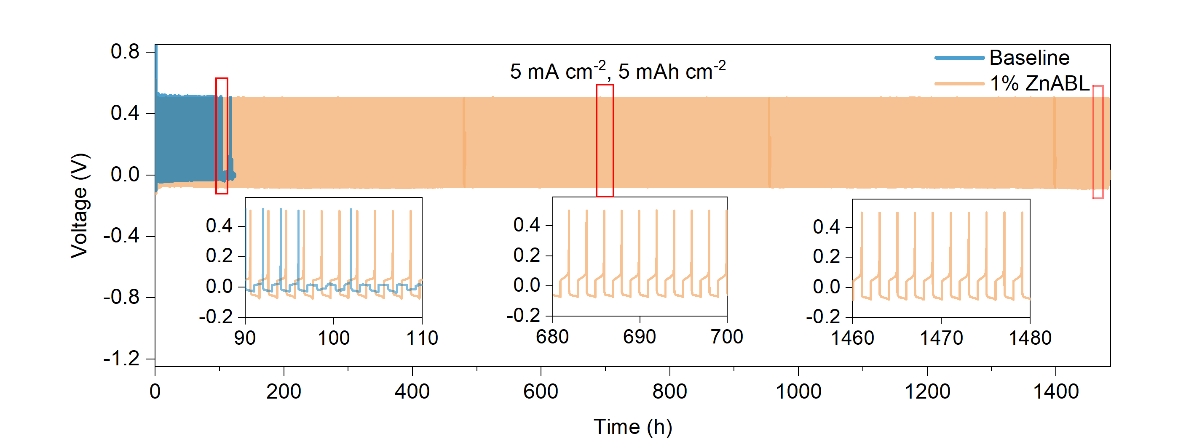
Supplementary Fig. 20. Time-voltage curves of Zn||Cu asymmetric batteries with baseline and 1% ZnABL electrolyte. (Insets are the partial enlargement of the curve at different time).
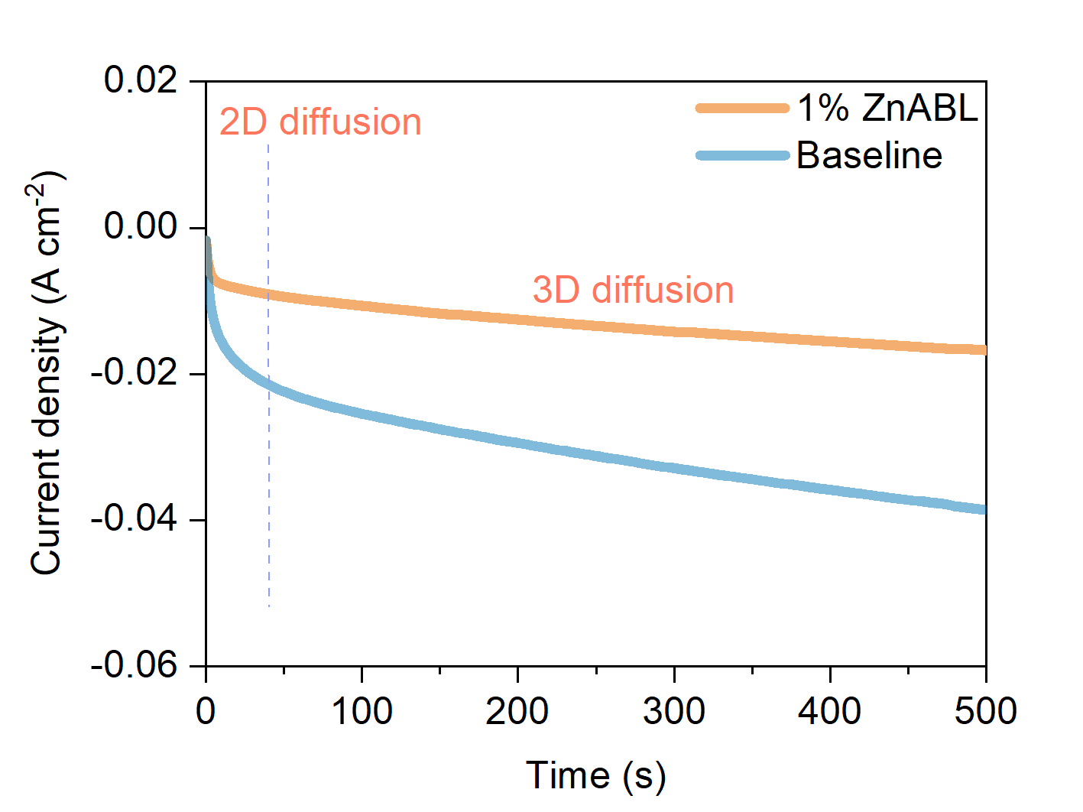
Supplementary Fig. 21. Chronoamperometry testing of Zn||Zn symmetric batteries with pure ZnSO₄ and 1% ZnABL.
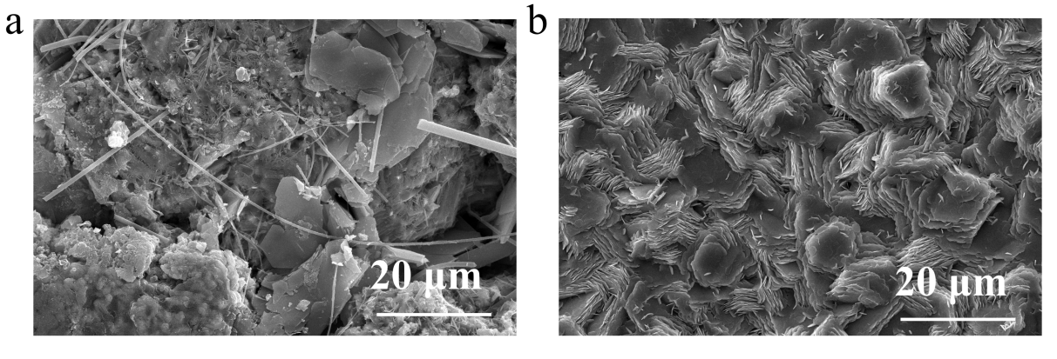
Supplementary Fig. 22. SEM images of zinc plating Cu substrate after cycles (a) baseline, (b) 1% ZnABL electrolyte.
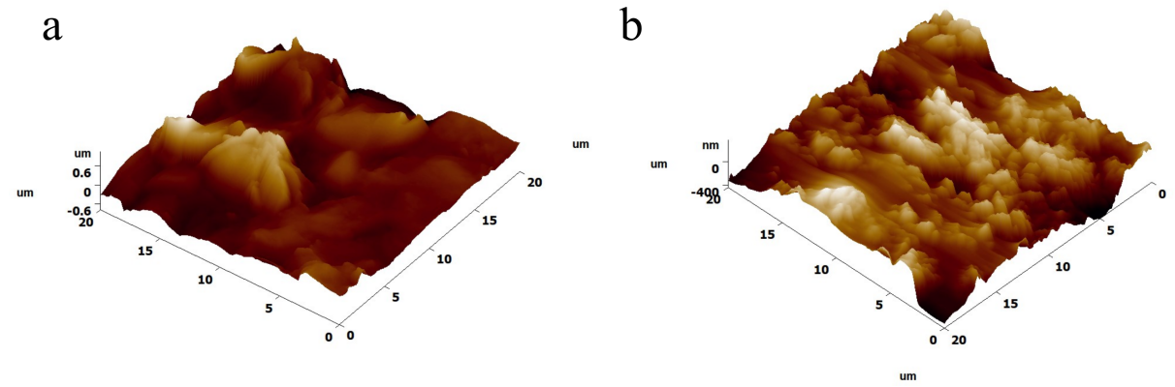
Supplementary Fig. 23. AFM results of Zn anode after cycle (a) baseline, (b) 1% ZnABL electrolyte.

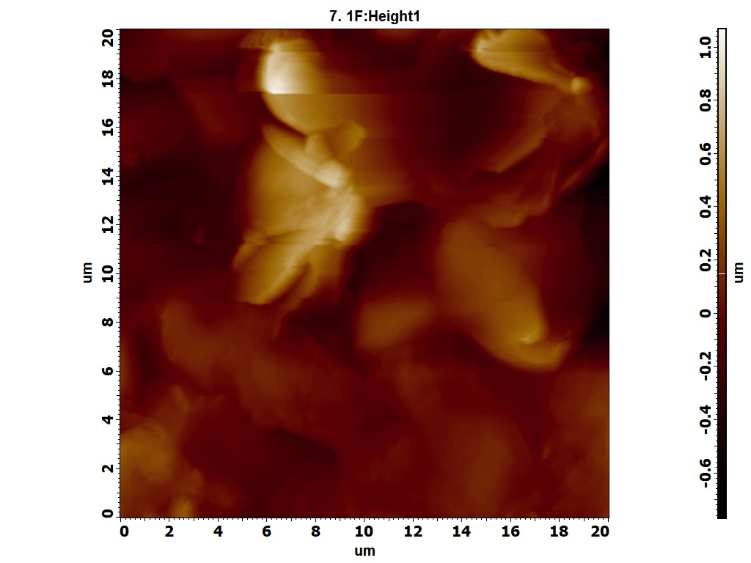
Supplementary Fig. 24. 2D AFM contour image of Zn anode surface after cycled in baseline electrolyte.

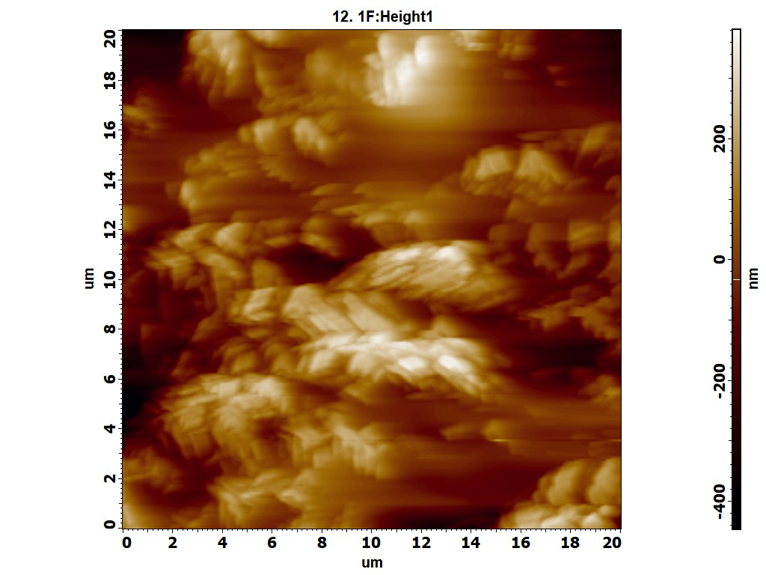
Supplementary Fig. 25. 2D AFM contour image of Zn anode surface after cycled in 1% ZnABL electrolyte.

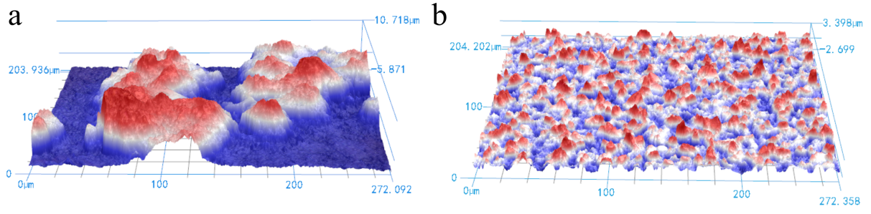
Supplementary Fig. 26. CLSM result of the Zn anode, (a) after cycle in baseline electrolyte, (b)after cycle in 1% ZnABL electrolyte.

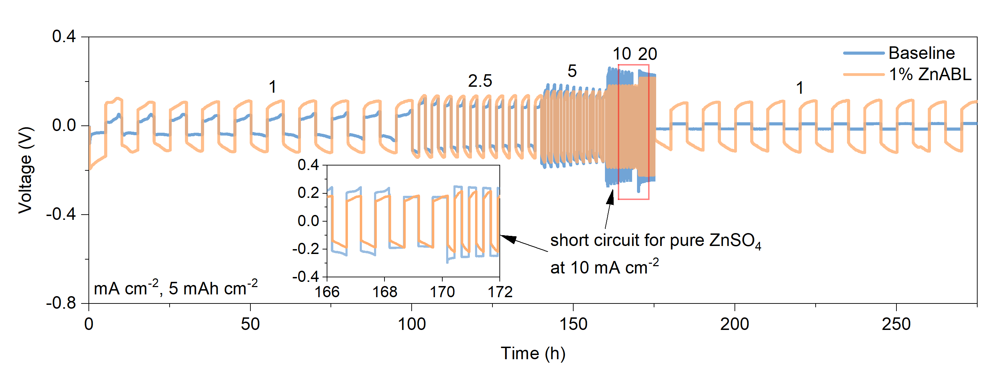
Supplementary Fig. 27. Rate performance of Zn||Zn symmetric cells at 5 mAh cm⁻², different current density.

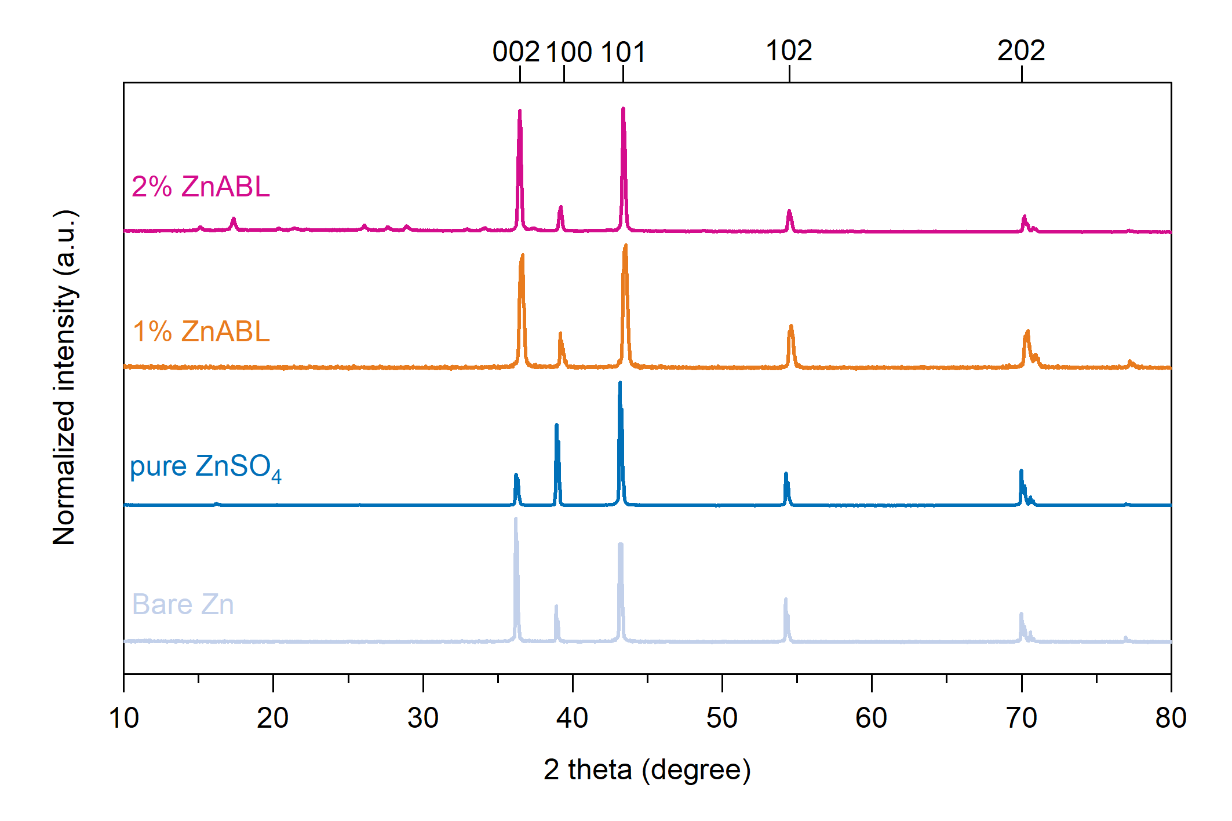
Supplementary Fig. 28. XRD results of the Zn anode after 50 cycles.

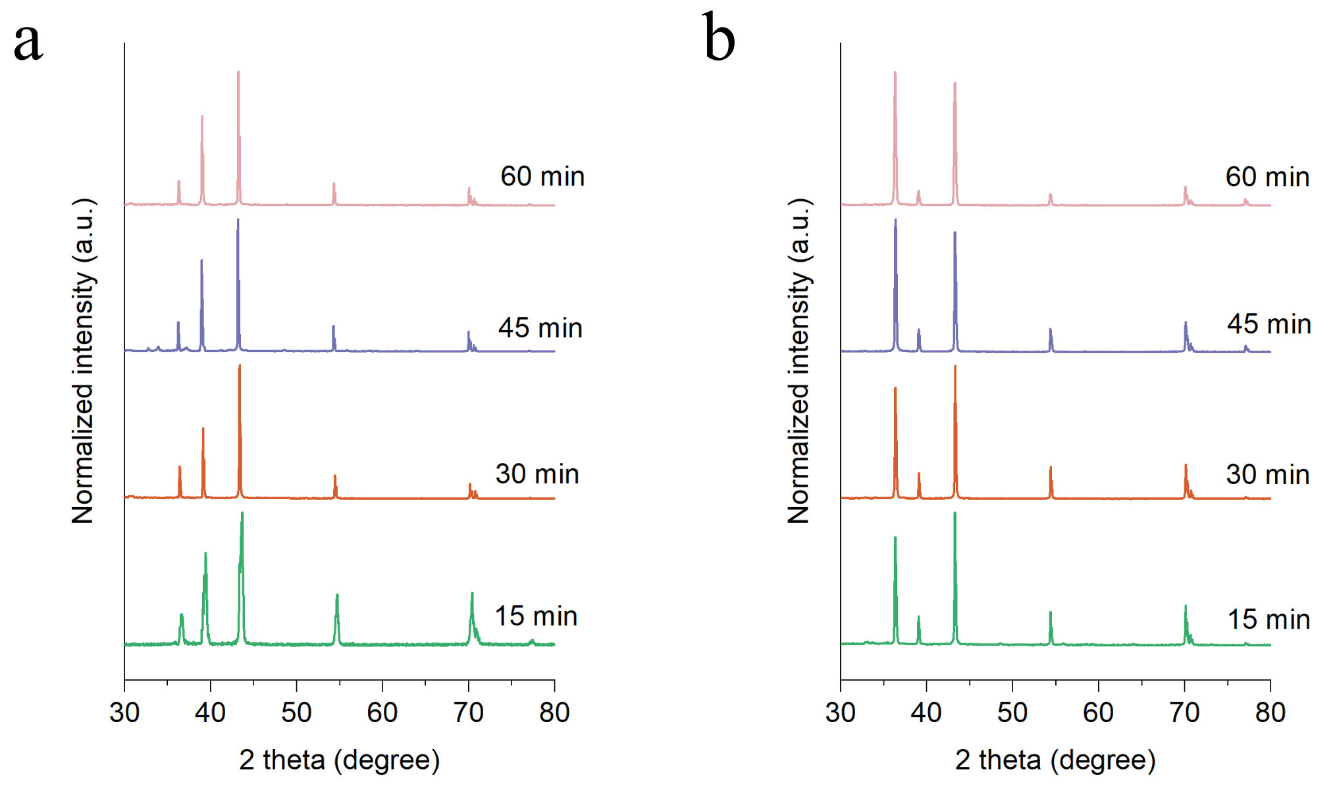
Supplementary Fig. 29. XRD result of the Zn anode after discharged for different time, at a constant current density of xxx in different electrolytes:, (a) baseline electrolyte, (b) 1% ZnABL electrolyte.
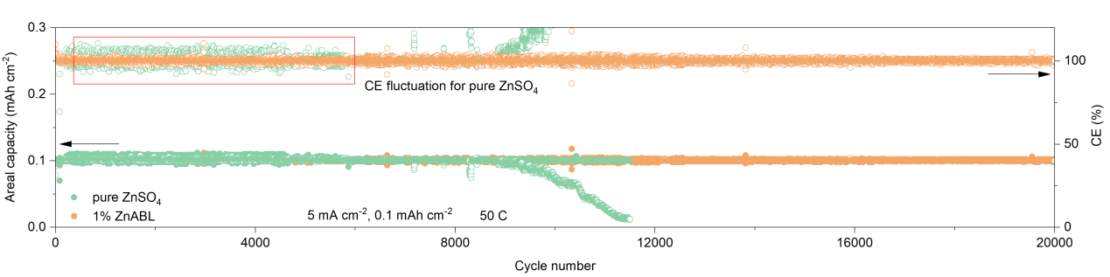
Supplementary Fig. 30. Zn||AC capacitors cycled at 5 mA cm⁻², 0.1 mAh cm⁻² (50 C) with baseline and 1% ZnABL (20000 cycles).

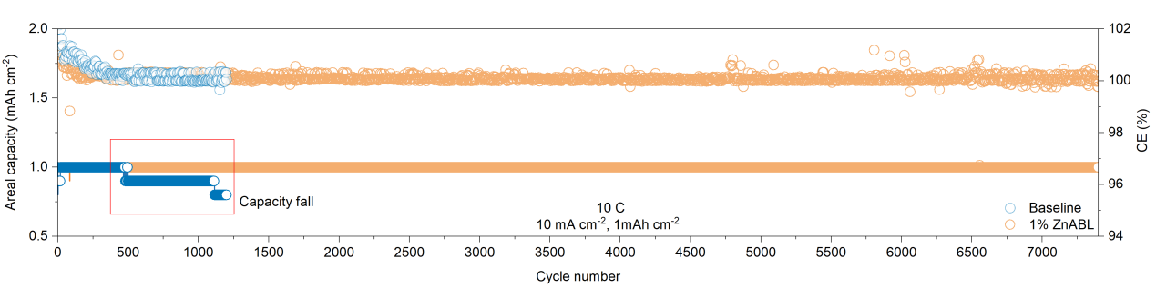
Supplementary Fig. 31. Zn||AC capacitors cycled at 10 mA cm⁻², 1 mAh cm⁻² (10 C) with baseline and 1% ZnABL (7600 cycles).

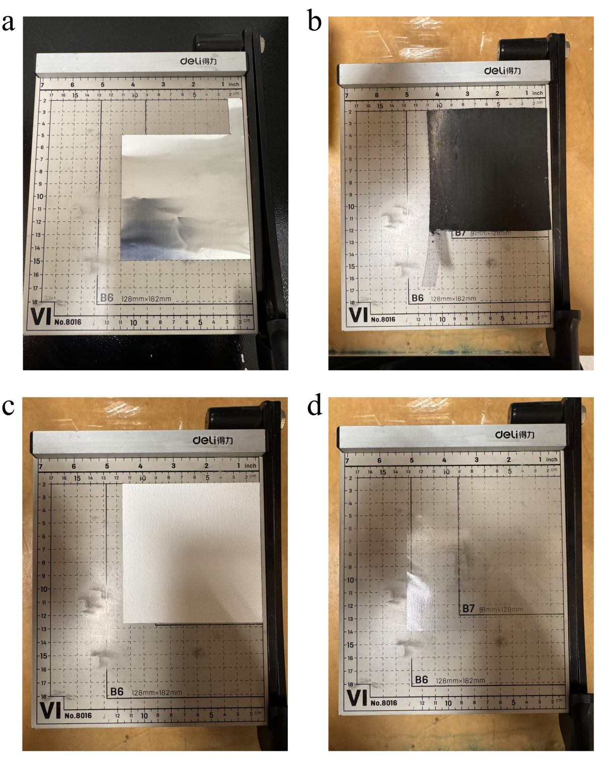
Supplementary Fig. 32. Length and width of each component of the pouch cell. (a) Zn anode, (b) cathode, (c) separator, (d) packaging thermoplastic film.
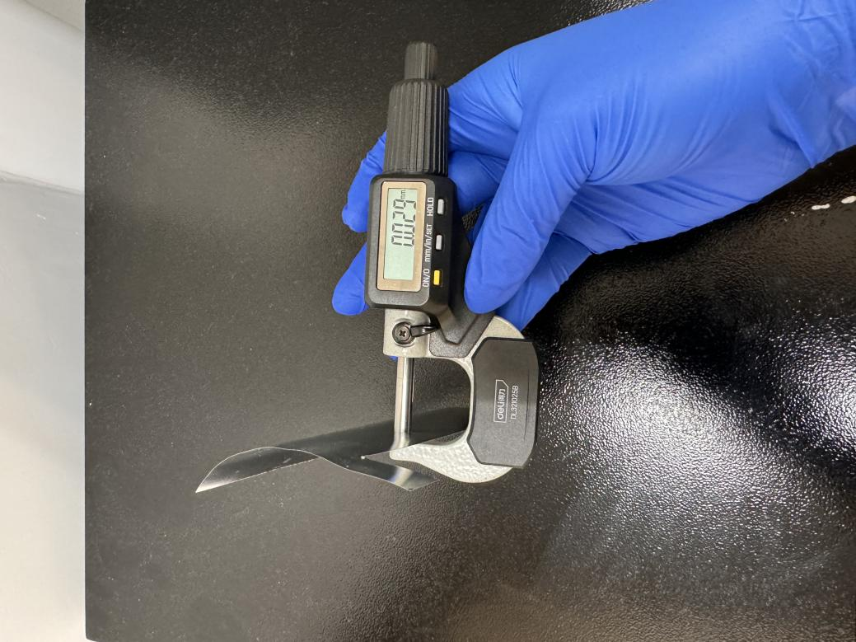
Supplementary Fig. 33. Thickness of the Zn anode (30 μm).

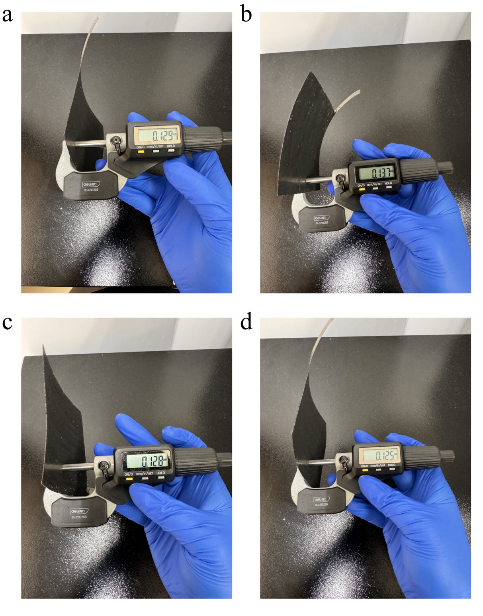
Supplementary Fig. 34. Thickness of the cathode (selected 4 different areas to measure).
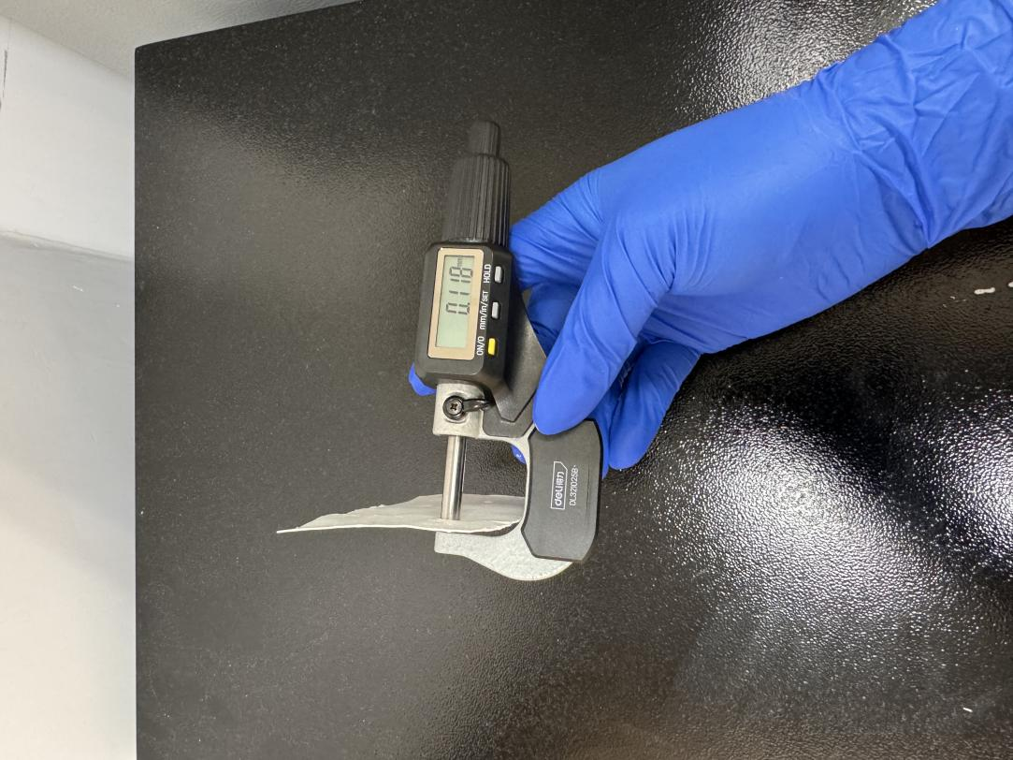
Supplementary Fig. 35. Thickness of the separator (after pressurization).

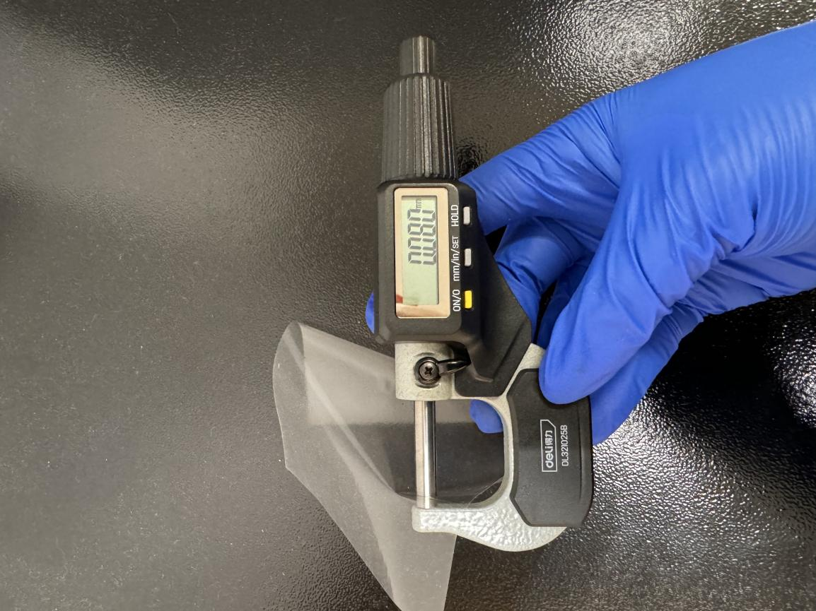
Supplementary Fig. 36. Thickness of the packaging thermoplastic film.
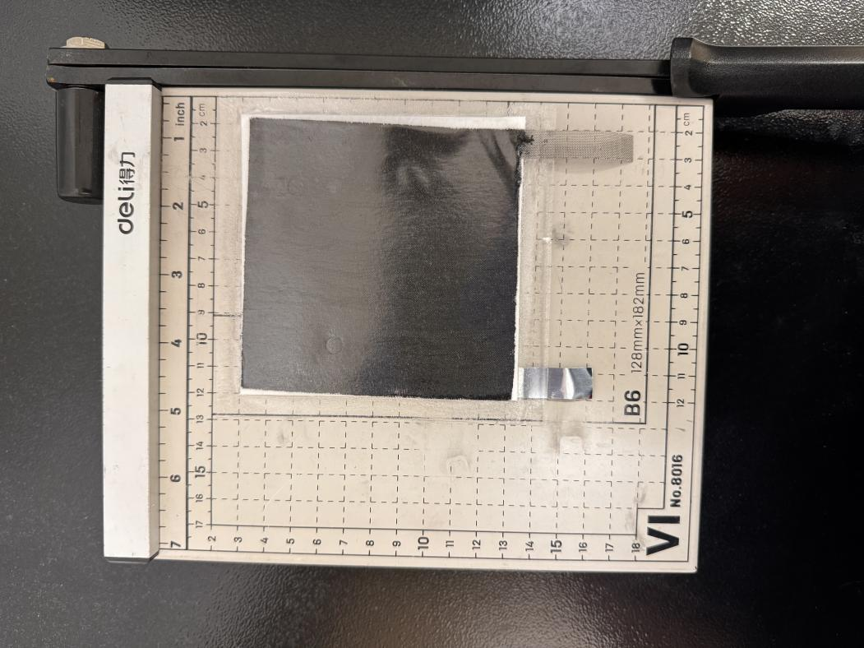
Supplementary Fig. 37. Length and width of the total pouch cell.

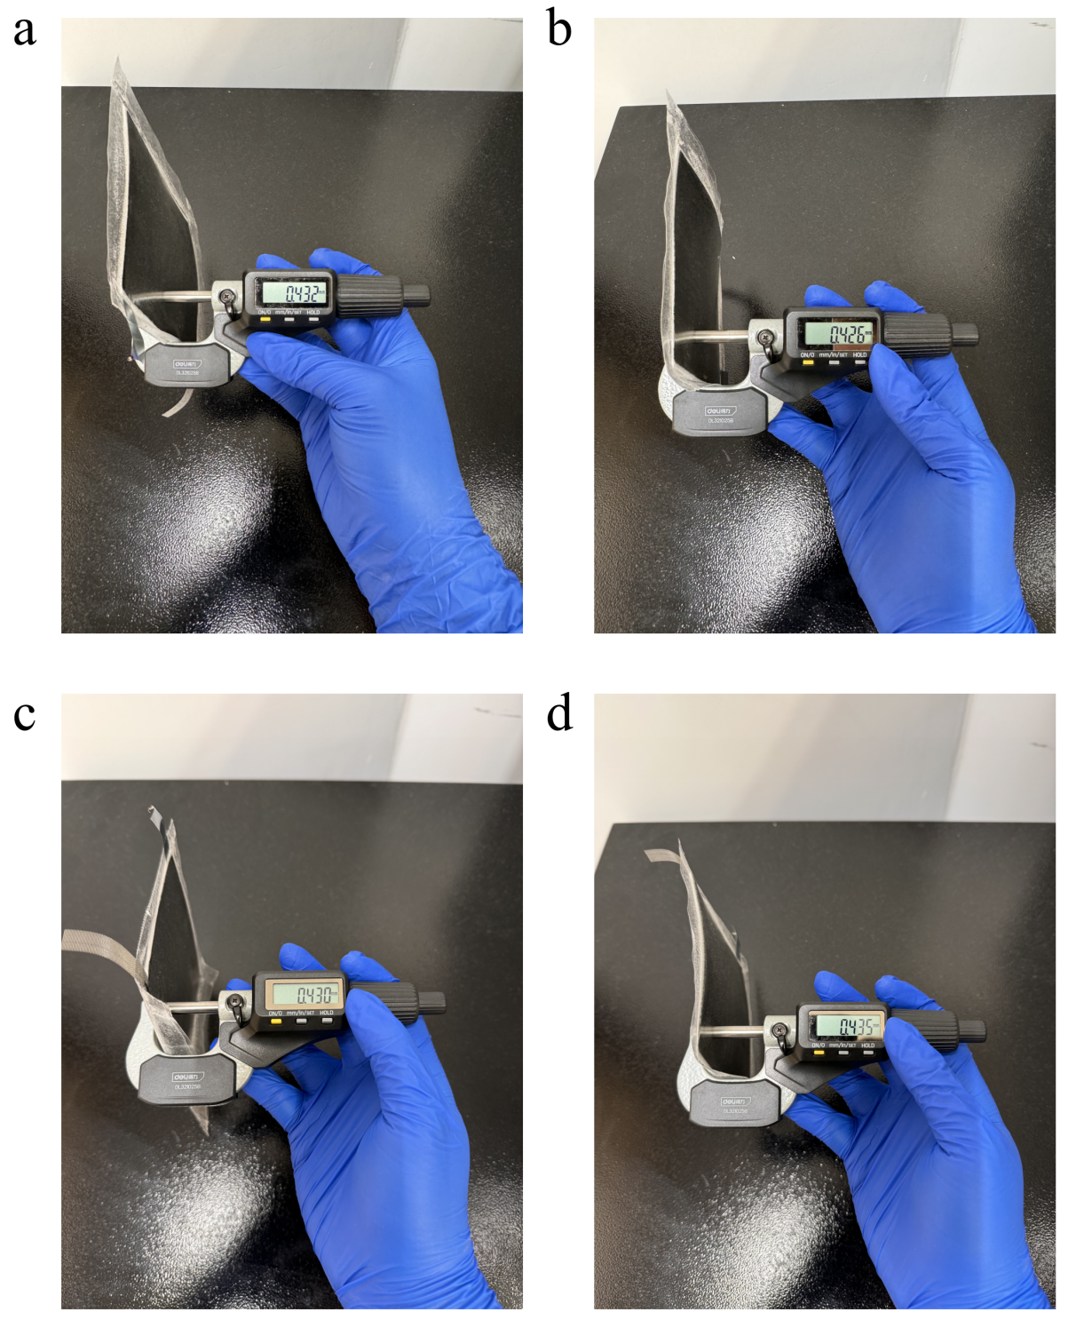
Supplementary Fig. 38. Thickness of the total pouch cell (selected 4 different point to measure).
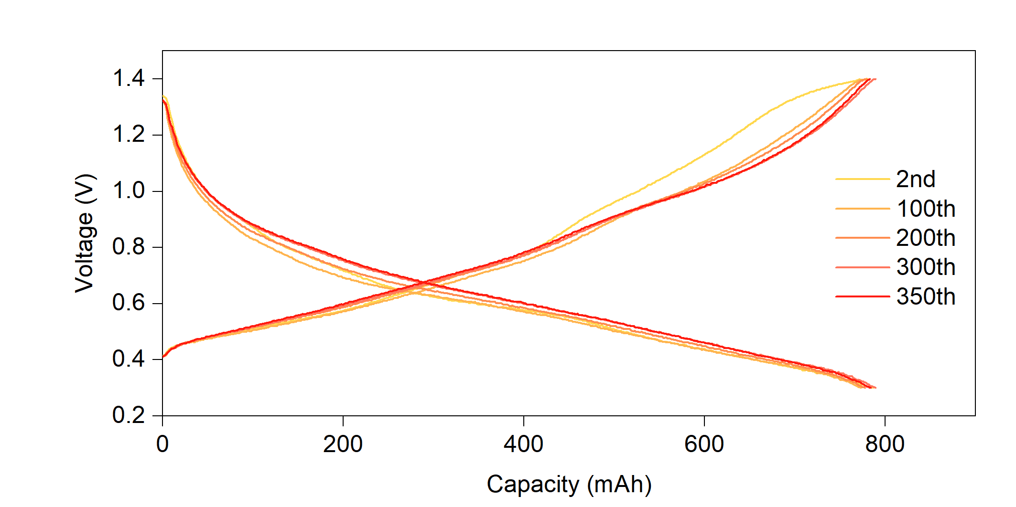
Supplementary Fig. 39. Voltage profiles of the pouch cell at different cycle.

 |  | 1 nm |  | 1.2 nm |  | 1.4 nm |  | 1.6 nm |  | 1.8 nm |  | 2.0 nm
 |  | SO₄²⁻ | ZnABL | SO₄²⁻ | ZnABL | SO₄²⁻ | ZnABL | SO₄²⁻ | ZnABL | SO₄²⁻ | ZnABL | SO₄²⁻ | ZnABL
Group 1 | Baseline | 0.319 | 0.000 | 1.009 | 0.000 | 1.979 | 0.000 | 3.409 | 0.000 | 6.183 | 0.000 | 13.219 | 0.000
Group 1 | 1% ZnABL | 0.008 | 6.000 | 0.026 | 6.000 | 0.055 | 6.000 | 0.099 | 6.000 | 0.652 | 6.000 | 4.295 | 6.000
Group 1 | 2% ZnABL | 0.678 | 13.880 | 1.937 | 13.964 | 4.299 | 13.999 | 6.990 | 14.000 | 10.826 | 14.000 | 15.998 | 14.000
Group 2 | Baseline | 0.107 | 0.000 | 0.395 | 0.000 | 1.310 | 0.000 | 3.030 | 0.000 | 6.695 | 0.000 | 18.058 | 0.000
Group 2 | 1% ZnABL | 0.443 | 6.000 | 0.547 | 6.000 | 0.654 | 6.000 | 0.794 | 6.000 | 1.006 | 6.000 | 1.331 | 6.000
Group 2 | 2% ZnABL | 0.535 | 14.000 | 1.290 | 14.000 | 2.300 | 14.000 | 3.928 | 14.000 | 7.199 | 14.000 | 9.782 | 14.000
Group 3 | Baseline | 0.190 | 0.000 | 0.586 | 0.000 | 1.592 | 0.000 | 3.263 | 0.000 | 8.255 | 0.000 | 17.642 | 0.000
Group 3 | 1% ZnABL | 0.010 | 6.000 | 0.052 | 6.000 | 0.134 | 6.000 | 0.422 | 6.000 | 1.690 | 6.000 | 3.554 | 6.000
Group 3 | 2% ZnABL | 0.983 | 13.944 | 1.608 | 13.999 | 2.578 | 14.000 | 3.759 | 14.000 | 8.046 | 14.000 | 14.597 | 14.000
Average | Baseline | 0.205 | 0.000 | 0.663 | 0.000 | 1.627 | 0.000 | 3.234 | 0.000 | 7.044 | 0.000 | 16.306 | 0.000
Average | 1% ZnABL | 0.154 | 6.000 | 0.208 | 6.000 | 0.281 | 6.000 | 0.438 | 6.000 | 1.116 | 6.000 | 3.060 | 6.000
Average | 2% ZnABL | 0.732 | 13.941 | 1.612 | 13.988 | 3.059 | 14.000 | 4.892 | 14.000 | 8.690 | 14.000 | 13.459 | 14.000
Supplementary Table 1. Number of absorbed SO₄²⁻ and ZnABL on Zn-(100) crystal plane.

 |  | 1 nm |  | 1.2 nm |  | 1.4 nm |  | 1.6 nm |  | 1.8 nm |  | 2.0 nm
 |  | SO₄²⁻ | ZnABL | SO₄²⁻ | ZnABL | SO₄²⁻ | ZnABL | SO₄²⁻ | ZnABL | SO₄²⁻ | ZnABL | SO₄²⁻ | ZnABL
0 | Baseline | 0.000 | 0.000 | 0.000 | 0.000 | 0.000 | 0.000 | 0.099 | 0.000 | 1.195 | 0.000 | 4.985 | 0.000
0 | 1% ZnABL | 0.028 | 5.997 | 0.062 | 6.000 | 0.091 | 6.000 | 0.115 | 6.000 | 0.692 | 6.000 | 2.353 | 6.000
0 | 2% ZnABL | 0.000 | 13.993 | 0.000 | 13.999 | 0.003 | 14.000 | 0.792 | 14.000 | 5.431 | 14.000 | 14.620 | 14.000
1 | Baseline | 0.000 | 0.000 | 0.021 | 0.000 | 0.051 | 0.000 | 1.067 | 0.000 | 1.330 | 0.000 | 9.677 | 0.000
1 | 1% ZnABL | 0.000 | 5.914 | 0.000 | 5.956 | 0.002 | 5.973 | 0.056 | 5.994 | 1.488 | 6.000 | 3.046 | 6.000
1 | 2% ZnABL | 0.479 | 13.984 | 0.590 | 14.000 | 0.839 | 14.000 | 1.275 | 14.000 | 2.935 | 14.000 | 6.399 | 14.000
2 | Baseline | 0.000 | 0.000 | 0.005 | 0.000 | 0.082 | 0.000 | 0.510 | 0.000 | 1.941 | 0.000 | 3.656 | 0.000
2 | 1% ZnABL | 0.003 | 5.603 | 0.021 | 5.688 | 0.036 | 5.741 | 0.051 | 5.814 | 0.096 | 5.879 | 0.217 | 5.943
2 | 2% ZnABL | 0.021 | 11.505 | 0.115 | 11.589 | 0.591 | 11.659 | 1.561 | 11.713 | 3.460 | 11.735 | 6.942 | 11.750
Average | Baseline | 0.000 | 0.000 | 0.009 | 0.000 | 0.044 | 0.000 | 0.559 | 0.000 | 1.489 | 0.000 | 6.106 | 0.000
Average | 1% ZnABL | 0.010 | 5.838 | 0.028 | 5.881 | 0.043 | 5.905 | 0.074 | 5.936 | 0.759 | 5.960 | 1.872 | 5.981
Average | 2% ZnABL | 0.167 | 13.161 | 0.235 | 13.196 | 0.478 | 13.220 | 1.209 | 13.238 | 3.942 | 13.245 | 9.320 | 13.250
Supplementary Table 2. Number of absorbed SO₄²⁻ and ZnABL on Zn-(002) crystal plane.

 |  | 1 nm |  | 1.2 nm |  | 1.4 nm |  | 1.6 nm |  | 1.8 nm |  | 2.0 nm
 |  | SO₄²⁻ | ZnABL | SO₄²⁻ | ZnABL | SO₄²⁻ | ZnABL | SO₄²⁻ | ZnABL | SO₄²⁻ | ZnABL | SO₄²⁻ | ZnABL
0 | Baseline | 0.161 | 0.000 | 2.314 | 0.000 | 5.920 | 0.000 | 14.415 | 0.000 | 24.258 | 0.000 | 33.331 | 0.000
0 | 1% ZnABL | 1.278 | 6.000 | 2.121 | 6.000 | 3.584 | 6.000 | 4.683 | 6.000 | 6.183 | 6.000 | 8.219 | 6.000
0 | 2% ZnABL | 0.828 | 14.000 | 1.769 | 14.000 | 3.906 | 14.000 | 9.742 | 14.000 | 18.863 | 14.000 | 31.090 | 14.000
1 | Baseline | 0.407 | 0.000 | 1.849 | 0.000 | 4.667 | 0.000 | 10.930 | 0.000 | 19.073 | 0.000 | 28.410 | 0.000
1 | 1% ZnABL | 1.183 | 6.000 | 2.649 | 6.000 | 5.230 | 6.000 | 8.733 | 6.000 | 15.333 | 6.000 | 23.766 | 6.000
1 | 2% ZnABL | 0.504 | 14.000 | 2.475 | 14.000 | 5.455 | 14.000 | 9.476 | 14.000 | 18.365 | 14.000 | 29.027 | 14.000
2 | Baseline | 0.046 | 0.000 | 1.367 | 0.000 | 3.567 | 0.000 | 13.527 | 0.000 | 22.445 | 0.000 | 30.606 | 0.000
2 | 1% ZnABL | 0.899 | 6.000 | 1.150 | 6.000 | 3.305 | 6.000 | 7.578 | 6.000 | 14.119 | 6.000 | 20.952 | 6.000
2 | 2% ZnABL | 0.311 | 14.000 | 2.559 | 14.000 | 4.316 | 14.000 | 8.701 | 14.000 | 14.985 | 14.000 | 30.307 | 14.000
Average | Baseline | 0.205 | 0.000 | 1.843 | 0.000 | 4.718 | 0.000 | 12.957 | 0.000 | 21.925 | 0.000 | 30.782 | 0.000
Average | 1% ZnABL | 1.120 | 6.000 | 1.973 | 6.000 | 4.040 | 6.000 | 6.998 | 6.000 | 11.878 | 6.000 | 17.646 | 6.000
Average | 2% ZnABL | 0.548 | 14.000 | 2.268 | 14.000 | 4.559 | 14.000 | 9.306 | 14.000 | 17.404 | 14.000 | 30.141 | 14.000
Supplementary Table 3. Number of absorbed SO₄²⁻ and ZnABL on Zn-(101) crystal plane.

 |  | 1 nm |  | 1.2 nm |  | 1.4 nm |  | 1.6 nm |  | 1.8 nm |  | 2.0 nm
 |  | SO₄²⁻ | ZnABL | SO₄²⁻ | ZnABL | SO₄²⁻ | ZnABL | SO₄²⁻ | ZnABL | SO₄²⁻ | ZnABL | SO₄²⁻ | ZnABL
0 | Baseline | 0.000 | 0.000 | 0.000 | 0.000 | 0.055 | 0.000 | 0.327 | 0.000 | 2.771 | 0.000 | 9.331 | 0.000
0 | 1% ZnABL | 0.013 | 6.000 | 0.051 | 6.000 | 0.172 | 6.000 | 0.601 | 6.000 | 4.685 | 6.000 | 6.937 | 6.000
0 | 2% ZnABL | 0.106 | 13.561 | 0.217 | 13.711 | 0.491 | 13.778 | 0.903 | 13.835 | 2.278 | 13.921 | 4.558 | 14.000
1 | Baseline | 0.000 | 0.000 | 0.000 | 0.000 | 0.007 | 0.000 | 2.005 | 0.000 | 6.848 | 0.000 | 14.731 | 0.000
1 | 1% ZnABL | 0.283 | 6.000 | 0.749 | 6.000 | 1.612 | 6.000 | 3.635 | 6.000 | 6.095 | 6.000 | 9.604 | 6.000
1 | 2% ZnABL | 0.601 | 14.000 | 0.900 | 14.000 | 1.192 | 14.000 | 1.357 | 14.000 | 1.452 | 14.000 | 1.578 | 14.000
2 | Baseline | 0.000 | 0.000 | 0.000 | 0.000 | 0.055 | 0.000 | 0.211 | 0.000 | 2.649 | 0.000 | 9.091 | 0.000
2 | 1% ZnABL | 0.251 | 5.957 | 0.366 | 5.984 | 1.229 | 5.997 | 3.790 | 6.000 | 6.201 | 6.000 | 10.065 | 6.000
2 | 2% ZnABL | 0.090 | 14.000 | 0.530 | 14.000 | 1.103 | 14.000 | 1.835 | 14.000 | 2.775 | 14.000 | 3.618 | 14.000
Average | Baseline | 0.000 | 0.000 | 0.000 | 0.000 | 0.039 | 0.000 | 0.848 | 0.000 | 4.089 | 0.000 | 11.051 | 0.000
Average | 1% ZnABL | 0.182 | 5.986 | 0.389 | 5.995 | 1.004 | 5.999 | 2.675 | 6.000 | 5.660 | 6.000 | 8.869 | 6.000
Average | 2% ZnABL | 0.266 | 13.854 | 0.549 | 13.904 | 0.929 | 13.926 | 1.365 | 13.945 | 2.168 | 13.974 | 3.251 | 14.000
Supplementary Table 4. Number of absorbed SO₄²⁻ and ZnABL on Zn-(102) crystal plane.

Reference
1. Kundu, D., Adams, B. D., Duffort, V., Vajargah, S. H. & Nazar, L. F. A high-capacity and long-life aqueous rechargeable zinc battery using a metal oxide intercalation cathode. Nat Energy 1, (2016).
2. Li, Q. et al. Calendar Life of Zn Batteries Based on Zn Anode with Zn Powder/Current Collector Structure. Advanced Energy Materials vol. 11 Preprint at https://doi.org/10.1002/aenm.202003931 (2021).
3. Ren, K. et al. Thioacetamide Additive Homogenizing Zn Deposition Revealed by In Situ Digital Holography for Advanced Zn Ion Batteries. Nanomicro Lett 16, (2024).
4. Sun, Z. et al. Electron-Donating Conjugation Effect Modulated Zn2+ Reduction Reaction for Separator-Free Aqueous Zinc Batteries. Angewandte Chemie - International Edition 63, (2024).
5. Kresse, G. & Furthmü, J. Efficient Iterative Schemes for Ab Initio Total-Energy Calculations Using a Plane-Wave Basis Set. (1996).
6. Blochl, P. E. Projector Augmented-+rave Method. PHYSICAL REVIEW B VOLUME vol. 50.
7. Perdew, J. P., Burke, K. & Ernzerhof, M. Generalized Gradient Approximation Made Simple. (1996).
8. Grimme, S., Antony, J., Ehrlich, S. & Krieg, H. A consistent and accurate ab initio parametrization of density functional dispersion correction (DFT-D) for the 94 elements H-Pu. Journal of Chemical Physics 132, (2010).
9. Plimpton, S. Fast parallel algorithms for short-range molecular dynamics. J Comput Phys 117, 1–19 (1995).
10. Jorgensen, W. L., Maxwell, D. S. & Tirado-Rives, J. Development and Testing of the OPLS All-Atom Force Field on Conformational Energetics and Properties of Organic Liquids. https://pubs.acs.org/sharingguidelines (1996).
11. Horn, H. W. et al. Development of an improved four-site water model for biomolecular simulations: TIP4P-Ew. Journal of Chemical Physics 120, 9665–9678 (2004).
12. Li, P., Roberts, B. P., Chakravorty, D. K. & Merz, K. M. Rational design of particle mesh ewald compatible lennard-jones parameters for +2 metal cations in explicit solvent. J Chem Theory Comput 9, 2733–2748 (2013).
13. Jewett, A. I. et al. Moltemplate: A Tool for Coarse-Grained Modeling of Complex Biological Matter and Soft Condensed Matter Physics. J Mol Biol 433, (2021).
14. Martinez, L., Andrade, R., Birgin, E. G. & Martínez, J. M. PACKMOL: A package for building initial configurations for molecular dynamics simulations. J Comput Chem 30, 2157–2164 (2009).
15. Stukowski, A. Visualization and analysis of atomistic simulation data with OVITO-the Open Visualization Tool. Model Simul Mat Sci Eng 18, (2010).

