Supplementary Table 1. Demographic and clinical characteristics of the cohort.
 | HUNT3 | HUNT4 70+
Total, n | 2537 | 8949
Age, yr
Mean, sd | 64.0 ± 2.98 | 77.6 ± 6.22
Median, min, max | 63.7 [58.0; 69.9] | 76 [70; 100]
Female, n (%) | 1298 (51.2) | 4798 (53.6)
ApoE ε4 carrier, n (%)
ε3ε3/ε3ε2/ε2ε2 | 1698 (66.9) | 6251 (68.9)
ε2ε4/ε3ε4 | 723 (28.5) | 2405 (26.9)
ε4ε4 | 97 (3.82) | 234 (2.61)
Missing | 19 (0.75) | 59 (0.66)
Education, n (%)
Primary | 717 (25.3) | 2755 (30.8)
Secondary | 1182 (46.6) | 3902 (43.6)
Tertiary | 632 (24.9) | 2232 (24.9)
Missing | 6 (0.24) | 60 (0.67)

HUNT=The Trøndelag Health Study, Wave 3 and 4; yr=years; sd=standard deviation; ApoE=apolipoprotein E.

Supplementary Table 2. Age dependent prevalence of plasma pTau217 concentration below the lower cut-off (rule-out) for Alzheimer’s disease neuropathological changes, above the upper cut-off (rule-in) and in the intermediate group.
Age group (yr) | n | pTau217  mean ± sd | Cut-off groups (pg/mL)
Age group (yr) | n | pTau217  mean ± sd | < 0.40 | 0.40 - 0.63 | ≥ 0.63
58 - 59 | 174 | 0.32 ± 0.23 | 140 (79.6) | 24 (13.8) | 10 (6.5)
58 - 59 | 174 | 0.32 ± 0.23 | [73.3 - 85.1] | [9.32 - 19.3] | [3.45 - 10.9]
60 - 64 | 1400 | 0.30 ± 0.17 | 1144 (82.0) | 214 (15.1) | 42 (2.8)
60 - 64 | 1400 | 0.30 ± 0.17 | [80.0 - 83.9] | [13.4 - 17.0] | [2.08 - 3.75]
65 - 69 | 963 | 0.37 ± 0.21 | 689 (70.4) | 181 (19.1) | 93 (10.5)
65 - 69 | 963 | 0.37 ± 0.21 | [67.5 - 73.3] | [16.7 - 21.7] | [8.61 - 12.5]
70 - 74 | 3828 | 0.44 ± 0.32 | 2221 (58.0) | 934 (24.4) | 673 (17.6)
70 - 74 | 3828 | 0.44 ± 0.32 | [56.4 - 59.6] | [23.1 - 25.8] | [16.4 - 18.8]
75 - 79 | 2446 | 0.54 ± 0.38 | 1089 (44.5) | 673 (27.5) | 684 (28.0)
75 - 79 | 2446 | 0.54 ± 0.38 | [42.6 - 46.5] | [25.8 - 29.3] | [26.2 - 29.8]
80 - 84 | 1416 | 0.71 ± 0.59 | 415 (29.3) | 396 (28.0) | 605 (42.7)
80 - 84 | 1416 | 0.71 ± 0.59 | [27.0 - 31.7] | [25.7 - 30.4] | [40.2 - 45.3]
85 - 89 | 772 | 0.88 ± 0.70 | 127 (16.5) | 206 (26.7) | 439 (56.9)
85 - 89 | 772 | 0.88 ± 0.70 | [14.0 - 19.2] | [23.7 - 30.0] | [53.3 - 60.3]
90 + | 487 | 0.95 ± 0.64 | 77 (15.8) | 94 (19.3) | 316 (64.9)
90 + | 487 | 0.95 ± 0.64 | [12.8 - 19.3] | [16.0 - 23.1] | [60.5 - 69.0]
pTau217= phosphorylated tau at threonine 217; yr=years; sd= standard deviation; pg/mL= picograms per millilitre. Numbers in brackets represents 95% confidence intervals. The estimated prevalences for individuals aged 58 to 69.9 years were calculated using weights that account for the probability of being selected from HUNT4 70+. These weights correct for selection bias and ensure representativeness of the target population.

Supplementary Table 3. Proportions with and without Alzheimer’s disease neuropathological changes in people 70+ years with dementia, mild cognitive impairment or cognitively unimpaired.
Age group (yr) | n (%) with pTau217 < 0.40 pg/mL, |  |  |  | P-value | n (%) with pTau217 ≥ 0.63 pg/mL |  |  |  | P-value
Age group (yr) | CU | MCI | Dementia | Total | P-value | CU | MCI | Dementia | Total | P-value
70 - 74 | 1363 (61.8) | 755 (54.8) | 83 (39.7) | 2221 (58.0) | <.001 | 319 (14.5) | 274 (19.9) | 71 (34.0) | 673 (17.6) | <.001
70 - 74 | [59.8 - 63.8] | [52.2 - 57.4] | [33.3 - 46.5] | [56.4 - 59.6] | <.001 | [13.1 - 16.0] | [17.9 - 22.1] | [27.9 - 40.7] | [16.4 - 18.8] | <.001
75 - 79 | 643 (49.0) | 386 (43.4) | 50 (23.1) | 1089 (44.5) | <.001 | 302 (23.0) | 264 (29.7) | 108 (50.0) | 684 (28.0) | <.001
75 - 79 | [46.6 - 51.7] | [40.1 - 46.7] | [18.0 - 29.2] | [42.6 - 46.5] | <.001 | [20.8 - 25.4] | [26.8 - 32.7] | [43.4 - 56.6] | [26.2 - 29.8] | <.001
80 - 84 | 244 (35.1) | 130 (28.0) | 39 (16.5) | 415 (29.3) | <.001 | 240 (34.5) | 206 (44.3) | 149 (63.1) | 605 (42.7) | <.001
80 - 84 | [31.6 - 38.7] | [24.1 - 32.2] | [12.3 - 21.8] | [27.0 - 31.7] | <.001 | [31.1 - 38.1] | [39.8 - 48.9] | [56.8 - 69.1] | [40.2 - 45.3] | <.001
85 - 89 | 58 (23.4) | 31 (15.0) | 29 (12.1) | 127 (16.5) | 0.014 | 116 (46.8) | 134 (54.3) | 169 (70.4) | 439 (56.9) | <.001
85 - 89 | [18.5 - 29.1] | [11.1 - 20.0] | [8.53 - 16.8] | [14.0 - 19.2] | 0.014 | [40.6 - 53.0] | [48.0 - 60.4] | [64.3 - 75.8] | [53.3 - 60.3] | <.001
90 + | 19 (26.4) | 17 (11.7) | 35 (14.5) | 77 (15.8) | 0.096 | 45 (62.5) | 89 (54.3) | 162 (67.2) | 316 (64.9) | 1.000
90 + | [17.5 - 37.8] | [7.41 - 18.1] | [10.6 - 20.0] | [12.8 - 19.3] | 0.096 | [50.8 - 72.9] | [53.2 - 68.9] | [61.0 - 72.9] | [60.5 - 69.0] | 1.000
All | 2327 (51.4) | 1325 (42.4) | 236 (20.7) | 3929 (43.9) | <.001 | 1022 (22.6) | 967 (31.0) | 659 (57.7) | 2717 (30.4) | <.001
All | [49.9 - 52.8] | [40.7 - 44.2] | [18.4 - 23.1] | [42.9 - 44.9] | <.001 | [21.4 - 23.8] | [29.4 - 32.6] | [54.8 - 60.5] | [29.4 - 31.3] | <.001
pTau217= phosphorylated tau at threonine 217; pg/mL= picograms per millilitre; CU=cognitively unimpaired; MCI=mild cognitive impairment; yr=years. Numbers in brackets represents 95% confidence intervals. P-values were calculated by using the Chi-squared test. All p-values were adjusted for multiple testing with the Bonferroni method. The proportions are calculated by dividing the number of cases in each cognitive and age group (classified as below or above the cut-off) by the total number of participants in that group.

Supplementary Table 4. Prevalence of preclinical AD, prodromal AD and AD dementia.
Age group (yr) | Female, n (%) |  |  |  | Male, n (%) |  |  |  | Total, n (%)
Age group (yr) | N | CU | MCI | Dementia | N | CU | MCI | Dementia | N | CU | MCI | Dementia
70 - 74 | 1947 | 164 (8.42) | 134 (6.88) | 32 (1.64) | 1881 | 155 (8.24) | 140 (7.44) | 39 (2.07) | 3828 | 319 (8.33) | 274 (7.16) | 71 (1.85)
70 - 74 | 1947 | [7.19 - 9.66] | [5.76 - 8.01] | [1.08 - 2.21] | 1881 | [7.00 - 9.48] | [6.26 - 8.63] | [1.43 - 2.72] | 3828 | [7.46 - 9.21] | [6.34 - 7.97] | [1.43 - 2.28]
75 - 79 | 1286 | 169 (13.1) | 116 (9.02) | 52 (4.04) | 1160 | 133 (11.5) | 148 (12.8) | 56 (4.83) | 2446 | 302 (12.3) | 264 (10.8) | 108 (4.41)
75 - 79 | 1286 | [11.3 - 15.0] | [7.45 - 10.6] | [2.97 - 5.12] | 1160 | [9.63 - 13.3] | [10.8 - 14.7] | [3.59 - 6.06] | 2446 | [11.0 - 13.7] | [9.56 - 12.0] | [3.60 - 5.23]
80 - 84 | 760 | 107 (14.1) | 103 (13.6) | 78 (10.3) | 656 | 133 (20.3) | 103 (15.7) | 71 (10.8) | 1416 | 240 (16.9) | 206 (14.5) | 149 (10.5)
80 - 84 | 760 | [11.6 - 16.6] | [11.1 - 16.0] | [8.11 - 12.4] | 656 | [17.2 - 23.4] | [12.9 - 18.5] | [8.45 - 13.2] | 1416 | [15.0 - 18.9] | [12.7 - 16.4] | [8.92 - 12.1]
85 - 89 | 480 | 59 (12.3) | 75 (15.6) | 105 (21.9) | 292 | 57 (19.5) | 59 (20.2) | 64 (21.9) | 772 | 116 (15.0) | 134 (17.4) | 169 (21.9)
85 - 89 | 480 | [9.35 - 15.2] | [12.4 - 18.9] | [18.2 - 25.6] | 292 | [15.0 - 24.1] | [15.6 - 24.8] | [17.2 - 26.7] | 772 | [12.5 - 17.6] | [14.7 - 20.0] | [19.0 - 24.8]
90 + | 325 | 25 (7.69) | 51 (15.7) | 110 (33.8) | 162 | 20 (12.3) | 38 (23.5) | 52 (32.1) | 487 | 45 (9.24) | 89 (18.3) | 162 (33.3)
90 + | 325 | [4.80 - 10.6] | [11.7 - 19.7] | [28.7 - 39.0] | 162 | [7.28 - 17.4] | [16.9 - 30.0] | [24.9 - 39.3] | 487 | [6.67 - 11.8] | [14.8 - 21.7] | [29.1 - 37.5]
All | 4798 | 524 (10.9) | 479 (9.98) | 377 (7.86) | 4151 | 498 (12.0) | 488 (11.8) | 282 (6.79) | 8949 | 1022 (11.4) | 967 (10.8) | 659 (7.36)
All | 4798 | [10.0 - 11.8] | [9.14 - 10.8] | [7.10 - 8.62] | 4151 | [11.0 - 13.0] | [10.8 - 12.7] | [6.03 - 7.56] | 8949 | [10.8 - 12.1] | [10.2 - 11.4] | [6.82 - 7.91]
AD=Alzheimer’s disease; CU=cognitively unimpaired; MCI=mild cognitive impairment. Preclinical AD is defined as cognitively unimpaired people having Alzheimer’s disease neuropathological changes. Prodromal AD is defined as people with mild cognitive impairment having Alzheimer’s disease neuropathological changes. AD dementia is defined as people with dementia having Alzheimer’s disease neuropathological changes. Prevalences are calculated by dividing the number of cases in each cognitive and age group above the cut-off by the total number of participants in each age group, separately for each sex and overall. Numbers in brackets represents 95% confidence intervals. Of the 8,949 participants, 153 could not be categorized as either CU, MCI or dementia. Of those, 69 (0.77% of the total) had ANDC (pTau217 ≥ 0.63 picograms per millilitre).

Supplementary Table 5. Proportions of Alzheimer's Disease neuropathological changes in people 70+ years by ApoE genotype and cognitive status.
pTau217 | ApoE ε4 allele | CU | MCI | Dementia | Total | P-value
< 0.40 | ε3ε3/ε3ε2/ε2ε2 | 1897 (58.0) | 1075 (49.9) | 200 (28.0) | 3205 (52.3) | <.001
 | ε2ε4/ε3ε4 | 405 (34.9) | 232 (27.3) | 30 (8.40) | 675 (28.1) | <.001
 | ε4ε4 | 18 (21.2) | 7 (8.00) | 3 (5.30) | 28 (12.0) | 0.006
0.40 - 0.63 | ε3ε3/ε3ε2/ε2ε2 | 770 (23.5) | 539 (25.0) | 182 (25.5) | 1526 (24.4) | 0.341
 | ε2ε4/ε3ε4 | 381 (32.8) | 260 (30.6) | 54 (15.0) | 701 (29.1) | <.001
 | ε4ε4 | 26 (30.6) | 22 (25.3) | 8 (14.0) | 58 (24.8) | 0.078
≥ 0.63 | ε3ε3/ε3ε2/ε2ε2 | 603 (18.4) | 541 (25.1) | 332 (46.5) | 1520 (24.3) | <.001
 | ε2ε4/ε3ε4 | 375 (32.3) | 358 (42.1) | 275 (76.6) | 1029 (42.8) | <.001
 | ε4ε4 | 41 (48.2) | 58 (66.7) | 46 (80.7) | 148 (63.2) | <.001

pTau217= phosphorylated tau at threonine 217, measured in picograms per millilitre; ApoE=apolipoprotein E; CU=cognitively unimpaired; MCI=mild cognitive impairment. P-values were calculated by using the Chi-squared test. All p-values were adjusted for multiple testing with the Bonferroni method. The proportions are calculated by dividing the number of cases in each cognitive and ApoE genotype group (classified as above the cut-off) by the total number of participants in that group.

Supplementary Table 6. Association between self-reported medical disorders and plasma pTau217 concentration.
Medical disorder | Frequency  n (%) | n (%) with pTau217  ≥ 0.63 pg/mL |  | mean ± sd  pTau217, pg/mL |  | Effect size | 95% CI | P-value
Medical disorder | Frequency  n (%) | No | Yes | No | Yes | Effect size | 95% CI | P-value
Angina pectorix | 853 (12.2) | 1660 (27.1) | 337 (39.5) | 0.54 ± 0.43 | 0.68 ± 0.55 | 0.30 | [0.22, 0.38] | <.001
Myocardial infarction | 936 (13.3) | 1665 (27.2) | 356 (38.0) | 0.54 ± 0.44 | 0.66 ± 0.56 | 0.23 | [0.15, 0.31] | <.001
Heart failure | 506 (7.30) | 1747 (27.3) | 247 (48.8) | 0.54 ± 0.44 | 0.77 ± 0.57 | 0.46 | [0.35, 0.56] | <.001
Atrial fibrillation¤ | 1081 (14.1) | 1796 (27.2) | 364 (33.7) | 0.54 ± 0.47 | 0.6 ± 0.42 | 0.12 | [0.06, 0.18] | 0.002
Stroke/brain haemorrhage | 841 (12.0) | 1714 (27.9) | 286 (34.0) | 0.55 ± 0.43 | 0.63 ± 0.6 | 0.16 | [0.08, 0.24] | 0.001
COPD or emphysema | 766 (10.9) | 1772 (28.3) | 245 (32.0) | 0.55 ± 0.45 | 0.57 ± 0.4 | 0.04 | [-0.04, 0.11] | 1.000
Diabetes | 1029 (13.8) | 1807 (28.0) | 354 (34.4) | 0.55 ± 0.43 | 0.63 ± 0.56 | 0.16 | [0.09, 0.23] | <.001
Cancer | 1681 (23.2) | 1542 (27.8) | 535 (31.8) | 0.55 ± 0.45 | 0.59 ± 0.49 | 0.09 | [0.03, 0.15] | 0.027
Migraine¤ | 936 (12.0) | 1971 (28.7) | 257 (27.5) | 0.56 ± 0.47 | 0.55 ± 0.41 | 0.02 | [-0.04, 0.09] | 1.000
Psoriasis | 723 (10.3) | 1782 (28.4) | 210 (29.0) | 0.55 ± 0.45 | 0.57 ± 0.53 | 0.04 | [-0.05, 0.12] | 1.000
Kidney disease (other than urinary tract infection) | 588 (8.40) | 1746 (27.4) | 257 (43.7) | 0.54 ± 0.39 | 0.81 ± 0.98 | 0.37 | [0.26, 0.48] | <.001
Rheumatoid arthritis¤ | 783 (10.1) | 1964 (28.3) | 230 (29.4) | 0.55 ± 0.45 | 0.57 ± 0.43 | 0.04 | [-0.04, 0.11] | 1.000
Spondylarthritis¤ | 99 (1.30) | 2154 (28.4) | 29 (29.3) | 0.56 ± 0.46 | 0.56 ± 0.42 | 0.00 | [-0.19, 0.18] | 1.000
Gout¤ | 691 (8.90) | 1955 (27.7) | 252 (36.5) | 0.55 ± 0.44 | 0.66 ± 0.53 | 0.24 | [0.15, 0.32] | <.001
Seeking help for mental health problem¤ | 939 (12.1) | 1964 (28.7) | 260 (27.7) | 0.56 ± 0.47 | 0.56 ± 0.44 | 0.00 | [-0.07, 0.07] | 1.000
Epilepsy* | 111 (1.50) | 2177 (29.6) | 35 (31.5) | 0.57 ± 0.46 | 0.59 ± 0.47 | 0.04 | [-0.15, 0.23] | 1.000
Eczema on hands* | 708 (9.10) | 2119 (30.0) | 200 (28.2) | 0.57 ± 0.45 | 0.57 ± 0.57 | 0.01 | [-0.08, 0.09] | 1.000
* Assessed only in HUNT 3, ¤ Assessed only in HUNT 4. pTau217= phosphorylated tau at threonine 217, measured in picograms per millilitre. The effect size is based on the Cohen's d. P-values were calculated by using the Chi-squared test. All p-values were adjusted for multiple testing with the Bonferroni method.

Supplementary Table 7. Step-by-Step procedure for calculating weights to correct for selection bias in HUNT3, considering participation probabilities and plasma pTau217 selection in HUNT4 70+.
 | Dementia | MCI | CU | Others
Total Invited to HUNT3 | 93,860
Participants in HUNT3 | 50,807
Probability of participation in HUNT3 | 0.5413
Total Invited to HUNT4 70+ | 19,463
Participants in HUNT4 70+ | 9,930
Complete data with diagnosis at HUNT4 70+ | 1,470 | 3,382 | 4,811 | 267
Participants with Plasma pTau217 in HUNT4 70+ | 1,142 | 3,124 | 4,530 | 152
Participants in HUNT4 70+ that participated in HUNT3 | 1,148 | 2,973 | 4,289 | 140
Participants with Plasma pTau217 in HUNT3 | 1,112 | 1,892 | 944 | 0
Probability of participation in HUNT4 70+ | 0.0755 | 0.1738 | 0.2472 | 0.0137
Probability of selection for Plasma pTau217 analysis | 0.7769 | 0.9237 | 0.9416 | 0.5693
Probability of being selected in HUNT3 | 0.9686 | 0.6364 | 0.2201 | 0.0000
Total probability of being selected | 0.0308 | 0.0553 | 0.0277 | 0.0000
Weight | 32.5041 | 18.0855 | 36.0622 | 0.0000

Supplementary Figure 1. Study overview.

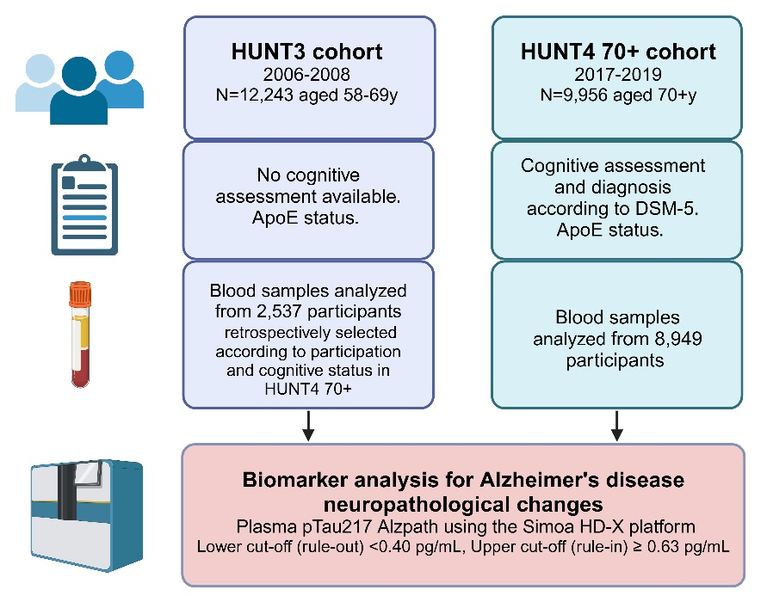
HUNT=The Trøndelag Health Study, Wave 3 and 4; y=years, DSM-5=The Diagnostic and Statistical Manual of Mental Disorders, Fifth Edition, ApoE=apolipoprotein E, pTau217=phosphorylated tau at threonine 217; pg/mL=picograms per millilitre. Figure created in BioRender. Sunde, AL. (2025) https://BioRender.com/b17k567.

Supplementary Figure 2. Association between the prevalence of Alzheimer’s disease neuropathological changes, age and sex in the different cognitive groups.
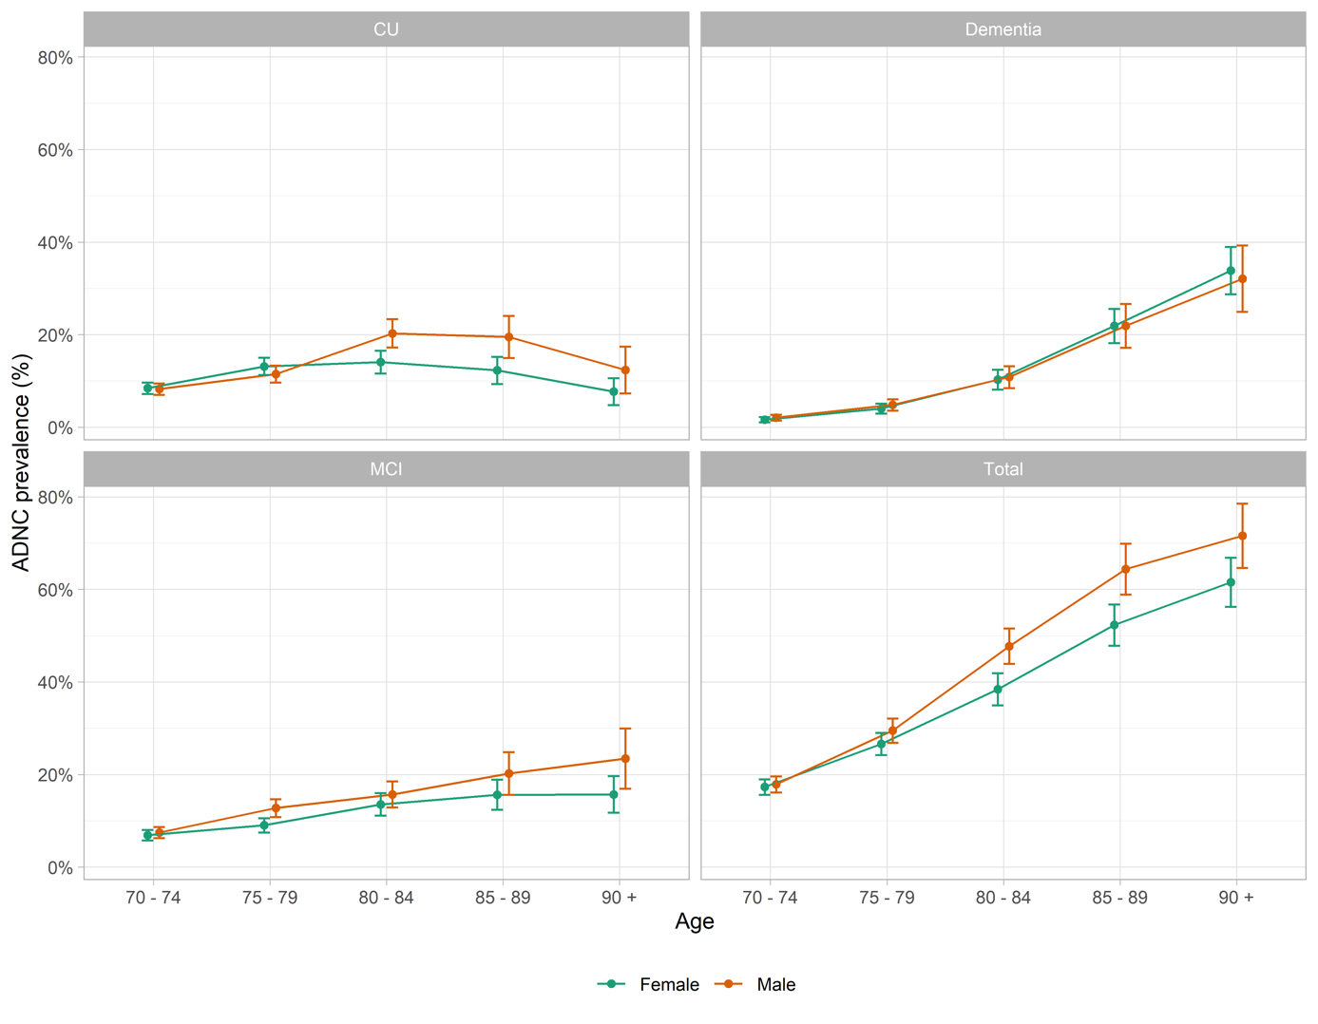
ADNC=Alzheimer’s disease neuropathological changes; CU=cognitively unimpaired; MCI=mild cognitive impairment.

Supplementary Figure 3. Piecewise regression analysis of plasma pTau217 and serum creatinine concentrations, showing fitted regression lines and identified cutoff point.
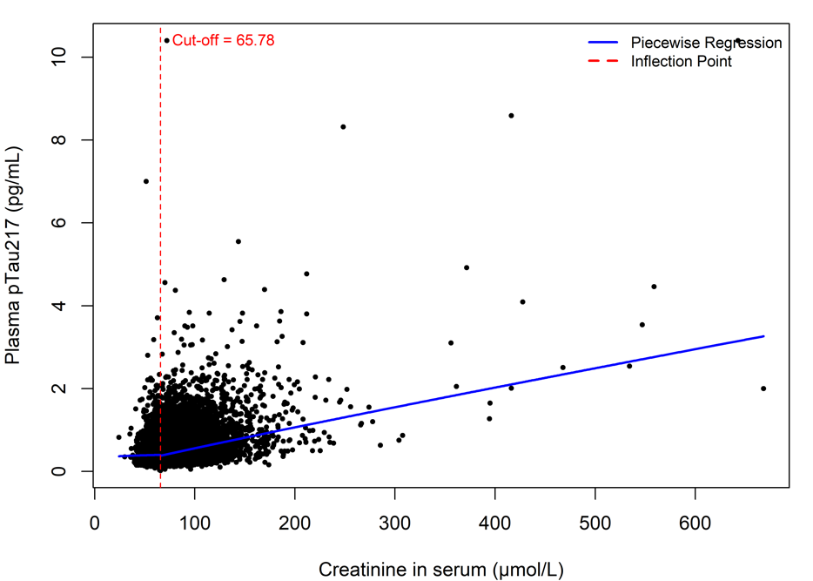
Black dots: Represent individual data points of plasma pTau217 concentrations and corresponding serum creatinine concentrations. Blue solid line: Represents the fitted piecewise regression model, which allows for different slopes on either side of a threshold. Red dashed vertical line: Indicates the inflection point (cutoff) at 65.78 µmol/L of serum creatinine, where the slope of the regression changes. pg/mL=picograms per millilitre; µmol/l=micromole per litre.

Supplementary Figure 4. Prevalence of Alzheimer’s Disease neuropathological changes across age and educational groups.
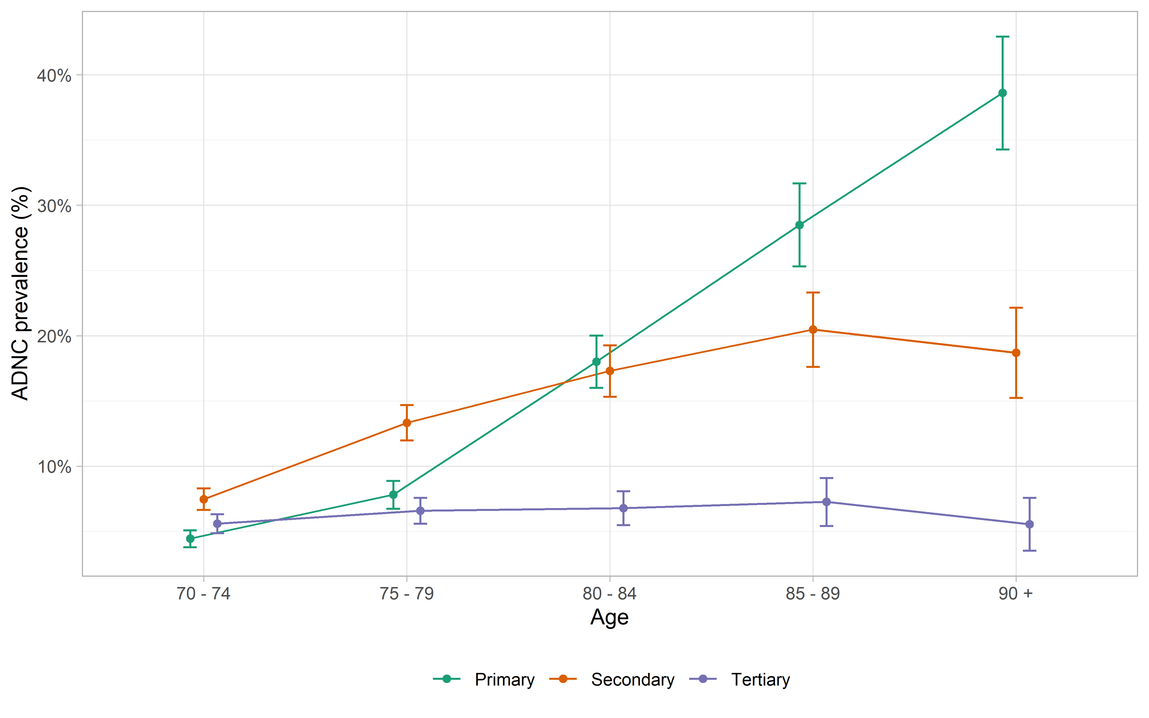
ADNC=Alzheimer’s disease neuropathological changes; Primary Education = up to 10 years of compulsory primary and lower secondary education; Secondary Education = 1–2 years of academic or vocational school, 3 years of academic or vocational school, or 3–4 years of vocational training or apprenticeship; Tertiary Education = college or university education of less than four years or four years or more. Prevalences are calculated by dividing the number of individuals with ADNC in each cognitive and age group by the total number of participants in each age group.

Supplementary Figure 5. Algorithm for identifying people eligible for treatment with disease-modifying drugs against AD according to recommendations
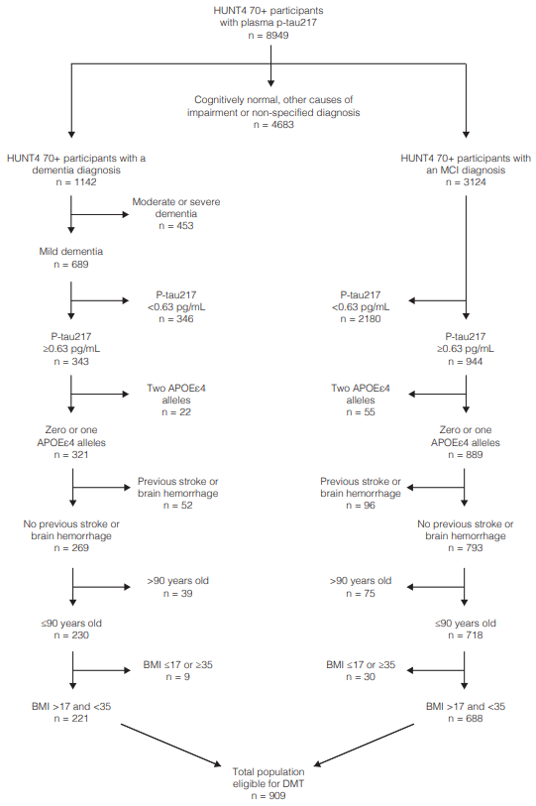
HUNT=The Trøndelag Health Study; MCI=mild cognitive impairment; pTau217= phosphorylated tau at threonine 217; pg/mL= picograms per millilitre; ApoE=apolipoprotein E; BMI=Body Mass Index; DMT=disease-modifying treatment.

