Task diagram | Requirements | Task interface | Design principles
Task 1:  Tennis Hitting  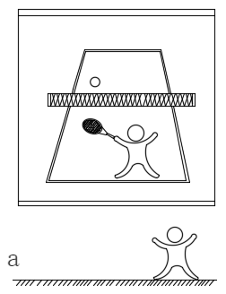 | Children are required to judge the direction and position of a ball approaching on the screen, and perform either a forehand or backhand hit to the corresponding target area. | 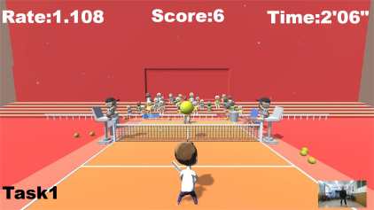 | This task is grounded in Dynamic Systems Theory (DST), emphasizing the role of environmental stimuli in promoting the development of motor control and body coordination. The primary focus is on fine motor skill training, particularly hand-eye coordination, upper-limb coordination, and movement planning abilities.²⁵
Task 2:  Parkour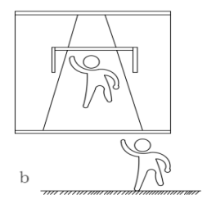 | Children navigate through a dynamic environment by performing jumps, squats, and other movements to avoid or leap over obstacles of varying sizes and shapes. | 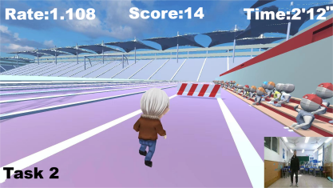 | This task applies Sensory Integration Theory (SI), challenging children’s balance and reaction abilities through dynamic scene-based obstacles. It primarily strengthens gross motor skills, including lower-limb strength, core stability, and overall body coordination.²⁶
Task 3:  Quick Reaction  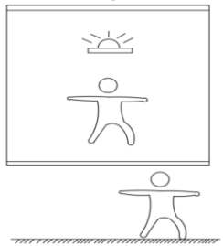 | Children must quickly perform specified actions (e.g., kicking or catching a ball) upon auditory cues. | 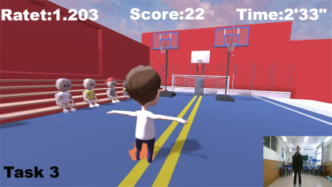 | Based on the Attention Control Theory (ACT), this task trains the connection between sensory perception and executive function by using auditory cues to trigger rapid bodily responses. It enhances auditory-motor coordination while improving attention, precision of movements, and multisensory integration capabilities.²⁷
Task 4:  Skiing Over Obstacles  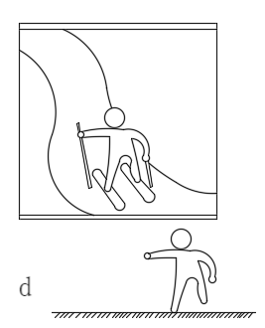 | Children balance on a ski board while holding ski poles, navigating a virtual snow mountain while crossing obstacles of varying heights and sizes. | 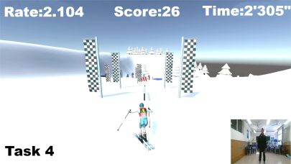 | This task integrates the Multisensory Dynamic Balance Theory (MPB), improving dynamic balance while enhancing control over body position and posture. It emphasizes visual-dominant multisensory coordination for dynamic balance, core stability, and continuous and open-loop movement skills.²⁶
Task 5:  Human-shaped Wall  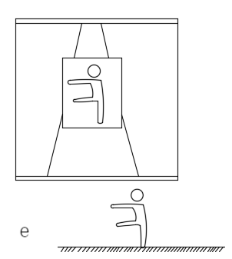 | Children must quickly mimic a specific pose from a human-shaped figure on the screen during a running sequence to pass through an obstacle. | 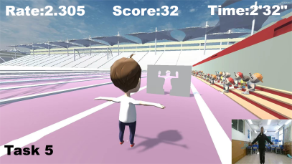 | This task is based on the Mirror Neuron Theory (MNT), where mimicking specific actions reinforces whole-body motor planning and execution abilities. It progresses from distributed to focused practice, training full-body coordination and movement skills.²⁶
Table 2. Description of exergame-VR motor intervention tasks, including task interfaces, design principles, schematic diagrams, and requirements.

Stage | Task | ADHD group  (n=37) |  | ADHD＋DCD group  (n=33) |  | DCD group  (n=34) |  | TD group  (n=35) |  | Main effect between groups after intervention
Stage | Task | First vs. Last | η2 | First vs. Last | η2 | First vs. Last | η2 | First vs. Last | η2 | F | p | η2
 | Task 1 | 29.11 vs. 35.22 | 0.48 | 24.05 vs. 34.83 | 0.47 | 27.56 vs. 32.88 | 0.57 | 36.91 vs. 42.03 | 0.55 | 87.85 | .000 | 0.66
 | Task 2 | 27.3 vs. 33.22 | 0.73 | 25.35 vs. 33.14 | 0.66 | 23.91 vs. 30.18 | 0.67 | 32.2 vs. 38.37 | 0.6 | 31.98 | .000 | 0.41
Stage 1 | Task 3 | 26.00 vs. 31.14 | 0.56 | 24.86 vs. 29.97 | 0.52 | 23.94 vs. 28.26 | 0.51 | 29.46 vs. 35.43 | 0.59 | 58.46 | .000 | 0.56
 | Task 4 | 33.59 vs. 39.51 | 0.65 | 30.92 vs. 37.46 | 0.59 | 29.52 vs. 37.09 | 0.59 | 39.8 vs. 44.37 | 0.67 | 76.08 | .000 | 0.63
 | Task 5 | 29.58 vs. 34.22 | 0.46 | 29 vs. 34.01 | 0.46 | 27.53 vs. 32.88 | 0.57 | 34.06 vs. 41.09 | 0.73 | 96.98 | .000 | 0.68
 | Task 1 | 35.08 vs. 44.00 | 0.65 | 33.92 vs. 44.49 | 0.66 | 32.82 vs. 41.74 | 0.62 | 38.03 vs. 47.17 | 0.64 | 12.92 | .000 | 0.22
 | Task 2 | 28.54 vs. 37.00 | 0.84 | 28.62 vs. 37.05 | 0.56 | 27.71 vs. 34.54 | 0.55 | 34.26 vs. 42.63 | 0.71 | 39.53 | .000 | 0.46
Stage 2 | Task 3 | 29.54 vs.37.51 | 0.73 | 29.46 vs. 37.46 | 0.71 | 27.82 vs. 37 | 0.76 | 34.4 vs. 41.69 | 0.73 | 40.31 | .000 | 0.47
 | Task 4 | 38.41 vs.44.50 | 0.64 | 37.32 vs. 43.38 | 0.60 | 36.97 vs. 42.26 | 0.62 | 43.23 vs. 49.17 | 0.7 | 73.17 | .000 | 0.61
 | Task 5 | 36.16 vs.45.00 | 0.65 | 34.08 vs. 42.89 | 0.64 | 34.85 vs. 43.71 | 0.52 | 37.06 vs. 47.2 | 0.73 | 10.98 | .02 | 0.19
 | Task 1 | 37.92 vs.45.6 | 0.85 | 39.11 vs. 46.95 | 0.57 | 36.03 vs. 43.47 | 0.55 | 42.26 vs. 49.34 | 0.61 | 18.45 | .001 | 0.28
 | Task 2 | 38.95 vs.43.41 | 0.41 | 38.73 vs. 43.32 | 0.46 | 35.03 vs. 41.41 | 0.31 | 39.71 vs. 46.11 | 0.63 | 6.9 | .002 | 0.13
Stage 3 | Task 3 | 38.24 vs.43.39 | 0.49 | 37.22 vs. 42.38 | 0.44 | 37.5 vs. 42.85 | 0.63 | 38.51 vs. 44.09 | 0.57 | 3.4 | .03 | 0.07
 | Task 4 | 45.51 vs.52.08 | 0.67 | 43.46 vs. 50.08 | 0.57 | 44.15 vs. 51.32 | 0.70 | 47.6 vs. 52.94 | 0.71 | 13.39 | .000 | 0.22
 | Task 5 | 43.16 vs.50.57 | 0.59 | 41.24 vs. 49.54 | 0.58 | 42.08 vs. 49.38 | 0.53 | 44.29 vs. 51.31 | 0.62 | 4.26 | .03 | 0.36
Retension | Task 1 | 41.97 vs.44.08 | 0.20 | 41.81 vs. 43.92 | 0.2 | 40.74 vs. 43.12 | 0.18 | 42.43 vs. 44.74 | 0.31 | 1.26 | .29 | 0.03
Retension | Task 2 | 38.68 vs.39.78 | 0.38 | 39.14 vs. 39.59 | 0.06 | 37.32 vs. 39.03 | 0.20 | 40.11 vs. 41.97 | 0.22 | 5.46 | .001 | 0.12
Retension | Task 3 | 40.51 vs.41.03 | 0.05 | 38.92 vs. 40.73 | 0.26 | 38.44 vs. 40.03 | 0.32 | 41.94 vs. 42.91 | 0.12 | 7.8 | .000 | 0.14
Retension | Task 4 | 48.59 vs.49.05 | 0.13 | 46.22 vs. 47.27 | 0.06 | 46.24 vs. 48.03 | 0.41 | 46.94 vs. 47.89 | 0.11 | 4.48 | .005 | 0.09
Retension | Task 5 | 44.97 vs.47.32 | 0.23 | 43.11 vs. 45.27 | 0.07 | 43.88 vs. 45.94 | 0.14 | 47.23 vs. 48.34 | 0.06 | 7.47 | .003 | 0.21
Table 3. Intra- and inter-group comparisons of Motor Skill Index (MSI) scores across three intervention phases and the retention phase for the ADHD, ADHD+DCD, DCD, and typically developing (TD) groups. Note: "First vs. Last" indicates the comparison between the first and last sessions within each phase; italicized and bolded values denote statistical significance (p < 0.05).

Sports event | ADHD group |  |  |  |  | ADHD＋DCD group |  |  |  |  | DCD group |  |  |  |  | TD group | Time×group
Sports event | T1 | T2 | t | p | d | T1 | T2 | t | p | d | T1 | T2 | t | p | d | T1 | F | p | η²
Run | 5.50±1.44 | 6.48±1.23 | -1.97 | .06 | 2.26 | 5.25±1.56 | 6.22±1.23 | -4.06 | .07 | 2.32 | 5.02±1.54 | 5.97±1.19 | -2.34 | 0.07 | 2.02 | 6.54±1.01 | 7.86 | .01 | .11
Gllop | 5.40±1.43 | 6.06±0.83 | -1.52 | .14 | 1.52 | 4.03±1.36 | 5.81±0.91 | -8.90 | .000 | 1.31 | 4.5±1.42 | 5.5±0.99 | -3.84 | 0.001 | 1.52 | 6.06±0.8 | 8.20 | .01 | .11
Skip | 6.10±1.04 | 6.48±1.52 | -0.65 | .52 | 2.29 | 4.79±1.17 | 6.41±1.71 | -4.55 | .001 | 2.14 | 5.24±1.02 | 5.97±1.7 | -1.89 | 0.07 | 2.27 | 6.57±1.52 | 3.83 | .06 | .06
Hop | 4.90±1.72 | 5.39±0.79 | -0.9 | .37 | 1.82 | 4.45±1.86 | 5.19±0.91 | -5.96 | .003 | 1.87 | 3.88±1.74 | 4.85±1.02 | -2.98 | 0.01 | 1.90 | 5.4±0.77 | 8.88 | .00 | .12
Horizontal Jump | 4.49±1.17 | 5.45±1.33 | -1.89 | .07 | 2.01 | 4.21±1.11 | 5.11±1.35 | -6.44 | .02 | 1.20 | 3.65±1.1 | 4.85±1.5 | -3.26 | 0.001 | 2.16 | 5.37±1.33 | 2.41 | .13 | .04
Slide | 4.3±1.71 | 6.55±1.44 | -6.6 | .001 | 1.79 | 3.27±1.68 | 6.24±1.59 | -11.18 | .001 | 1.68 | 3.65±1.57 | 5.91±1.62 | -7.64 | 0.001 | 1.73 | 6.51±1.48 | 2.59 | .11 | .04
Locomotor Skills | 30.8±3.21 | 37.42±3.69 | -3.58 | .000 | 7.12 | 25.61±3.94 | 35.0±4.86 | -10.05 | .001 | 5.11 | 24.91±3.32 | 33.06±5.37 | -5.64 | 0.001 | 7.39 | 36.46±3.59 | 13.61 | .000 | .17
Overhand Throw | 4.3±2.212 | 5.39±1.48 | -1.8 | 0.08 | 2.55 | 3.39±2.08 | 5.08±1.64 | -5.70 | .001 | 2.02 | 3.65±2.16 | 4.76±1.58 | -2.86 | 0.01 | 2.28 | 5.49±1.50 | 4.00 | .05 | .06
Kick | 4.73±2.08 | 6.36±1.39 | -2.85 | .01 | 2.77 | 4.76±2.08 | 6.03±1.54 | -4.87 | .001 | 1.75 | 4.00±2.1 | 5.71±1.47 | -3.65 | 0.002 | 2.73 | 6.37±1.40 | 3.45 | .07 | .05
One-Hand Dribble | 3.11±1.63 | 4.42±1.46 | -2.36 | .02 | 2.44 | 2.3±1.51 | 4.05±1.58 | -5.49 | .002 | 2.22 | 2.56±1.48 | 3.76±1.44 | -3.18 | 0.001 | 2.21 | 4.46±1.44 | 3.59 | .06 | .05
Catch | 3.92±1.50 | 5.27±0.76 | -3.37 | .01 | 1.76 | 3.03±1.45 | 4.89±0.81 | -7.86 | .001 | 1.64 | 3.29±1.4 | 4.59±0.92 | -4.4 | 0.001 | 1.71 | 5.29±0.75 | 10.66 | .001 | .14
Two-Hand Strike of a Stationary Ball | 3.97±1.68 | 5.52±1.37 | -2.89 | .01 | 2.44 | 4.09±1.59 | 5.14±1.40 | -3.97 | .03 | 1.33 | 3.35±1.55 | 4.82±1.45 | -3.75 | 0.001 | 2.29 | 5.54±1.34 | 3.68 | .06 | .05
Underhand Throw | 4.32±1.20 | 4.97±1.05 | -0.95 | .35 | 2.08 | 3.81±1.03 | 4.65±1.30 | -5.36 | .004 | 1.22 | 3.71±1.09 | 4.29±1.12 | -1.93 | 0.07 | 1.78 | 5.03±1.04 | 7.27 | .01 | .10
One-Hand Forehand Strike | 3.92±1.86 | 5.36±2.16 | -1.99 | .05 | 3.39 | 3.94±1.92 | 5.03±2.35 | -4.23 | .01 | 3.29 | 3.21±1.87 | 4.74±2.19 | -2.71 | 0.01 | 3.30 | 5.34±2.22 | 1.30 | .26 | .02
Ball Skills | 28.3±6.1 | 37.30±5.26 | -3.64 | .001 | 10.96 | 24.97±4.51 | 35.86±7.1 | -11.85 | .001 | 7.44 | 23.76±4.95 | 32.68±6.14 | -5.85 | 0.001 | 8.89 | 37.51±5.45 | 11.76 | .000 | .15
TGMD-3 total score | 59.19±8.0 | 75.73±7.53 | -3.94 | .001 | 16.60 | 51.58±7.13 | 70.9±8.7 | -13.52 | .001 | 15.96 | 49.68±7.37 | 67.74±9.92 | -6.20 | 0.001 | 14.10 | 73.97±7.52 | 17.02 | .000 | .21
Coin/Peg (dominant hand) | 6.92±3.01 | 9.67±2.16 | -2.9 | .01 | 3.79 | 5.42±2.83 | 8.73±2.05 | -6.51 | .001 | 3.74 | 5.79±3.1 | 8.12±2.01 | -3.58 | 0.001 | 3.79 | 9.69±2.10 | 1.07 | .31 | .02
Coin/pin (non-dominant ) | 6.24±2.44 | 9.79±2.42 | -3.78 | .001 | 4.09 | 4.88±2.38 | 8.78±2.30 | -6.70 | .001 | 4.21 | 5.15±2.52 | 6.21±2.36 | -4.31 | 0.06 | 4.13 | 9.77±2.35 | 0.74 | .39 | .01
Threading/Beading | 7.68±1.51 | 9.79±0.93 | -4.65 | .001 | 1.52 | 6.33±1.67 | 8.84±0.90 | -11.82 | .002 | 1.68 | 6.71±1.57 | 8.24±0.99 | -5.01 | 0.001 | 1.78 | 9.8±0.90 | 4.93 | .03 | .07
Drawing Trail | 3.35±1.78 | 6.79±1.93 | -6.08 | .001 | 2.68 | 2.27±1.66 | 6.03±1.98 | -10.22 | .001 | 2.54 | 2.24±1.65 | 5.32±2.03 | -6.99 | 0.001 | 2.57 | 6.91±1.96 | 1.78 | .19 | .03
Manual Dexterity | 6.54±1.10 | 8.61±1.56 | -4.07 | .001 | 2.39 | 4.42±1.12 | 8.14±1.70 | -9.83 | .001 | 2.39 | 4.5±1.11 | 7.68±1.59 | -7.7 | 0.001 | 2.41 | 8.66±1.53 | 6.06 | .02 | .08
Aiming and Catching | 9.78±1.51 | 11.91±1.55 | -2.94 | .01 | 2.63 | 7.42±1.37 | 11.05±1.5 | -9.87 | .001 | 2.61 | 7.82±1.55 | 10.56±1.64 | -5.83 | 0.001 | 2.73 | 11.97±1.54 | 7.29 | .01 | .10
Balance | 8.78±1.53 | 10.86±1.5 | -4.28 | .001 | 2.04 | 8.45±1.67 | 10.24±0.90 | -7.37 | .003 | 2.03 | 8.02±1.6 | 9.56±1.24 | -2.16 | 0.04 | 2.14 | 10.97±0.95 | 76.12 | .000 | .54
MABC-2 total score | 7.22±1.78 | 11.22±1.1 | -5.38 | .001 | 2.89 | 5.81±1.22 | 10.13±1.59 | -12.34 | .001 | 2.68 | 5.32±1.55 | 9.43±1.72 | -5.98 | 0.001 | 2.98 | 10.8±1.57 | 64.48 | .000 | .49
Table 4. Intra- and inter-group comparisons of gross and fine motor skill scores pre- and post-intervention. T1 and T2 represent pre-intervention baseline levels and post-intervention levels, respectively.

