Supplementary tables and figures

Prevalence of statin use and incidence of CVD
Supplementary Table 1: Prevalence of statin use each year in CVD primary prevention cohort
Year | Total follow up in years | Prescriptions | Prescriptions per 1000 person years
1998 | 738031 | 8585 | 11.63
1999 | 837959 | 27044 | 32.27
2000 | 1040735 | 56827 | 54.60
2001 | 1295439 | 106348 | 82.09
2002 | 1429880 | 186787 | 130.63
2003 | 1591167 | 310417 | 195.09
2004 | 1648158 | 488761 | 296.55
2005 | 1700595 | 661788 | 389.15
2006 | 1744492 | 870761 | 499.15
2007 | 1775518 | 1030767 | 580.54
2008 | 1801027 | 1142698 | 634.47
2009 | 1799115 | 1240413 | 689.46
2010 | 1777610 | 1263314 | 710.68
2011 | 1712269 | 1217875 | 711.26
2012 | 1669433 | 1216451 | 728.66
2013 | 1546937 | 1152425 | 744.97
2014 | 1325230 | 1000030 | 754.61
2015 | 1051748 | 806999 | 767.29
2016 | 204290 | 154993 | 758.69
Total | 26689633 | 12943283 | 484.96

Supplementary Table 2: Rate of initiation of statin treatment each year in CVD primary prevention cohort
Year | Total follow up in years | Number initiated | Incidence rate per 1000 person years
1998 | 738031 | 2133 | 2.89
1999 | 837959 | 3391 | 4.05
2000 | 1040735 | 5664 | 5.44
2001 | 1295439 | 9587 | 7.40
2002 | 1429880 | 15370 | 10.75
2003 | 1591167 | 22554 | 14.17
2004 | 1648158 | 31251 | 18.96
2005 | 1700595 | 30791 | 18.11
2006 | 1744492 | 37520 | 21.51
2007 | 1775518 | 29573 | 16.66
2008 | 1801027 | 29384 | 16.32
2009 | 1799115 | 28322 | 15.74
2010 | 1777610 | 22398 | 12.60
2011 | 1712269 | 18499 | 10.80
2012 | 1669433 | 19326 | 11.58
2013 | 1546937 | 16623 | 10.75
2014 | 1325230 | 13255 | 10.00
2015 | 1051748 | 10295 | 9.79
2016 | 204290 | 2330 | 11.41
Total | 26689633 | 348266 | 13.05

Calibration of the marginal structural model and interval censored Cox model
Calibration of the marginal structural models and interval censored Cox models (used to calculate reduction in risk in Table 3) are presented here. When assessing the calibration of the MSM (in either the development or validation cohorts), it was done on the subset of patients who received no statin treatment during follow up. This is because the risk scores generated were conditional on having no statin treatment during follow up. The calibration of the interval censored Cox model was carried out on the entire development/validation cohorts. The interval censored Cox model would under predict the risk of patients who do not receive statins during follow up.
Supplementary Figures 1 and 2 show that when secular trend was not adjusted for under the MSM setting, there was a significant under prediction of risks in the validation cohort, which could be accounted for by modelling calendar time. This is very similar to the non-MSM setting, for which the calibration of the interval censored Cox model is presented in Supplementary Figures 3 and 4.

Supplementary Figure 1: Calibration of the MSM in the validation cohort, with or without adjustment for calendar time (male cohort)
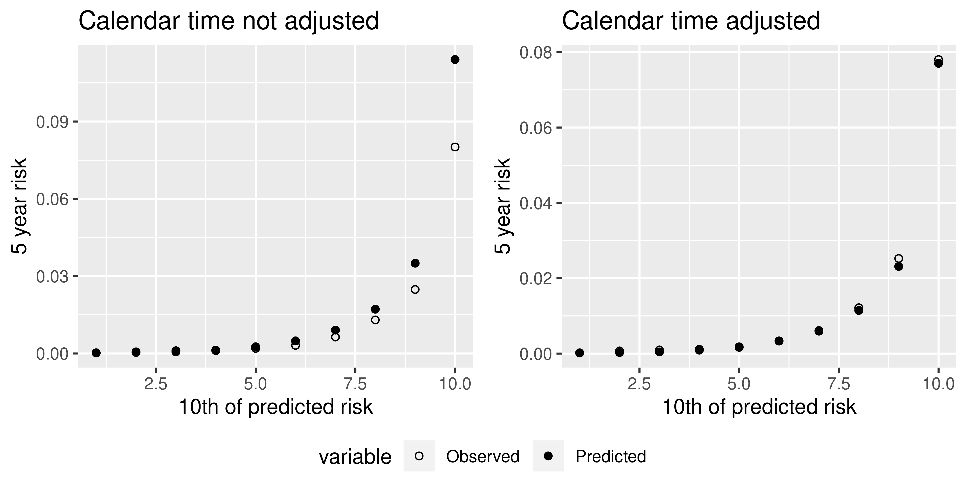

Supplementary Figure 2: Calibration of the MSM in the validation cohort, with or without adjustment for calendar time (female cohort)
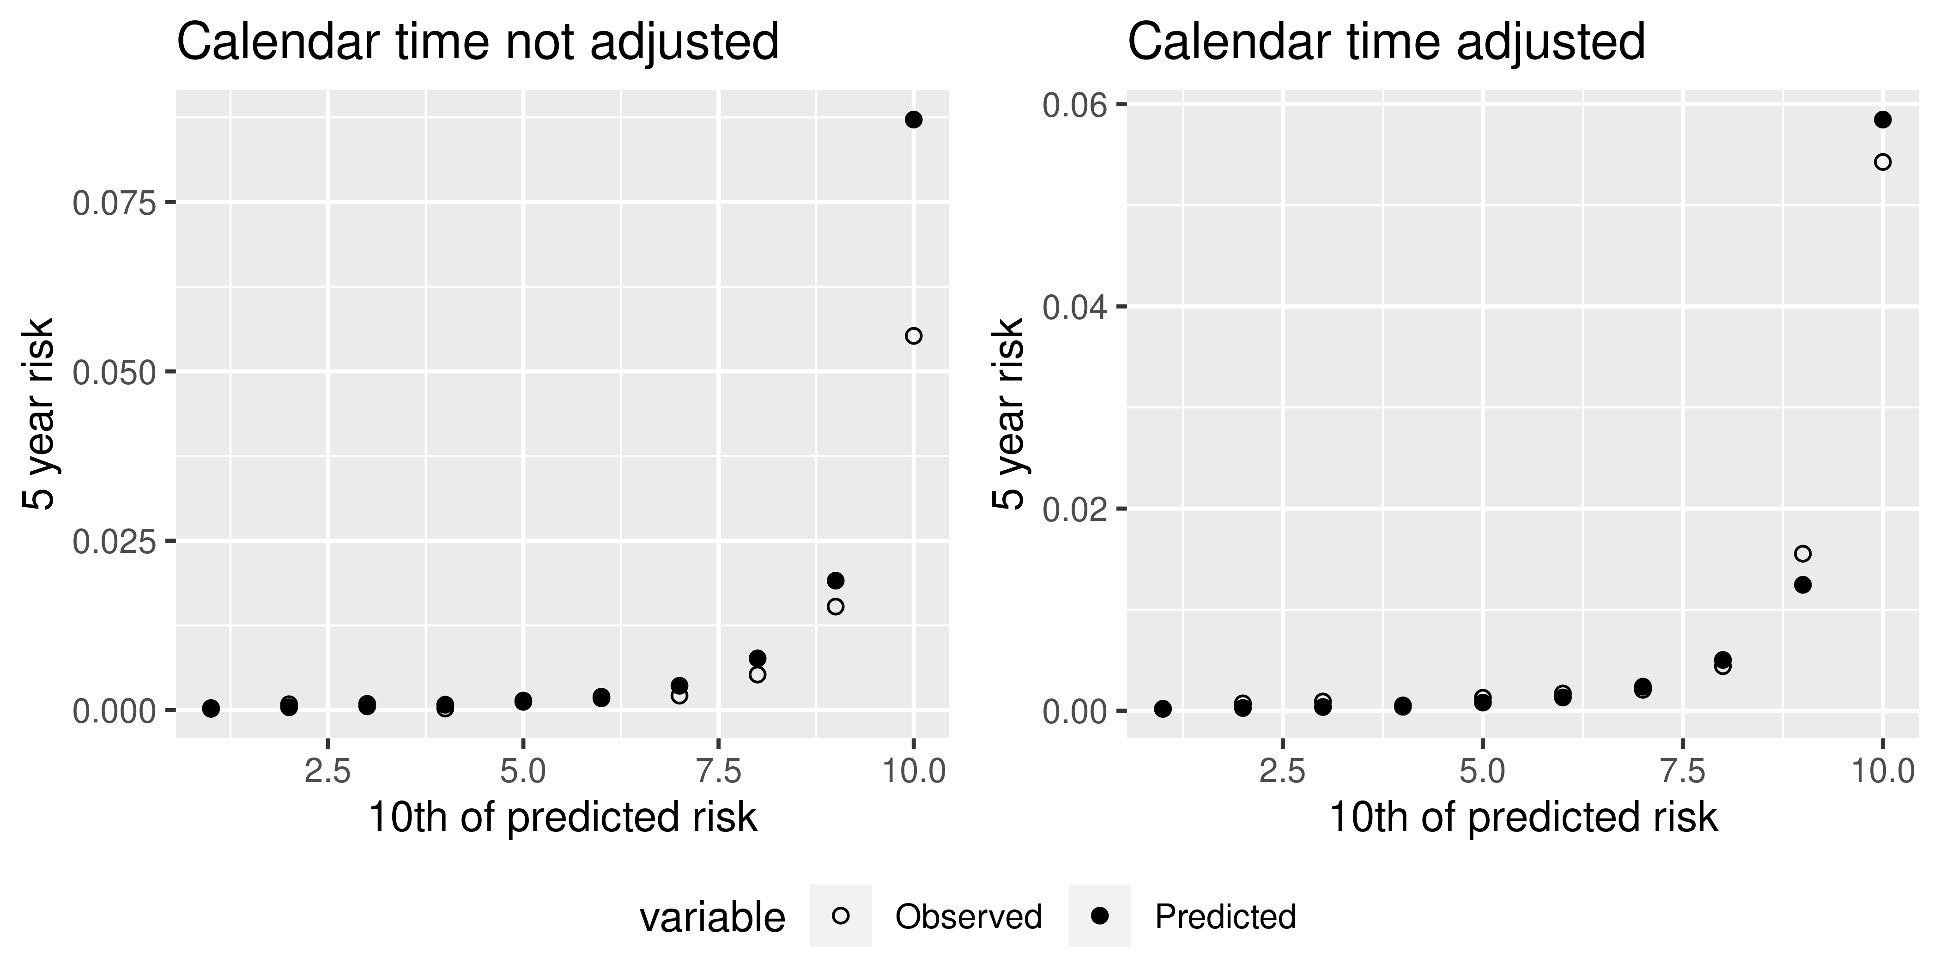
Supplementary Figure 3: Calibration of the interval censored Cox model in the validation cohort, with or without adjustment for calendar time (male cohort)
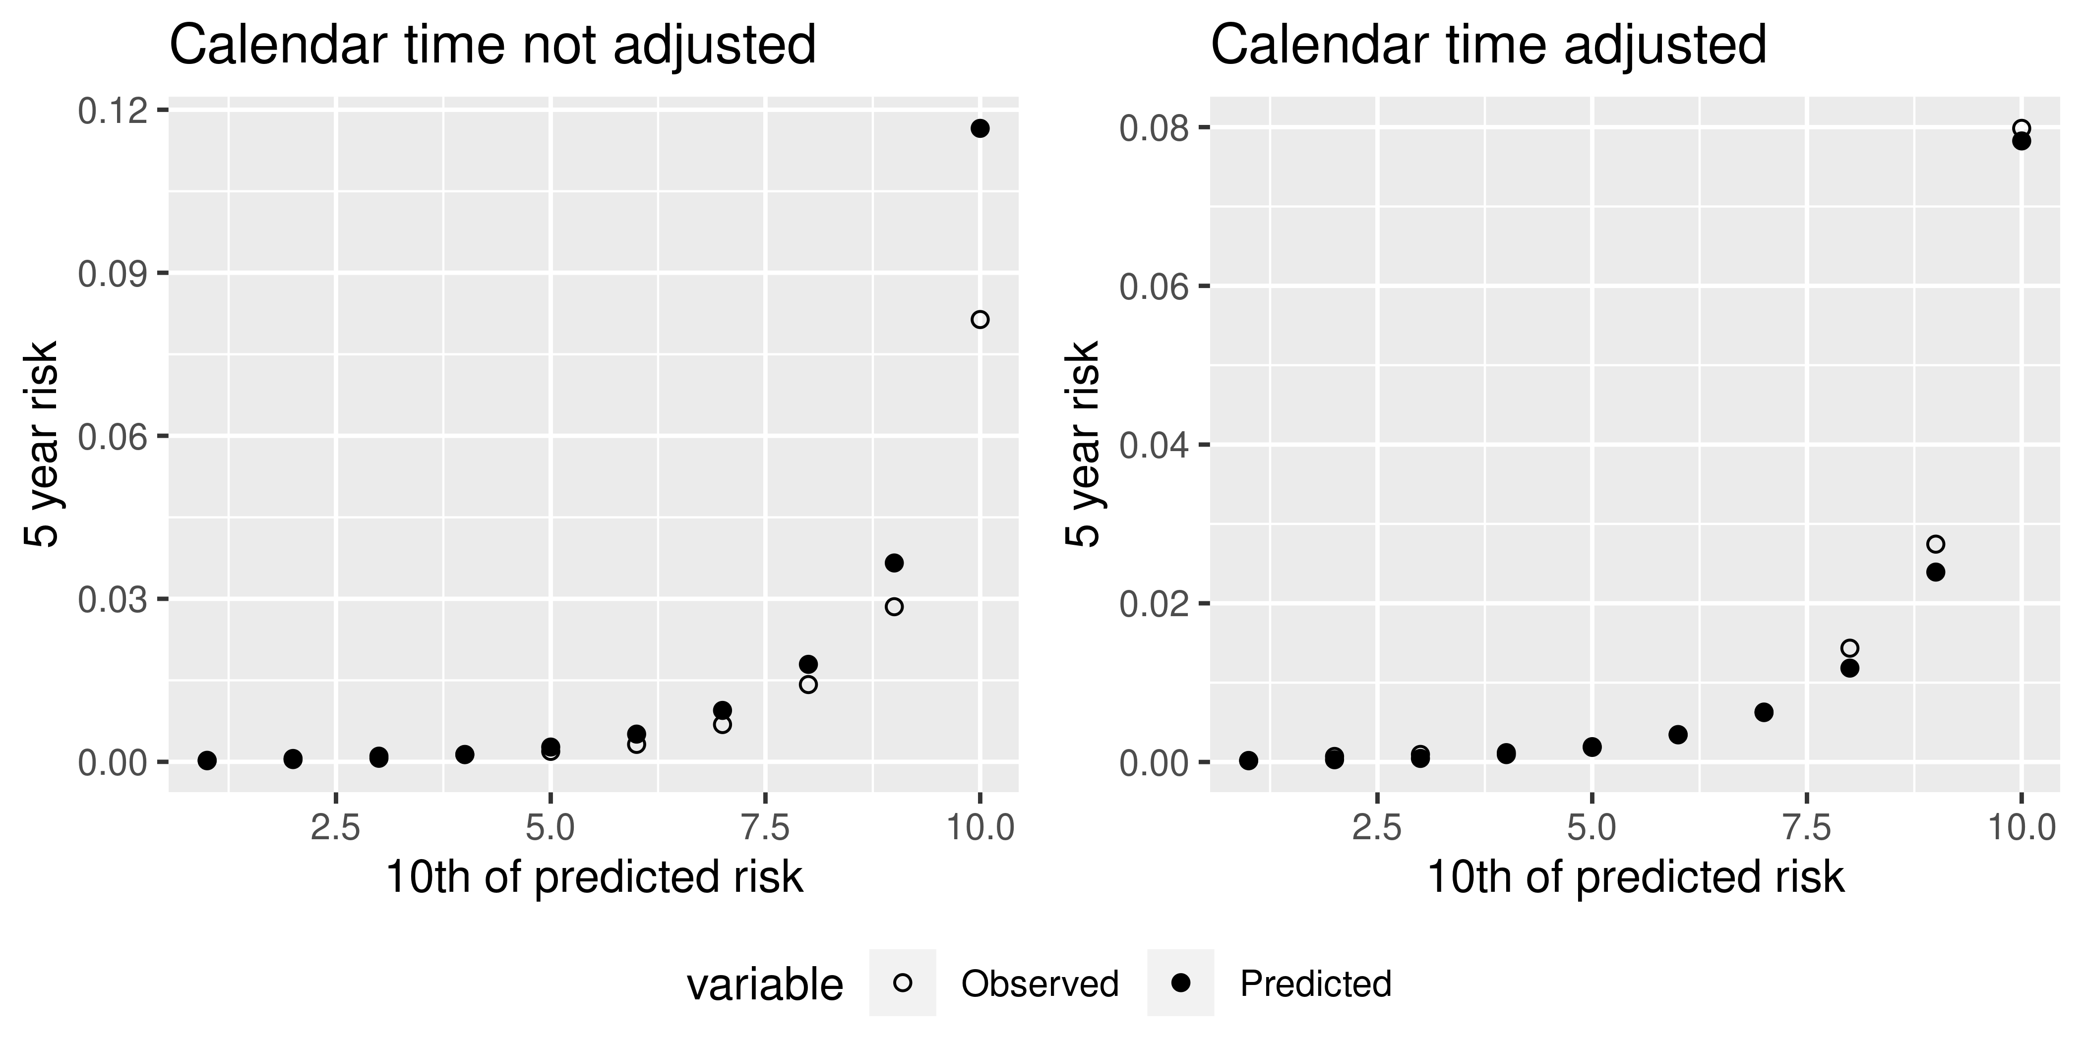
Supplementary Figure 4: Calibration of the interval censored Cox model in the validation cohort, with or without adjustment for calendar time (female cohort)
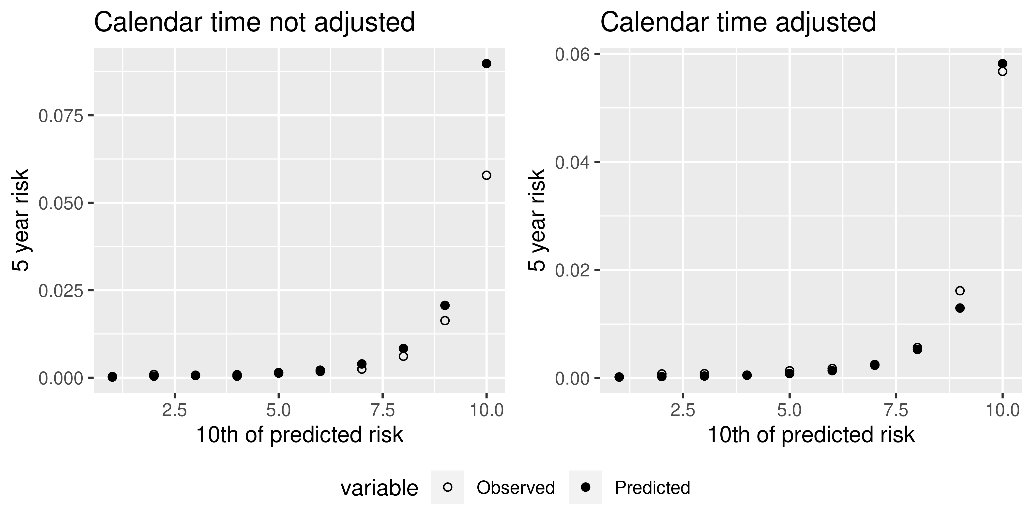

It is worth noting here that after adjusting for calendar time, the calibration is slightly poorer than in section 5.4.3, where standard cox models were used on data at baseline. I hypothesise this is because we were unable to test for fractional polynomials of the continuous variables when running an interval censored Cox model, meaning we re-used the same fractional polynomials from the standard Cox regression carried out in section 5.4.3. Given that the data was imputed differently, these may not be the best fractional polynomials to use. We did compare them to using no fractional polynomials, and the models were better calibrated when including them.

