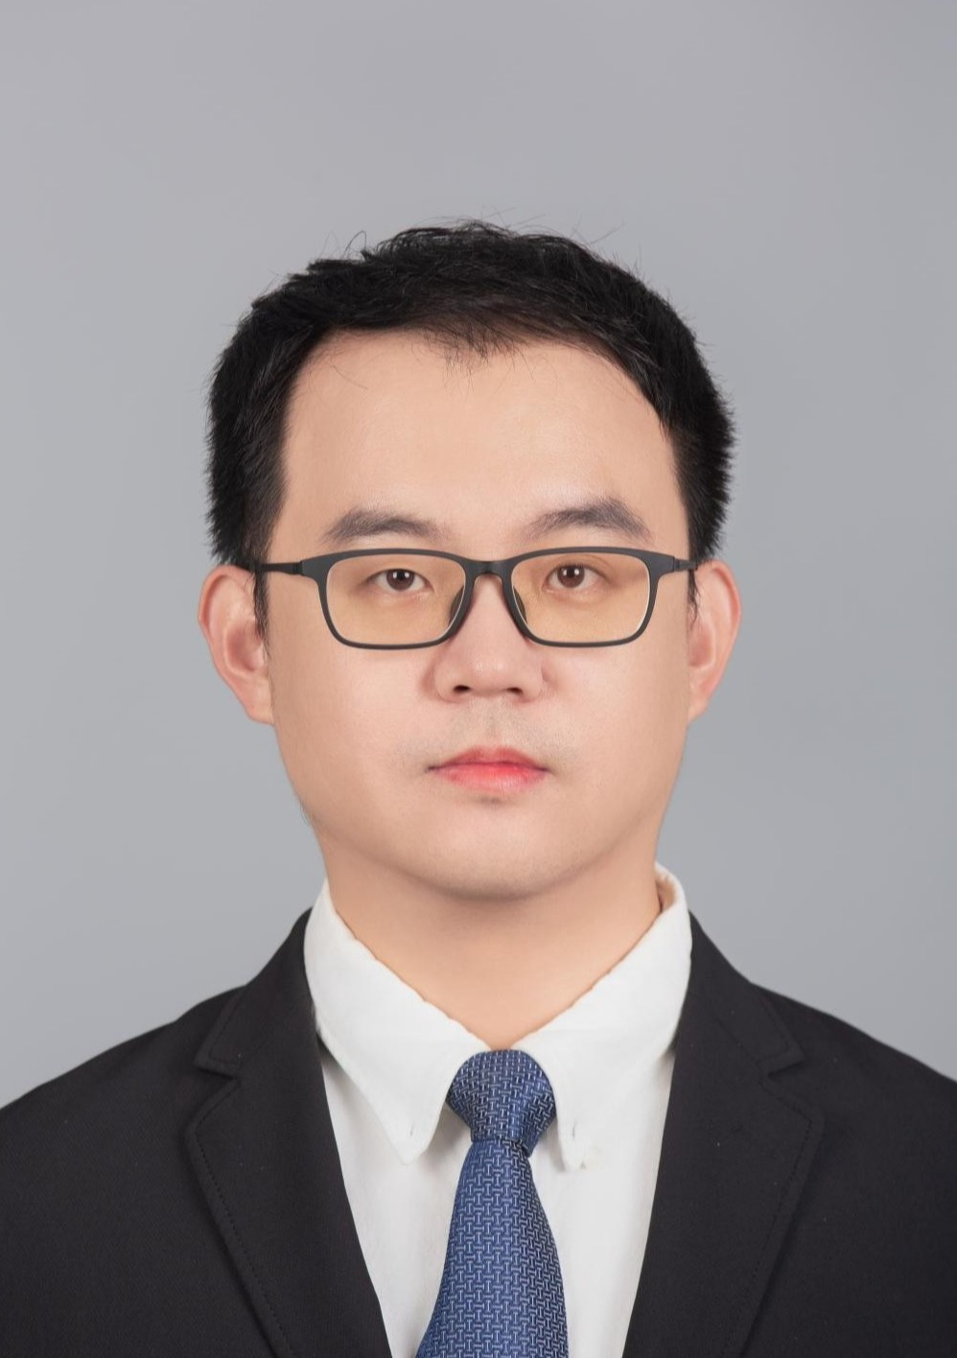
Yang Yong received the B.S. degree in mechanical engineering and automation from Hehai University, Jiang Su, China, in 2007; and the M.S. degree in weapon launching theory and technology from Nanjing University of Technology, Jiang Su, China, in 2009; the Ph. D. degree in mechanical manufacturing and automation from Tongji University, Shang Hai, China, in 2015. At present, he is a lecturer in the College of Mechanical Engineering, Suzhou University of Science and Technology. His main research field focuses on the AI, structural bionic design method.

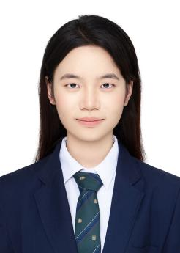
Zhu Ji-hong is one graduate student of Suzhou University of science and technology. His major is mechanical manufacturing and automation. His research direction is the mechanical structure optimization design method and the optimization algorithm.

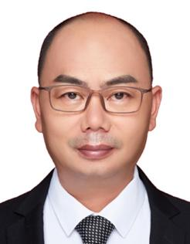
Wang Li-qing is the R&D director of Zhongke Motong (Changzhou) Intelligent Manufacturing Co., Ltd. He has long been focused on and involved in the research and application of artificial intelligence in the field of intelligent manufacturing, as well as collaborative industry-university talent cultivation projects.

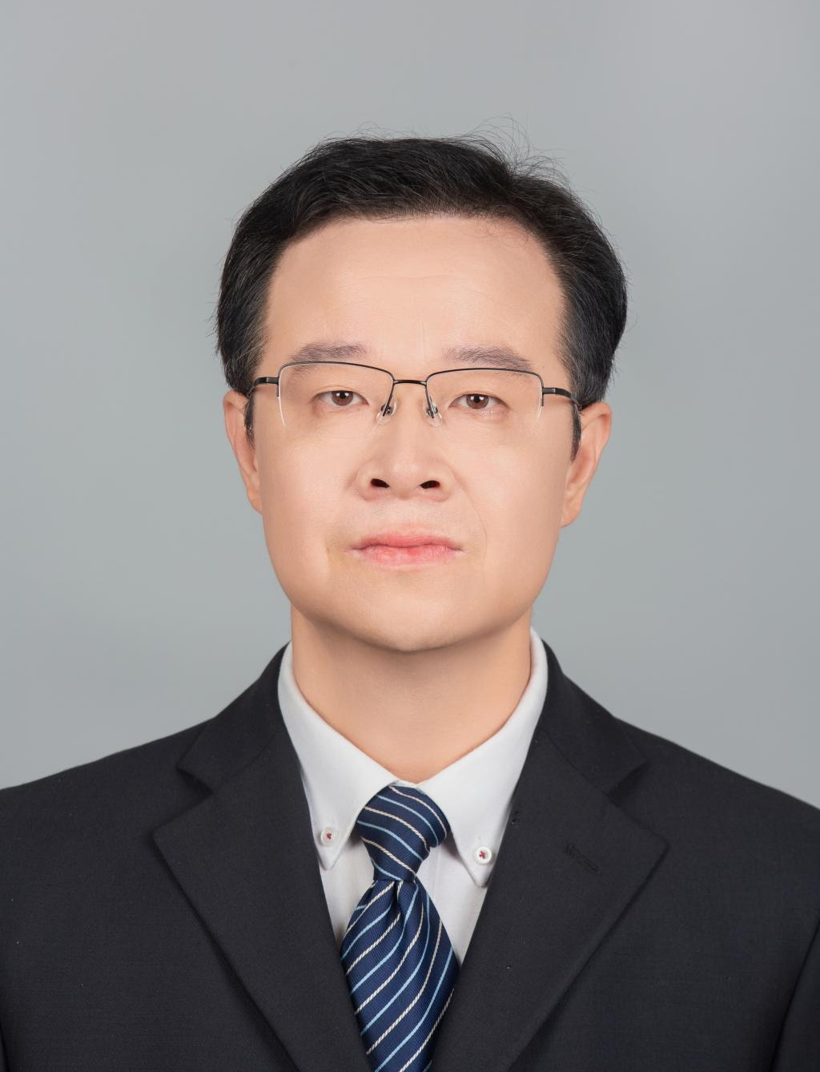
Cao Zi-yang is professor and vice dean of the School of Mechanical Engineering, Suzhou University of Science and Technology. He holds a Ph.D. in Mechanical Manufacturing and Automation from Nanjing University of Aeronautics and Astronautics and was a visiting scholar at the University of Michigan, Ann Arbor (cooperating with Professor Jun Ni, Director of the S.M. Wu Manufacturing Research Center). He has been awarded the "Young Teacher Hanshan Education Award," "Outstanding Young Backbone Teacher of the University," "Outstanding Teacher of Suzhou University of Science and Technology," "Excellent Young Backbone Teacher of Jiangsu Province's Qinglan Project," and has been included in Jiangsu Province's "333 High-Level Talent Training Project" and "Science and Technology Deputy Program." Currently, he serves as a member of the Mechanical Discipline Teaching Committee of the China Machinery Industry Education Association, a senior member of the Chinese Mechanical Engineering Society, a national high-tech enterprise evaluation expert, and a review expert for national key research and development programs. His main research areas include artificial intelligence and intelligent manufacturing.

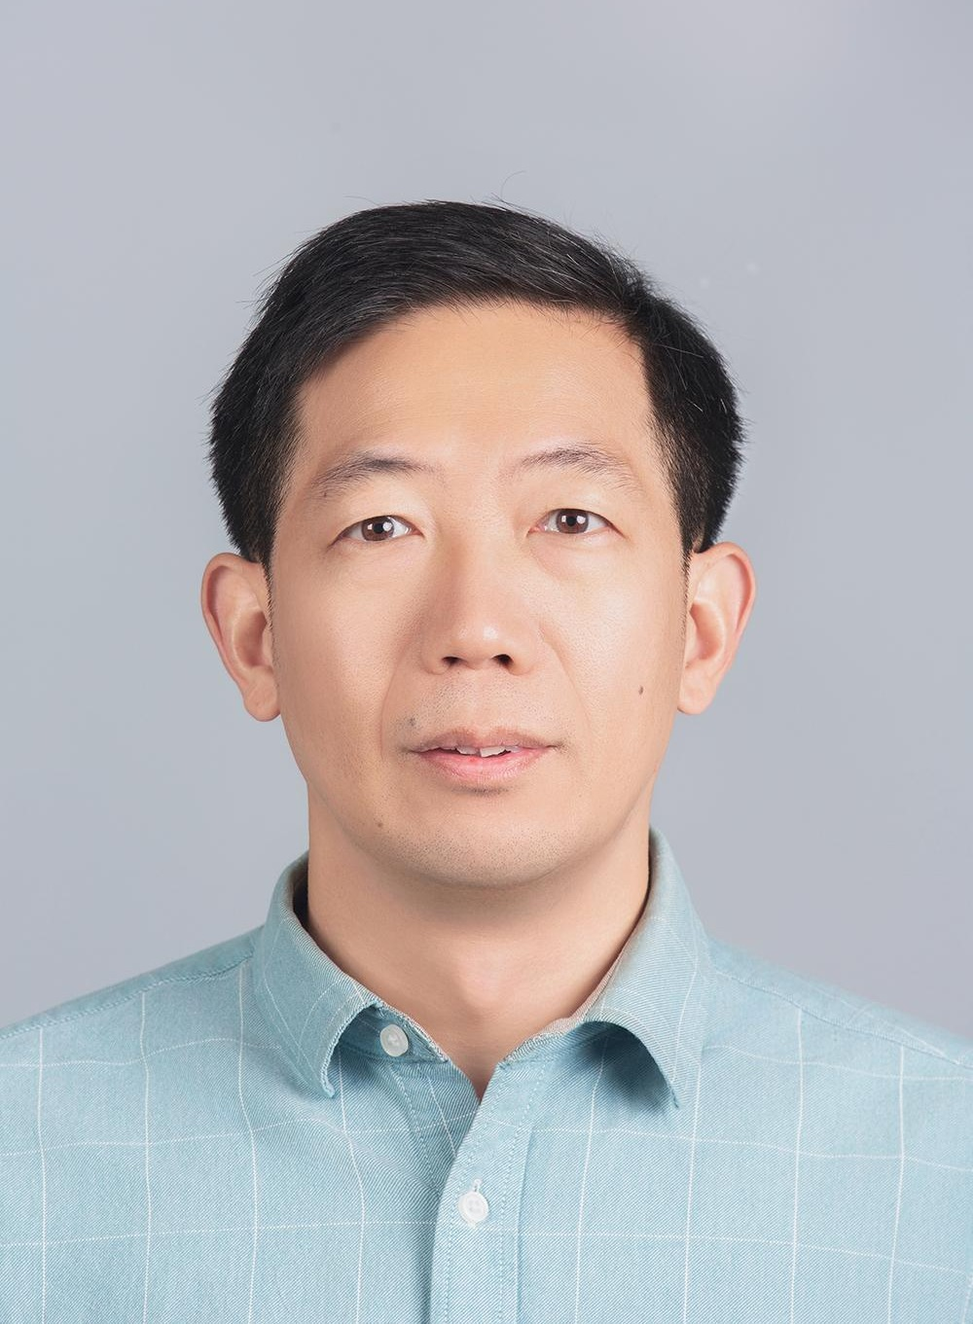
Jiang Quan-sheng is professor and vice dean of the School of Mechanical Engineering, Suzhou University of Science and Technology. He obtained his Ph.D. in Mechanical Manufacturing and Automation from Southeast University in April 2009 and was a visiting scholar at the Department of Mechanical Engineering, University of South Wales, UK, in 2016. He was selected as a master's supervisor in 2017 and was awarded the title of Outstanding Teacher at Suzhou University of Science and Technology in 2018. He is a senior member of the Chinese Mechanical Engineering Society, a senior member of the Chinese Society of Vibration Engineering, a member of the IEEE, a member of the Chinese Association of Automation, and an expert in the Jiangsu Provincial Science and Technology Expert Database. In 2022, he was appointed as a specially invited expert for the Jiangsu Provincial Science and Technology Deputy Program. His main research direction is the application of artificial intelligence in fault diagnosis.

