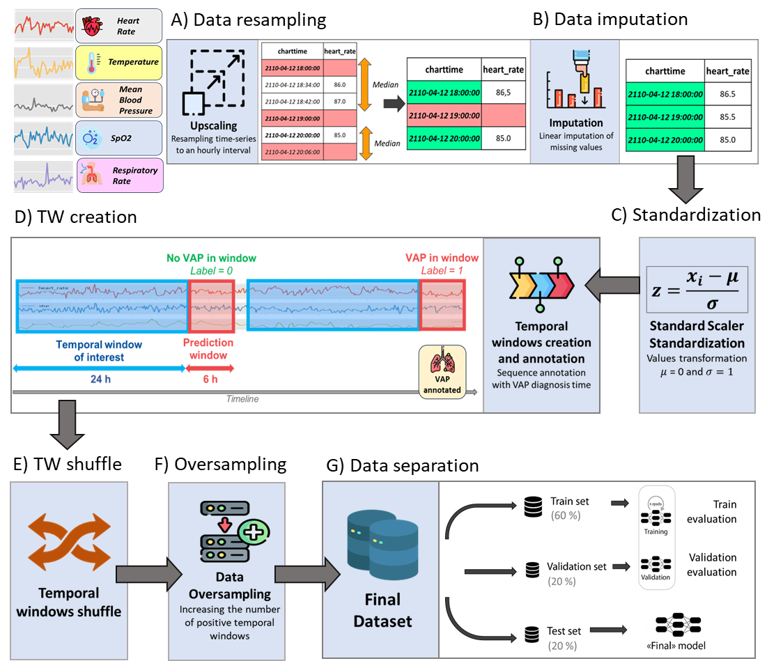
Supplemental figure 2 : Data preprocessing pipeline

Temporal Windows with oversampling (n) | Train Set | Validation Set | Test Set
VAP 6 hours prediction | 207 960 | 69 320 | 69 320
VAP 12 hours prediction | 202 954 | 67 652 | 67 652
VAP 24 hours prediction | 196 708 | 65 570 | 65 570

Supplemental table 2 : Data separation details

