Data oversampling
VAP temporal windows (TW) represented less than 1 % of all TW in the dataset. To improve model performance in this case of unbalanced learning, we have chosen as recommended to implement an oversampling strategy ¹⁸. We used the Synthetic Minority Over-sampling Technique (SMOTE)¹⁷, a method used to balance class distribution by generating synthetic samples of the minority class. The core idea was to create synthetic examples along the line segments joining a minority class instance and its nearest neighbors. An empirically derived oversampling rate of 3% of the total TW for the minority class was selected for VAP prediction windows at 6 and 12 hours. An oversampling rate of 5% was used for VAP prediction windows à 24 hours as TW already represent 3 % of dataset for 24h predictions (supplementary data). This process involved 3 key stages: 1) Each TW was flattened for conversion to a dataset shape the technique can handle (vectors with shape [x, 24$×$5=120] with x = number of TW). 2) SMOTE technique was then applied to the flattened dataset and 3) The sequences were restored to their original configuration (array with shape [x, 24, 5] - Supplemental figure 4). We assessed the quality of oversampling strategy by studying graphical representation of a sample of 100 augmented TW to ensure that the chronological logic of the time-series was respected.
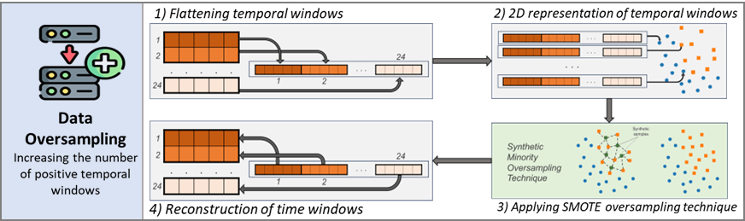
Supplemental figure 3 : Data oversampling technique

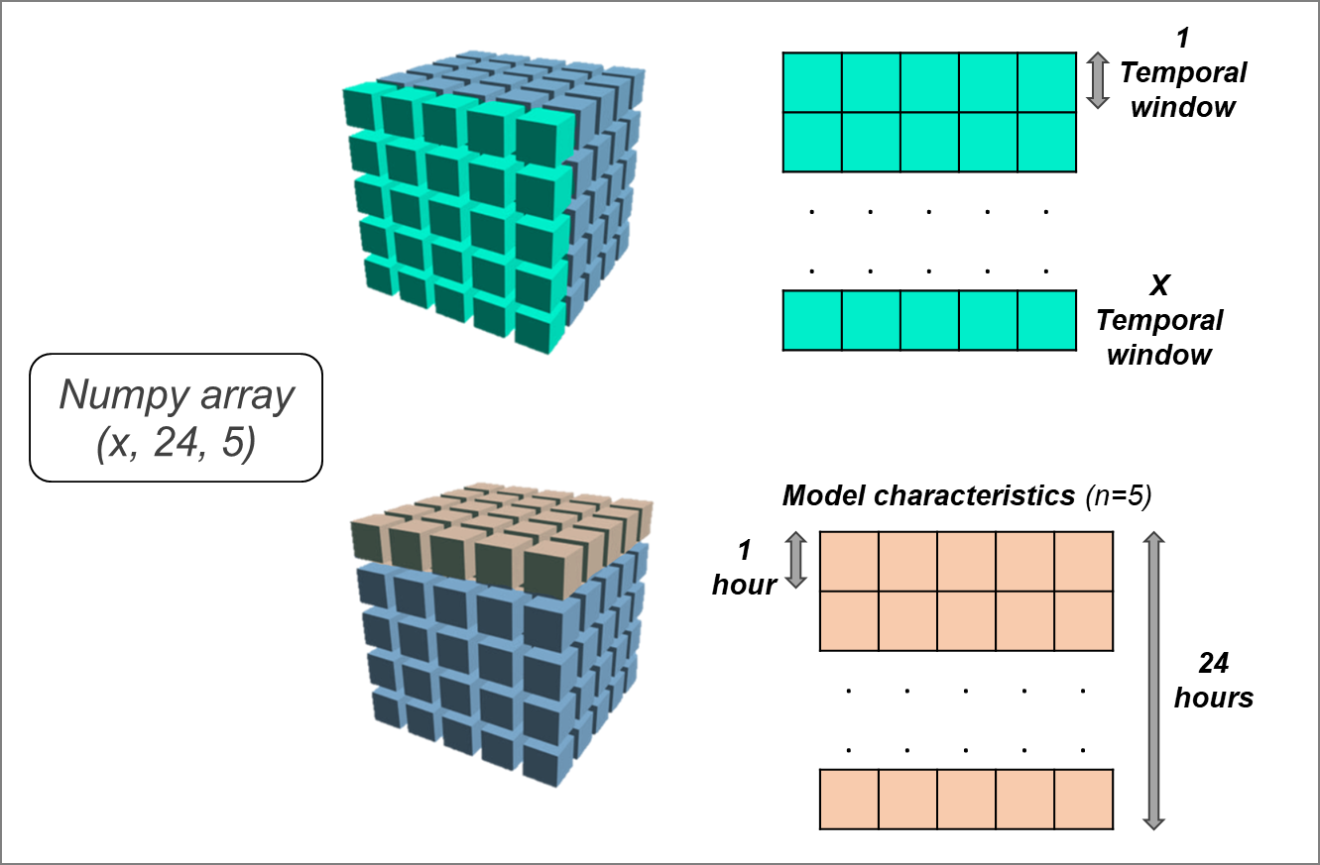
Supplemental figure 4 : 3D data representation for algorithm training

Temporal Windows (n) | Initial VAP Temporal Windows | %  before  oversampling | Oversampled  PAVM Temporal Windows | %  after oversampling
VAP 6 hours prediction | 2 260 | 0.6 | 10 095 | 3
VAP 12 hours prediction | 4 965 | 1.5 | 9 852 | 3
VAP 24 hours prediction | 10 347 | 3.2 | 14 630 | 5

Supplemental table 1 : Temporal windows before and after oversampling

