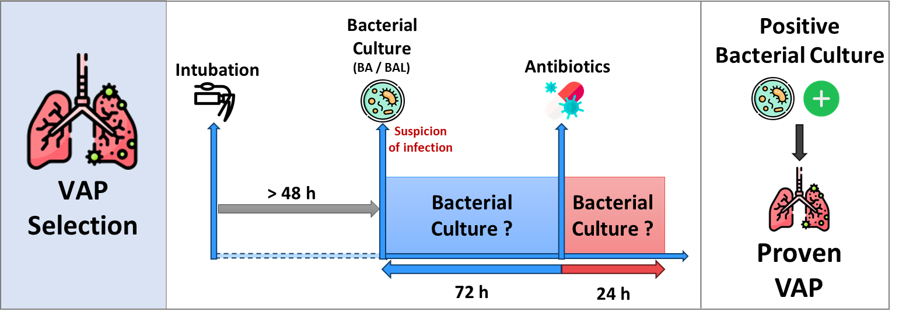
Supplemental figure 1 : VAP annotation algorithm

