Model development
For algorithm regularization, we used two techniques: dropout and batch-normalization. Batch normalization layers were inserted between each LSTM layers (n=3) in order to stabilize and accelerates the learning process by normalizing the outputs of LSTM layers^{31,32}. Additionally, it acted as a regularizer, introducing slight noise during training which mitigates overfitting and improves the model's generalization capability. To enhance the training we used a custom optimizer based on the Adam algorithm. This optimizer incorporated adaptive learning rate schedules and weight decay to improve convergence speed and model stability. Weight decay acted as a regularizer, preventing overfitting by penalizing large weights³³. The optimizer employed momentum, which leveraged past gradients to smooth the optimization trajectory and accelerate convergence³⁴. Hyperparameter optimization (HPO) was manually realized with the study of training curves after each train. The hyperparameters that could be varied were: the dropout rate, the number of layers and the number of neurons in each layer. The evaluation of the model metrics during the HPO process was conducted using the validation set. After each training session, a precision/recall curve was plotted. The classification threshold selected for evaluating performance of the algorithm was the crossover point offering both the best possible precision and recall.
Concerning ML algorithms, for each prediction window (6, 12 and 24h) the HPO procedure required the training of 135 XGBoost models, 135 LightGBM models, 45 Random Forest models and 15 Logistic regression models. HPO was carried out to optimize AUPRC, which is highly effective when working with unbalanced data. Hyperparameters included in HPO procedure are listed in the following supplementary data.

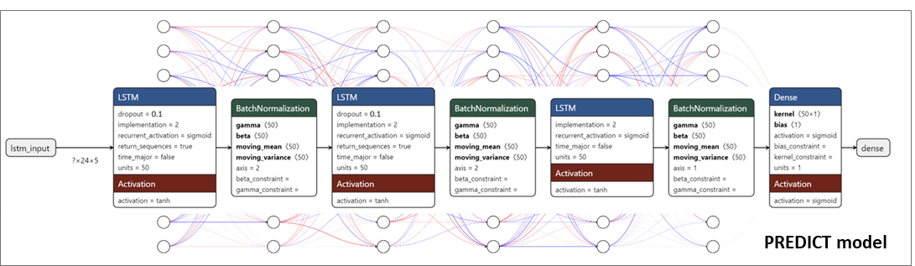
Supplemental figure 5 : PREDICT deep learning final model architecture

Model | Hyperparameter | Values
XGBoost | n_estimators | 50, 100, 200
XGBoost | max_depth | 3, 6, 9
XGBoost | learning_rate | 0.01, 0.1, 0.2
LightGBM | n_estimators | 50, 100, 200
LightGBM | max_depth | -1, 10, 20
LightGBM | learning_rate | 0.01, 0.1, 0.2
RandomForest | n_estimators | 50, 100, 200
RandomForest | max_depth | 10, 20, 30
LogisticRegression | C | 0.1, 1, 10
LogisticRegression | penalty | l2

Supplemental table 3 : Hyperparameters used for HPO procedure in concurrent ML models development

