Supplementary Information for

Buoyancy-driven self-purging stills exceeding 1% of thermodynamic limits

Junjie He^{1,2}*, Neng Yan^{1,2}, Baozhou Luo¹, Yu Liang¹, Lan Luo¹, Hong Li¹, Jing Wang^{1,2}, Song Li¹, Hongmei Zhao¹, Lei Zhao¹, Jing Li^{1,2}*
Corresponding author: junjiehe@ynau.edu.cn (J. He); lijing69@ynau.edu.cn (J. Li)

Contents
Nomenclature 1
Section 1. Theoretical model analysis and design 2
S1.0 Solutal Buoyancy Triggers Self-Cleansing Vortices 2
Buoyancy-driven vortices 3
S1.1 Exploration of heat and vapor transfer direction 5
S1.2 Exploration of the influence of distance on heat transport 10
S1.3 The influence of separation of the space on heat transport 13
S1.4 The effectiveness of nozzle 14
S1.5 The latent recovery model of one unit stage for experimental test 18
S1.6 The latent recovery models for i-MSS 20
S1.7 Exploration of mass transport 32
Mass transport in the whole i-MSS 32
S1.8 Photo-thermal heater 33
S1.9 Structure design of the EPs 36
Verification of the effectiveness of nozzles 38
Section 2. Fabrication of i-MSS prototype. 42
S2.1 Design and structural details of the key parts 42
S2.2 Preparation of porous media for evaporating layer 45
The morphology of the porous medias 45
S2.3 Properties of the evaporating media 47
BET area of the porous media 47
The thermal conductivity of the porous media 49
Calculation of the water recovery 50
S2.4 Photothermal heater 51
Section 3. Characterization of the performance of i-MSS 53
S3.1 Experimental set-up for heat-water efficiency 53
The influence of cover on the temperature of the EPs 56
S3.2 Desalination performance 58
ICP-MS analysis 58
S3.3 Light-water efficiency 60
S3.4 Outdoor experiment 61
Section 4. Economic analysis of i-MSS 63
Table S1. 63
Table S2. 65
References 67

Nomenclature
a_{(n)} | The water activity of saline on n layer
C_{n} | The heat capacity of saline on n layer (kJ kg⁻¹ K⁻¹)
C_{w} | The heat capacity of pure water (kJ kg⁻¹ K⁻¹)
C₀ | The heat capacity of saline on initial layer (kJ kg⁻¹)
C_{total} | The cost of the whole i-MSS ($)
C_{prod} | The cost of i-MSS needed for unit productivity rate (kg⁻¹ h⁻¹)
c_{i} | The salt mass ratio of feeding saline (%)
c_{c} | The salt mass ratio of concentrated saline (%)
c | Speed of light (m s⁻¹)
ε | Emissivity
f_{sal} | The flow rate of saline (kg)
f_{n} | The flow rate of condensed water on n layer (kg)
f_{i} | The flow rate of condensed water on initial layer (kg)
H_{w} | The latent heat of pure water (kJ kg⁻¹)
H_{n} | The latent heat of saline on n layer (kJ kg⁻¹)
H_{i} | The latent heat of saline on initial layer (kJ kg⁻¹)
M_{NaCl} | The molar weight NaCl (g mol⁻¹)
Q_{i} | The heat inlet from the initial layer (J)
Y_{c} | The salinity of the concentrated saline (%)
Y_{i} | The salinity of the initial saline (35g in 1kg saline, Y_{i}=3.5%)
K | Vapor to water conversion ratio
K_{n} | Vapor to water conversion ratio on n layer
V_{n} | The vapor flow from the n layer (kg)
V’_{n} | The side leakage of vapor flow from the n layer (kg)
V’_{n} | The vapor flow from the n layer through the nozzle (kg)
V_{R} | The vapor regeneration rate by recovering the latent heat of the steam beneath the EP.
v | Frequency of light (Hz)
∆W₀ | The weight change of one evaporation layer after heating (kg)
∆W₁ | The weight change of i-MSS after heating (kg)
R_{w} | The recovery rate of water (%)
∆T_{n} | The temperature difference between the n layer and environment (K)
∆T₀ | The temperature difference between the initial layer and environment (K)
T_{r} | Room temperature (K)
t | The temperature difference between the two evaporation layers (K)
L_{RE} | The latent heat recycling efficiency (%)
S_{E} | Solar-to-water efficiency (%)
σ | Stefan-Boltzmann constant 5.670374419 × 10⁻⁸ W m⁻² K⁻⁴

Section 1. Theoretical model analysis and design

S1.0 Solutal Buoyancy Triggers Self-Cleansing Vortices
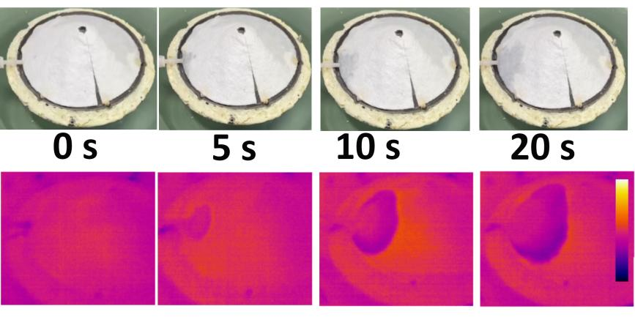
Fig.S0. 1
The water diffusion on bamboo fabric (Top) or the carbon SRVGL (Bottom) through capillary action

For numerical simulation of salt distribution on 3 dimensional porous media, cellulose serves as the porous media with a porosity of 0.7. The initial concentration in the SRVGL and the four drainage ports is 3.5% salinity and the molar ratio is 1.06%. The evaporation rate is determined by the concentration or molar ratio of water. Here, it is governed by -0.2 molar ratio of water in saline. As the saline density is a function of salinity and temperature,(1) the density of fluid is described by
where a₁=9.99×10², a₂=2.034×10⁻², a₃=-6.612×10⁻³, a₄=2.261×10⁻⁵, a₅=-4.657×10⁻⁸,
b₁=8.020×10², b₂=-2.001, b₃=1.677×10⁻², b₄=-3.060×10⁻⁵, b₅=-1.613×10⁻⁵
t is the temperature and S is the salinity.

Buoyancy-driven vortices
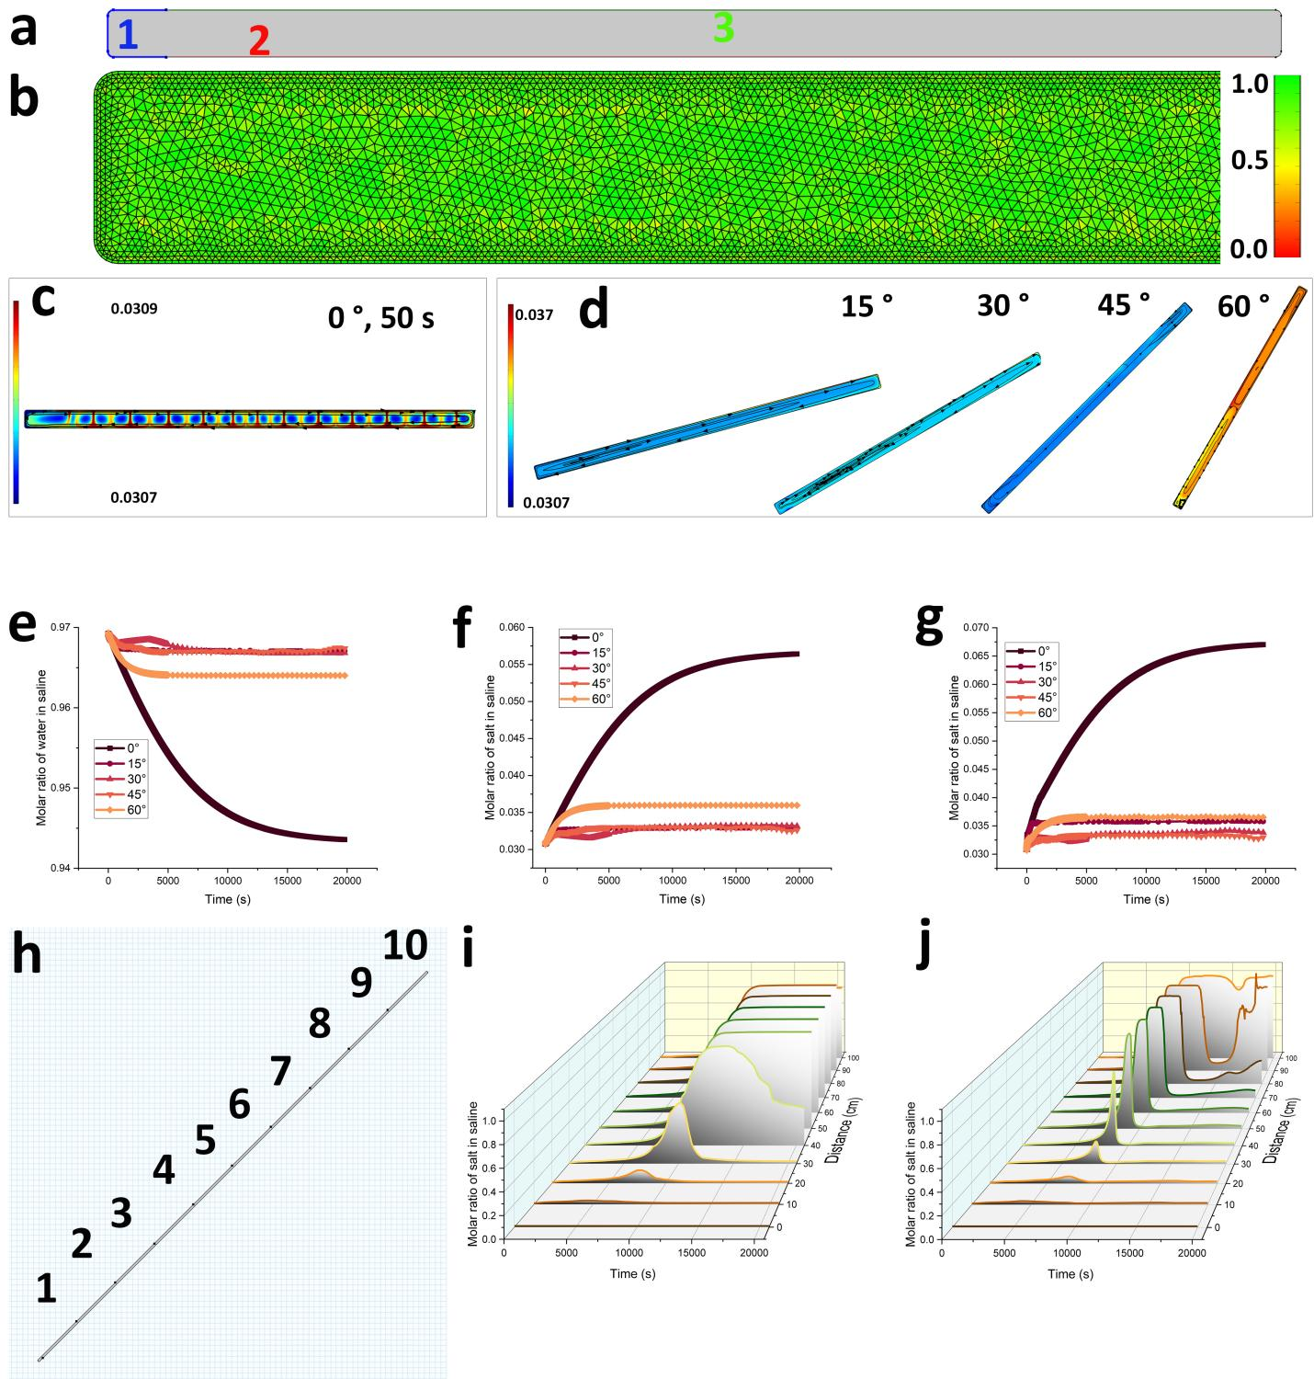
Fig.S0. 2
Theoretical simulation of salt removal in porous material. The 2D theoretical model is shown in (a). The boundaries labeled in number 1~3 are water feeding boundary, heating boundary and evaporating boundary, respectively. The mesh built for the model and its quality are shown in (b). The salinity distribution in the model set horizontally after 50 s evaporation is given in (c). The salinity distribution and vortical flow in the model set at different tilt angles after 20,000 s is presented in (d). (e) is the water content evolution with evaporation time in the porous model set at different angle. (f) is the total salt molar ratio evolution with evaporation time in the porous model set at different angle. (g) is the salt molar ratio evolution with evaporation time on the surface of porous model set at different angle. (h) shows a porous model is of 1 m long and ten salt molar ratio probes are set at every 10 cm farther away from the bottom. The evolution of molar ratio of salt at different positions on the surface of the model in (h), when the tilt angle is 30 degree (i) and 45 degree (j).

To simulate the salinity evolution in the porous material and to understand the mechanism of salt rejection on the EP surface, a theoretical model is constructed and presented in Fig. S0.2. Three boundaries, labeled 1 to 3, are defined. Boundary 1, colored in blue, represents the water feeding boundary that simulates the bottom area on the EP. Here, saline water flows in and out continuously, and its concentration is set to maintain a molar ratio of salt at 0.031. Boundary 2 is where a heat source of 1000 W m⁻² is applied. Water exits the system at boundary 3, mimicking the surface evaporation on the porous media.
The mesh constructed for the model is depicted in Fig. S0.2(a~b). The quality of all the mesh elements is higher than 0.5. The molar ratio of salt in the porous media at various tilted angles after a specific period of evaporation is shown in Fig. Fig. S0.2(c~d). To monitor the evolution of the molar ratio at different positions on the surface, 10 probes are positioned on the surface of the porous media from the bottom side (feeding area) to the top, as illustrated in Fig. S0.2(h). These probes are distributed evenly across the surface. The evolution of the molar ratio from the probes at different positions is presented in Fig. S0.2(i~j). At a distance of 80 cm from the feeding point, there is no significant increase in concentration on the surface after 5.6 hours of continuous operation.

S1.1 Exploration of heat and vapor transfer direction
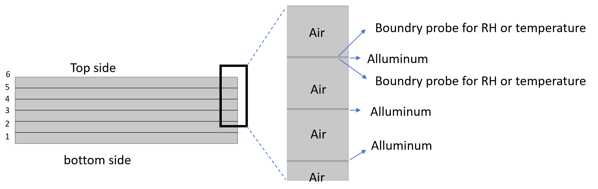
Fig.S1. 1
The model for heating direction study. The number shows the order of layers of Model-B. The number of the layers should be reversed when the heating direction is Top-Down for Model-T.

To investigate the feasibility of heating the i-MSS from the bottom side, a simple model was established and simulated using the finite element method. COMSOL Multiphysics® was applied for finite element method analysis in this study. The model consists of 6 layers of air with a relative humidity (RH) of 0.5, and aluminum foil (Fig. S1.1). On the side of all aluminum layers along the heating direction, the RH is 1.0, and a boundary probe for temperature monitoring is set. The other side of the aluminum layer is monitored by a RH boundary probe. The top boundary of Model-T and the bottom boundary of Model-B are subjected to a heat flux of 1000 W m⁻², respectively. Three sets of equations are solved numerically to obtain the RH and temperature profiles in the model. In detail, "Moisture Transport in Air" (mt) is used to simulate the moisture changes in the air and on the solid surfaces. "Laminar Flow" (spf) is utilized to calculate the air flow in the gaps of the model, while "Heat Transfer in Solids and Fluids" (ht) is applied to analyze the heat transfer throughout the entire model. The fluid flow and heat transfer are coupled in the multiphysics model of nonisothermal flow. Gravity is included in both models, and the inertial term is neglected. An "extremely fine" mesh, controlled by the physics, is created with 194,961 degrees of freedom. The properties of the materials, including those of the air and aluminum, are inherited from the database in COMSOL Multiphysics® without modification.
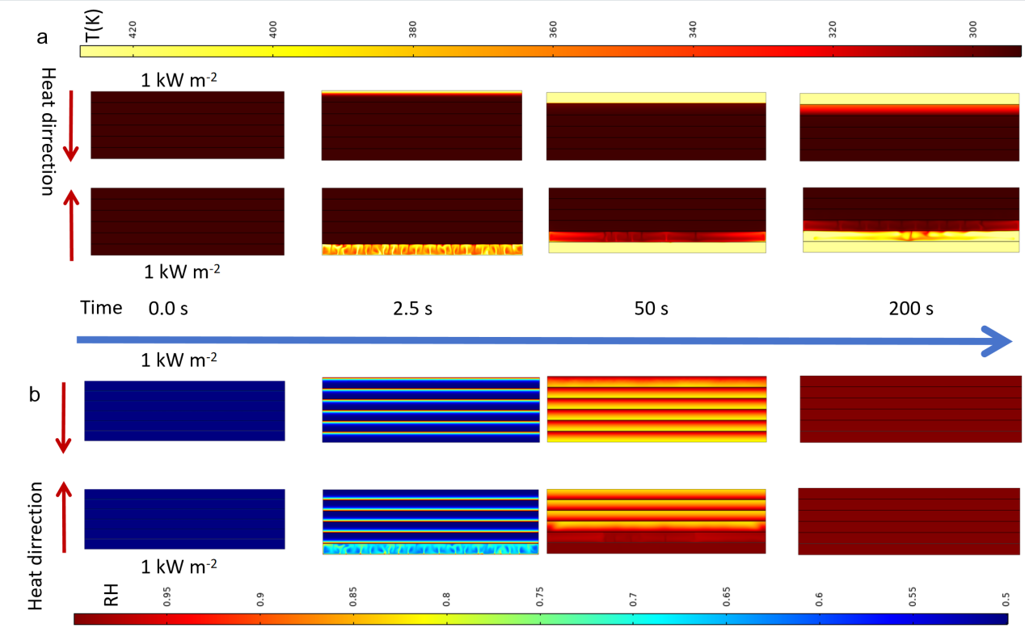
Fig.S1. 2
(a) The temperature (T，K) and (b) relative humidity (RH) distribution of Model-T and Model-B at different time. The heat power is 1000 W m⁻² for the both models. The scale bars are shared by both Model-T and Model-B.
According to the temperature distribution of Model-B, some areas at the top of the first layer have heated up to nearly 400 K after only 2.5 seconds (see Fig. S1.2). However, the temperature of the aluminum surface of the first layer (from the top) remains almost unchanged in Model-T. The typical convection characteristic, a vortex, is observed in Model-B. After 200 seconds, the temperature of the third layer in Model-B shows observable changes, but that of Model-T remains around the initial temperature. The RH change in each layer is also accelerated in Model-B due to convection. After 200 seconds, the RH in each layer of both models reaches 1.0, because moisture diffusion is driven by the concentration difference at the same time.

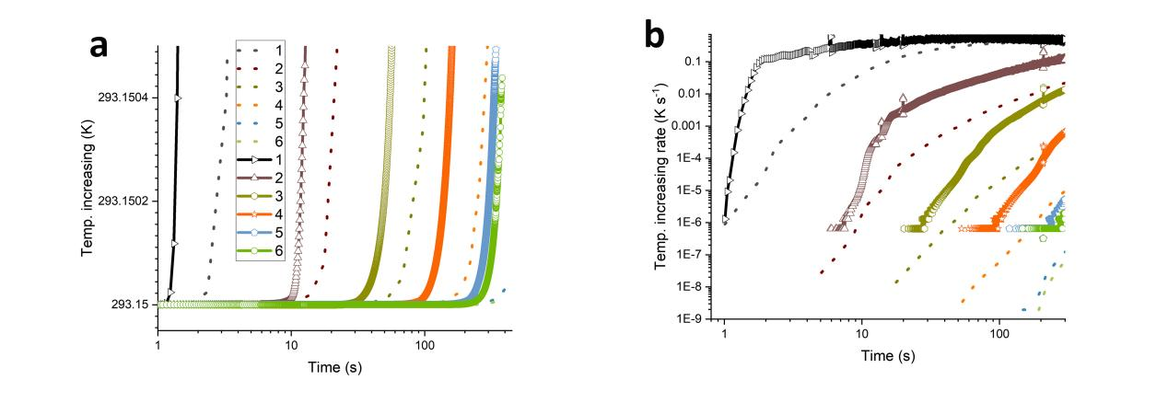
Fig.S1. 3
The evolution of temperature (a) and temperature increasing rate (b) on each layer (from 1 to 6). Solid lines with symbols are for Model-B, while the dashed lines are for Model-T. The legend are shared in both pictures.
The temperature of each layer in both models is monitored by boundary probes during the heating process and presented in Fig.S1. 3. In both models, a smaller number indicates the nearer distance to the heater. The temperature of the layers in Model-B increases much faster than that in Model-T. The temperature increase rate is obtained by differentiating temperature with respect to time. The temperature increase rate is 0.1 K s⁻¹ for Model-B at 1.5 s, while that of Model-T is only 1.0×10⁻⁵ K s⁻¹. This means the heat transfer efficiency of Model-B is thousands of times higher than that of Model-T. With time, the difference in temperature increase rate of Model-B and Model-T is narrowed. It arises from the limitation of thermal conductivity of aluminum layer and the evaporation of water on the other side of the aluminum layer, which takes away heat and limits the temperature continuous increase. The temperature and RH distribution of Model-T are even, while those of Model-B show vigorous fluctuation. Because there is only heat conduction in Model-T, while heat transfer in Model-B is dominated by convection. The evolution of temperature and RH for each aluminum layer are presented in Supplementary Fig. 1.3a. The temperature and RH of Model-B increase much faster than that of Model-T. The largest temperature increase rate of Model-B is a thousand times higher than that of Model-T (see Supplementary Fig. S1.3b).

S1.2 Exploration of the influence of distance on heat transport
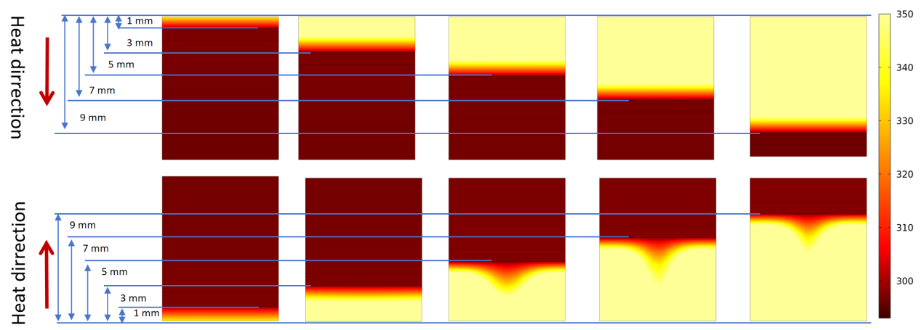
Fig.S1. 4
The temperature distribution of Model-T and Model-B when the heat exchange layers are set at several millimetre away from the heating boundary. All of these models are heated for 10 s.

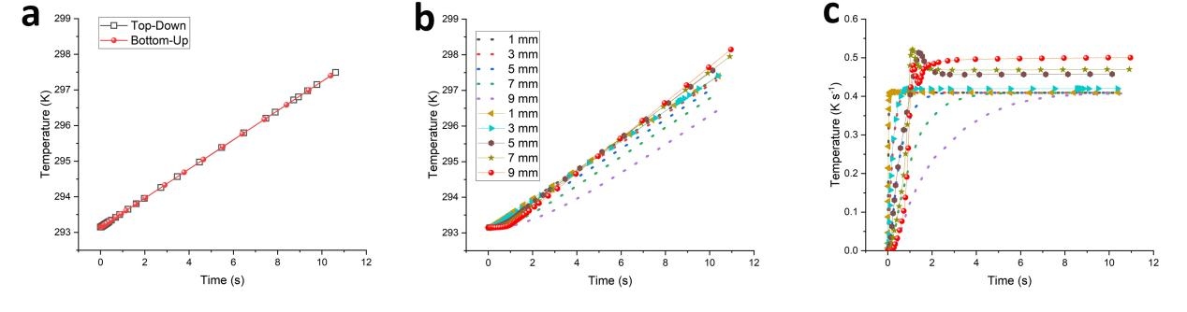
Fig.S1. 5
The temperature evolution of surfaces of aluminum layer set 1 mm away from the heating layer, while the heat directions are opposite in two models (a). The temperature evolution of Model-T and Model-B with different thickness of air gap (b). The temperature increasing rate of the aluminum layer surfaces in Model-T and Model-B with different thickness of air gap (c). The legends in (b) are shared by (c).
The distance between the aluminum layer and the heating area influences the airflow in the gap. When the thickness of the air gap (TAG) is only 1.0 mm, the convection of the air is hindered. From the temperature distribution in Fig. S1.4, we can observe an obvious difference between the Top-Down and Bottom-Up models. The temperature evolution of the aluminum surfaces is monitored and presented in Fig. S1.5a. It is evident that the temperature evolution of the aluminum surfaces is completely the same. In the heat transfer models, the heat transfer resistance of the air is the highest due to its larger thickness and poor thermal conductivity (k_{(aluminum)}: 238 W m⁻¹ K⁻¹, k_{(air)}: 2.623~6.76×10⁻² W m⁻¹ K⁻¹ between 300 and 900 K.).(2) The k_{(air)} in the Comsol model is calculated according to the function below:
k_{(air)} = -2.28 ×10⁻³+ 1.15 × 10⁻⁴ × T - 7.90 × 10⁻⁸ × T²+4.12 × 10⁻¹¹ ×T³ - 7.44 10⁻¹⁵ × T⁴ (W m⁻¹ K⁻¹)
where T is Kelvin temperature in K.
At room temperature, k(air) is only 2.6×10⁻² W m⁻¹ K⁻¹, which is thousands of times lower than that of aluminum. Thus, the heat transfer rate is dominated by the state of the air gap. When the TAG is 1.0 mm, the heat transfer rate in both the Top-Down and Bottom-Up models is limited by k(air). However, the heat transfer rate increases with the TAG when the TAG is larger than 3.0 mm (Fig. S1.5b~c). More space allows for the convection of air in the gap, which boosts the heat transfer rate. For the Bottom-Up model, the convection of air in the gap is observed in the temperature distribution in Fig. S1.4. In our model, when the TAG is 1.0 mm, there is no difference in any heating direction (Top-Down or Bottom-Up, see Fig. S1.). This is because convection is limited in narrow spaces due to the viscous drag that reduces air flow.(3) The heat transfer is dominated by heat conduction in both cases. When the heating direction is Top-Down, it takes longer to reach a specific temperature with increasing TAG (Fig. S1.5). However, in the case where the heating direction is Bottom-Up, the temperature increase rate (TIR) does not change when the TAG is increased to 3.0 mm. For those with a larger TAG, the TIR decreases with TAG only during the initial several seconds. The temperature increase rate increases with TAG after 5 seconds. This should also be attributed to the high heat transfer efficiency (HTE) arising from convection. HTE can be defined as the time consumed for a specific amount of heat transfer over a specific distance. Later experimental results confirmed this theoretical prediction.
The natural evaporating direction in the i-MSS allows for a larger distance between the EPs. Different from the i-MSS with the Model-T structure, which requires a thin air gap for high efficiency, the larger air distance in the i-MSS is also important to avoid contamination due to the splash of brine from explosive boiling. The efficiency does not decrease when the distance increases to 1.0 cm (Fig. S1.5). This feature of the i-MSS allows operation under high energy power input.

S1.3 The influence of separation of the space on heat transport
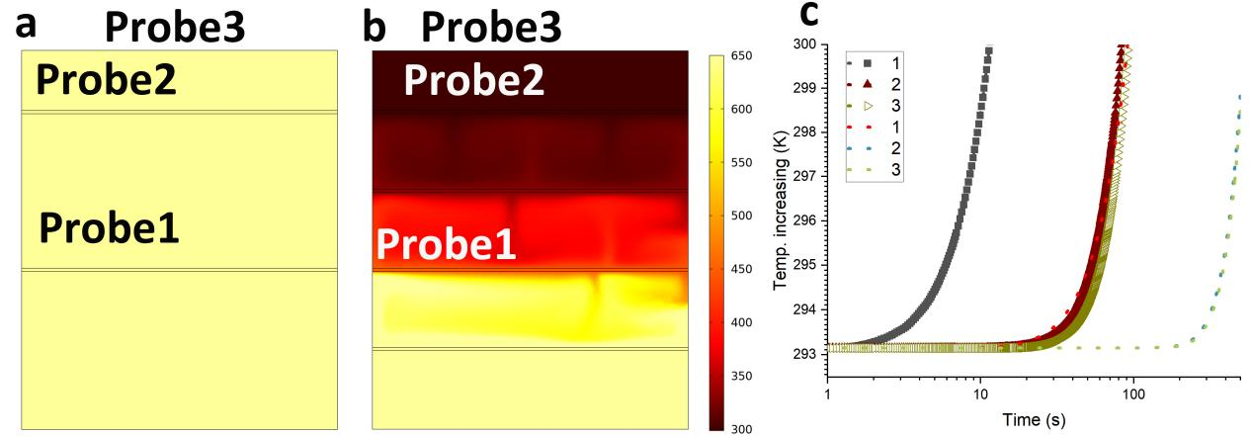
Fig.S1. 6
The influence of addition of aluminum layers on heat transfer. For both models the heat inlet from bottom is at a power of 1000 W m⁻². Model in (a) has 2 aluminum layers, while the one in (b) has two more aluminum layer in the middle of the air gap. The temperature probes are set on the aluminum layers at the same height. (c) shows the temperature evolution before (curves with symbols) and after inserting more aluminum layers (dashed lines).
Two models with dimensions of 12×10 cm are established and presented in Fig. S1.6a~b. Except for the model in Fig. S1.6b, which has two additional aluminum layers within the air gap, all other conditions are the same for both models. Three probes are set on the surfaces of the aluminum layers at the same height on the models. It is clear that the temperature of the model with fewer aluminum layers increases much faster than that of the model with two additional aluminum layers under the same conditions. This means that for an i-MSS with more layers, the heat transfer resistance is greater. It indicates that for an i-MSS, a smaller distance will significantly hinder heat transfer. The heat transfer rate is also crucial for boosting the i-MSS to reach its optimal working condition and enhance daily water production due to the limited light-illuminating time in one day.

S1.4 The effectiveness of nozzle
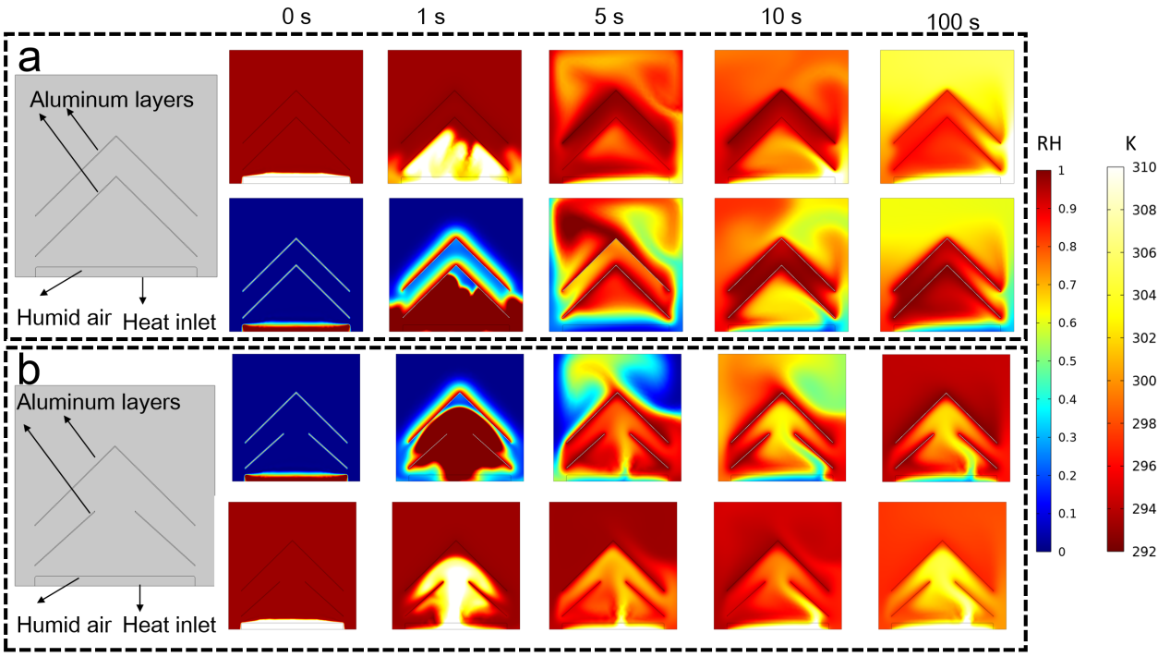
Fig.S1. 7
The temperature and relative humidity (RH) evolution in model 1 without a nozzle (a) or model 2 with a nozzle (b) under a heat inlet of 100 W at the bottom. Except the nozzle in the first layer of the model below, they have the complete same initial parameters. The scale bars for RH and temperature are shared by the both models.
On the other hand, the increased pressure in one stage is a double-edged sword. The higher pressure is beneficial for vapor condensation and heat transfer to the next stage, but harmful to water evaporation due to the increased partial pressure of vapor in the chamber. The small nozzles allow the incondensable air and excessive vapor to escape to the pot above, maintaining the pressure in each stage at atmospheric pressure. To analyze the positive effect of the nozzle in each stage, a simplified one-stage model with a nozzle (a) and a model without a nozzle are established, as shown in Fig. S1.7a and Fig. S1.7b, respectively. The temperature distribution along with heating time is presented in Fig. S1.7. According to the temperature distribution, we can observe the heat transfer of the hot air in the models. In the one without a nozzle in the middle, the hot air escapes from the edge at the first aluminum layer after the layer is filled (Fig. S1.7a, 5 s). The hot air continuously flows to the top (after 100 s) without heating the first layer to generate water vapor and allowing the hot vapor to condense on the layer. This means that the latent heat of the steam cannot be recycled effectively. However, the nozzle allows the excess vapor to flow through it and stay in the bottom rather than flowing away to the top. This makes the recovery of the latent heat of the excess vapor possible. As we can see, the hot air generated from the heating plate at the bottom always flows through the nozzle and stays on the bottom side, while the temperature of the air at the top increases slowly because the heat flow needs to heat the aluminum layers one by one before reaching the top air. This is ideal for the recycling of the latent heat. Another interesting property of model 2 is that the hot air from the bottom does not flow directly and straight to the nozzle but flows to the shell of the aluminum layer first, even under such an ideal numerical model. This property is also crucial for water vapor condensation.

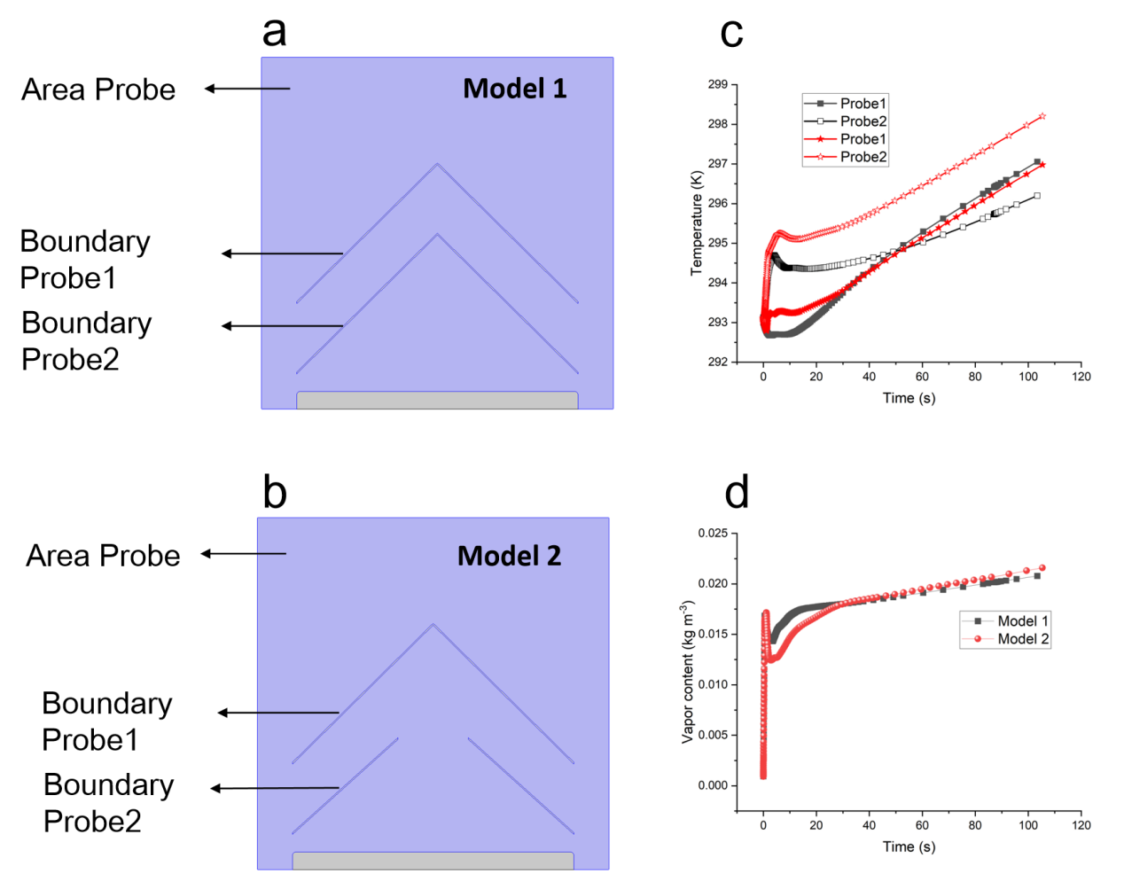
Fig.S1. 8 The boundary and area probes set in model 2 with nozzle (a) or model 1 without nozzle (b) under a heat inlet of 100 W at the bottom. c shows the evolution of the temperature data acquired by the related boundary probes in model 1 (black) and model 2 (red). d is the water vapor content in the area monitored by the area probe.
In Fig. S1.8c, the temperature of the layers in both models increases with time. The temperature of the first layer (from the bottom) in model 2 is always higher than that in model 1 because of the flow route of the hot air. The temperature of the top layer in model 2 is surpassed by that in model 1 after a few seconds (Fig. S1.8c). This arises from the hot air flowing directly to the top rather than due to the higher heat transfer efficiency of model 1 (Fig. S1.7a, 5 s). Nevertheless, the temperature increase rate of model 2 is the same as that of model 1 after 50 s. This confirms the excellent heat transfer in model 2. As a result, the water content in the air of model 2 increases and becomes higher than that in model 1. More heat is used for water evaporation on the aluminum surfaces in model 2.

S1.5 The latent recovery model of one unit stage for experimental test
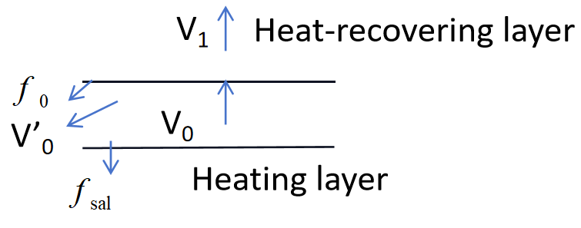
Fig.S1. 9
Latent recovery model for evaporator with one unit stage.
(SE1.0)
The temperature of the i-MSS in our case is lower than 373.15 K. The radiative heat loss of the layers is 329.79 to 439.72 W m⁻² according to the Stefan-Boltzmann law (SE1.0), when an emissivity (ε) of 0.3 to 0.4 is applied for aluminum. As the layers with high temperature are always covered by a layer with a lower temperature above, through which the radiative energy from beneath can be recovered well, the edge of the plate is negligible due to the small relative area. Thus, all the models we used to simulate the latent recovery did not include the radiative heat loss below. However, for the bottom light-harvesting layer, it is 16 to 22% (the downward half part of it) energy loss without any protection under an irradiation power of 1000 W m⁻².
If the evaporation of the heating layer is not influenced by the layer above and f_{sal} is 0, ${∆W}_{0}$ is the weight change of the heating layer.
(SE1.1)
V₀=${∆W}_{0}{=f}_{0}$+V’₀
After setting a heat-recovering layer, the weight change of the total evaporator is
(SE1.2)
$∆$W₁=V₁+$f_{0}$+V’₀
(SE1.3)
V₁=${∆W}_{1}−{∆W}_{0}$
(SE1.4)
$f_{0}$=$K_{0}V_{0}$
(SE1.5)
$V_{1}$= $\frac{K_{0}V_{0}(H_{w}−{∆T}_{1}C)}{H_{1}}$
(SE1.6)
$\frac{V_{1}}{V_{0}}= \frac{K_{0}(H_{w}−{∆T}_{1}C)}{H_{1}}=\frac{{∆W}_{1}−{∆W}_{0}}{V_{0}}$
(SE1.7)
$K_{0}=\frac{（{∆W}_{1}−{∆W}_{0}）H_{1}}{V_{0}(H_{w}−{∆T}_{1}C)}$
when the vapor from the heating layer is completely transformed into water (K₀ is 100 %) and H₁ is H₁ = H_{w}(1-Y₁),(3) then
$\frac{V_{1}}{V_{0}}= \frac{H_{w}−{∆T}_{1}C}{H_{1}}$= $\frac{H_{w}−{∆T}_{1}C}{H_{w}(1−Y_{1})}$ (SE1.8)
Under such ideal conditions, the V₁/V₀ equals 88% when the ΔT₁ is 70 K. It means that even if the vapor were to condense into water completely and the heat is used for the evaporation on the top surface, the condensed water would still take 12% of the heat out of the chamber.
We used pure water as the water source for the K₀ measurement. After three repetitions of the experiment, K₀ is 88±1%.

S1.6 The latent recovery models for i-MSS
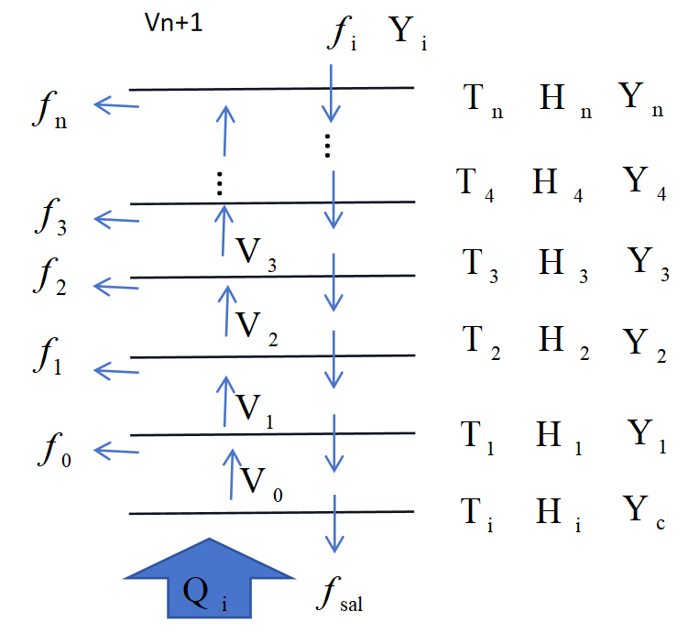
Fig.S1. 10
Mathematical model of Model-B.
To investigate the heat transfer and latent heat recovery through mass flow in i-MSS, a mathematical model is established and shown in Fig.S1.10. The heat input from the bottom and the saline (f_{i} ~ f_{sal}) come down from the top of the model. The vapor generated in each layer (V_{i} ~ V_{n}) is condensed by the layer above. At the same time, the condensed water flow (f₀ ~ f_{n}) out of each stage and the latent heat is used by the water on the top surface of each stage to evaporate. The bottom layer is the heat layer, where the heat is input.
The condensed water flow can be calculated as below,
(SE2.1)
where the flow of concentrated saline, f_{sal} takes some heat out of the system. ∆T_{i} is the temperature difference between the first condensing layer (T_{i}) and the room temperature (T_{r}, 298.15 ℃). K is the conversion ratio from vapor to condensed water.
∆T_{i} = T_{i} - T_{r}
(SE2.2)
is small and negligible.(1)
Thus,
(SE2.3)

(SE2.4)
Obviously, the less brine means less heat loss from the concentrated brine flow from the heating layer. If K₀ is 100%, the temperature of the heating layer is 100℃, and the room temperature is 25℃, the heat taken out by the concentrated brine (0.15 kg) is about 1.8% of the latent heat from 1 kg of 100 ℃ vapor. Under such condition, the water recovery ratio is 88%.
(SE2.5)

Similarly, we have
(SE2.6)
The total vapor evaporated in the i-MSS
(SE2.7)

Then,
(SE2.8)

If the temperature difference between the layers nearby is the same in whole i-MSS
(SE2.9)
(SE2.10)
Then
(SE2.11)

The latent heat recovery efficiency (L_{RE}) and vapor generation efficiency (VGE) can be calculated as below,
(SE2.12)

let
(SE2.13)

(SE2.14)

(SE2.15)

(SE2.16)

If K₀=K₁=K₂=...=K_{n-1}=100%,
then
(SE2.17)
Because the specific heat (C_{w}) and latent heat (H_{w}) are constants, the b and u can be calculated when ∆T₀ and t are given. Then the L_{RE} can be calculated accordingly.
Under this situation, the weight of the total fresh water is equal to that of the total weight of vapor generated.
(SE2.18)

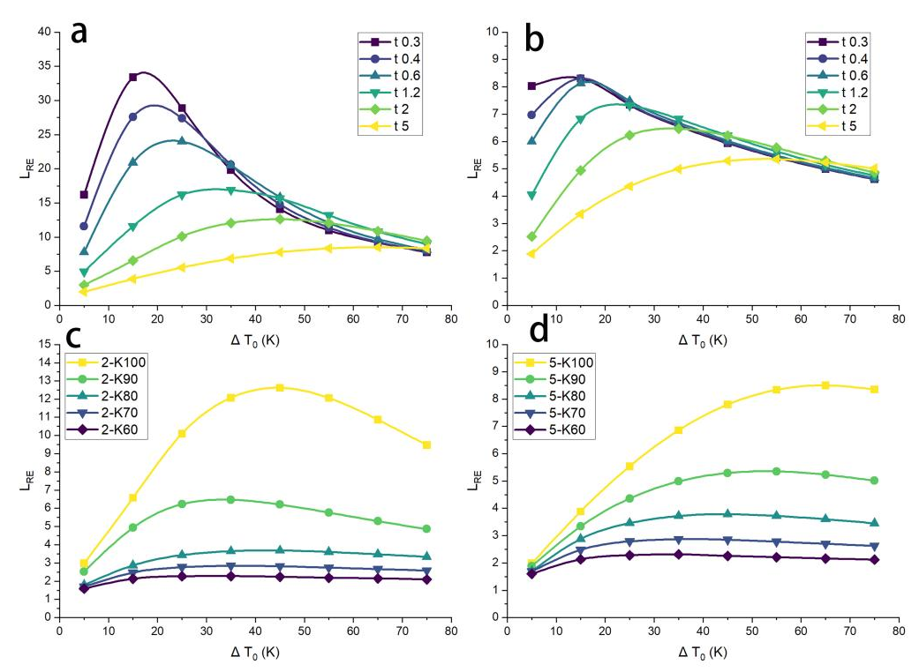
Fig.S1. 11
L_{RE} calculated from the mathematical model above. (a) shows the L_{RE} evolution along with the ∆T₀ and t, when the vapor to water conversion ratio K is 100%. (b) presents the L_{RE} evolution along with the ∆T₀ when the temperature difference between the layers is from 0.3~5 K (vapor to water conversion ratio K is 90%). (c) presents the L_{RE} evolution along with the ∆T₀ when the temperature difference between the layers is 2 K and the vapor to water conversion ratio K is from 60~100%. (d) presents the L_{RE} evolution along with the ∆T₀ when the temperature difference between the layers is 5 K and the vapor to water conversion ratio K is from 60~100%.
The L_{RE} is calculated according to ES2.17 and presented in Fig. S1.11. The higher vapor to water conversion ratio in each stage is critical for the L_{RE.} When the vapor to water conversion ratio K is 100%, the surprisingly high L_{RE} of ~ 34 is obtained. It means under such ideal condition vapor generated in this kind of i-MSS can be up to ~ 49.98 kg kWh⁻¹ (H_{w}=2,455.6 kJ kg⁻¹), less than 4.7% of thermodynamic limit.(4) However, it needs the vapor to water conversion ratio K is 100% and 50 stages. If the K of each stage are equal and decrease to 90%, the L_{RE} drops to 9.12, and the weight of vapor production is 13.4 kg kWh⁻¹. Improving the K should be the most important work need to do in the coming future. The L_{RE} is influenced a lot by the temperature difference between the initial condensing layer and environment (∆T₀). When the temperature difference between the layers (t) is lower than 5 K, an obvious peak L_{RE} around 15 ~ 35 K is observed. The L_{RE} fluctuation arises from the heat removed by the condensed water (SE2.4 and ES2.6). The higher ∆T₀ gives the chance to set more stages but also removes more heat by the condensed water flow (f_{n}).
Besides, the temperature difference between the layers is only 0.3 K. This is possible for water with low salinity but not applicable for seawater or other highly concentrated salines. The driving force for the separation of salt and water depends on the difference in water vapor pressure between the surfaces of the evaporating and condensing layers. Higher salinity requires a higher temperature difference between the evaporating and condensing layers for distillation (discussed below Fig. S1.12). Thus, we explored the L_{RE} evolution along with the ΔT₀ as the temperature difference (ΔT) between the evaporating and condensing layers ranges from 0.3 to 10 K (Fig. S1.11b). The larger ΔT results in a smaller L_{RE}. This is because a larger ΔT in one i-MSS allows fewer stages that can actually operate (as the layer temperature drops to room temperature).
The calculation above is base on the vapor generated on the bottom layer. For energy to vapor generation, the radiative heat loss of the layers is 16~22% should be considered (SE1.0). Thus, all the L_{RE} above should be deducted 16~22% to get the theoretical limit of energy-vapor efficiency (η_{TL}) for this model.
$μ_{TL}=L_{RE}×（0.78\sim 0.84）×100\%$ (SE2.19)
The η_{TL} is in the range of 39.0~42.0 kg kWh⁻¹ under ideal condition, where the vapor to water conversion ratio K is 100%. It is 3.7~4.0% of thermodynamic limit.(4)
In fact, the separation of salt and water not only depends on the evaporation of water but is also influenced by the absorption of water vapor by the concentrated saline in one stage. The driving force is the difference in water vapor pressure between the surfaces of the evaporating and condensing layers and can be described by Raoult's law as follows:(4, 5),
(SE2.20)
where a_{n} is the activity of water in saline and p_{v(n, et)} is the water vapor pressure at the temperature of evaporating layer. a_{w} and p_{w} are the activity and water vapor pressure of pure water at a specific temperature of condensation surface. a_{n} can be calculated according to the salinity as below,
(SE2.21)
$a_{n}= \frac{M_{NaCl}(1−Y_{n})}{M_{NaCl}(1−Y_{n})+2M_{H_{2}O}Y_{n}}=\frac{M_{NaCl}}{M_{NaCl}+2M_{H_{2}O}\frac{Y_{ n}}{(1−Y_{n})}}$
$= \frac{58.5}{58.5+36\frac{Y_{ n}}{(1−Y_{n})}}$ = (1+0.615$\frac{Y_{ n}}{(1−Y_{n})}$)⁻¹
where Y_{n} is the salinity of saline on the top surface of the evaporating layer. M_{NaCl} and M_{H2O} are the molar weight of NaCl and H₂O. The vapour pressure (p_{v}) can be evaluated via Antoine’s semi-empirical correlation:
(SE2.22)
where A, B and C are material specific constants, in this case equal to 8.07, 1,730.63 and 233.42, respectively. T is the Celsius temperature. The minimum temperature difference t_{min} for water distillation can be calculated according to the combination of SE2.20~SE2.22.

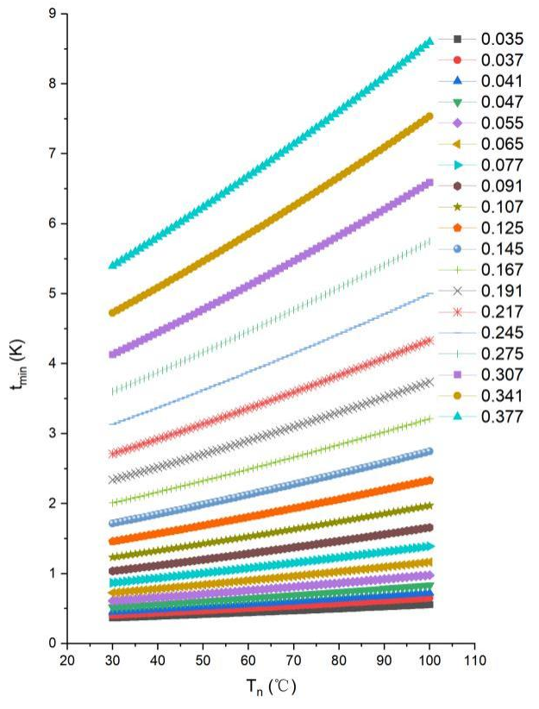
Fig.S1. 12
The evolution of the minimum temperature difference t_{min} for water distillation along with the temperature of the evaporating layer, when the salinity increases from 0.035~0.377 kg kg⁻¹.
In Fig.S1.12, the t_{min} within the stages needed when the evaporating layer is at different temperature. The higher the salinity is on the evaporating layer, it needs the bigger temperature difference between the evaporating and condensing layers. It indicates that the largest t_{min} should be set at the stage where the salinity on the evaporating layer is the highest in the whole i-MSS. Besides, 5 K is enough to separate the water in the saline with a salinity of 0.25 kg kg⁻¹, which is a very high salt concentration. Thus, the influence of K on L_{RE}, when the ∆T₀ equals to 5 K, is calculated and shown in Fig. S1.11c. To get a WPR greater than 5 kg m⁻² h⁻¹ under 1 sun, L_{RE} of 3.57 is required. It means the K should not be less than 80%. For waste water with low salinity, decrease the temperature is beneficial for improving L_{RE}.
In summary, the ultrahigh VGE and salt rejecting ability of the i-MSS arises from the heat and mass transfer inside it, thus enabling a high efficient distillation and salt rejection. Under ideal condition, one distillation unit containing two EP can generate 88% more vapor than the vapor from the bottom heating layer (Supplementary Information 1.3~1.4). The VGE is 188% under such condition. From the model for i-MSS, out of which the concentrated saline continuously flowing (SE2.1), the vapor generated on the heating surface (v₀) depends upon the layer temperature and the saline flow flux (f_{sal}), when the input heat Q_{i} is same (SE2.4). Less f_{sal} is not only beneficial for prevention of heat loss on the heating layer and decrease the liquid brine discharge, but also critical to increase the salinity of saline and increase the water recovery (R_{w}, SE2.5). According to SE2.4 and SE2.6, the heat mainly removed by the the concentrated brine flow and the fresh water with high temperature. It is crucial to recover the heat from them. Especially, that heat recovery can speed up the initialization of water production in winter, as the temperature of the i-MSS need to be increased first .
The total vapor evaporated in the i-MSS can be calculated according to (SE2.7~SE2.8). Then, the latent heat recovery efficiency (L_{RE}) and VGE can be calculated (SE2.12) under a specific combination of ∆T₀ and t (Fig. S1.12). For feeding water with low salinity, a less temperature difference between the surfaces of evaporating and condensing layers is required and can give a peak VGE up to ~3400% under ideal conditions. In regard to the driving force of water separation of saline is the difference of water vapour pressure between the surfaces of evaporating and condensing layers, the minimum temperature difference (t_{min}) for water distillation is calculated for saline with various salinity (Fig. S1.12). It is found that 5 K is enough to separate the water in the saline with a salinity of 0.25 kg kg⁻¹ in the whole temperature range. If the vapor to water conversion ratio (K) is 100%, an attractive VGE of 850% and 12.5 kg kWh⁻¹ vapor production rate are expected (Fig. S1.11c). K should not be less than 80% for a commercial WPR target (> 5 kg m⁻² h⁻¹).
The maximum of heat input to the i-MSS depends on the flow rate of the feeding water. In the present design, it is 20 mL min⁻¹, which needs 793.3 W of heat for its total evaporation without latent heat recovery. It corresponds to 48.4 kW m⁻² input energy density. That is a critical value for it determines the maximum size of LC. Compared to once evaporation, the highest WPR is increased by 4.2 times here, the input energy density is 11.5 kW m⁻² for the evaporation of the maximum flow of feeding water. It means the current i-MSS can be operated under about 11.5 sun irradiation.

S1.7 Exploration of mass transport

Mass transport in the whole i-MSS
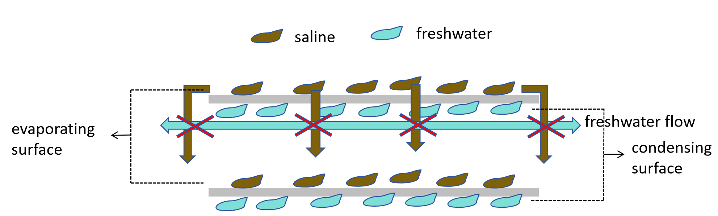
Fig.S1. 13
Space intersection of the saline and freshwater flow on the stages of i-MSS.

S1.8 Photo-thermal heater
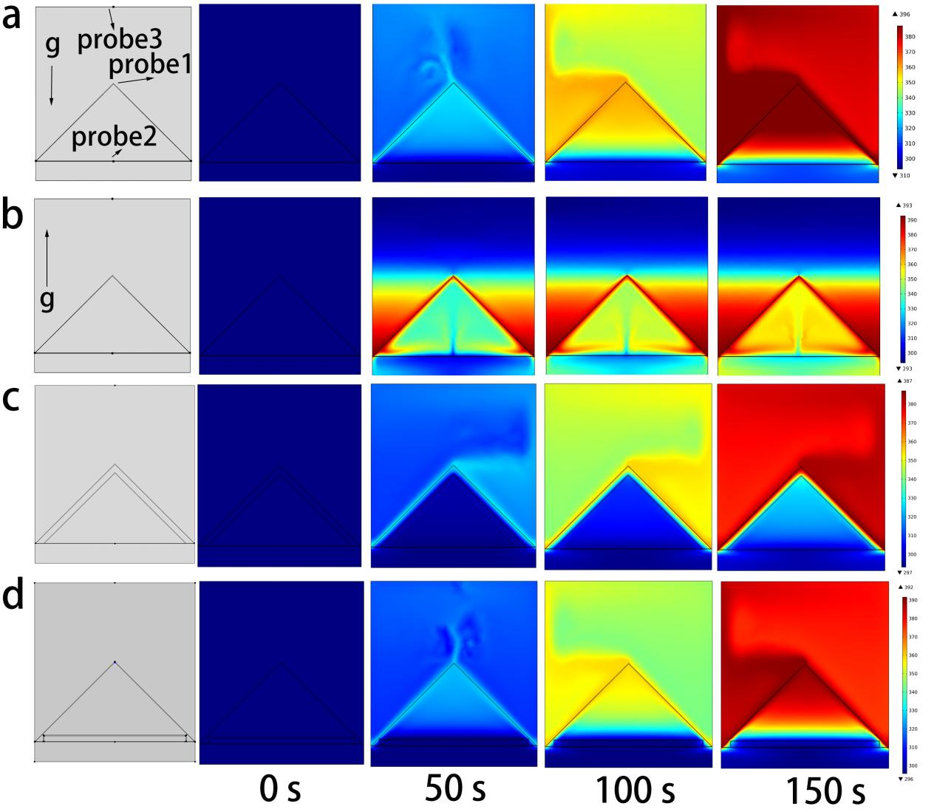
Fig.S1. 15.
The distribution and evolution of temperature in different models of photo-thermal heaters. The top surfaces of the triangles are the photo-thermal surfaces where the solar irradiation transforms into therm for heating the area out of the triangles. The inner areas of the triangles are formed a chamber. Three probes are set at the same positions for all models. (a) Shows the heater structure of Model-B studied in this work, where the heat input is from bottom. (b) Shows a heater model has the same structure, but the gravity is reversed. It is the situation for the heater of Model-T, where the heat input direction is parallel with that of the gravity. In (c) and (d) models, the gravity is set the same as the model in (a). But one more layer of PMMA is added to form a layer of air in triangle or tetragonal shape as heat insulating layer.

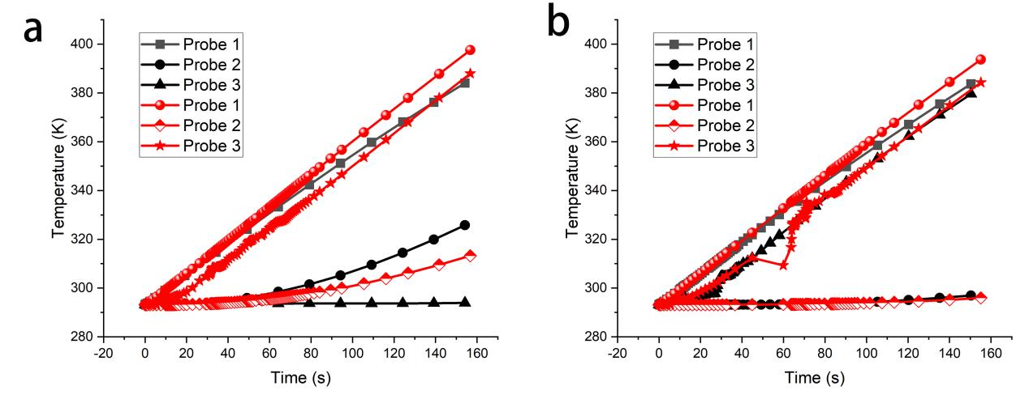
Fig.S1. 16
The temperature evolution monitored by the probes set as in Fig.S1. 15. (a) For our photo-thermal heater, the heat input direction is against that of the gravity (red). (b) The temperature evolution monitored by the probes when triangle (black) or tetragonal (red) shape heat insulating layer are applied. `
After comparing the temperature distributions in Fig.S1. 15 (a) and (b), it is evident that the heater structure of Model-B studied in this work has significant advantages. The area outside the triangles is effectively heated (Fig.S1. 16 (a)), and the side of the heater facing the light incidence is parallel to the convection of the air, allowing the heat loss to be easily insulated by a layer of air [Fig.S1. 16 (c) and Fig.S1. 16 (d)]. A simple tetragonal-shaped heat-insulating layer is even more effective. The area where probe 3 is located is heated to over 100 ℃, whereas the temperature of the surface on the light-incident side remains almost unchanged. This indicates that an excellent heat-insulating efficiency can be easily achieved with this design.

S1.9 Structure design of the EPs

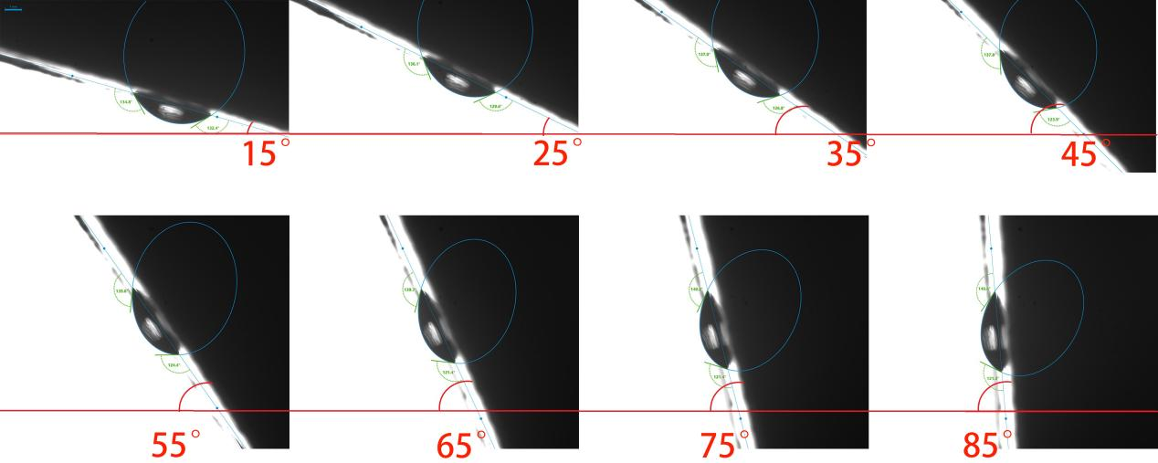
Fig.S1. 17
Images of contacting angle evolution of water on the aluminum surface with the change of the tilted angle . The advance and receding angles are measured from the above pictures

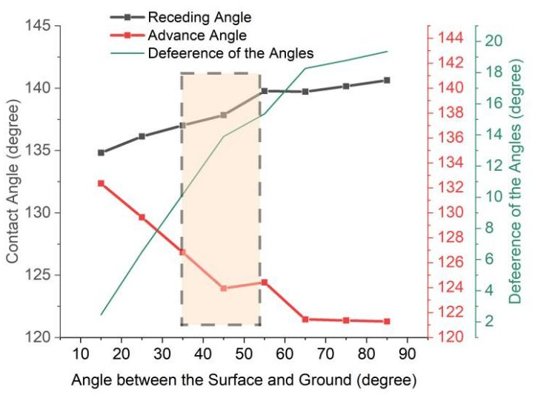
Fig.S1. 18
Evolution of receding and advance angle of the water droplet on the surface of aluminum plate with the change of the tilted angle. The changes of the difference of the receding and advance angle is presented.
The condensed water should be promptly removed from the evaporating surface to prevent secondary evaporation. The condensed water droplets are driven out of the chamber by the force of gravity. However, the viscous force of water on the bottom surface of the aluminum plate impedes the movement of the condensed water. To determine the optimal tilt angle for the aluminum plate, the receding and advancing angles of the water droplet on the bottom surface of the aluminum plate are measured. A larger difference between the receding and advancing angles signifies a greater driving force for the movement of water droplets. This difference increases rapidly when the tilt angle relative to the ground exceeds 30 degrees (shadowed area in Fig.S1 18).

Verification of the effectiveness of nozzles
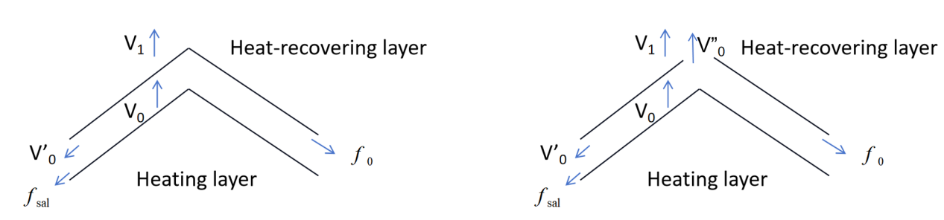
Fig.S1. 19
The mass flow in the two-stage stiller when the nozzle is closed or open.
In the two stage situation shown in Fig. S1. 19, the EPs are covered by porous media (bamboo fabric or carbon cloth). Proper amount of water added on to the top of the heating layer and make sure the water will not flow out. Under proper control, the total weight change (M_{t}) of the whole stiller is from the vapor escaped as gas and f₀ . The f_{sal} is 0 g. In this study, the amount of f₀ is low and does not flow down from the edge. All the distillates are collected and weighed by absorbing the distillates on a tissue with known weight. For the nozzle off situation, the mass flows have the relationship below:
(SE2.23)
When the nozzle is on, we have:
(SE2.24)
Because of
(SE2.25)
then
(SE2.26)

For both cases, V₀ and V₁ can be measured by monitoring the weight change of the related EPs. The vapor regenerated rate can be define and calculated below:
(SE2.27)

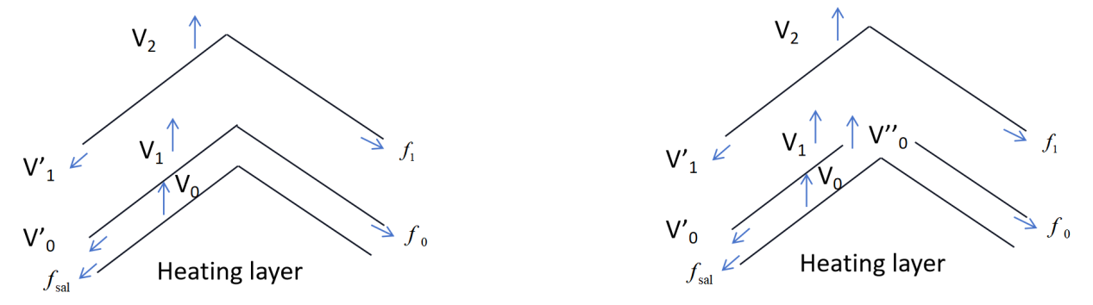
Fig.S1. 20
The mass flow in the two-stage stiller when the nozzle is closed (left) or open (right).
In the three stage situation shown in Fig. S1. 15, similarly we have the relationship below when f_{sal} is 0 g and the nozzle is off.
(SE2.28)
When the nozzle is on,
(SE2.29)
To get the accurate weight of vapor to the third EP, the edge between the first EP and the second EP are sealed to avoid gas leakage. V’₀ is 0 g. Then,
(SE2.30)

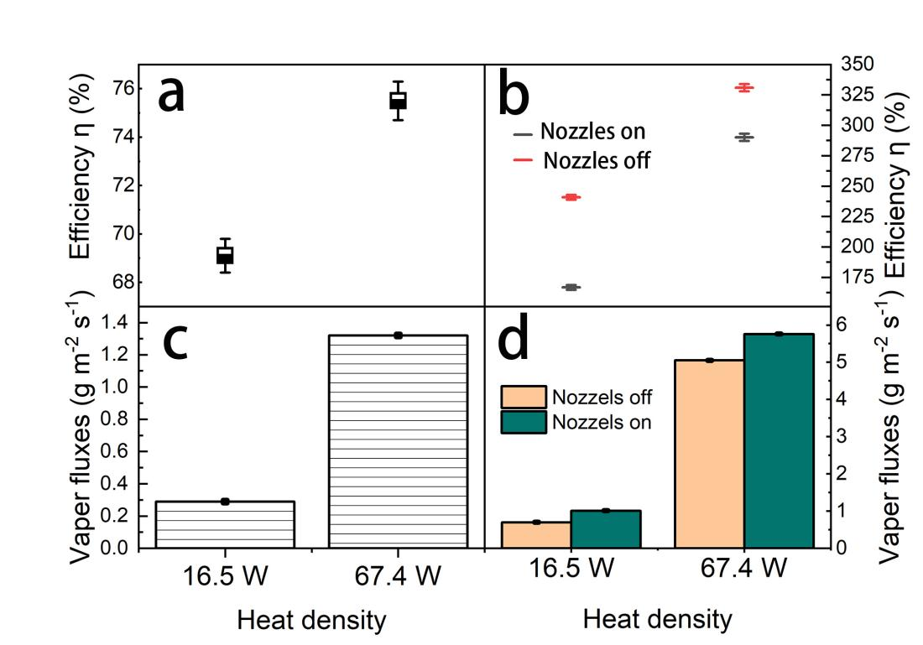
Fig.S1. 21
Nozzles influence on the vapor generation rate and energy-vapor efficiency (η) at different power input when one (a~c) or 15 EPs (b~d) are applied.

Section 2. Fabrication of i-MSS prototype.

S2.1 Design and structural details of the key parts
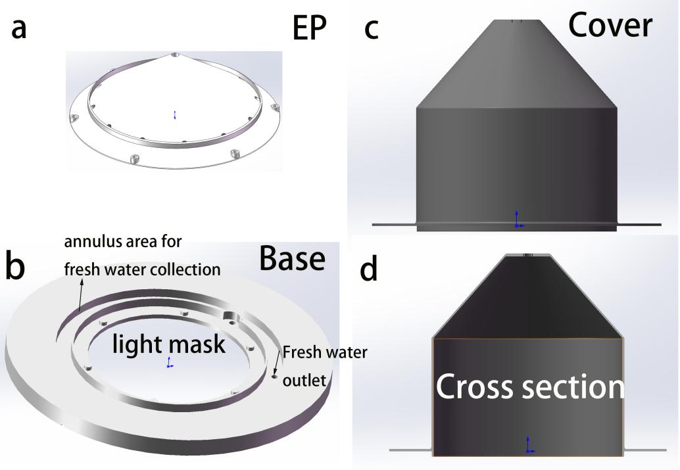
Fig. S2. 1
Key parts of the i-MSS prototype. (a) and (b) are the structure of the EPs and the base. (c) and (d) are the cover and its cross sectional view.
The basic structure of the prototype is designed based on the theoretical calculations and experimental results discussed above. The key component is the EPs of the prototype. For indoor and small-scale experiments, a conical EPs is designed. The top angle of the conical EPs is set at 110 degrees to achieve a 35-degree tilt angle of the EP surface relative to the horizon. This tilt angle design is a compromise between the effects of tilt angle on salinity and the flow of condensed water droplets. While a larger tilt angle facilitates the movement of condensed water (Fig.S1. 16), it hinders salt removal (Fig.S1. 14). The 3D structure of the EP is shown in Fig. S2.1a. A 5~10 mm high wall is designed to prevent saline flow to the edge. The wall’s height also controls the distance between EPs. 12 holes with a 5 mm diameter are positioned along the wall to allow saline to flow to the next EP below. The EPs are fabricated using 3D printing with aluminum, without additional polishing. On the top side, the edge is covered with a layer of PU foam to minimize heat loss and prevent reheating of the distillate from the EP above. To enhance the condensation efficiency of the EPs, the bottom side of the EPs is coated with a thin layer of hydrophobic material.
A base was designed to support the EPs, the cover, and to collect distillates. Additionally, the middle window of the base serves as a mask to control the incident light from the solar simulator. An annular manager is designed for distillate collection and water outlet, with 10 mm high walls. The base is constructed from a piece of polyethylene. The cover of the i-MSS is 3D printed from Nylon reinforced with glass fiber (Fig. S2.1c~d). The cover is then enveloped with a silica rubber pipe to harvest heat from the vapor leaked from the EPs, thereby enhancing its condensation capability. The feeding water in the pipe can be preheated. To minimize heat loss, a ~2 cm thick layer of PU foam is coated on the pipes. Aluminum foil is used to shield the PU foam from violet light irradiation and environmental influences.

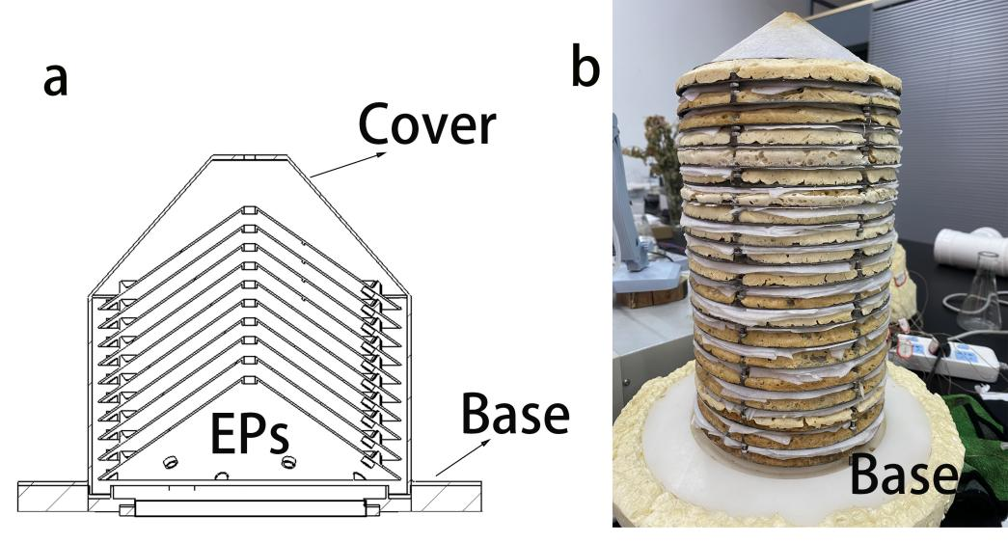
Fig. S2. 2
Assemble of the parts. (a) is the cross sectional view of a i-MSS containing ten stages. (b) is a photo picture of a i-MSS without cover. It has 20 layers of EPs.
The EPs are stacked together on a base, which features an annular area for collecting fresh water droplets from the edges of the EPs and a mask window for controlling the incident light to the photothermal layer. The direction or position of the EPs is adjusted using screws at the edges (Fig. S2. 2a). The EPs are stacked one atop the other (Fig. S2. 2b). Between each EP, a layer of fabric is placed over the PU foam. This layer prevents vapor leakage within the stage while allowing distillates to flow out of the stage.

S2.2 Preparation of porous media for evaporating layer

The morphology of the porous medias
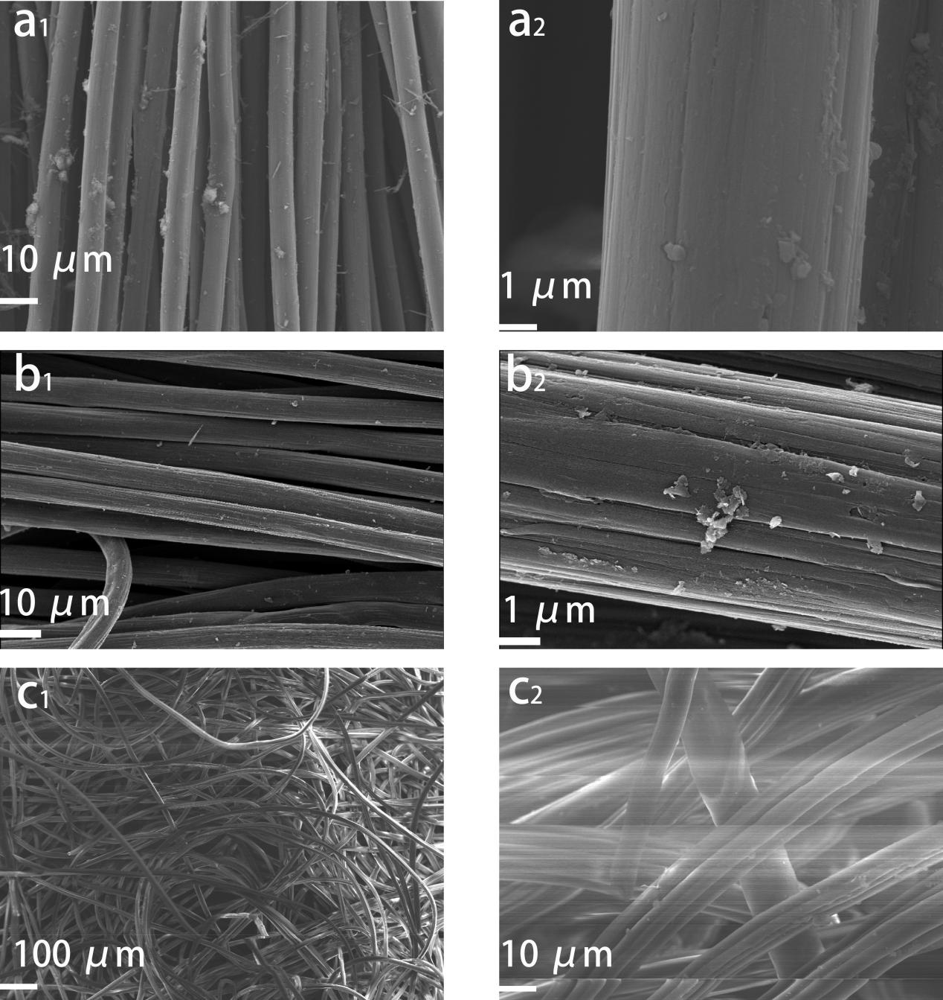
Fig. S2. 3
The SEM images of the evaporation layer on top of the EPs. (a₁~a₂) The fiber of carbon cloth from the market. (b₁~b₂) The fiber of carbon cloth annealed at 400 ℃ for 4 h. (c₁~c₂) The fiber of hydrophilic bamboo tissue from the market.
The morphology of the samples was characterized using SEM (ZEISS·Gemini-300, Germany Carl Zeiss). A layer of hydrophilic tissue was used to transfer water on the EPs. The hydrophilic tissue, commonly available in the market as towel material, is primarily composed of bamboo fibers. The tissue has a thickness of 1 mm and a porosity of approximately 70%. For this purpose, the tissue was cut into a shape that properly covers the EPs and directs saline flow to the next EP. We analyzed three materials: hydrophilic bamboo tissue made from bamboo fibers (Fabric), carbon cloth (CC), and carbon cloth annealed at high temperatures in air (CC-H). SEM images in Fig. S2. 3 reveal the smooth surface of CC fibers. In contrast, the surface of the fibers in CC-H becomes rougher and is filled with cracks along the fiber, which are beneficial for water transfer. The bamboo tissue has thinner fibers.

S2.3 Properties of the evaporating media
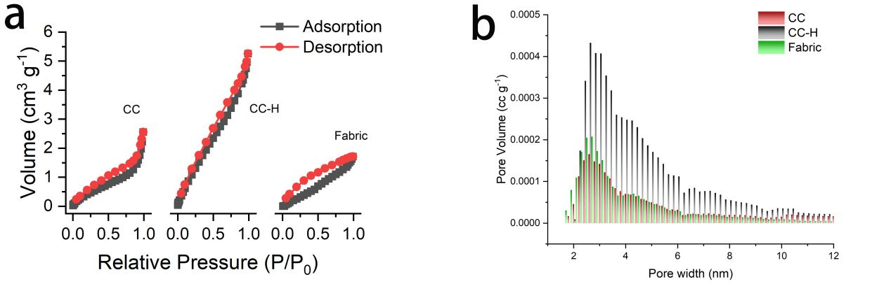
Fig. S2. 4
(a) N₂ adsorption–desorption isotherms of the three types of tissues. (b) The pore volume distribution of the materials.

BET area of the porous media
Approximately 25 mg of each material was accurately weighed and placed at 120 ℃ under high vacuum (< 50 mTorr) overnight in an oven-dried BET tube to remove adsorbed water. The samples were then weighed again and transferred to the Quantachrome BET instrument. N2 isotherms were collected at 77 K from a relative pressure range of 0.001 to 1.000.
The BET surface area is similar for CC and bamboo Fabric. However, the BET area of CC-H shows significant improvement compared to the original CC, particularly in the pore volume between 3 and 8 nm. This observation is consistent with the results from the SEM images.

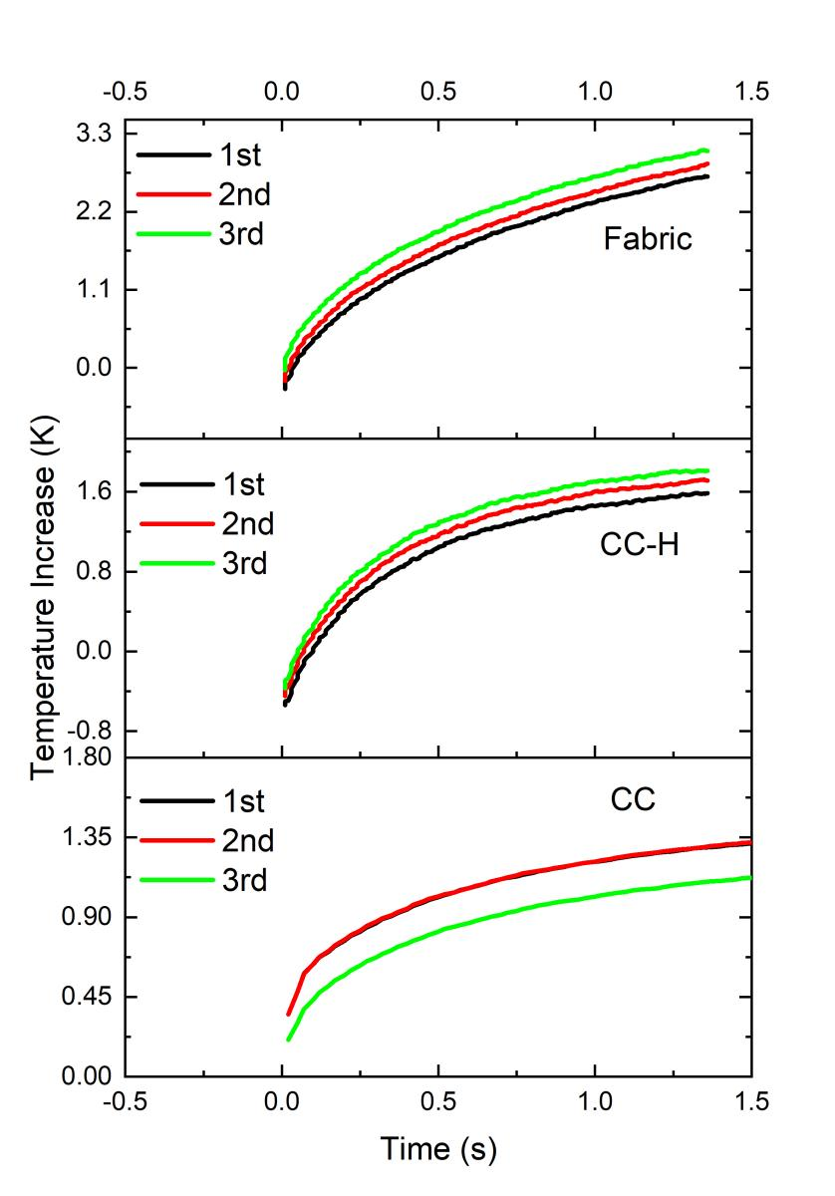
Fig. S2. 5
Temperature increase curves of different materials. They are obtained by transient plane heat source (hot disc)method according to ISO 22007-2.

The thermal conductivity of the porous media
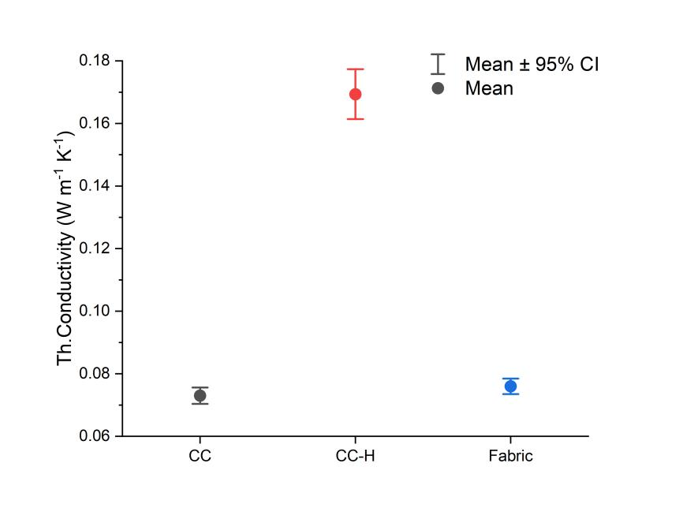
Fig. S2. 6
The thermal conductivity is calculated according to the thermal analysis.
To compare the thermal properties of the materials, thermal property analysis was conducted using the Hotdisk TPS 2500S. The temperature evolution curves are shown in Fig. S2. 5. The testing temperature was approximately 100 ℃, and the measuring time ranged from 1 to 5 seconds. The disc used was of type Kapton 102003 with a radius of 0.8880 mm. The results are presented in Fig. S2. 6.
CC-H has much higher thermal conductivity over 0.16 W m⁻¹ K⁻¹ compared to the others (lower than 0.08 W m⁻¹ K⁻¹). It is an advantage to boost the heat transfer from the plate to the evaporating surface.
To evaluate the evaporation of water on different materials, the evaporation rate is measured by monitoring the weight change of the wet materials on a hot plate with same electrical power input. For the bamboo Fabric, the evaporation rate is 3.2±0.2 g min⁻¹, while that of CC-H is 5.1±0.2 g min⁻¹. That of CC is not detectable because of the highly hydrophobic surface. Thus, CC is not available for the application as evaporation layer directly.
Those EPs covered with tissue are stacked one by one. All of the EPs are identical except for the heating layer, which is either attached with electrical resistors at the bottom or coated with a light-harvesting coating. For this layer, evaporation is most vigorous, and the water supply needs to be at a higher speed than for the other EPs due to the significant heat input. The limiting factor for evaporation speed is not thermal conductivity but water loading.

Calculation of the water recovery
(SE2.31)
where c_{i} and c_{c} are the concentration of the feeding saline and the saline after distillation, respectively.

S2.4 Photothermal heater

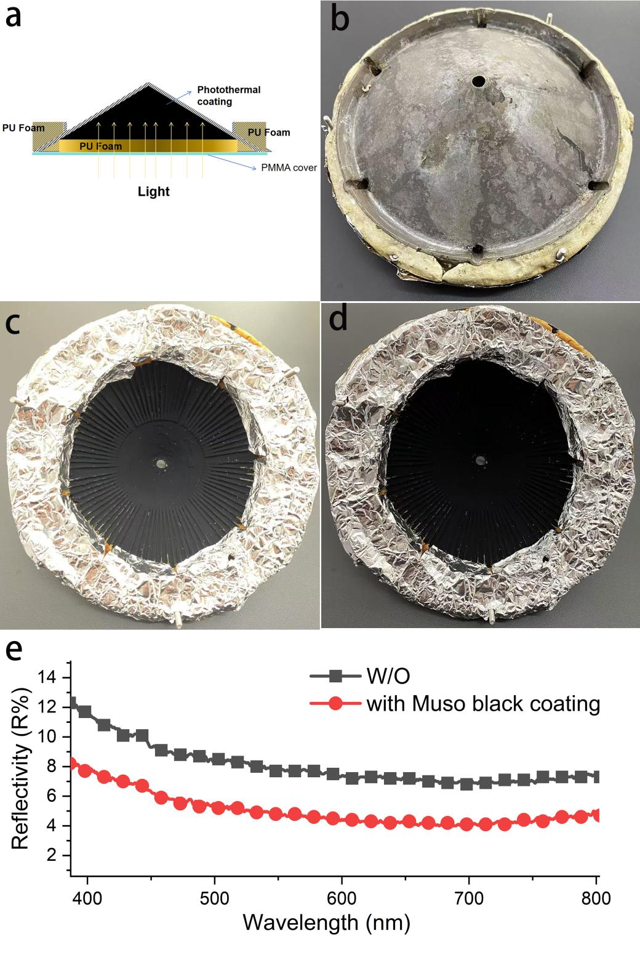
Fig. S2. 7
Photo-thermal heater. (a) The structure of the photo-thermal heater. (b) The top view of the photo-thermal heater made with 3D print. (c) The bottom side of the photo-thermal heater coated with a commercial available photo-thermal coating. The PMMA transparent cover is removed for clarity. (d) A layer of anti-reflection is further applied above the photo-thermal coating. (e) The reflectivity of the heating layer when coated with regular solar coating versus when an additional Muso black coating is applied on top of the regular solar coating.
The photo-thermal heater is designed as depicted in Fig.S2.7. It is similar to the other EPs, with the exception that only one outlet is open, and the bottom side is covered with a photo-thermal layer. The photo-thermal layer is prepared by applying a photo-thermal coating, sourced from the market, followed by a layer of anti-reflection coating.

Section 3. Characterization of the performance of i-MSS

S3.1 Experimental set-up for heat-water efficiency
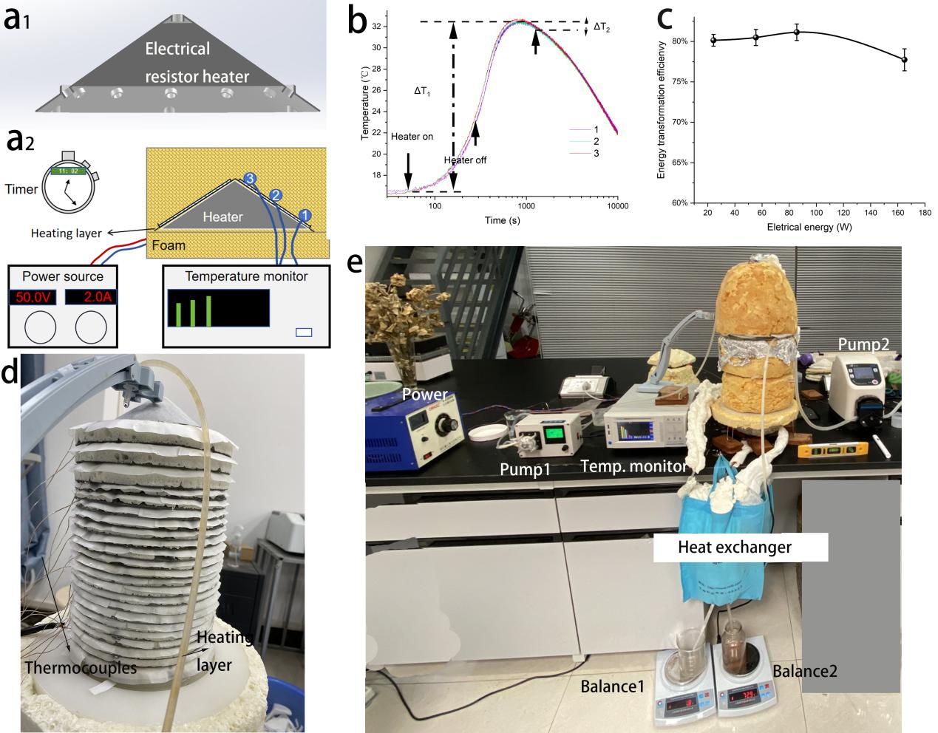
Fig. S3. 1
Study on the heat-water efficiency. (a) The first heating layer assembled from a EP and an electrical resistor. (b) The temperature profiles of the places set sensors on the heater. And the temperature increase after a specific period of electrical energy input is recorded as ΔT₁ and the temperature decay from the peak temperature after the same period between the power turned off and reaching the peak temperature is recorded as ΔT₂. (c) Electric energy to thermal energy transformation efficiency when different power input applied. Three times of measurement are carried out at same electrical power input. (d) The stacked EPs on the base. Thermocouples are set in all the stages for temperature monitoring. (e) Photo of the experimental platform.
A thermal source from an electrical resistor was designed. The resistor is set in an aluminum conical brick to form a heater (Fig. S3. 1a₁). To obtain the precise heat input to the i-MSS, the electricity to heat efficiency of the heater is calibrated first. The whole resistor heater and the first EP of i-MSS are covered by PU foam with a thickness of 10 cm. To investigate the electric to heat transformation efficiency, three temperature sensors were set at different position from bottom to the top as shown in Fig. S3. 1a₂. The electrical energy input at different power is applied to the heater for a specific period. The temperature at three different positions are monitored. The decay of temperature from the peak temperature after the same period between the power turned off and reaching the peak temperature is recorded as ΔT₂. ΔT₂ is used to evaluate the heat loss during the period between the heater turned off and reaching the peak temperature. In our cases, ΔT₂/ΔT₁ is 4%, which means the heat loss during the temperature increasing period is less than 4% because of the temperature during this period is lower than peak temperature. The method to evaluate the efficiency may underestimate the efficiency but only less than 4%. It is a acceptable range. When the temperature at three different positions reach the peak temperature, that means the heat spread on the heater is even. That temperature is the exact temperature of the heater. Based on the specific heat capacity of aluminum (C_{Al}, 0.88×10³ J kg⁻¹ ℃⁻¹), the heat generated from the resistor is obtained. The electricity to heat transformation efficiency of the heater can be calculated below,
(SE3.1)
The efficiency at different electrical power input were tested for three times. The results are given in Fig. S1. (c). The efficiency is about 80% when the electrical power input less than 100 W. The higher power leads to a lower efficiency (78%). For the following experiments for studying the energy-water efficiency, the input energy is the electrical energy.
To estimate the error from the heat dissipation through the PU foam. The temperature decay curves are also monitored. We can see the temperature decay is very slow when the temperature is lower than 24 ℃.
The EPs are stacked together on the base. Between the EPs, a layer of porous tissue is allied to avoid leakage of vapor and allow the distillate to flow out. The feeding water flow from the top to the bottom. The leakage of feeding water in each stage should be avoided before assemble them with the cover. Then the platform is prepared for studying the energy-water efficiency.

The influence of cover on the temperature of the EPs
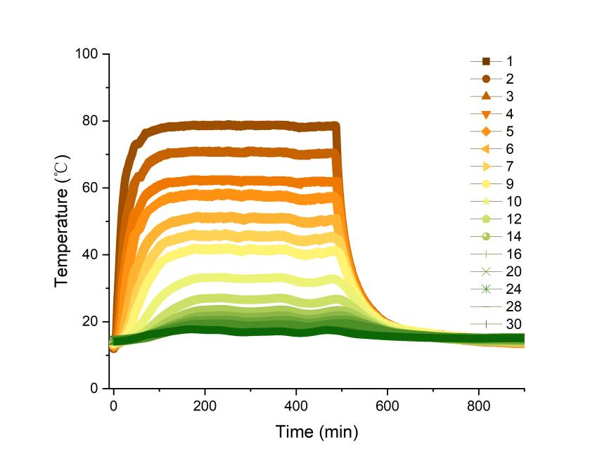
Fig. S3. 2
The temperature profiles of a i-MSS without cover. The input electrical power is 65.6 W. The power is off at 500 min.
In Fig. S3.2, the first EP reached the stable temperature after 2 h of heating. However, the temperature of it could not increase further even the heating lasts for more than 8 h. This should be mainly attributed to the the radiative heat loss of the heating and the top EPs. It means that reducing the loss of energy to raise the temperature is necessary.

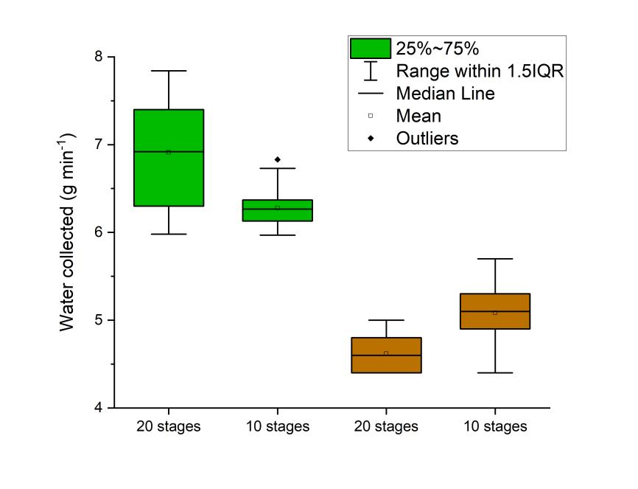
Fig. S3. 3
Water productivity of i-MSS having different stages of EPs when 19.22 W of incident light applied. The green boxes are for the cases feeding pure water, while the brown ones are for the cases feeding 3.5% saline.
To investigate the influence of the number of EPs on the productivity of distillates, we compared the performance of the i-MSS containing 20 EPs and 10 EPs when fed with pure water or 3.5% saline solution (Fig. S3.3). For pure water feeding, a higher number of EPs…he i-MSS with 10 EPs. Interestingly, for the saline feeding group, the i-MSS with 10 EPs demonstrated better productivity. This can be attributed to the fact that fewer EPs can provide a larger temperature difference, which benefits vapor condensation and helps avoid secondary absorption of vapor by the saline on the surfaces of the EPs.

S3.2 Desalination performance

ICP-MS analysis
Measurements were initially calibrated using authentic standards of Na, K, Ca, and Mg solutions with concentrations ranging from 1 to 150 ppm. The concentrated saline from the i-MSS had much higher concentrations. For the salines used for feeding or those coming out from the i-MSS, they were diluted with ultra-pure water to a concentration of 1 to 100 ppm before measurement. The distillates were measured directly. For Li, measurements were calibrated with authentic standards of Li with concentrations ranging from 1 to 150 ppb. All measurements were conducted in triplicate.

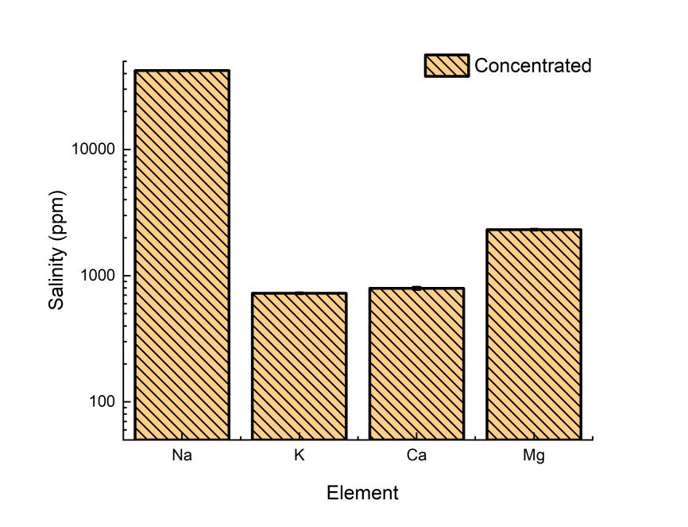
Fig. S3. 4
The main different ions in the saline after distillation.

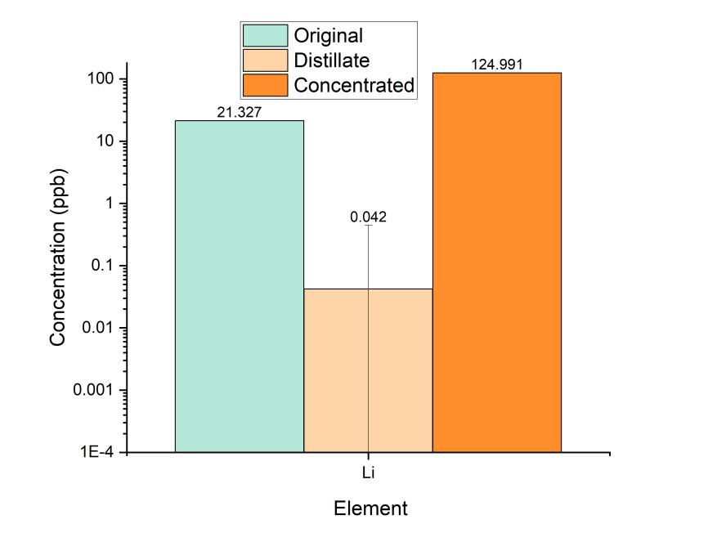
Fig. S3. 5
The concentration of Li in original saline, distillate and the saline after concentration.

S3.3 Light-water efficiency
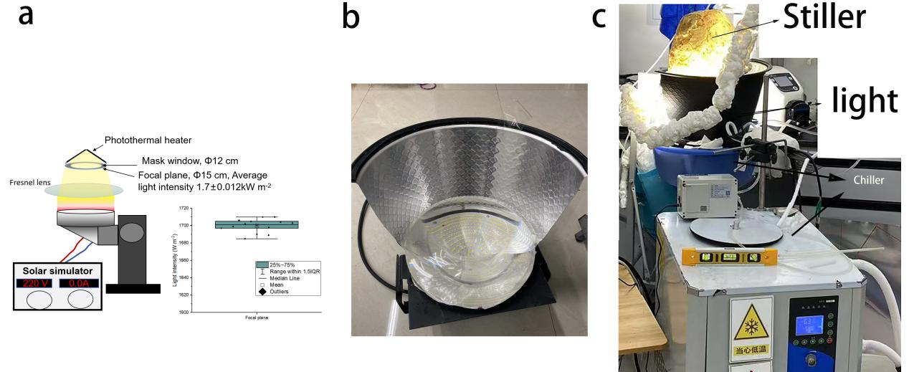
Fig. S3. 6
The experimental platform for study on light-water efficiency. (a) Structure of the high powerful solar simulator and the statistic results of the radiant intensity at the focal plane.
In order to get a uniform, high powerful and large irradiating area (round area with a diameter of 12 cm), a white light LED array (Colour temperature: 5500-6500 K) with a label power of 1000 W equipped a Fresnel lens with a diameter of 30 cm is applied as the light source (Fig. S3. 6a ~ b). At the focal plane of the Fresnel lens, the light intensity is 1.70±0.012 kW m⁻². The power statistic results of the light intensity at the focal plane are presented in Fig. S3. 6a. The light intensity is well controlled by a temperature controller composed of coolant recycling system (Fig. S3. 6c). The light intensity is stable more than 10 h. The incident light is from a mask with a window of a diameter of 12 cm at the focal plane. It ensures the power to the photothermal heater can be calculated precisely. For all the tests, the input power of light is 19.22 W.

S3.4 Outdoor experiment
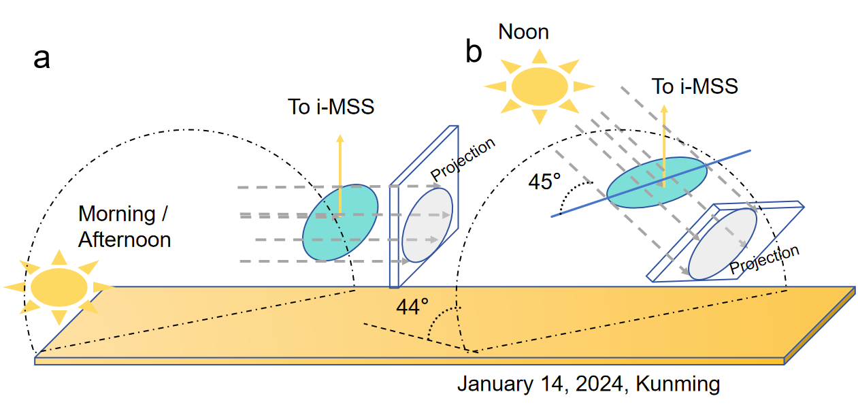
Fig. S3. 7
The solar light harvested outdoor by a LC (light blue circle) depends on the area of projection,which is influenced by the position of the sun and the angle of the LC to the horizon. When the angle between the light and the plan of the LC is 45° (b), the area of projection is 0.0499 m² for a LC with a diameter of 30 cm. Solar elevation angle is 44° on January 14, 2024 in Kunming.

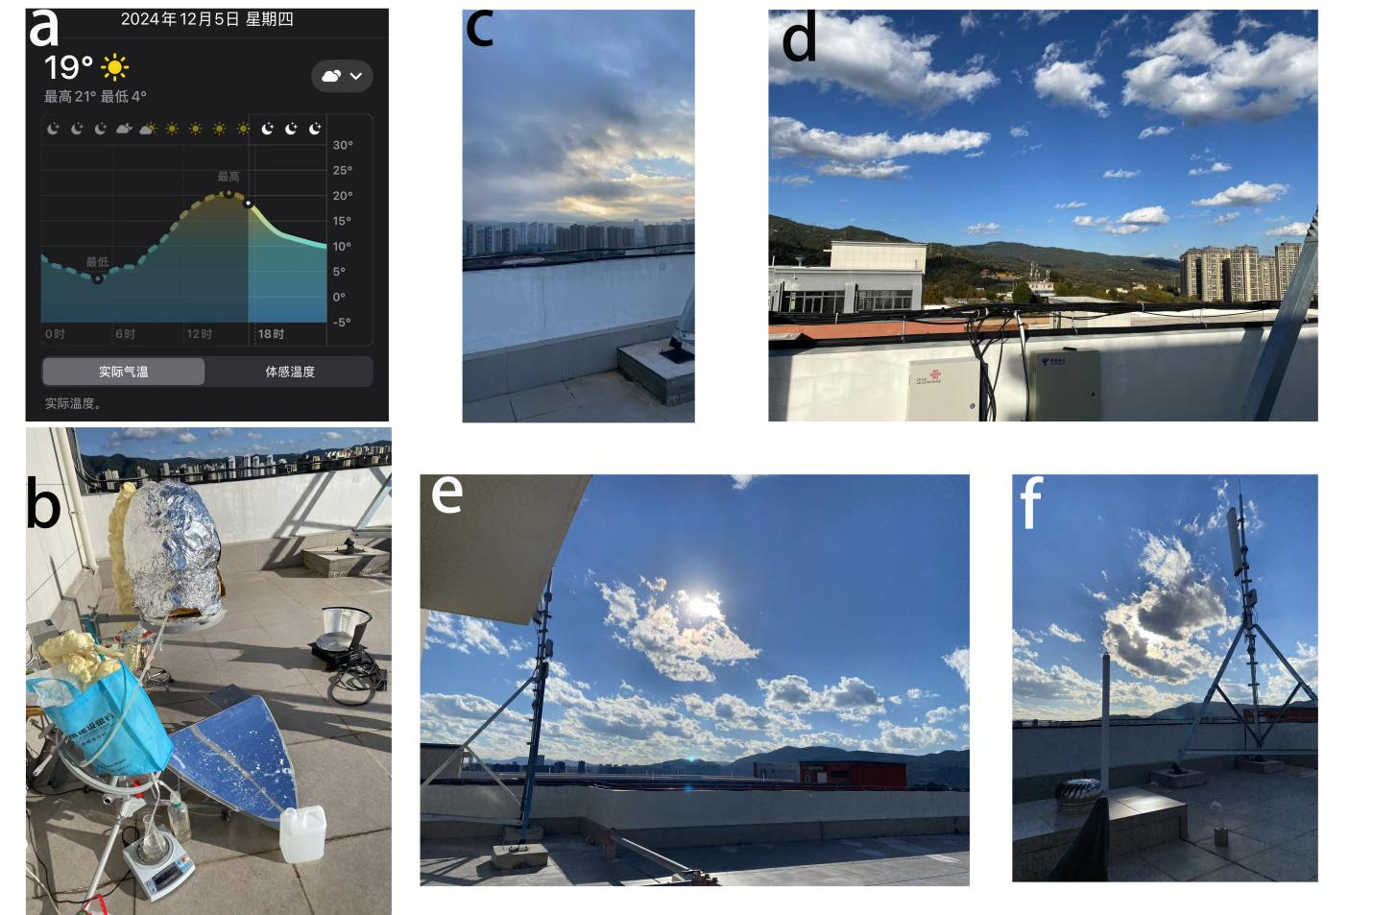
Fig. S3. 8
The weather condition of December 05, 2024, in Kunming. The local weather report (a). The experimental set up with high power input LC (Area of LC is 0.29 m²). (c) The sky of the cloudy morning. (d) The partly sunny noon and the afternoon (e~f).

Section 4. Economic analysis of i-MSS

Table S1.
Cost of the raw materials for i-MSS.
Item | Unit cost  (CNY) | Unit cost  (USD) | Cost of 20 EPs  (USD) | Cost of 10 EPs  (USD) | Retailer
Aluminum alloy | 18.9/kg | 2.65/kg | 516.0 | 258.0 | Alibaba.com
Bamboo fabric Tissue | 20.0/kg | 2.8/kg | 28.0 | 14.0 | Alibaba.com
Nylon + Glass fiber | 33.0/kg | 4.62/kg | 46.2 | 46.2 | Alibaba.com
Solar coating | 110/kg | 15.41/kg | 15.4 | 15.4 | Alibaba.com
Silica pipe | 0.6/m | 0.084/m | 8.4 | 8.4 | Alibaba.com
LC | 110/m² | 15.41/m² | 15.4 | 15.4 | taobao.com
Carbon Cloth | 120/m² | 16.8/m² | 336.2 | 168.1 | Alibaba.com
Basic total cost |  |  | 965.6 | 525.5

*Currency: CNY/USD=0.1401
The basic cost of the raw materials of the MSS is given in Table S1. One standard i-MSS has 1 m² of light harvesting layer and LC. The cost of a specific i-MSS with different area of LC is the basic cost of materials plus the cost of the larger area of LC applied. Based upon this, the cost of unit WPR can be calculated accordingly. It is the total cost divided by the related WPR under the specific energy input (Fig. 6B and Fig. S4.1).

Capital cost of i-MSS can be estimated according to the method reported previously.(6)
(SE4.2)
where C_{p} is the capital cost per person, C_{t} is the total capital cost, A is the area of i-MSS, M is the daily productivity per unit area and W is the water amount required per day of each person, which is assumed as 2 kg d⁻¹. The cost of all the materials for 1 m² of i-MSS with 10 or 20 stages is listed in Table S1.
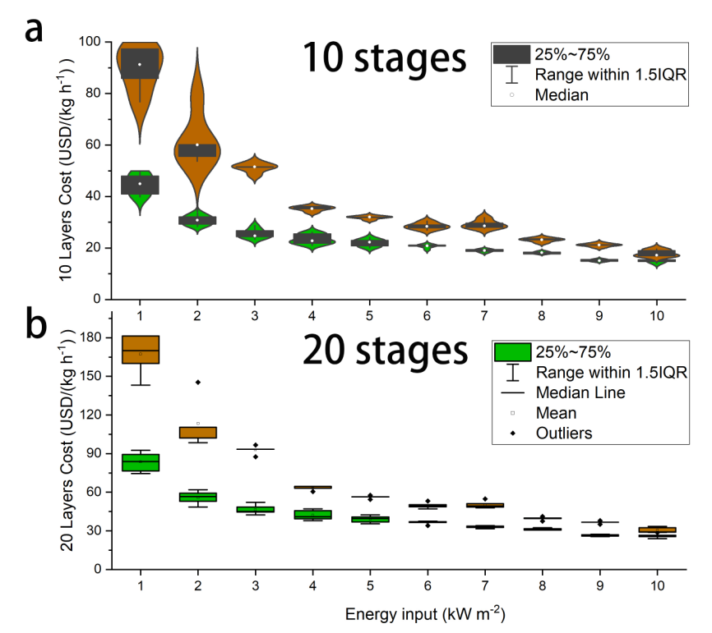
Fig. S4. 1
The cost of raw materials for unit WPR from the i-MSS with different stages (C_{prod}). The wide distribution of the cost arises from the fluctuation of the efficiency. The increase of cost is only from the more LC used.
$C_{prod}=C_{total}/WPR$ (SE4.2)

Table S2.
Some major progress of solar stills in recent years.
N_{o}. | Vapor fluxes (kg m⁻² h⁻¹) | Energy-to-vapor Efficiency (η ) | Energy-to-water Efficiency (η ) | Areal productivity (kg m⁻² h⁻¹) | year | Note | References
1 | 16.8 | 920% | 850% | 15.5 | 2025 | pure water feeding | This work
1 | 14.3 | 770% | 710% | 13.2 | 2025 | 3.5% saline feeding | This work
2 | 6.25 | 417% | 410% | 5.9 | 2024 |  | (7)
3 | 4.31 |  | 132% | 3.55 | 2024 |  | (8)
4 |  |  | 407% | 9.0 | 2024 | Excess heat input | (9)
5 | 1.87 |  | 110% | 1.87 | 2024 |  | (10)
6 | 6.09 | 414% | 151% | 2.22 | 2023 |  | (11)
7 |  |  | 322% | 3.82 | 2023 |  | (12)
8 |  |  | 400% | 3.6 | 2023 |  | (13)
9 | 3.92 | 88.70% |  | 1.7 | 2023 |  | (14)
10 |  |  | 221% | 2.37 | 2023 |  | (15)
11 |  |  | 147% | 2.19 | 2022 |  | (16)
12 |  |  | 145% | 2.21 | 2022 |  | (17)
13 | 8.26 |  | 134% | 2.05 | 2022 |  | (18)
14 |  |  | 252% | 2.4 | 2021 |  | (19)
15 |  |  | 246% | 2.62 | 2021 |  | (20)
16 | 5.78 | 385% | 295% | 4.33 | 2020 |  | (21)
17 |  |  | 125% | 0.65 | 2020 |  | (22)
18 |  |  | 131% | 0.595 | 2020 |  | (23)
19 | 2.9 | 80% |  |  | 2020 |  | (24)
20 |  |  | 224% | 2.07 | 2019 |  | (25)

References
1. M. H. Sharqawy, J. H. Lienhard, S. M. Zubair, Desalin. Water Treat. 16, 354 (2010).
2. K. Kadoya, N. Matsunaga, A. Nagashima, J. Phys. Chem. Ref. Data 14, 947 (1985).
3. S. Uehara, H. Takana, J. Electrostatics 104, 103417 (2020).
4. K. C. Ng et al., npj Clean Water 4, 25 (2021).
5. A. Alkhudhiri, N. Darwish, N. Hilal, Desalination 287, 2 (2012).
6. G. Peng, S. W. Sharshir, Desalination 565, 116829 (2023).
7. S. Li, S. Liu, Q. Yang, S. Deng, M. Lin, Energy Environ. Sci., (2024).
8. M. Chen et al., Nano Lett., (2024).
9. P. Poredoš et al., Nat. Commun. 15, 7890 (2024).
10. P. Shi, J. Li, Y. Song, N. Xu, J. Zhu, Nano Lett. 24, 5673 (2024).
11. B. Yang et al., Nature 622, 499 (2023).
12. J. Gao et al., Joule 7, 2274 (2023).
13. Z. Zhu, H. Zheng, H. Kong, X. Ma, J. Xiong, Nat. Water 1, 790 (2023).
14. X. Li et al., ACS ES&T Water 3, 1740 (2023).
15. Y. Li, S. Cheng, B. Jin, Z. Yu, R. Gu, Desalination 562, 116714 (2023).
16. Y. Dong, P. Poredoš, Q. Ma, R. Wang, Desalination 543, 116103 (2022).
17. Y. Li, S. Cheng, Z. Yu, R. Gu, X. He, J. Clean. Prod. 375, 134025 (2022).
18. S. Cheng, Y. Li, B. Jin, Z. Yu, R. Gu, Desalination 531, 115688 (2022).
19. W. Wang et al., Joule 5, 1873 (2021).
20. W. Wang et al., Nano Lett. 21, 5068 (2021).
21. Z. Xu et al., Energy Environ. Sci. 13, 830 (2020).
22. L. Huang et al., Desalination 477, 114260 (2020).
23. M. Morciano, M. Fasano, S. V. Boriskina, E. Chiavazzo, P. Asinari, Energy Environ. Sci. 13, 3646 (2020).
24. Q.-F. Guan, Z.-M. Han, Z.-C. Ling, H.-B. Yang, S.-H. Yu, Nano Lett. 20, 5699 (2020).
25. E. Chiavazzo, M. Morciano, F. Viglino, M. Fasano, P. Asinari, Nat. Sustain. 1, 763 (2018).

