Supplementary Materials
- Figures
  - Figure S1. Participant Eating Patterns
  - Figure S2. Relationship between first calorie shift and last calorie shift
  - Figure S3. Relationship between eating window and first- or last-calorie shift
  - Figure S4. Eating pattern patterns of regular workers and shift workers
  - Figure S5. Time of consumption of top 100 items
- Tables 1-17
  - Table S1: Participant characteristics
  - Table S2: Food/Beverage logs in hourly bins
  - Table S3: The daily average number of food/beverages logs and eating events logged
  - Table S4: Food/Beverage logs and eating patterns of participants…Separate File
  - Table S5: Metrics to assess timing of daily eating patterns.
  - Table S6: Deciles of each eating pattern metric
  - Table S7: Effects of Age, Sex, Work Hours on Eating Pattern
  - Table S8: Statistical Tests for Work Hours
  - Table S9: Effect size for difference in eating pattern between users of self-reported work schedule.
  - Table S10: 95% confidence interval for the difference in median eating pattern between users of self-reported work schedul
  - Table S11: Eating Pattern by Age
  - Table S12: Rank Order of Food and Beverages Logged …Separate File
  - Table S13: Effects of Age, Sex, Work Hours on Top Ranked Food and Beverages.Separate File
  - Table S14: Deciles of Food and Beverage Diversity
  - Table S15: Effects of Age, Sex, and Work Hours on Food Diversity
  - Table S16. Consistency of food and beverage consumption: Number of food and beverages consumed by 100+ people for 7+ days
  - Table S17. TF50 of Food/Beverages When Logged as a Habitual or Singleton Item

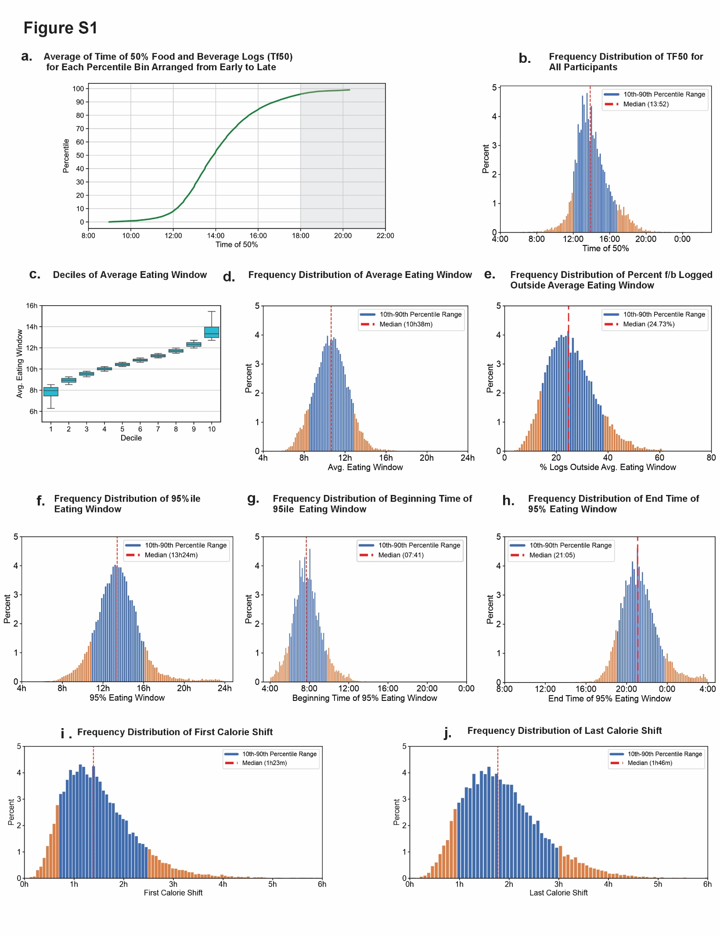

Figure S1. Participant Eating Patterns a. Percentile rank of time of 50% log for all users arranged from earliest (left) to latest (right). b. Frequency distribution of TF50 for all users. c. Frequency distribution and d. mean (+/- sd) of decile bins of users’ average eating window over 14 days. Plot whiskers range from 2.5th to 97.5th percentiles. e. Frequency distribution of the percentage of the timing of food/beverage logs that fall outside of the average eating window calculated from the average eating window of compliant days. This shows that the average eating window can miss as much as 26% of the timing of food and beverage consumption. Frequency distribution of f. 95% eating window, g. beginning of 95% eating window, h. end of 95% eating window, i. first eating event shift and j. last eating event shift.

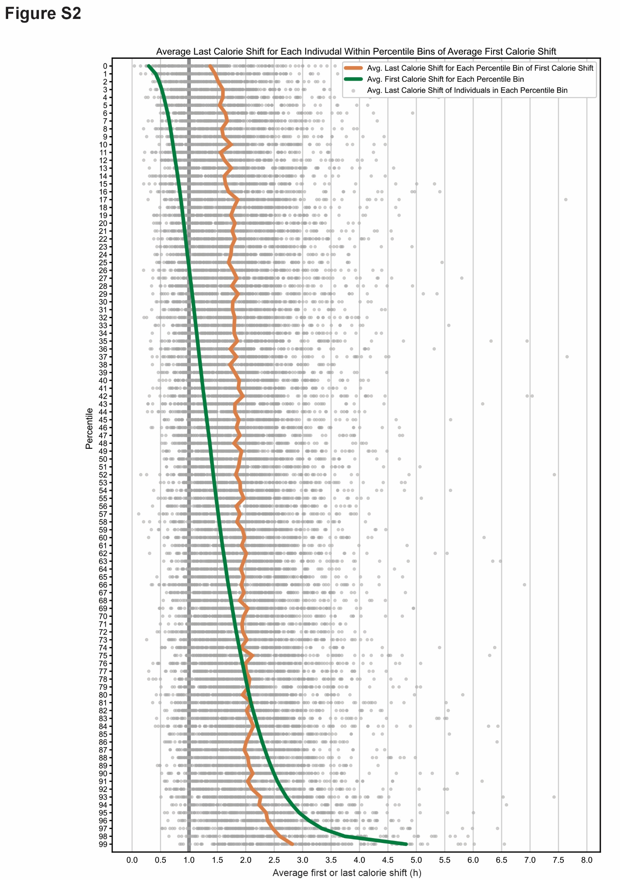

Figure S2. Relationship between first calorie shift and last calorie shift. mean percentile bins of mean first calorie shift (green line) from shortest (top) to longest (bottom). For each percentile bin of first calorie shift, the mean last calorie shift all individuals in the bin (blue dots) and the bin mean (orange line) are shown. For bins 1- ~75 of first calorie shift, the bin mean of last calorie shift is longer (orange line is to the right of the green line).

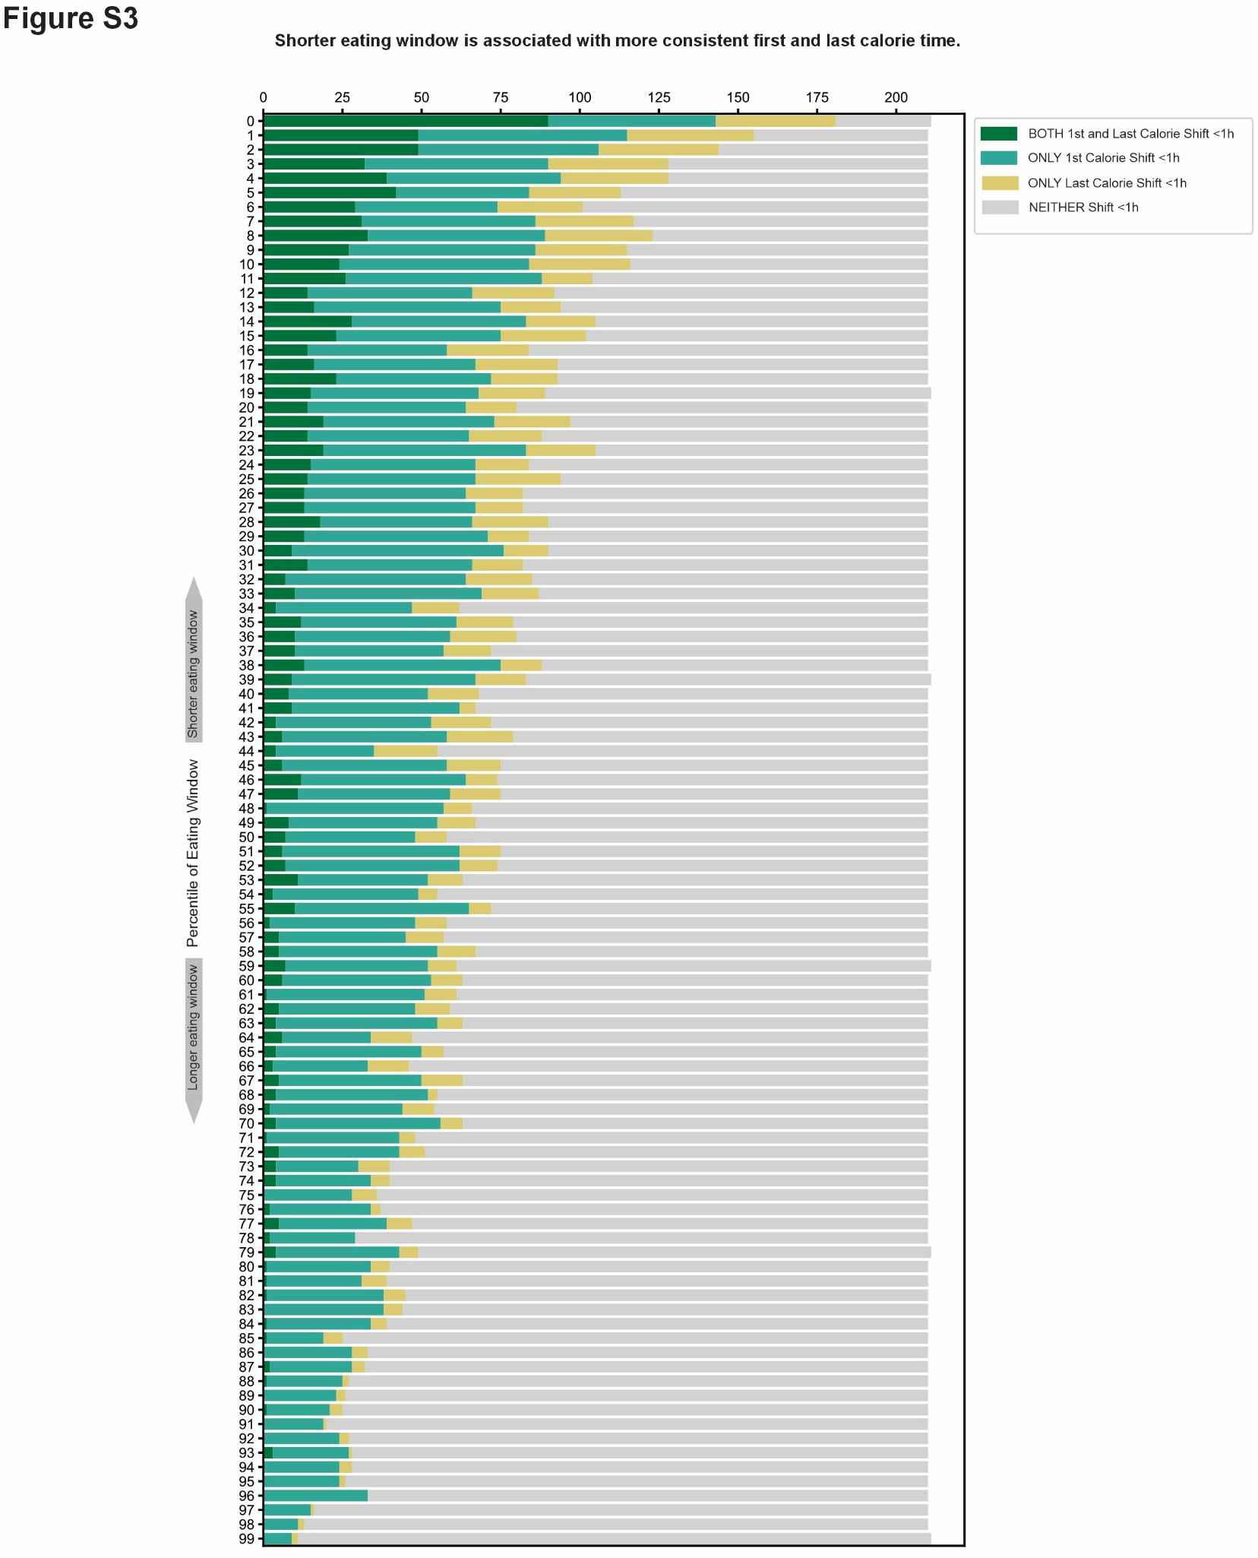

Figure S3. Relationship between eating window and first- or last-calorie shift. For each percentile bin of eating window (~210 individuals/bin; shortest bin on the top to longest at the bottom), the number of individuals who have only the mean first calorie shift <1h (light blue) or both first and last calorie shift <1h (dark blue) are shown. Note, bins of shorter eating windows are more likely to have more individuals with smaller first or last calorie shifts and hence are more consistent in their eating window.

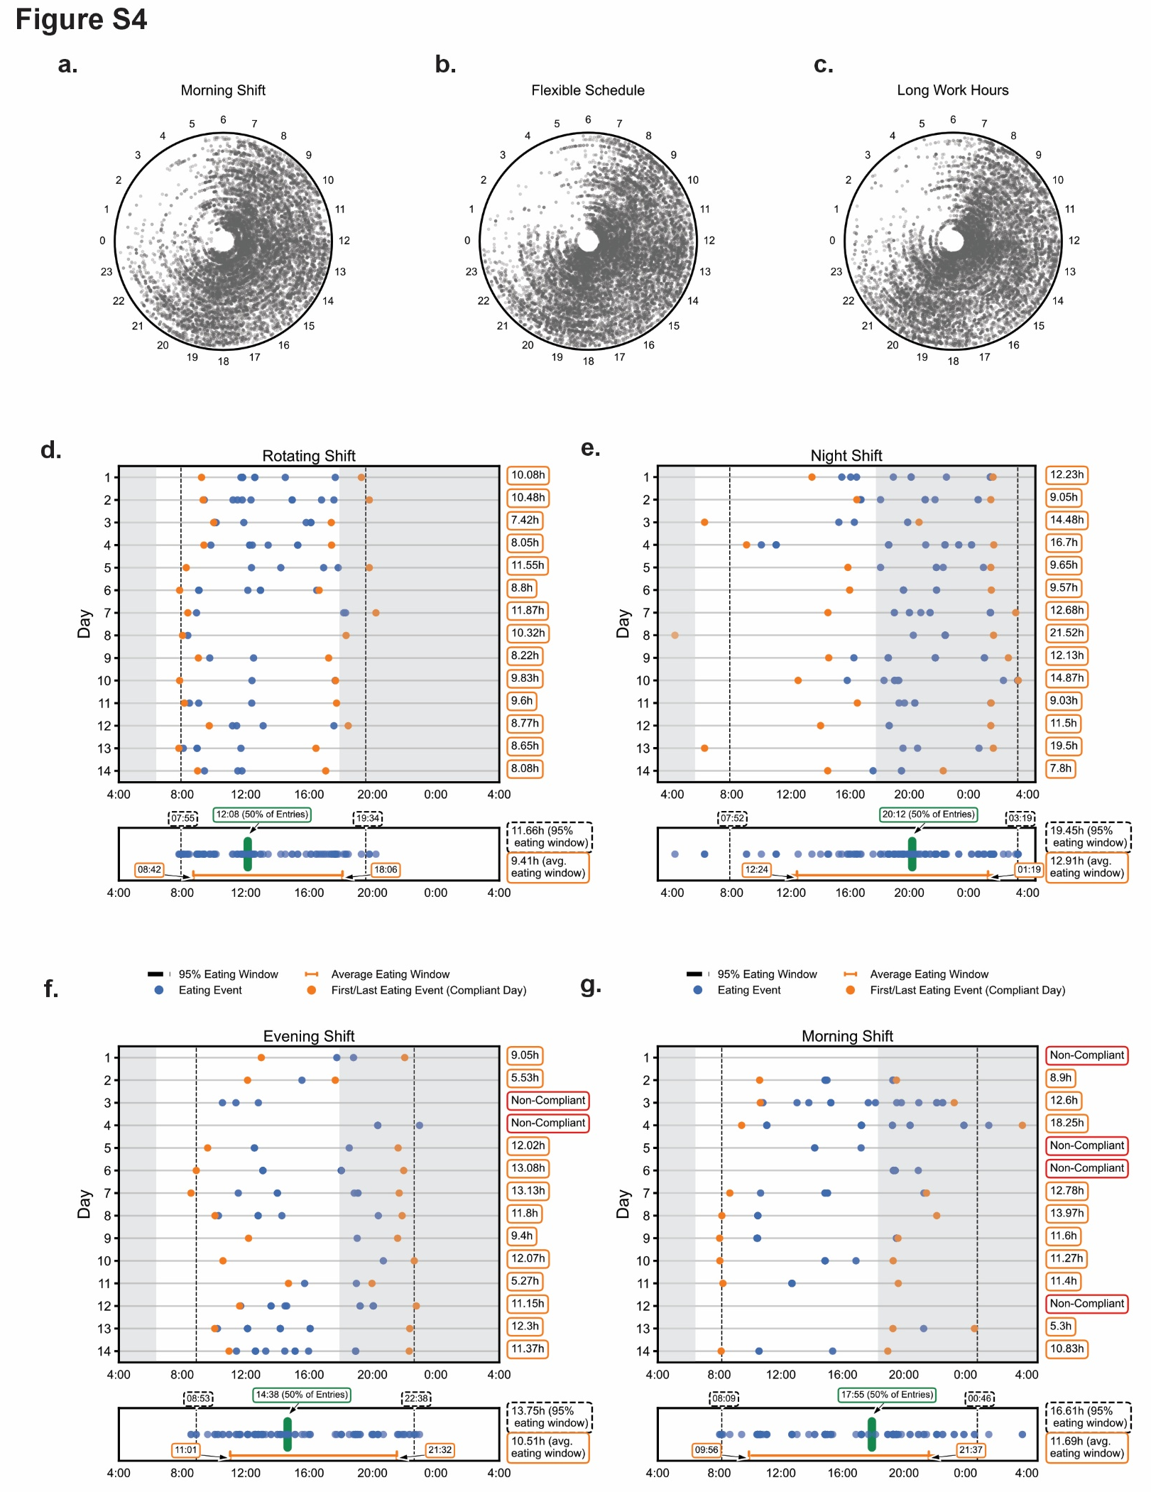

Figure S4. Eating pattern patterns of regular workers and shift workers. Polar plots of randomly picked 150 individuals self-reported as working in a. morning shift, b. flexible schedule, c. long work hours. Representative feedograms of d. rotating shift, e. night shift, f. evening shift, and g. morning shift worker.

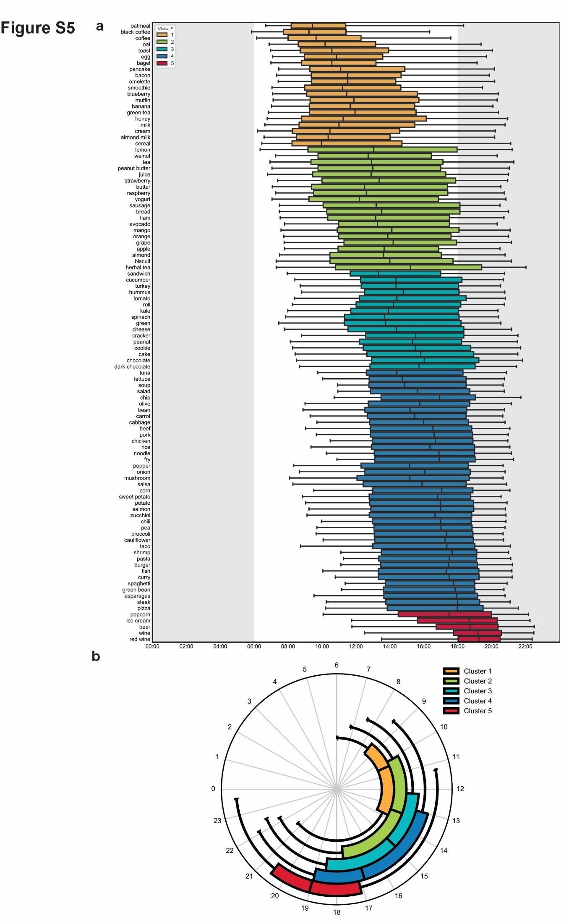

Figure S5. Time of consumption of top 100 items. a. Box plots representing median (25-75% range) and whiskers representing 10-90% range for each of the 100 items item groups by cluster clusters 1 through 5. b. Box plots along the radial axis showing the median (25-75% range) and whisker representing 10-90% range for each of the five clusters in the top 100 food and beverages.

Table S1. Participant Characteristics.
 | Male | Female | Unknown | Total
Participants who logged 10-14 days | 7636 | 13327 | 43 | 21006
Age
<40 yrs | 3071 | 4732 | 27 | 7830
40-60 yrs | 3724 | 7146 | 5 | 10875
>60 yrs | 841 | 1449 | 0 | 2290
Unknown | 0 | 0 | 11 | 11
Work Hours
Regular Work Hours | 3029 | 5099 | 6 | 8134
Flexible Schedule | 2036 | 4387 | 17 | 6440
Long Work Hours | 1169 | 1627 | 3 | 2799
Evening Shift | 98 | 128 | 0 | 226
Morning Shift | 182 | 272 | 1 | 455
Rotating shift | 274 | 395 | 2 | 671
Night Shift | 84 | 103 | 2 | 189
Geographic Location
United States | 4218 | 7519 | 33 | 11770
United Kingdom | 476 | 1074 | 1 | 1551
Other | 2107 | 2855 | 8 | 4970
Unknown | 835 | 1879 | 1 | 2715
Table S2. Food/Beverage Logs in Hourly Bins. Count and percentage of food and beverage containing myCircadianClock logs in hourly bins.
Hour | Number of Logs | Percentage of All Logs
00:00 | 11142 | 0.42
01:00 | 5933 | 0.22
02:00 | 3662 | 0.14
03:00 | 3421 | 0.13
04:00 | 5630 | 0.21
05:00 | 17417 | 0.66
06:00 | 55278 | 2.08
07:00 | 120248 | 4.53
08:00 | 166861 | 6.28
09:00 | 175107 | 6.59
10:00 | 160551 | 6.05
11:00 | 170209 | 6.41
12:00 | 246752 | 9.29
13:00 | 212187 | 7.99
14:00 | 156551 | 5.89
15:00 | 131331 | 4.95
16:00 | 127533 | 4.8
17:00 | 176532 | 6.65
18:00 | 237167 | 8.93
19:00 | 202221 | 7.61
20:00 | 133511 | 5.03
21:00 | 77754 | 2.93
22:00 | 39592 | 1.49
23:00 | 19128 | 0.72

Table S3. The daily average number of food/beverages logs and eating events logged. Mean, SD, and 95% CI for daily log counts and eating events, grouped by deciles based on each participant’s average.
 | Individual Logs |  |  | Eating Events
Decile | Mean | SD | 95% CI | Mean | SD | 95% CI
1 | 3.81 | 0.58 | (3.78, 3.83) | 2.76 | 0.27 | (2.75, 2.77)
2 | 5.09 | 0.29 | (5.08, 5.10) | 3.32 | 0.12 | (3.31, 3.32)
3 | 6.01 | 0.25 | (6.00, 6.02) | 3.68 | 0.1 | (3.68, 3.68)
4 | 6.87 | 0.25 | (6.85, 6.88) | 4 | 0.1 | (4.00, 4.01)
5 | 7.72 | 0.25 | (7.71, 7.73) | 4.33 | 0.1 | (4.32, 4.33)
6 | 8.68 | 0.31 | (8.67, 8.70) | 4.66 | 0.1 | (4.66, 4.67)
7 | 9.86 | 0.38 | (9.85, 9.88) | 5.03 | 0.11 | (5.02 5.03)
8 | 11.38 | 0.51 | (11.35, 11.40) | 5.47 | 0.15 | (5.46, 5.47)
9 | 13.64 | 0.84 | (13.60, 13.67) | 6.08 | 0.22 | (6.07, 6.09)
10 | 19.18 | 3.75 | (19.02, 19.34) | 7.43 | 0.87 | (7.39, 7.47)

Table S4: Food/Beverage logs and eating patterns of participants…………………Separate File
Table S5. Metrics to Assess Timing of Daily Eating Patterns. Definitions of metrics used to assess participant eating patterns.

 | Definition | Data Use | Units
TF50 | Median log time for all food and beverage (caloric) logs | All food and beverage containing logs per user | Clock Time (hh:mm)
Avg. Eating Window | Average time between earliest and latest caloric logs. | Days on which a participant logged 2+ caloric logs, >= 5h between first and last log. | Hours, minutes
95% Eating Window | Time window in which 95% of all caloric logs are logged. | All food and beverage containing logs per user | Hours, minutes
Caloric Intake Shift | Mean magnitude of day-to-day shift in the timing of a specific intake event, such as the first intake. | Days on which a participant logged 2+ caloric logs, >= 5h between first and last log. | Hours, minutes

Table S6. Deciles of Each Eating Pattern Metric. Chi-squared tests of independence were used to assess whether decile membership was dependent on demographic group. Table includes the percentage of each group per decile and the group-wise mean of the corresponding metric. P-values were corrected for multiple comparisons using the Holm-Bonferroni correction.

Decile | 1 | 2 | 3 | 4 | 5 | 6 | 7 | 8 | 9 | 10 | p value | χ² | df
95%ile window | 9h 50m | 11h 23m | 12h 07m | 12h 40m | 13h 10m | 13h 38m | 14h 07m | 14h 42m | 15h 27m | 17h 50m
% of all users | 10 | 10 | 10 | 10 | 10 | 10 | 10 | 10 | 10 | 10
% of all males in this decile | 10.57 | 9.34 | 9.65 | 9.38 | 9.14 | 9.53 | 8.84 | 10.33 | 11.09 | 12.13 | 3.23056e-19 | 113.01 | 9
% of all Females | 9.68 | 10.39 | 10.2 | 10.35 | 10.47 | 10.27 | 10.65 | 9.82 | 9.39 | 8.76 | 3.23056e-19 | 113.01 | 9
% of all Regular workers | 9.6 | 10.22 | 10.63 | 10.88 | 10.88 | 10.46 | 10.72 | 9.75 | 9.85 | 7.01 | 3.507097e-121 | 595.37 | 9
% of all Shift workers | 7.46 | 6.94 | 6.88 | 6.55 | 7.46 | 7.01 | 9.99 | 9.73 | 11.16 | 26.8 | 3.507097e-121 | 595.37 | 9
% of all young | 9.96 | 9.8 | 9.72 | 9.68 | 9.9 | 10.1 | 10.23 | 9.64 | 9.57 | 11.4 | 7.996437e-07 | 48.57 | 9
% of all old | 13.19 | 10.44 | 10.87 | 10.74 | 10.22 | 9.74 | 8.6 | 9.96 | 7.9 | 8.34 | 7.996437e-07 | 48.57 | 9
Beginning of 95% window (h) | 5.35 | 6.33 | 6.82 | 7.18 | 7.52 | 8.87 | 8.2 | 8.63 | 9.23 | 10.64
% of all users | 10 | 10 | 10 | 10 | 10 | 10 | 10 | 10 | 10 | 10
% of all males in this decile | 11.28 | 9.99 | 10.11 | 10.02 | 9.63 | 9.49 | 9.25 | 8.92 | 9.43 | 11.89 | 6.068905e-15 | 91.36 | 9
% of all Females | 9.3 | 10.02 | 9.93 | 10.07 | 10.12 | 10.28 | 10.41 | 10.69 | 10.26 | 8.91 | 6.068905e-15 | 91.36 | 9
% of all Regular workers | 9.18 | 11.18 | 11.03 | 11.31 | 10.87 | 10.17 | 10.09 | 9.43 | 8.99 | 7.76 | 8.335985e-47 | 246.32 | 9
% of all Shift workers | 21.61 | 11.1 | 8.76 | 7.79 | 7.79 | 7.66 | 7.33 | 9.02 | 8.18 | 10.77 | 8.335985e-47 | 246.32 | 9
% of all young | 7.78 | 8.3 | 8.51 | 8.94 | 9.4 | 10.1 | 10.64 | 11 | 12.12 | 13.22 | 3.831406e-32 | 175.99 | 9
% of all old | 12.62 | 11.48 | 11.09 | 11.14 | 9.78 | 9.13 | 9.83 | 9.83 | 7.82 | 7.29 | 3.831406e-32 | 175.99 | 9
TF50 | 11:12:00 | 12:25:00 | 12:54:00 | 13:16:00 | 13:39:00 | 14:05:00 | 14:33:00 | 15:10:00 | 16:02:00 | 17:54:00
% of all users | 10 | 10 | 10 | 10 | 10 | 10 | 10 | 10 | 10 | 10
% of all males in this decile | 11.52 | 9.89 | 9.25 | 9.53 | 9.26 | 8.8 | 9.56 | 9.68 | 10.36 | 12.15 | 4.781149e-21 | 122.18 | 9
% of all Females | 9.12 | 10.07 | 10.41 | 10.29 | 10.42 | 10.67 | 10.27 | 10.19 | 9.78 | 8.76 | 4.781149e-21 | 122.18 | 9
% of all Regular workers | 11.06 | 12.34 | 11.41 | 10.73 | 10.4 | 9.39 | 9.22 | 8.84 | 8.75 | 7.84 | 2.032065e-15 | 227.9 | 9
% of all Shift workers | 11.42 | 7.4 | 6.62 | 8.24 | 7.01 | 10.06 | 8.7 | 10.51 | 12.85 | 17.2 | 2.032065e-15 | 227.9 | 9
% of all young | 8.72 | 9.35 | 9.6 | 9.5 | 8.88 | 10.17 | 10.41 | 10.69 | 11.29 | 11.39 | 5.926095e-43 | 94.01 | 9
% of all old | 12.88 | 10.13 | 10.09 | 10.7 | 12.31 | 8.43 | 8.43 | 7.99 | 9.13 | 9.91 | 5.926095e-43 | 94.01 | 9
Ending of 95% window | 18:20:00 | 19:27:00 | 20:01:00 | 20:28:00 | 20:53:00 | 21:18:00 | 21:45:00 | 22:17:00 | 23:03:00 | 01:07:00
% of all users | 10 | 10 | 10 | 10 | 10 | 10 | 10 | 10 | 10 | 10
% of all males in this decile | 9.72 | 9.42 | 9.73 | 9.48 | 9.26 | 9.65 | 9.63 | 10.01 | 11.08 | 12.04 | 8.668741e-14 | 85.26 | 9
% of all Females | 10.19 | 10.32 | 10.29 | 10.2 | 10.43 | 10.17 | 10.4 | 9.84 | 9.35 | 8.81 | 8.668741e-14 | 85.26 | 9
% of all Regular workers | 10.61 | 11.46 | 11.34 | 11.02 | 11.05 | 10.5 | 10.44 | 8.96 | 8.45 | 6.18 | 5.779793e-151 | 734.1 | 9
% of all Shift workers | 9.21 | 6.55 | 7.27 | 7.14 | 6.49 | 8.18 | 6.75 | 9.28 | 12.07 | 27.06 | 5.779793e-151 | 734.1 | 9
% of all young | 7.89 | 7.61 | 8.22 | 9.22 | 10.06 | 9.89 | 10.57 | 11.61 | 11.69 | 13.23 | 5.927338e-71 | 360.31 | 9
% of all old | 16.99 | 13.67 | 11.18 | 9.91 | 9.39 | 7.82 | 8.3 | 7.29 | 8.25 | 7.21 | 5.927338e-71 | 360.31 | 9
First Caloric Intake Shift | 0h 33m | 0h 49m | 0h 59m | 1h 09m | 1h 18m | 1h 28m | 1h 40m | 1h 54m | 2h 14m | 3h 07m
% of all users | 10 | 10 | 10 | 10 | 10 | 10 | 10 | 10 | 10 | 10
% of all males in this decile | 9.9 | 9.53 | 9.18 | 9.14 | 9.73 | 10.21 | 9.9 | 10.61 | 10.62 | 11.17 | 1.330057e-06 | 46.72 | 9
% of all Females | 10.05 | 10.29 | 10.49 | 10.47 | 10.14 | 9.87 | 10.05 | 9.63 | 9.66 | 9.34 | 1.330057e-06 | 46.72 | 9
% of all Regular workers | 11.06 | 11.04 | 10.89 | 10.39 | 10.29 | 9.88 | 10 | 9.88 | 8.88 | 7.68 | 5.416378e-89 | 44.98 | 9
% of all Shift workers | 5.52 | 6.75 | 7.07 | 8.83 | 7.92 | 8.05 | 8.89 | 10.12 | 13.24 | 23.62 | 5.416378e-89 | 44.98 | 9
% of all young | 10.57 | 9.94 | 9.11 | 9.89 | 10.17 | 9.92 | 9.91 | 9.69 | 10.06 | 10.74 | 0.06572738 | 16.06 | 9
% of all old | 9.61 | 9.96 | 10.74 | 9.65 | 8.95 | 9.87 | 9.69 | 10.83 | 11.14 | 9.56 | 0.06572738 | 16.06 | 9
Last Caloric Intake Shift | 0h 45m | 1h 05m | 1h 18m | 1h 29m | 1h 41m | 1h 53m | 2h 05m | 2h 21m | 2h 43m | 3h 36m
% of all users | 10 | 10 | 10 | 10 | 10 | 10 | 10 | 10 | 10 | 10
% of all males in this decile | 10.74 | 9.97 | 9.39 | 9.85 | 10.15 | 9.49 | 9.68 | 9.85 | 10.06 | 10.83 | 0.006811046 | 24.63 | 9
% of all Females | 9.58 | 10.02 | 10.35 | 10.12 | 9.91 | 10.29 | 10.15 | 10.09 | 9.97 | 9.51 | 0.006811046 | 24.63 | 9
% of all Regular workers | 11.15 | 10.7 | 10.56 | 10.4 | 9.82 | 10.24 | 9.72 | 9.47 | 9.52 | 8.42 | 7.047941e-36 | 194.04 | 9
% of all Shift workers | 6.29 | 6.16 | 7.27 | 8.5 | 9.6 | 10.25 | 10.45 | 11.68 | 12.72 | 17.07 | 7.047941e-36 | 194.04 | 9
% of all young | 8.94 | 9.11 | 9.71 | 10.08 | 10.2 | 10.1 | 10.63 | 10.28 | 10.61 | 10.34 | 2.233315e-07 | 52.03 | 9
% of all old | 12.71 | 11.75 | 9.61 | 9.83 | 10.09 | 9.52 | 9.17 | 8.73 | 9.61 | 9 | 2.233315e-07 | 52.03 | 9

Table S7. Effects of Age, Sex, and Work Hours on Eating Patterns. Mean (SD) of each eating pattern metric per self-reported demographic group.
 | Participant Characteristics | TF50 | 95% Eating Window | Beginning of eating window | End of eating window | First food shift | Last food shift
Age | <40yrs | 14:16 (116m) | 13h 33m (137m) | 8:01 (91m) | 21:34 (115m) | 1h 32m (48m) | 1h 55m (49m)
Age | 40-60yrs | 14:02 (110m) | 13h 30m (131m) | 7:39 (86m) | 21:08 (109m) | 1h 30m (44m) | 1h 53m (50m)
Age | >60yrs | 13:57 (115m) | 13h 16m (137m) | 7:34 (85m) | 20:48 (117m) | 1h 31m (44m) | 1h 49m (50m)
Sex | Male | 14:14 (117m) | 13h 36m (143m) | 7:48 (95m) | 21:24 (119m) | 1h 34m (48m) | 1h 54m (51m)
Sex | Female | 14:08 (100m) | 13h 25m (129m) | 7:46 (84m) | 21:11 (110m) | 1h 30m (44m) | 1h 53m (49m)
Working Hours | Regular Work Hours | 13:54 (107m) | 13h 19m (118m) | 7:41 (82m) | 21:00 (100m) | 1h 26m (41m) | 1h 50m (47m)
Working Hours | Flexible Schedule | 14:14 (114m) | 13h 17m (132m) | 8:01 (89m) | 21:17 (115m) | 1h 30m (45m) | 1h 53m (49m)
Working Hours | Long Work Hours | 14:11 (109m) | 13h 52m (131m) | 7:36 (89m) | 21:28 (108m) | 1h 35m (43m) | 1h 57m (51m)
Working Hours | Evening Shift | 14:51 (130m) | 13h 50m (144m) | 8:23 (104m) | 22:13 (125m) | 1h 39m (54m) | 2h 05m (44m)
Working Hours | Morning Shift | 13:30 (116m) | 13h 53m (158m) | 7:01 (96m) | 20:54 (131m) | 1h 41m (48m) | 1h 58m (59m)
Working Hours | Rotating Shift | 14:38 (118m) | 14h 45m (171m) | 7:34 (96m) | 22:19 (137m) | 1h 55m (58m) | 2h 12m (55m)
Working Hours | Night Shift | 16:39 (182m) | 18h 04m (234m) | 7:09 (140m) | 1:13 (148m) | 2h 58m (98m) | 2h 49m (72m)
Average time or duration and (SD) are shown. TF50 = time to 50% of food/beverage logs.

Table S8. Statistical Tests for Work Hours. Kruskal-Wallis test assessed overall group differences in eating metrics. Post-hoc Dunn’s tests were used for pairwise comparisons with Holm-Bonferroni correction.
Work Hours | TF50 | 95% Eating Window | First Eating Event Shift | Last Eating Event Shift
Kruskal Wallis Test Statistic | 452.16 | 609.54 | 456.62 | 287.87
p-value | 1.68E-94 | 2.04E-128 | 1.84E-95 | 3.25E-59
Post-hoc Dunn’s Tests w/ Holm-Bonferroni Correction
 | Regular worker | Flexible schedule | Long work hours | Evening shift | Morning shift | Rotating shift | Night shift
TF50 Statistical Tests
Regular Work Hours | N/A
Flexible Schedule | 3.82E-32 | N/A
Long Work Hours | 4.99E-14 | 3.55E-01 | N/A
Evening Shift | 4.80E-13 | 2.22E-05 | 5.76E-06 | N/A
Morning Shift | 4.67E-04 | 3.67E-14 | 2.18E-11 | 3.00E-16 | N/A
Rotating Shift | 1.15E-13 | 3.08E-06 | 4.99E-07 | 3.55E-01 | 6.48E-21 | N/A
Night Shift | 6.39E-43 | 8.25E-28 | 1.09E-28 | 1.04E-06 | 5.31E-43 | 4.80E-13 | N/A
95% Eating Window Statistical Tests
Regular Work Hours | N/A
Flexible Schedule | 4.45E-02 | N/A
Long Work Hours | 2.28E-31 | 1.66E-39 | N/A
Evening Shift | 4.13E-02 | 6.75E-03 | 7.04E-01 | N/A
Morning Shift | 4.44E-05 | 7.27E-07 | 8.24E-01 | 8.24E-01 | N/A
Rotating Shift | 3.59E-37 | 1.73E-42 | 1.57E-08 | 5.97E-05 | 6.13E-06 | N/A
Night Shift | 4.73E-58 | 8.22E-62 | 2.47E-34 | 7.38E-24 | 2.18E-28 | 2.98E-15 | N/A
First eating event shift statistical tests
Regular Work Hours | N/A
Flexible Schedule | 4.65E-05 | N/A
Long Work Hours | 8.86E-19 | 3.67E-07 | N/A
Evening Shift | 6.06E-03 | 1.25E-01 | 7.95E-01 | N/A
Morning Shift | 1.53E-09 | 1.33E-05 | 1.25E-01 | 5.28E-01 | N/A
Rotating Shift | 9.29E-37 | 1.91E-26 | 1.77E-12 | 6.84E-04 | 3.53E-03 | N/A
Night Shift | 1.30E-52 | 1.16E-45 | 1.87E-34 | 1.61E-19 | 1.63E-20 | 6.74E-13 | N/A
Last eating event shift statistical tests
Regular Work Hours | N/A
Flexible Schedule | 1.55E-03 | N/A
Long Work Hours | 9.07E-10 | 2.34E-03 | N/A
Evening Shift | 2.84E-07 | 3.07E-05 | 4.49E-03 | N/A
Morning Shift | 1.10E-01 | 1.00E+00 | 1.00E+00 | 4.49E-03 | N/A
Rotating Shift | 6.44E-24 | 3.89E-17 | 2.92E-09 | 1.00E+00 | 3.24E-06 | N/A
Night Shift | 4.10E-33 | 1.34E-28 | 1.30E-22 | 1.17E-06 | 7.49E-19 | 5.44E-08 | N/A
Statistical tests for work hours were used to validate age and sex outcomes as values were similar.

Table S9. Effect size for difference in eating pattern between users of self-reported work schedule. Effect size of p-values reported in Table S8.
Cliff’s Delta for Effect Size Measurement
 | Regular worker | Flexible schedule | Long work hours | Evening shift | Morning shift | Rotating shift | Night shift
TF50
Regular Work Hours | N/A
Flexible Schedule | 1.17E-01 | N/A
Long Work Hours | 1.01E-01 | -1.74E-02 | N/A
Evening Shift | 1.84E-01 | 1.84E-01 | 2.00E-01 | N/A
Morning Shift | -2.17E-01 | -2.17E-01 | -2.03E-01 | -3.69E-01 | N/A
Rotating Shift | 2.33E-01 | 1.2E-01 | 1.38E-01 | -6.69E-02 | 3.22E-01 | N/A
Night Shift | 5.66E-01 | 4.99E-01 | 5.12E-01 | 3.37E-01 | 6.20E-01 | 4.21E-01 | N/A
95% Eating Window
Regular Work Hours | N/A
Flexible Schedule | -2.70E-02 | N/A
Long Work Hours | 1.55E-01 | 1.73E-01 | N/A
Evening Shift | 1.04E-01 | 1.25E-01 | -4.27E-02 | N/A
Morning Shift | 1.28E-01 | 1.46E-01 | -1.49E-02 | 2.26E-02 | N/A
Rotating Shift | 3.04E-01 | 3.15E-01 | 1.70E-01 | 1.99E-01 | 1.75E-01 | N/A
Night Shift | 6.81E-01 | 6.80E-01 | 6.12E-01 | 6.15E-01 | 5.96E-01 | 4.91E-01 | N/A
First eating event shift
Regular Work Hours | N/A
Flexible Schedule | 4.36E-02 | N/A
Long Work Hours | 1.17E-01 | 7.22E-02 | N/A
Evening Shift | 1.25E-01 | 8.22E-02 | 1.39E-02 | N/A
Morning Shift | 1.78E-01 | 1.35E-01 | 6.78E-02 | 4.98E-02 | N/A
Rotating Shift | 2.97E-01 | 2.55E-01 | 1.93E-01 | 1.69E-01 | 1.25E-01 | N/A
Night Shift | 6.39E-01 | 6.09E-01 | 5.76E-01 | 5.39E-01 | 4.23E-01 | 5.39E-01 | N/A
Last eating event shift
Regular Work Hours | N/A
Flexible Schedule | 3.61E-02 | N/A
Long Work Hours | 8.27E-02 | 4.70E-02 | N/A
Evening Shift | 2.19E-01 | 1.83E-01 | 1.31E-01 | N/A
Morning Shift | 5.13E-01 | 2.54E-02 | -1.97E-02 | -1.48E-01 | N/A
Rotating Shift | 2.41E-01 | 2.06E-01 | 1.56E-01 | 2.79E-02 | 1.71E-01 | N/A
Night Shift | 5.96E-02 | 4.85E-01 | 4.43E-01 | 3.59E-01 | 4.45E-01 | 3.20E-01 | N/A

Table S10: 95% confidence interval for the difference in median eating pattern between users of self-reported work schedule. 95% confidence interval of values reported in Table S8.
Difference of Medians in Hours (CI)
 | Regular worker | Flexible schedule | Long work hours | Evening shift | Morning shift | Rotating shift | Night shift
TF50
Regular Work Hours | N/A
Flexible Schedule | 0.38 [0.34,0.46] | N/A
Long Work Hours | 0.35 [0.25,0.42] | -0.03 [-0.13, 0.02] | N/A
Evening Shift | 1.07 [0.71,1.43] | 0.68 [0.31, 1.04] | 0.72 [0.35, 1.08] | N/A
Morning Shift | -0.30 [-0.45, -0.07] | -0.68 [-0.83, -0.47] | -0.65 [-0.80, -0.41] | -1.37 [-1.80, -0.95] | N/A
Rotating Shift | 0.74 [0.57, 0.92] | 0.36 [0.18, 0.52] | 0.39 [0.24, 0.60] | -0.33 [-0.71, 0.07] | 1.04 [0.77, 1.27] | N/A
Night Shift | 3.12 [2.58, 3.60] | 2.73 [2.20, 3.22] | 2.77 [2.23, 3.25] | 2.05 [1.40, 2.67] | 3.42 [2.85, 3.95] | 2.38 [1.88, 2.90] | N/A
95% Eating Window
Regular Work Hours | N/A
Flexible Schedule | -0.09 [-0.17, -0.01 | N/A
Long Work Hours | 0.55 [0.45, 0.64] | 0.64 [0.54,0.73] | N/A
Evening Shift | 0.28 [-0.07, 0.66] | 0.37 [0.04, 0.75] | -0.27 [-0.62, 0.10] | N/A
Morning Shift | 0.56 [0.27, 0.76] | 0.65 [0.35, 0.86] | 0.01 [-0.26, 0.22] | 0.28 [-0.16, 0.65] | N/A
Rotating Shift | 1.11 [0.88, 1.27] | 1.20 [0.97, 1.36] | 0.56 [0.32, 0.73] | 0.83 [0.42, 1.23] | 0.55 [0.25, 0.93 | N/A
Night Shift | 5.38 [4.48, 6.14] | 5.47 [4.58, 6.26] | 4.83 [3.93, 5.55] | 5.10 [4.18, 5.84] | 4.83 [3.93, 5.55] | 4.27 [3.30, 5.02] | N/A
First eating event shift
Regular Work Hours | N/A
Flexible Schedule | 0.05 [0.03, 0.08] | N/A
Long Work Hours | 0.13 [0.10, 0.16] | 0.08 [0.04, 0.10 | N/A
Evening Shift | 0.12 [-0.01, 0.24] | 0.07 [-0.07, 0.19] | -0.01 [-0.15, 0.11] | N/A
Morning Shift | 0.25 [0.14, 0.32] | 0.20 [0.09, 0.27] | 0.12 [0.02, 0.20] | 0.13 [-0.02, 0.28] | N/A
Rotating Shift | 0.38 [0.27, 0.49] | 0.32 [0.22, 0.42] | 0.24 [0.13, 0.36] | 0.25 [0.09, 0.41] | 0.13 [-0.01, 0.27] | N/A
Night Shift | 1.37 [1.10, 1.75] | 1.32 [1.04, 1.75] | 1.24 [0.96, 1.59] | 1.25 [0.93, 1.71] | 1.12 [0.83, 1.57] | 0.99 [0.69, 1.42] | N/A
Last eating event shift
Regular Work Hours | N/A
Flexible Schedule | 0.04 [0.00, 0.08] | N/A
Long Work Hours | 0.11 [0.06, 0.16] | 0.07 [0.02, 0.12] | N/A
Evening Shift | 0.30 [0.20, 0.46] | 0.27 [0.16, 0.42] | 0.20 [0.09, 0.36] | N/A
Morning Shift | 0.07 [-0.04, 0.20] | 0.03 [-0.08, 0.15] | -0.04 [-0.15, 0.09] | -0.24 [-0.40, -0.07] | N/A
Rotating Shift | 0.29 [0.22, 0.38] | 0.25 [0.18, 0.33] | 0.18 [0.11, 0.28] | -0.01 [-0.17, 0.11] | 0.22 [0.08, 0.35] | N/A
Night Shift | 0.89 [0.70, 1.00] | 0.85 [0.66, 0.96] | 0.78 [0.59, 0.92] | 0.58 [0.32, 0.73] | 0.82 [0.57, 0.97] | 0.60 [0.38, 0.70] | N/A

 | Sex | TF50 | 95% Eating Window | Beginning of eating window | End of eating window | First food shift | Last food shift
<40yrs | Male (n=3071) | 14:23 (126m) | 13h 35m (145m) | 8:06 (99m) | 21:40 (122m) | 1h 35m (50m) | 1h 55m (50m)
<40yrs | Female (n=4732) | 14:12 (108m) | 13h 31m (132m) | 7:59 (85m) | 21:30 (111m) | 1h 30m (46m) | 1h 56m (48m)
40-60yrs | Male (n=3724) | 14:06 (120m) | 13h 40m (139m) | 7:38 (91m) | 21:17 (114m) | 1h 33m (46m) | 1h 55m (51m)
40-60yrs | Female (n=7146) | 14:01 (104m) | 13h 25m (127m) | 7:39 (82m) | 21:04 (107m) | 1h 29m (43m) | 1h 52m (49m)
>60yrs | Male (n=841) | 13:50 (123m) | 13h 26m (151m) | 7:25 (88m) | 20:51 (122m) | 1h 33m (48m) | 1h 48m (54m)
>60yrs | Female (n=1449) | 14:01 (110m) | 13h 10m (128m) | 7:39 (83m) | 20:48 (113m) | 1h 30m (42m) | 1h 50m (47m)
Table S11. Eating Pattern by Age and Sex. Mean (SD) values for eating pattern metrics stratified by age group and sex.

Table S12. Rank Order of Food and Beverages Logged - Separate File. Logging frequency in 2-hour bins and statistics for foods and beverages ordered by user popularity
Table S13. Effects of Age, Sex, Work Hours on Top Ranked Food and Beverages – Separate File. Ranks of the 200 most-logged foods and beverages across age, sex, and work schedule groups.

 | Days
Deciles | 1 | 2 | 3 | 4 | 5 | 6 | 7 | 8 | 9 | 10 | 11 | 12 | 13 | 14
1 | 4 | 7 | 9 | 10 | 12 | 13 | 14 | 15 | 16 | 17 | 17 | 18 | 19 | 20
2 | 6 | 10 | 13 | 16 | 18 | 20 | 22 | 23 | 24 | 26 | 27 | 28 | 29 | 30
3 | 7 | 11 | 15 | 18 | 21 | 23 | 25 | 27 | 29 | 31 | 32 | 34 | 35 | 37
4 | 7 | 12 | 17 | 20 | 23 | 26 | 29 | 31 | 33 | 35 | 37 | 39 | 40 | 42
5 | 8 | 14 | 18 | 22 | 26 | 29 | 32 | 34 | 37 | 39 | 41 | 43 | 45 | 47
6 | 8 | 14 | 20 | 24 | 28 | 32 | 35 | 38 | 40 | 43 | 45 | 47 | 50 | 51
7 | 9 | 16 | 21 | 26 | 30 | 34 | 38 | 41 | 44 | 47 | 50 | 52 | 55 | 57
8 | 9 | 17 | 23 | 29 | 33 | 38 | 42 | 45 | 49 | 52 | 55 | 58 | 60 | 63
9 | 10 | 19 | 26 | 32 | 37 | 42 | 47 | 51 | 55 | 58 | 62 | 65 | 68 | 71
10 | 12 | 23 | 31 | 39 | 45 | 51 | 57 | 62 | 66 | 71 | 75 | 78 | 82 | 86
Table S14. Deciles of Food and Beverage Diversity. Median daily diversity per days passed, grouped by deciles based on diversity at day 14

Table 15. Effects of Age, Sex, and Work Hours on Food Diversity. Mean (SD) food and beverage diversity and sample sizes across age, sex, and work schedule groups.
Demographics |  | Number of Participants | Average Unique Food Items | Standard Deviation
Age | <40yrs | 7817 | 49.82 | 21.32
Age | 40-60yrs | 10868 | 50.73 | 18.45
Age | >60yrs | 2289 | 50.09 | 20.42
Sex | Female | 13321 | 53.45 | 20.12
Sex | Male | 7621 | 44.88 | 19.18
Work Hours | Regular Work Hours | 8125 | 49.89 | 20.16
Work Hours | Flexible Schedule | 6434 | 51.05 | 20.39
Work Hours | Long Work Hours | 2796 | 50.49 | 20.00
Work Hours | Evening Shift | 226 | 48.13 | 16.96
Work Hours | Morning Shift | 455 | 48.91 | 19.97
Work Hours | Rotating Shift | 671 | 51.34 | 19.13
Work Hours | Night Shift | 189 | 50.28 | 20.03

Table S16.Consistency of food and beverage consumption: Number of food and beverages consumed by 100+ people for ≥ 7days. Food and beverage items consumed by at least 100 users on 7 or more days, with consistency summarized by days of consumption.
 |  | Days
Item Name | Food (f) or Beverage (b) | 7+ | 8+ | 9+ | 10+ | 11+ | 12+ | 13+ | 14
coffee | b | 10282 | 9567 | 8736 | 7733 | 6489 | 5075 | 3442 | 1534
tea | b | 2516 | 2169 | 1862 | 1547 | 1260 | 943 | 651 | 327
egg | f | 2298 | 1702 | 1282 | 911 | 586 | 380 | 186 | 76
milk | b | 2244 | 1986 | 1740 | 1485 | 1218 | 934 | 619 | 311
banana | f | 1877 | 1384 | 959 | 686 | 459 | 275 | 136 | 46
salad | f | 1827 | 1178 | 758 | 472 | 261 | 133 | 63 | 17
cheese | f | 1769 | 1234 | 835 | 557 | 369 | 218 | 111 | 39
black coffee | b | 1546 | 1405 | 1254 | 1081 | 876 | 659 | 409 | 159
bread | f | 1521 | 1157 | 874 | 642 | 453 | 265 | 144 | 44
yogurt | f | 1277 | 933 | 677 | 457 | 310 | 182 | 92 | 30
apple | f | 1186 | 793 | 545 | 361 | 227 | 136 | 67 | 17
chicken | f | 1013 | 553 | 322 | 179 | 108 | 51 | 24 | 8
tomato | f | 1004 | 692 | 459 | 290 | 162 | 88 | 45 | 14
avocado | f | 911 | 639 | 431 | 262 | 166 | 98 | 42 | 14
butter | f | 907 | 678 | 513 | 364 | 252 | 155 | 89 | 30
chocolate | f | 843 | 566 | 371 | 242 | 144 | 78 | 35 | 15
rice | f | 834 | 595 | 431 | 305 | 185 | 117 | 61 | 20
blueberry | f | 790 | 581 | 428 | 308 | 192 | 122 | 62 | 20
green tea | b | 783 | 621 | 481 | 389 | 264 | 179 | 111 | 42
almond | f | 732 | 531 | 374 | 256 | 170 | 104 | 51 | 15
toast | f | 660 | 454 | 317 | 214 | 143 | 91 | 42 | 11
oatmeal | f | 659 | 500 | 388 | 288 | 211 | 138 | 90 | 32
peanut butter | f | 647 | 466 | 328 | 208 | 146 | 85 | 51 | 13
almond milk | b | 617 | 498 | 411 | 305 | 231 | 164 | 100 | 44
oat | f | 564 | 451 | 347 | 262 | 193 | 120 | 60 | 19
carrot | f | 538 | 352 | 220 | 141 | 82 | 48 | 17 | 1
herbal tea | b | 529 | 422 | 328 | 242 | 172 | 114 | 64 | 32
spinach | f | 512 | 368 | 249 | 152 | 88 | 49 | 24 | 8
beer | b | 485 | 325 | 208 | 130 | 76 | 39 | 24 | 3
black tea | b | 429 | 372 | 310 | 249 | 195 | 133 | 74 | 29
smoothie | b | 428 | 327 | 250 | 172 | 109 | 72 | 34 | 10
dark chocolate | f | 419 | 303 | 226 | 164 | 110 | 67 | 34 | 11
walnut | f | 388 | 282 | 205 | 150 | 90 | 49 | 25 | 6
protein shake | b | 369 | 281 | 211 | 155 | 107 | 70 | 36 | 16
wine | b | 355 | 261 | 178 | 123 | 81 | 48 | 25 | 11
cucumber | f | 345 | 222 | 148 | 94 | 51 | 30 | 11 | 3
broccoli | f | 340 | 215 | 134 | 88 | 50 | 34 | 14 | 4
porridge | f | 333 | 273 | 200 | 159 | 120 | 70 | 38 | 12
cereal | f | 322 | 233 | 170 | 117 | 79 | 51 | 22 | 7
bacon | f | 316 | 207 | 136 | 80 | 48 | 28 | 13 | 5
soy milk | b | 315 | 269 | 228 | 177 | 142 | 117 | 77 | 40
red wine | b | 303 | 207 | 149 | 89 | 43 | 24 | 9 | 0
orange | f | 302 | 223 | 160 | 111 | 71 | 45 | 23 | 7
kale | f | 301 | 207 | 146 | 102 | 62 | 30 | 18 | 4
Item Name | Food (f) or Beverage (b) | 7+ | 8+ | 9+ | 10+ | 11+ | 12+ | 13+ | 14
strawberry | f | 301 | 199 | 125 | 79 | 38 | 17 | 12 | 4
oat milk | b | 296 | 250 | 207 | 166 | 130 | 99 | 72 | 38
latte | b | 295 | 242 | 210 | 173 | 128 | 89 | 60 | 28
flax | f | 292 | 241 | 195 | 148 | 103 | 71 | 42 | 17
granola | f | 277 | 193 | 141 | 97 | 51 | 28 | 15 | 5
greek yogurt | f | 277 | 206 | 144 | 101 | 68 | 38 | 19 | 6
espresso | b | 265 | 231 | 202 | 173 | 138 | 95 | 63 | 23
potato | f | 257 | 134 | 81 | 45 | 26 | 14 | 6 | 2
bulletproof coffee | b | 257 | 227 | 195 | 164 | 131 | 96 | 56 | 19
kombucha | b | 255 | 171 | 130 | 89 | 51 | 27 | 16 | 4
green | f | 251 | 184 | 130 | 91 | 59 | 41 | 20 | 8
mushroom | f | 243 | 152 | 107 | 76 | 49 | 27 | 12 | 6
kefir | b | 239 | 198 | 155 | 117 | 80 | 44 | 21 | 8
cookie | f | 238 | 141 | 90 | 56 | 30 | 19 | 7 | 3
hummus | f | 234 | 153 | 99 | 58 | 36 | 20 | 12 | 0
sandwich | f | 233 | 176 | 128 | 91 | 50 | 29 | 12 | 2
ham | f | 226 | 138 | 93 | 65 | 41 | 20 | 9 | 4
chia seed | f | 224 | 170 | 119 | 80 | 53 | 39 | 21 | 6
muesli | f | 222 | 179 | 136 | 100 | 66 | 41 | 16 | 6
juice | b | 220 | 164 | 134 | 97 | 71 | 41 | 25 | 7
cappuccino | b | 216 | 182 | 151 | 118 | 86 | 62 | 32 | 10
protein bar | f | 213 | 155 | 115 | 81 | 57 | 38 | 21 | 7
cracker | f | 196 | 116 | 60 | 29 | 19 | 10 | 4 | 3
soup | f | 194 | 117 | 80 | 49 | 33 | 18 | 8 | 4
lettuce | f | 194 | 140 | 87 | 46 | 26 | 15 | 7 | 1
diet coke | b | 173 | 138 | 114 | 81 | 64 | 43 | 29 | 18
cashew | f | 164 | 109 | 77 | 46 | 32 | 19 | 7 | 2
cake | f | 163 | 101 | 56 | 32 | 15 | 8 | 3 | 1
coconut | f | 162 | 118 | 78 | 54 | 36 | 18 | 10 | 0
coconut milk | b | 162 | 124 | 108 | 77 | 56 | 30 | 19 | 8
sweet potato | f | 159 | 103 | 61 | 36 | 23 | 9 | 5 | 2
peanut | f | 159 | 104 | 68 | 49 | 26 | 18 | 8 | 4
bean | f | 154 | 93 | 59 | 42 | 29 | 14 | 5 | 1
shake | b | 153 | 115 | 88 | 70 | 43 | 29 | 13 | 4
grape | f | 152 | 100 | 65 | 32 | 19 | 9 | 4 | 0
raisin | f | 152 | 108 | 77 | 49 | 29 | 19 | 11 | 4
raspberry | f | 151 | 97 | 67 | 48 | 31 | 16 | 7 | 1
almond butter | f | 150 | 108 | 76 | 50 | 31 | 21 | 7 | 1
chip | f | 150 | 92 | 44 | 25 | 16 | 5 | 2 | 1
cottage cheese | f | 147 | 95 | 67 | 44 | 31 | 20 | 6 | 1
beef | f | 144 | 101 | 62 | 43 | 28 | 19 | 10 | 4
protein powder | b | 142 | 118 | 94 | 75 | 53 | 35 | 22 | 7
date | f | 140 | 99 | 68 | 47 | 23 | 14 | 6 | 1
mixed nut | f | 139 | 98 | 69 | 44 | 27 | 17 | 8 | 2
biscuit | f | 139 | 80 | 53 | 34 | 20 | 11 | 7 | 2
Item Name | Food (f) or Beverage (b) | 7+ | 8+ | 9+ | 10+ | 11+ | 12+ | 13+ | 14
ice cream | f | 134 | 69 | 37 | 23 | 10 | 3 | 0 | 0
pepper | f | 133 | 86 | 58 | 39 | 25 | 17 | 11 | 5
pumpkin seed | f | 130 | 97 | 67 | 44 | 26 | 18 | 7 | 3
pasta | f | 127 | 62 | 29 | 14 | 8 | 5 | 2 | 1
sunflower seed | f | 121 | 86 | 65 | 44 | 31 | 16 | 8 | 4
olive | f | 121 | 72 | 42 | 20 | 13 | 10 | 6 | 2
brazil nut | f | 119 | 87 | 58 | 45 | 29 | 19 | 8 | 2
caffeine | b | 117 | 101 | 80 | 66 | 51 | 36 | 21 | 6
sausage | f | 116 | 74 | 48 | 29 | 17 | 10 | 3 | 1
lemon water | b | 115 | 85 | 75 | 59 | 41 | 29 | 20 | 7
cherry | f | 114 | 79 | 55 | 32 | 23 | 15 | 12 | 5
orange juice | b | 111 | 88 | 71 | 54 | 41 | 24 | 11 | 2
cabbage | f | 110 | 68 | 43 | 23 | 11 | 4 | 2 | 1
green smoothie | b | 109 | 89 | 71 | 53 | 33 | 21 | 14 | 2
chia | f | 108 | 88 | 68 | 54 | 36 | 22 | 10 | 3
matcha | b | 105 | 77 | 58 | 40 | 26 | 16 | 11 | 3
salmon | f | 104 | 62 | 38 | 20 | 12 | 7 | 3 | 1
iced tea | b | 103 | 81 | 56 | 44 | 33 | 21 | 11 | 6
cocoa | b | 100 | 77 | 56 | 41 | 30 | 20 | 14 | 6

Table S17. TF50 of Food/Beverages When Logged as a Habitual or Singleton Item. Time of 50% logging for habitual items (consumed by 100+ participants on ≥7 days) compared to the same items when logged by at least 100 one-time (singleton) consumers.
Food/Beverage | Habitual | Singleton |  | F/B Continued | Habitual | Singleton
porridge | 8:56:00 | 9:58:00 |  | spinach | 12:59:00 | 15:36:00
lemon water | 9:02:00 | 11:30:00 |  | bread | 13:00:00 | 15:35:00
cereal | 9:03:00 | 11:42:00 |  | kale | 13:01:00 | 15:59:00
bulletproof coffee | 9:05:00 |  |  | cherry | 13:03:00 | 15:25:00
oatmeal | 9:08:00 | 10:00:00 |  | orange | 13:05:00 | 14:20:00
black coffee | 9:11:00 | 9:58:00 |  | apple | 13:06:00 | 14:31:00
muesli | 9:20:00 | 10:40:00 |  | date | 13:07:00 | 15:45:00
orange juice | 9:26:00 | 11:55:00 |  | coconut | 13:10:00 | 15:36:00
coffee | 9:36:00 | 11:12:00 |  | protein bar | 13:14:00 | 14:26:00
coconut milk | 9:46:00 | 14:28:00 |  | mushroom | 13:14:00 | 17:24:00
oat | 9:50:00 | 11:21:00 |  | biscuit | 13:18:00 | 13:40:00
toast | 9:54:00 | 11:30:00 |  | cashew | 13:27:00 | 15:33:00
caffeine | 9:54:00 | 11:52:00 |  | bean | 13:33:00 | 16:47:00
granola | 9:54:00 | 11:40:00 |  | iced tea | 13:41:00 | 14:32:00
almond milk | 10:02:00 | 12:04:00 |  | grape | 13:44:00 | 14:53:00
espresso | 10:06:00 | 13:21:00 |  | salmon | 13:47:00 | 17:58:00
chia seed | 10:08:00 | 11:28:00 |  | cheese | 13:50:00 | 15:59:00
chia | 10:08:00 | 12:47:00 |  | pepper | 13:53:00 | 17:16:00
latte | 10:09:00 | 12:27:00 |  | cucumber | 13:58:00 | 15:31:00
egg | 10:15:00 | 11:49:00 |  | kombucha | 13:58:00 | 15:30:00
matcha | 10:16:00 | 13:13:00 |  | tomato | 14:02:00 | 15:22:00
smoothie | 10:18:00 | 12:55:00 |  | mixed nut | 14:04:00 | 15:27:00
cappuccino | 10:23:00 | 13:01:00 |  | beef | 14:09:00 | 17:38:00
soy milk | 10:25:00 | 12:19:00 |  | soup | 14:10:00 | 15:40:00
bacon | 10:27:00 | 12:00:00 |  | lettuce | 14:11:00 | 15:32:00
flax | 10:27:00 | 11:48:00 |  | hummus | 14:13:00 | 15:42:00
oat milk | 10:28:00 | 12:00:00 |  | peanut | 14:20:00 | 16:08:00
raisin | 10:33:00 | 13:17:00 |  | olive | 14:22:00 | 17:06:00
raspberry | 10:35:00 | 14:13:00 |  | diet coke | 14:28:00 | 15:24:00
blueberry | 10:35:00 | 12:31:00 |  | sweet potato | 14:33:00 | 17:55:00
green smoothie | 10:38:00 | 12:32:00 |  | cabbage | 14:38:00 | 17:07:00
milk | 10:45:00 | 13:26:00 |  | carrot | 14:40:00 | 16:41:00
shake | 10:48:00 | 15:00:00 |  | cake | 14:40:00 | 16:32:00
sausage | 11:00:00 | 15:00:00 |  | rice | 14:42:00 | 17:45:00
pumpkin seed | 11:00:00 | 14:40:00 |  | herbal tea | 14:44:00 | 16:46:00
black tea | 11:02:00 | 13:04:00 |  | dark chocolate | 14:55:00 | 16:52:00
juice | 11:05:00 | 14:11:00 |  | cracker | 14:57:00 | 16:22:00
banana | 11:09:00 | 13:00:00 |  | salad | 14:59:00 | 16:47:00
yogurt | 11:13:00 | 13:35:00 |  | potato | 15:01:00 | 17:40:00
kefir | 11:16:00 | 14:39:00 |  | broccoli | 15:06:00 | 18:01:00
green tea | 11:18:00 | 13:44:00 |  | cookie | 15:09:00 | 15:56:00
protein powder | 11:30:00 | 11:34:00 |  | pasta | 15:26:00 | 18:07:00
protein shake | 11:34:00 | 13:30:00 |  | chicken | 15:30:00 | 17:33:00
butter | 11:34:00 | 14:30:00 |  | chocolate | 15:34:00 | 16:37:00
walnut | 11:39:00 | 14:18:00 |  | chip | 16:06:00 | 17:24:00
greek yogurt | 11:48:00 | 14:12:00 |  | ice cream | 18:35:00 | 18:50:00
sunflower seed | 11:59:00 | 14:30:00 |  | beer | 18:48:00 | 18:45:00
almond butter | 12:00:00 | 14:31:00 |  | wine | 19:14:00 | 19:25:00
ham | 12:01:00 | 13:36:00 |  | red wine | 19:19:00 | 19:18:00
avocado | 12:58:00 | 13:42:00

