Supplementary information for

Development of a CRISPR-based cytosine base editor for
restriction-modification system inactivation to enhance
transformation efficiency in Vibrio sp. dhg
Yang Jun Shon^{a,1}, Dongyeop Baek^{a,1}, Su Bin Jin^{c}, Woo Jae Kimª,
Gyoo Yeol Jung^{a,b,*}, Hyun Gyu Lim^{c,*}
ªDepartment of Chemical Engineering, Pohang University of Science and Technology, 77 Cheongam-Ro, Nam-Gu, Pohang, Gyeongbuk 37673, Korea
^{b}School of Interdisciplinary Bioscience and Bioengineering, Pohang University of Science and Technology, 77 Cheongam-Ro, Nam-Gu, Pohang, Gyeongbuk 37673, Korea
^{c}Department of Biological Sciences and Bioengineering, Inha University, 100 Inha-Ro, Michuhol-Gu, Incheon 22212, Korea
¹ These authors contributed equally
*Corresponding authors: Gyoo Yeol Jung and Hyun Gyu Lim
Department of Chemical Engineering, Pohang University of Science and Technology, 77 Cheongam-Ro, Nam-Gu, Pohang, Gyeongbuk 37673, Korea
Tel.: +82-54-279-2391, Fax: +82-54-279-5528, E-mail: gyjung@postech.ac.kr
Department of Biological Sciences and Bioengineering, Inha University, 100 Inha-Ro, Michuhol-Gu, Incheon 22212, Korea
Tel.: +82-32-860-7538, Fax:+82-32-860-7726, E-mail: hyungyu.lim@inha.ac.kr

Supplementary Tables

Table S1. Strains used in this study
Strain | Description^{a,b} | Source
E. coli Mach1-T1® | Cloning host | Invitrogen
Vibrio sp. dhg | A novel alginate-metabolizing microorganism | (Lim et al. 2019)
VDHG100 | Vibrio sp. dhg Δdns | (Lim et al. 2019)
VDHG rpoB^{S531F} | Vibrio sp. dhg Δdns rpoB^{S531F} | This study
VDHG pyrF^{W83*} | Vibrio sp. dhg Δdns ΔpyrF^{W83*} | This study
RE1 | Vibrio sp. dhg Δdns ΔRE1ª | This study
RE2 | Vibrio sp. dhg Δdns ΔRE2^{b} | This study
RE3 | Vibrio sp. dhg Δdns ΔRE1ª ΔRE2^{b} | This study
ª indicates inactivation by stop codon formation in four REase genes of RE1 listed in Table 1
^{b} indicates inactivation by stop codon formation in three REase genes of RE2 listed in Table 1

Table S2. Plasmids used in this study
Plasmid | Descriptionª | Source
pACYCDuet™-1 | Source of pACYC vector (p15a ori-Cm^{R}), and used for transformation assay as empty plasmid | Novagen
pJUMP24-1A | Source of pRO1600/ColE1 vector (pRO1600/ColE1 ori-Kan^{R}) | (Martínez-García et al. 2023)
pScI_dCas9-CDA-UL | Source of dCas9-CDA-UGIL | (Banno et al. 2018)
pST_116_LVL2 cam | Source of sfGFP dropout system | (Stukenberg et al. 2022)
pCBE1 | pACYC_P_{BAD}-dCas9-CDAL, araC | This study
pCBE2 | pACYC_P_{BAD}-dCas9-CDA-UGIL, araC | This study
psgRNA_sfGFP | pRO1600/ColE1_P_{J23119}-sgRNA-sfGFP | This study
psgRNA_rpoB | pRO1600/ColE1_P_{J23119}-sgRNA-rpoB^{S531F} | This study
psgRNA_pyrF | pRO1600/ColE1_P_{J23119}-sgRNA-pyrF^{W83*} | This study
psgRNA_sgfp d/o_0-1 | pRO1600/ColE1_P_{J23119}-sfGFP d/o  Level 0-1 (sfGFP dropout system for RE0-1) | This study
psgRNA_sgfp d/o_0-2 | pRO1600/ColE1_P_{J23119}-sfGFP d/o  Level 0-2 (sfGFP dropout system for RE0-2) | This study
psgRNA_sgfp d/o_0-3 | pRO1600/ColE1_P_{J23119}-sfGFP d/o  Level 0-3 (sfGFP dropout system for RE0-3) | This study
psgRNA_sgfp d/o_0-4 | pRO1600/ColE1_P_{J23119}-sfGFP d/o  Level 0-4 (sfGFP dropout system for RE0-4) | This study
psgRNA_sgfp d/o_0-5 | pRO1600/ColE1_P_{J23119}-sfGFP d/o  Level 0-5 (sfGFP dropout system for RE0-5) | This study
psgRNA_sgfp d/o_0-6 | pRO1600/ColE1_P_{J23119}-sfGFP d/o  Level 0-6 (sfGFP dropout system for RE0-6) | This study
psgRNA_sgfp d/o_0-7 | pRO1600/ColE1_P_{J23119}-sfGFP d/o  Level 0-7 (sfGFP dropout system for RE0-7) | This study
psgRNA_sgfp d/o_1 | pRO1600/ColE1_P_{J23119}-sfGFP d/o  Level 1-1 (sfGFP dropout system for RE1) | This study
psgRNA_sgfp d/o_2 | pRO1600/ColE1_P_{J23119}-sfGFP d/o  Level 1-2 (sfGFP dropout system for RE2) | This study
psgRNA_RE0-1 | pRO1600/ColE1_P_{J23119}-sgRNA-RE0-1ª | This study
psgRNA_RE0-2 | pRO1600/ColE1_P_{J23119}-sgRNA-RE0-2ª | This study
psgRNA_RE0-3 | pRO1600/ColE1_P_{J23119}-sgRNA-RE0-3ª | This study
psgRNA_RE0-4 | pRO1600/ColE1_P_{J23119}-sgRNA-RE0-4ª | This study
psgRNA_RE0-5 | pRO1600/ColE1_P_{J23119}-sgRNA-RE0-5ª | This study
psgRNA_RE0-6 | pRO1600/ColE1_P_{J23119}-sgRNA-RE0-6ª | This study
psgRNA_RE0-7 | pRO1600/ColE1_P_{J23119}-sgRNA-RE0-7ª | This study
pMultisgRNA_RE1 | pRO1600/ColE1_P_{J23119}-sgRNA-RE0-1ª,  P_{J23119}-sgRNA-RE0-2ª,  P_{J23119}-sgRNA-RE0-3ª,  P_{J23119}-sgRNA-RE0-4ª | This study
pMultisgRNA_RE2 | pRO1600/ColE1_P_{J23119}-sgRNA-RE0-5ª,  P_{J23119}-sgRNA-RE0-6ª,  P_{J23119}-sgRNA-RE0-7ª | This study
ªREase targets listed in Table 1

Table S3. Primers used in this study
Name | Sequence (5’ – 3’)^{a,b}
CBE, sgRNA dual plasmid system cloning
pACYC_FWD | CTGCTGCCACCGCTGAGCAATAAC
UL-pACYC_REV | GTTATTGCTCAGCGGTGGCAGCAGTTATGCAACCAGTCCTAGCATCTTGATC
pACYC-Pbad_REV | CCATTTGACAGGCACATTATGCATCGAGCGCAACGCAATTAATGTAAGTTAGCTCAC
Pbad_FWD | TCGATGCATAATGTGCCTGTCAAATGG
Pbad-UTR_REV | TTCTCCCTCCGATGAACCAAACGTTTATTGACAAAAAAACGGGTATGGAGAAACAGTAGAGAG
UTR-dCas9_FWD | TCAATAAACGTTTGGTTCATCGGAGGGAGAAATGGATAAGAAATACTCAATAGGCTTAGCTATCGG
LVA-pACYC_F | GGACTGGTTGCATAACTGCTGC
CDA_R | AACAGCAGGACTCTTAGTGGTGTGG
pRO1600/ColE1_FWD | CTTCTGACTGAGTTGCACGCTG
pRO1600/ColE1_REV | CTCCGGTCTCACTCCAGAGAC
sgRNA_Ins_F | TCGACTCGTCTCTGGAGTGAGTTGACAGCTAGCTCAGTCCTAGGTATAATG
sgRNA_Ins_R | TCGACTCGTCTCACATTCACATTTCCCCGAAAAGTGCCAC
Multiplex sgRNA plasmid cloning
gRNA-sgfp(d/o)_Ins_F | TAGACTTAGCAGAGACCGAAAGTGAAACGTGATTTCATG
gRNA-sgfp(d/o)_Ins_R | TCCAGCATAGCTCTGAAACTGAGACC
gRNA-sgfp(d/o)_Vec_F | TATACTGGTCTCAGTTTTAGAGCTAGAAATAGCAAGTTAAAATAAGGCTAG
gRNA-sgfp(d/o)_Vec_R | GACAATGGTCTCTGCTAGCATTATACCTAGGACTGAGCTAG
sgRNA_Lv0-1_Vec_GGF | GTACACTACTAGAGACGGCTGCAGGGAGTTGTCTTCGAAG
sgRNA_Lv0-1_Ins_GGR | TCGACTCGTCTCTAGTACACATTTCCCCGAAAAGTGCCAC
sgRNA_Lv0-2_Vec_GGF | GTACACAGGTAGAGACGGCTGCAGGGAGTTGTCTTCGAAG
sgRNA_Lv0-2_Vec_GGR | CTATGAAGTAAGAGACGGAATTCAGCGAAAAGCAGGTGTTCC
sgRNA_Lv0-2_Ins_GGF | TCGACTCGTCTCTACCTCACATTTCCCCGAAAAGTGCCAC
sgRNA_Lv0-2_Ins_GGR | TCGACTCGTCTCGTACTTGAGTTGACAGCTAGCTCAGTCCTAGG
sgRNA_Lv0-3_Vec_GGF | GTACACGCCTAGAGACGGCTGCAGGGAGTTGTCTTCGAAG
sgRNA_Lv0-3_Ins_GGR | TCGACTCGTCTCTAGGCCACATTTCCCCGAAAAGTGCCAC
sgRNA_Lv0-3_Vec_GGR | CTATGAACCTAGAGACGGAATTCAGCGAAAAGCAGGTGTTCC
sgRNA_Lv0-3_Ins_GGF | TCGACTCGTCTCGAGGTTGAGTTGACAGCTAGCTCAGTCCTAGG
sgRNA_Lv0-4_Vec_GGF | GTACACCGCTAGAGACGGCTGCAGGGAGTTGTCTTCGAAG
sgRNA_Lv0-4_Ins_GGR | TCGACTCGTCTCTAGCGCACATTTCCCCGAAAAGTGCCAC
sgRNA_Lv0-4_Vec_GGR | CTATGAAGGCAGAGACGGAATTCAGCGAAAAGCAGGTGTTCC
sgRNA_Lv0-4_Ins_GGF | TCGACTCGTCTCGGCCTTGAGTTGACAGCTAGCTCAGTCCTAGG
sgRNA_Lv0-5_Vec_GGR | CTATGAAGCGAGAGACGGAATTCAGCGAAAAGCAGGTGTTCC
sgRNA_Lv0-5_Ins_GGF | TCGACTCGTCTCGCGCTTGAGTTGACAGCTAGCTCAGTCCTAGG
sgRNA_Lv1-1_Vec_R | GTCAACTCACTCCAGAGACGCTCTAG
sgRNA_Lv1-1_Ins_F | GCTTCTAGAGCGTCTCTGGAGTGAG
sgRNA_Lv1-2_Ins_R | GCTACTAGTACGTCTCACATTCACATTTCC
Ptac-gam-bet_FWD | GAGTTTTGCAGGTGCCTTGGAACAC
pQE-R2 | CCAGATGGAGTTCTGAGGTCATTACTGG
MultigRNA_Vec_F | GTGGCACTTTTCGGGGAAATGTG
MultigRNA_Vec_R | ATTATACCTAGGACTGAGCTAGCTGTCAA
gRNA exchange
rpoB_gRNA_GF | ATTTCTGCATTGGGTCCTGGGTTTTAGAGCTAGAAATAGCAAGTTAAAATAAGGCTAG
rpoB_gRNA_GR | CCAGGACCCAATGCAGAAATGCTAGCATTATACCTAGGACTGAGCTAGC
pyrF_gRNA_GF | CATCCAAACACCCAGTTCCGGTTTTAGAGCTAGAAATAGCAAGTTAAAATAAGGCTAG
pyrF_gRNA_GR | CGGAACTGGGTGTTTGGATGGCTAGCATTATACCTAGGACTGAGCTAGC
sgfp_gRNA_F | TAGCAGCACTGCACGCCGTAGGTC
sgfp_gRNA_R | AAACGACCTACGGCGTGCAGTGCT
RM0-1_gRNA_F | TAGCCCCATAGTTGCTGAGGTGTT
RM0-1_gRNA_R | AAACAACACCTCAGCAACTATGGG
RM0-2_gRNA_F | TAGCACCCAATTGAGGGAATTAAG
RM0-2_gRNA_R | AAACCTTAATTCCCTCAATTGGGT
RM0-3_gRNA_F | TAGCACGACAAGACCAAACTGCTG
RM0-3_gRNA_R | AAACCAGCAGTTTGGTCTTGTCGT
RM0-4_gRNA_F | TAGCAGCCATCGTTTAGGGCTGAC
RM0-4_gRNA_R | AAACGTCAGCCCTAAACGATGGCT
RM5_gRNA_F | TAGCCGTCAATGGCTAGTCGATAT
RM5_gRNA_R | AAACATATCGACTAGCCATTGACG
RM6_gRNA_F | TAGCACAAGAGAGCTTGGATGTGG
RM6_gRNA_R | AAACCCACATCCAAGCTCTCTTGT
RM7_gRNA_F | TAGCCCAAATTAGTAAAGAAGTAA
RM7_gRNA_R | AAACTTACTTCTTTACTAATTTGG
Mutagenesis site sequencing
rpoB_mut_FWD | GCCTAGGCGATCTTGATGCTGTTATG
rpoB_mut_REV | CACGTTTCGCAACTGCAGTTACAC
pyrF_mut_FWD | CTGATGCGCTTGCGTTTGTAGATC
pyrF_mut_REV | GTCACCTTGCTCAGAACCAGCAG
RM1_mut-check_FWD | GTACTGAGCTGGCTAATCGCATGG
RM1_mut-check_REV | GTTTCTTTCGGTGTCGCGGTTAGC
RM2_mut-check_FWD | GCTTATTGGGAGGAGTTATGGCTCG
RM2_mut-check_REV | GGTTAGACTGCTTGAACCCTCACTC
RM3_mut-check_FWD | CCAGCCACTCTGCTCATGCTG
RM3_mut-check_REV | CAGTGGCCGCAATCTGGTAGG
RM4_mut-check_FWD | GACGATTGGAGTGTAGCGACAGC
RM4_mut-check_REV | GCAGCAAGGTATTCCTCGCTACC
RM5_mut-check_FWD | GTTGACGGAGAGGACGCTTTAAATCG
RM5_mut-check_REV | CACGCCACGGCTTGATATGAGAAG
RM6_mut-check_FWD | GATTGGCAGTCGGCTAATAGAATTGTCG
RM6_mut-check_REV | GCTGATAATCCCAGAGCGGTTTATCG
RM7_mut-check_FWD | GGTCGCTGGGTTGATAATGTCTTTATCG
RM7_mut-check_REV | GGTCTTACTGATACGTCTCCGGACAC
ª Overhangs used in PCR for Gibson and Golden Gate Assembly are underlined
^{b} Sticky ends of gRNA oligonucleotides are shown in bold

Table S4. gRNA targeting genes in Vibrio sp. dhg
Target | Spacer sequence (5’ – 3’)
rpoB | ATTTCTGCATTGGGTCCTGG
pyrF | CATCCAAACACCCAGTTCCG
RE0-1 | CCCATAGTTGCTGAGGTGTT
RE0-2 | ACCCAATTGAGGGAATTAAG
RE0-3 | ACGACAAGACCAAACTGCTG
RE0-4 | AGCCATCGTTTAGGGCTGAC
RE0-5 | CGTCAATGGCTAGTCGATAT
RE0-6 | ACAAGAGAGCTTGGATGTGG
RE0-7 | CCAAATTAGTAAAGAAGTAA

Supplementary Figures

Figure S1. Rifampicin-resistance gain by CBE-mediated mutagenesis of rpoB
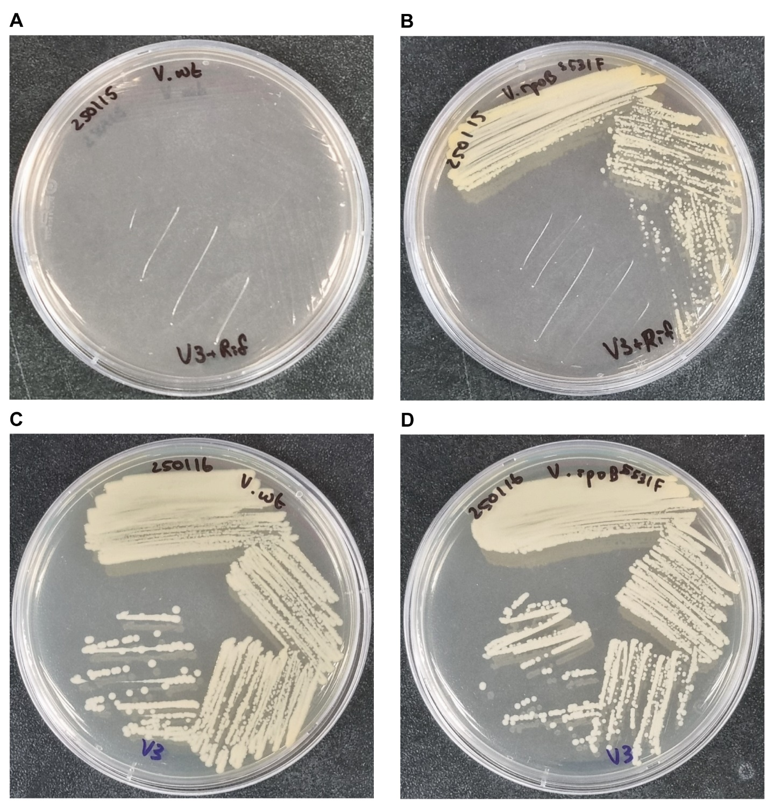
Streaking of (A) the wildtype strain, (B) Vibrio sp. dhg rpoB^{S531F} mutant strain on solid medium with rifampicin. Streaking of (C) the wildtype strain and (D) Vibrio sp. dhg rpoB^{S531F} mutant strain on nonselective medium shown as a positive control.

Figure S2. 5-FOA-resistance increase by CBE-mediated mutagenesis of pyrF
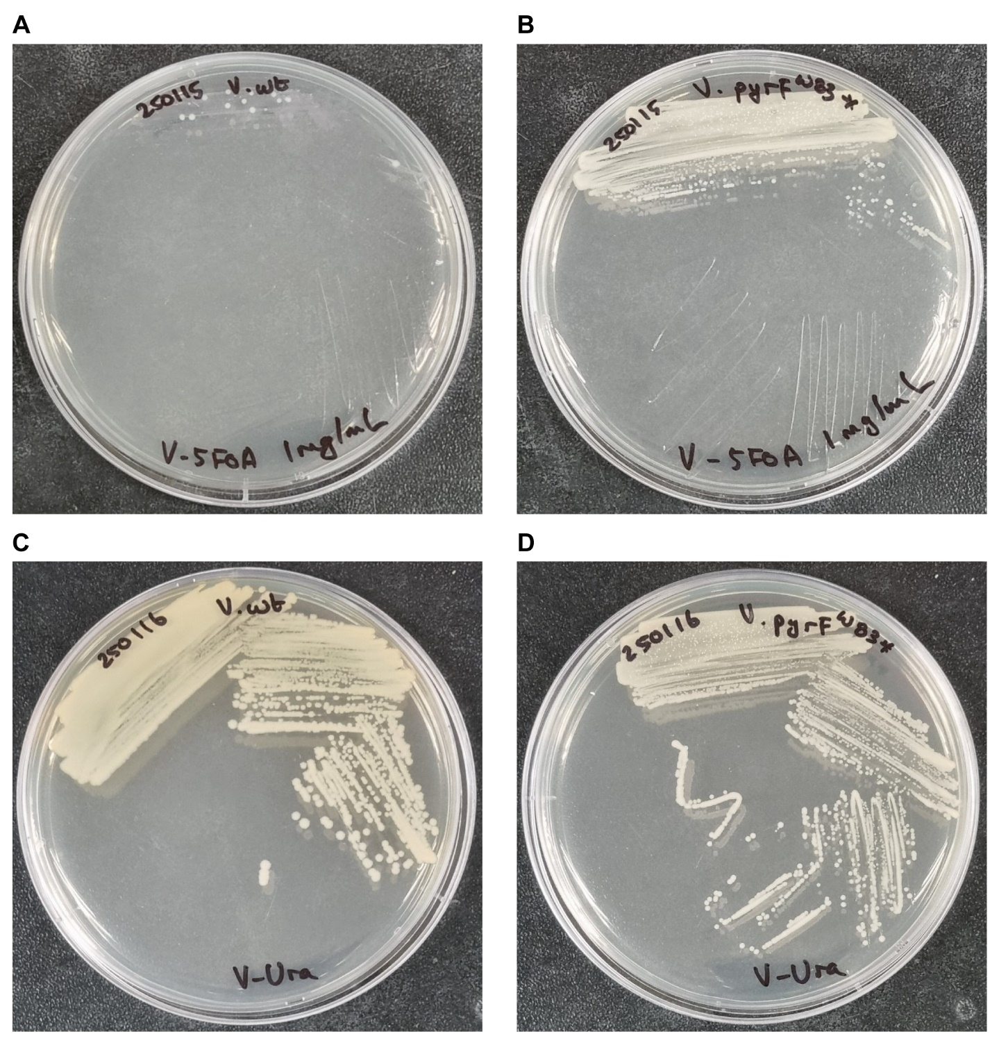
Streaking of (A) the wildtype strain, (B) Vibrio sp. dhg pyrF^{W83*} mutant strain on solid medium with 5-FOA and uracil. Streaking of (C) the wildtype and (D) Vibrio sp. dhg pyrF^{W83*} mutant strain on nonselective medium with uracil shown as a positive control.

Figure S3. Multiplex base editing efficiency by target site
Multiplex base editing efficiency of RE1 targets (green) and RE2 targets (blue) regarding the ratio of edited colonies in each target site.

