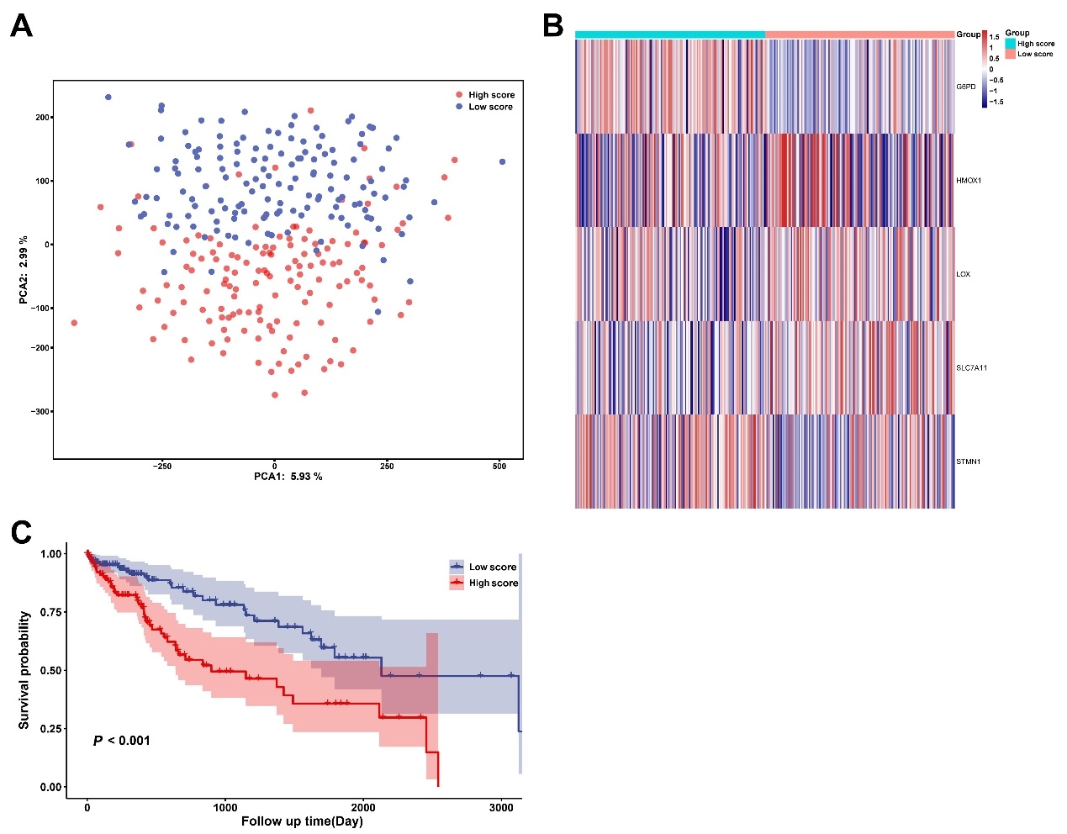
Supplementary Figure 1. Validation the gene signature for HCC patients in the International Cancer Genome Consortium (ICGC) cohort. (A) Principal component analysis (PCA) plot of HCC patients based on the expression profiles of the signature genes in different score groups. (B) Heatmap of mRNA expression of five selected ferroptosis-related genes in high and low-score samples. (C) Kaplan-Meier survival curves indicated that the overall survival in the low-score group was markedly higher than that in the high-score group.

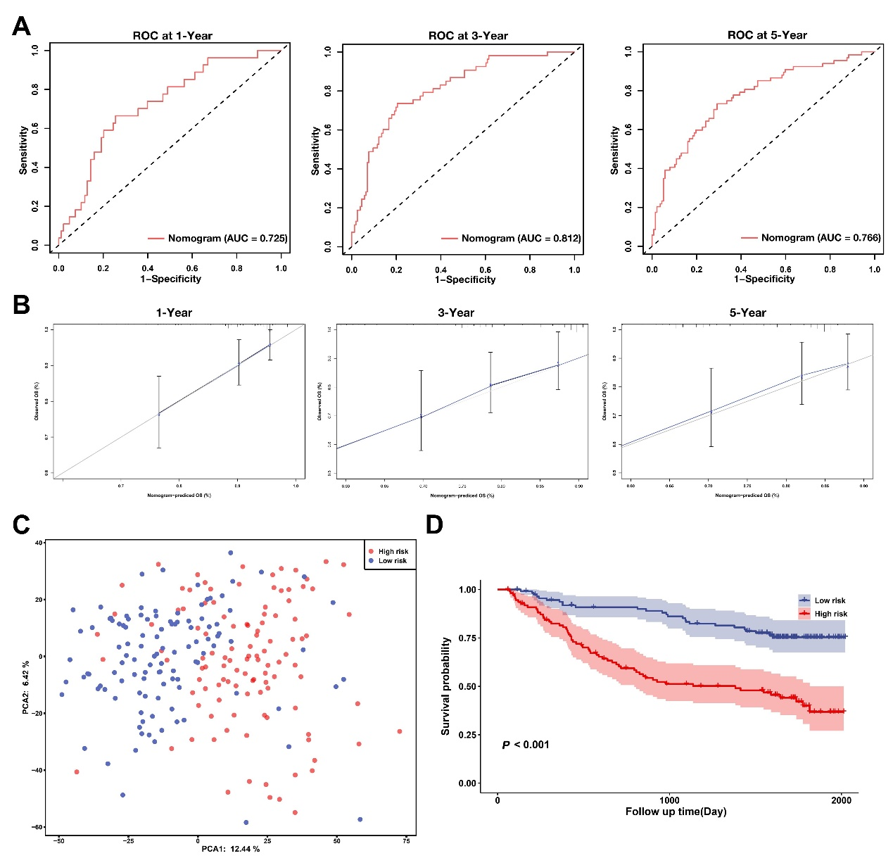
Supplementary Figure 2. Validation the nomogram for HCC patients in the GEO cohort. (A)The receiver operating characteristic (ROC) curves of the nomogram for the survival prediction of HCC patients at 1-, 3-, and 5-year. (B) The calibration curves of the nomogram for 1-, 3-, and 5-year survival probabilities. (C) Principal component analysis (PCA) plot of HCC patients based on the expression profiles of the signature genes in different risk groups. (D) Kaplan-Meier survival curves indicated that the overall survival in the low-risk group was markedly higher than that in the high-risk group. ROC, receiver operating characteristic; AUC, areas under receiver operating characteristic curve; OS, overall survival.

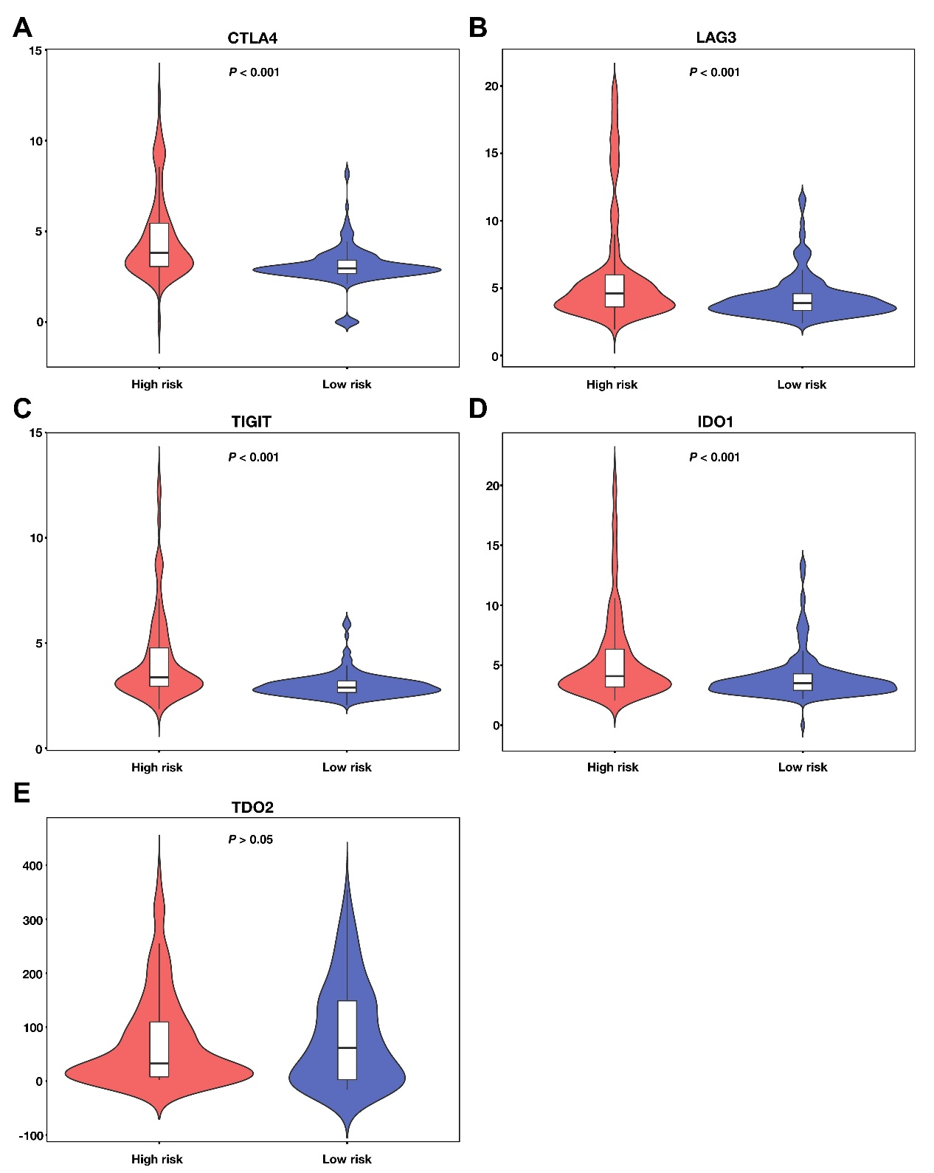
Supplementary Figure 3. Expression of immune checkpoints in different risk groups. (A-E) Expression of CTLA4, LAG3, TIGIT, IDO1, and TDO2 in high and low-risk samples.

