File: Ola farmakologia 2024-11-28 15h06m04s
Cell lines: CLBL-1, GL-1
From left to right:
lane 1; CLBL-1 0 µM, lane 2; CLBL-1 25 µM, lane 3; CLBL-1 50 µM, lane 4; GL-1 0 µM, lane 5; GL-1 25 µM, lane 6; GL-1 50 µM
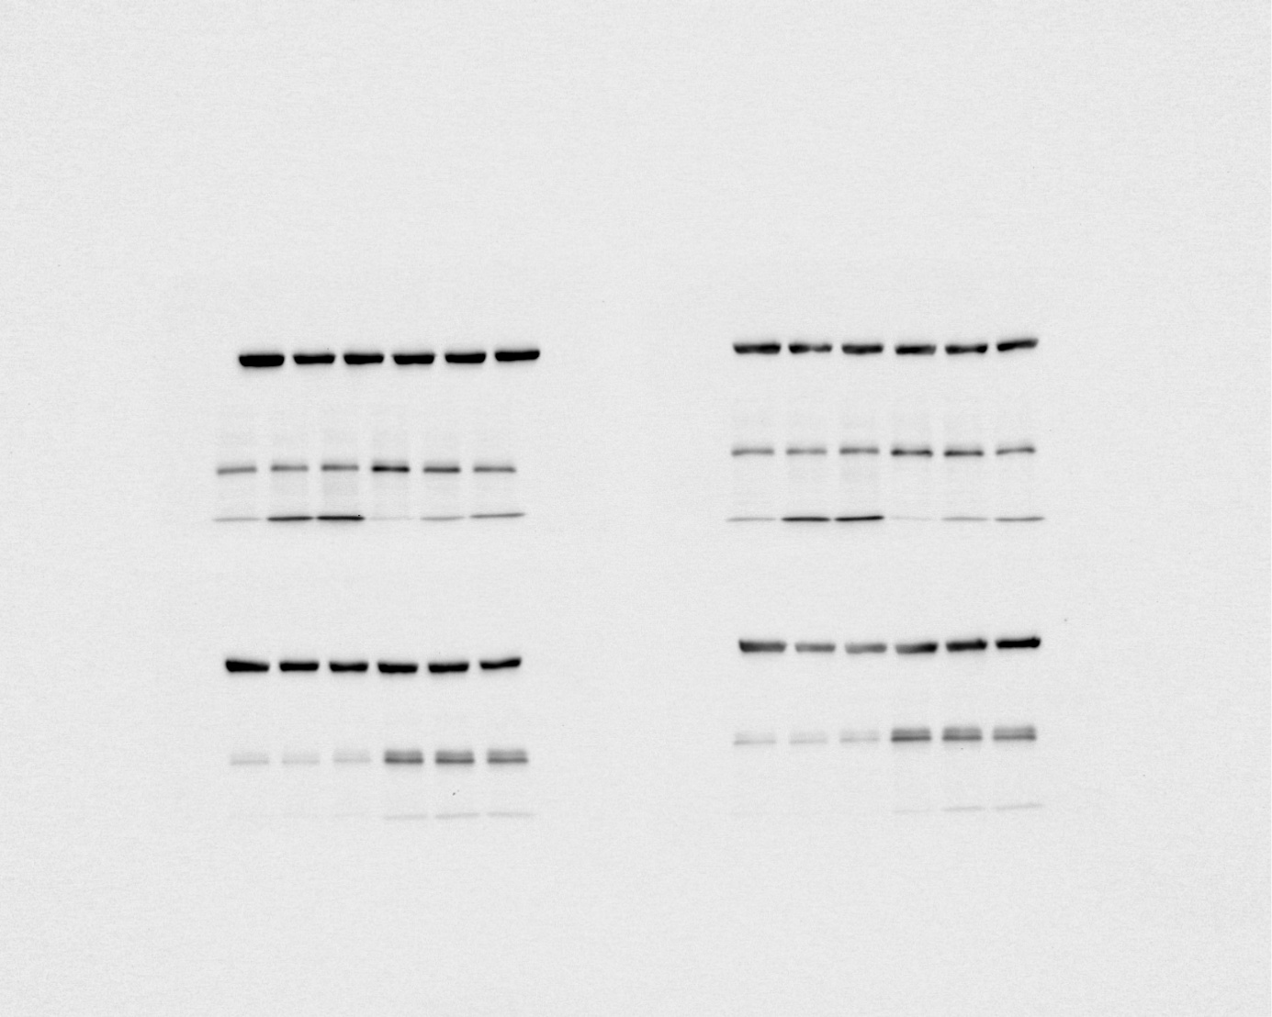
1 2 3 4 5 6
1 2 3 4 5 6
1 2 3 4 5 6
1 2 3 4 5 6

File: Ola farmakologia 2024-11-29 14h14m52s
Cell lines: CLBL-1, GL-1
From left to right:
lane 1; CLBL-1 0 µM, lane 2; CLBL-1 25 µM, lane 3; CLBL-1 50 µM, lane 4; GL-1 0 µM, lane 5; GL-1 25 µM, lane 6; GL-1 50 µM

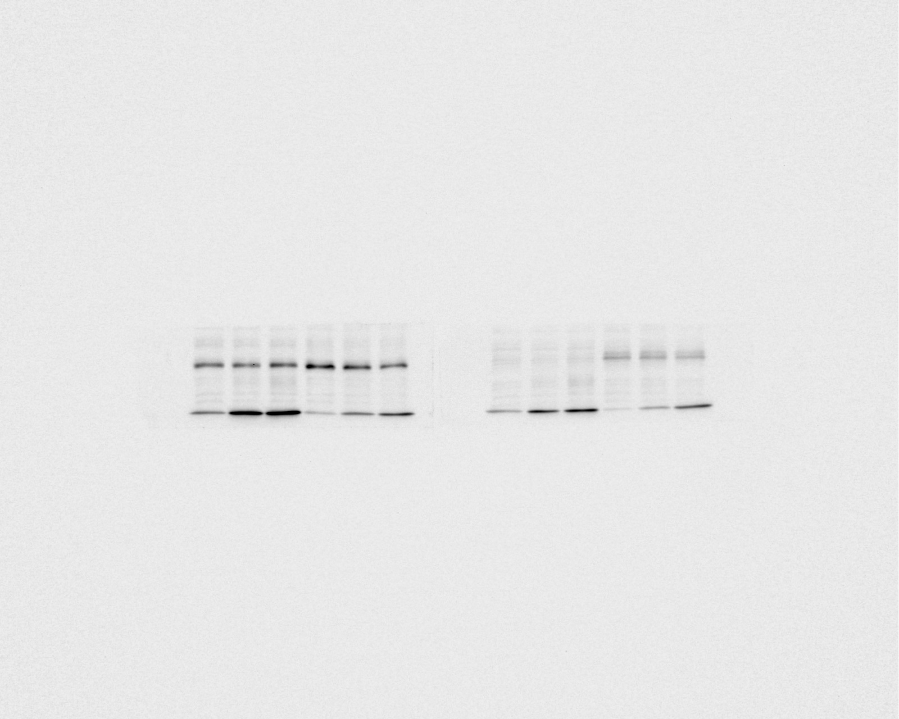
1 2 3 4 5 6
1 2 3 4 5 6

File: Ola farmakologia 2024-12-05 14h34m47s
Cell lines: CNK-89, CLB70
From left to right:
lane 1; CNK-89 0 µM, lane 2; CNK-89 25 µM, lane 3; CNK-89 50 µM, lane 4; CLB70 0 µM, lane 5; CLB70 25 µM, lane 6; CLB70 50 µM

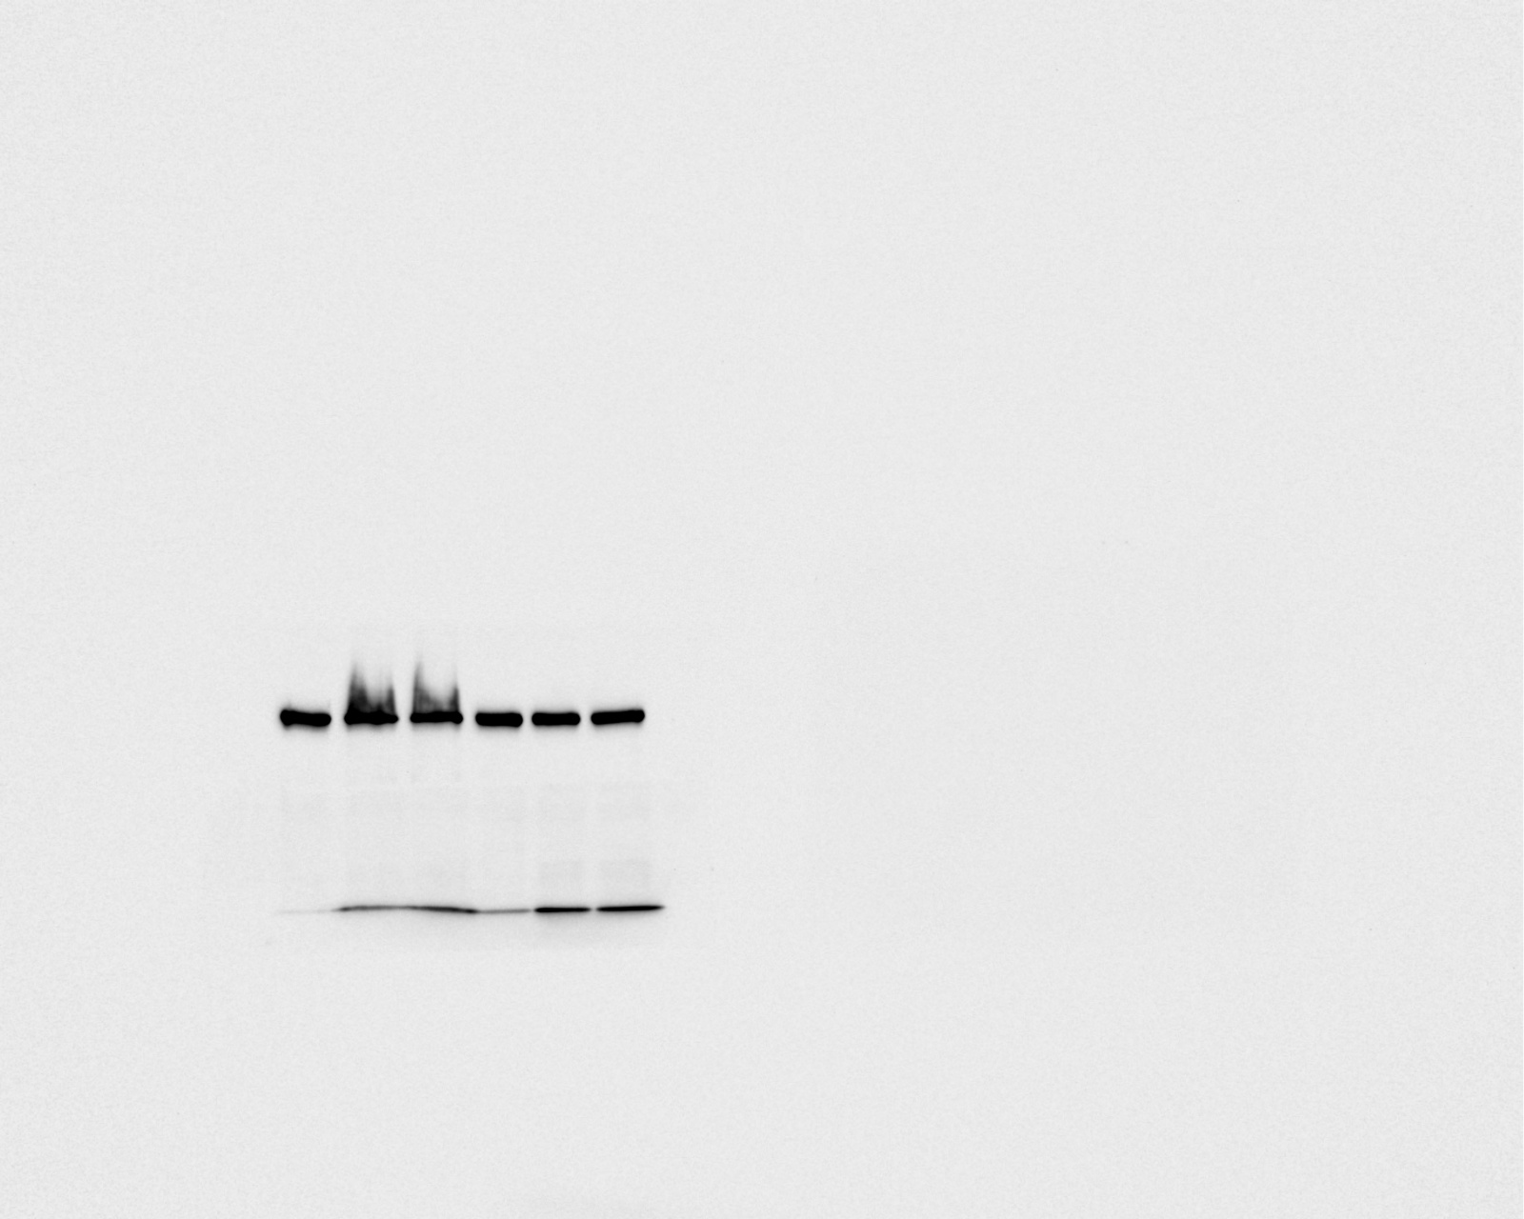
1 2 3 4 5 6

File: Ola farmakologia 2024-12-09 14h20m14s
Cell lines: CNK-89, CLB70 (On this image only lower membranes belongs to CNK-89 and CLB70 cell lines)
From left to right:
lane 1; CNK-89 0 µM, lane 2; CNK-89 25 µM, lane 3; CNK-89 50 µM, lane 4; CLB70 0 µM, lane 5; CLB70 25 µM, lane 6; CLB70 50 µM

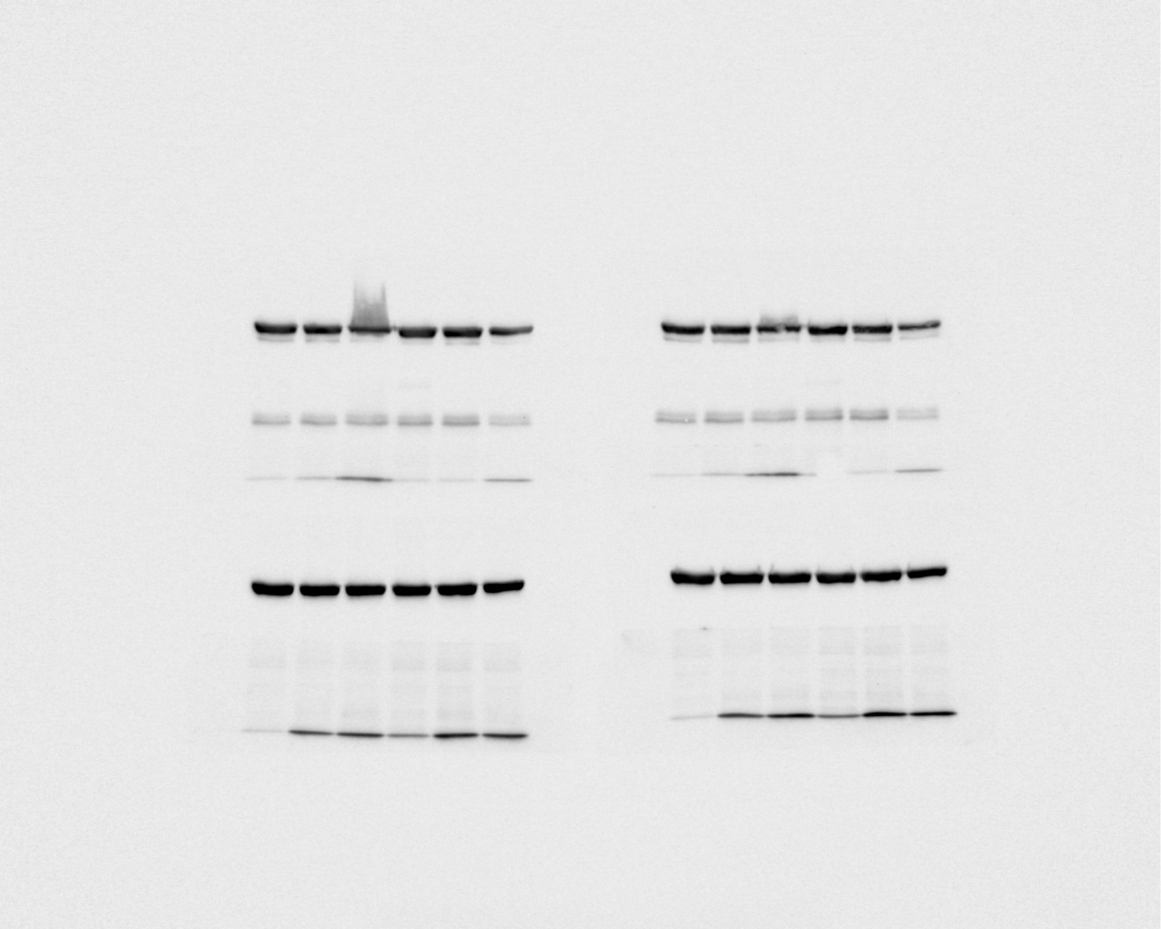
1 2 3 4 5 6
1 2 3 4 5 6

