SUPPLEMENTARY MATERIAL
SINGLE ADSORPTION OF DICLOFENAC AND RONIDAZOLE FROM AQUEOUS SOLUTION ON COMMERCIAL ACTIVATED CARBONS: EFFECT OF CHEMICAL AND TEXTURAL PROPERTIES
A. I. Moral-Rodríguez¹, R. Leyva-Ramos¹*, E. Mendoza-Mendoza^{1,2}, P. E. Díaz-Flores³, D. H. Carrales-Alvarado⁴, M. F. Alexandre-Franco⁵, C. Fernández-González⁵

¹ Centro de Investigación y Estudios de Posgrado, Facultad de Ciencias Químicas, UASLP,
Av. Dr. Manuel Nava No. 6, San Luis Potosí, SLP 78210, Mexico
² Cátedra-CONACYT
³ Facultad de Agronomía y Veterinaria, Universidad Autónoma de San Luis Potosí. San Luis Potosí, SLP 78321, Mexico
⁴ Instituto de Catálisis y Petroleoquímica, CSIC, C/Marie Curie 2, L10, 28049 Madrid, Spain.
⁵ Departamento de Química Orgánica e Inorgánica, Universidad de Extremadura, Badajoz, Spain

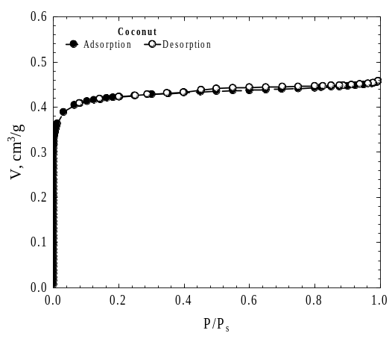  (a) | 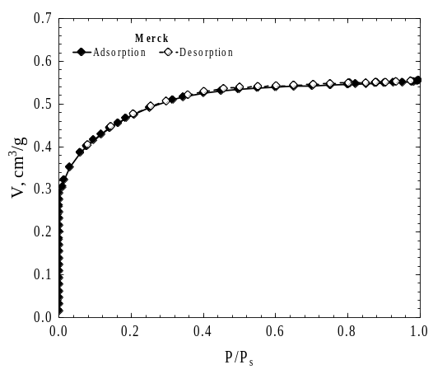  (b)
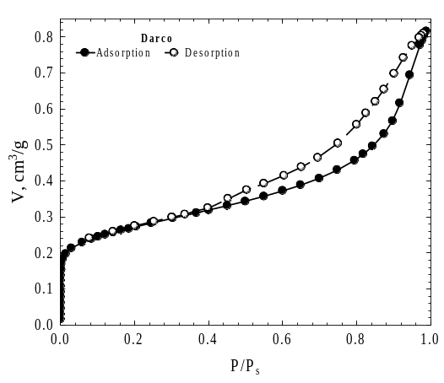  (c) | 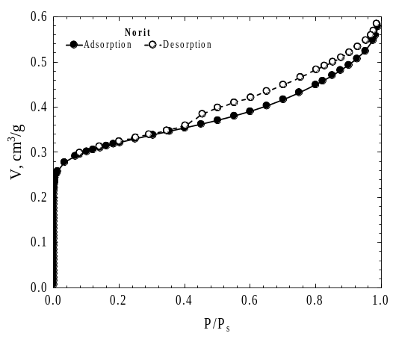  (d)
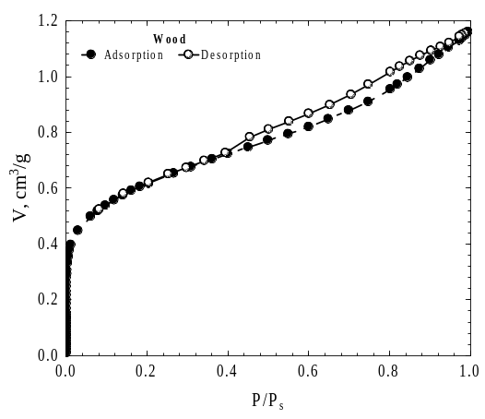
(e)
Figure S.1 Adsorption-desorption isotherms of N₂ at 77 K on commercial ACs: a) Coco, b) Merck, c) Darco, d) Norit and e) Wood.
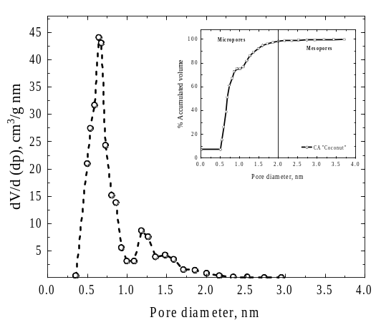  (a) |  | 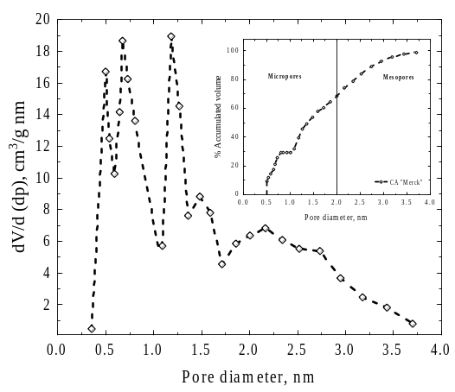  (b)
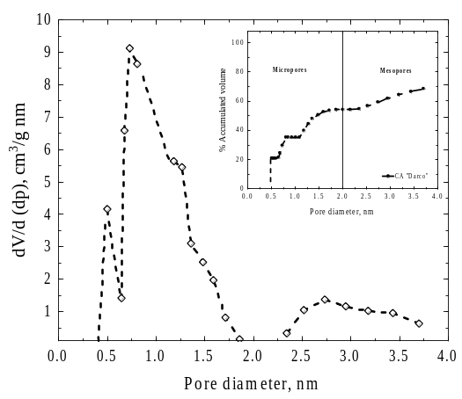  (c) |  | 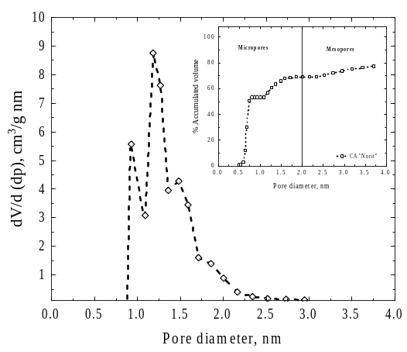  (d)
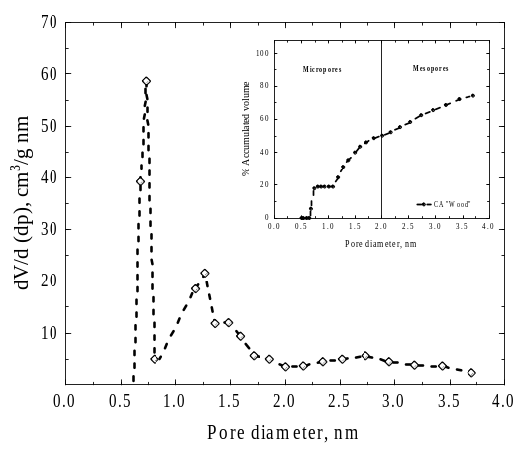
(e)
Figure S.2 Distribution of pore volume and total accumulated pore volume against the pore diameter for the commercial ACs: a) Coconut, b) Merck, c) Darco, d) Norit and e) Wood.

