OSCAR Analysis

Demographics & data completeness

Patient data
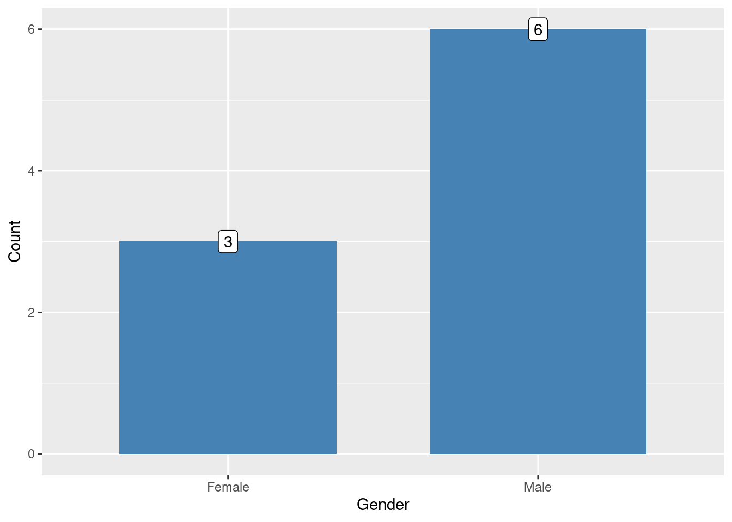
Figure 1: Patient Gender
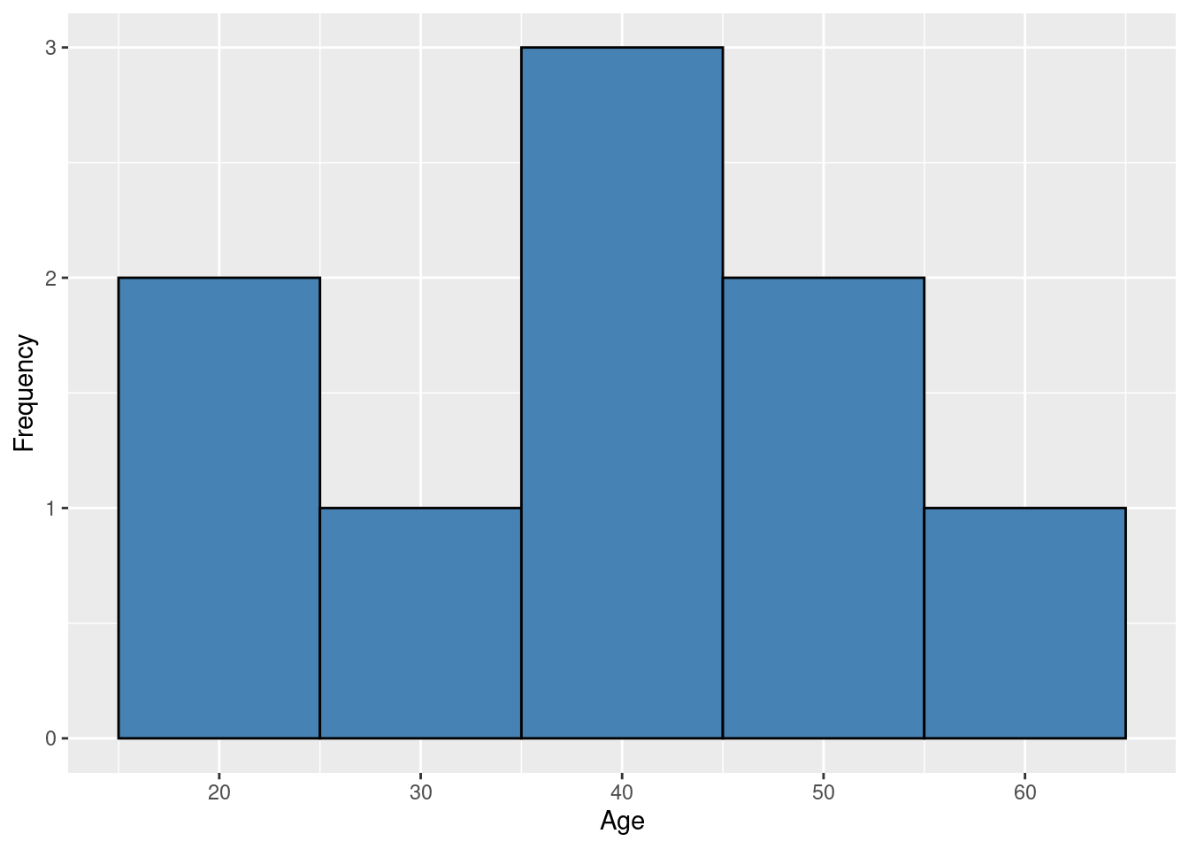
Figure 2: Patient Ages
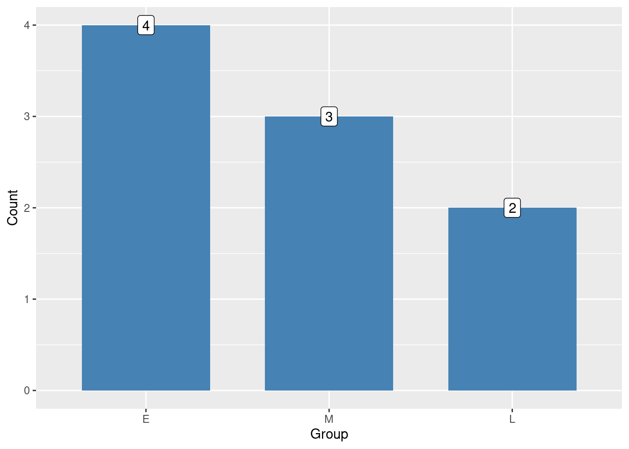
Figure 3: Treatment delay allocation. E: 6-8 days, M: 9-11days, L: 12-14 days
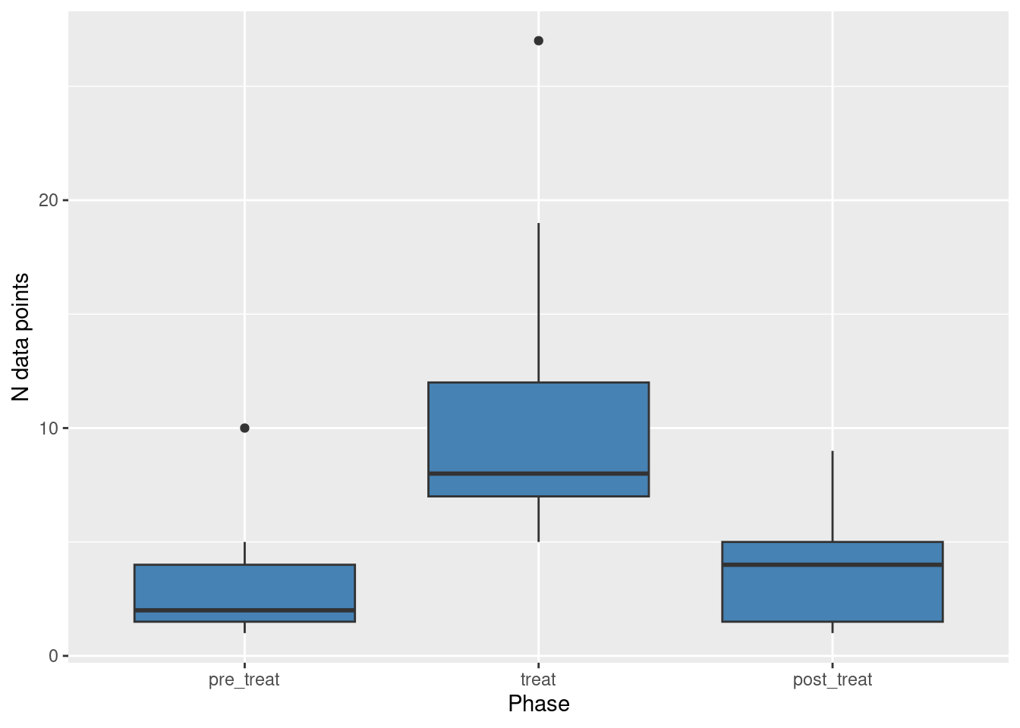
Figure 4: Box and whisker plot: number of datapoints during each phase, per patient

Osteopath data
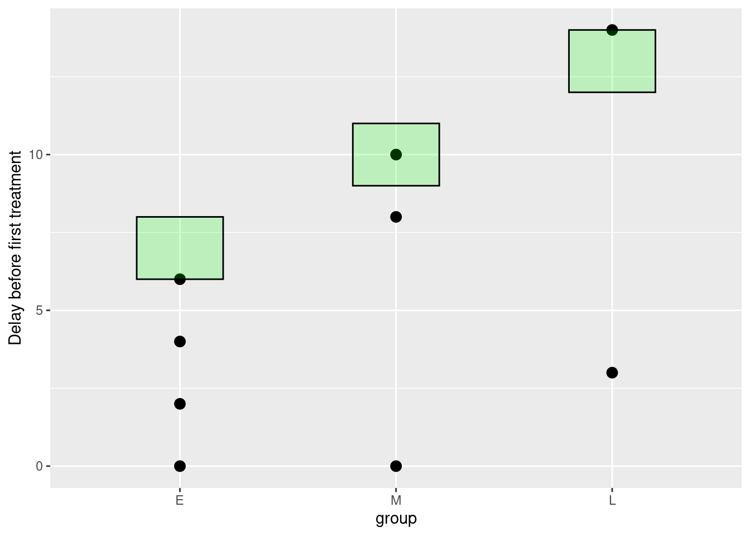
Figure 5: Compliance with randomisation. Green rectangles show range within which delay before treatment should have been.
Table 1: Counts of completion of PABS questionnaire by osteopaths. PABS1 - completed at baseline, PABS2 - completed before BPSM course, completed after BPSM course
pabs_source | n
PABS1 | 11
PABS2 | 10
PABS3 | 2

NPRS and PSFS scores

Correlation between NPRS and PSFS
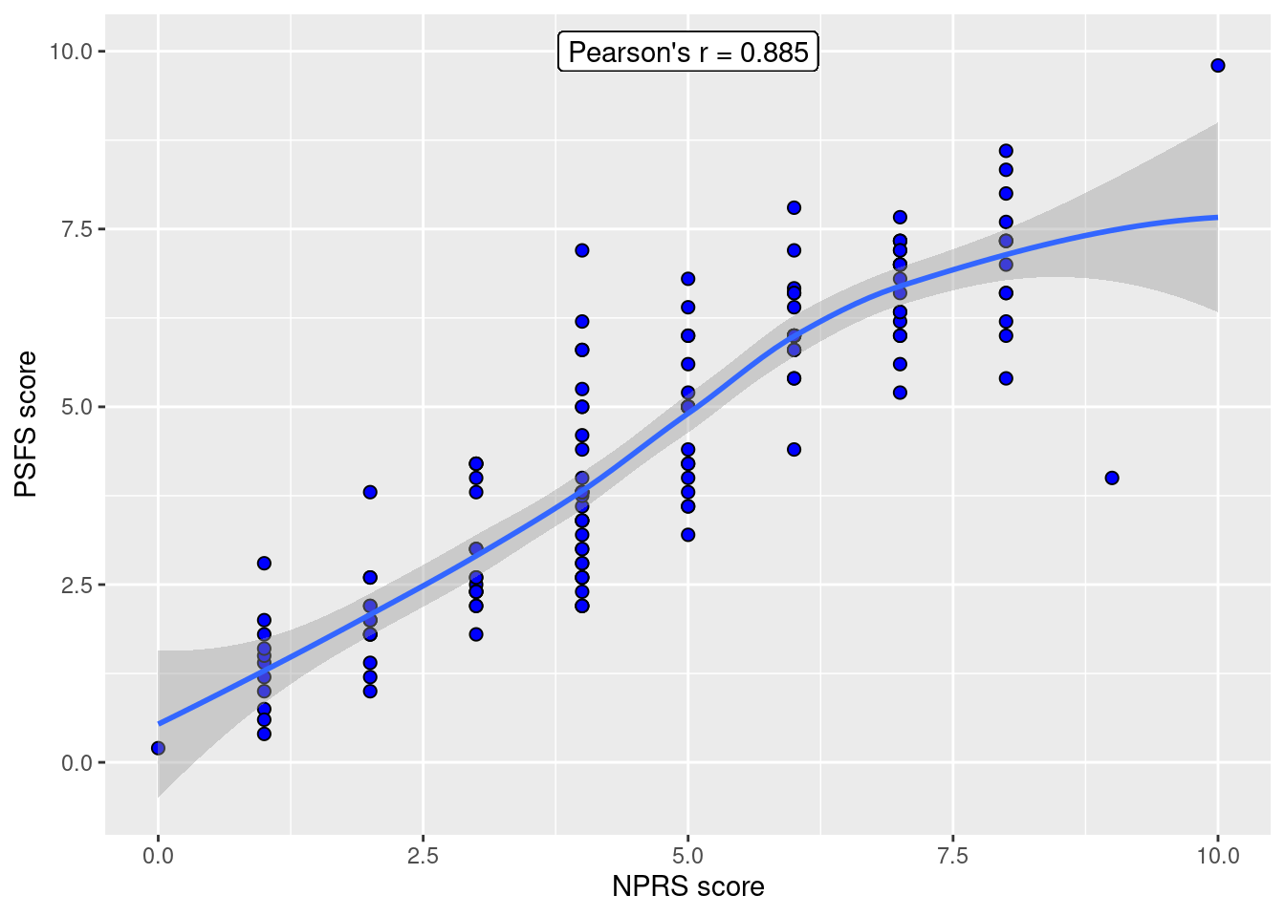
Figure 6: Scatterplot NPRS vs PSFS

Modelling NPRS and PSFS scores
Software used:
- R:
  - R version 4.3.1 (2023-06-16) [6]
- Lme4:
  - Version 1.1.34 [2]
- lmerTest:
  - Version 3.1.3 [4]
Variables considered in the modelling:
- cohort (patient enrolled before or after osteopath BPS training course)
- age (patient age)
- gender (patient gender)
- phase (phase of the study: pre-treatment, during treatment, or post-treatment)
- daycount (number of days passed since enrollment)
- ptID (patient ID)
- nprs NPRS score
- psfs PSFS score
Modelling started with a maximal model. This was compared to more parsimonious (nested) models using likelihood ratio tests (LRT) and the Akaike Information Criterion (AIC), in a step-wise fashion. Reference was also made to the Bayes Information criterion (BIC) where there was doubt. Maximum likelihood estimation was used when comparing models with the LRT. The REML (restricted maximum likelihood) criterion was used to estimate parameter variances. p-values were calculated based on the Kenward-Roger’s method of estimating the denominator degrees of freedom. Significance levels were set at 0.05.
Maximal model:
Y ~ phase * time * cohort + age + gender + (daycount|ptID)
where Y is either nprs or psfs. phase * time * cohort is the three-way interaction of the three variables including all the lower-order terms. (daycount|ptID) represents random effects with patient-specific random intercepts and slopes. Examination of the individual patient time series points to approximately linear trends in score that varies across individuals, pointing to the needs to model subject-specific slopes and intercepts to account for the lack of independence of repeated measurements.
Models where checked for normality of residuals and random effects, associations between fixed effects and residuals, associations between fitted values and residuals, and correspondence between predicted values and the data. Lag plots where used to look for remaining serial correlations between residuals, and checks where carried out for overly influential observations [5].

NPRS scores
The final model chosen for modelling the NPRS data was:
NPRS model 3: nprs ~ daycount * phase + (daycount|ptID) + gender
The corresponding model summary and analysis of deviance tables of model 3 are shown in Tables 2 and 3. This model needs to be treated with caution as it is a singular fit. Singular fits are a common occurrence especially with small to medium sized data sets and may indicate overfitting, but are never-the-less theoretically possible [5]. A singular fit means inferential procedures maybe inappropriate (see [1]). Comparing the chosen model with a model that includes cohort:
NPRS model 2: nprs ~ daycount * phase * cohort + (daycount|ptID) + gender
indicates that the model 3 is a better fit to the data (see Table 4). The analysis of deviance table for model 2 indicates that cohort is not significant (Table 5), justifying not including cohort in the model.
Table 2: NPRS model summary
 | nprs
Predictors | Estimates | CI | p
(Intercept) | 4.12 | 2.75 – 5.48 | <0.001
daycount | -0.07 | -0.11 – -0.04 | <0.001
phase [pre_treat] | -0.23 | -1.05 – 0.58 | 0.570
phase [post_treat] | 0.13 | -1.27 – 1.54 | 0.854
gender [Male] | 2.51 | 1.35 – 3.68 | <0.001
daycount × phase  [pre_treat] | 0.24 | 0.12 – 0.35 | <0.001
daycount × phase  [post_treat] | 0.03 | 0.00 – 0.05 | 0.047
Random Effects
σ² | 1.27
τ₀₀ _{ptID} | 2.68
τ₁₁ _{ptID.daycount} | 0.00
ρ₀₁ _{ptID} | 1.00
N _{ptID} | 10
Observations | 155
Marginal R² / Conditional R² | 0.778 / NA

Table 3: NPRS analysis of deviance table: model 3
 | Sum Sq | Mean Sq | NumDF | DenDF | F value | p_val
daycount | 12.18 | 12.18 | 1 | 11.15 | 9.60 | < 0.01 **
phase | 23.54 | 11.77 | 2 | 106.09 | 9.27 | < 0.001 ***
gender | 13.26 | 13.26 | 1 | 3.19 | 10.46 | < 0.01 *
daycount:phase | 21.17 | 10.59 | 2 | 55.96 | 8.30 | < 0.001 ***

Table 4: Comparing model 2 and 3, likelihood ratio test, AIC and BIC
 | npar | AIC | BIC | logLik | deviance | Chisq | Df | Pr(>Chisq)
Model 3 | 11 | 533.68 | 567.16 | -255.84 | 511.68 | NA | NA | NA
Model 2 | 17 | 538.70 | 590.44 | -252.35 | 504.70 | 6.98 | 6 | 0.32

Table 5: NPRS analysis of deviance table: model 2
 | Sum Sq | Mean Sq | NumDF | DenDF | F value | p_val
daycount | 8.49 | 8.49 | 1 | 8.14 | 6.97 | < 0.01 *
phase | 24.59 | 12.29 | 2 | 116.87 | 10.08 | < 0.001 ***
cohort | 0.09 | 0.09 | 1 | 7.33 | 0.07 | 0.792
gender | 4.26 | 4.26 | 1 | 4.52 | 3.50 | 0.127
daycount:phase | 18.22 | 9.11 | 2 | 127.94 | 7.47 | < 0.001 ***
daycount:cohort | 0.42 | 0.42 | 1 | 8.87 | 0.34 | 0.572
phase:cohort | 1.18 | 0.59 | 2 | 122.61 | 0.48 | 0.617
daycount:phase:cohort | 4.99 | 2.50 | 2 | 134.30 | 2.05 | 0.133
Table 3 indicates there was a significant interaction between daycount and phase. Table 2 shows that the slope is more positive (or less negative) in the pre-treatment and post-treatment phases than the treatment phase. This points to a faster rate of recovery in the treatment phase than the other two phases. Also, male gender has a significantly higher NPRS score than the female gender.

PSFS scores
The final model chosen for modelling the PSFS data was:
PSFS model 4: nprs ~ daycount * phase + (daycount|ptID) + gender
The corresponding model summary and analysis of deviance tables of model 3 are shown in Tables 6 and 7.
Table 6: PSFS chosen model summary
 | psfs
Predictors | Estimates | CI | p
(Intercept) | 5.94 | 4.95 – 6.94 | <0.001
daycount | -0.09 | -0.13 – -0.05 | <0.001
phase [pre_treat] | 0.02 | -0.57 – 0.61 | 0.952
phase [post_treat] | -1.22 | -2.35 – -0.09 | 0.034
daycount × phase  [pre_treat] | 0.21 | 0.13 – 0.30 | <0.001
daycount × phase  [post_treat] | 0.05 | 0.03 – 0.07 | <0.001
Random Effects
σ² | 0.60
τ₀₀ _{ptID} | 2.17
τ₁₁ _{ptID.daycount} | 0.00
ρ₀₁ _{ptID} | 0.03
ICC | 0.92
N _{ptID} | 10
Observations | 155
Marginal R² / Conditional R² | 0.268 / 0.941

Table 7: PSFS analysis of deviance table: model 4
 | Sum Sq | Mean Sq | NumDF | DenDF | F value | p_val
daycount | 4.09 | 4.09 | 1 | 9.20 | 6.80 | < 0.01 *
phase | 30.49 | 15.25 | 2 | 137.52 | 25.32 | < 0.001 ***
daycount:phase | 24.78 | 12.39 | 2 | 138.40 | 20.58 | < 0.001 ***
Modelling of the PSFS data was not affected by singular fits. The result of the PSFS modelling produced similar results to that of the NPRS, except that gender was not a significant effect. As with the NPRS data, there was a significant interaction between daycount and phase, with the slope being more positive (or less negative) in the pre-treatment and post-treatment phases than the treatment phase. Again, this points to a faster rate of recovery in the treatment phase than the other two phases. This is not surprising given the strong correlation between NPRS and PSFS scores.

Analysis of residuals and random effects

NPRS

Random effects
Table 8: Comparing model with slopes & intercepts to intercepts only
 | npar | logLik | AIC | LRT | Df | Pr(>Chisq)
<none> | 11 | -264.82 | 551.63 | NA | NA | NA
daycount in (daycount | ptID) | 9 | -280.67 | 579.35 | 31.71 | 2 | 0

Table 9: Comparing model with and without random effects
 | npar | logLik | AIC | LRT | Df | Pr(>Chisq)
<none> | 11 | -264.82 | 551.63 | NA | NA | NA
(daycount | ptID) | 8 | -325.75 | 667.50 | 121.87 | 3 | 0
Tables 8 & 9 indicate that random effects are highly significant in the model and that a model with random intercepts and slopes is superior to one with only random intercepts. These results suggest that the linear trends in the time course of NPRS is significantly patient-specific. Figure 8 indicates random effects do not depart substantially from a normal distribution.
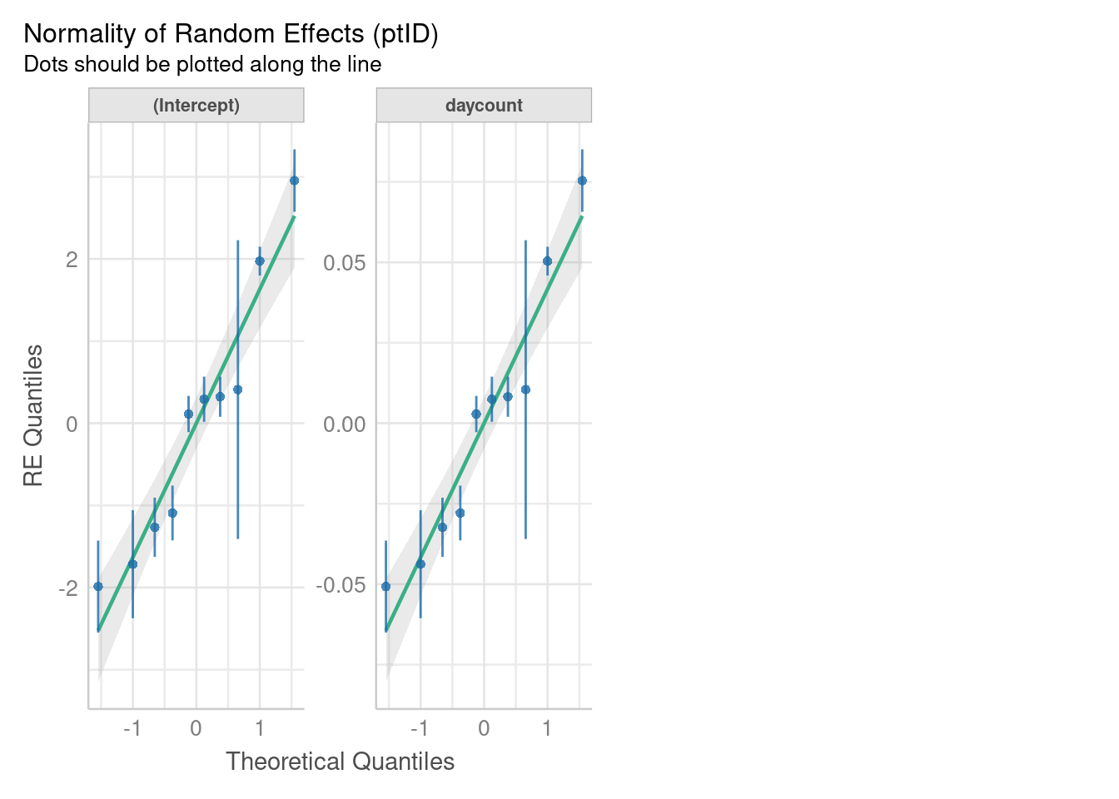
Figure 8: Distribution of random effects: NPRS scores

Residuals
Residuals of the chosen model did not, for the most part, deviate substantially from a normal distribution (figures 9 & 10). There may be outliers weighting the tails. However, figure 11 does not indicate overly influential data points. A plot of residuals versus fitted values (fig 12 ) did not indicate heteroscedasticity or a residual systematic trend in the residuals. However, there is again some evidence of outliers. Lag plots of serial residuals with different lags did not indicate any remaining autocorrelations (not shown).
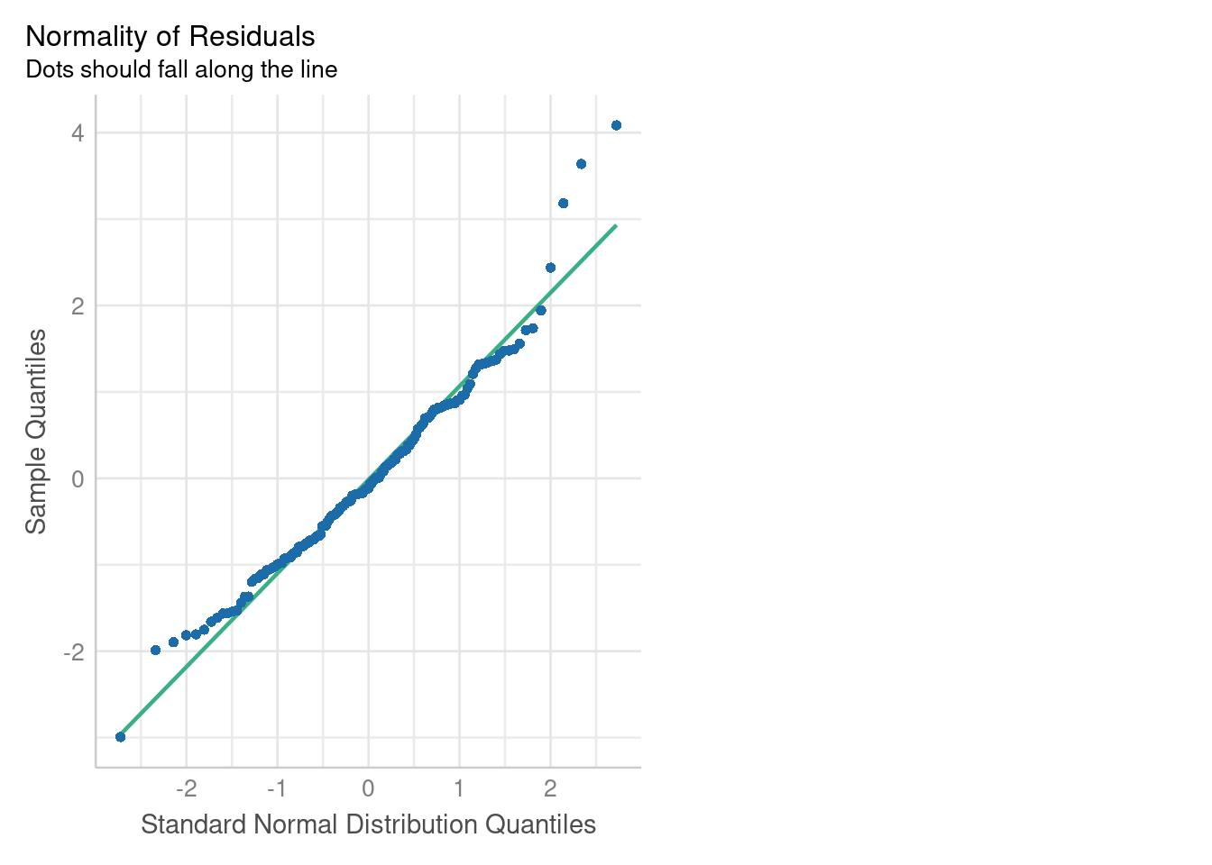
Figure 9: QQ plot of residuals: NPRS
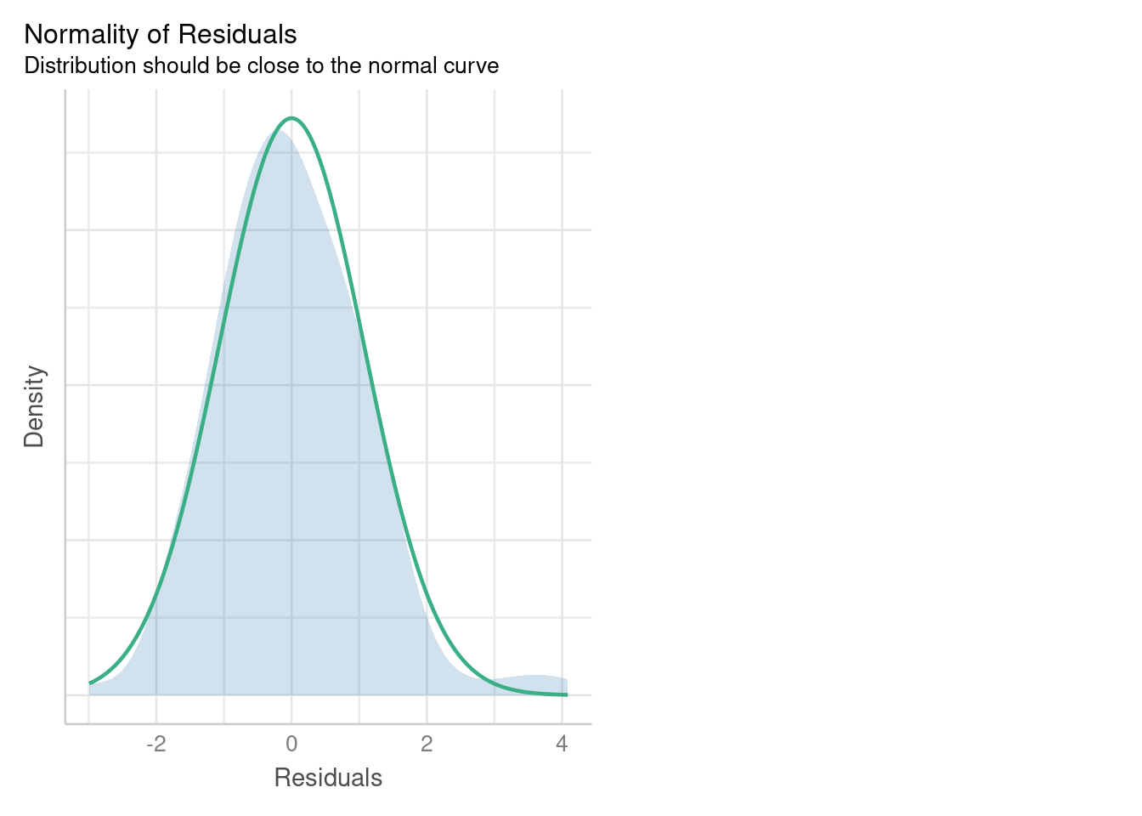
Figure 10: Histogram of residuals: NPRS
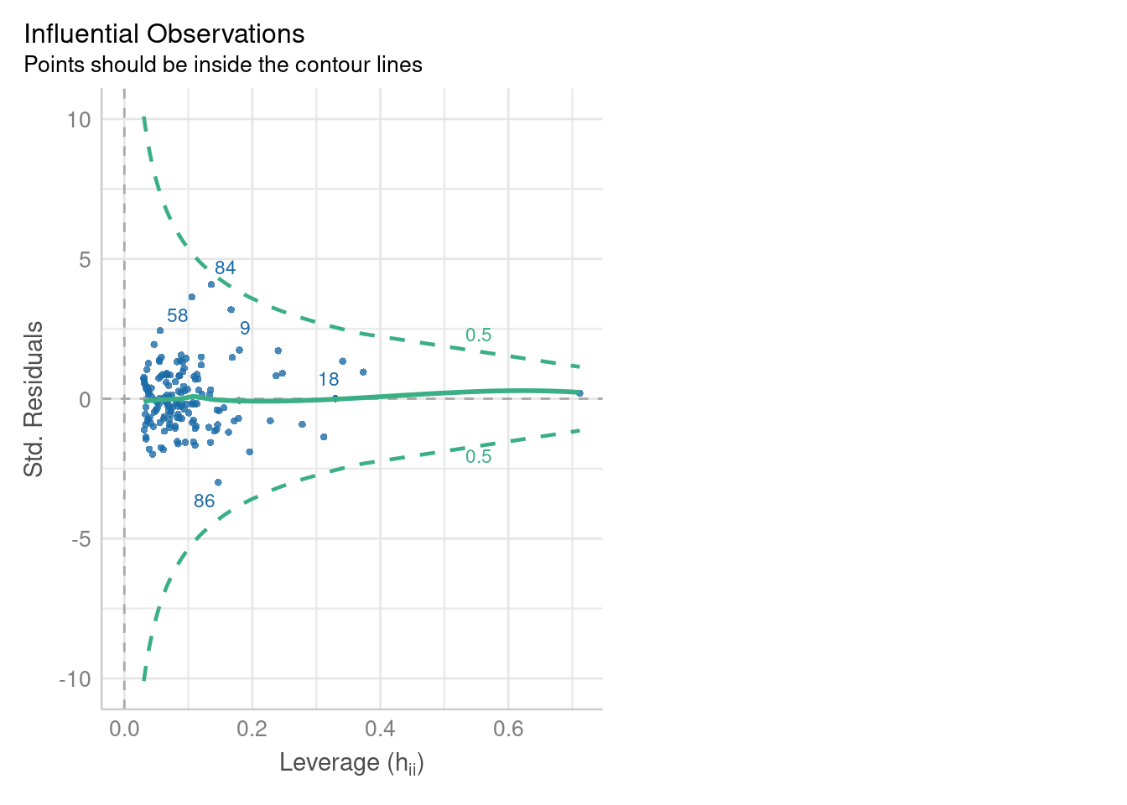
Figure 11: Histogram of residuals: NPRS
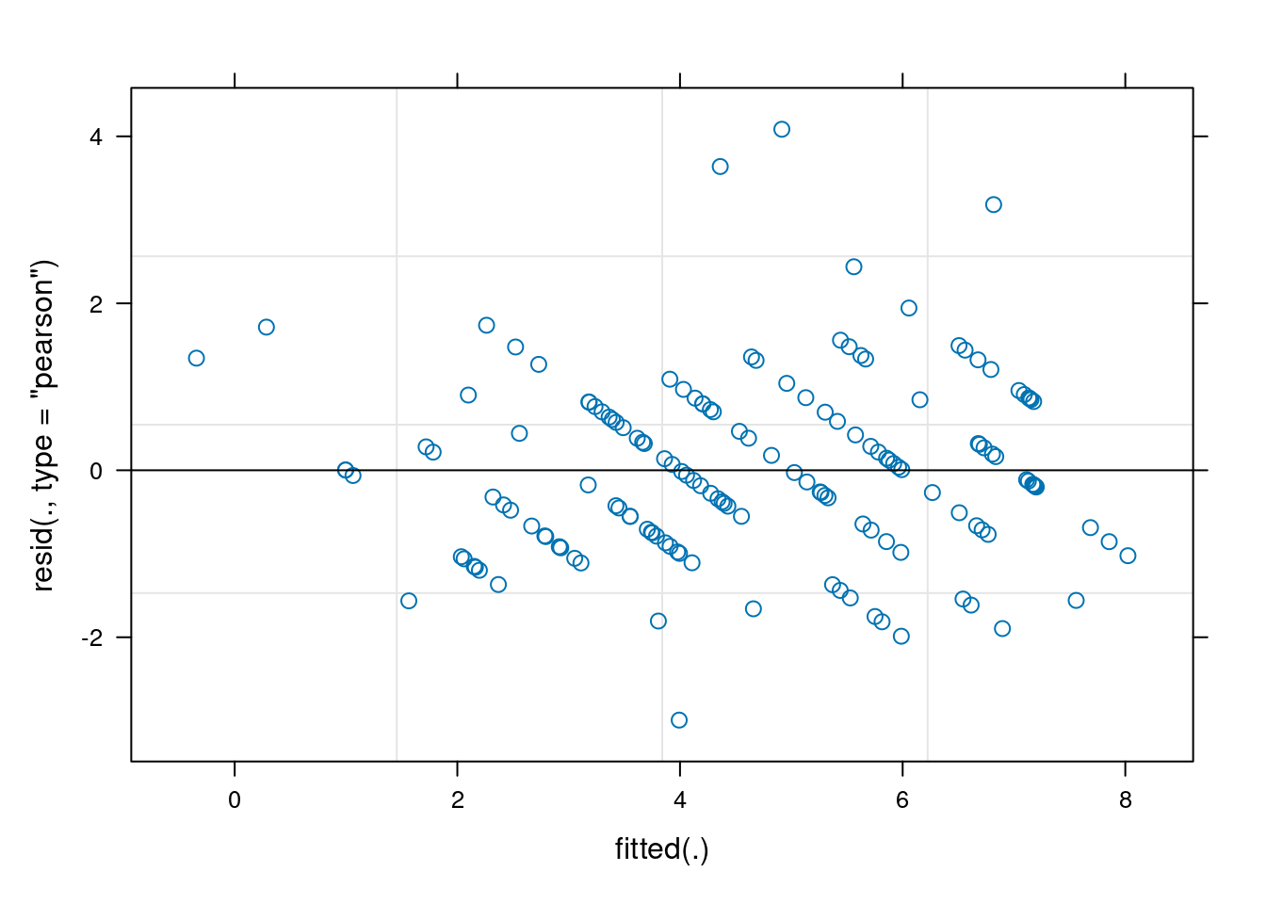
Figure 12: Histogram of residuals: NPRS

PSFS

Random effects
Table 10: Comparing model with slopes & intercepts to intercepts only
 | npar | logLik | AIC | LRT | Df | Pr(>Chisq)
<none> | 10 | -220.80 | 461.60 | NA | NA | NA
daycount in (daycount | ptID) | 8 | -249.24 | 514.48 | 56.88 | 2 | 0

Table 11: Comparing model with and without random effects
 | npar | logLik | AIC | LRT | Df | Pr(>Chisq)
<none> | 10 | -220.80 | 461.60 | NA | NA | NA
(daycount | ptID) | 7 | -317.22 | 648.44 | 192.84 | 3 | 0
Tables 10 & 11 indicate that random effects are highly significant in the model and that a model with random intercepts and slopes is superior to one with only random intercepts. These results suggest that the linear trends in the time course of PSFS, as with the NPRS data, is significantly patient-specific. Figure 13 indicates random effects do not depart substantially from a normal distribution.
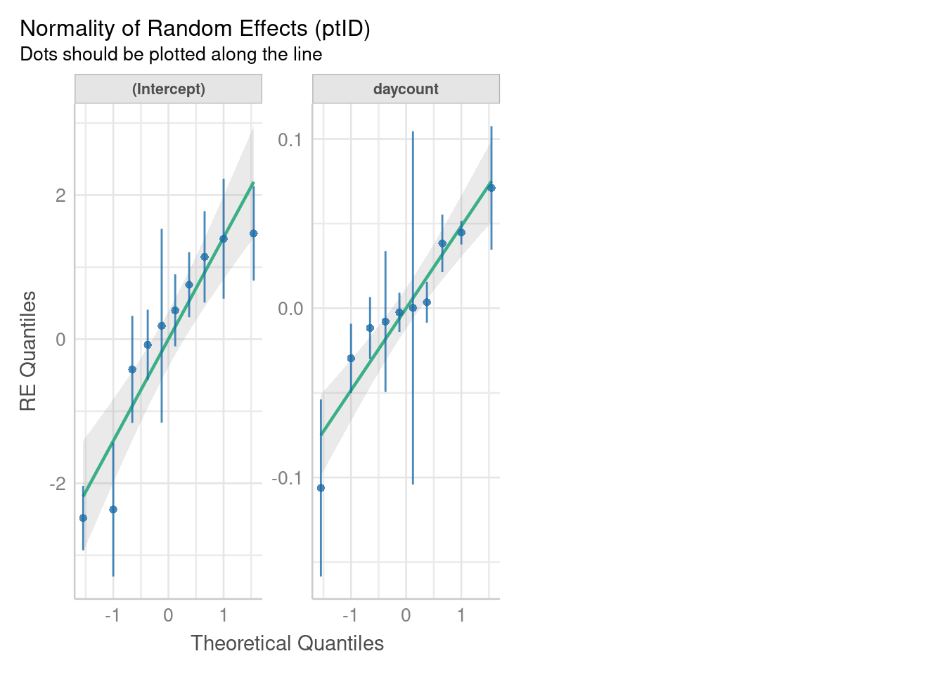
Figure 13: Distribution of random effects: PSFS scores

Residuals
Residuals of the chosen model did not, for the most part, deviate substantially from a normal distribution (figures 14 & 15). There may be outliers weighting the tails and the distribution appears mildly leptokurtotic. figure 16 indicates 1 data point that is overly influential. A plot of residuals versus fitted values (fig 17 ) did not indicate heteroscedasticity or a residual systematic trend in the residuals. However, there is again some evidence of outliers. Lag plots of serial residuals with different lags did not indicate any remaining autocorrelations (not shown).
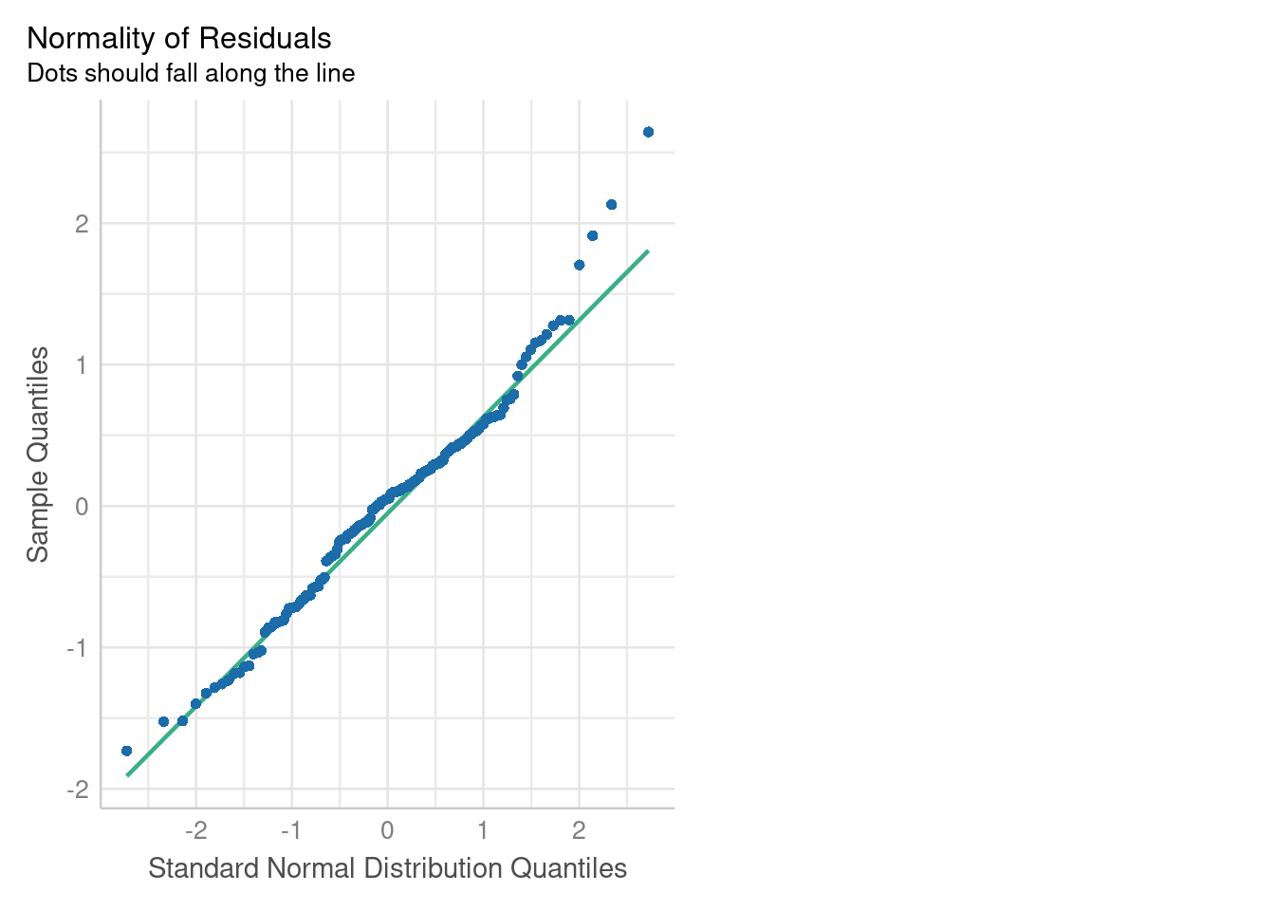
Figure 14: QQ plot of residuals: PSFS
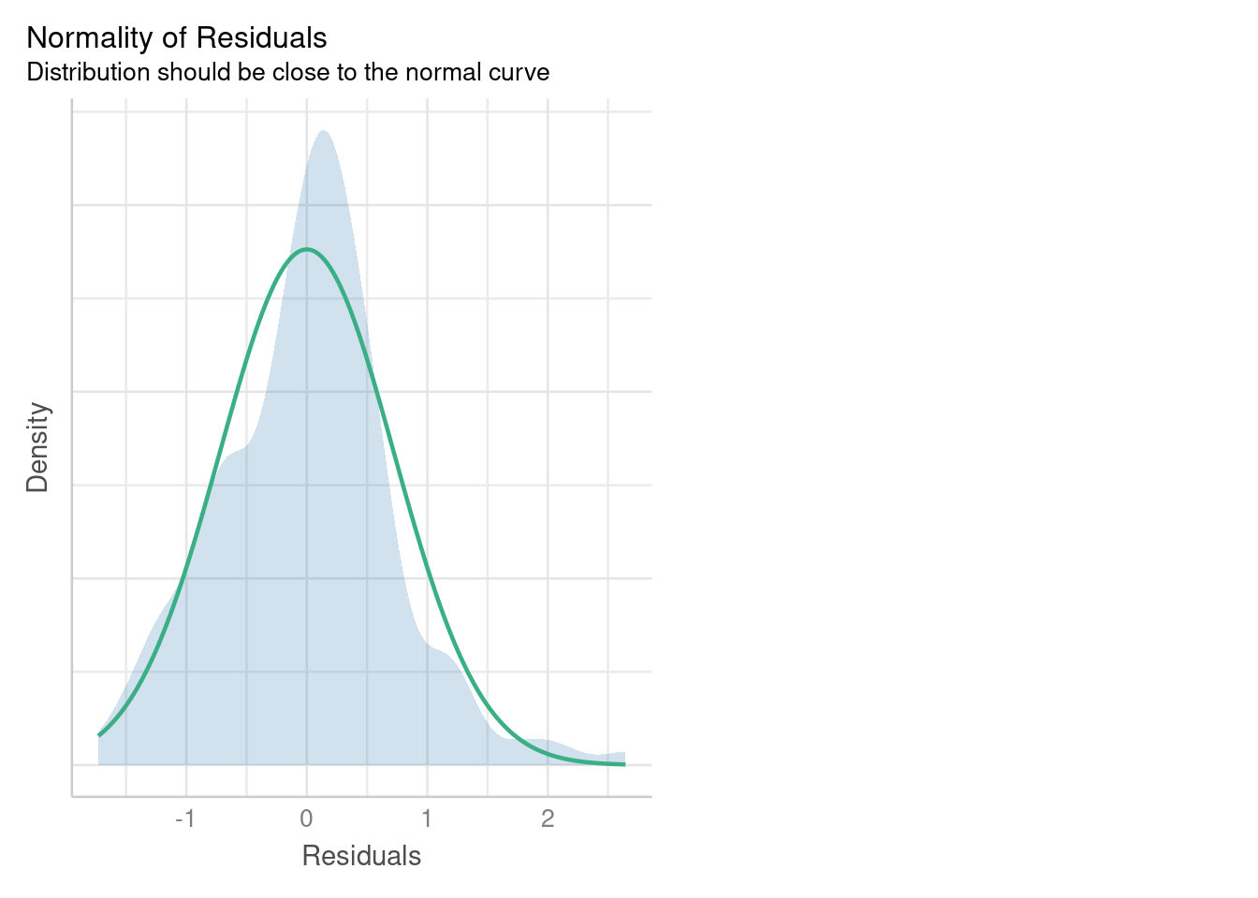
Figure 15: Histogram of residuals: PSFS
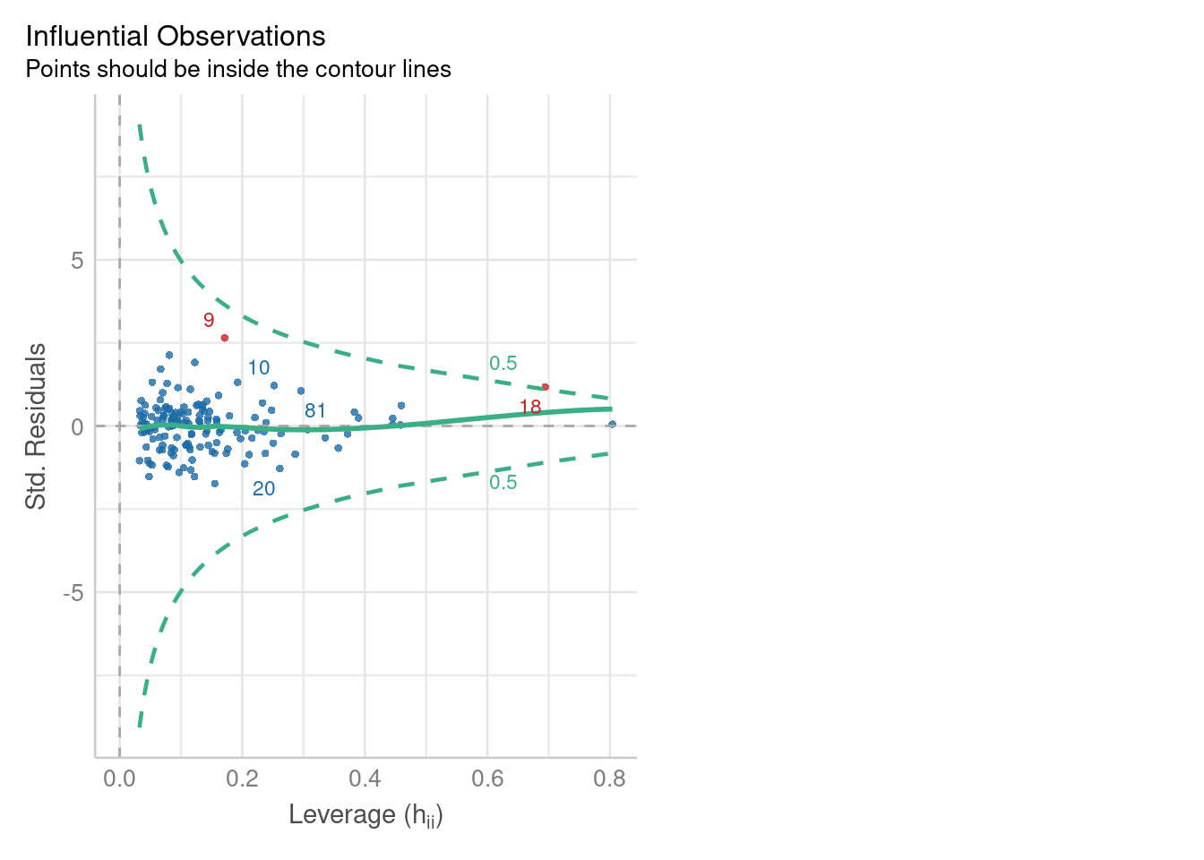
Figure 16: Histogram of residuals: PSFS
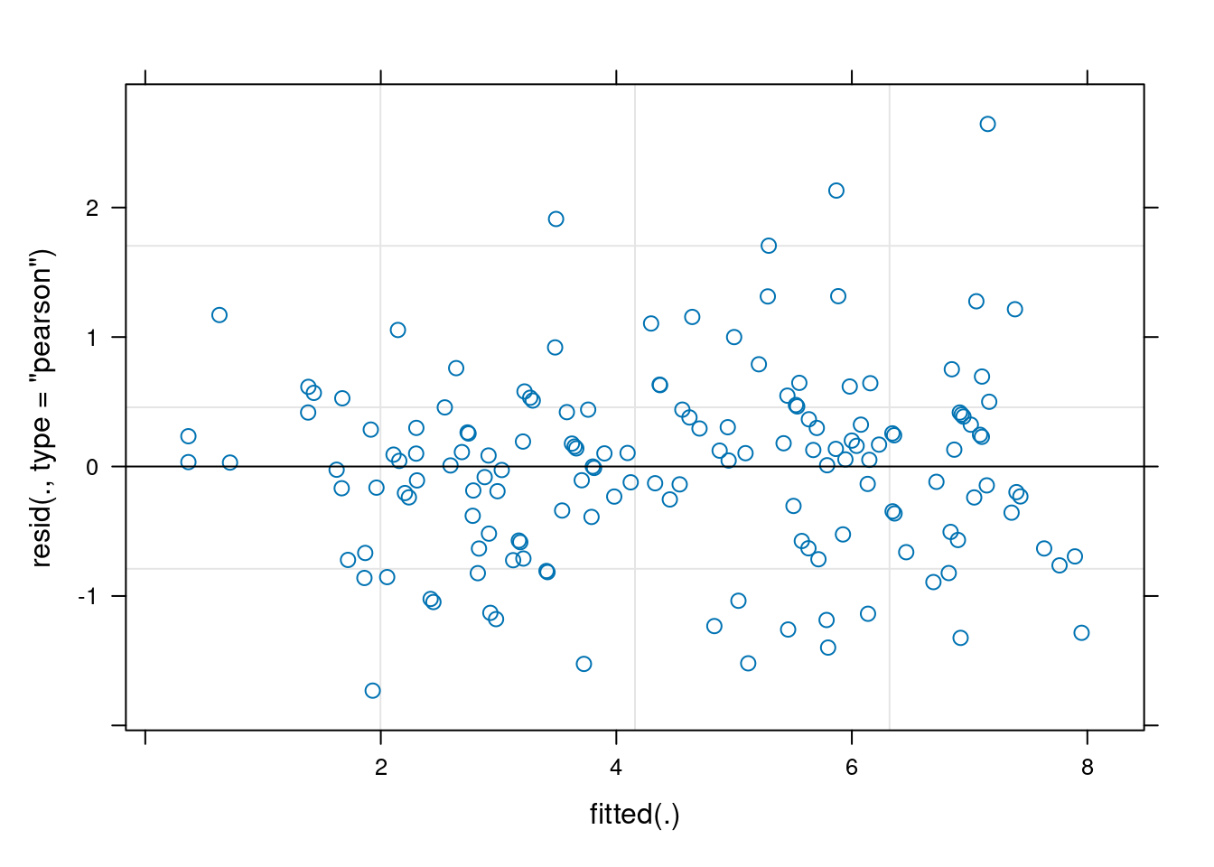
Figure 17: Histogram of residuals: PSFS

Residuals analysis conclusion
There was some indication of outliers and an examination of the outlying points indicated they were from one individual (if…5X), affecting both the NPRS and the PSFS scores at the same points in time. These points correspond to a peak in scores just before treatment started and the final point obtained 82 days after the study began. This latter point was obtained substantially after the other points and may be why it appeared as an outlier. Otherwise, the data seemed to conform quite well to the assumptions underlying the model.

MSKHQ and DAPOS results

MSKHQ scales
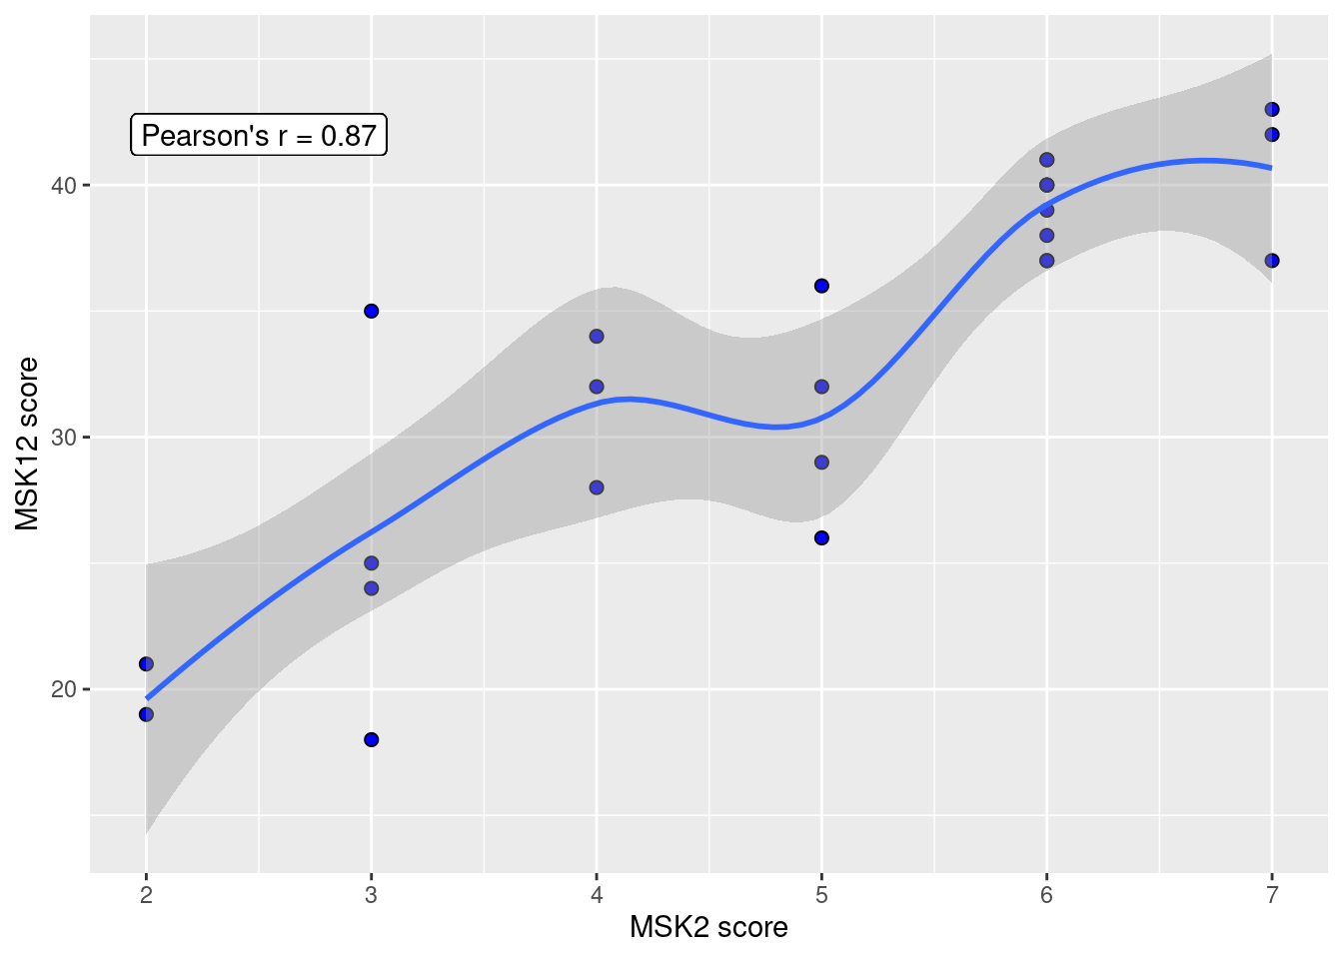
Figure 18: Association between scales MSK2 and MSK12
Due to an error in coding the levels of the MSKHQ, only the first two items had correct level names. Items 12 & 13 of MSKHQ were not reverse coded, as they should have been, so were removed from the data. All other items had coding in the correct sense (i.e. not reversed) but with some level names incorrect. Hence, 2 new scales were calculated: ‘MSK2’ and ‘MSK12’. MSK2 consisted of the scores for items 1 & 2 only (possible range of values: 0-8). MSK12 consisted of all items except 12 and 13 (possible range of values: 0-48). There was a strong correlation between these two scales: r = 0.87 [0.72-0.94 95% C.I.] (see 18)). Caution should be exercised when making inferences about the true MSKHQ scale. However, internal consistency of the MSKHQ has been shown to be acceptable (Cronbach’s \(\alpha\) = 0.88) and items 12 and 13 have the lowest correlation to the total score [3], lending weight to the argument that these reduced scales give some information about the true MSKHQ scale.

MSKHQ vs time
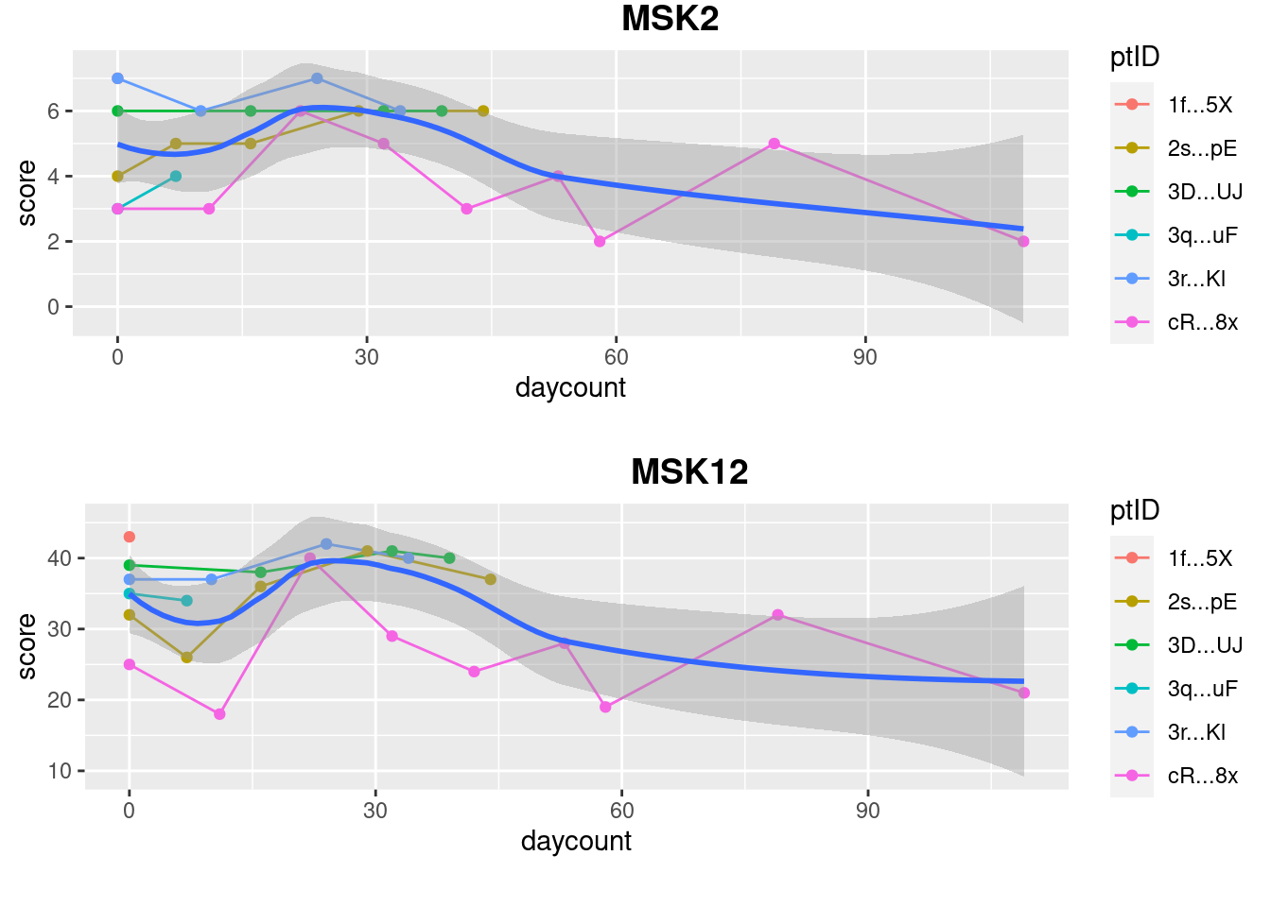
Figure 19: Change in MSK scale since start of study, individual patient participants.
Regarding change in MSK scales over time (fig 19), there appears to be an overall downward trend, but the trend is dominated by one patient participant (cR…8x). There appears to be an initial decrease followed by an increase up to to the 30 day point.

DAPOS vs time
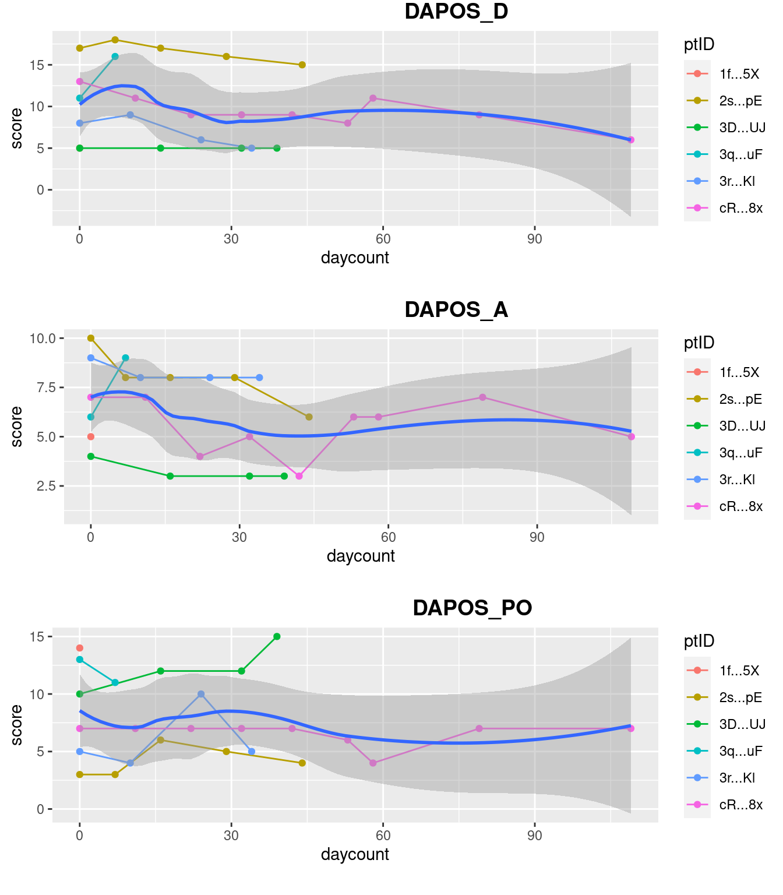
Figure 20: Change in DAPOS scales since start of study, individual patient participants.
DAPOS scales (DAPOS_D - depression, DAPOS_A - anxiety, DAPOS_PO - positive outlook) have fairly flat responses (fig 20), again dominated by the data from one participant (cR…8x) .

References
[1]
lme4: Linear mixed-effects models using ’eigen’ and S4, n.d.
[2]
D. Bates, M. Mächler, B. Bolker, S. Walker, Fitting linear mixed-effects models using lme4, Journal of Statistical Software. 67 (2015) 1–48.
[3]
J.C. Hill, S. Kang, E. Benedetto, H. Myers, S. Blackburn, S. Smith, K.M. Dunn, E. Hay, J. Rees, D. Beard, Development and initial cohort validation of the arthritis research UK musculoskeletal health questionnaire (MSK-HQ) for use across musculoskeletal care pathways, BMJ Open. 6 (2016) e012331.
[4]
A. Kuznetsova, P.B. Brockhoff, R.H.B. Christensen, lmerTest package: Tests in linear mixed effects models, Journal of Statistical Software. 82 (2017) 1–26.
[5]
Y. Lee, J.A. Nelder, Y. Pawitan, Generalized linear models with random effects: Unified analysis via h-likelihood, second edition, in: CRC Press, 2018: pp. 51–55.
[6]
R Core Team, R: A language and environment for statistical computing, R Foundation for Statistical Computing, Vienna, Austria, 2023.

