DISPERSAL LIMITATION AND TEMPERATURE RESTRICT PLANT INVASION IN A SUBARCTIC TREELINE ENVIRONMENT

Supplementary
Table S1. Results from a Poisson generalized linear model testing the effect of habitat (tundra or boreal forest) on seed germination.
L. vulgaris
Predictors | Estimates | SE | χ² | df | p
Intercept | -0.9808 | 0.5774 | 2.8861 | 1 | 0.0893
Habitat | -1.0986 | 1.1547 | 0.9052 | 1 | 0.3414
Year | -18.7506 | 3.576*10³ | 0 | 1 | 0.9958
P. major
Predictors | Estimates | SE | χ² | df | p
Intercept | -1.386 | 0.7071 | 3.8436 | 1 | 0.0499
Habitat | <0.0001 | 1.000 | 0 | 1 | 1.000
Year | -18.92 | 3.885*10³ | 0 | 1 | 0.9961
T. officinale
Predictors | Estimates | SE | χ² | df | p
Intercept | 3.5337 | 0.0604 | 3421.4218 | 1 | <0.0001
Habitat | -1.3646 | 0.1339 | 103.8298 | 1 | <0.0001
Year | -20.274 | 826.3364 | 0.0006 | 1 | 0.9804

Table S2. Total number of surviving and dead transplants, and the proportion of surviving transplants each year from 2022-2024.
Species | Habitat | 2022 |  |  | 2023 |  |  | 2024
Species | Habitat | #  Surviving | #  Dead | Proportion surviving | # Survival | # Dead | Proportion surviving | # Survival | # Dead | Proportion surviving
L. vulgaris | Boreal | 37 | 3 | 0.925 | 30 | 9 | 0.769 | 24 | 10 | 0.706
L. vulgaris | Tundra | 31 | 9 | 0.775 | 2 | 29 | 0.065 | 0 | 2 | 0
P. major | Boreal | 36 | 4 | 0.900 | 35 | 1 | 0.972 | 14 | 21 | 0.400
P. major | Tundra | 27 | 13 | 0.675 | 6 | 21 | 0.222 | 4 | 2 | 0.667
T. officinale | Boreal | 34 | 6 | 0.850 | 21 | 14 | 0.600 | 3 | 18 | 0.143
T. officinale | Tundra | 20 | 20 | 0.500 | 0 | 20 | 0 | 0 | 40 | 0

Table S3. Results from a binomial generalized linear model testing the effect of habitat (tundra or boreal forest) and year on plant survival.
L. vulgaris
Predictors | χ² | df | p
Intercept | 17.5149 | 1 | <0.0001
Habitat | 3.2299 | 1 | 0.0723
Year | 9.7829 | 2 | 0.0075
Habitat * Year | 6.5836 | 2 | 0.0372
P. major
Predictors | χ² | df | p
Intercept | 17.3829 | 1 | <0.0001
Habitat | 5.4894 | 1 | 0.0191
Year | 30.6165 | 2 | <0.0001
Habitat * Year | 7.5334 | 2 | 0.0231
T. officinale
Predictors | χ² | df | p
Intercept | 15.3451 | 1 | <0.0001
Habitat | 10.1623 | 1 | 0.0014
Year | 32.4975 | 2 | <0.0001
Habitat * Year | 0.0002 | 2 | 0.9999

Table S4. Summary statistics of survival of non-native transplants in tundra and boreal forest habitats each year, and odds ratio (p-values) of comparisons.
Year | Habitat | Probability estimates (95% CI) | SE | OR | p
L. vulgaris
2022 | Tundra | 0.775 (0.6212-0.8786) | 0.0660 | 0.2790 | 0.0723
2022 | Boreal | 0.925 (0.7917-0.9756) | 0.0416 | 0.2790 | 0.0723
2023 | Tundra | 0.050 (0.0125-0.1791) | 0.0345 | 0.0175 | <0.0001
2023 | Boreal | 0.750 (0.5946-0.8599) | 0.0685 | 0.0175 | <0.0001
2024 | Tundra | 0 | 0 | 0 | 0.9853
2024 | Boreal | 0.600 (0.4435-0.7385) | 0.0775 | 0 | 0.9853
P. major
2022 | Tundra | 0.675 (0.517 - 0.801) | 0.0741 | 0.2308 | 0.0191
 | Boreal | 0.900 (0.7620-0.9620) | 0.0474 | 0.2308 | 0.0191
2023 | Tundra | 0.150 (0.069-0.296) | 0.0565 | 0.0252 | <0.0001
 | Boreal | 0.875 (0.733-0.947) | 0.0523 | 0.0252 | <0.0001
2024 | Tundra | 0.100 (0.038-0.238) | 0.0474 | 0.2063 | 0.0112
 | Boreal | 0.350 (0.219-0.508) | 0.0754 | 0.2063 | 0.0112
T. officinale
2022 | Tundra | 0.500 (0.3498-0.650) | 0.0791 | 0.176 | 0.0014
 | Boreal | 0.850 (0.7041-0.9310) | 0.0565 | 0.176 | 0.0014
2023 | Tundra | 0 | 0 | 0 | 0.9908
 | Boreal | 0.525 (0.3727-0.673) | 0.0790 | 0 | 0.9908
2024 | Tundra | 0 | 0 | 0 | 0.9920
 | Boreal | 0.075 (0.0244-0.208) | 0.0416 | 0 | 0.9920

Table S5. Results from a linear mixed effects model testing the effect of habitat (tundra or boreal forest) and year on plant performance.
L. vulgaris height
Predictors | F | df | p
Intercept | 26.9299 | 1 | <0.0001
Habitat | 21.0929 | 1 | 0.0009
Year | 43.4376 | 2 | <0.0001
Initial height | 2.3466 | 1 | 0.1282
Habitat * Year | 0.8939 | 1 | 0.3464
L. vulgaris number of ramets
Predictors | F | df | p
Intercept | 3.1066 | 1 | 0.0818
Habitat | 0.4650 | 2 | 0.5107
Year | 0.4922 | 1 | 0.6125
Initial height | 3.0257 | 1 | 0.0844
Habitat * Year | 0.7678 | 1 | 0.38261
P. major leaf length
Predictors | F | df | p
Intercept | 31.8359 | 1 | <0.0001
Habitat | 0.5048 | 1 | 0.4983
Year | 51.1332 | 2 | <0.0001
Initial leaf size | 26.8694 | 1 | <0.0001
Habitat * Year | 0.8889 | 1 | 0.4136
P. major number of leaves
Predictors | F | df | p
Intercept | 20.0944 | 1 | 0.0001
Habitat | 1.6241 | 1 | 0.2417
Year | 11.5975 | 2 | <0.0001
Initial leaf size | 1.2343 | 1 | 0.2684
Habitat * Year | 0.6369 | 1 | 0.5304
T. officinale leaf length
Predictors | F | df | p
Intercept | 21.6226 | 1 | <0.0001
Habitat | 5.1640 | 1 | 0.0571
Year | 24.4861 | 2 | <0.0001
Initial leaf size | 4.4659 | 1 | 0.0378
Habitat * Year |  | 0
T. officinale number of leaves
Predictors | F | df | p
Intercept | 0.7704 | 1 | 0.3842
Habitat | 3.5470 | 1 | 0.1031
Year | 0.9433 | 2 | 0.3927
Initial leaf size | 5.1565 | 1 | 0.0252
Habitat * Year |  | 0
Table S6. Results from a linear mixed effects model testing the effect of habitat (tundra or boreal forest) on dried plant biomass of P. major. There were no surviving L. vulgaris or T. officinale in the tundra by 2024.
Predictors | Estimates | F | df | p
P. major
Intercept | 39.405 | 0.6217 | 1 | 0.4371
Habitat | -1.959 | 0.0024 | 1 | 0.9615
Initial leaf size | 6.921 | 2.7521 | 1 | 0.1062

Table S7. Results from a Poisson generalized linear mixed model testing the effect of treatment (warming versus control) and year on seed germination.
L. vulgaris
Predictors | Estimates | SE | χ² | df | p
Intercept | -4.342 | 1.999 | 4.7196 | 1 | 0.0298
Treatment | 1.305 | 1.410 | 0.8559 | 1 | 0.3549
Year | -29.122 | 2.048 * 10³ | 0.0002 | 1 | 0.9887
P. major
Predictors | Estimates | SE | χ² | df | p
Intercept | -3.0605 | 0.0.9369 | 10.6700 | 1 | 0.0011
Treatment | 1.9656 | 0.8847 | 4.9370 | 1 | 0.0263
Year | -2.0149 | 0.7528 | 7.1678 | 1 | 0.0074
S. alba
Predictors | Estimates | SE | χ² | df | p
Intercept | -1.5705 | 0.6868 | 5.2296 | 1 | 0.0222
Treatment | 1.0920 | 0.7524 | 2.1068 | 1 | 0.1467
Year | -4.1744 | 1.0074 | 17.1688 | 1 | <0.0001
T. officinale
Predictors | Estimates | SE | χ² | df | p
Intercept | 1.317 | 0.343 | 14.7556 | 1 | 0.0001
Treatment | 1.412 | 0.458 | 9.5107 | 1 | 0.0020
Year | -6.524 | 1.001 | 42.4937 | 1 | <0.0001

Table S8. Results from a binomial generalized linear mixed model testing the effect of treatment (warming versus control), and year on plant survival.
L. vulgaris
Predictors | Estimates | SE | χ² | df | p
Intercept | 1.2777 | 0.4587 | 7.7577 |  | 0.0053
Treatment | 0.6117 | 0.6503 | 0.8848 |  | 0.3469
Year | -2.7614 | 0.5593 | 24.3782 |  | <0.0001
Habitat * Year | 0.3367 | 0.7103 | 0.2247 |  | 0.6355
P. major
Predictors | Estimates | SE | χ² | df | p
Intercept | 0.7794 | 0.4749 | 2.6937 | 1 | 0.1007
Treatment | 0.5713 | 0.6828 | 0.7001 | 1 | 0.4028
Year | -1.0683 | 0.4468 | 5.7157 | 1 | 0.0168
Habitat * Year | 0.1171 | 0.6370 | 0.0338 | 1 | 0.8541
T. officinale
Predictors | Estimates | SE | χ² | df | p
Intercept | -1.6576 | 0.5326 | 9.6874 | 1 | 0.0019
Treatment | 0.1700 | 0.7123 | 0.0570 | 1 | 0.8113
Year | -1.7553 | 0.6686 | 6.8918 | 1 | 0.0087
Habitat * Year | 0.1191 | 0.9088 | 0.0172 | 1 | 0.8957
Table S9. Summary statistics of survival of non-native transplants warming versus control treatments each year, and odds ratio (p-values) of comparisons.
Year | Habitat | Probability estimates (95% CI) | SE | OR | p
L. vulgaris
2023 | Control | 0.782 (0.5935-0.898) | 0.0782 | 1.84 | 0.3469
2023 | Warming | 0.869 (0.7170-0.945) | 0.0559 | 1.84 | 0.3469
2024 | Control | 0.185 (0.0824-0.364 | 0.0712 | 2.58 | 0.1286
2024 | Warming | 0.369 (0.2050-0.571) | 0.0974 | 2.58 | 0.1286
P. major
2023 | Control | 0.686 (0.462-0.847) | 0.1024 | 1.77 | 0.4027
2023 | Warming | 0.794 (0.592-0.911) | 0.0816 | 1.77 | 0.4027
2024 | Control | 0.428 (0.231-0.651) | 0.1141 | 1.99 | 0.2994
2024 | Warming | 0.599 (0.372-0.790) | 0.1132 | 1.99 | 0.2994
T. officinale
2023 | Control | 0.1601 (0.0629-0.351) | 0.0716 | 1.19 | 0.8113
2023 | Warming | 0.1843 (0.0732-0.393) | 0.0806 | 1.19 | 0.8113
2024 | Control | 0.0319 (0.0078-0.0121 | 0.0226 | 1.34 | 0.7558
2024 | Warming | 0.0421 (0.0106-0.153) | 0.0290 | 1.34 | 0.7558

Table S10. Results from a linear mixed effects model testing the effect of treatment (warming versus control), and year on plant performance.
L. vulgaris height
Predictors | F | df | p
Intercept | 3.3102 | 1 | 0.0719
Treatment | 0.2197 | 1 | 0.6413
Year | 10.0972 | 1 | 0.0019
Initial height | 11.9671 | 1 | 0.0007
Treatment * Year | 0.5541 | 1 | 0.4582
L. vulgaris number of ramets
Predictors | F | df | p
Intercept | 5.0374 | 1 | 0.0273
Treatment | 0.8390 | 1 | 0.3637
Year | 2.5520 | 1 | 0.1128
Initial height | 5.3981 | 1 | 0.0221
Treatment * Year | 0.2132 | 1 | 0.6451
P. major leaf length
Predictors | F | df | p
Intercept | 54.4089 | 1 | <0.0001
Treatment | 1.7157 | 1 | 0.1958
Year | 17.0475 | 1 | <0.0001
Initial leaf size | 9.8434 | 1 | 0.0021
Treatment * Year | 0.0699 | 1 | 0.7920
P. major number of leaves
Predictors | F | df | p
Intercept | 79.3319 | 1 | <0.0001
Treatment | 2.0344 | 1 | 0.1595
Year | 8.3220 | 1 | 0.0047
Initial leaf size | 6.3635 | 1 | 0.0129
Treatment * Year | 0.1548 | 1 | 0.6947
T. officinale leaf length
Predictors | F | df | p
Intercept | 2.7510 | 1 | 0.1074
Treatment | 0.0001 | 1 | 0.9911
Year | 2.8047 | 1 | 0.1093
Initial leaf size | 1.5553 | 1 | 0.2216
Treatment * Year | 0.0007 | 1 | 0.9797
T. officinale number of leaves
Predictors | F | df | p
Intercept | 0.4690 | 1 | 0.4983
Treatment | 0.4427 | 1 | 0.5136
Year | 0.0505 | 1 | 0.8241
Initial leaf size | 0.3898 | 1 | 0.5375
Treatment * Year | 0.0526 | 1 | 0.4759
Table S11. Results from a linear mixed effects model testing the effect of treatment (warming versus control) on dried plant biomass.
L. vulgaris
Predictors | Estimates | F | df | p
Intercept | 21.293 | 0.2073 | 1 | 0.6523
Treatment | 24.150 | 0.6838 | 1 | 0.4206
Initial height | 2.594 | 1.5524 | 1 | 0.2214
P. major
Predictors | Estimates | F | df | p
Intercept | 13.9572 | 0.7492 | 1 | 0.3915
Treatment | -0.5411 | 0.0024 | 1 | 0.9612
Initial leaf size | 6.7207 | 10.6757 | 1 | 0.0020
T. officinale
Predictors | Estimates | F | df | p
Intercept | 52.743 | 0.2855 | 1 | 0.6102
Treatment | 15.154 | 0.2390 | 1 | 0.6882
Initial leaf size | -1.901 | 0.0526 | 1 | 0.8257

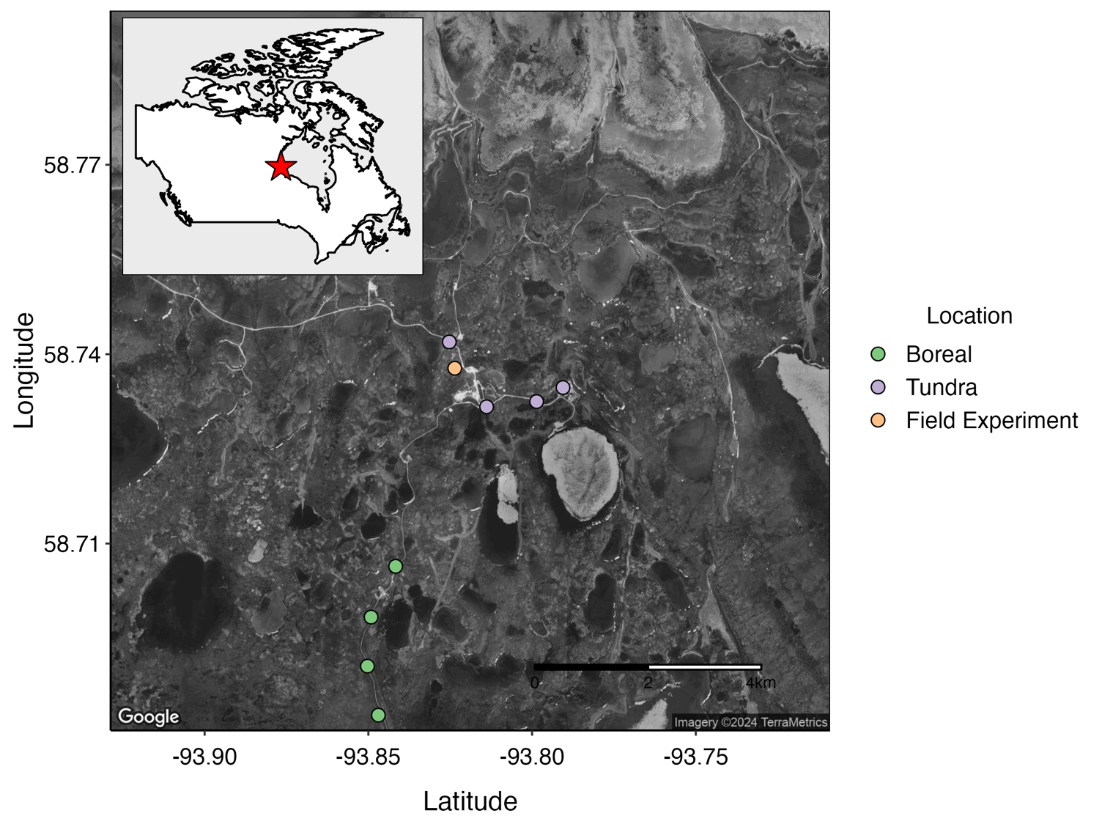
Figure S1. Boreal forest (green) and tundra (purple) sites in the cross-biome experiment, and the location of the warming experiment (orange). Map of Churchill Northern Studies Centre. Google Earth (2024).

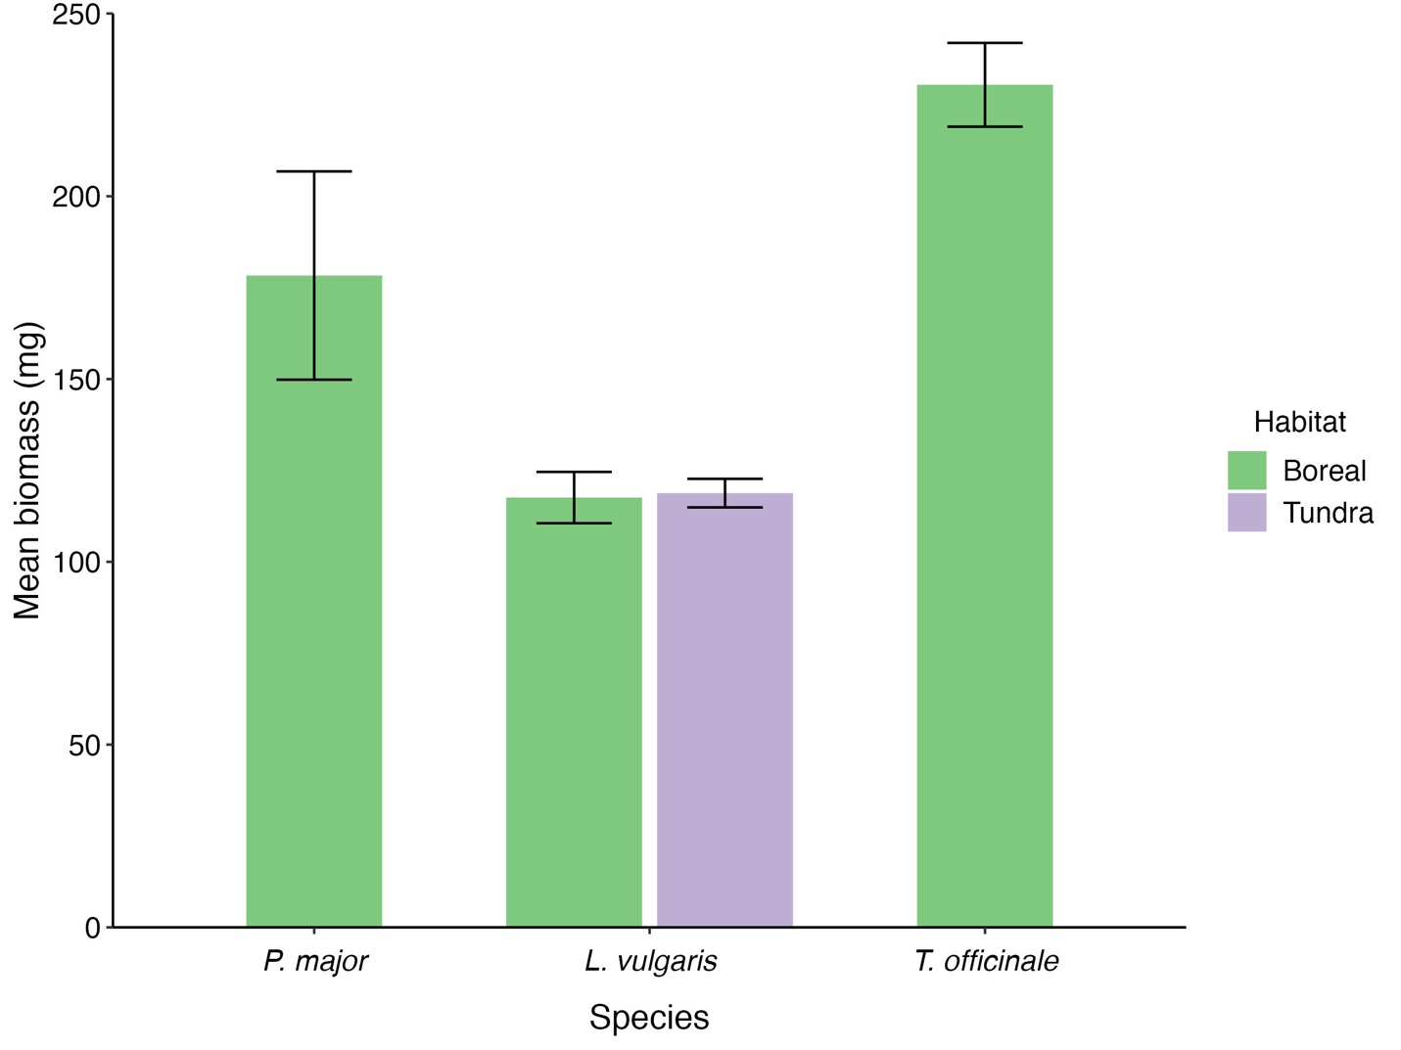
Figure S2. Biomass (mg) of surviving transplants per species in the boreal forest (green) and tundra (purple). There was no significant difference between P. major transplants in boreal forest or tundra sites (p = 0.96)
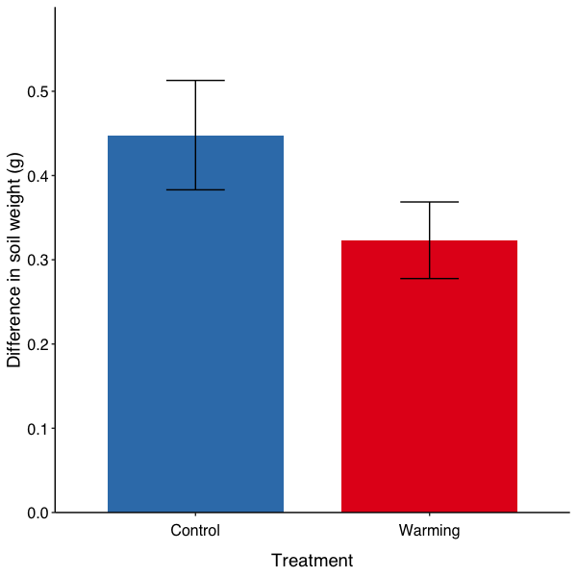
Figure S3. The difference in soil sample weight (g) after drying was higher in the control (blue) compared to the warming (red) treatments. This difference was not significant (U = 261, p = 0.1022).

