SUPPLEMENTARY MATERIALS #4

Standardised and unstandardised mortality (adults)
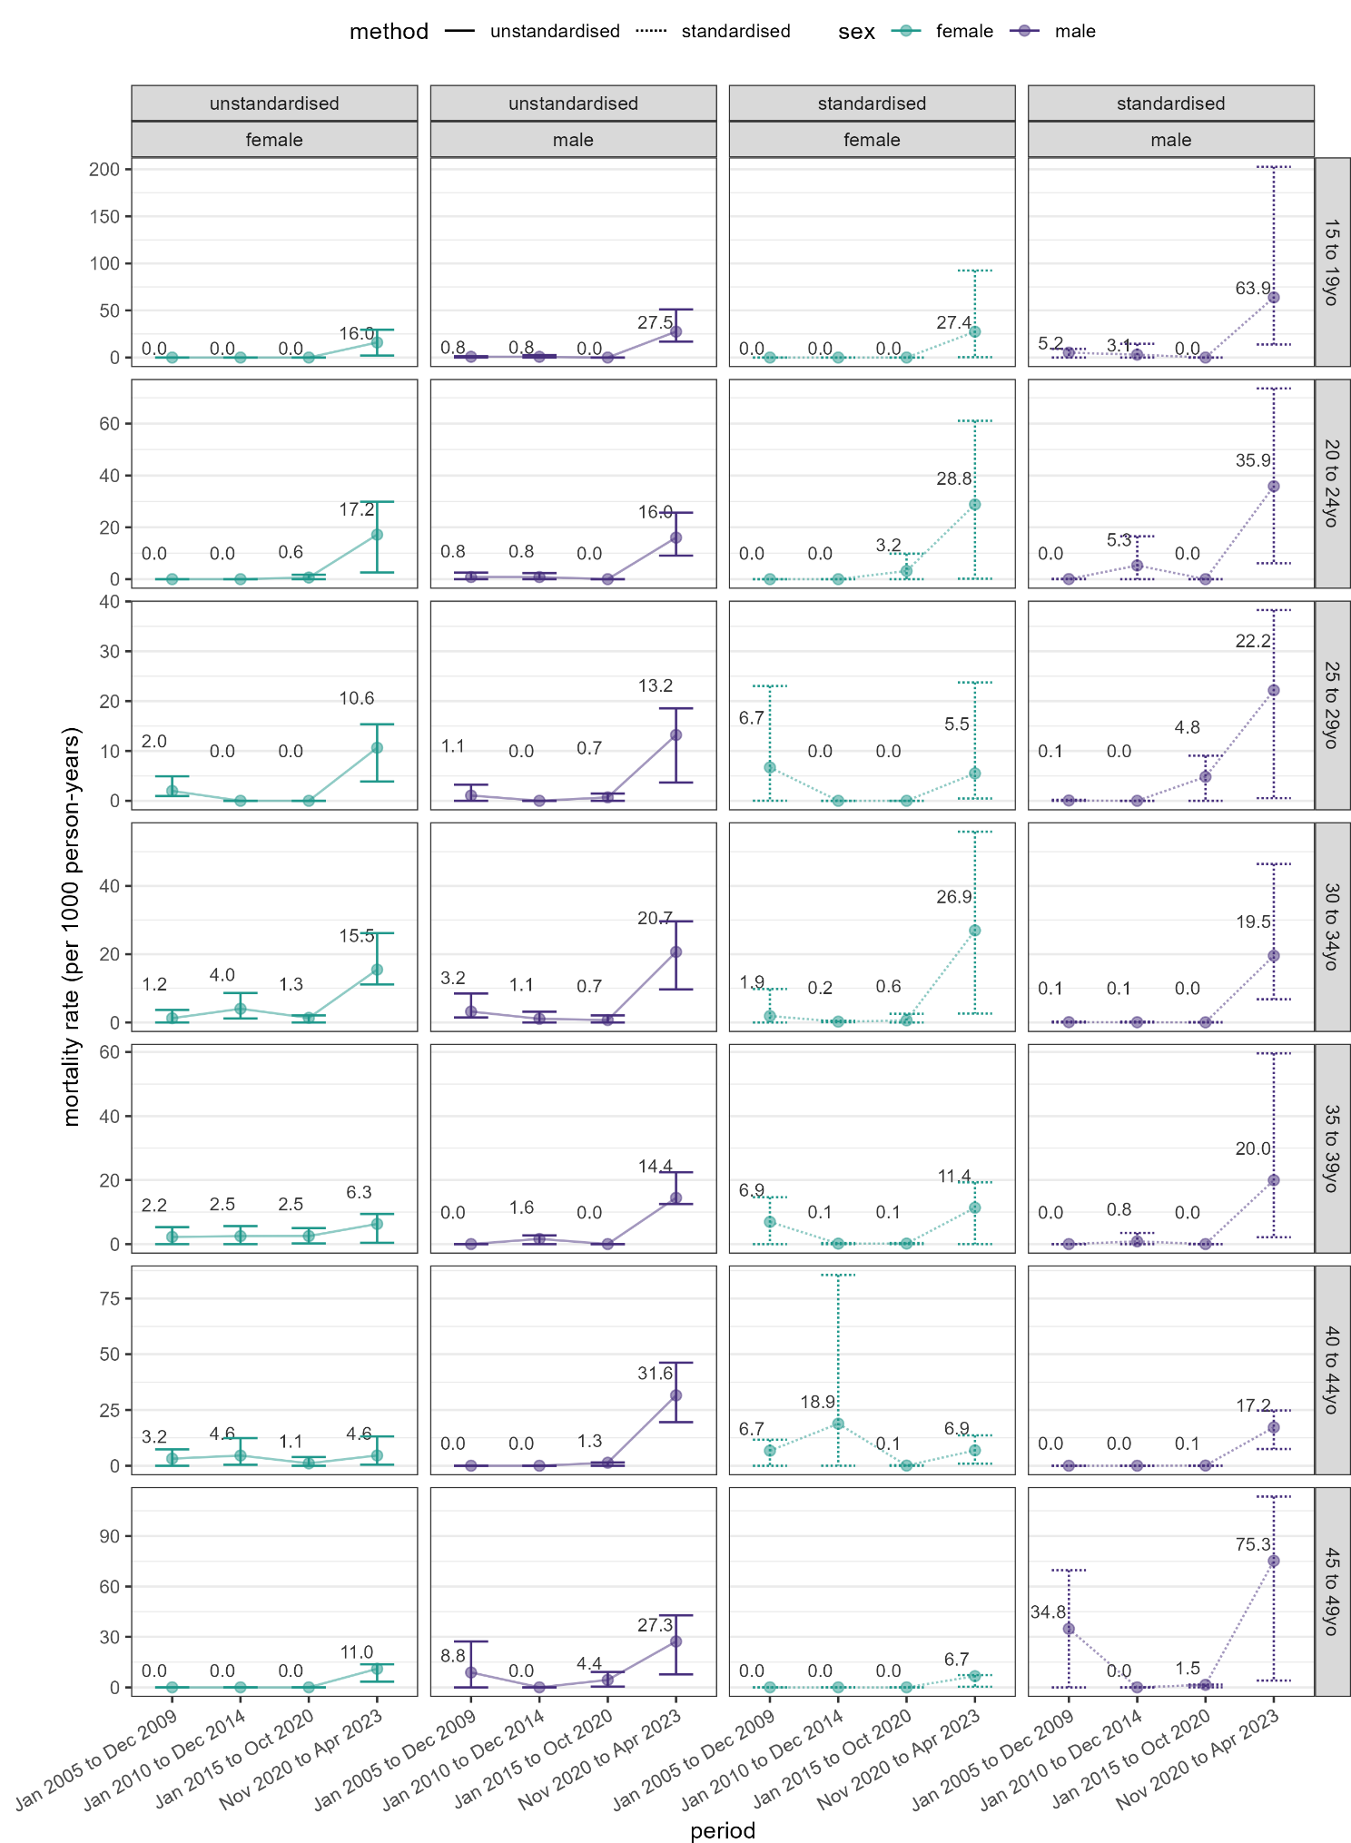
Unstandardised and standardized mortality rates among siblings of the respondents or their spouses, by period, sex and age stratum. Points and labels indicate point estimates, and vertical brackets 95%CIs.

