SUPLEMENTARY MATERIAL #2
Wealth index items, distribution of urban vs rural residence, distribution of wealth index quintiles

Wealth index construction
Questionnaire items used to construct a socio-economic wealth index. To avoid data sparsity, some items were grouped into a single category before constructing the wealth index.
Item category |  | Items
Assets |  | Electricity, radio, television, telephone (fixed), telephone (mobile), refrigerator, watch, computer, bank account, table, chair, bed (cotton, with springs), electric mitad (bread-making grill), kerosene pressure lamp
Transportation means |  | Bicycle, motorcycle or scooter, car or truck, cart, bajaj (minivan)
Sanitation sharing |  | Whether sanitation source is shared or single-household
Sanitation type |  | DHS survey item | RDS survey item | Harmonised item
 |  | flush to piped sewer system | flush elsewhere | flush elsewhere
 |  | flush to septic tank | flush to septic tank | flush to septic tank
 |  | flush to pit latrine | flush to pit latrine | flush to pit latrine
 |  | flush to somewhere else | flush elsewhere | flush elsewhere
 |  | flush, don't know where | flush elsewhere | flush elsewhere
 |  | ventilated improved pit latrine | other type of toilet | other type of toilet
 |  | pit latrine with slab | pit latrine with slab | pit latrine with slab
 |  | pit latrine without slab/open pit | pit latrine without slab/open pit | pit latrine without slab
 |  | no facility/bush/field | no facility / bush/ field | no facility / bush/ field
 |  | composting toilet | other type of toilet | other type of toilet
 |  | bucket toilet | other type of toilet | other type of toilet
 |  | hanging toilet/latrine | hanging toilet / latrine | hanging toilet / latrine
 |  | other | other type of toilet | other type of toilet
Item category | Group | DHS survey item | RDS survey item | Harmonised item
Water source | 1 | cart with small tank | cart with small tank | cart with small tank
Water source | 1 | rainwater | rainwater | rainwater
Water source | 1 | tanker truck | tanker truck | tanker truck
Water source | 1 | other | other | other
Water source | 2 | piped to yard/plot | piped to yard/plot | piped to yard/plot
Water source | 2 | piped to neighbor | piped to neighbor | piped to neighbor
Water source | 3 | tube well or borehole | tube well or borehole | tube well or borehole
Water source | 3 | protected well | protected well | protected well
Water source | 3 | protected spring | protected spring | protected spring
Water source | 4 | unprotected spring | unprotected spring | unprotected spring
Water source | 4 | unprotected well | unprotected well | unprotected well
Water source | 4 | river/dam/lake/ponds/stream/canal/irrigation channel | surface | surface
Water source | 5 | piped into dwelling | piped into dwelling | piped into dwelling
Water source | 5 | bottled water | bottled water | bottled water
Water source | 6 | public tap/standpipe | public tap/standpipe | public tap/standpipe
Dwelling floor type | 1 | earth/sand | earth/sand | earth/sand
Dwelling floor type | 1 | dung | dung | dung
Dwelling floor type | 1 | wood planks | wood planks | wood planks
Dwelling floor type | 1 | palm/bamboo | palm/bamboo | palm/bamboo
Dwelling floor type | 1 | carpet | carpet | carpet
Dwelling floor type | 2 | vinyl or asphalt strips | vinyl or asphalt strips | vinyl or asphalt strips
Dwelling floor type | 2 | ceramic tiles | ceramic tiles | ceramic tiles
Dwelling floor type | 2 | cement | cement | cement
Dwelling floor type | 2 | n/a | other floor type | other floor type

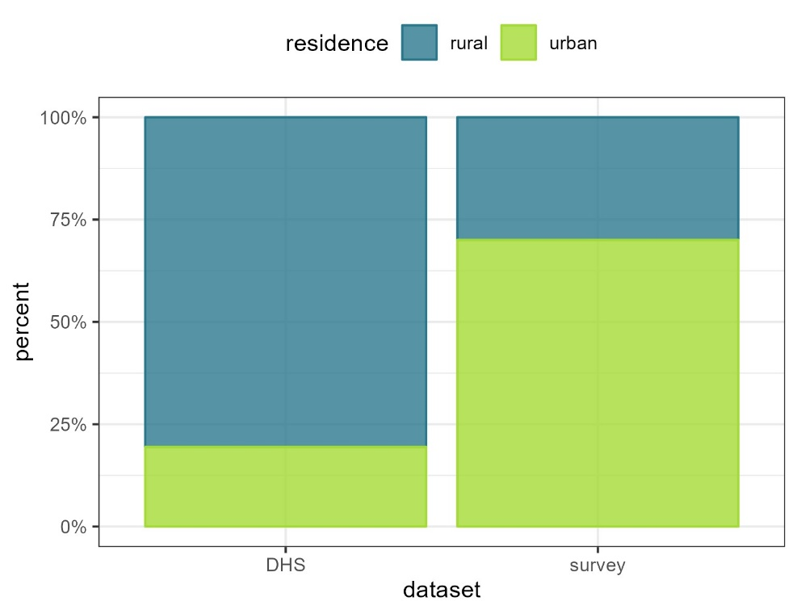
Distribution of urban versus rural residence, by source dataset (DHS 2019 versus this survey).

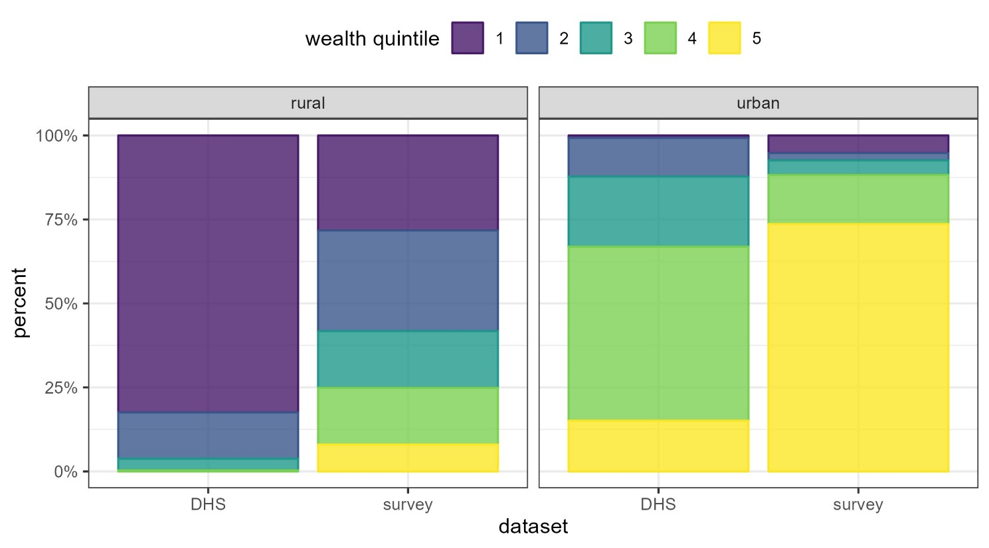
Distribution of wealth index quintiles, by urban versus rural residence and source dataset (DHS 2019 versus this survey).

