SUPPLEMENTARY MATERIALS #7

Birth interval

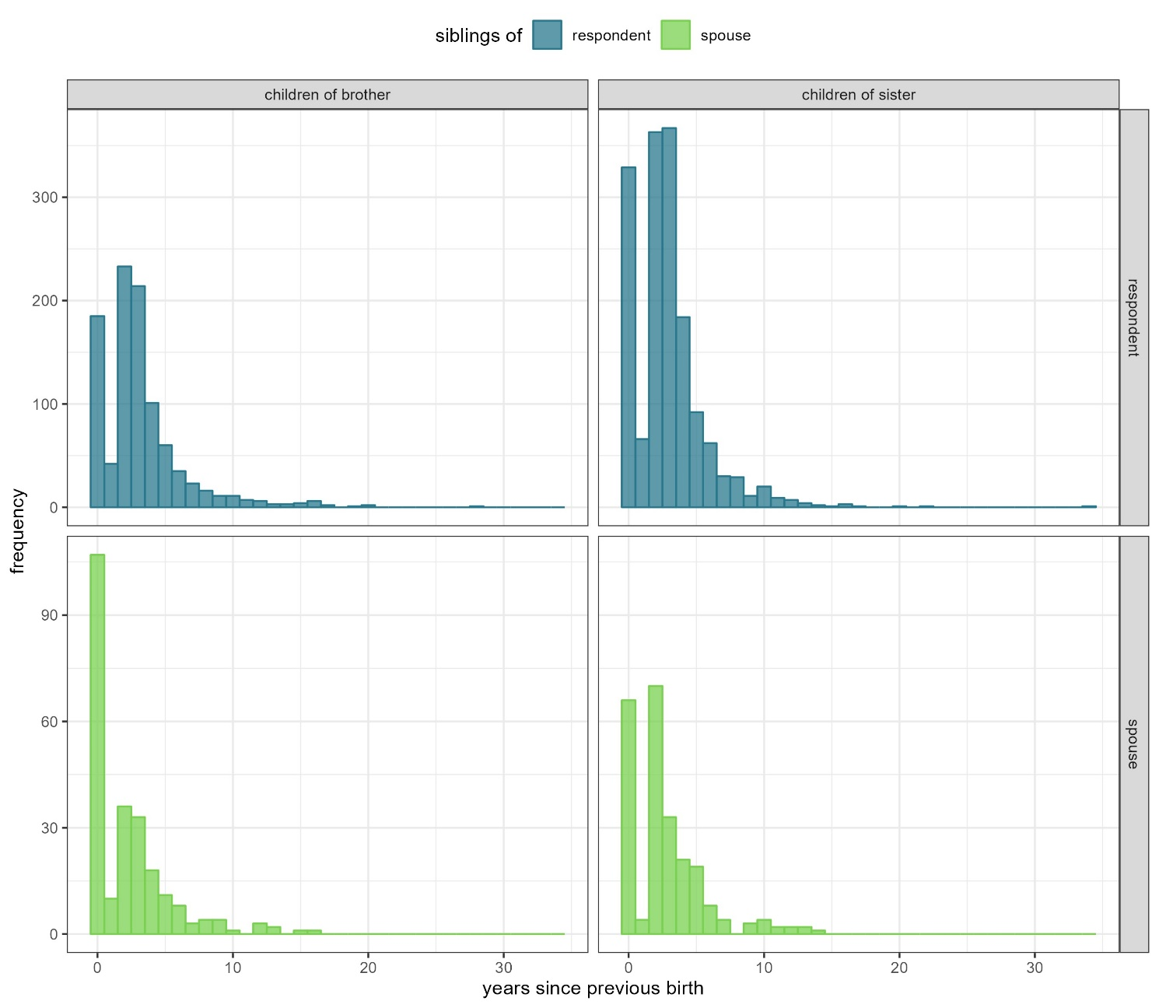
Distribution of birth intervals (excluding the first-born child) by parent’s sex and relation to the respondent.

