SUPPLEMENTARY MATERIALS #6

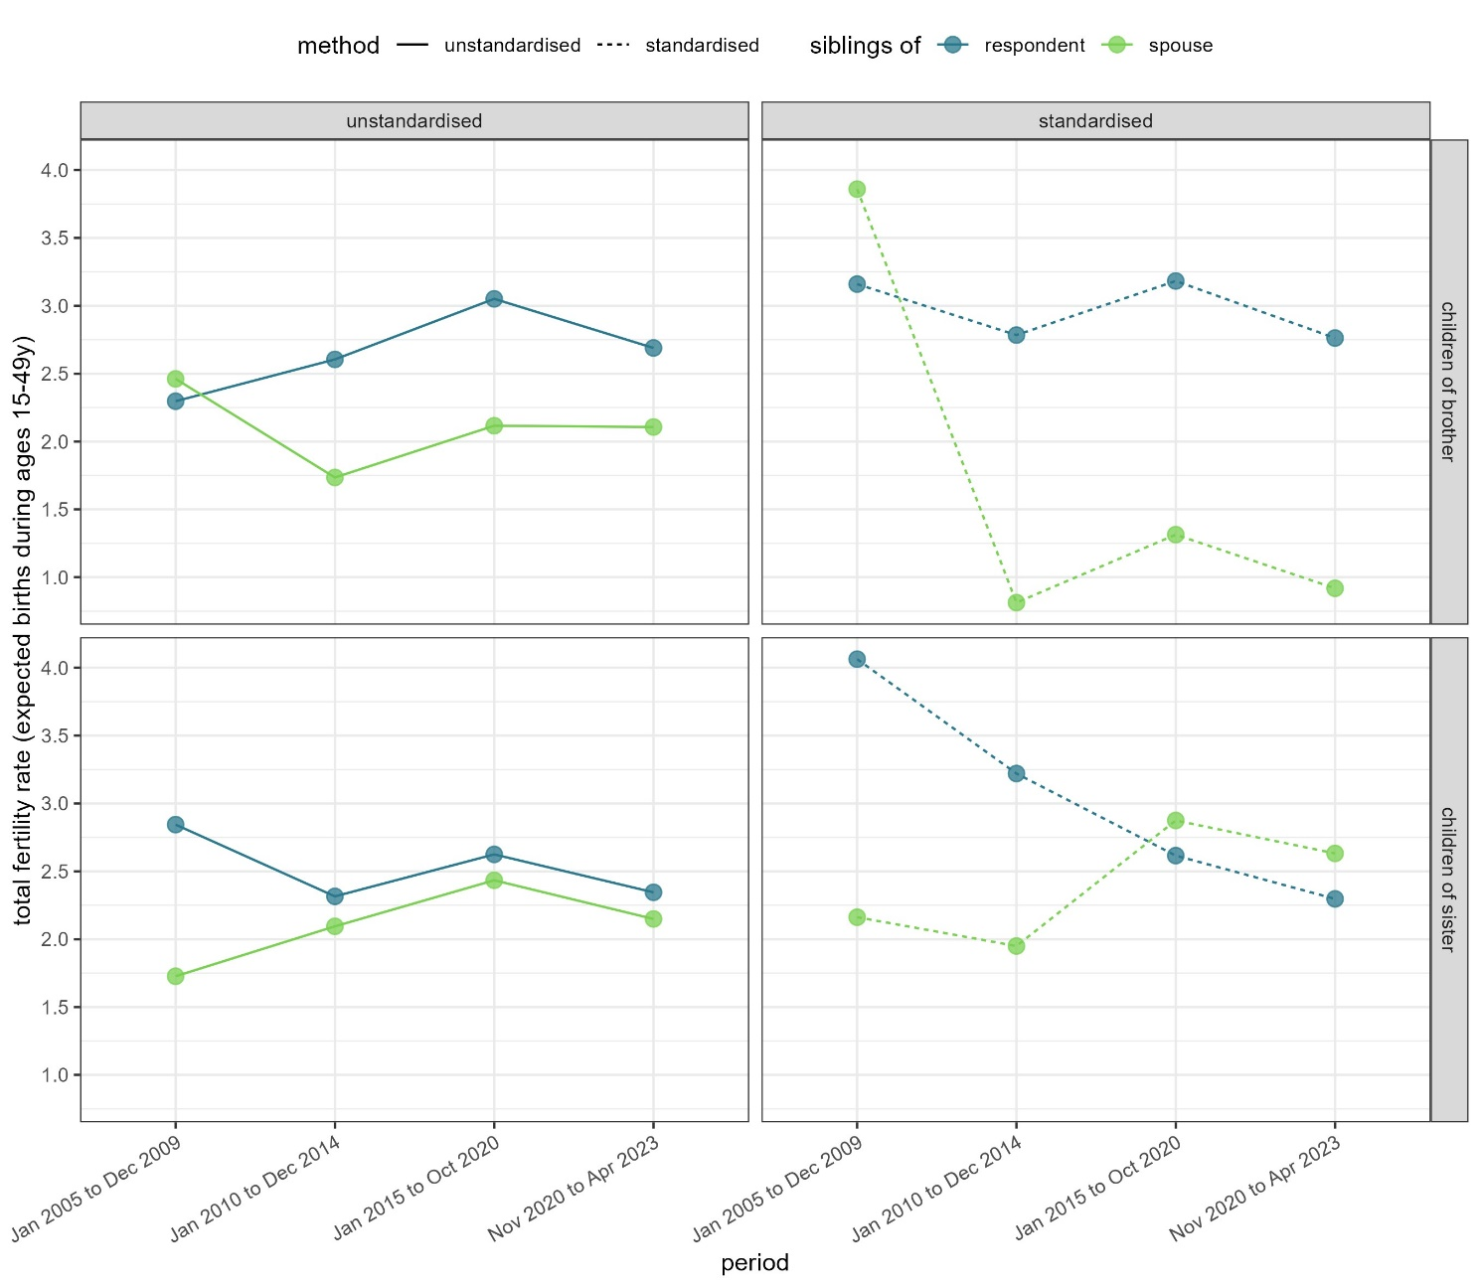
Estimated standardized and unstandardized total fertility rate, by period, parent’s sex and relation to the respondent.

Standardised and unstandardised fertility rates

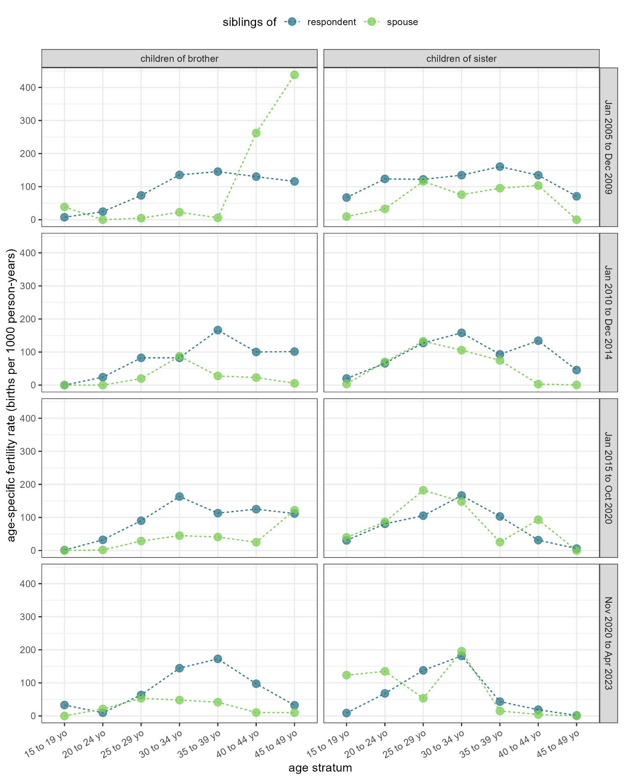
Standardised age-specific fertility rates by period, sex of the parent and relation to the respondent.

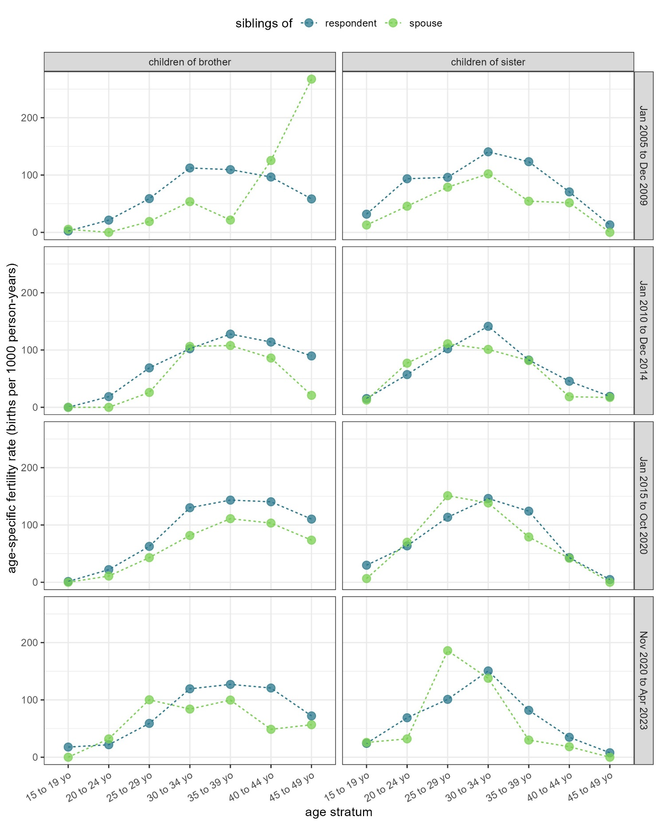
Unstandardised age-specific fertility rates by period, sex of the parent and relation to the respondent.

FC

