SupplementaryInformation for

Polarity- and molecular orbital-engineered host materials for stable and efficient blue thermally activated delayed fluorescence
Soo-Ghang Ihn,^{1*} Daun Jeong,² Eun Suk Kwon,¹Sangmo Kim,¹ Yeon Sook Chung,¹ Myungsun Sim,¹ Jun Chwae,¹ Yasushi Koishikawa,¹ Soon Ok Jeon,¹Jong Soo Kim,¹ Joonghyuk Kim,¹ Sungho Nam,¹ Hyeonho Choi,¹Sunghan Kim¹
¹Organic Materials Laboratory, Materials Research Center,Samsung Advanced Institute of Technology, Samsung Electronics Co., LTD, 130 Samsung-ro, Yeongtong-gu, Suwon-si, Gyeonggi-do, 16678, the Republic of Korea.
²Data and Information Technology Center, Samsung Electronics Co., LTD, 1 Samsungjeonja-ro, Hwaseong-si, Gyeonggi-do 18448, the Republic of Korea.

Contents
Supplementary Figure 1 S2
Supplementary Figure 2 S3
Supplementary Figure 3 S4
Supplementary Figure 4 S5
Supplementary Figure 5 S6
Supplementary Figure 6 S6
Supplementary Figure 7 S7
Supplementary Figure 8 S7
Supplementary Figure 9 S8
Supplementary Figure 10 S8
Supplementary Figure 11 S9
Supplementary Figure 12 S9

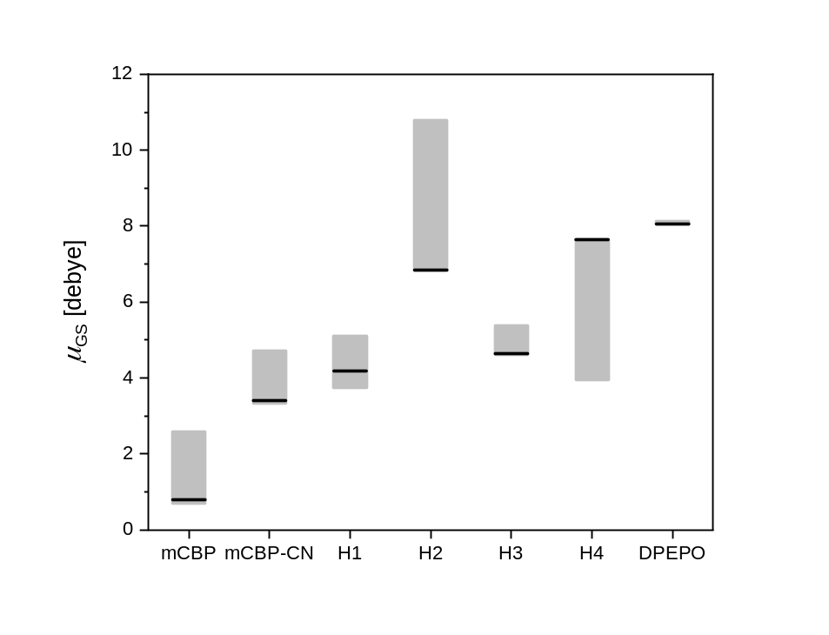
Supplementary Figure 1. Ground-state dipole moments μ_{GS} of hosts calculated from various conformer structures, related Figure 2. The representative value, corresponding to the minimum energy structure for each host, is marked with ablack solid line.

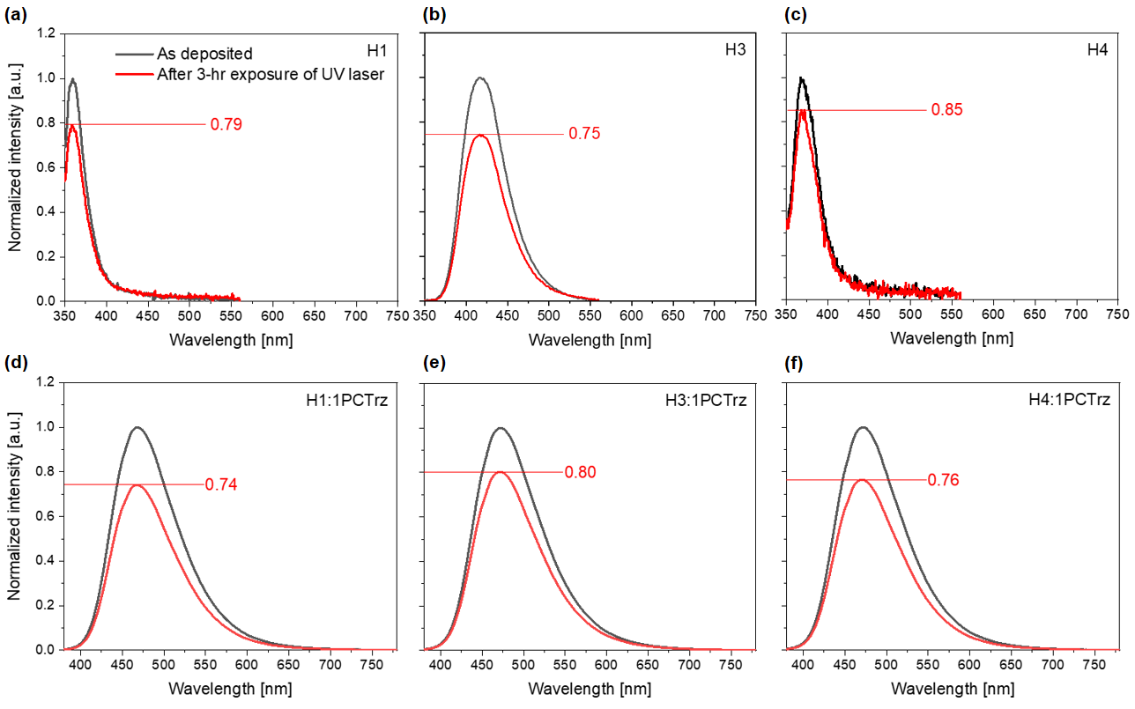
Supplementary Figure 2. PL stability of various host films with and without 1PCTrz doping, related to Figure 6.

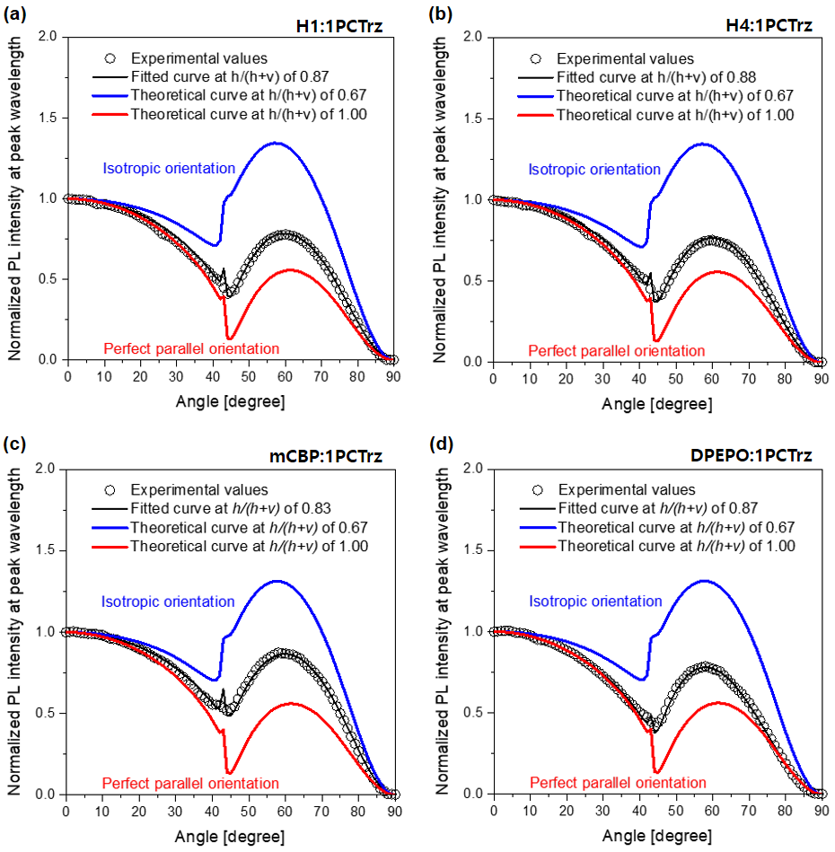
Supplementary Figure 3. Analysis of the horizontal orientations of the transition dipolemoments, h/(h + v), related Figure 7. Angle-dependent PL intensities at peak wavelengths. The black open squares represent the PL intensities from a. H1:1PCTrz, b. H4:1PCTrz, c. mCBP:1PCTrz, and d. DPEPO:1PCTrz films. Inspection of the solid curves for the films of the four 15% TADF emitter (1PCTrz)-doped hosts (H1, H4, mCBP, and DPEPO) reveal that the horizontal orientations of (h/(h + v)) are 0.87, 0.88, 0.83, and 0.87, respectively. The blue and red lines correspond to theoretical curves constructed with h/(h + ν) values of 0.67 (isotropic orientation) and 1.0 (perfect parallel orientation), respectively.

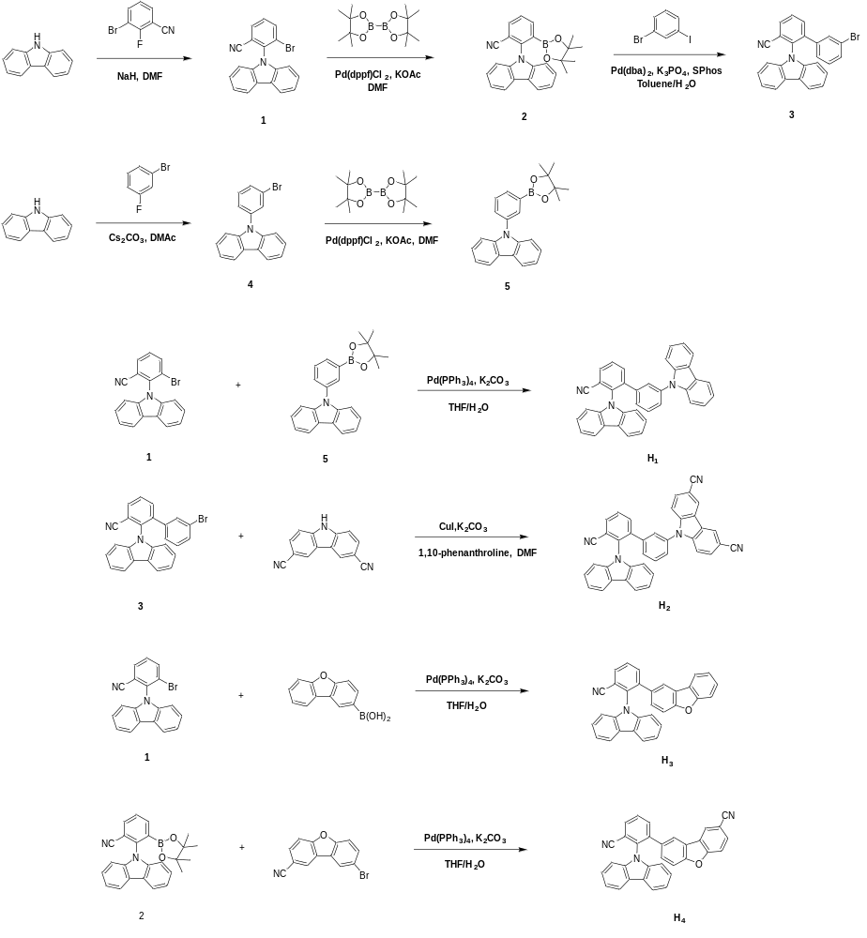
Supplementary Figure 4. Synthetic route for H1, H2, H3, H4.
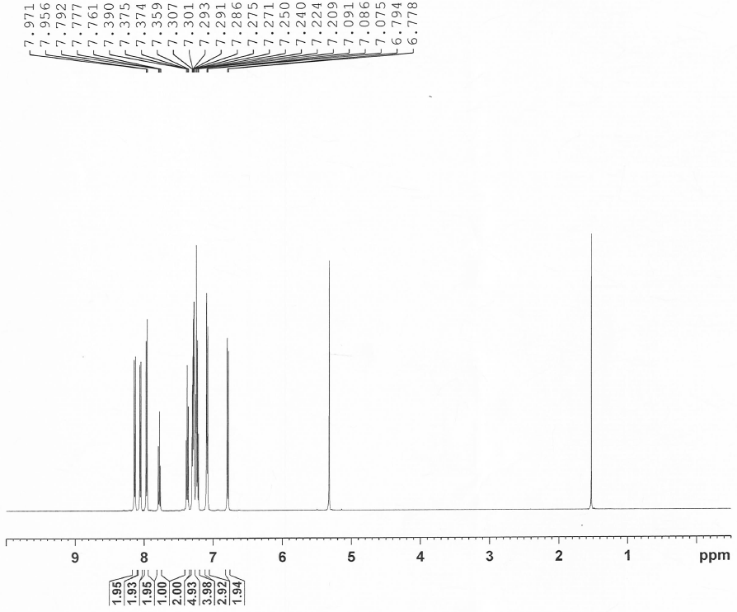
Supplementary Figure 5. ¹H NMR spectra of H1.
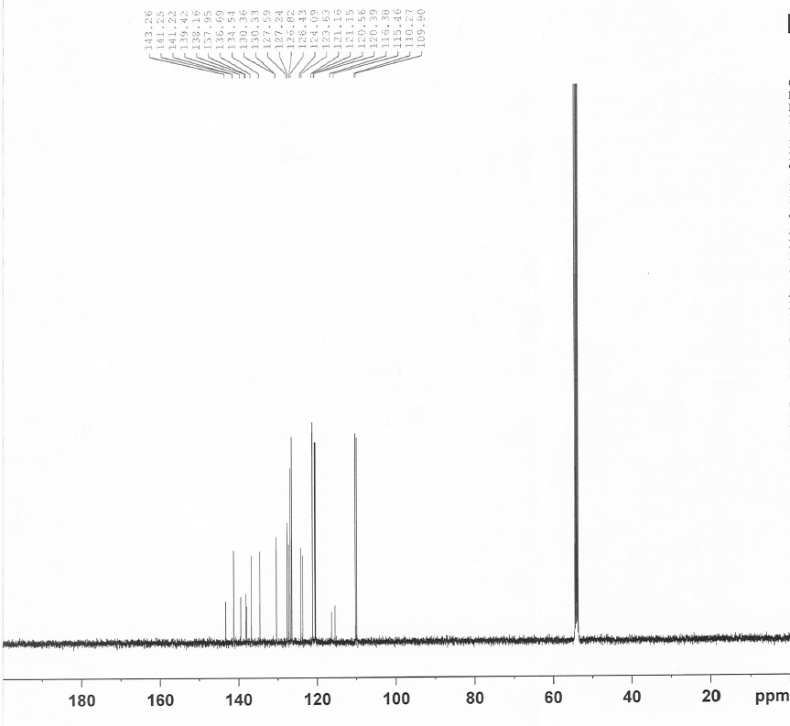
Supplementary Figure 6. ¹³C NMR spectra of H1.
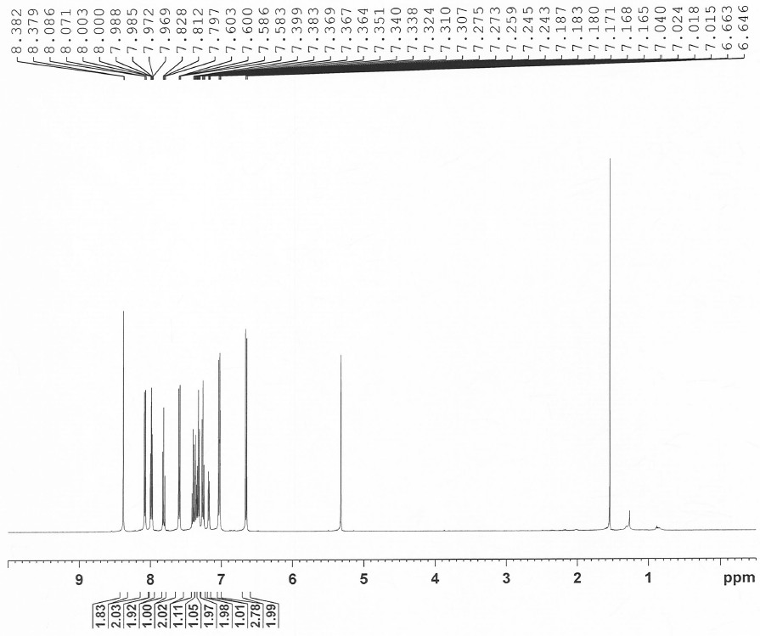
Supplementary Figure 7. ¹H NMR spectra of H2.
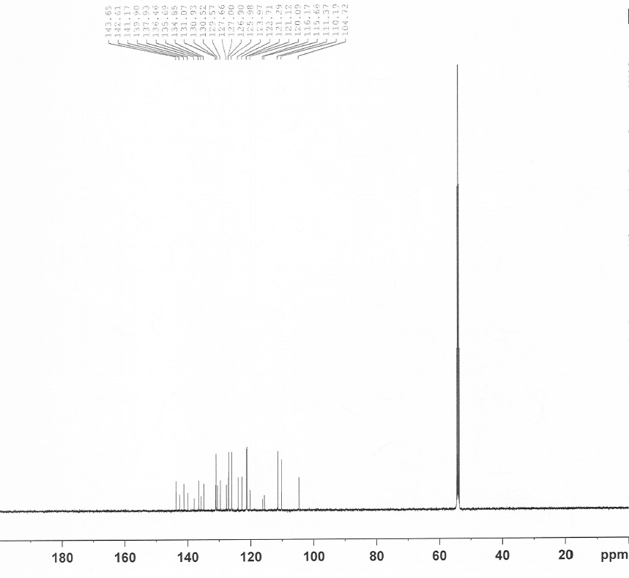
Supplementary Figure 8. ¹³C NMR spectra of H2.
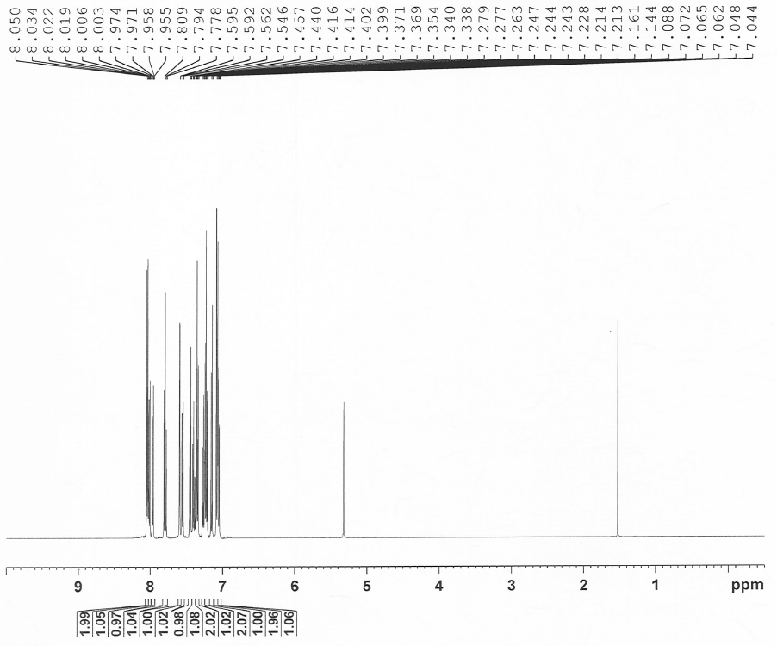
Supplementary Figure 9. ¹H NMR spectra of H3.
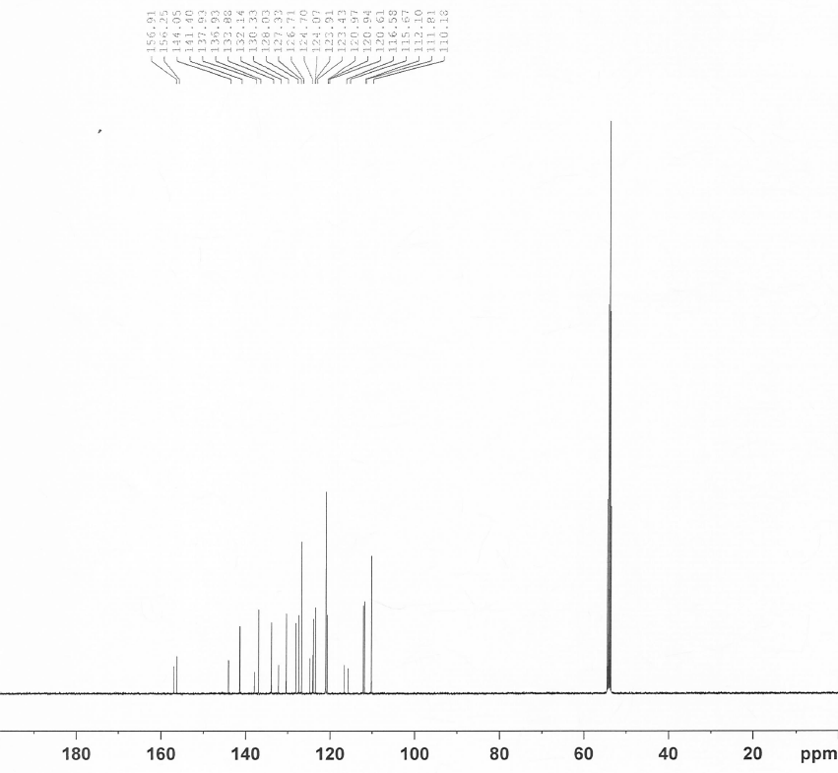
Supplementary Figure 10. ¹³C NMR spectra of H3.
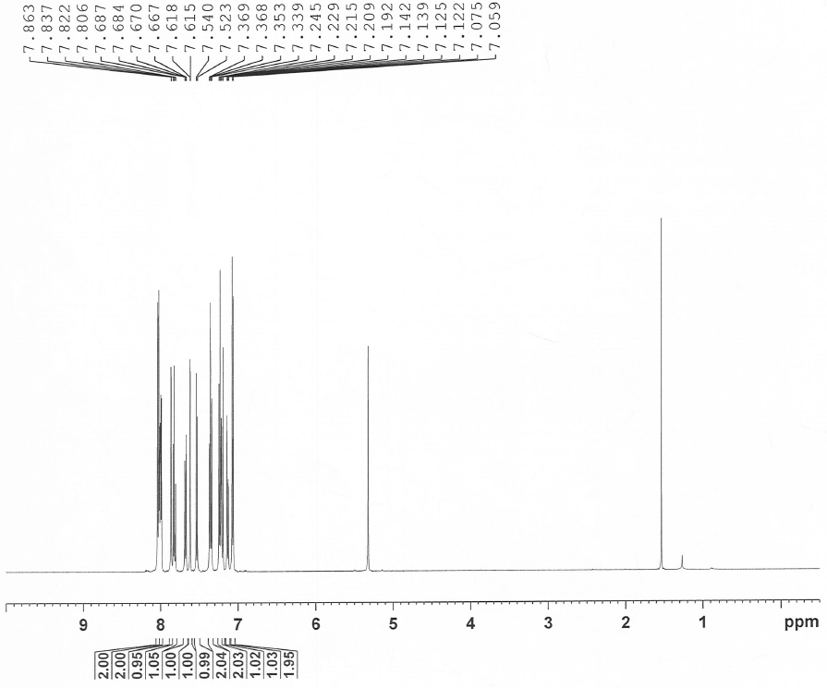
Supplementary Figure 11.¹H NMR spectra of H4.
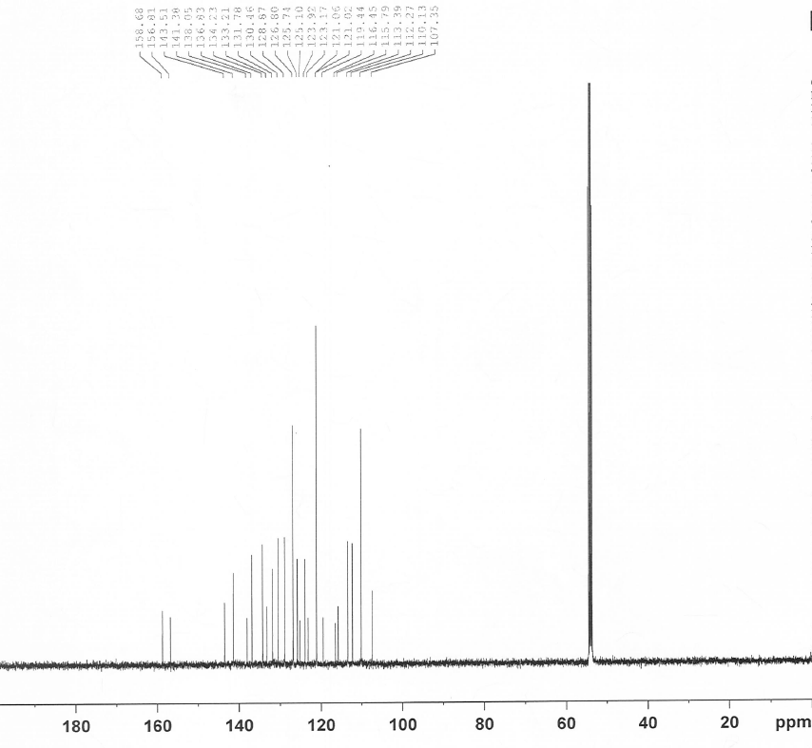
Supplementary Figure 12. ¹³C NMR spectra of H4.

