Supplementary information
Statistical analysis.
We deviated from the analysis in https://www.animalstudyregistry.org/10.17590/asr.0000305 due to the complexity of the dataset. We realized that data distribution, repeated measures within subjects, multiple experimental protocols, and interacting factors would not be adequately analyzed within a traditional hypothesis-testing framework. Instead, we decided to fit Generalized Linear Mixed Models (GLMMs) to the data, allowing for a more comprehensive and accurate analysis.
Comparisons across experiments – C1 & C2
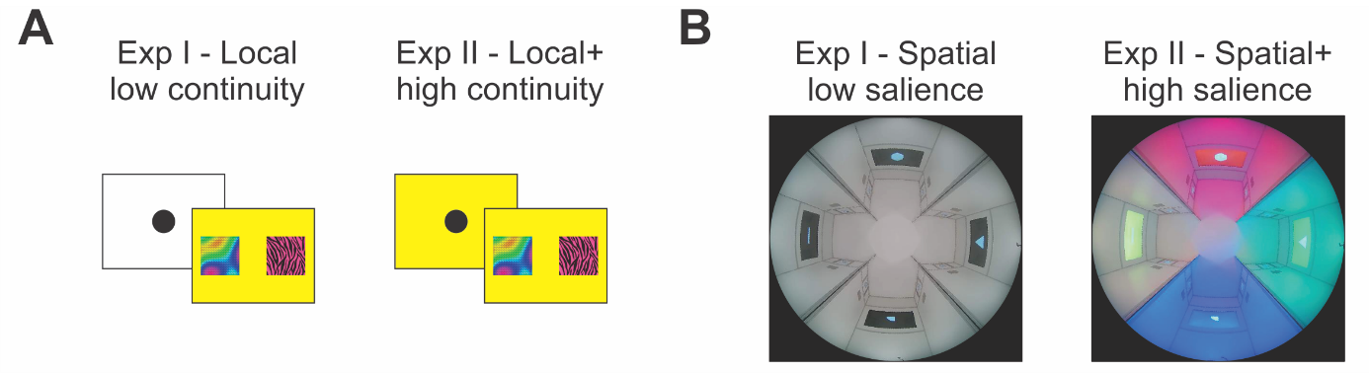
Fig. SI1. (A) Local contexts: The low continuity context (local) displayed contextual information only during the choice screen, while the high continuity context (local+) showed contextual information during both screens, including the initiation of the task. (B) Spatial contexts: The low salience spatial context (spatial context) was illuminated by white LED light and displayed landmarks against a black background. The high salience spatial context (spatial+, referred to as environmental context in the study) featured differentiated LED lights for each arm of the arena, and the monitors at the end of each arm had a background that matched the light while displaying the landmarks

