Supplementary information document for:

Decarbonising aviation does not imply successful climate change mitigation

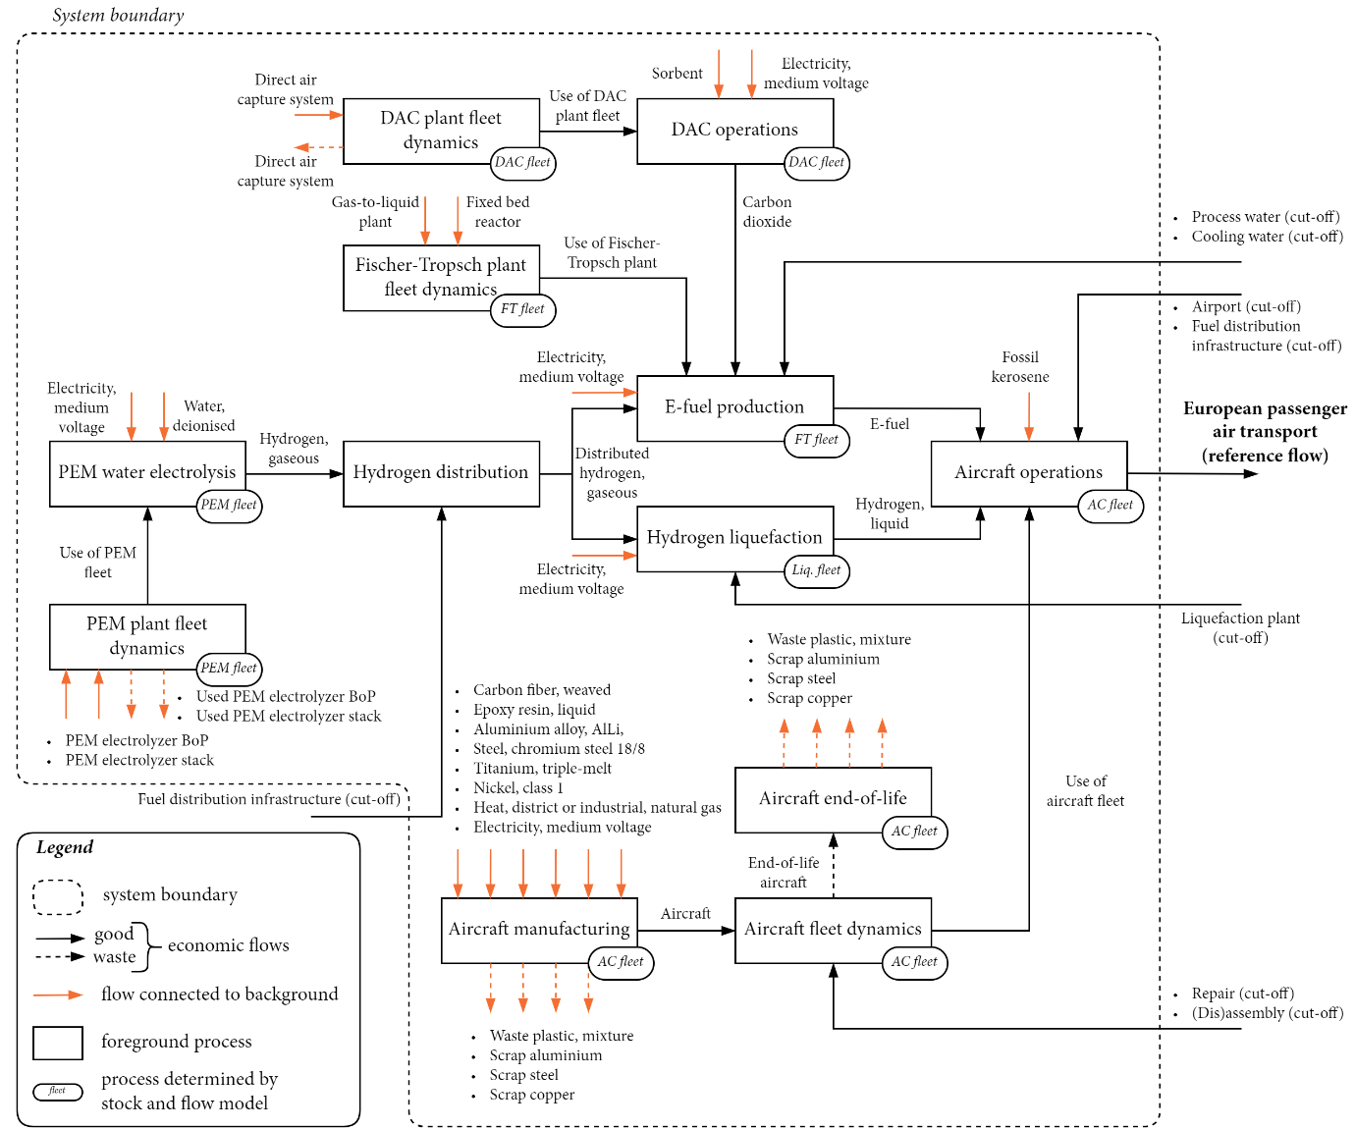
Supplementary Figure 1 System diagram for the provision of European passenger air transport. The inputs and outputs of activities labelled with “fleet” are not quantified by set values, but by dynamic stock-and-flow models (see ‘Fleet dynamics’ in ‘Methods’). Flows connected to the background are sourced from background databases created using the premise python library (see ‘Prospective background lifecycle inventories’ in ‘Methods’).
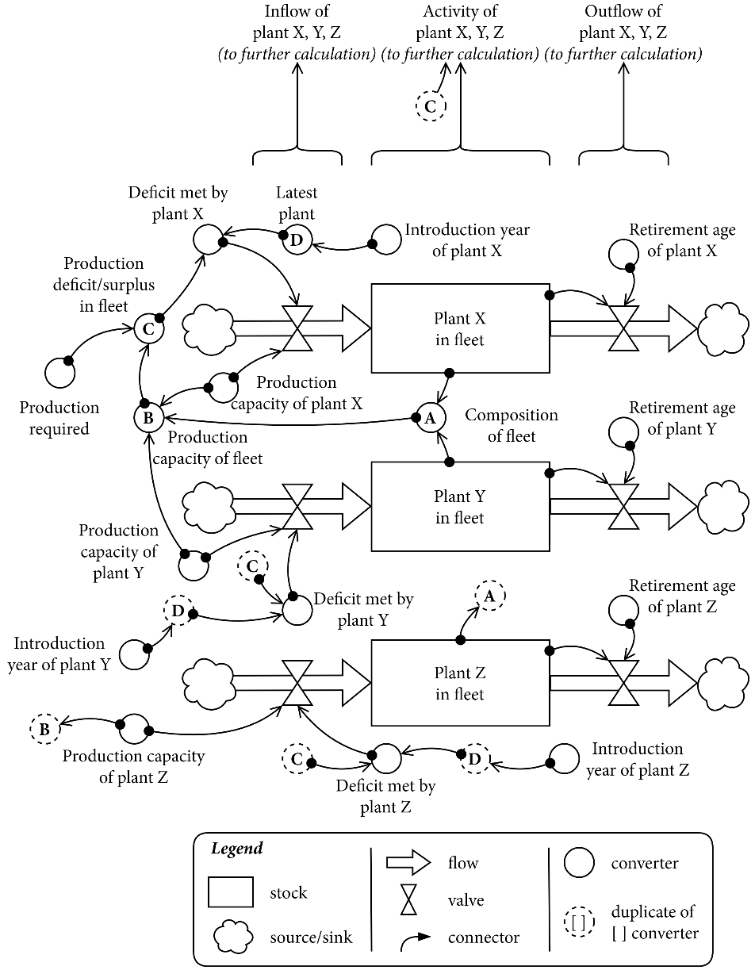
Supplementary Figure 2 Representation of the stock-and-flow model used for AAF plants (see ‘Fleet dynamics’ in ‘Methods’). As the performance of several plants is a function of their construction year, each possible construction year is represented by its own stock. For readability, the stocks of three generic plants are shown. A fleet representing any AAF plant therefore consists of all non-zero stocks of the time interval at hand.
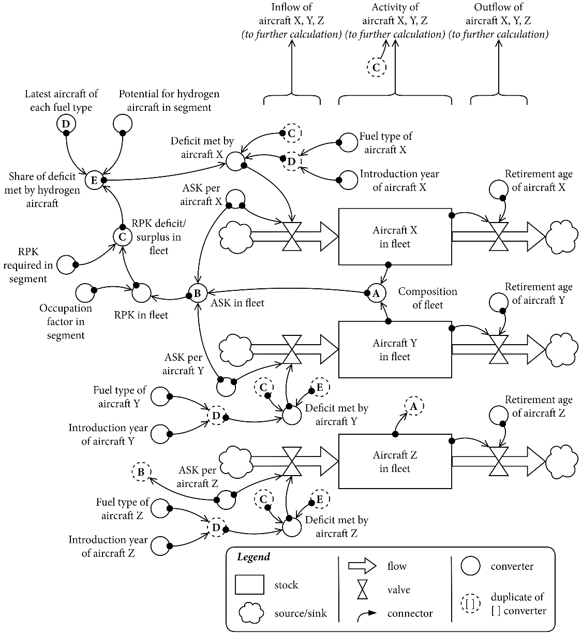
Supplementary Figure 3 Representation of the stock-and-flow model used for aircraft fleets (see ‘Fleet dynamics’ in ‘Methods’). A separate fleet is created for each flight segment (see ‘European aviation and air transport demand’), distinguishing between distances and aircraft types. For readability, the stocks of three generic aircraft are shown. ASK: available seat kilometres, RPK: revenue passenger kilometres.
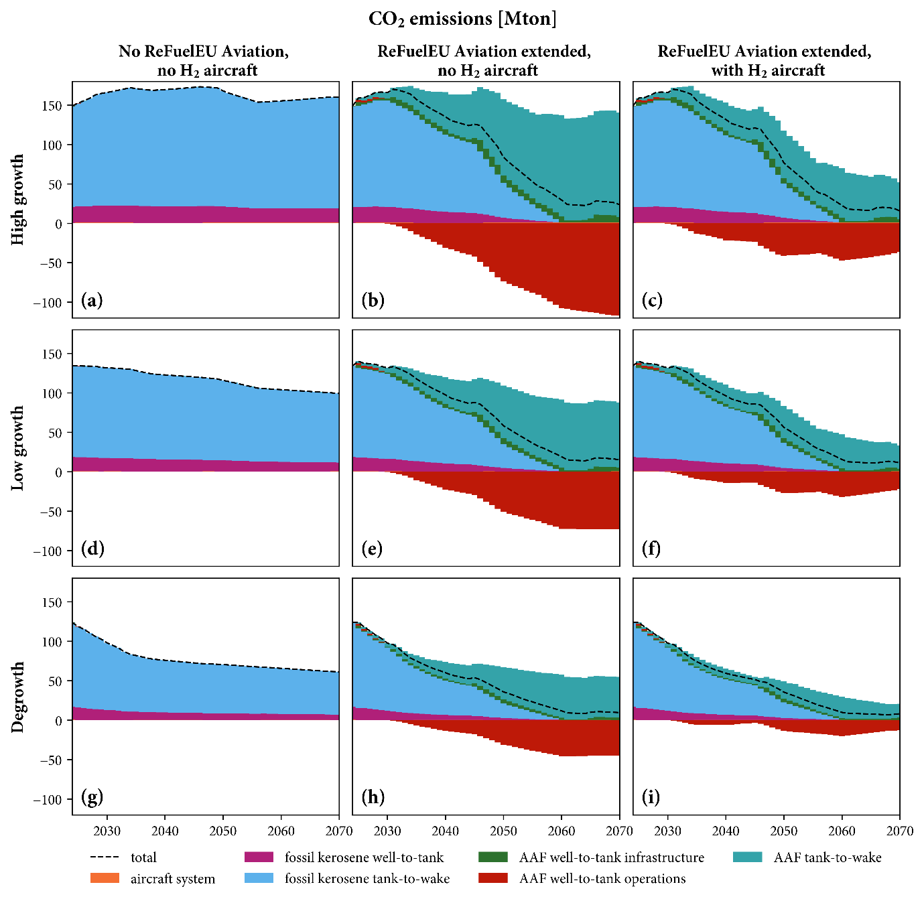
Supplementary Figure 4 Environmental flows of CO₂ for each time interval of the scenarios presented in the main text, shown according to the stage of the system where the flows occur. The negative contribution from AAF well-to-tank operations indicates that CO₂ emissions occurring in the supply of energy and consumables to AAF plants is outweighed by the withdrawal of atmospheric CO₂ in the production of e-fuel. This uptake of carbon is emitted again with fuel combustion, in the AAF tank-to-wake phase. Note that contributors to radiative forcing other than CO₂ are not included in this figure.
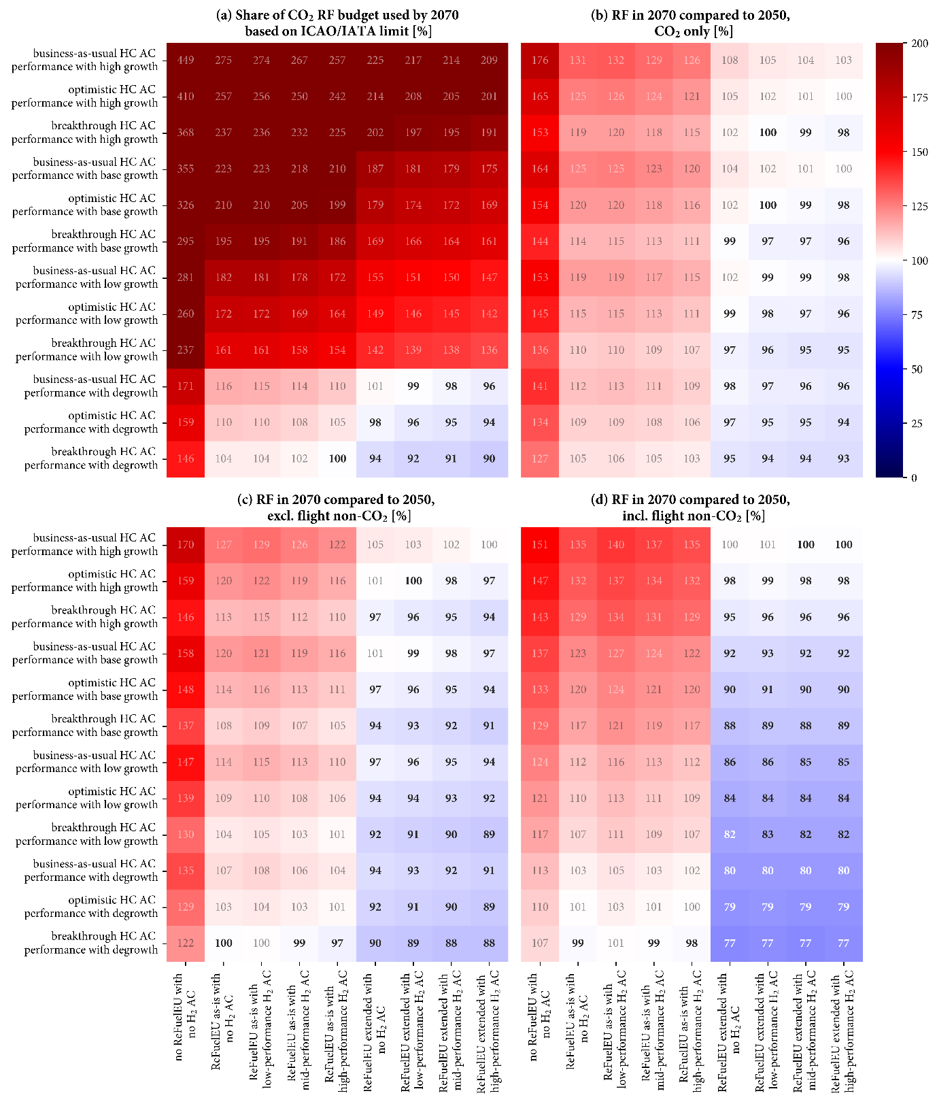
Supplementary Figure 5 Heatmap depicting the results for the share of the CO₂ radiative forcing budget based on ICAO/IATA targets which was used by 2070 (a), and climate neutrality when evaluated based on the change in radiative forcing in 2070 compared to 2050 and considering CO₂ emissions alone (b), CO₂ emissions and all ground emissions (c), and all climate forcers (d). Scenario variables which were combined in the scenarios presented in the main text are shown independently here, increasing the scenario number from 9 to 108.
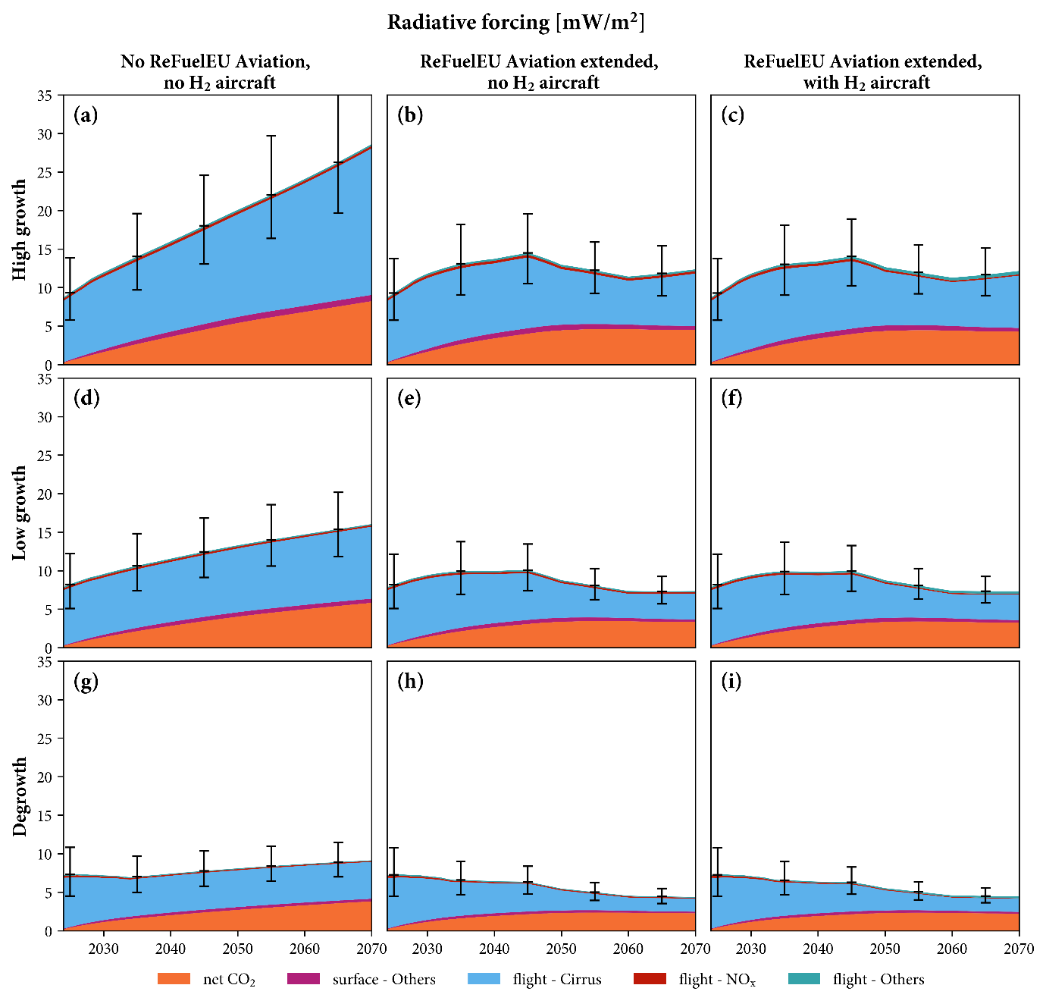
Supplementary Figure 6 Radiative forcing attributed to the commercial aviation system in the period 2024-2070 for the nine scenarios presented in the main text. Radiative forcing is broken down based on main contributors and the origin of emissions. While all CO₂ is treated equally, only NO_{x} emitted during flight is considered as contributing to climate change. Ranges for radiative forcing efficiencies of in-flight emissions are given for 5% and 95% certainty¹, primarily stemming from uncertainty in the efficiency of aviation-induced cloudiness. Other sources of uncertainty are not depicted here.

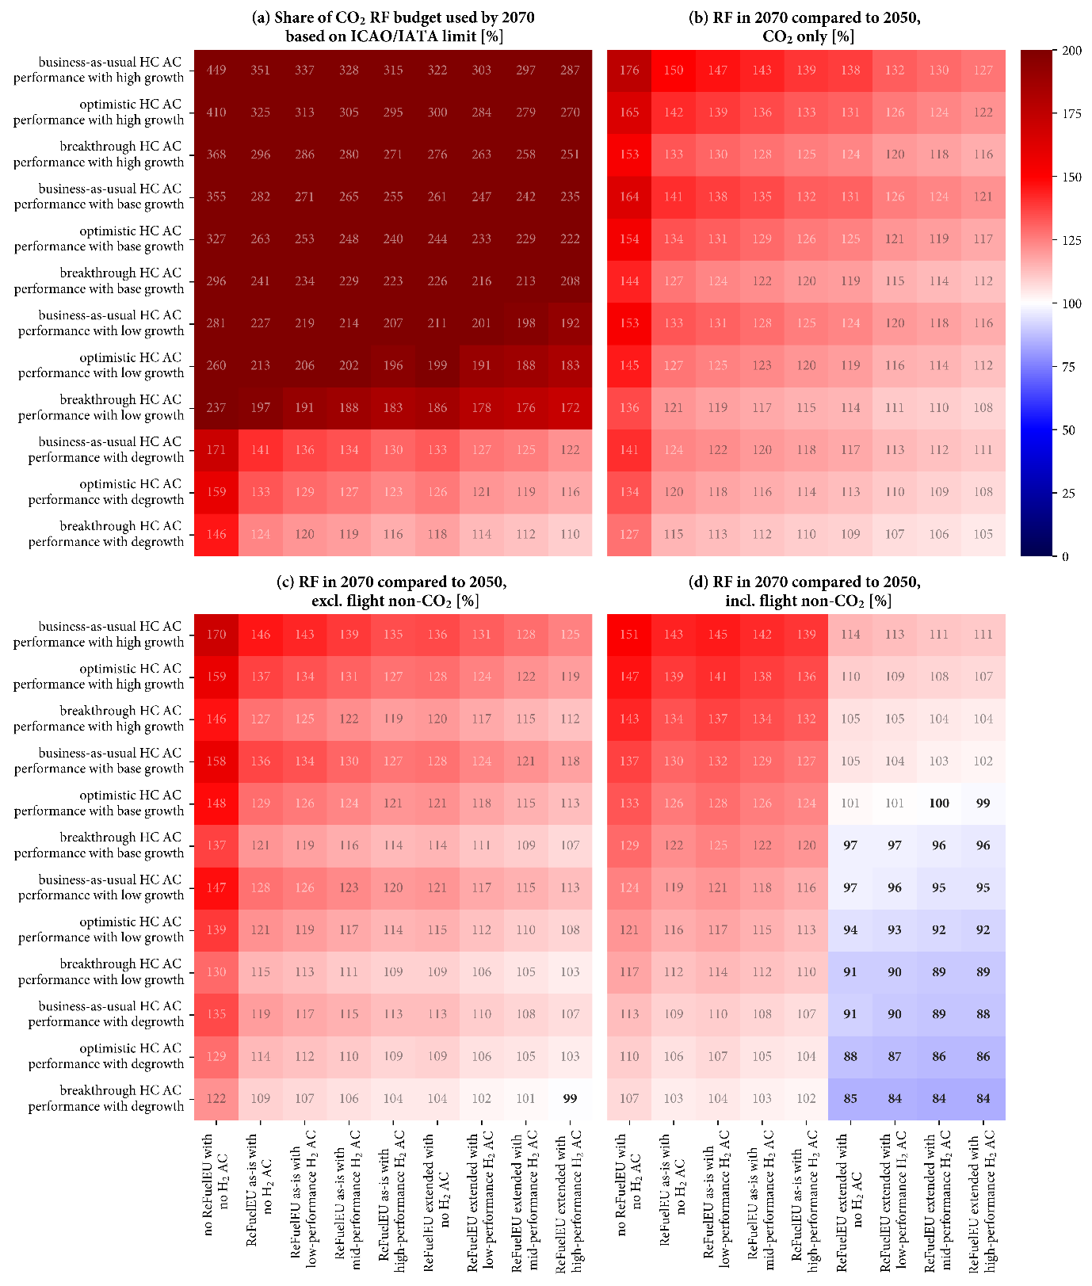
Supplementary Figure 7 Heatmap depicting the results when a prospective hydrogen market is used to supply the system, showing the share of the CO₂ radiative forcing budget based on ICAO/IATA targets which was used by 2070 (a), and climate neutrality when evaluated based on the change in radiative forcing in 2070 compared to 2050 and considering CO₂ emissions alone (b), CO₂ emissions and all ground emissions (c), and all climate forcers (d). The prospective hydrogen market is generated for the SSP2-PkBudg1550 pathway following the work of Wei et al.².
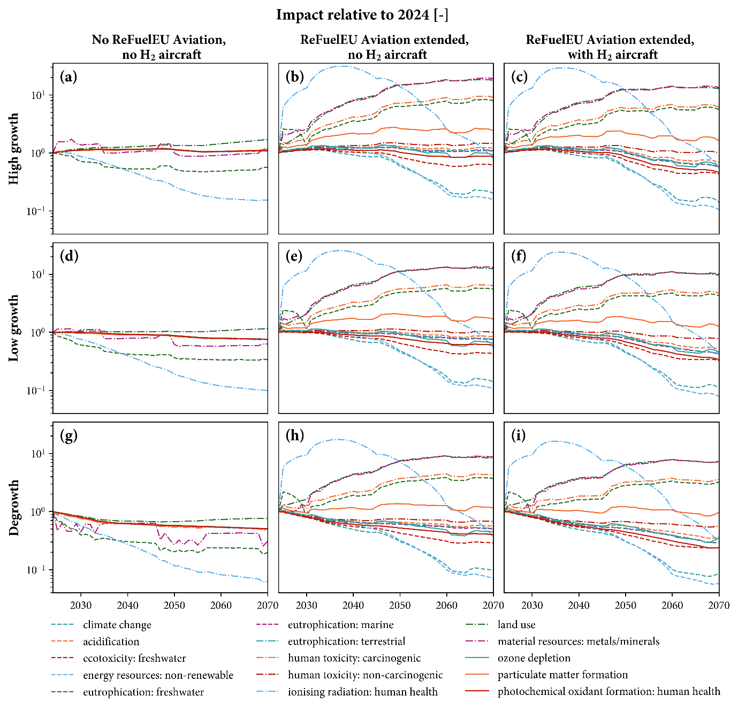
Supplementary Figure 8 Impact assessment results for the scenarios presented in the main text using impact categories of the EF 3.1 family. The “water use” impact category is excluded, as the emission of water to air plays a prominent role in its calculation. In the context of this research, water is primarily emitted because of fuel combustion, rather than the abstraction of water resources. Inventories for each one-year time interval are evaluated. This gives an impression of the environmental burden contributed each year, but does not convey the cumulative impacts which some impact categories would face.
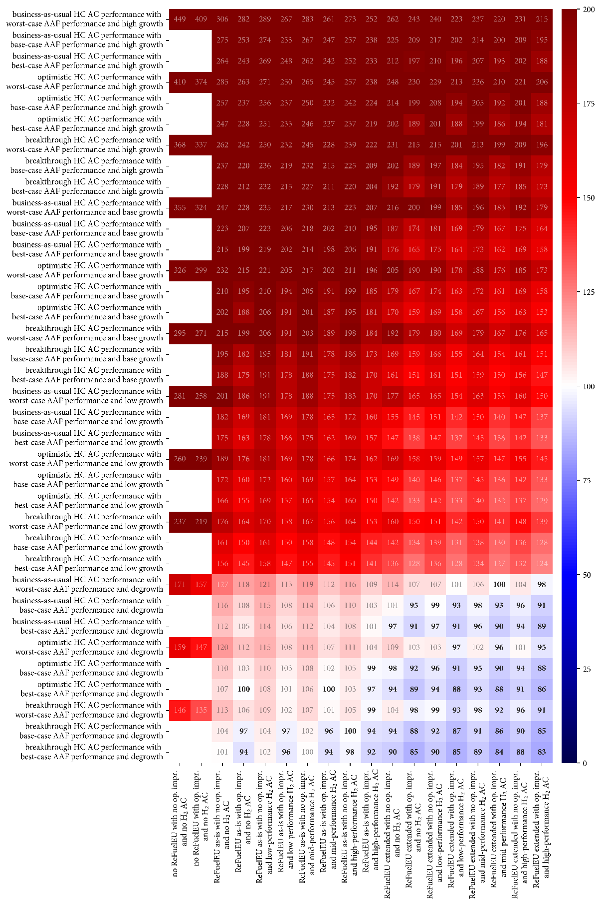
Supplementary Figure 9 Heatmap displaying the share of the CO₂ radiative forcing budget based on ICAO/IATA targets which was used by 2070, expressed as percentage. Scenario variables reflected in Supplementary Figure 6 are expanded by adding the possibility of increasing seat occupancy rate to 90% (operational improvement, op. impr.) and changing the performance of AAF infrastructure (see Supplementary Tables 1-3). Both variables can be seen to have a relatively minor influence on the results. AC: aircraft, HC: hydrocarbon.

Supplementary Table 1 Inputs for plants used in the production, transport, and liquefaction of hydrogen based on literature (see ‘Fuel supply and fuel product system’ in ‘Methods’). One-year time intervals for changes in performance as a function of plant construction year are obtained by assuming a linear progression between two flanking years. No improvements beyond 2050 are considered. All scenarios presented in the main text make use of the base performance. Other performance values are used for sensitivity analysis (Supplementary Figure 8).
Inputs per process [unit] | Year | Worst-case performance | Base performance | Best-case performance
PEM plant
Electricity [kWh/MJ] | 2019 | 4.96e-1 | 4.55e-1 | 4.15e-1
Electricity [kWh/MJ] | 2030 | 4.41e-1 | 4.28e-1 | 4.08e-1
Electricity [kWh/MJ] | 2050 | 4.15e-1 | 3.81e-1 | 3.75e-1
Water, deionised [kg/MJ] | all | 1.17e-1 | 8.33e-2 | 7.50e-2
Hydrogen compression for transport
Electricity [kWh/MJ] | all | 2.67e-2 | 2.67e-2 | 2.67e-2
Hydrogen liquefaction
Electricity [kWh/MJ] | 2020 | 1.25e-1 | 8.67e-2 | 5.00e-2
Electricity [kWh/MJ] | 2050 | 1.25e-1 | 5.00e-2 | 5.00e-2

Supplementary Table 2 Inputs for DAC plants, depending on construction year, based on literature (see ‘Fuel supply and fuel product system’ in ‘Methods’). One-year time intervals for changes in performance as a function of plant construction year are obtained by assuming a linear progression between two flanking years. All scenarios presented in the main text make use of the base performance. Other performance values are used for sensitivity analysis (Supplementary Figure 8). As a deployment rate for DAC is assumed in the calculation of the learning rates, one can reflect on the consistency between this dimension and the dimension of the background system, which incorporates the degree of climate change mitigation.
DAC plant | Year | Worst-case performance | Base performance | Best-case performance
Electricity [kWh/kg] | 2020 | 1.13 | 1.13 | 5.00e-1
Electricity [kWh/kg] | 2025 | 1.13 | 9.80e-1 | 3.75e-1
Electricity [kWh/kg] | 2030 | 1.13 | 9.61e-1 | 3.61e-1
Electricity [kWh/kg] | 2035 | 1.13 | 9.49e-1 | 3.53e-1
Electricity [kWh/kg] | 2040 | 1.13 | 9.42e-1 | 3.48e-1
Electricity [kWh/kg] | 2045 | 1.13 | 9.36e-1 | 3.43e-1
Electricity [kWh/kg] | 2050 | 1.13 | 9.31e-1 | 3.40e-1
Electricity [kWh/kg] | 2055 | 1.13 | 9.27e-1 | 3.37e-1
Electricity [kWh/kg] | 2060 | 1.13 | 9.23e-1 | 3.35e-1
Electricity [kWh/kg] | 2065 | 1.13 | 9.20e-1 | 3.33e-1
Electricity [kWh/kg] | 2070 | 1.13 | 9.17e-1 | 3.31e-1
Sorbent [kg/kg] | 2020 | 3.00e-3 | 3.00e-3 | 3.00 e-3
Sorbent [kg/kg] | 2025 | 3.00e-3 | 2.54e-3 | 1.98e-3
Sorbent [kg/kg] | 2030 | 3.00e-3 | 2.49e-3 | 1.90e-3
Sorbent [kg/kg] | 2035 | 3.00e-3 | 2.46e-3 | 1.87e-3
Sorbent [kg/kg] | 2040 | 3.00e-3 | 2.44e-3 | 1.84e-3
Sorbent [kg/kg] | 2045 | 3.00e-3 | 2.43e-3 | 1.83e-3
Sorbent [kg/kg] | 2050 | 3.00e-3 | 2.41e-3 | 1.81e-3
Sorbent [kg/kg] | 2055 | 3.00e-3 | 2.40e-3 | 1.80e-3
Sorbent [kg/kg] | 2060 | 3.00e-3 | 2.40e-3 | 1.79e-3
Sorbent [kg/kg] | 2065 | 3.00e-3 | 2.39e-3 | 1.78e-3
Sorbent [kg/kg] | 2070 | 3.00e-3 | 2.38e-3 | 1.78e-3

Supplementary Table 3 Inputs for e-fuel production via Fischer-Tropsch (see ‘Fuel supply and fuel product system’ in ‘Methods’). Because the Fischer-Tropsch process itself is well-established, these inventories are not considered to change over time. All scenarios presented in the main text make use of the base performance. Other performance values are used for sensitivity analysis (Supplementary Figure 8).
Fischer-Tropsch plant | Worst-case performance | Base performance | Best-case performance
Electricity [kWh/MJ] | 2.00e-2 | 2.00e-2 | 2.00e-2
H₂ [MJ/MJ] | 2.30 | 1.59 | 1.37
CO₂ input [kg/MJ] | 9.36e-2 | 8.62e-2 | 7.61e-2
CO₂ emissions [kg/MJ] | 2.46e-2 | 1.72e-3 | 7.07e-3

References
1. Lee, D. S. et al. The contribution of global aviation to anthropogenic climate forcing for 2000 to 2018. Atmospheric Environment 244, 117834 (2021).
2. Wei, S., Sacchi, R., Tukker, A., Suh, S. & Steubing, B. Future environmental impacts of global hydrogen production. Energy & Environmental Science 17, 2157–2172 (2024).

