Supplementary information
Molecular Spin Sensor for In-Situ Monitoring of Crystallization Behavior and Phase Transition in Aromatic Materials
Linshan Liu,^{1,5} Chong Zhao,³ Yingjian Zhang,¹ Zhuxia Zhang,⁴ Chunru Wang,² and Taishan Wang*¹
¹MOE Key Laboratory of Cluster Science, School of Chemistry and Chemical Engineering, Beijing Institute of Technology, Beijing 102488, China
²Beijing National Laboratory for Molecular Sciences, Key Laboratory of Molecular Nanostructure and Nanotechnology, Institute of Chemistry, Chinese Academy of Sciences, Beijing 100190, China
³State Key Laboratory of Functions and Applications of Medicinal Plants, College of Pharmacy, Guizhou Medical University, Guiyang 550025, China
⁴College of Chemistry, Taiyuan University of Technology, Taiyuan 030024, China
⁵College of Chemistry, Beijing Normal University, Beijing 100875, China
E-mail: wangtais@bit.edu.cn

Table of Contents
- Synthesis and Separation of Y₂@C₇₉N
- EPR measurements of Y₂@C₇₉N
- XRD and POM measurements of materials

1.Synthesis and Separation of Y₂@C₇₉N
Y₂@C₇₉N was synthesized by the arc-discharge method. Figure S1a shows the first stage HPLC separation on Buckyprep column. Figure S1b shows the HPLC chromatogram of isolated Y₂@C₇₉N on Buckyprep column. The purity of Y₂@C₇₉N was determined by matrix-assisted laser desorption/ionization time-of-flight mass spectrometry (MALDI-TOF-MS, AXIMA Assurance, Shimadzu), as shown in Figure S1c.

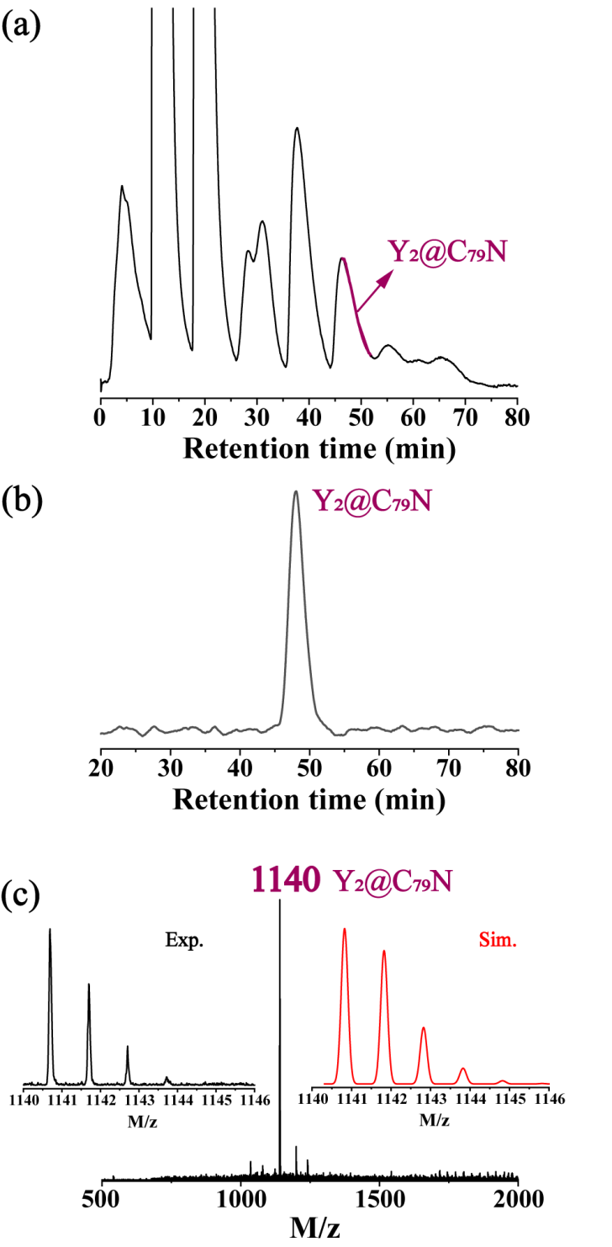
Figure S1. (a) The first stage HPLC separation of Y₂@C₇₉N (HPLC conditions: 20 mm × 250 mm Buckyprep column; mobile phase toluene; flow rate 12 mL∙min⁻¹; detection wavelength 310 nm). (b) HPLC chromatogram of isolated Y₂@C₇₉N (HPLC conditions: 20 mm × 250 mm Buckyprep column; mobile phase toluene; flow rate 12 mL∙min⁻¹; detection wavelength 310 nm). (c) MALDI-TOF mass spectrum of the isolated Y₂@C₇₉N sample. The insets show the experimental and simulated isotopic distributions patterns of mass spectrum peak.

2.EPR measurements of Y₂@C₇₉N
The Y₂@C₇₉N was respectively dissolved in 1-chloronaphthalene and 5CB with the same molar concentration, and the samples with equal volume were taken for EPR measurements. The solution was placed into a quartz tube and then implemented to degas by ultrasonic treatments, and finally protective nitrogen gas was filled into the tube. Temperature-dependent EPR spectra were collected on CIQTEK EPR200-Plus with continuous-wave X-band frequency.
Table S1. Line widths (ΔH_{pp}, Gauss) of three groups of EPR signals for Y₂@C₇₉N dissolved in 1-chloronaphthalene measured at different temperatures.
 | ΔH_{pp} | ΔH_{pp} | ΔH_{pp}
Temperature (K) | (Low field) | (Centre field) | (High field)
290 K | 6.10 | 6.60 | 6.40
270 K | 6.00 | 6.30 | 5.60
250 K | 5.80 | 6.10 | 5.20
245 K | 6.70 | 6.50 | 5.50
240 K | 7.50 | 7.00 | 5.70
235 K | 10.00 | 7.90 | 6.50
230 K | 13.00 | 10.40 | 7.40
Table S2. Line widths (ΔH_{pp}, Gauss) of three groups of EPR signals for Y₂@C₇₉N dissolved in 5CB measured at different temperatures.
 | ΔH_{pp} | ΔH_{pp} | ΔH_{pp}
Temperature (K) | (Low field) | (Centre field) | (High field)
320 K | 6.73 | 7.37 | 5.77
315 K | 7.37 | 6.73 | 6.09
310 K | 6.73 | 6.41 | 6.09
305 K | 6.41 | 6.73 | 5.45
300 K | 6.73 | 6.73 | 5.45
295 K | 6.41 | 6.73 | 5.45
290 K | 6.73 | 7.05 | 5.77
280 K | 8.65 | 8.65 | 7.37
270 K | 17.62 | 13.77 | 10.89
Figure S2. Temperature dependence of the signal (a) linewidth and (b) intensity for Y₂@C₇₉N dissolved in 1-chloronaphthalene. Temperature dependence of the signal (c) linewidth and (d) intensity for Y₂@C₇₉N dissolved in 5CB.

3.XRD and POM measurements of solvents
For 1-chloronaphthalene and 5CB, X-ray diffraction (XRD) experiments were performed by in-situ XRD instrument with a temperature controller. The PANalytical Empyrean X-ray diffractometer was employed for the characterization of samples. A volume of 100 μL of the solvent was placed in a custom-designed sample cell and positioned on the sample stage for analysis. To achieve temperature control, a low-temperature nitrogen gas was used to establish an equilibrium atmosphere. A temperature probe was positioned in close proximity to the sample surface to monitor the environmental temperature. Spectra were acquired for each sample at different temperatures, with a stabilization period of ten minutes at each temperature.
The polarized-light optical microscope (POM) imaging of was performed under varied temperatures. An Olympus BX51 polarized-light optical microscope (POM) equipped with a charge-coupled device (CCD) digital camera and a Linkam THMS-600 heating stage was used to detect the crystallization of 1-chloronaphthalene and 5CB. The sample (3 μL) was putted in the middle of two slides. The sample was cooled at a rate of 5 K/min.
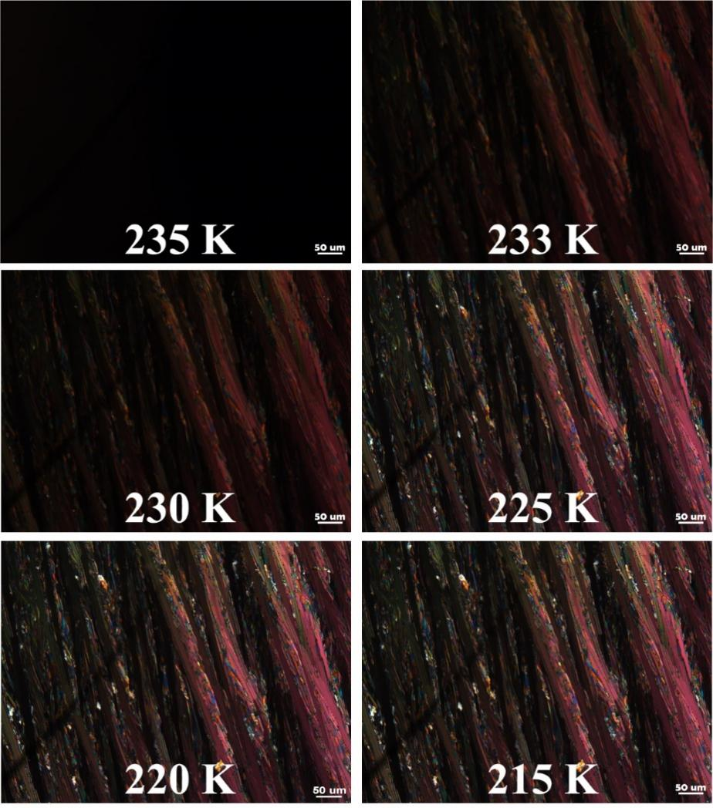
Figure S3. In-situ polarized-light optical microscope (POM) pictures of 1-chloronaphthalene at different temperatures.

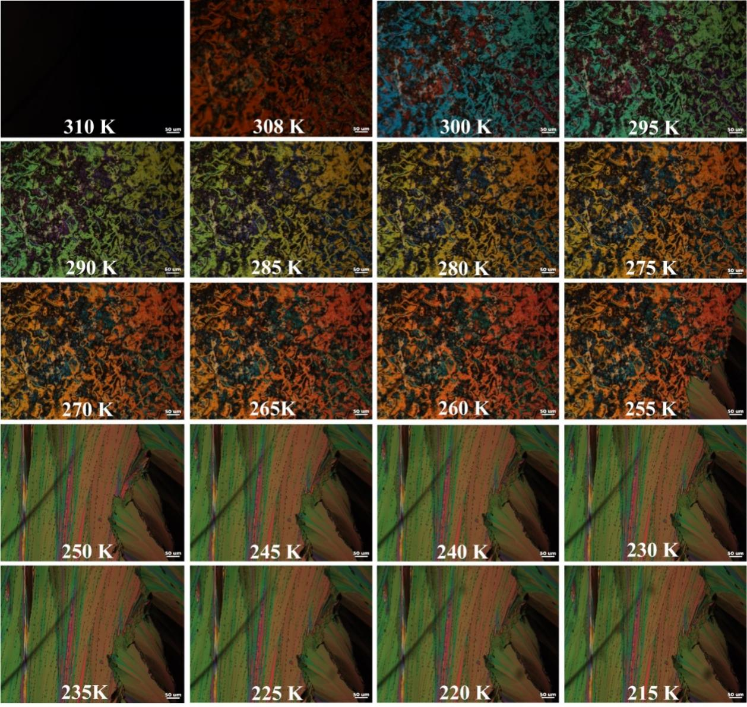
Figure S4. In-situ polarized-light optical microscope (POM) pictures of 5CB at different temperatures.

