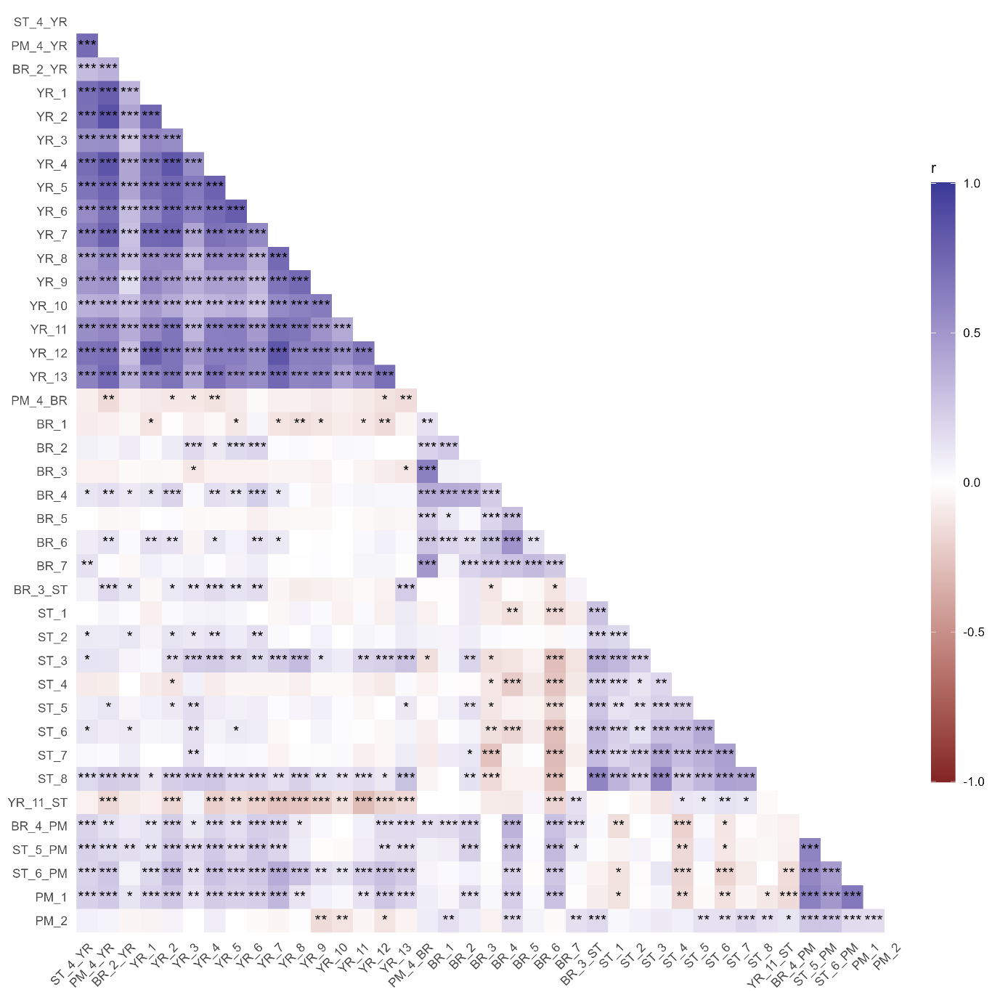
Supplementary Figure S1. Correlation of percentage disease infection scores in the WAGTAIL wheat association mapping panel between all traits and trials, using the variety means on untransformed data. Trial codes: BR = brown rust, PM = powdery mildew, ST = Septoria tritici blotch, YR = yellow rust. Significance: P = 0.05*, P = 0.01**, P = 0.001***. Where more than one disease score date was recorded for a given trial, here data from the last date was used for correlation analysis.

