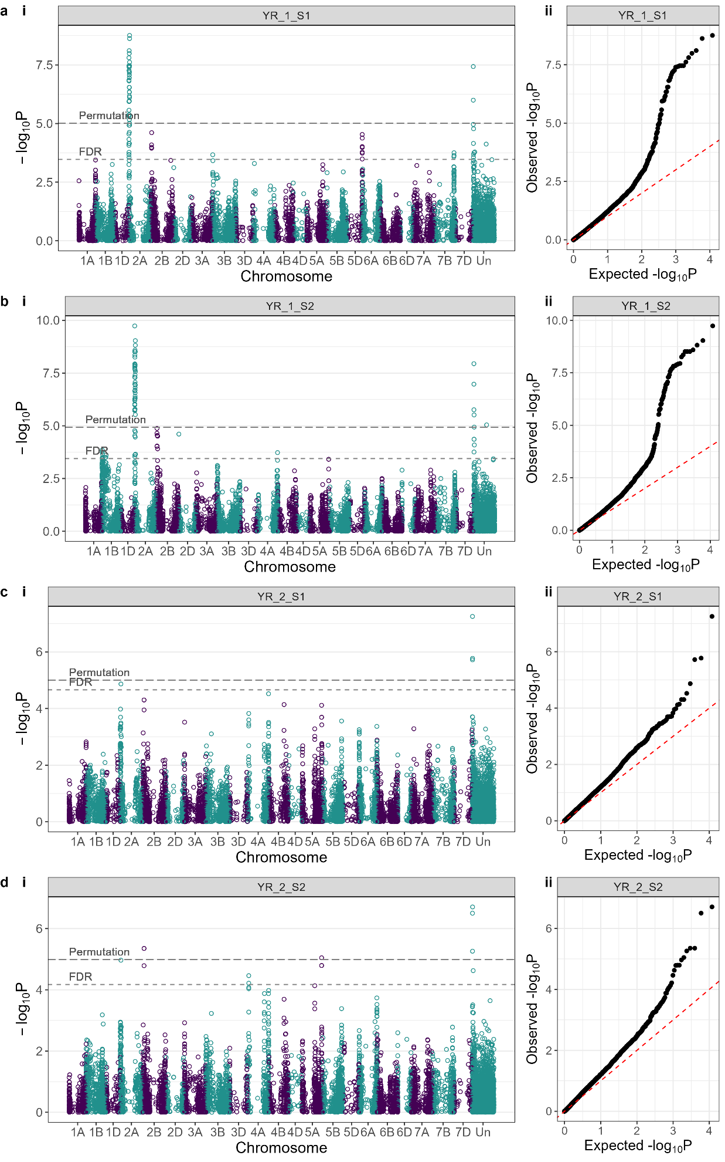
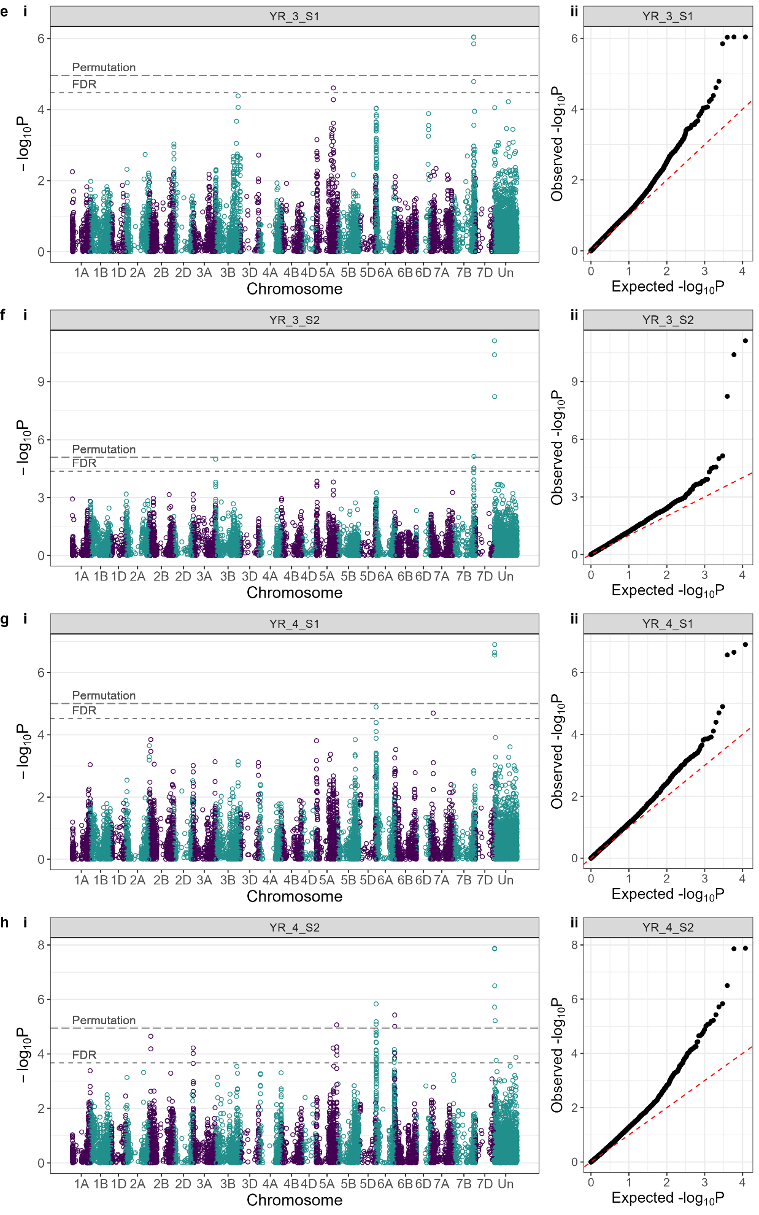
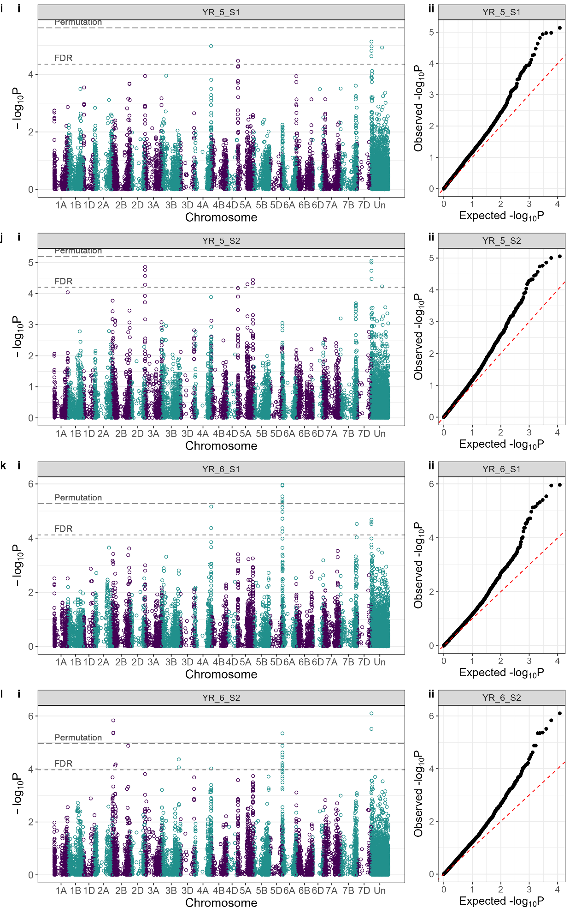
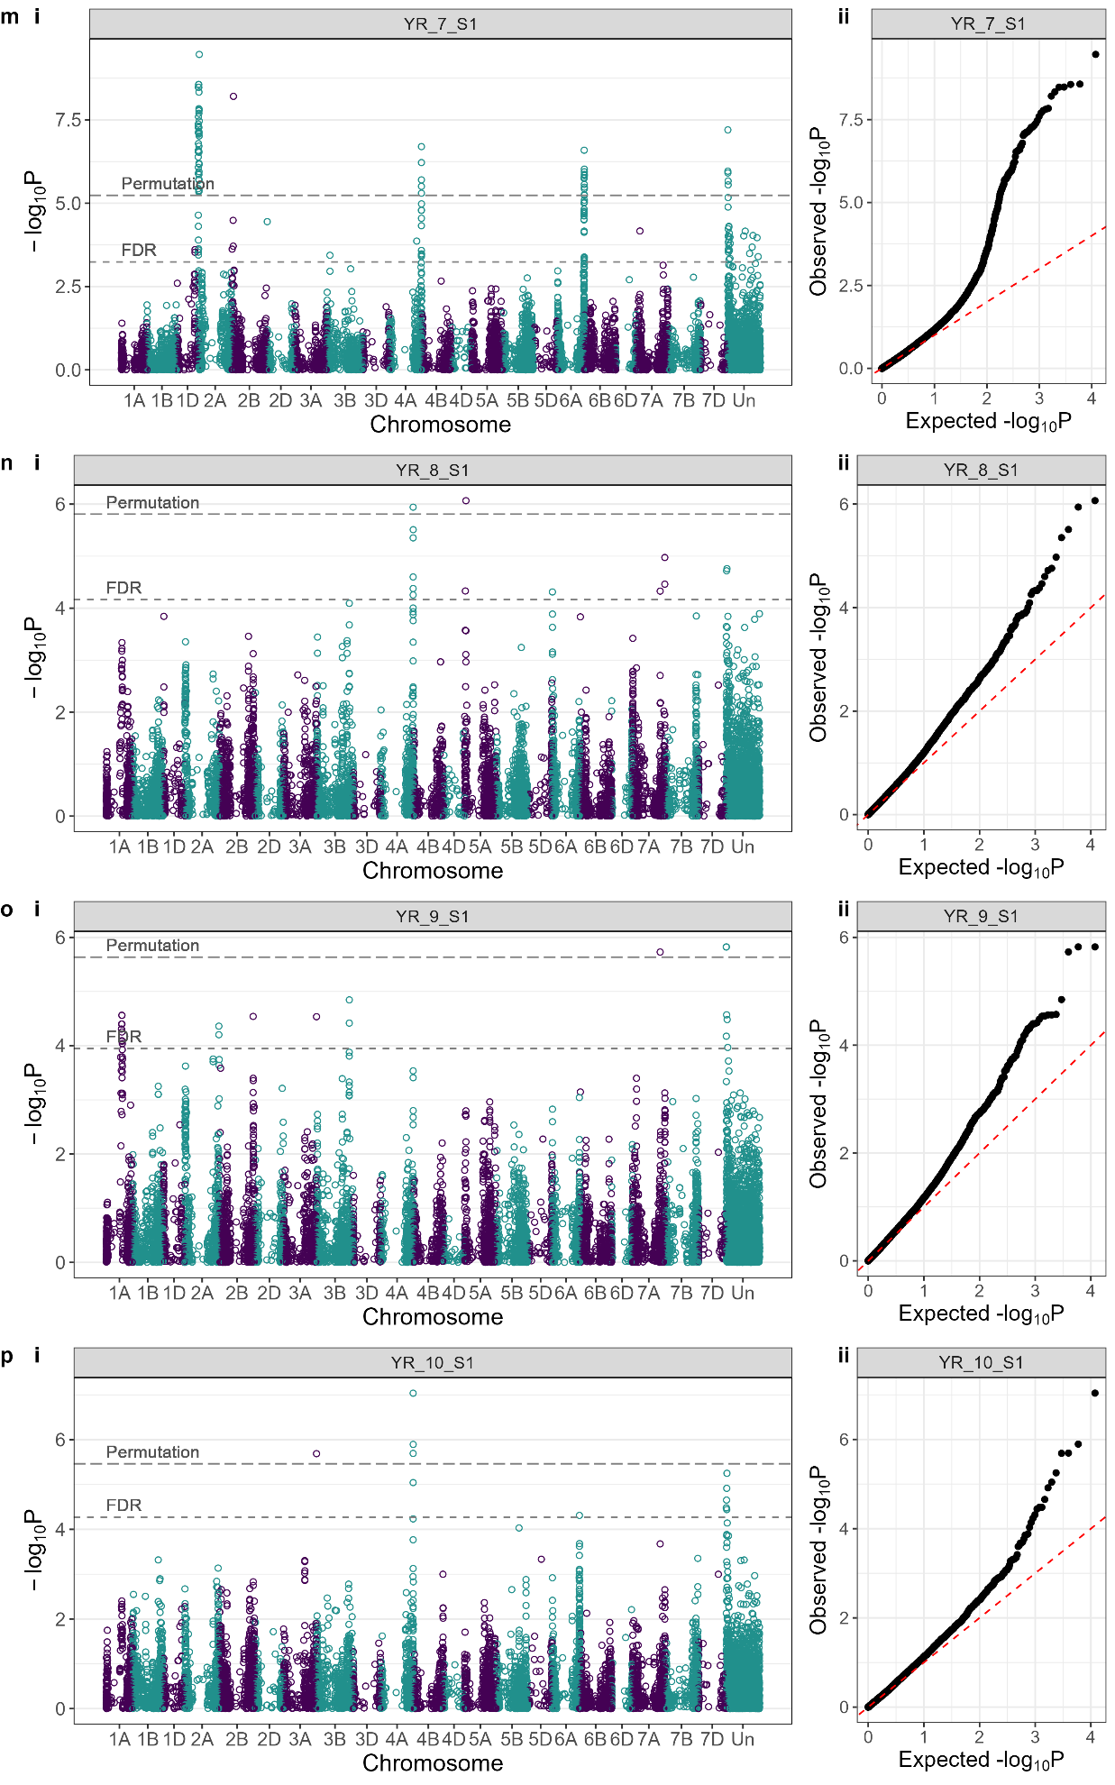
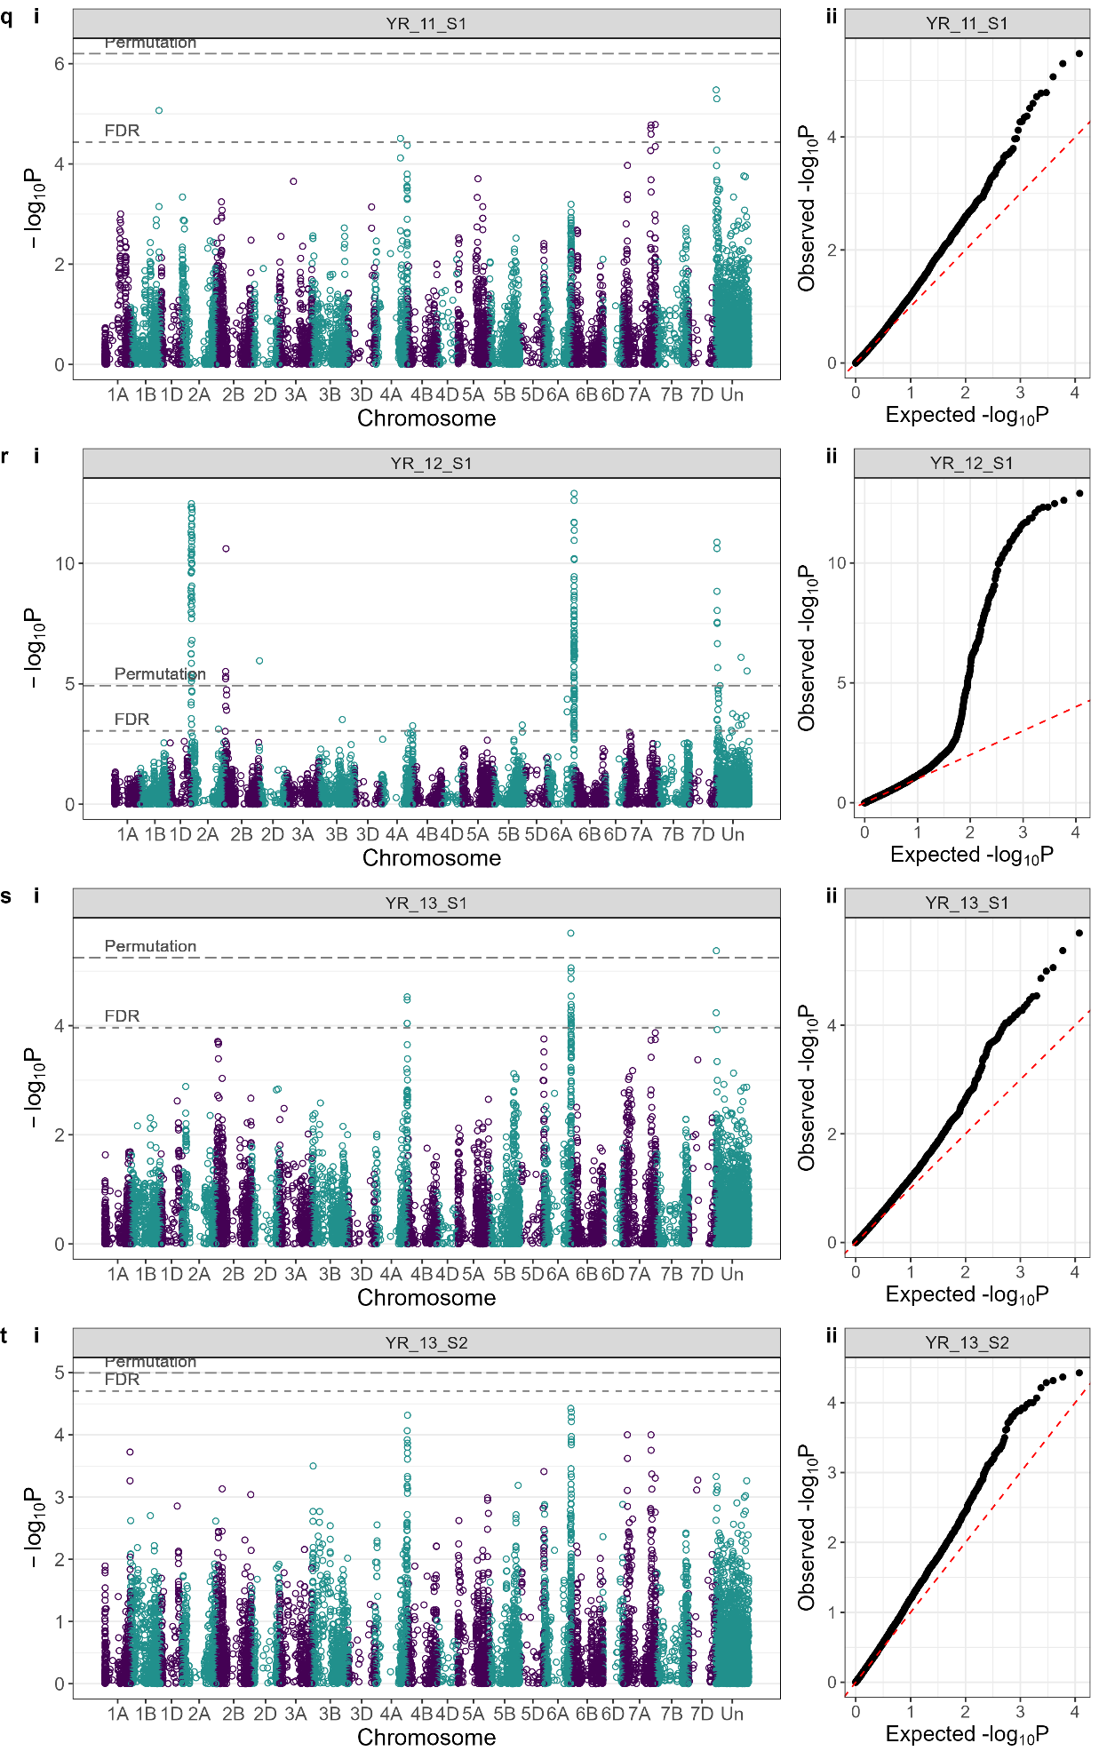
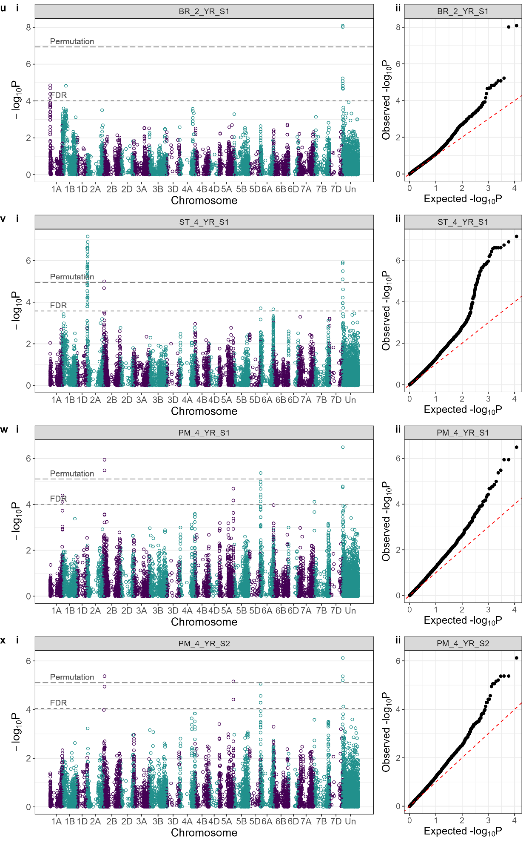
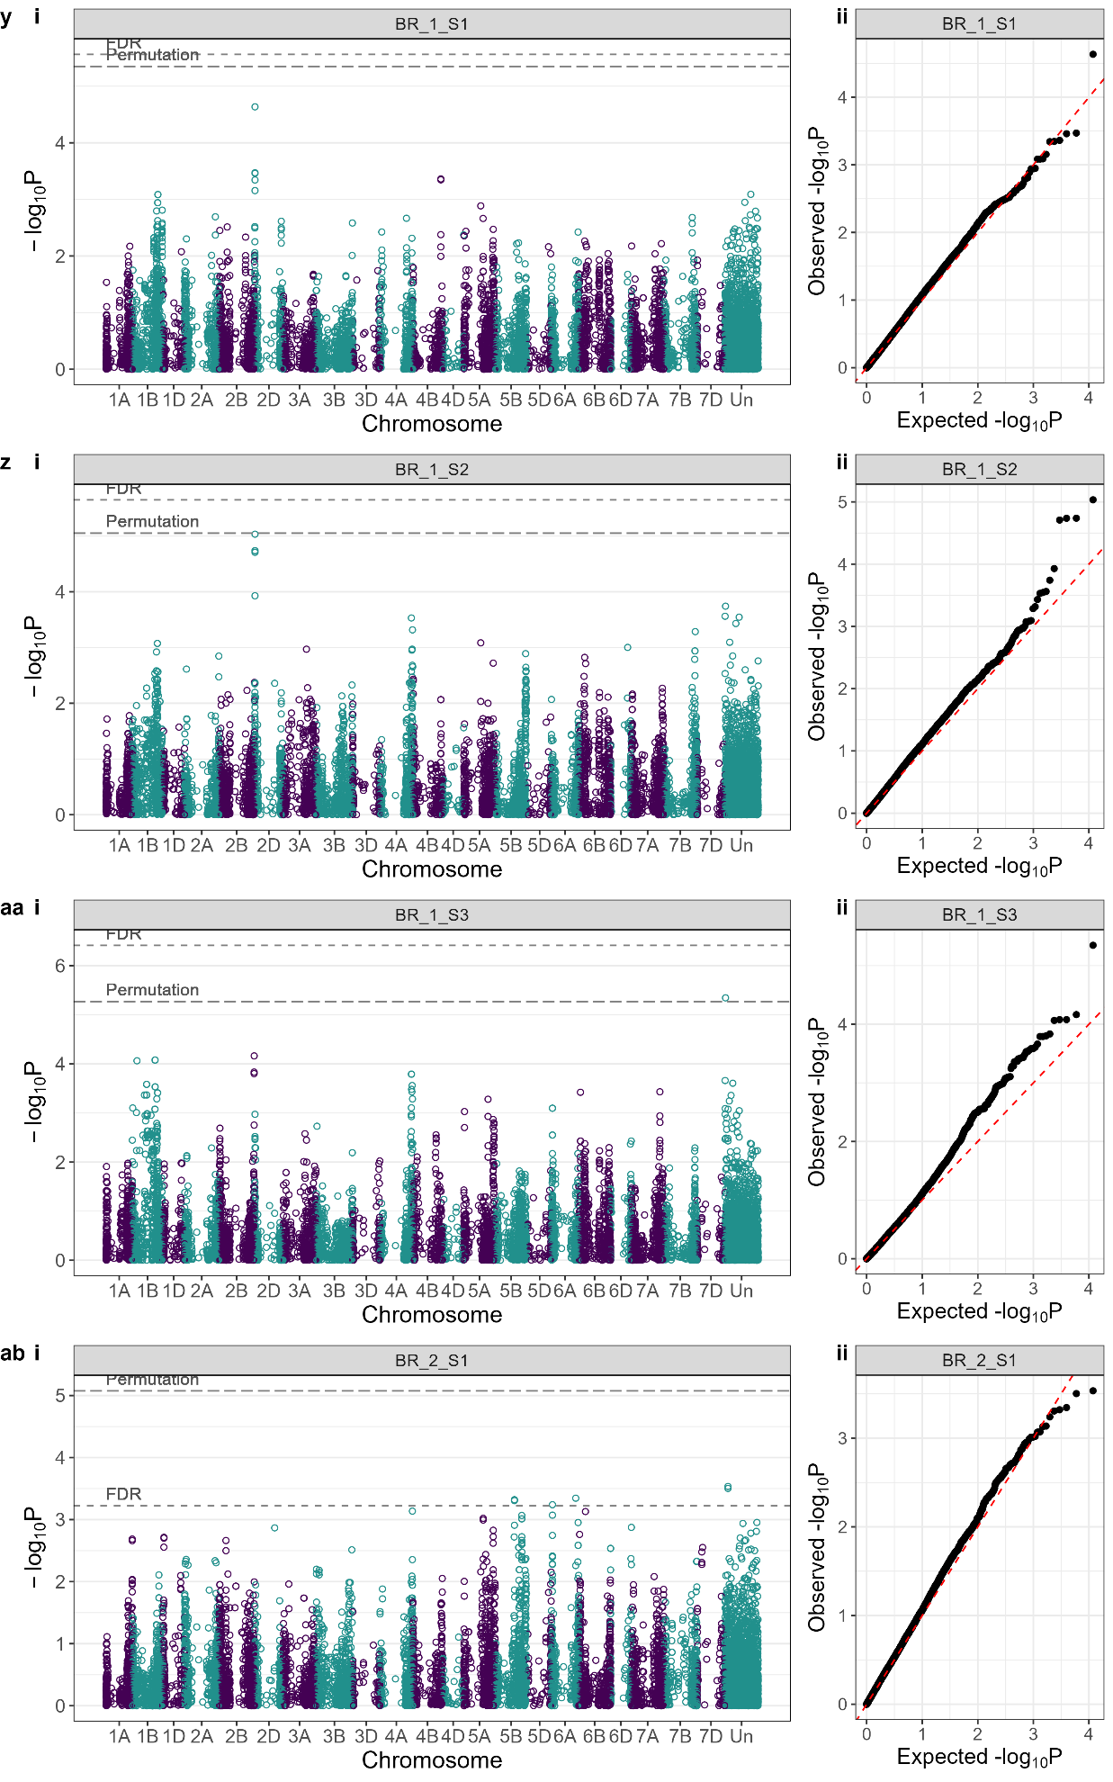
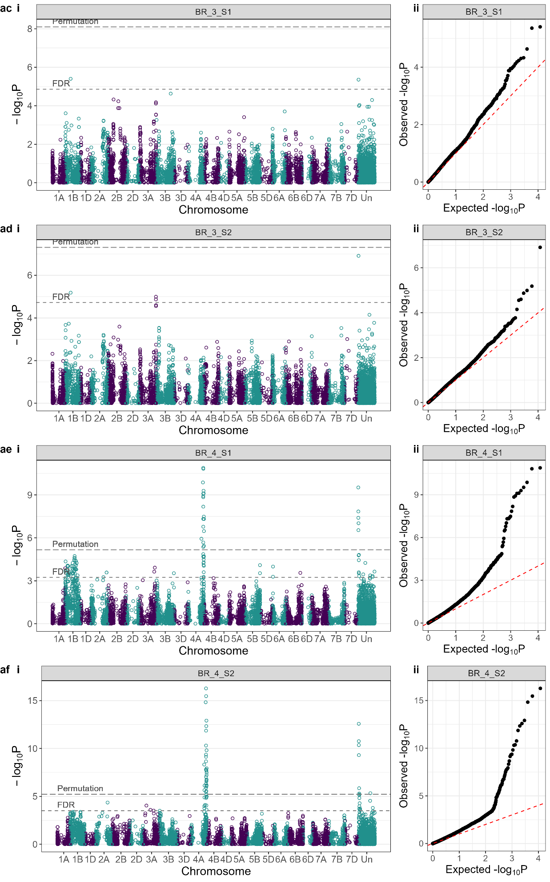
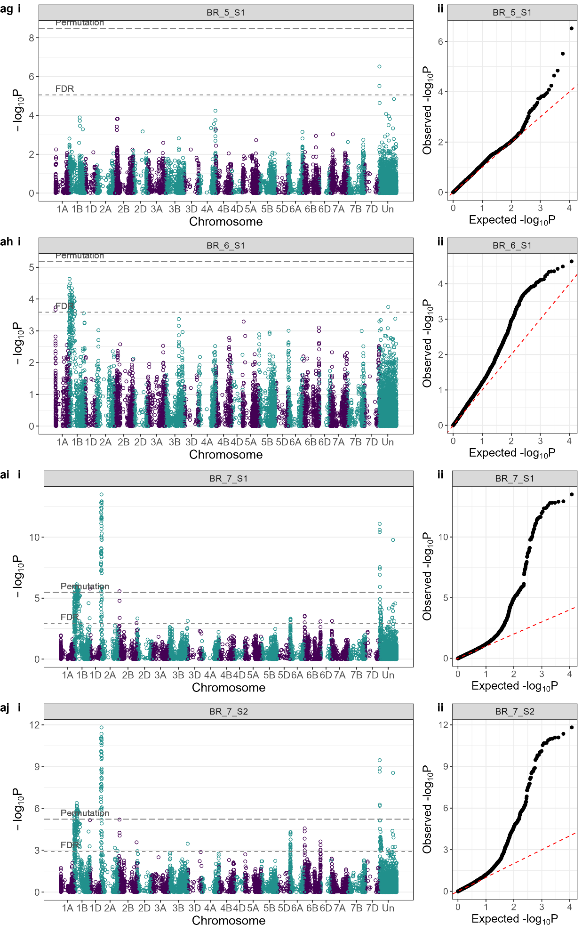
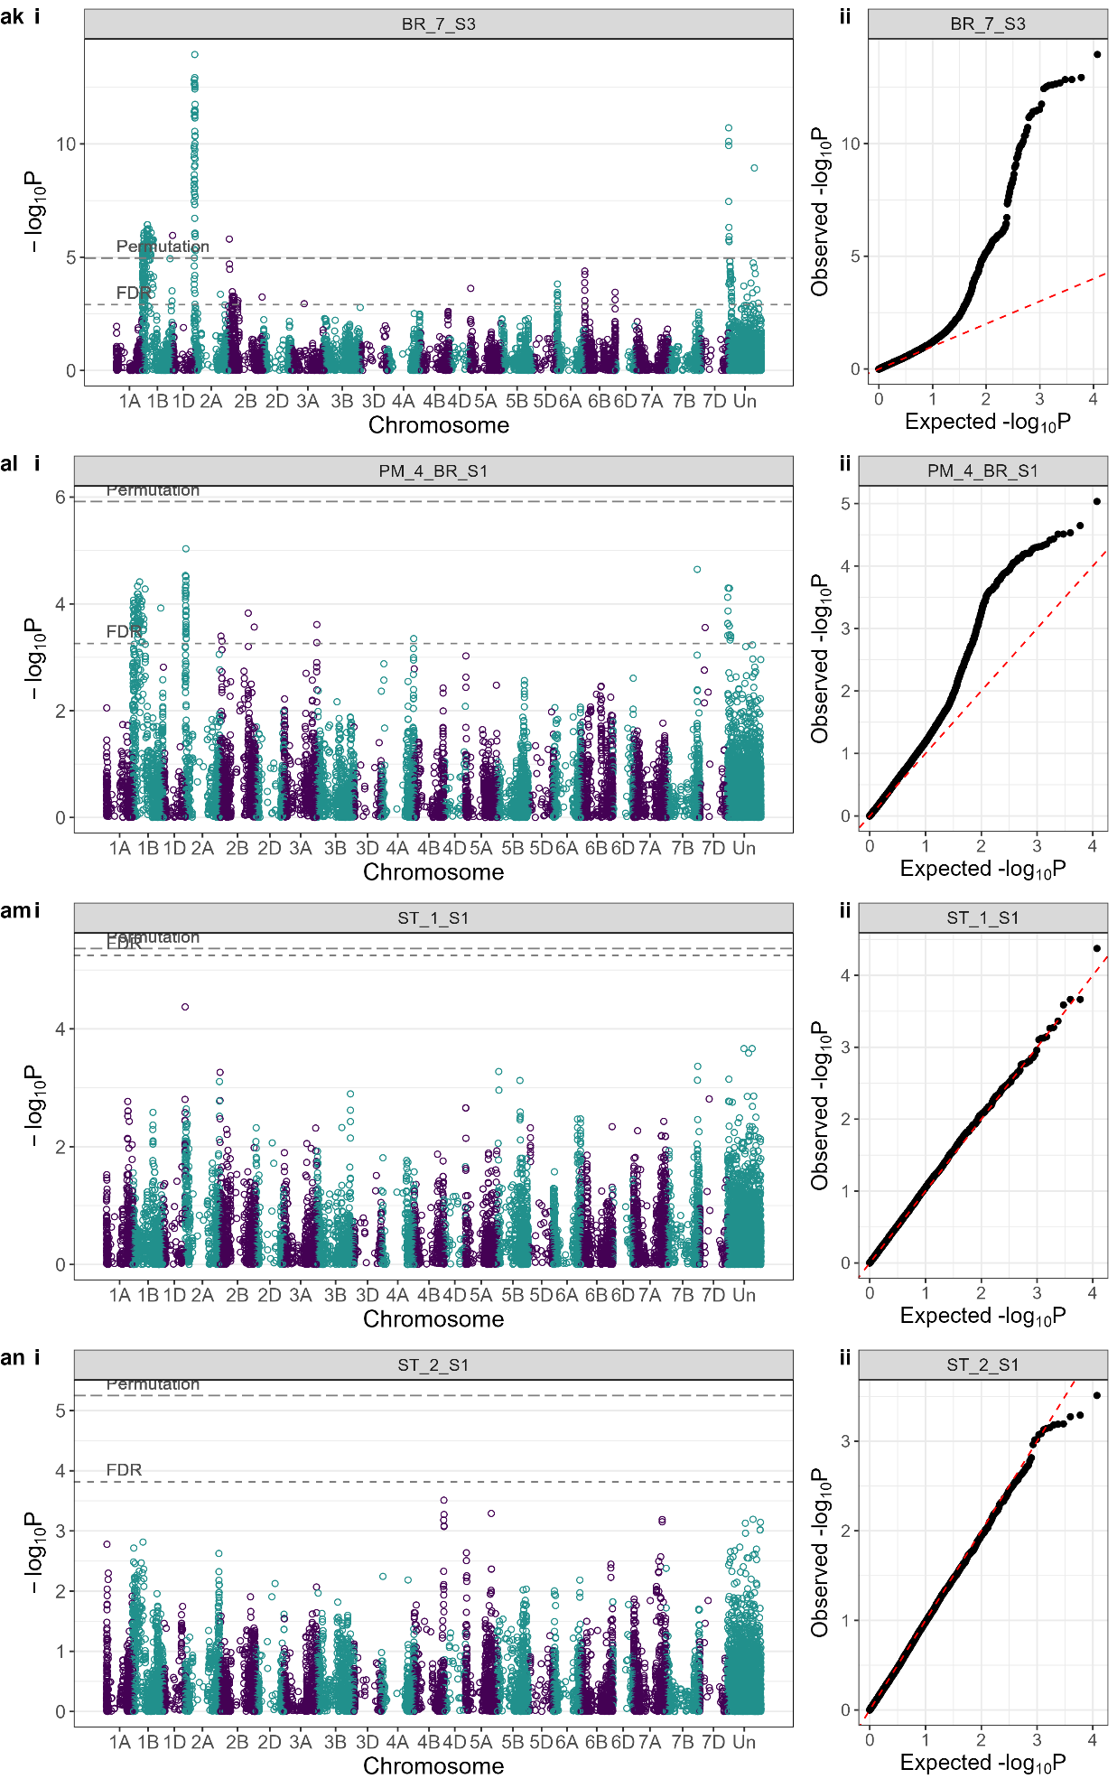
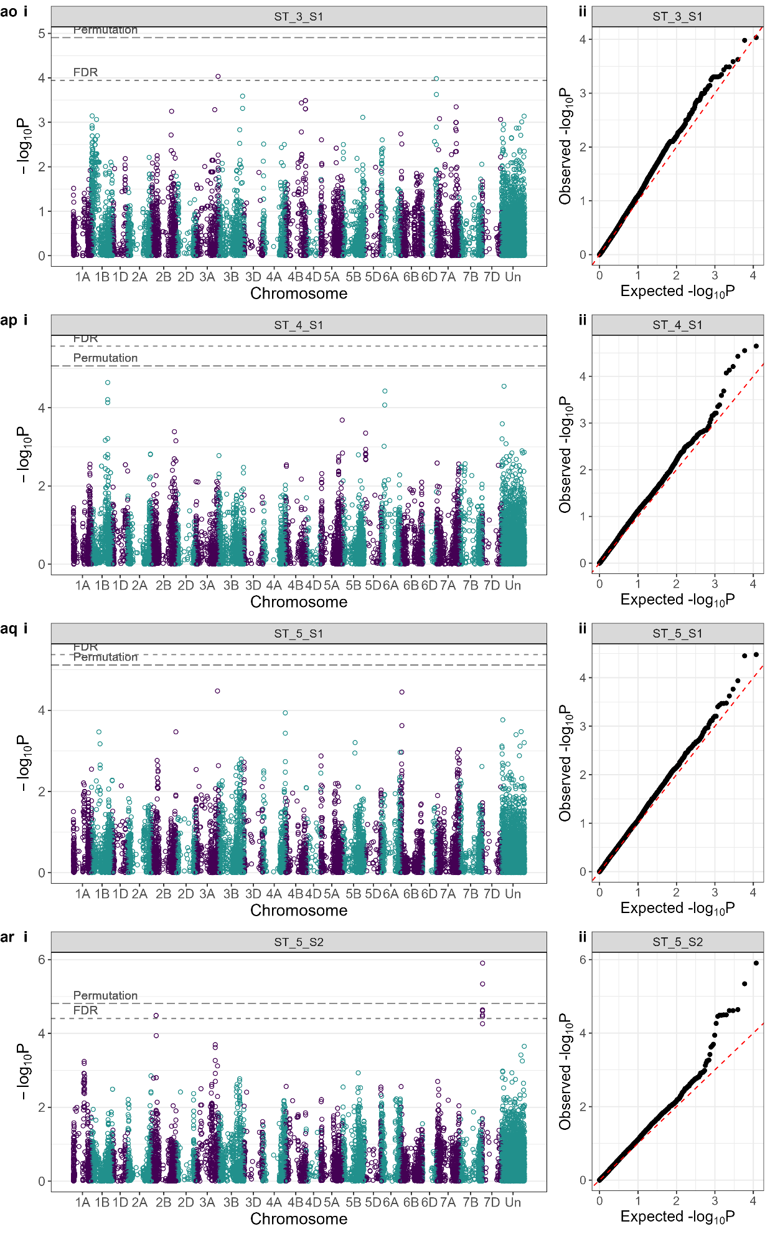
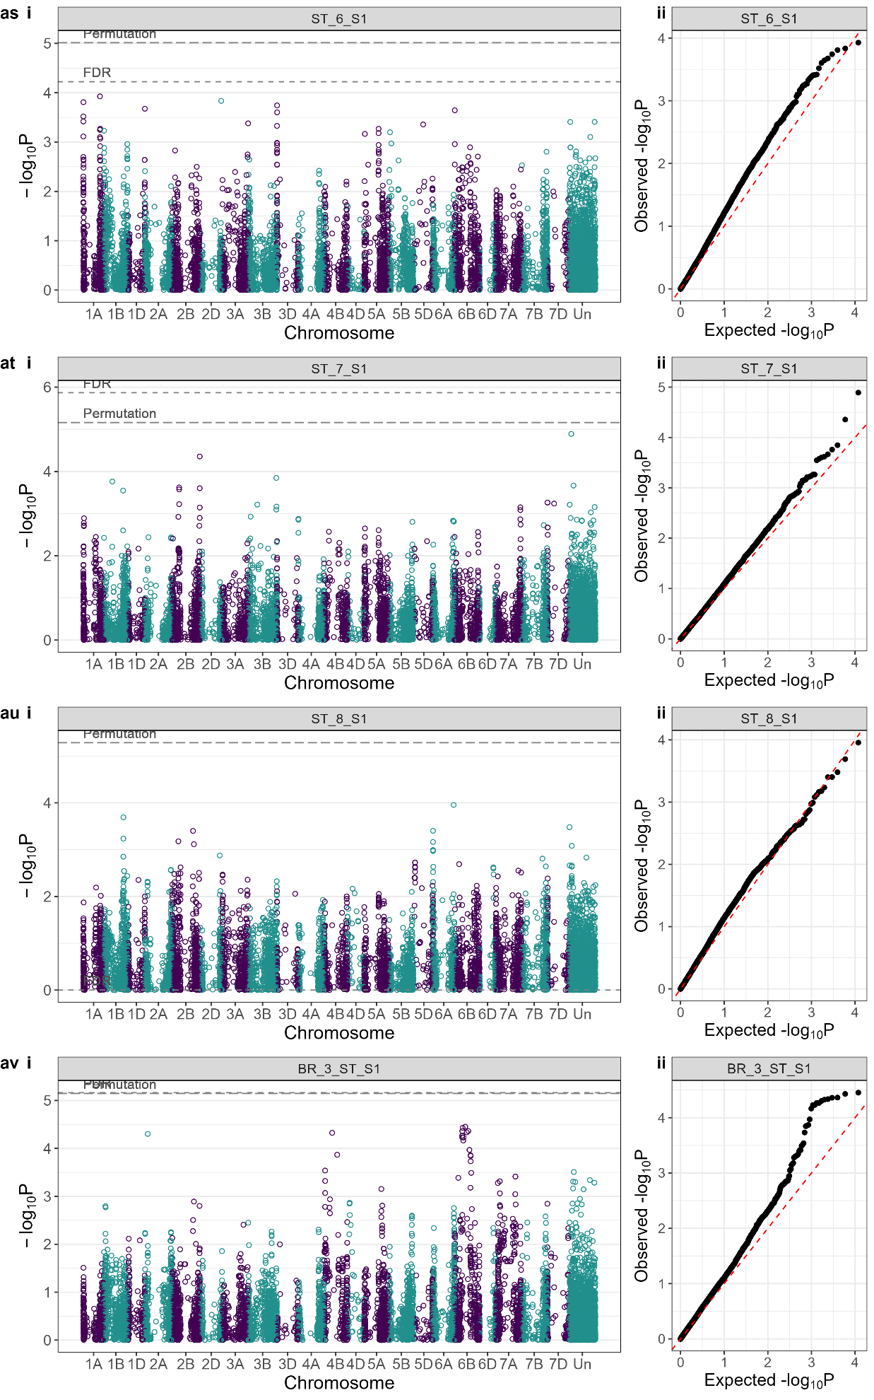
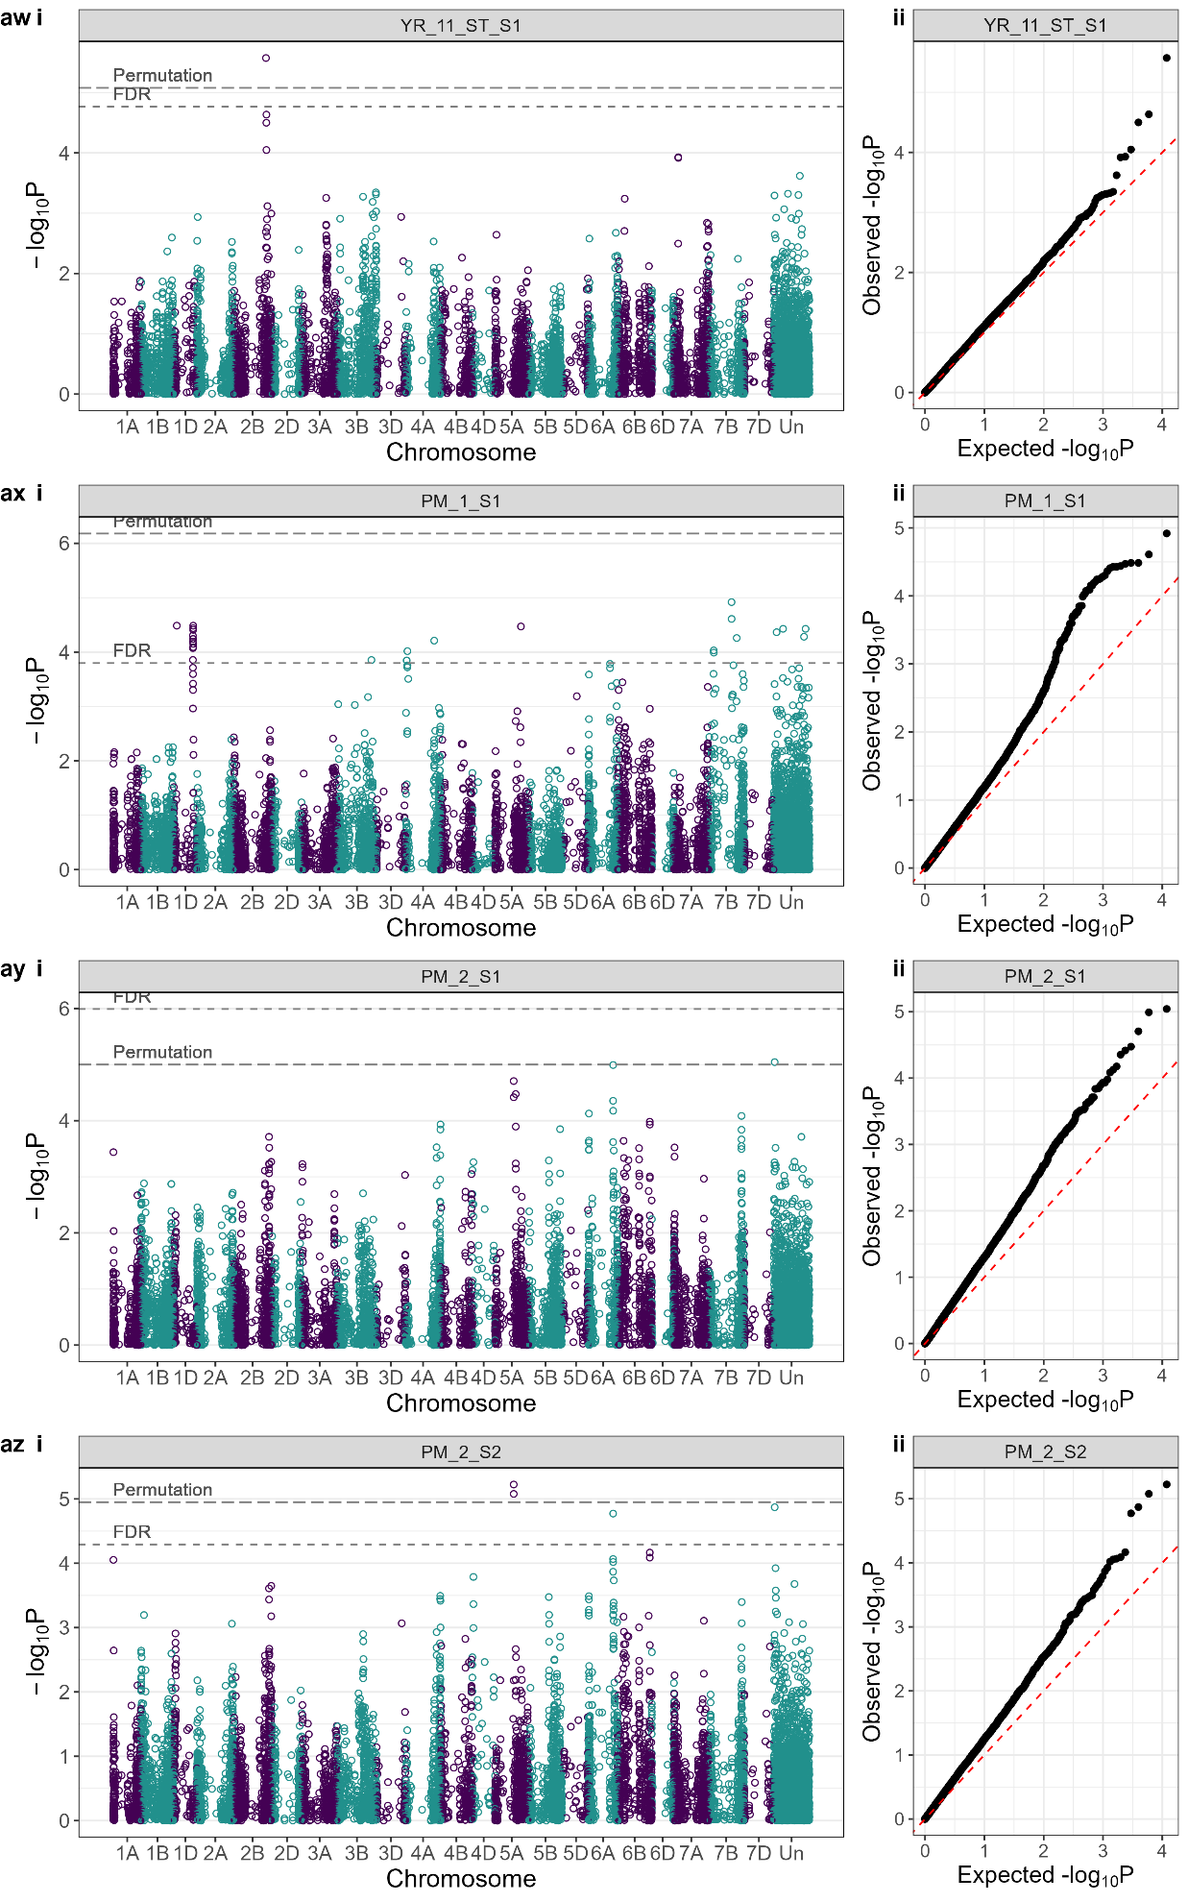
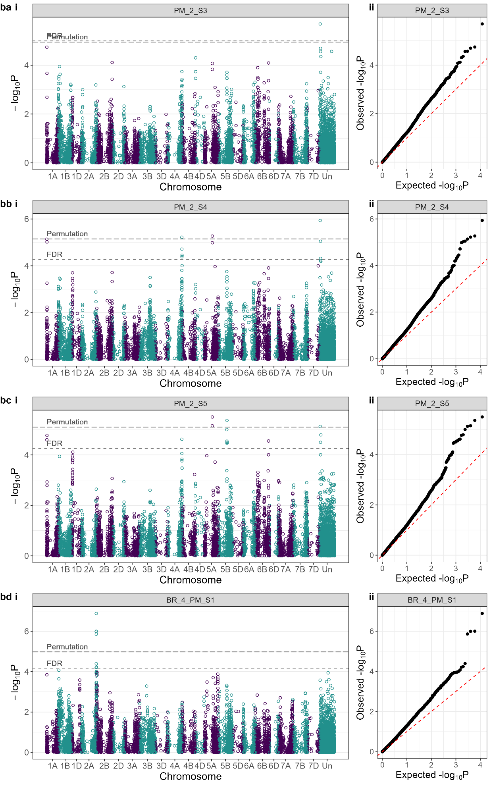
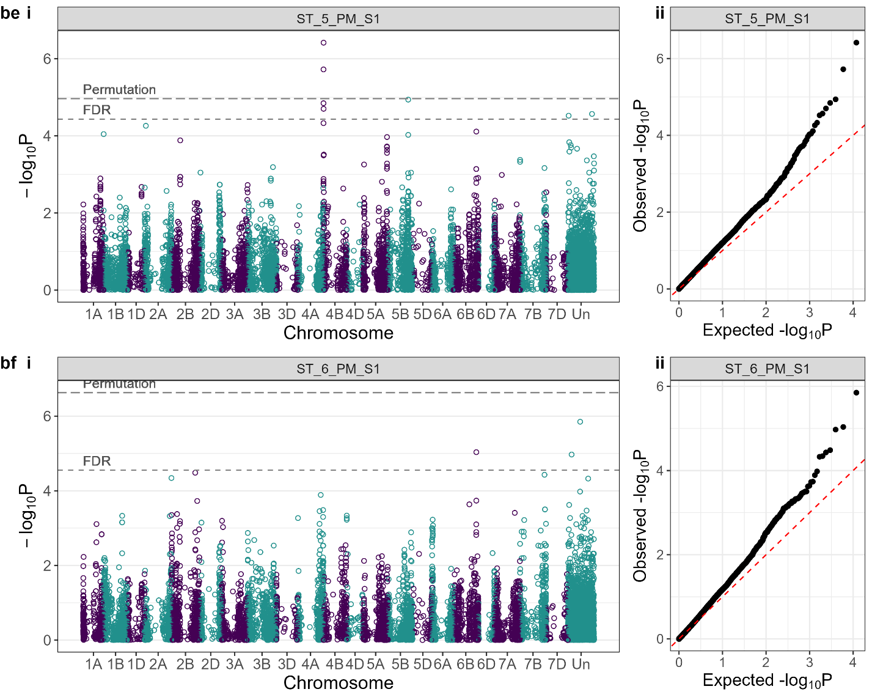
Supplementary Fig. S2 Genome-wide association study (GWAS) results for all trial, disease, disease score timepoints analysed in the WAGTAIL bread wheat association mapping panel. BR = brown rust. PM = powdery mildew, ST = Septoria tritici blotch, YR = yellow rust. S1 = disease score timepoint-1, S2 = disease score timepoint-2. (i) Manhattan plots, (ii) Quantile-Quantile plots. FDR = false discovery rate significance threshold with q-value cut-off of q = 0.05. Permutation = permutated significance threshold with 1,000 permutations and α = 0.05.

