Table 1. Goodness-of-fit (GOF) analysis for exponential, logistic and Weibull models to the experimental transfer rates of single-species (L96) and multi-species (F96, F107, and F168).
Foci | Stats | Exponential | Logistic | Weibull
L96 | GOF statistic
 | Kolmogorov-Smirnov test | 0.26 | 0.24 | 0.17
 | Anderson-Darling test | 1.64 | 0.99 | 0.34
 | GOF criteria
 | Akaike information criterion | 41.37 | 55.04 | 40.17
F96 | GOF statistic
 | Kolmogorov-Smirnov test | 0.31 | 0.26 | 0.15
 | Anderson-Darling test | 1.39 | 0.98 | 0.17
 | GOF criteria
 | Akaike information criterion | 50.56 | 65.96 | 49.19
F107 | GOF statistic
 | Kolmogorov-Smirnov test | 0.27 | 0.26 | 0.11
 | Anderson-Darling test | 1.42 | 1.00 | 0.19
 | GOF criteria
 | Akaike information criterion | 45.78 | 61.09 | 44.59
F168 | GOF statistic
 | Kolmogorov-Smirnov test | 0.27 | 0.25 | 0.12
 | Anderson-Darling test | 1.43 | 0.91 | 0.18
 | GOF criteria
 | Akaike information criterion | 51.41 | 66.16 | 50.01

Table 2. Weibull model parameters of shape and scale, mean ± SD, for single-species (L96) and multi-species (F96, F107 and F168) biofilms. There are no significant differences between biofilms for shape or scale values.
Biofilm system | Shape | Scale
L96 | 0.61 ± 0.06 | 1.92 ± 1.22
F96 | 0.58 ± 0.15 | 2.68 ± 1.70
F107 | 0.63 ± 0.10 | 2.23 ± 0.67
F168 | 0.62 ± 0.09 | 2.93 ± 1.23

Table 3. Goodness-of-fit (GOF) analysis for log-normal, gamma and Weibull frequency distributions to the experimental transfer rates of single-species (L96) and multi-species (F96, F107 and F168) biofilms.
Foci | Stats | Log-normal | Gamma | Weibull
L96 | Cluster 1
 | GOF statistic
 | Kolmogorov-Smirnov test | 0.09 | 0.12 | 0.13
 | Anderson-Darling test | 0.56 | 0.89 | 1.03
 | GOF criteria
 | Akaike information criterion | 302.76 | 302.91 | 304.21
 | Cluster 2
 | GOF statistic
 | Kolmogorov-Smirnov test | 0.10 | 0.05 | 0.06
 | Anderson-Darling test | 0.47 | 0.23 | 0.23
 | GOF criteria
 | Akaike information criterion | 140.98 | 138.30 | 138.56
 | Cluster 3
 | GOF statistic
 | Kolmogorov-Smirnov test | 0.07 | 0.12 | 0.09
 | Anderson-Darling test | 0.33 | 0.86 | 0.48
 | GOF criteria
 | Akaike information criterion | 132.82 | 139.73 | 133.24
F96 | Cluster 1
 | GOF statistic
 | Kolmogorov-Smirnov test | 0.07 | 0.05 | 0.07
 | Anderson-Darling test | 0.37 | 0.36 | 0.41
 | GOF criteria
 | Akaike information criterion | 525.71 | 523.24 | 525.82
 | Cluster 2
 | GOF statistic
 | Kolmogorov-Smirnov test | 0.13 | 0.08 | 0.09
 | Anderson-Darling test | 2.111 | 0.51 | 0.61
 | GOF criteria
 | Akaike information criterion | 257.14 | 240.01 | 240.61
 | Cluster 3
 | GOF statistic
 | Kolmogorov-Smirnov test | 0.15 | 0.07 | 0.08
 | Anderson-Darling test | 0.80 | 0.94 | 3.41
 | GOF criteria
 | Akaike information criterion | 121.43 | 144.15 | 146.11
F107 | Cluster 1
 | GOF statistic
 | Kolmogorov-Smirnov test | 0.07 | 0.09 | 0.09
 | Anderson-Darling test | 0.27 | 0.65 | 0.97
 | GOF criteria
 | Akaike information criterion | 412.55 | 417.83 | 423.73
 | Cluster 2
 | GOF statistic | Log-normal | Gamma | Weibull
 | Kolmogorov-Smirnov test | 0.08 | 0.07 | 0.07
 | Anderson-Darling test | 0.49 | 0.59 | 0.68
 | GOF criteria
 | Akaike information criterion | 205.03 | 206.84 | 210.26
 | Cluster 3
 | GOF statistic
 | Kolmogorov-Smirnov test | 0.11 | 0.15 | 0.12
 | Anderson-Darling test | 0.17 | 0.42 | 0.18
 | GOF criteria
 | Akaike information criterion | 190.50 | 211.83 | 212.96
F168 | Cluster 1
 | GOF statistic
 | Kolmogorov-Smirnov test | 0.06 | 0.10 | 0.10
 | Anderson-Darling test | 0.29 | 0.57 | 0.86
 | GOF criteria
 | Akaike information criterion | 401.54 | 401.62 | 404.68
 | Cluster 2
 | GOF statistic | Log-normal | Gamma | Weibull
 | Kolmogorov-Smirnov test | 0.05 | 0.09 | 0.11
 | Anderson-Darling test | 0.31 | 1.03 | 1.31
 | GOF criteria
 | Akaike information criterion | 249.81 | 255.91 | 259.15
 | Cluster 3
 | GOF statistic
 | Kolmogorov-Smirnov test | 0.07 | 0.12 | 0.11
 | Anderson-Darling test | 0.34 | 1.63 | 1.64
 | GOF criteria
 | Akaike information criterion | 101.18 | 116.05 | 120.01
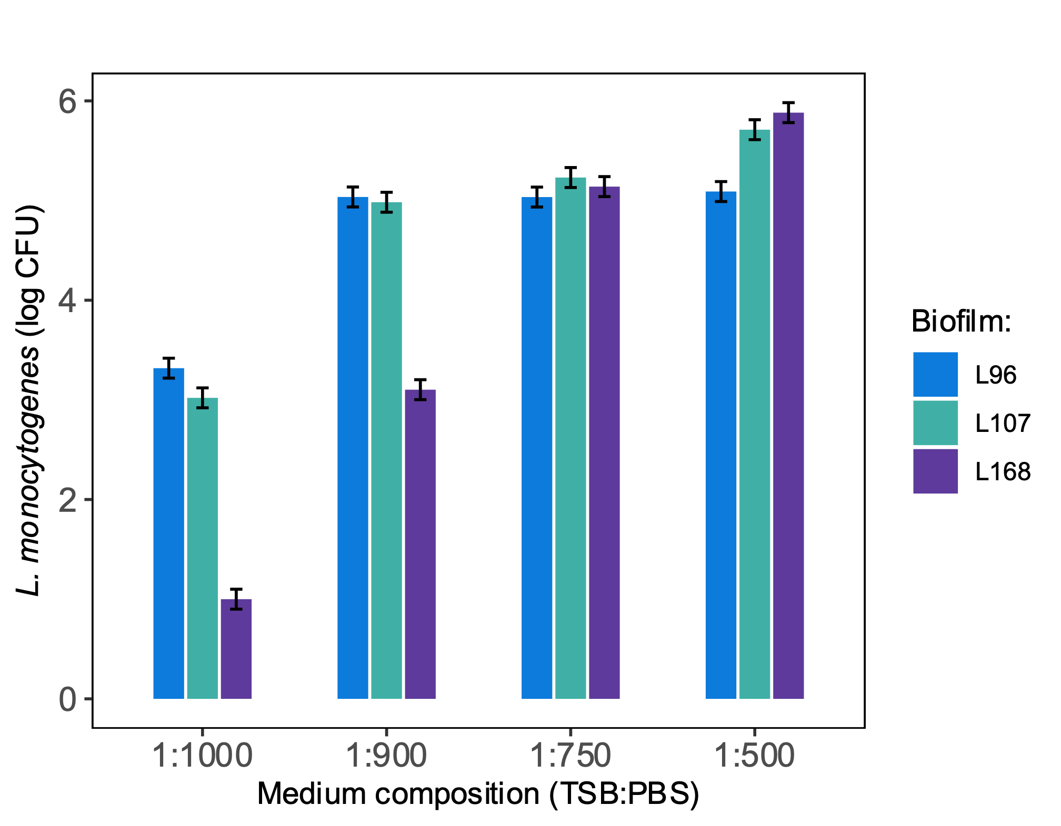
Figure 1. L. monocytogenes cell counts for single-species biofilms L96, L107 and L168 in low nutrient media TSB:PBS.

