Supplementary Information

Constructing Interfacial Prestress to Achieve Homogeneously Strained Perovskites

Qian Wang^{#1,2}, Xiangzhe Li^{#3}, Lizhi Ren^{#3}, Huiyi Zong³, Tao Ye⁴, Chang Liu⁵, Jin Qian³, Kai Wang³*, Shengzhong (Frank) Liu^{1,2,6}*, Dong Yang²*

¹Key Laboratory of Applied Surface and Colloid Chemistry, Ministry of Education, Shaanxi Key Laboratory for Advanced Energy Devices, Shaanxi Engineering Lab for Advanced Energy Technology, School of Materials Science & Engineering, Shaanxi Normal University, 620, West Chang’an Avenue, Xi’an 710119, China
²State Key Laboratory of Photoelectric Conversion and Utilization of Solar Energy, Dalian Institute of Chemical Physics, Dalian 116023, China
³Huanjiang Laboratory, Zhejiang University, Zhuji 311800, China
⁴Ministry of Education Key Laboratory of Micro/Nano Systems for Aerospace, Key Laboratory of Micro- and Nano-Electro-Mechanical Systems of Shaanxi Province, School of Mechanical Engineering, Northwestern Polytechnical University, Xi’an 710072, China
⁵Zhejiang Provincial Engineering Research Center of Energy Optoelectronic Materials and Devices, Ningbo Institute of Materials Technology & Engineering, Chinese Academy of Sciences, Ningbo 315201, China
⁶CNNP Optoelectronics Technology, 2828 Canghai Road, Lingang, Shanghai 201311, China

#Equal contribution
*Correspondence: K.W.: kaikaiwang@zju.edu.cn; S.L.: szliu@dicp.ac.cn; D.Y.: dongyang@dicp.ac.cn

Experimental section
Material
All materials were purchased from commercial suppliers without further purification. Titanium tetrachloride (purity: 99.99%) precursors were purchased from Aladdin (Shanghai, China). AG materials were purchased from adamas. Dimethylformamide (DMF), dimethyl sulfoxide (DMSO), chlorobenzene, isopropyl alcohol, and acetonitrile (ACN) were purchased from Sigma-Aldrich. Cesium iodide (CsI), lead bromide (PbBr₂), methylammonium bromide (MABr), methylammonium chloride (MACl), bistrifluoromethane sulfonimide Lithiumwere (LiTFSI), Co-TFSI, and 4-tert-butylpyridine (tBP) were purchased from Xi’an Polymer Light Technology. Glass/FTO, lead iodide (PbI₂), formamidinium iodide (FAI), spiro-OMeTAD, and [6,6]-phenyl-C61-butyric acid methyl ester (PCBM) were purchased from Liaoning Preferred New Energy Technology in China.
Device fabrication
Glass/FTO substrates were first cleaned by ultrasonic for 15 min, and then by circulating ultrasonic cleaning with deionized water and ethanol for two times. After drying, glass/FTO substrates were put into the glass petri dish and treated with ozone processor for 15 min. 2.15 mL TiCl₄ was added in 200 mL deionized water to prepare TiCl₄ solution (different concentrations of AG were added into this solution to prepare the mixing solution), and then placed substrates in the solution in the oven at 70 ℃ for 60 min. The glass/FTO/TiO₂ and glass/FTO/TiO₂-AG were rinsed with deionized water and dried with N₂. 1.26 M Cs_{0.05}(FA_{0.98}MA_{0.02})_{0.95}Pb(I_{0.98}Br_{0.02})₃ was dissolved in 1 mL DMF and DMSO (v:v = 8:1), 35 mol% MACl was added and stirred for 6 hours. In a glove box filled with nitrogen, 60 μL of perovskite precursor solution was dropped on TiO₂ and TiO₂-AG surface, and then coated by 1000 rpm for 10 s (first step) and 5000 rpm for 30 s (second step), and 900 μL of diethyl ether was dropped as anti-solvent when the second step remaining 25 s. The films were annealed at 150 ℃ for 20 min and 100 ℃ for 20 min. Spiro-OMeTAD was dissolved in chlorobenzene to prepare a concentration of 90 mg mL⁻¹ solution, which processed 22 μL Li-TFSI solution (520 mg/mL dissolved in acetonitrile) and 36 μL of tBP. 50 μL spiro-OMeTAD solution was spin-coated onto the perovskite layer at 5000 rpm for 30 s. For electron-only device, 50 μL PCBM (20 mg mL⁻¹ dissolved in chlorobenzene) was dropped onto the perovskite layer at 5000 rpm for 30 s. Metal materials were deposited as electrodes by thermal evaporation. The active area of 0.09 cm² was determined by mask aperture during testing.
Enthalpy calculation
The enthalpy ($H$) is calculated based on the thermodynamic relation ($H=U+PV$), where $U$ is the internal energy and $PV$ represents the pressure-volume work. The enthalpy of the AG and Ti(OH)_{4-x}(AG)_{x} molecule was calculated using molecular mechanics and quantum chemical methods. In the process, the geometry optimization and energy calculations primarily rely on molecular mechanics methods, which approximate the potential energy surface of the system using Universal Force Field. The force field model decomposes the molecular energy into several classical mechanical terms: $E=E_{bond}+E_{angle}+E_{torsion}+E_{non-bond}$, where $E_{bond}$ describes the elastic potential energy of bond lengths between atoms, following Hooke's law, $E_{angle}$ reflects the energy change due to deviations from equilibrium bond angles, $E_{torsion}$ characterizes the energy associated with conformational changes, such as rotational barriers in cyclic structures, and $E_{non-bond}$ includes van der Waals forces (modeled by the Lennard-Jones potential) and electrostatic interactions (described by Coulomb’s law). To ensure the accuracy of the results, we iteratively adjusted atomic coordinates to locate a local minimum on the potential energy surface (i.e., the lowest energy conformation) during optimization. To be specific, optimization stops when the energy difference between successive iterations falls below a predefined value (e.g., 1×10⁻⁵ kcal mol⁻¹). The RMS of atomic forces (energy gradients) must approach zero, typically set to less than 0.001 kcal/(mol·Å). In the meanwhile, we provided higher precision in electronic structure analysis by approximating electron density based on Density Functional Theory. About truncation of non-bonded interactions, only short-range van der Waals and electrostatic interactions were considered.
Device characterization
The J-V characteristics of the devices were recorded using a Keithley 2450 Source Meter under AM 1.5 G illumination. Before the measurement, the light intensity was calibrated using a standard crystalline Si-cell. The devices were measured with a scan rate of 100 mV s⁻¹ at an interval of 10 mV with the reverse scan range from 1.3 to 0 V, and the forward scan from 0 to 1.3 V. The EQE was tested by a quantum efficiency system (EnliTech) with monochromatic light. Mott-Schottky and EIS were performed by using an impedance spectroscopy analyzer (ZENNIUM, Zahner, Germany). SCLC were measured on a Keithley 2450 source meter under dark conditions. The top-view and cross-sectional SEM images were obtained by field-emission SEM (Hitachi SU8020). The UV–vis absorption spectra were measured using a UV-vis spectrophotometer (UH-4150, Hitachi). The AFM images were measured using a JPK NanoWizard Ultra Speed &Renishaw inVia (NanoWizard, Renishaw and JPK). The XRD patterns were analyzed with a SmartLab diffractometer using Cu Kα1 irradiation (λ= 1.541 Å). Steady-state PL and TRPL spectra were recorded by a fluorescence spectrometer (FluoTime 300, EasyTau). XPS and UPS measurements were conducted on an ESCALAB Xi+ system (Thermo Fisher Scientific). FTIR profiles were obtained using a Bruker Vertex 70.

Supplementary Notes 1-4

Supplementary Note 1
Mechanism in reducing surface energy of TiO₂ nanocrystals by AG
The hydroxyl groups and hydrophilic glucoside moiety in AG interact with high energy surface sites on TiO₂, such as undercoordinated Ti⁴⁺ ions and hydroxyl groups, potentially forming hydrogen bonds or coordinating directly to passivate these sites, thereby lowering the surface tension. AG bulky structure provides steric stabilization, creating a physical barrier that prevents nanoparticle aggregation and reduces van der Waals forces, while its hydrophilic nature generates a hydration layer, inducing electrostatic repulsion between particles. Additionally, AG reducing properties stabilize surface oxygen vacancies and Ti³⁺ states, neutralizing surface defects and further lowering surface energy. By adsorbing preferentially onto smaller nanocrystals, AG prevents Ostwald ripening and stabilizes the particle population, ensuring uniform size and morphology. These combined effects lead to thermodynamic stabilization, improved dispersion, and controlled growth of TiO₂ nanocrystals, making AG a versatile agent for optimizing TiO₂ properties.

Supplementary Note 2
Finite element simulation
In order to accurately obtain surface tension distribution characteristics of the perovskite precursor droplet in contact angle experiments, two-dimensional transient finite element simulation of the contact angle was carried out. The phase-field method was used to track the wetting, spreading and deformation process of the perovskite precursor droplet falling onto a solid flat substrate in a nitrogen environment. The numerical simulation was conducted under ideal conditions, and the following assumptions have been made: (1) Fluids were incompressible Newtonian fluids considering the influence of gravity, and the fluids flow conformed to the laminar-flow law. (2) There was no penetration of the liquid on the solid surface, and the volume fraction of the liquid remained unchanged during the spreading process. (3) Chemical reactions and heat exchanges didn’t occur among gas-liquid-solid three phases. Regarding the setting of initial conditions for gas-liquid two-phase flow calculations, the ambient temperature was 20 °C, and the pressure was 101 kPa. The density and dynamic viscosity coefficient of the gas phase (i.e., the nitrogen) were 1.165 kg m⁻³ and 0.017716 Pa·s, respectively. While those of the liquid phase (i.e., the perovskite precursor droplet) were 1101 kg m⁻³ and 0.001987 Pa·s, respectively. The surface tension coefficient between the gas phase and the liquid phase was taken as 0.0435 N m⁻¹. The calculation domain size of nitrogen was set to 6 μm × 16 μm, with the velocity inlet on the left and the pressure outlet on the right. The droplet radius was set to 1 μm and the contact angle was 45°. The droplet and the wetted wall were divided into finer meshes, while the rest areas were divided into conventional meshes. All the meshes were free triangular and their sizes were hydrodynamically calibrated.

Supplementary Note 3
Trap density calculation
The trap density ($N_{t}$) can be calculated by following equation:
$N_{t}=\frac{2ε_{0}ε_{r}V_{TFL}}{qL^{2}}$ (1)
where $V_{TFL}$, $L$, $ε_{0}$, and $ε_{r}$ denote the trap filled limit voltage, film thickness, vacuum permittivity, and dielectric constant of the perovskite film, respectively. The device based on TiO₂-AG shows a smaller $V_{TFL}$ of 0.11 V than that of the control (0.19 V), leading to a smaller $N_{t}$ of 3.03 × 10¹⁵ cm⁻³compared to that of 5.23 × 10¹⁵ cm⁻³ for TiO₂.

Supplementary Note 4
Trap density calculation
The n_{ID} can be calculated using following equation:
$n_{ID}=\frac{e}{k_{B}T}\frac{dV_{OC}}{dLnP}$ (2)
where $k_{B}$ is the Boltzmann constant, $T$ is the thermodynamic temperature, $e$ is the elementary charge, and $\frac{dV_{OC}}{dLnp}$ represents the slope of the V_{OC} with respect to the logarithm of the light intensity ($P$).

Supplementary Figures 1-14

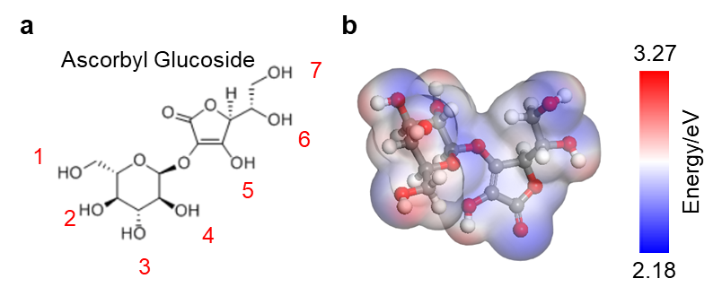
Supplementary Fig. 1. a, Chemical structure of the AG molecular. b, ESP images of AG molecule.

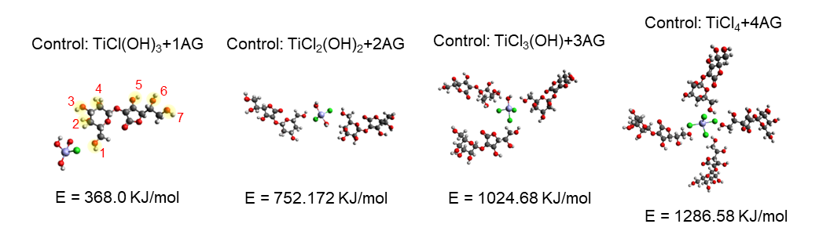
Supplementary Fig. 2. Control of the possible configurations of Ti(OH)_{4-x}(AG)_{x} (1≤x≤4) and their corresponding enthalpy values.

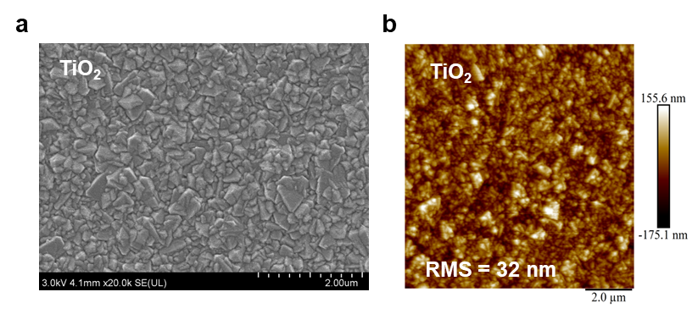
Supplementary Fig. 3. a, Top-view SEM and b, AFM images of pristine TiO₂ deposited on the FTO.

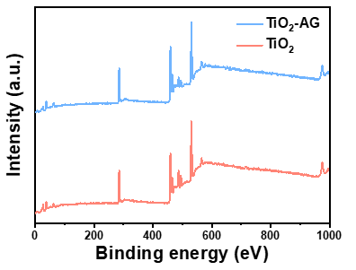
Supplementary Fig. 4. XPS spectra of TiO₂ and TiO₂-AG films.

Supplementary Fig. 5. Transmittance spectra of TiO₂ and TiO₂-AG.

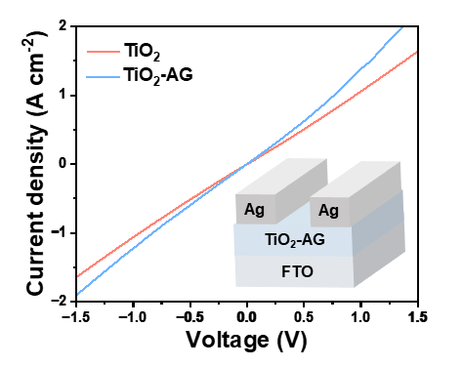
Supplementary Fig. 6. I–V curves for the devices with structure of FTO/ETL/Ag, where the ETL is TiO₂ and TiO₂-AG.

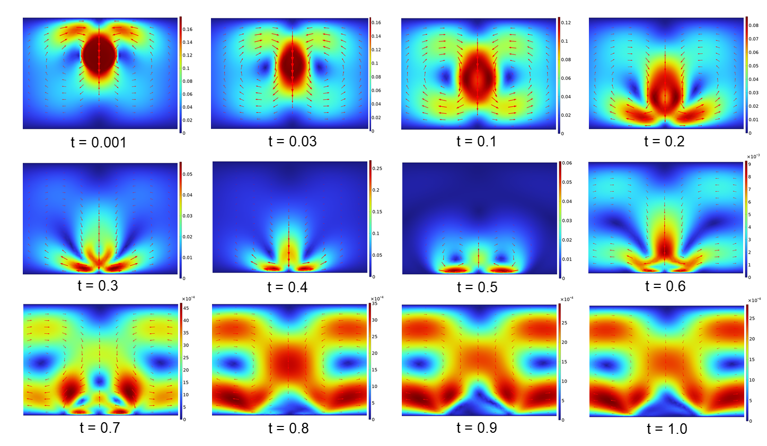
Supplementary Fig. 7. Velocity cloud maps of the perovskite precursor droplet falling to a solid flat substrate in a nitrogen environment (the time t has been normalized).

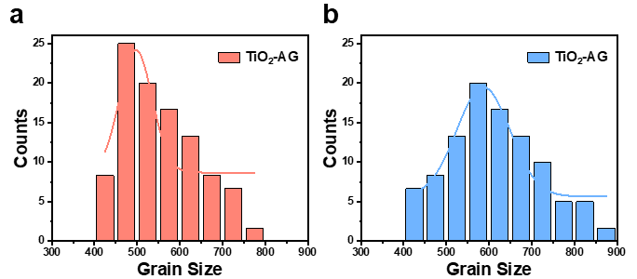
Supplementary Fig. 8. Grain size of perovskite films deposited on a, TiO₂ and b, TiO₂-AG. (Size unit: nm)

Supplementary Fig. 9. FWHM of the perovskite (110) plane based on TiO₂ and TiO₂-AG from XRD patterns.
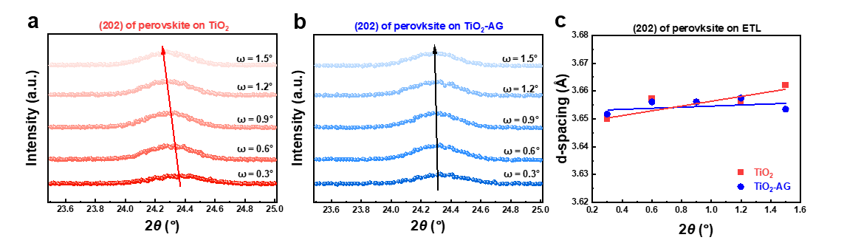
Supplementary Fig. 10. Depth-dependent GIXRD patterns of the perovskite (202) plane based on a, TiO₂ and b, TiO₂-AG films. c, D-spacing values obtained from the perovskite (202) plane as a function of incidence angle.

Supplementary Fig. 11. a, UV–vis spectrum and b, Tauc plot of perovskite film.

Supplementary Fig. 12. Statistical photovoltaic parameters of the devices with different AG concentrations include a, V_{OC} and b, J_{SC}, respectively.

Supplementary Fig. 13. J–V curves of PSCs with TiO₂ and TiO₂-AG scanned at forward and reverse directions.

Supplementary Fig. 14. V_{OC} values of the PSCs with TiO₂ and TiO₂-AG ETL under different light intensity.

Supplementary Tables 1 and 2

Supplementary Table S1. Fitting parameters of TRPL for the perovskite films grown on TiO₂ and TiO₂-AG.
ETL | τ₁ (μs) | A₁ | τ₂ (μs) | A₂ | τ_{ave} (μs)
TiO₂ | 161.93 | 17.17% | 1659.72 | 82.83% | 1630.02
TiO₂-AG | 136.52 | 21.89% | 956.08 | 78.11% | 924.55

Supplementary Table S2. Detailed photovoltaic parameters of champion devices optimized by different AG concentration.
Concentration | J_{SC} (mA/cm²) | V_{OC} (V) | FF (%) | PCE (%)
0 mg/mL | 25.54 | 1.17 | 77.14 | 23.05
0.44 mg/mL | 24.96 | 1.17 | 78.86 | 23.03
0.59 mg/mL | 26.03 | 1.17 | 77.10 | 23.48
0.73 mg/mL | 25.97 | 1.19 | 79.56 | 24.59
0.88 mg/mL | 25.31 | 1.15 | 77.34 | 22.51

