Supporting information
Fe^{III}-Driven Self-Cycled Fenton via Contact-Electro-Catalysis for Water Purification

Dongmei Ma ^{†,‡,1}, Jin Zhang ^{†,1}, Wei Li †,‡,*, Jinxing Ma §, Kuanchang He §, Kui Yang §, Jianghu Cui †,‡, Qian Liu †, Sihao Lv †, Min Zhang ‡, Faliang Cheng ‡, Defeng Xing ¶
† Research Center for Eco-environmental Engineering, School of Environment and Civil Engineering, Dongguan University of Technology, Dongguan 523808, China
‡ Guangdong Engineering and Technology Research Center for Advanced Nanomaterials, School of Environment and Civil Engineering, Dongguan University of Technology, Dongguan 523808, China
§ School of Ecology, Environment and Resources, Guangdong University of Technology, Guangzhou 510006, China
¶ State Key Laboratory of Urban Water Resource and Environment, School of Environment, Harbin Institute of Technology, Harbin 150090, China
¹ Dongmei Ma and Jin Zhang contributed equally to this work
* Corresponding author. Research Center for Eco-environmental Engineering, Dongguan University of Technology, Dongguan 523808, China
E-mail address: liwei@dgut.edu.cn

The supplementary file included: 6 Notes, 5 Tables, 21 Figures.

Supplementary Note 1. The detection of Fe species and in-situ detection of fresh Fe^{II}
Note 1.1 The ex-situ detection of Fe^{II} and Fe^{III} by 1,10-phenanthroline spectrophotometry:
For Fe^{II} quantification, 1 mL of filtered liquid sample was added into a 20 mL colorimetric tube. The analytical sequence proceeded as follows: 2 mL of acetic acid/sodium acetate solution (pH = 4.6), 0.4 mL of 1,10-phenanthroline solution (1.2 g·L^{–1}), and 6.6 mL of DI water were introduced. After 5 min of controlled chromogenic development under ambient conditions, absorbance measurements were analyzed by a UV-Vis spectrophotometer at 510 nm. Fe^{II} concentrations were calculated through linear regression against pre-established calibration curves.
Fe^{III} concentrations was calculated by difference between total Fe and Fe^{II} concentrations. For total Fe quantification, 1 mL of filtered liquid sample was introduced into a 20 mL colorimetric tube, followed by the addition of 2 mL of acetic acid/sodium acetate solution (pH = 4.6), 0.4 mL of hydroxylamine hydrochloride (100 g·L^{–1}), 0.4 mL of 1,10-phenanthroline solution (1.2 g·L^{–1}), and 6.2 mL of DI water. Following 5 min of standardized chromogenic development under ambient conditions, absorbance measurements were measured by a UV-Vis spectrophotometer at 510 nm. Total Fe concentrations were derived from pre-established calibration curves, with Fe^{III} levels determined by subtracting Fe^{II} values from total Fe measurements.
Note 1.2 The in-situ detection of fresh Fe^{II} by 1,10-phenanthroline spectrophotometry:
A reaction system containing 3 mg of FEP particles and 0.1 mL of Fe^{III} stock solution (300 mM) was prepared 30 mL of 1,10-phenanthroline solution (48 mg·L^{–1}). The mixture underwent ultrasound irradiation at 110 W, 40 kHz. The reaction solution was withdrawn at certain time intervals and analyzed by a UV-Vis spectrophotometer at 510 nm. The detection limit of this method could reach to 0.01 mM of Fe^{II}.

Supplementary Note 2. Chemical regents
The fluorinated ethylene propylene (FEP, average 5 μm) and polyvinylidene fluoride (PVDF, average 6.5 μm) were purchased from Mingshun Chemical Co. Ltd. (Guangdong, China). The polytetrafluoroethylene (PTFE, <d> ∼ 1−5 μm), FeCl₃, FeCl₂⋅4H₂O, potassium titanyl oxalate, sulfadiazine (SDZ), phenol (PE), atrazine (ATZ), and methanol (MeOH) were supplied by Aladdin Chemistry Co. Ltd. (Shanghai, China).

Supplementary Note 3. The fluorescence-based method for hydroxyl radical detection
The hydroxyl radical was analyzed by a fluorescence-based method using terephthalic acid (TA) as the molecule probe¹. Specifically, 3 mg of FCPs powders were dispersed in 30 mL TA solution (0.5 mM). Then the reaction was driven by an ultrasound bath (BRANSON, 3800-CPXH, USA) at 25 ± 2 °C, along with 40 kHz and 110 W. At the 10 min intervals, 3 mL filtered liquid sample was analyzed for fluorescent intensity at 425 nm (excited at 312 nm) with a fluorescence spectrometer (Shimadzu, RF-6000).

Supplementary Note 4. The detection of reactive species by electron paramagnetic resonance (EPR)
Note 4.1 The detection of hydroxyl radical by EPR
The EPR analysis of hydroxyl radical was conducted with 5,5-dimethyl-1-pyrroline-1-oxide (DMPO) as trapping agent: 3 mg of FCPs powders were dispersed in 30 mL of DMPO solution (100 mM). Then the reaction was driven by an ultrasound bath (BRANSON, 3800-CPXH, USA) at 25 ± 2 °C, along with 40 kHz and 110 W. At 2, 5, 10 min, the solution product was analysed by the EPR spectroscopy (Bruker, A200S-95, GER).
Note 4.2 The detection of superoxide radical by EPR
The EPR analysis of superoxide radical was conducted with DMPO (100 mM) as trapping agent in the dimethyl sulfoxide solvent (DMSO, 1 M). Then the reaction was driven by an ultrasound bath (BRANSON, 3800-CPXH, USA) at 25 ± 2 °C, along with 40 kHz and 110 W. The solution product was analysed by the EPR spectroscopy (Bruker, A200S-95, GER).

Supplementary Note 5. Density functional theory (DFT) calculations
We have employed the Vienna Ab Initio Package (VASP) to perform DFT calculations within the generalized gradient approximation (GGA) in the PBE formulation. We have chosen the projected augmented wave (PAW) potentials to describe the ionic cores and taken valence electrons into account using a plane wave basis set with a kinetic energy cutoff of 450 eV. Partial occupancies of the Kohn−Sham orbitals were allowed using the Methfessel-Paxton smearing method and a width of 0.05 eV. The electronic energy was considered self-consistent when the energy change was smaller than 10⁻⁵ eV. A geometry optimization was considered convergent when the residual forces were smaller than 0.05 eV/Å. Finally, the free energy of a gas phase molecule or an adsorbate on the surface was calculated by the equation G = E + ZPE − TS, where E is the total energy, ZPE is the zero-point energy, T is the temperature in kelvin (298.15 K is set here), and S is the entropy. For interfacial electric field (IEF) applied state structures, full optimization is performed by applying IEF (0.3 V/Å) to the system.
The molecular structure of FCPs was constructed according to their stoichiometric formula, incorporating a 12-carbon backbone structure. The configurations were shown as follow.
 | FEP | PTFE | PVDF
Formula
Constructed structure
The adsorption energies (E_{ads}) between H₂O and FCPs were computed by the Equation S1:
E_{ads} = E (_{FCP+H2O}) – E_{FCP} – E_{H2O} (S1)
where E(_{FCP+H2O}) was the total energy of the system, E_{FCP} was the energy of the FCP system alone, and E_{H2O} was the energy of H₂O in the vacuum.

Supplementary Note 6. Characterizing the transferred electrons of FCP surface
To mimic the transferred charges of FCP particles, three FCP films with 100 μm thickness was used to represent the FCP surface. These three FCP films (5 cm × 5 cm) were stuck to an acrylic base-supported copper paper (FCP@Cu) to assemble three single electrode triboelectric nanogenerator (SETENG). The contact-separation of SETENG and water was precisely controlled through a linear motor (R-LP3). The transferred electrons were quantitatively monitored using a digital oscilloscope (KEYSIGHT DSO-X 3024T) and high-impedance digital multimeter (Keithley 6514, 10 MΩ) to ensure measurement fidelity.

Supplementary Table 1. The –F density of FEP, PTFE and PVDF.
Name | Structure | −F density ª | Number of F | Number of C  (on main chain)
Fluorinated ethylene propylene (FEP) |  | 2.5 | 10 | 4
Polytetrafluoroethylene (PTFE) |  | 2 | 4 | 2
Polyvinylidene fluoride (PVDF) |  | 1 | 2 | 2
a: –F density was defined as the atomic ratio of F to C (on the main chain).

Supplementary Table 2. The comparison of H₂O₂ generation performance of reported Piezo-catalytic and Contact-electrification-catalytic materials.
Catalyst | Dosage of catalyst (mg L⁻¹) | H₂O₂ accumulated yield (mM) | H₂O₂ generation rate (mmol·g_{cat}⁻¹·h⁻¹) | References
FEP | 100 | 0.767 | 7.67 | This study
PTFE | 100 | 0.324 | 3.24 | ²
Au/BiVO₄ | 500 | 0.0045 | 0.009 | ³
Ag/t-BaTiO₃ | 2000 | 0.0321 | 0.01605 | ⁴
BiOCl | 500 | 0.0028 | 0.0056 | ⁵
BiOIO₃ | 500 | 0.115 | 0.46 | ⁶
Bi₁₂O₁₇Cl₁₂ | 500 | 0.194 | 0.388 | ⁷
BaCaZrTi | 1000 | 0.02215 | 0.02215 | ⁸
C₃N₅ | 500 | 0.523 | 0.626347305 | ⁹
BiFeO₃ | 1000 | 0.11 | 0.11 | ¹⁰
BiTiNbO₉ | 1000 | 0.247 | 0.185714286 | ¹¹

Supplementary Table 3. The adsorption energy between FCPs and H₂O.
Name | E_{ads} (eV)
FEP-H₂O | –0.4783
PTFE-H₂O | –0.3125
PVDF-H₂O | –0.1098

Supplementary Table 4. The comparison of degradation performance in CEC, piezo-catalysis and photo-catalysis induced self-cycled Fenton systems.
 | Conditions | Catalyst  (mg·L^{–1}) | Pollutants  (mg·L^{–1}) | H₂O₂ generation rate (mmol·g_{cat}⁻¹·h⁻¹) | Iron source  (mM) | Time and degree of degradation (min, %) | k_{obs} (min^{–1}) | k_{nobs}ª  (L·min⁻¹·g⁻¹) | Ref
Contact-electro-catalysis | 110 W, 40 kHz | FEP  (100) | Sulfadiazine  (SDZ, 5) | 7.670 | Fe^{III}  (1.0) | 60, 100 | 0.125 | 1.25 | This study
Contact-electro-catalysis | 120 W, 40 kHz | 2.5PTFE/ZSM-5 (333) | Methyl orange  (MO, 10) | 1.9788 | Fe^{III}  (1.0) | 10, 98.5 | 0.458 | 1.36 | ¹²
Piezo-catalysis | 152 W, 40 kHz | BIO  (500) | Sulfamethazine  (SMZ, 20) | 0.46 | Fe^{III}  (1.0) | 30, 98 | 0.138 | 0.276 | ⁶
Piezo-catalysis | 300 W, 40 kHz | C₃N₅  (500) | Tetracycline  (TC, 5) | 0.614 | Fe^{III}  (0.004) | 100, 100 | 0.0561 | 0.112 | ⁹
Piezo-catalysis | 100 W, 40 kHz | Bi1₂O₁₇Cl₁₂  (500) | Acetaminophen  (ACE, 10) | 0.388 | Fe^{II}  (1.0) | 60, ~75 | 0.023 | 0.046 | ⁷
Photo-catalysis | λ> 420 nm,  700 mW·cm^{–2} | Garland g-C₃N₄  (500) | 2,4-dichlorophenol  (2, 4-DCP, 10) | 0.025 | Fe^{II}  (0.018) | 30, 88.8 | 0.07 | 0.14 | ¹³
Photo-catalysis | λ> 400 nm,  100 mW·cm^{–2} | g-C₃N₄  (500) | 2,4-dichlorophenol  (2, 4-DCP, 10) | 0.05 | Fe^{III}  (0.07) | 60, 98.73 | 0.069 | 0.138 | ¹⁴
a: k_{obs} normalized at catalyst dosage.

Supplementary Table 5. The detection paramaters for various pollutants
EPs | Abbreviations | Mobile phase (v/v) | Detection wavelength (nm) | Retention time
Sulfadiazine | SDZ | Acetonitrile/0.2% formic acid (30/70) | 270 | 2.9
Carbamazepine | CBZ | Acetonitrile/H₂O (40/60) | 286 | 1.5
Phenol | PE | Acetonitrile/H₂O (40/60) | 280 | 1.0
Atrazine | ARZ | Methanol/H₂O₂ (30/70) | 225 | 1.2

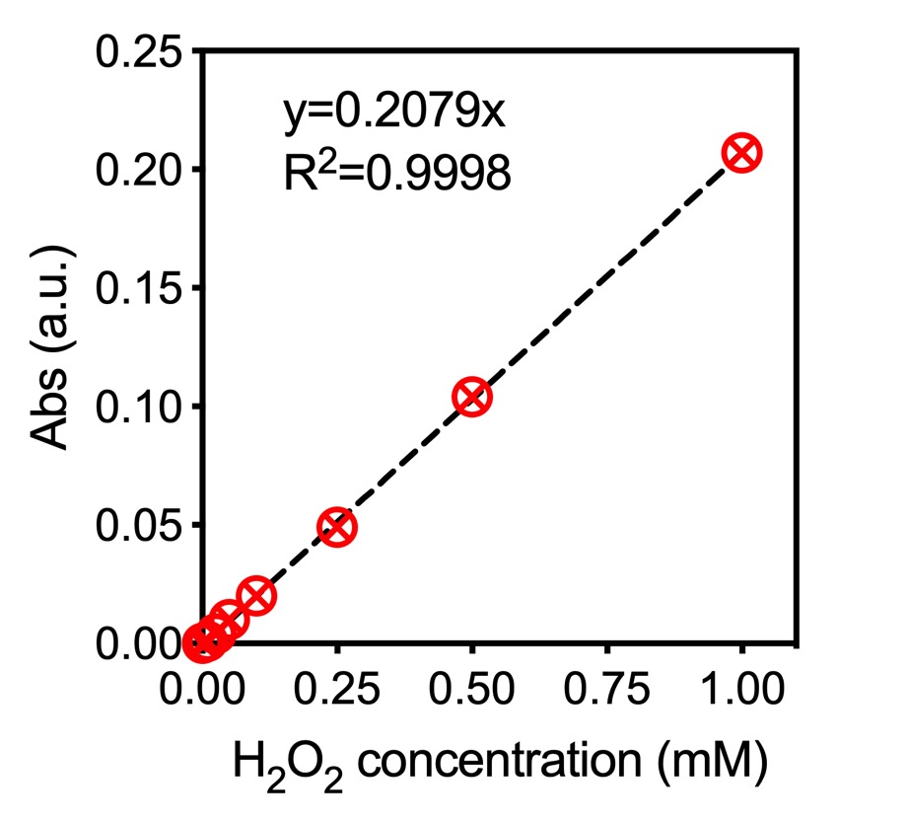
Supplementary Figure 1. The standard curve between the concentration of H₂O₂ and the absorbance (Linear equation: y = 0.2079x, R² = 0.9998).

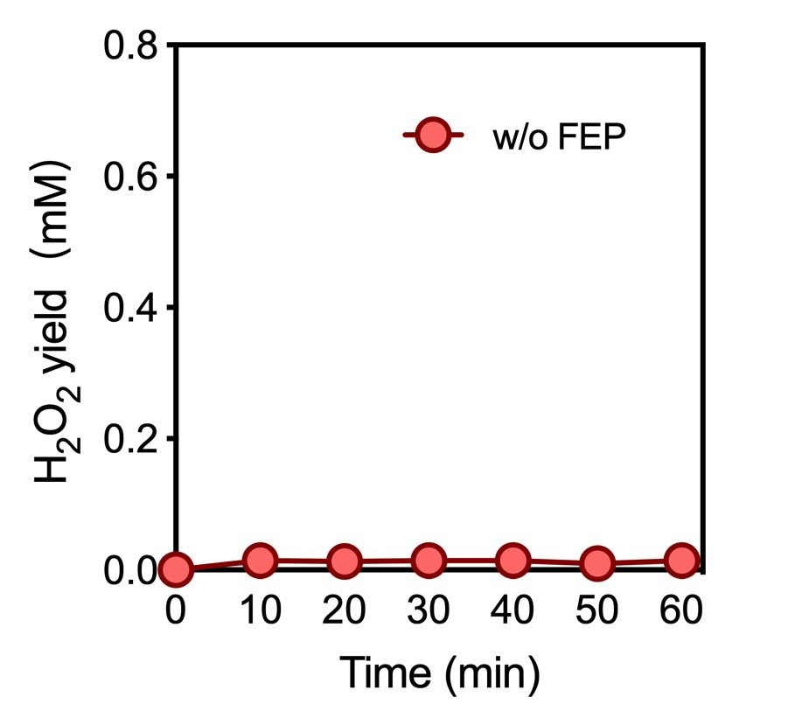
Supplementary Figure 2. The H₂O₂ production under ultrasound irradiation (US) without addition of FEP. Experimental conditions: [FEP]₀ = 0 g·L^{–1},T = 25 ± 2°C, ultrasound irradiation (40 kHz, 110 W).

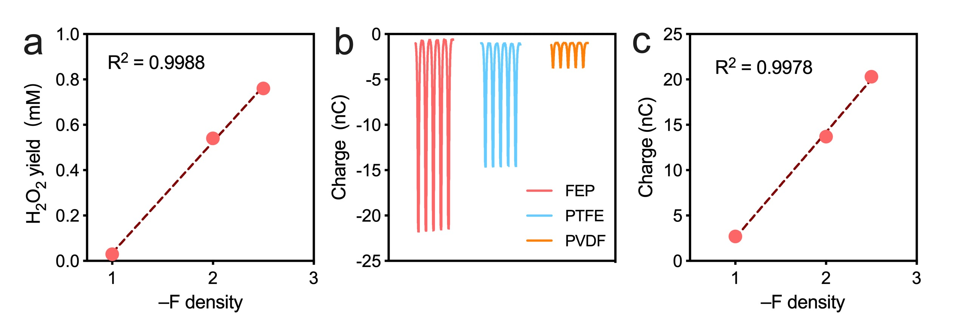
Supplementary Figure 3. The correlations between −F density and H₂O₂ accumulated amount (a). The transferred electrons of FCPs (FEP, PTFE, and PVDF) in contact with H₂O (b). The correlations between −F density and the number of transferred electrons (c). Experimental conditions: [FCPs]₀ = 0.1 g·L^{–1}, T = 25 ± 2°C, ultrasound irradiation (40 kHz, 110 W).

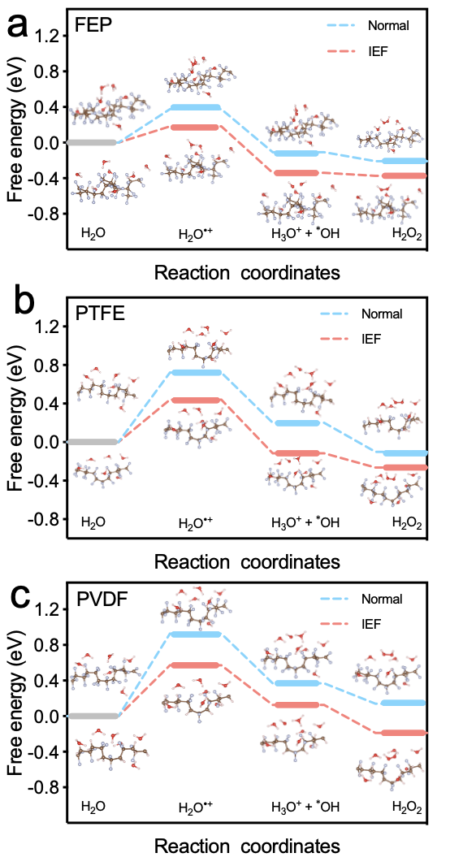
Supplementary Figure 4. Free energy profile of the indirect 2e– WOR process in FEP/CEC (a), PTFE/CEC (b), and PVDF (c) were compared with and without IEF.

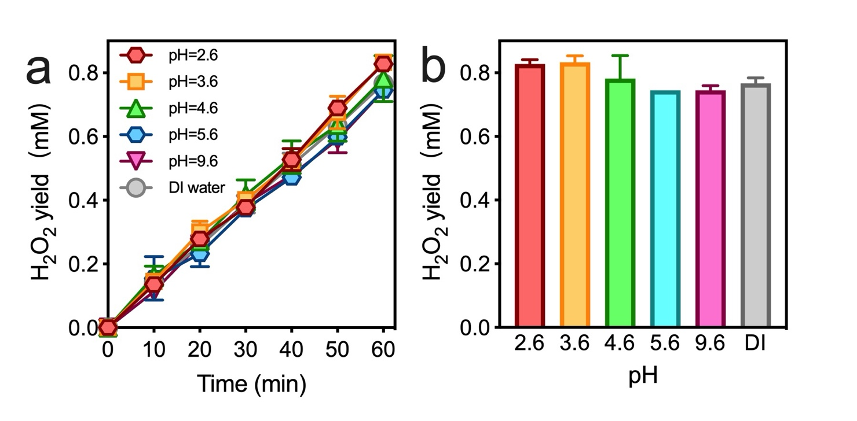
Supplementary Figure 5. Time course of the H₂O₂ generation (a) and final yield of H₂O₂ in FEP/CEC under different pH conditions. Experimental conditions: [FEP]₀ = 0.1 g·L^{–1}, T = 25 ± 2°C, ultrasound irradiation (40 kHz, 110 W).
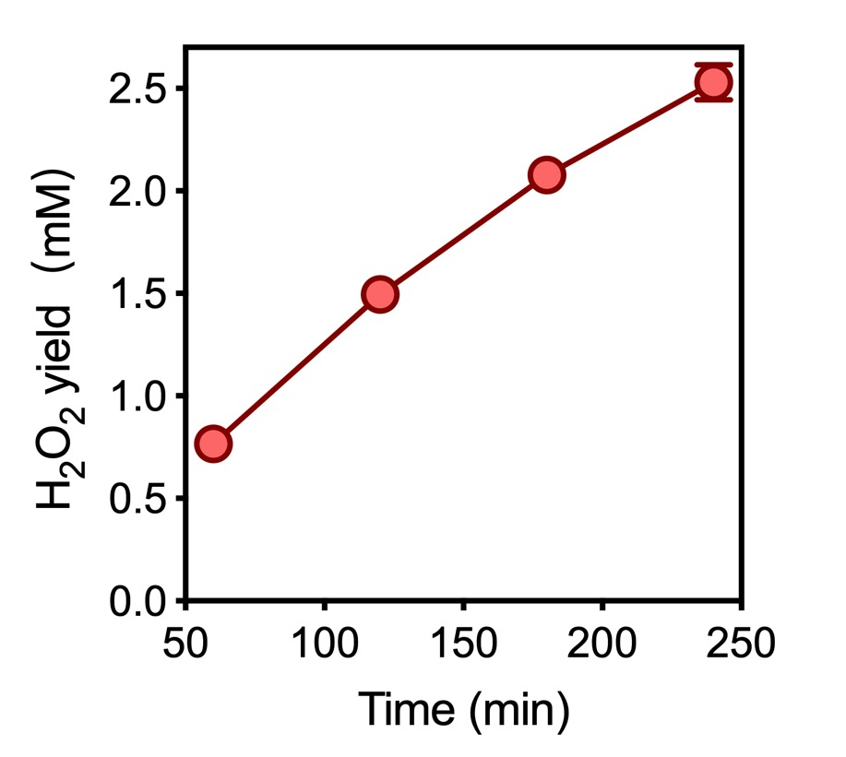
Supplementary Figure 6. The H₂O₂ yield of FEP/CEC from 1 to 4 h. Experimental conditions: [FEP]₀ = 0.1 g·L^{–1}, T = 25 ± 2°C, ultrasound irradiation (40 kHz, 110 W).

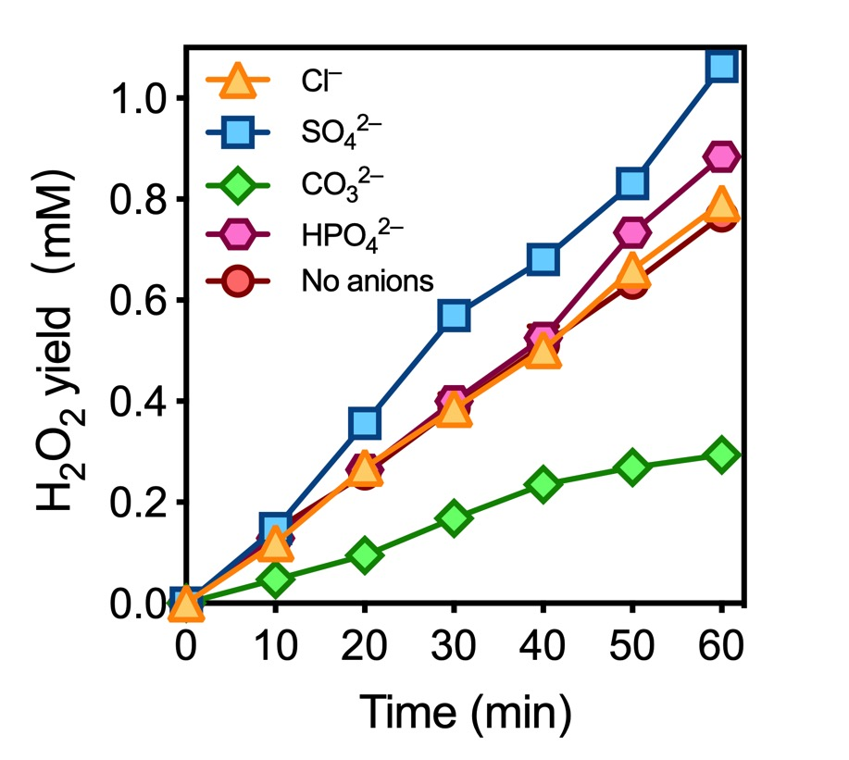
Supplementary Figure 7. The H₂O₂ yield of FEP/CEC in the presence of anions. Experimental conditions: [FEP]₀ = 0.1 g·L^{–1}, [Anions]₀ = 5 mM, T = 25 ± 2°C, ultrasound irradiation (40 kHz, 110 W).
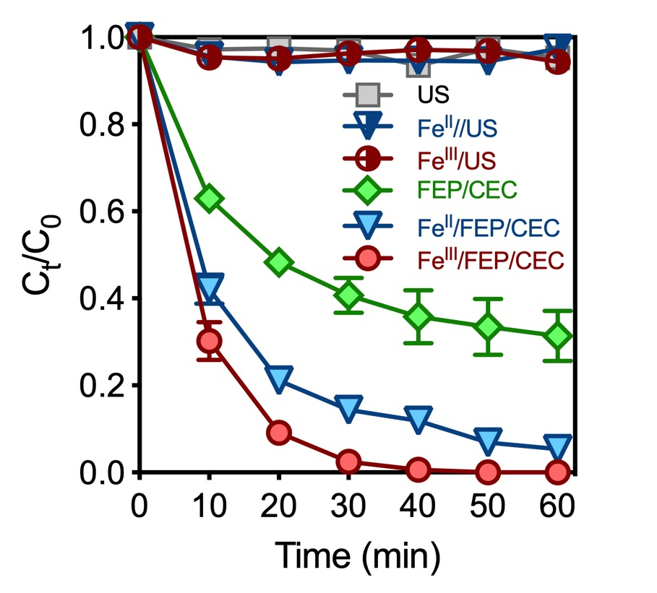
Supplementary Figure 8. The SDZ degradation performance by US, Fe^{II}/US, Fe^{III}/US, FEP/CEC, Fe^{II}/FEP/CEC and Fe^{III}/FEP/CEC. Experimental conditions: [FEP]₀ = 0.1 g·L^{–1}, [Fe^{III}]₀ = [Fe^{II}]₀ = 1 mM, [SDZ]₀ = 5 mg·L^{–1}, T = 25 ± 2°C, ultrasound irradiation (40 kHz, 110 W).
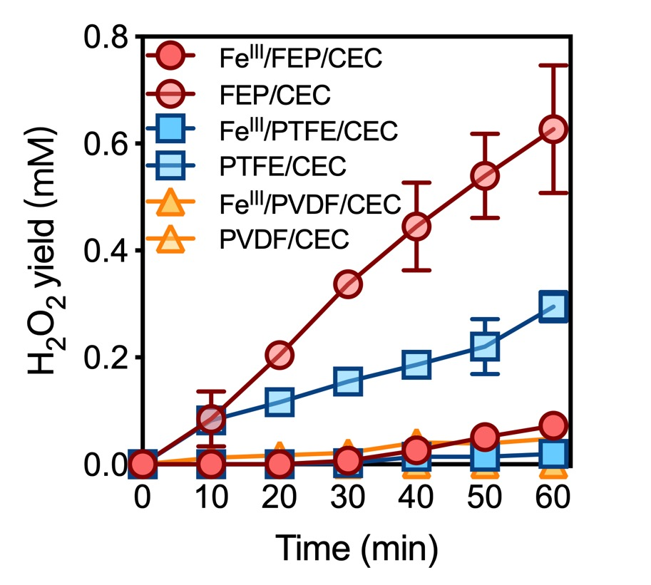
Supplementary Figure 9. The H₂O₂ yield during FCP/CEC and Fe^{III}/FCP/CEC for SDZ degradation. Experimental conditions: [FEP]₀ = 0.1 g·L^{–1}, [SDZ]₀ = 5 mg·L^{–1}, T = 25 ± 2°C, ultrasound irradiation (40 kHz, 110 W).

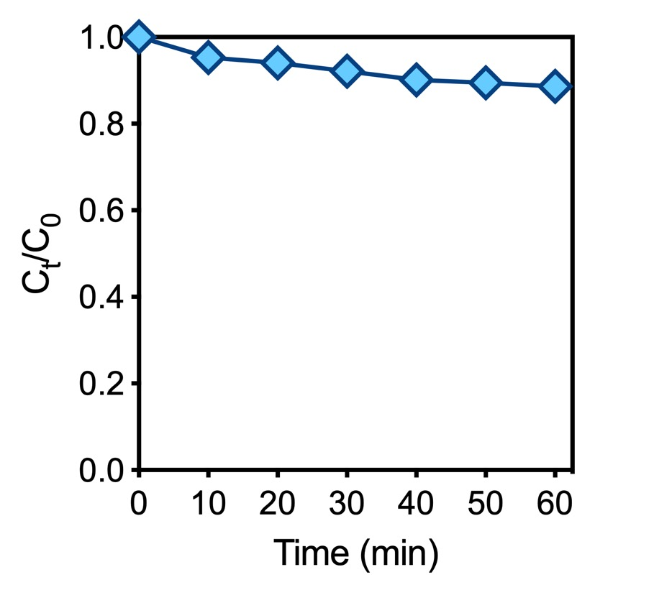
Supplementary Figure 10. The SDZ degradation in H₂O₂/US. Experimental conditions: [H₂O₂]₀ = 0.5 mM, [SDZ]₀ = 5 mg·L^{–1}, T = 25 ± 2°C, ultrasound irradiation (40 kHz, 110 W).

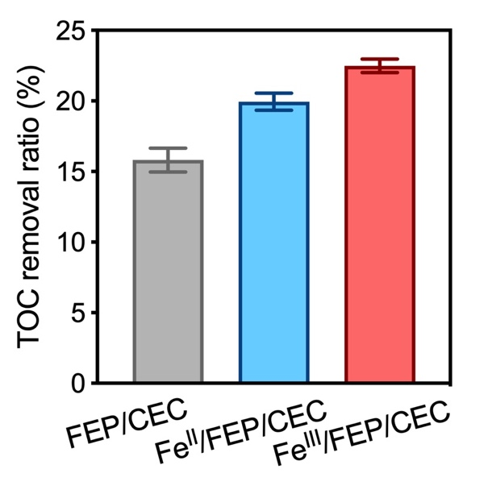
Supplementary Figure 11. The TOC removal rate of FEP/CEC, Fe^{II}/FEP/CEC and Fe^{III}/FEP/CEC. Experimental conditions: [FEP]₀ = 0.1 g·L^{–1}, [Fe^{III}]₀ = [Fe^{II}]₀ = 1 mM, [SDZ]₀ = 5 mg·L^{–1}, T = 25 ± 2°C, ultrasound irradiation (40 kHz, 110 W).
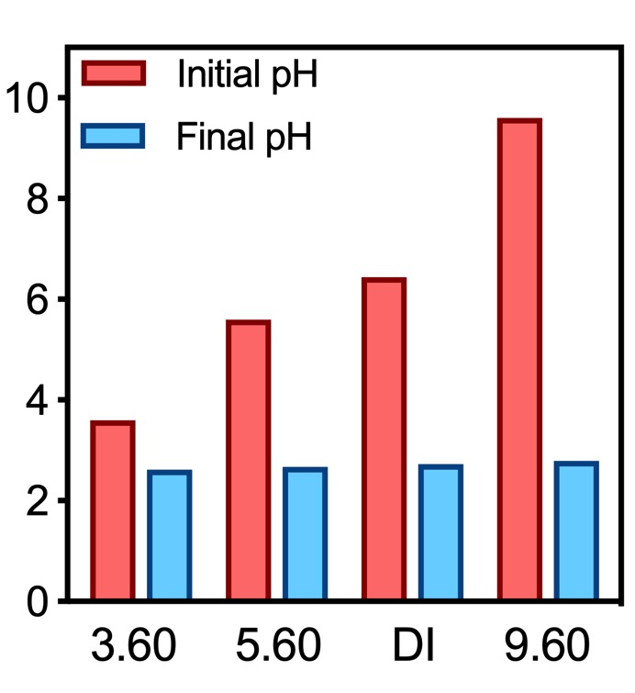
Supplementary Figure 12. The pH changes of Fe^{III}/FEP/CEC under different initial pH conditions. Experimental conditions: [FEP]₀ = 0.1 g·L^{–1}, [Fe^{III}]₀ = [Fe^{II}]₀ = 1 mM, [SDZ]₀ = 5 mg·L^{–1}, T = 25 ± 2°C, ultrasound irradiation (40 kHz, 110 W).

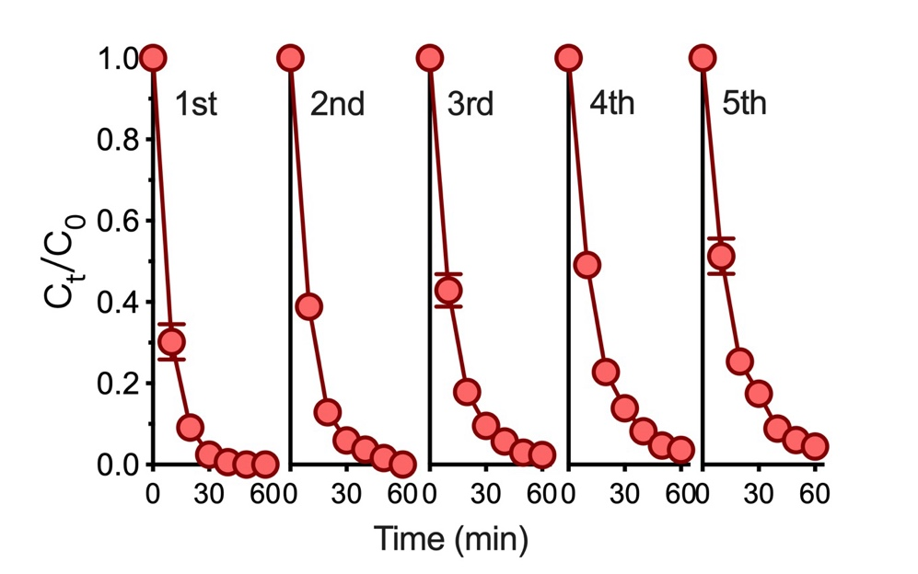
Supplementary Figure 13. The catalytic stability of Fe^{III}/FCP/CEC on SDZ degradation during reutilization. Experimental conditions: [FEP]₀ = 0.1 g·L^{–1}, [SDZ]₀ = 5 mg·L^{–1}, [Fe^{III}] = 1 mM, T = 25 ± 2°C, ultrasound irradiation (40 kHz, 110 W).

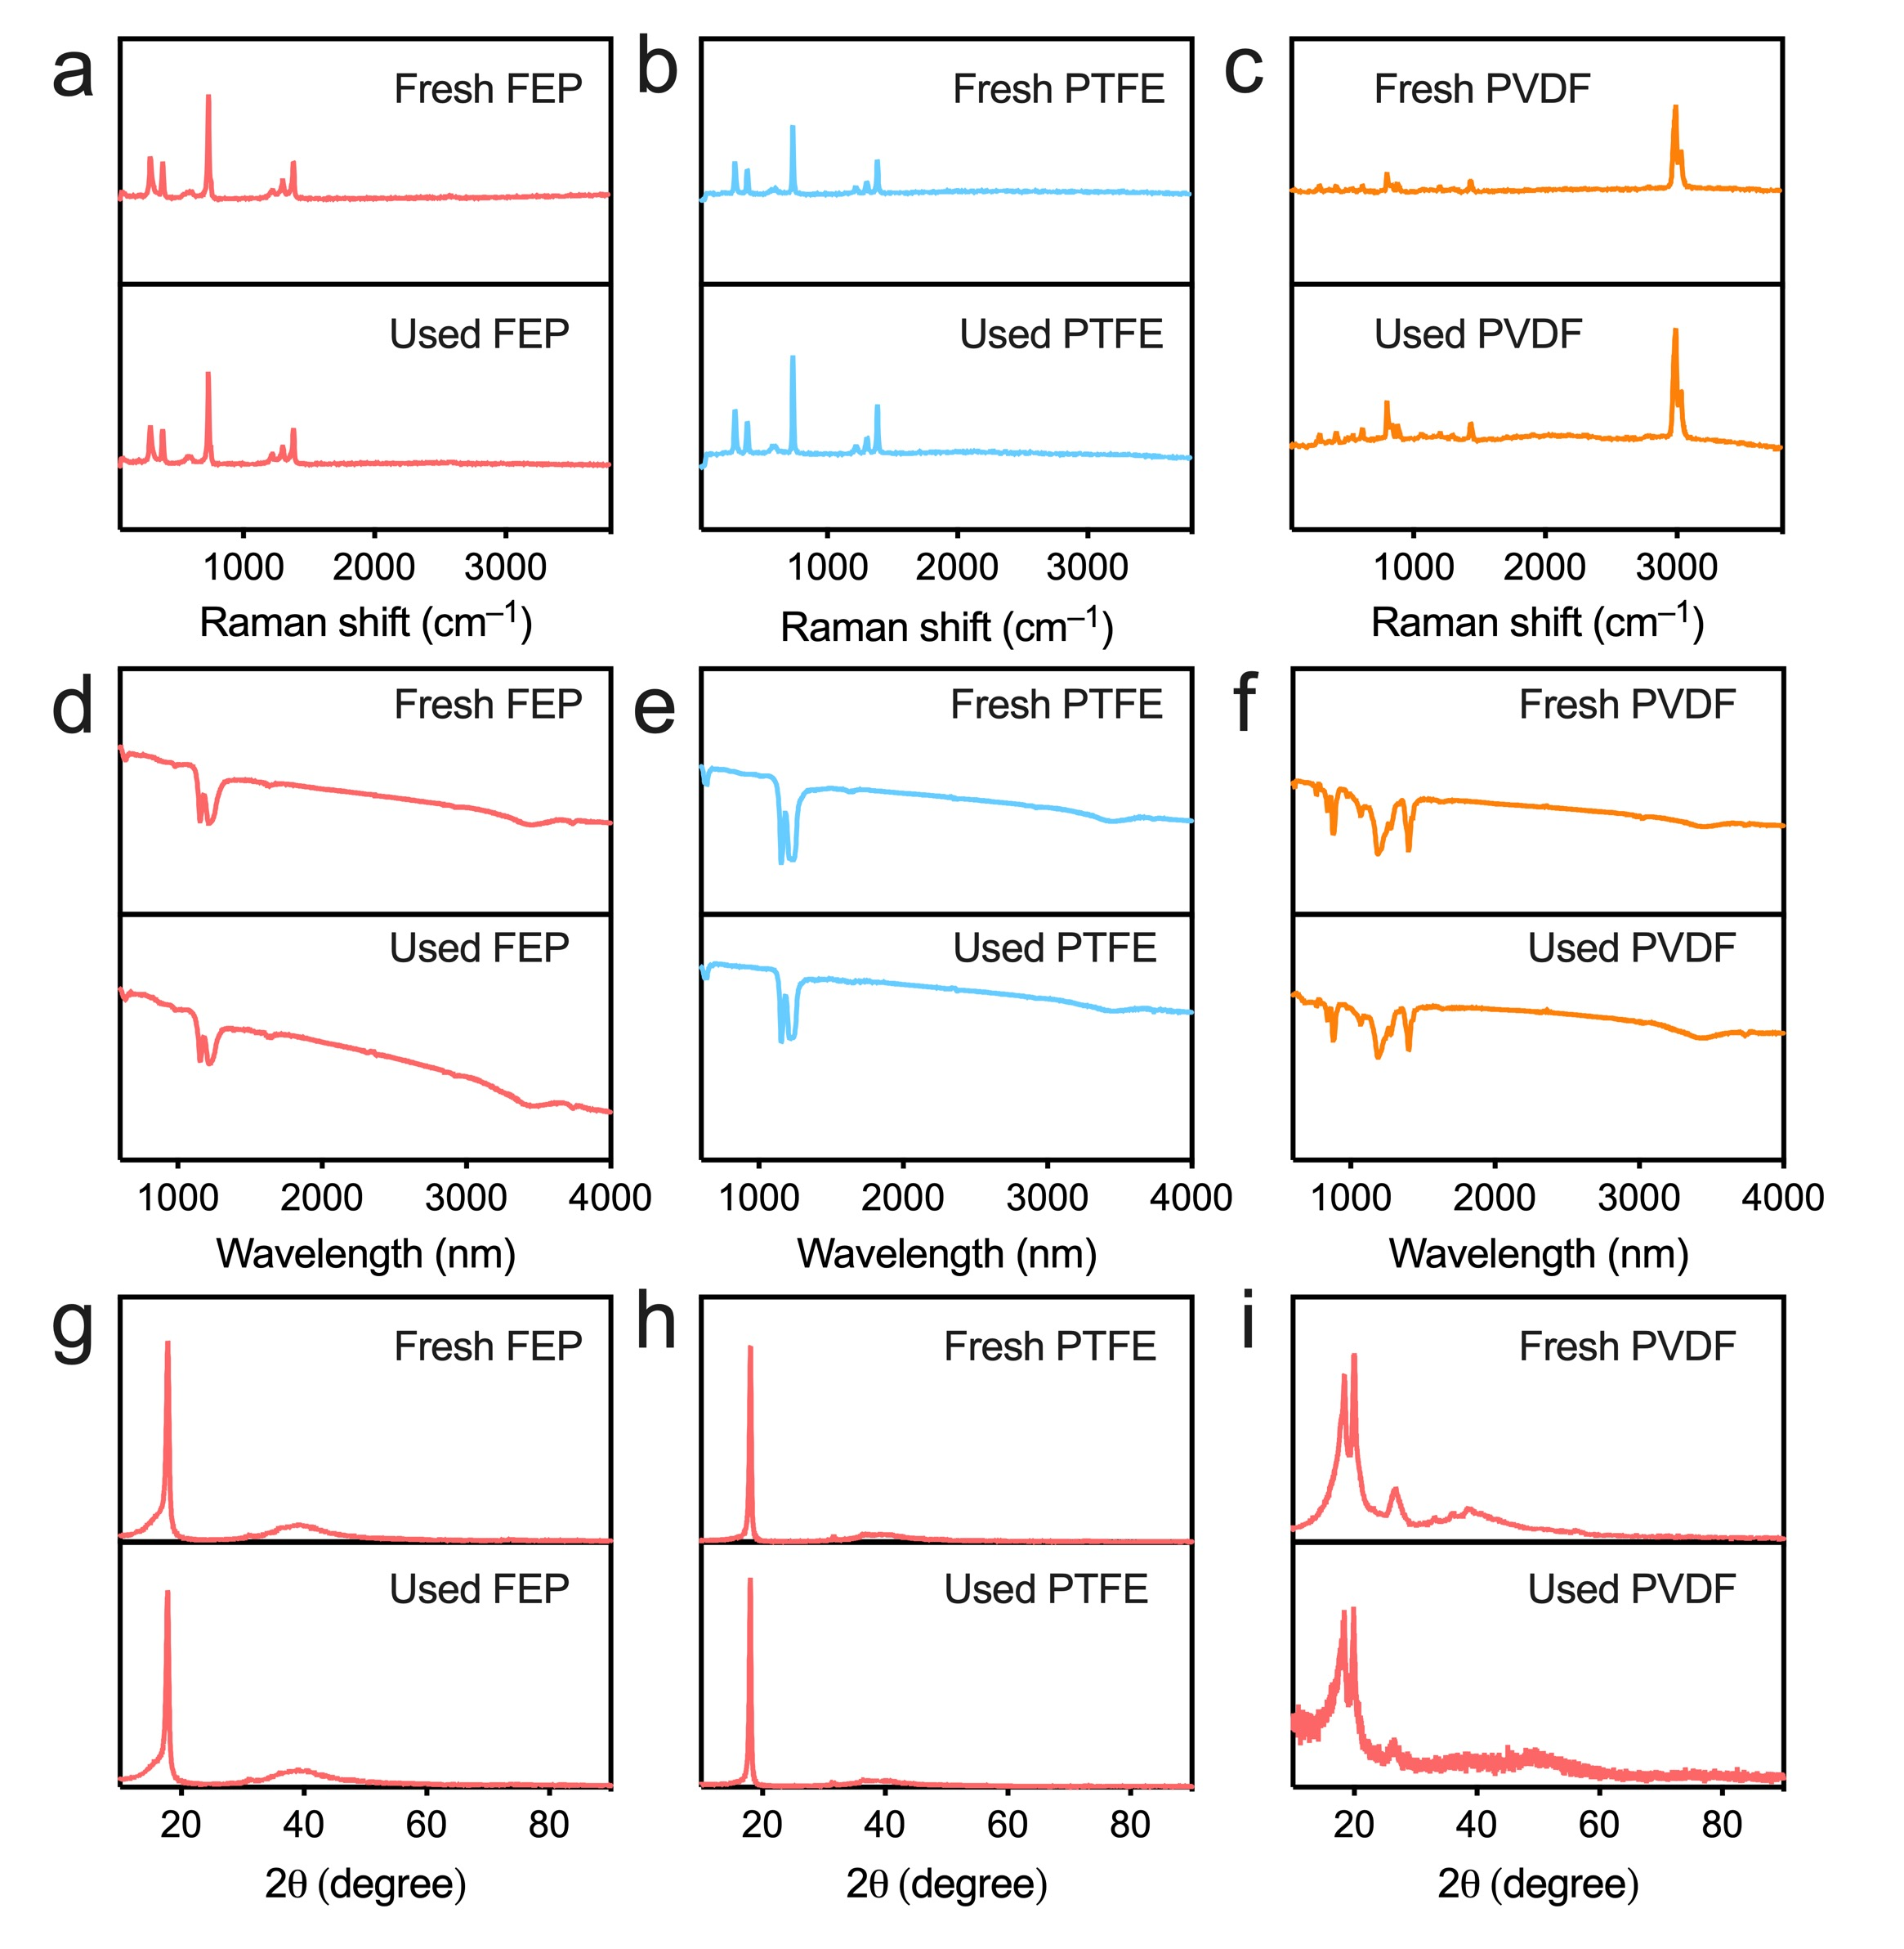
Supplementary Figure 14. The Raman spectra (a-c), FT-IR spectra (d-f), and the XRD diffraction peaks (g-i) of FCPs before and after reaction.

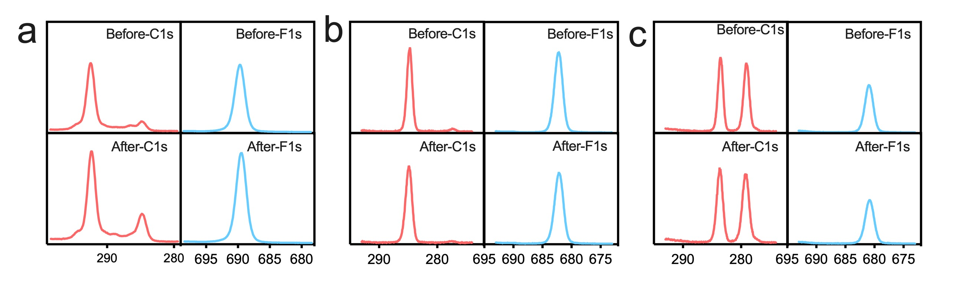
Supplementary Figure 15. The C1s and F1s XPS spectra of FEP (a), PTFE (b), and PVDF (c) before and after reaction.

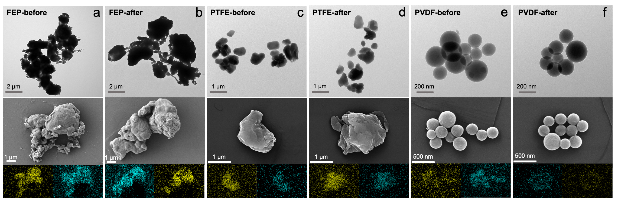
Supplementary Figure 16. The TEM (top), SEM (middle), and EDS of C (bottom-left) and F (bottom-right) images of before-FEP (a), after-FEP (b), before-PTFE (c), after-PTFE (d), before-PVDF (f), and after-PVDF (right).

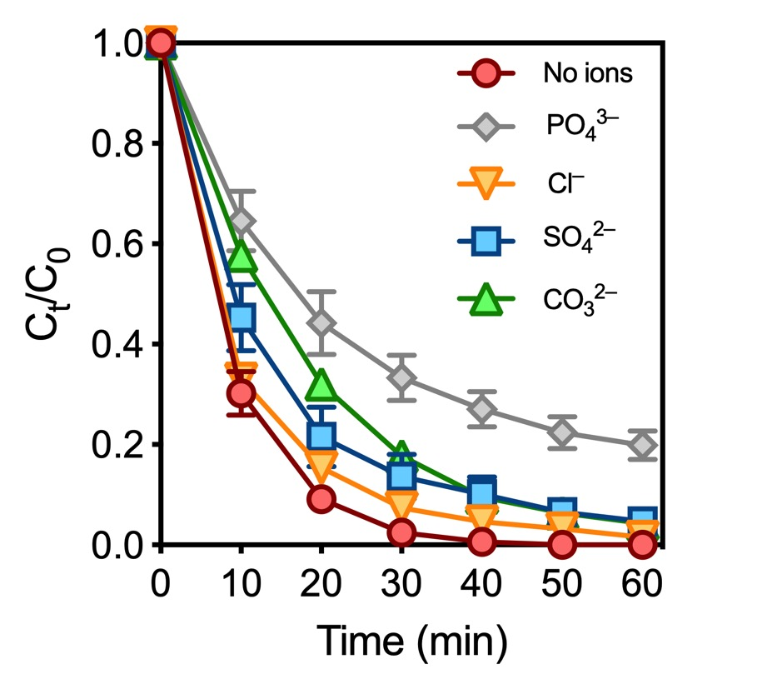
Supplementary Figure 17. The effect of typical ions on Fe^{III}/FEP/CEC degradation performance.
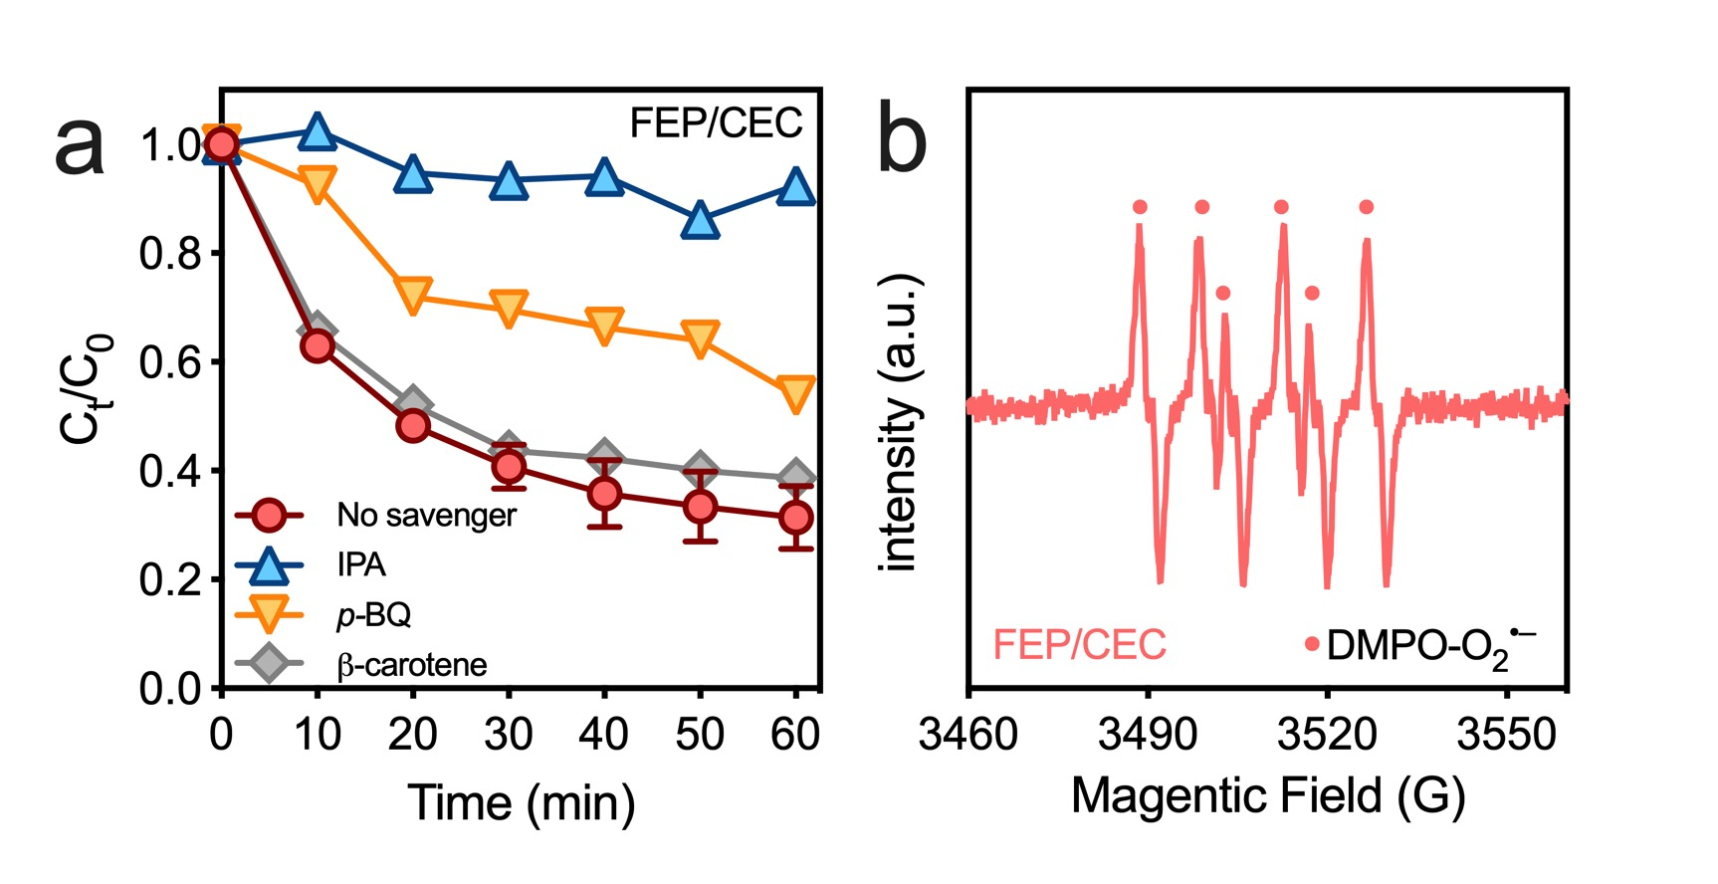
Supplementary Figure 18. The inhibited effect from different scavengers on SDZ degradation performance in FEP/CEC (a). The EPR signal of DMPO/DMSO- O₂^{•−}. Experimental conditions: [FEP]₀ = 0.1 g·L^{–1}, [SDZ]₀ = 5 mg·L^{–1}, [Fe^{III}] = 1 mM, T = 25 ± 2°C, ultrasound irradiation (40 kHz, 110 W).

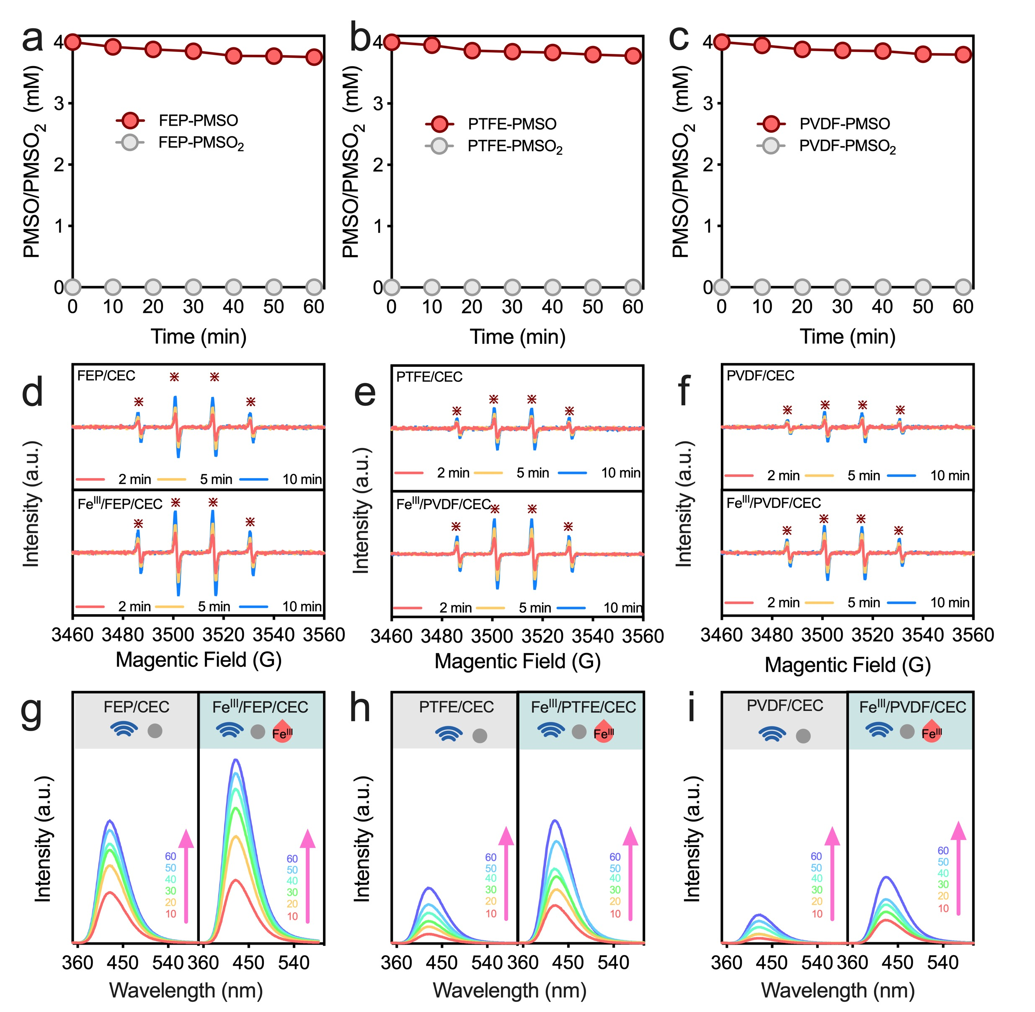
Supplementary Figure 19. The PMSO consumption and PMSO₂ formation in Fe^{III}/FEP/CEC (a), Fe^{III}/PTFE/CEC (b), and Fe^{III}/PVDF/CEC (c) over time. The EPR signals of DMPO-•OH of FEP/CEC and Fe^{III}/FEP/CEC (d), PTFE/CEC and Fe^{III}/PTFE/CEC (e), and PVDF/CEC and Fe^{III}/PVDF/CEC (f), The self-quantitatively analysis of •OH yield in FEP/CEC and Fe^{III}/FEP/CEC (g), PTFE/CEC and Fe^{III}/PTFE/CEC (h), and PVDF/CEC and Fe^{III}/PVDF/CEC (i).

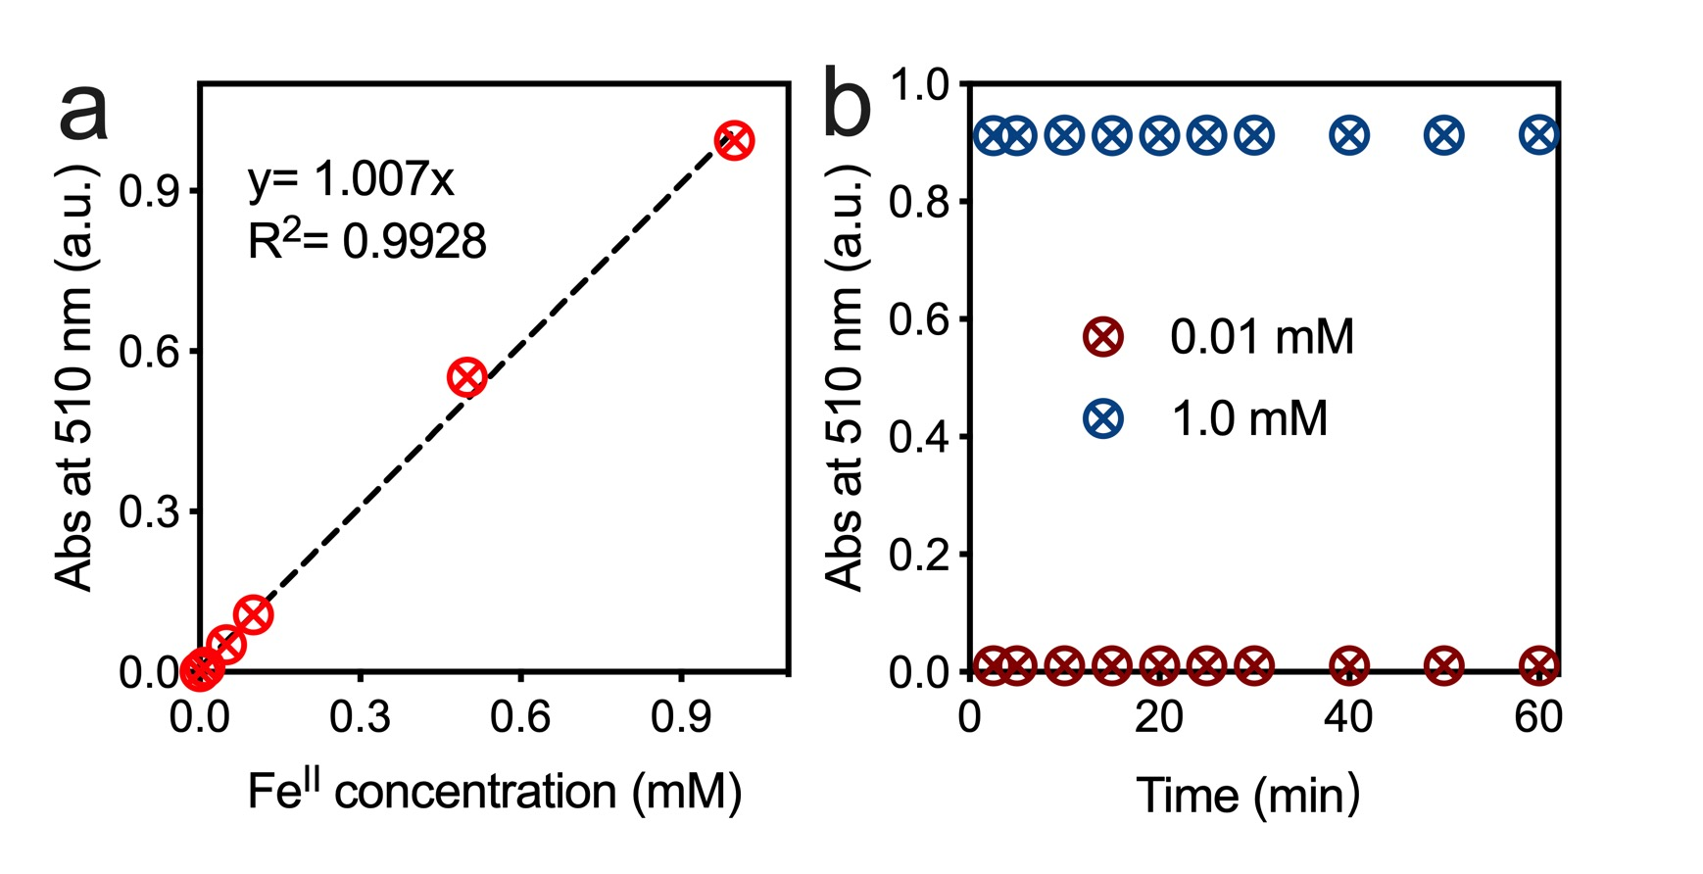
Supplementary Figure 20. The standard curve between the concentration of Fe^{II} and the UV absorbance at 510 nm (Linear equation: y = 1.007x, R² = 0.9928) (a). The stability of the observed UV absorbance at 510 nm of 0.01 mM and 1.0 mM of Fe^{II} (b).

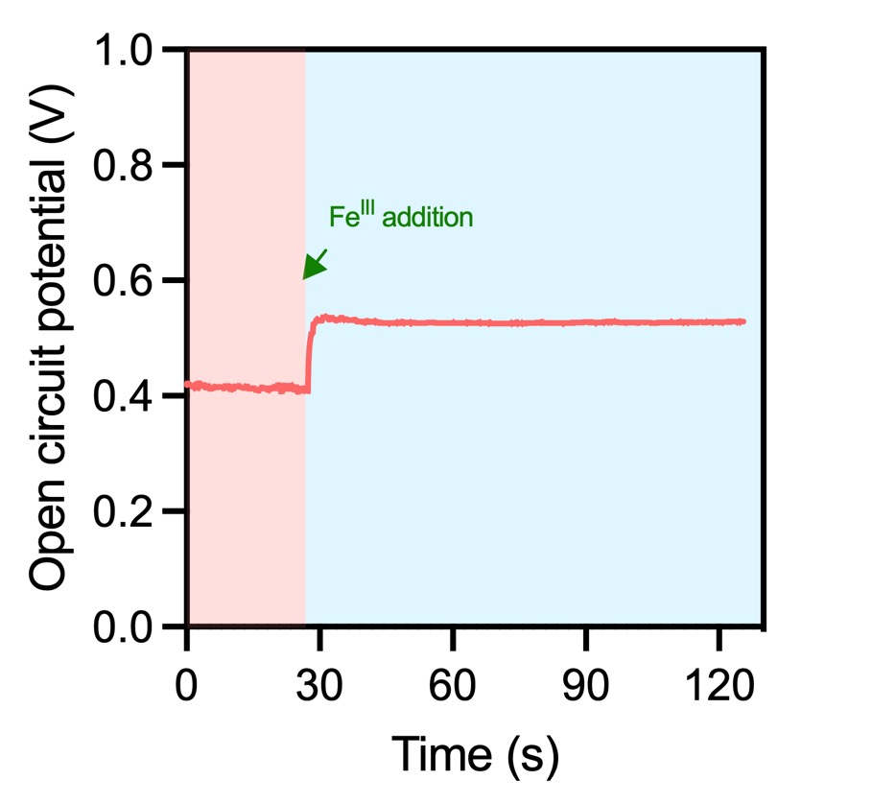
Supplementary Figure 21. The influence of Fe^{III} on the open-circuit potential curves of FEP/CEC. Experimental conditions: [FEP]₀ = 0.1 g·L^{–1}, [Fe^{III}] = 1 mM, T = 25 ± 2°C, ultrasound irradiation (40 kHz, 110 W).

References
1 Xu, T. et al. Mechanisms for the enhanced photo-Fenton activity of ferrihydrite modified with BiVO₄ at neutral pH. Appl. Catal., B 212, 50-58 (2017). https://doi.org:https://doi.org/10.1016/j.apcatb.2017.04.064
2 Wang, Y. et al. O₂-independent H₂O₂ production via water–polymer contact electrification. Environ. Sci. Technol. 58, 925-934 (2024). https://doi.org:https://doi.org//acs.est.3c07674
3 Wei, Y., Zhang, Y., Geng, W., Su, H. & Long, M. Efficient bifunctional piezocatalysis of Au/BiVO₄ for simultaneous removal of 4-chlorophenol and Cr(VI) in water. Appl. Catal., B 259, 118084 (2019). https://doi.org:https://doi.org/10.1016/j.apcatb.2019.118084
4 Feng, J. et al. Significant improvement and mechanism of ultrasonic inactivation to Escherichia coli with piezoelectric effect of hydrothermally synthesized t-BaTiO₃. ACS Sustainable Chem. Eng. 6, 6032-6041 (2018). https://doi.org:https://doi.org/10.1021/acssuschemeng.7b04666
5 Shao, D., Zhang, L., Sun, S. & Wang, W. Oxygen reduction reaction for generating H₂O₂ through a piezo-catalytic process over bismuth oxychloride. ChemSusChem 11 3, 527-531 (2018). https://doi.org:https://doi.org/10.1002/cssc.201702405
6 Xu, J. et al. Highly efficient Fe^{III}-initiated self-cycled Fenton system in piezo-catalytic process for organic pollutants degradation. Angew. Chem. Int. Ed. 62, e202307018 (2023). https://doi.org:https://doi.org/10.1002/anie.202307018
7 Wu, Y. et al. Triggering dual two-electron pathway for H₂O₂ generation by multiple [Bi−O]n interlayers in ultrathin Bi₁₂O₁₇Cl₂ towards efficient piezo-self-Fenton catalysis. Angew. Chem. Int. Ed. 63, e202316410 (2024). https://doi.org:https://doi.org/10.1002/anie.202316410
8 Wang, K. et al. Ternary BaCaZrTi perovskite oxide piezocatalysts dancing for efficient hydrogen peroxide generation. Nano Energy 98, 107251 (2022). https://doi.org:https://doi.org/10.1016/j.nanoen.2022.107251
9 Fu, C. et al. Dual-defect enhanced piezocatalytic performance of C₃N₅ for multifunctional applications. Appl. Catal., B 323, 122196 (2023). https://doi.org:https://doi.org/10.1016/j.apcatb.2022.122196
10 Zeng, H. et al. Boost piezocatalytic H₂O₂ production in BiFeO₃ by defect engineering enabled dual-channel reaction. Mater. Today Energy 39, 101475 (2024). https://doi.org:https://doi.org/10.1016/j.mtener.2023.101475
11 Cui, Y. et al. Harvesting vibration energy to produce hydrogen peroxide with Bi₃TiNbO₉ nanosheets through a water oxidation dominated dual-channel pathway. ACS Sustainable Chem. Eng. 12, 3595-3607 (2024). https://doi.org:https://doi.org/10.1021/acssuschemeng.3c06572
12 Li, W. et al. Boosting reactive oxygen species generation via contact-electro-catalysis with Fe^{III}-initiated self-cycled Fenton system. Angew. Chem. Int. Ed. n/a, e202413246 (2024). https://doi.org:https://doi.org/10.1002/anie.202413246
13 Wu, Y. et al. Boosting 2e⁻ oxygen reduction reaction in garland carbon nitride with carbon defects for high-efficient photocatalysis-self-Fenton degradation of 2,4-dichlorophenol. Appl. Catal., B 307, 121185 (2022). https://doi.org:https://doi.org/10.1016/j.apcatb.2022.121185
14 Wang, F. et al. Unprecedentedly efficient mineralization performance of photocatalysis-self-Fenton system towards organic pollutants over oxygen-doped porous g-C₃N₄ nanosheets. Appl. Catal., B 312, 121438 (2022). https://doi.org:https://doi.org/10.1016/j.apcatb.2022.121438

