Value of intratumoral combined with peritumoral radiomics model in the prediction of Ki-67 expression in lung adenocarcinoma: a multi-center study

Supplementary Materials
- Supplementary Methods
Appendix E1. Inclusion and exclusion criteria for patients with lung cancer
Appendix E2. The procedure of pathological detection of Ki-67
Appendix E3. Image preprocessing
Appendix E4. The details of radiomics features
Appendix E5. Intra-observer and inter-observer repeatability analysis
Appendix E6. The procedures of radiomics feature selection
Appendix E7. The optimal hyperparameter combinations for machine learning classifier
Appendix E8. Model evaluation
Appendix E9. Clinical model construction

- Supplementary Tables
Table S1. The CT scanners and scanning parameters in three centers
Table S2. The definitions and scoring rules for clinical characteristics and CT features
Table S3. The selected features for GTV, GPTV₃, GPTV₆, and GPTV₉ radiomics models
Table S4. Comparison of GTV, GPTV₃ model, GPTV₆ model and GPTV₉ model prediction performance
Table S5. The comparison of clinical model, GPTV₆ radiomics model and nomogram using Delong tests in the training cohort,internal validation cohort and external validation cohorts
Table S6. Univariable and Multivariable Logistic Regression Analysis of predictive characteristics related with Ki-67 expression
Table S7. The corresponding score in the nomogram

- Supplementary Figures
Figure S1. The procedure of ROI segmentation.
Figure S2. LASSO coefficient distributions of radiomics features for each VOI (A-D). L1 regularizer was used as the cost function, and the error value of cross validation is 5, and the maximum number of iterations is 1000.
Figure S3. The performance of GTV, GPTV₃, GPTV₆, and GPTV₉ radiomics signatures in all cohorts. The ROC curves of 4 different radiomics signatures in training cohort (A), internal validation cohort (B), external validation cohort 1 (C), and external validation cohort 2 (D).
Figure S4. The nomogram to predict the epresion level of Ki-67 in patients with lung adenocarcinoma. Draw a line straight upward to the points’axis to determine the points of each variable, add the points, and locate the final sum on the axis of total points. Finally, draw a line straight down to find the patient’s probability of Ki-67＞10%.
Figure S5. The performance of clinical model, GPTV₆ radiomics model, and nomogram in all cohorts. The ROC curves of 3 different models in training cohort (A), internal validation cohort (B), external external validation cohort 1 (C), and external validation cohort 2 (D)
Figure S6. The performance of clinical model, GPTV₆ radiomics model, nomogram was evaluated in the training cohort. The calibration curves (A), and DCA curves (B) of different models.
Appendix E1
Inclusion and exclusion criteria for patients with lung cancer
The inclusion criteria are as follows: (1) lung adenocarcinoma confirmed by pathology; (2) After immunohistochemical examination, there are clear results of Ki-67 expression; (3) Chest CT examination (with complete continuous thin-slice medical digital transmission and communication (DICOM) images with a slice thickness of 1mm) before operation or within 3 months before puncture.
The exclusion criteria are as follows: (1) no complete clinical data; (2) Patients receiving chemotherapy or radiotherapy before surgery or puncture; (3) CT image quality is poor, such as obvious motion or metal artifacts; (4) Combined with other malignant tumors.

Appendix E2
The procedure of pathological detection of Ki-67
All surgical or biopsy specimens were fixed in formalin, dehydrated, paraffin-embedded and sliced into sections of uniform thickness. Immunohistochemistry was performed with mouse anti-human Ki-67 monoclonal antibody (Gene Tech Co., Ltd., Shanghai) according to the kit instructions. Cells with brown nuclei were recognized as positive. The number of Ki-67 positive tumor cells was counted under a light microscope in high magnification fields (×400). The percentage of positive staining of Ki-67 expression level was calculated: (number of positive tumor cells in each field / total tumor cells in each field) × 100%. Ki-67 indices were recorded for five domains and averaged. The Ki-67 was assessed by noting the percentage of positively stained cells. With the thresholdvalue of 10%, we classified lung adenocarcinoma lesions into low Ki-67 group (Ki-67 ≤10%) and high Ki-67 group (Ki-67 > 10%). The histopathological evaluation was performed by a senior pathologist with more than 10 years of experience, who was blinded to all radiological and clinical results.

Appendix E3
Image preprocessing
The voxel size of VOI was resampled to 1×1×1 mm³ by cubic interpolation to reduce the variability of radiomics feature values arising from different voxel sizes. Hounsfeld Units (HU) were standardized by setting consistent window levels across all images, typically ranging from -1000 HU (air) to 1000 HU (bone).

Appendix E4
The details of radiomics features
A total of 1688 features were extracted for each VOI, including 14 shape and size features, 18 first-order statistical features, 75 texture features, and 1581 filter and wavelet features. The extracted radiomics features can be grouped into four groups: (1) first-order features include 18 features, also known as histogram features, which describe the distribution of voxel intensities within the volume of interest (VOI), involving energy, entropy, mean, and median; (2) shape features include 14 features, which reflect the shape and size of the region, involving mesh surface, pixel surface, perimeter, and maximum diameter; (3) texture features include 75 features, which evaluate regional heterogeneity differences, including gray level co-occurrence matrix (GLCM), gray level dependence matrix (GLDM), gray level run length matrix (GLRLM), gray level size zone matrix (GLSZM), and neighborhood gray tone difference matrix (NGTDM); (4) filter and wavelet features include 1581 features, which include the intensity and texture features derived from filter transformation and wavelet transformation of the original image, obtained by applying filters such exponential, gradient, logarithm, square, square root, lbp2D, lbp3D, and wavelet using eight frequency band combinations (low-high-low [LHL], low-high-high [LHH], high-low-low [HLL], low-low-high [LLH], high-low-high [HLH], high-high-high[HHH], high-high-low [HHL], and low-low-low [LLL]).

Appendix E5
Intra-observer and inter-observer repeatability analysis
30 patients were randomly selected by another experienced radiologist for segmentation to assess inter-observer correlation coefficient of radiomics features, and to evaluate the repeatability of the intraobserver correlation coefficient, one radiologist repeats the above steps again after 2 weeks. Intra- and inter-class correlation coefficients (ICCs) values greater than 0.75 were considered to have good consistency.

Appendix E6
The procedures of radiomics feature selection
The feature selection methods included the variance threshold (variance threshold = 0.8), SelectKBest and the least absolute shrinkage and selection operator (LASSO) were used for this purpose. For the variance threshold method, the threshold is 0.8, so that the eigenvalues of the variance smaller than 0.8 were removed. The SelectKBest method, which belongs to a single variable feature selection method, using p value to analysis the relationship between the features and the classification results, all the features with p value smaller than 0.05 will be used. For LASSO model, L1 regularizer was used as the cost function, and the error value of cross validation is 5, and the maximum number of iterations is 1000.

Appendix E7
Machine learning algorithms
Constructing radiomic models with the radiomics features of the optimal signature combined with support vector machine (SVM).
The hyperparameters of the algorithm were optimized using GridSearch with ten-fold cross-validation, and the optimal hyperparameter combinations for SVM are as follows:
SVM: kernel(rbf), C(1), gamma(auto), class_weight(balanced), decision_function_shape(ovr), random_state(), split()

Appendix E8
Model evaluation
The predictive performance of clinical and combined models were assessed using ROC analyses, with AUC values, sensitivity, specificity, and accuracy. The DeLong test was used to compare the different models’ performance. Calibration curves were drawn to assess the nomogram with the Hosmer-Lemeshow goodness-of-fit test. The clinical utility of different models was evaluated with a decision curve analysis (DCA) by measuring the net benefits under different threshold probabilities. Comparison of all models was carried out in training, testing and validation cohorts.

Appendix E9
Clinical model construction
Univariable analysis results showed that nodule size, spicule sign, and nodule density were significantly different between Ki-67 high expression and Ki-67 low expression groups in the training cohort (all P<0.05). Multivariable LR analysis found that nodule size (odds ratio (OR): 1.096, 95% confidence interval (CI): 1.054-1.141, P＜0.001), spicule signand (OR: 2.335, 95% CI: 1.273-4.284, P=0.006), and nodule density (OR: 1.734, 95% CI: 1.058-2.844, P=0.029) were independent predictors of Ki-67 high expression in patients with lung adenocarcinoma. These characteristics were therefore used to establish the clinical model .

Table S1. The CT scanners and scanning parameters in 3 centers
Center | CT Scanner | Tube voltage  (kVp) | Tube current  (mA) | Rotational speed  (/turn) | Slice thickness  (mm) | Scanning matrix
Center 1 | Siemens Somatom Force scanner | 120 | Auto | 0.5 | 1.0 | 512×512
Center 1 | Philips brilliance iCT scanner | 120 | Auto | 0.5 | 1.0 | 768×768
Center 2 | Siemens Somatom Definition AS+ scanner | 130 | Auto | 0.5 | 1.0 | 512×512
Center 3 | Somatom Sensation 64 scanner | 130 | Auto | 0.5 | 1.0 | 512×512

Table S2. The definitions and scoring rules for conventional CT features
Feature | Definition | Scoring
Clinical feature
Age | Age of patients | Unit, years old
Sex | Gender of patients | 1, male; 2, female
Smoking status | The history of smoking cigarettes | 0, non-smoker; 1,current or former smoker
CT feature
Margin | Unclear,blurred demarcation between tumor and lung parenchyma; clear,clear demarcation of the tumor from the lung parenchyma | 0,unclear;1,clear
Density | Pure ground-glass opacity, unmasking the bronchi and vascular branches below; partial solid, presence of ground-glass opacity and solid components; solid, absence of ground-glass opacity | 1, solid;2, partial solid; 3, pure ground-glass opacity (GGO)
Lobulation sign | Surface of the tumour that showed a wavy or scalloped configuration | 0, no; 1, yes
Spicule sign | Short lines radiating from tumour margin；irregular, irregularity of tumour margin | 0, no; 1, yes
Pleural indentation | Retraction of the pleura toward the tumour | 0, no; 1, yes
Air bronchogram sign | Air-filled bronchi on a background of opaque airless lung | 0, no; 1, yes
Vacuole sign | Gas shadow seen in tumor lesions, generally less than 5 mm | 0, no; 1, yes

Table S3. The selected features for GTV, GPTV₃, GPTV₆, and GPTV₉ radiomics models
Segmentation | Filter | Radiomic class | Radiomic feature | Coefficient
GTV | CTROI-15-15-15_label_tumor_exponential | firstorder | Skewness | -0.01811
 | CTROI-15-15-15_label_tumor_lbp-2D | firstorder | InterquartileRange | -0.0612
 | CTROI-15-15-15_label_tumor_lbp-3D-k | firstorder | Maximum | 0.058323
 | CTROI-15-15-15_label_tumor_lbp-3D-k | gldm | LargeDependenceLowGrayLevelEmphasis | 0.056766
 | CTROI-15-15-15_label_tumor_lbp-3D-m2 | firstorder | InterquartileRange | 0.110075
 | CTROI-15-15-15_label_tumor_original | shape | LeastAxisLength | 0.033907
 | CTROI-15-15-15_label_tumor_original | shape | Maximum2DDiameterRow | 0.041772
 | CTROI-15-15-15_label_tumor_square | firstorder | Kurtosis | -0.02582
 | CTROI-15-15-15_label_tumor_wavelet-HHH | firstorder | Range | -0.07997
 | CTROI-15-15-15_label_tumor_wavelet-HHL | firstorder | Energy | 0.023067
 | CTROI-15-15-15_label_tumor_wavelet-HHL | firstorder | Range | 0.041338
 | CTROI-15-15-15_label_tumor_wavelet-LLH | gldm | LargeDependenceLowGrayLevelEmphasis | 0.013967
 | CTROI-15-15-15_label_tumor_wavelet-LLH | glrlm | LongRunLowGrayLevelEmphasis | 0.009034
 | CTROI-15-15-15_label_tumor_wavelet-LLH | glszm | ZoneEntropy | 0.011794
 | CTROI-15-15-15_label_tumor_wavelet-LLL | firstorder | Skewness | 0.016683
GPTV₃ | CTROI-15-15-15_label_tumor_gradient | firstorder | Maximum | -0.08144
 | CTROI-15-15-15_label_tumor_gradient | firstorder | Range | -0.07736
 | CTROI-15-15-15_label_tumor_lbp-3D-k | firstorder | Range | 0.014597
 | CTROI-15-15-15_label_tumor_lbp-3D-k | gldm | LargeDependenceLowGrayLevelEmphasis | 0.006413
 | CTROI-15-15-15_label_tumor_lbp-3D-k | glrlm | LongRunLowGrayLevelEmphasis | 0.069461
 | CTROI-15-15-15_label_tumor_lbp-3D-m1 | firstorder | TotalEnergy | 0.013401
 | CTROI-15-15-15_label_tumor_original | shape | LeastAxisLength | 0.011471
 | CTROI-15-15-15_label_tumor_wavelet-HHH | firstorder | Range | 0.042511
 | CTROI-15-15-15_label_tumor_wavelet-LLH | glrlm | RunVariance | -0.05544
 | CTROI-15-15-15_label_tumor_wavelet-LLH | glszm | ZoneEntropy | 0.038
 | CTROI-15-15-15_label_tumor_wavelet-LLL | firstorder | Skewness | -0.01445
 | CTROI-15-15-15_label_tumor_wavelet-LLL | gldm | LargeDependenceEmphasis | 0.023015
 | CTROI-15-15-15_label_tumor_wavelet-LLL | gldm | LargeDependenceHighGrayLevelEmphasis | 2.43E-05
 | CTROI-15-15-15_label_tumor-0-3_wavelet-HHH | firstorder | Energy | -0.02726
 | CTROI-15-15-15_label_tumor-0-3_wavelet-HHH | firstorder | Range | 0.019076
 | CTROI-15-15-15_label_tumor-0-3_wavelet-HHH | gldm | DependenceVariance | 0.042121
 | CTROI-15-15-15_label_tumor-0-3_wavelet-HHL | firstorder | Energy | 0.022111
 | CTROI-15-15-15_label_tumor-0-3_wavelet-HHL | firstorder | TotalEnergy | -0.01869
 | CTROI-15-15-15_label_tumor-0-3_wavelet-HLH | glszm | HighGrayLevelZoneEmphasis | -0.03567
 | CTROI-15-15-15_label_tumor-0-3_wavelet-LHH | gldm | DependenceVariance | 0.066399
 | CTROI-15-15-15_label_tumor-0-3_wavelet-LLL | firstorder | Minimum | 0.069444
GPTV₆ | CTROI-15-15-15_label_tumor_exponential | firstorder | TotalEnergy | -0.05691
 | CTROI-15-15-15_label_tumor_gradient | firstorder | Maximum | 0.032425
 | CTROI-15-15-15_label_tumor_gradient | firstorder | Range | 0.055479
 | CTROI-15-15-15_label_tumor_lbp-2D | firstorder | 10Percentile | -0.09257
 | CTROI-15-15-15_label_tumor_lbp-3D-k | firstorder | Range | 0.017704
 | CTROI-15-15-15_label_tumor_lbp-3D-k | gldm | LargeDependenceLowGrayLevelEmphasis | 0.106729
 | CTROI-15-15-15_label_tumor_lbp-3D-k | glrlm | LongRunLowGrayLevelEmphasis | 0.032387
 | CTROI-15-15-15_label_tumor_lbp-3D-m1 | firstorder | TotalEnergy | -0.03845
 | CTROI-15-15-15_label_tumor_lbp-3D-m2 | firstorder | InterquartileRange | 0.074402
 | CTROI-15-15-15_label_tumor_original | firstorder | Median | -0.00146
 | CTROI-15-15-15_label_tumor_original | gldm | LargeDependenceEmphasis | 0.046713
 | CTROI-15-15-15_label_tumor_original | shape | LeastAxisLength | -0.09834
 | CTROI-15-15-15_label_tumor_original | shape | Maximum2DDiameterRow | -0.07475
 | CTROI-15-15-15_label_tumor_square | firstorder | Skewness | 0.103995
 | CTROI-15-15-15_label_tumor_squareroot | firstorder | Median | 0.017391
 | CTROI-15-15-15_label_tumor_wavelet-HHH | firstorder | Range | 0.088843
 | CTROI-15-15-15_label_tumor_wavelet-HHL | firstorder | TotalEnergy | 0.094993
 | CTROI-15-15-15_label_tumor_wavelet-HLL | firstorder | Kurtosis | -0.00433
 | CTROI-15-15-15_label_tumor_wavelet-HLL | firstorder | TotalEnergy | 0.054081
 | CTROI-15-15-15_label_tumor_wavelet-LHH | firstorder | Kurtosis | 0.017174
 | CTROI-15-15-15_label_tumor_wavelet-LHL | firstorder | Maximum | 0.01118
 | CTROI-15-15-15_label_tumor_wavelet-LLH | glrlm | RunVariance | 0.032863
 | CTROI-15-15-15_label_tumor_wavelet-LLH | glszm | GrayLevelNonUniformity | -0.01556
 | CTROI-15-15-15_label_tumor_wavelet-LLH | glszm | ZoneEntropy | 0.037083
 | CTROI-15-15-15_label_tumor_wavelet-LLL | firstorder | Kurtosis | -0.01793
 | CTROI-15-15-15_label_tumor_wavelet-LLL | firstorder | Skewness | 0.065914
 | CTROI-15-15-15_label_tumor_wavelet-LLL | gldm | LargeDependenceHighGrayLevelEmphasis | -0.00924
 | CTROI-15-15-15_label_tumor-0-6_exponential | gldm | LargeDependenceEmphasis | -0.0927
 | CTROI-15-15-15_label_tumor-0-6_exponential | gldm | LargeDependenceHighGrayLevelEmphasis | -0.06942
 | CTROI-15-15-15_label_tumor-0-6_exponential | gldm | LargeDependenceLowGrayLevelEmphasis | 0.013882
 | CTROI-15-15-15_label_tumor-0-6_gradient | firstorder | Kurtosis | -0.01299
 | CTROI-15-15-15_label_tumor-0-6_gradient | gldm | LargeDependenceEmphasis | 0.082454
 | CTROI-15-15-15_label_tumor-0-6_gradient | gldm | LargeDependenceHighGrayLevelEmphasis | 9.88E-15
 | CTROI-15-15-15_label_tumor-0-6_lbp-2D | gldm | LargeDependenceEmphasis | 2.5E-16
 | CTROI-15-15-15_label_tumor-0-6_lbp-2D | gldm | LargeDependenceHighGrayLevelEmphasis | 2.88E-17
 | CTROI-15-15-15_label_tumor-0-6_lbp-2D | gldm | LargeDependenceLowGrayLevelEmphasis | 3.74E-17
 | CTROI-15-15-15_label_tumor-0-6_lbp-3D-k | glrlm | LongRunHighGrayLevelEmphasis | 1.17E-17
 | CTROI-15-15-15_label_tumor-0-6_lbp-3D-m1 | gldm | LargeDependenceEmphasis | 3.2E-18
 | CTROI-15-15-15_label_tumor-0-6_lbp-3D-m1 | gldm | LargeDependenceHighGrayLevelEmphasis | 2.14E-18
 | CTROI-15-15-15_label_tumor-0-6_lbp-3D-m1 | gldm | LargeDependenceLowGrayLevelEmphasis | 2.14E-18
 | CTROI-15-15-15_label_tumor-0-6_lbp-3D-m2 | gldm | LargeDependenceEmphasis | 2.14E-18
 | CTROI-15-15-15_label_tumor-0-6_lbp-3D-m2 | gldm | LargeDependenceHighGrayLevelEmphasis | 2.14E-18
 | CTROI-15-15-15_label_tumor-0-6_lbp-3D-m2 | gldm | LargeDependenceLowGrayLevelEmphasis | 2.14E-18
 | CTROI-15-15-15_label_tumor-0-6_logarithm | firstorder | InterquartileRange | 2.14E-18
 | CTROI-15-15-15_label_tumor-0-6_original | shape | Maximum2DDiameterColumn | 2.14E-18
 | CTROI-15-15-15_label_tumor-0-6_square | gldm | LargeDependenceEmphasis | 2.14E-18
 | CTROI-15-15-15_label_tumor-0-6_square | gldm | LargeDependenceHighGrayLevelEmphasis | 1.07E-17
 | CTROI-15-15-15_label_tumor-0-6_square | gldm | LargeDependenceLowGrayLevelEmphasis | 2.14E-18
 | CTROI-15-15-15_label_tumor-0-6_wavelet-HHH | firstorder | Energy | 0.026718
 | CTROI-15-15-15_label_tumor-0-6_wavelet-HHH | gldm | DependenceVariance | 0.0552
 | CTROI-15-15-15_label_tumor-0-6_wavelet-HHL | firstorder | TotalEnergy | 0.007784
 | CTROI-15-15-15_label_tumor-0-6_wavelet-HLH | firstorder | TotalEnergy | -0.08496
 | CTROI-15-15-15_label_tumor-0-6_wavelet-HLH | glszm | HighGrayLevelZoneEmphasis | -0.02983
 | CTROI-15-15-15_label_tumor-0-6_wavelet-HLL | firstorder | TotalEnergy | 0.118676
 | CTROI-15-15-15_label_tumor-0-6_wavelet-LHL | glszm | LargeAreaLowGrayLevelEmphasis | -0.01306
 | CTROI-15-15-15_label_tumor-0-6_wavelet-LLH | firstorder | Kurtosis | 0.006805
 | CTROI-15-15-15_label_tumor-0-6_wavelet-LLH | firstorder | Skewness | -0.03265
 | CTROI-15-15-15_label_tumor-0-6_wavelet-LLH | glszm | HighGrayLevelZoneEmphasis | -0.01487
 | CTROI-15-15-15_label_tumor-0-6_wavelet-LLL | firstorder | 90Percentile | -0.05263
 | CTROI-15-15-15_label_tumor-0-6_wavelet-LLL | firstorder | Maximum | -0.03487
 | CTROI-15-15-15_label_tumor-0-6_wavelet-LLL | firstorder | Minimum | 0.009667
GPTV₉ | CTROI-15-15-15_label_tumor_exponential | firstorder | TotalEnergy | -0.08591
 | CTROI-15-15-15_label_tumor_gradient | firstorder | Maximum | 0.044536
 | CTROI-15-15-15_label_tumor_gradient | firstorder | Range | 0.00043
 | CTROI-15-15-15_label_tumor_lbp-2D | firstorder | 10Percentile | -0.04951
 | CTROI-15-15-15_label_tumor_lbp-3D-k | firstorder | Range | 0.003638
 | CTROI-15-15-15_label_tumor_lbp-3D-k | gldm | LargeDependenceLowGrayLevelEmphasis | 0.073611
 | CTROI-15-15-15_label_tumor_lbp-3D-k | glrlm | LongRunLowGrayLevelEmphasis | 0.037832
 | CTROI-15-15-15_label_tumor_lbp-3D-m1 | firstorder | TotalEnergy | -0.00782
 | CTROI-15-15-15_label_tumor_original | shape | LeastAxisLength | 0.013508
 | CTROI-15-15-15_label_tumor_original | shape | Maximum2DDiameterColumn | 0.098581
 | CTROI-15-15-15_label_tumor_square | firstorder | Skewness | -0.05004
 | CTROI-15-15-15_label_tumor_square | firstorder | Skewness | 0.097829
 | CTROI-15-15-15_label_tumor_wavelet-HHH | firstorder | Range | -0.06051
 | CTROI-15-15-15_label_tumor_wavelet-HHL | firstorder | TotalEnergy | 0.021823
 | CTROI-15-15-15_label_tumor_wavelet-HLL | firstorder | Kurtosis | 0.057024
 | CTROI-15-15-15_label_tumor_wavelet-HLL | firstorder | TotalEnergy | 0.021595
 | CTROI-15-15-15_label_tumor_wavelet-LHH | firstorder | Kurtosis | 0.029606
 | CTROI-15-15-15_label_tumor_wavelet-LHL | firstorder | Maximum | 0.034396
 | CTROI-15-15-15_label_tumor_wavelet-LLH | gldm | LargeDependenceEmphasis | 0.007234
 | CTROI-15-15-15_label_tumor_wavelet-LLH | gldm | LargeDependenceEmphasis | 0.0867
 | CTROI-15-15-15_label_tumor_wavelet-LLH | glrlm | RunVariance | 3.74E-15
 | CTROI-15-15-15_label_tumor_wavelet-LLH | glszm | ZoneEntropy | 9.61E-17
 | CTROI-15-15-15_label_tumor_wavelet-LLL | firstorder | Skewness | 0.080108
 | CTROI-15-15-15_label_tumor_wavelet-LLL | firstorder | Skewness | -0.03673
 | CTROI-15-15-15_label_tumor_wavelet-LLL | gldm | LargeDependenceEmphasis | -0.02033
 | CTROI-15-15-15_label_tumor_wavelet-LLL | gldm | LargeDependenceHighGrayLevelEmphasis | 0.008641
 | CTROI-15-15-15_label_tumor-0-9_exponential | gldm | LargeDependenceEmphasis | 0.028582
 | CTROI-15-15-15_label_tumor-0-9_exponential | gldm | LargeDependenceHighGrayLevelEmphasis | -0.07381
 | CTROI-15-15-15_label_tumor-0-9_exponential | gldm | LargeDependenceLowGrayLevelEmphasis | -0.07562
 | CTROI-15-15-15_label_tumor-0-9_gradient | firstorder | Kurtosis | -0.01838
 | CTROI-15-15-15_label_tumor-0-9_gradient | gldm | LargeDependenceEmphasis | 0.035321
 | CTROI-15-15-15_label_tumor-0-9_gradient | gldm | LargeDependenceHighGrayLevelEmphasis | 4.7E-17
 | CTROI-15-15-15_label_tumor-0-9_gradient | gldm | LargeDependenceLowGrayLevelEmphasis | 2.14E-17
 | CTROI-15-15-15_label_tumor-0-9_lbp-2D | gldm | LargeDependenceHighGrayLevelEmphasis | 6.41E-18
 | CTROI-15-15-15_label_tumor-0-9_lbp-3D-k | glrlm | LongRunLowGrayLevelEmphasis | 6.41E-18
 | CTROI-15-15-15_label_tumor-0-9_lbp-3D-m1 | gldm | LargeDependenceEmphasis | 5.66E-17
 | CTROI-15-15-15_label_tumor-0-9_lbp-3D-m1 | gldm | LargeDependenceLowGrayLevelEmphasis | 2.03E-17
 | CTROI-15-15-15_label_tumor-0-9_lbp-3D-m2 | gldm | LargeDependenceEmphasis | 5.34E-18
 | CTROI-15-15-15_label_tumor-0-9_lbp-3D-m2 | gldm | LargeDependenceHighGrayLevelEmphasis | 5.34E-18
 | CTROI-15-15-15_label_tumor-0-9_lbp-3D-m2 | gldm | LargeDependenceLowGrayLevelEmphasis | 5.34E-18
 | CTROI-15-15-15_label_tumor-0-9_logarithm | ngtdm | Busyness | 5.34E-18
 | CTROI-15-15-15_label_tumor-0-9_original | ngtdm | Busyness | 3.84E-17
 | CTROI-15-15-15_label_tumor-0-9_original | shape | Maximum2DDiameterRow | 8.22E-17
 | CTROI-15-15-15_label_tumor-0-9_square | gldm | LargeDependenceEmphasis | 0.000531
 | CTROI-15-15-15_label_tumor-0-9_squareroot | ngtdm | Busyness | 0.015552
 | CTROI-15-15-15_label_tumor-0-9_wavelet-HHH | firstorder | Energy | -0.0268
 | CTROI-15-15-15_label_tumor-0-9_wavelet-HHH | firstorder | Minimum | 0.056141
 | CTROI-15-15-15_label_tumor-0-9_wavelet-HHH | firstorder | Range | -0.03212
 | CTROI-15-15-15_label_tumor-0-9_wavelet-HHH | gldm | DependenceVariance | 0.081138
 | CTROI-15-15-15_label_tumor-0-9_wavelet-HHL | firstorder | TotalEnergy | -0.13794
 | CTROI-15-15-15_label_tumor-0-9_wavelet-HLH | firstorder | TotalEnergy | 0.007668
 | CTROI-15-15-15_label_tumor-0-9_wavelet-HLL | firstorder | TotalEnergy | -0.003
 | CTROI-15-15-15_label_tumor-0-9_wavelet-LHL | glszm | LargeAreaLowGrayLevelEmphasis | -0.0403
 | CTROI-15-15-15_label_tumor-0-9_wavelet-LLH | firstorder | Minimum | 0.124008
 | CTROI-15-15-15_label_tumor-0-9_wavelet-LLH | firstorder | Skewness | 0.009659
 | CTROI-15-15-15_label_tumor-0-9_wavelet-LLH | gldm | LargeDependenceHighGrayLevelEmphasis | -0.02393

Table S4. The comparison of GPTV₆ with GTV, GPTV₃ and GPTV₉ radiomics model using Delong tests in the training ,internal validation and external validation cohorts [P value].
Cohort | GTV | GPTV₃ | GPTV₉
Training cohort | 0.0008 | 0.0326 | 0.0128
internal validation cohort | 0.0245 | 0.7303 | 0.3856
external validation cohort 1 | 0.0347 | 0.3339 | 0.1877
external validation cohort 2 | 0.0147 | 0.2866 | 0.0752
Abbreviations: NRI, the net reclassification index; GTV, gross tumor volume; PTV, peritumor volume.

Table S5. The comparison of nomogram with clinical model and GPTV₆ radiomics model using Delong tests in the training, internal validation and external validation cohorts [P value].
 | Clinical model | GPTV6 radiomics model
Training cohort | ＜0.0001 | 0.7252
internal validation cohort | 0.0145 | 0.5775
external validation cohort 1 | 0.0214 | 0.6388
external validation cohort 2 | 0.0014 | 0.1814
Abbreviations:PTV, peritumor volume.

Table S6. Univariable and Multivariable Logistic Regression Analysis of predictive characteristics related with Ki-67 expression
Characteristics | Univariable Analysis |  | Multivariable Analysis
Characteristics |  |  | Clinical model |  | Radiomics nomogram
Characteristics | OR(95% CI) | P-value | OR(95% CI) | P-value | OR(95% CI) | P-value
Age | 1.023 (0.995-1.052) | 0.108 | NA | NA | NA | NA
Sex | 1.699 (0.983-2.935) | 0.058 | NA | NA | NA | NA
Smoking history | 1.647 (0.890-3.047) | 0.112 | NA | NA | NA | NA
Size | 1.086 (1.047-1.127) | ＜0.001 | 1.096 (1.054-1.141) | ＜0.001 | 1.061 (1.005-1.121) | 0.034
Margin | 1.253 (0.715-2.198) | 0.431 | NA | NA | NA | NA
Density | 1.662 (1.066-2.592) | 0.025 | 1.734 (1.058-2.844) | 0.029 | 2.839 (1.484-5.432) | 0.002
Lobulation sign | 1.901 (1.097-3.295) | 0.022 | NA | NA | NA | NA
Spicule sign | 2.533 (1.437-4.466) | 0.001 | 2.335 (1.273-4.284) | 0.006 | 2.463 (1.373-4.624) | 0.024
Pleural indentation | 1.547 (0.898-2.667) | 0.116 | NA | NA | NA | NA
Air bronchogram sign | 1.352 (0.756-2.417) | 0.309 | NA | NA | NA | NA
Vacuole sign | 1.157 (0.569-2352) | 0.687 | NA | NA | NA | NA
Rad-score | 4.319 (3.041-6.136) | ＜0.001 | NA | NA | 4.594 (3.124-6.756) | ＜0.001
Abbreviations: OR, odds ratio; CI, confidence interval.

Table S7. The corresponding score in the nomogram
Characteristic | Assignment | Categories | Points
Size (mm) | — | 5-30 | 0-20.28955
Density
 | 1 | Solid | 0
 | 2 | Part-solid | 11.58376
 | 3 | GGO | 23.73138
Spicule sign
 | 1 | Yes | 10.7953
 | 0 | No | 0
GPTV₆-Rad-score* | + 100 × GPTV₆-Rad-score
Points = Size + Density +Spicule sign + GPTV₆-Rad-score
Prediction score of high Ki-67 = 1.10157542 * points ^4 +0.66912687 * points ^3 +-0.3258312 * points ^2 + 0.02578969 * points + -1.50324932
* Continuous variable.
Abbreviations: PTV, peritumor volume; Rad-score, radiomics score.

Figure S1. The procedure of ROI segmentation.
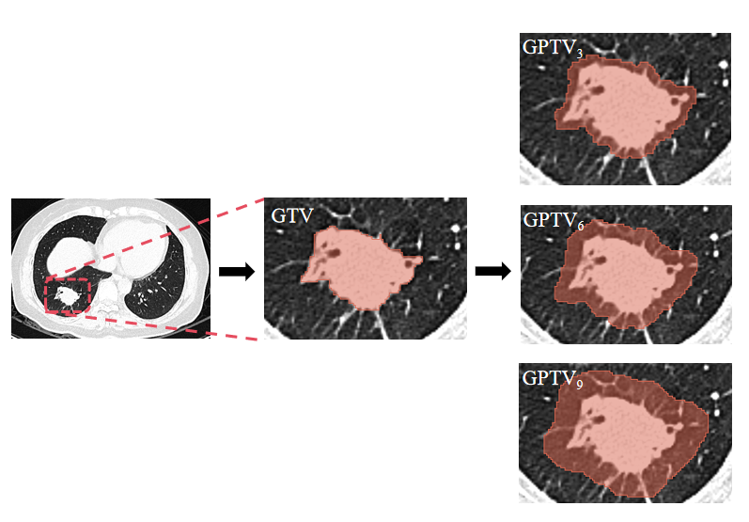
Figure S2. LASSO coefficient distributions of radiomics features for each VOI (A-D). L1 regularizer was used as the cost function, and the error value of cross validation is 5, and the maximum number of iterations is 1000.
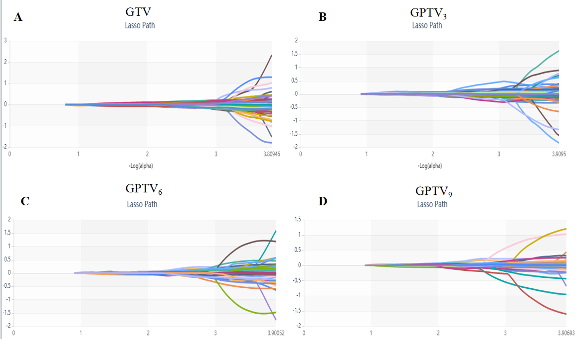
Figure S3. The performance of GTV, GPTV₃, GPTV₆, and GPTV₉ radiomics signatures in all cohorts. The ROC curves of 4 different radiomics signatures in training cohort (A), internal validation cohort (B), external validation cohort 1 (C), and external validation cohort 2 (D).
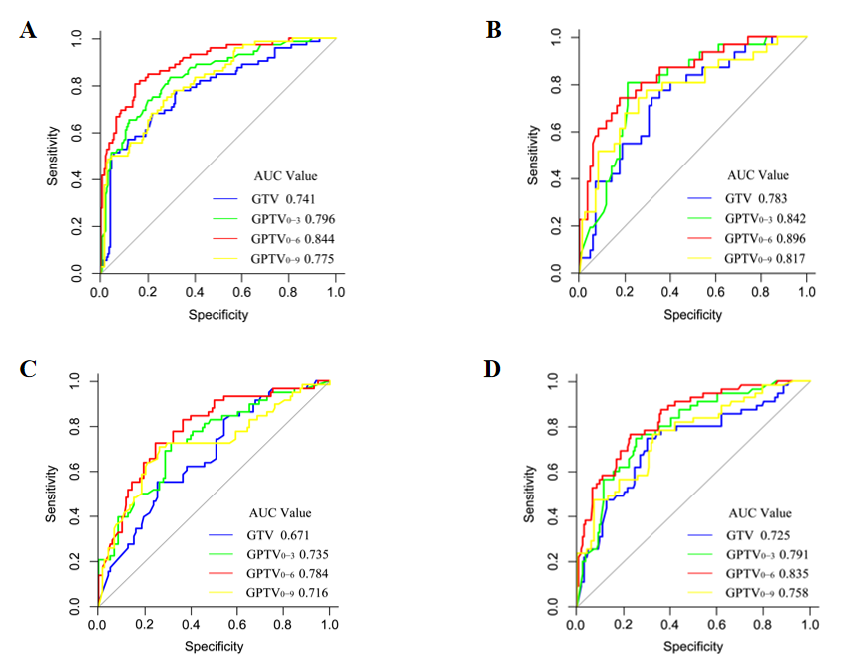

Figure S4. The nomogram to predict the epresion level of Ki-67 in patients with lung adenocarcinoma. Draw a line straight upward to the points’ axis to determine the points of each variable, add the points, and locate the final sum on the axis of total points. Finally, draw a line straight down to find the patient’s probability of Ki-67＞10%.

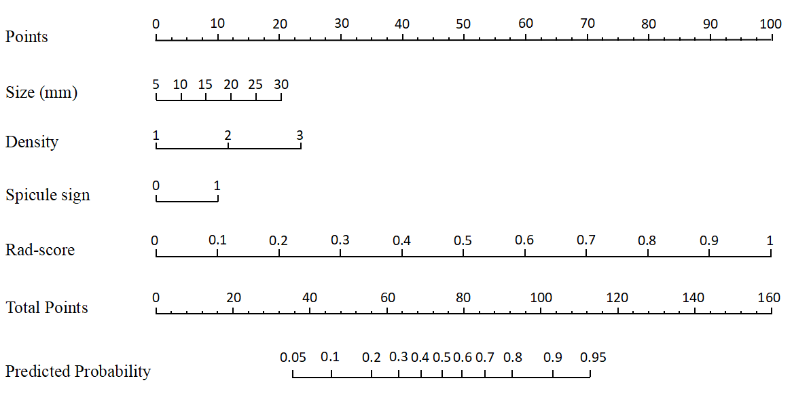
Figure S5. The performance of clinical model, GPTV₆ radiomics model, and nomogram in all cohorts. The ROC curves of three different models in training cohort (A), internal validation cohort (B), external validation cohort 1 (C), and external validation cohort 2 (D)
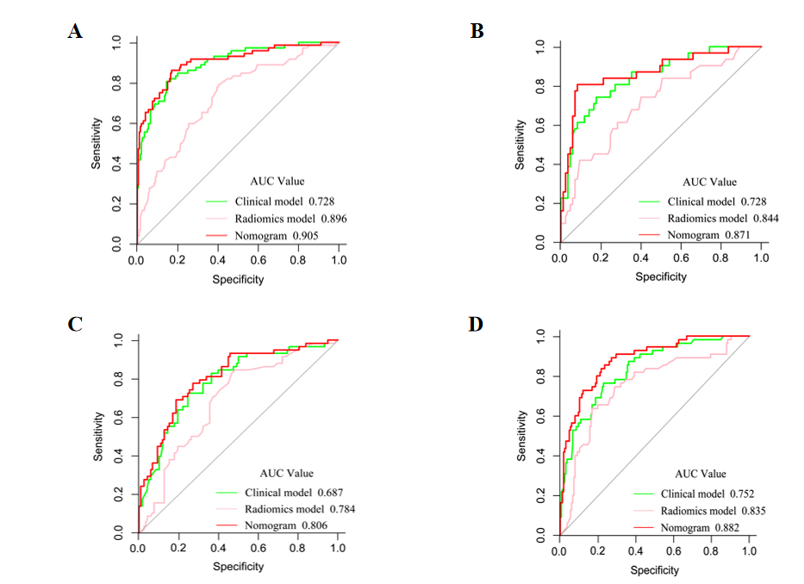

Figure S6. The performance of clinical model, GPTV₆ radiomics model, nomogram was evaluated in the training cohort. The calibration curves (A), and DCA curves (B) of different models.
