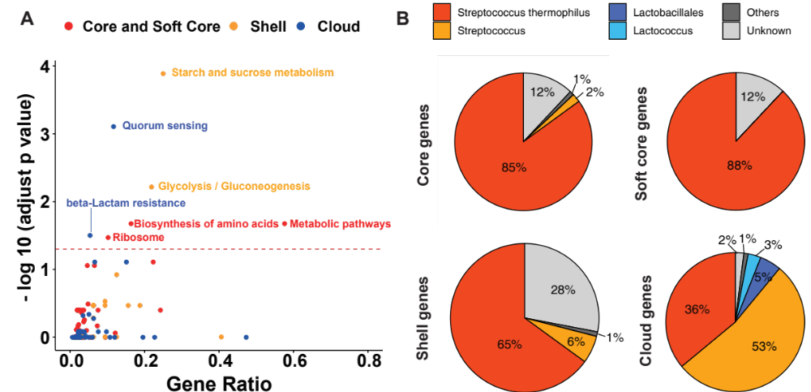
Figure S1. Pathway enrichment results and origin of genes in pan-genome. (A) Enriched KEGG pathway of pan-genome. (B) The origin of different gene type in pan-genome.

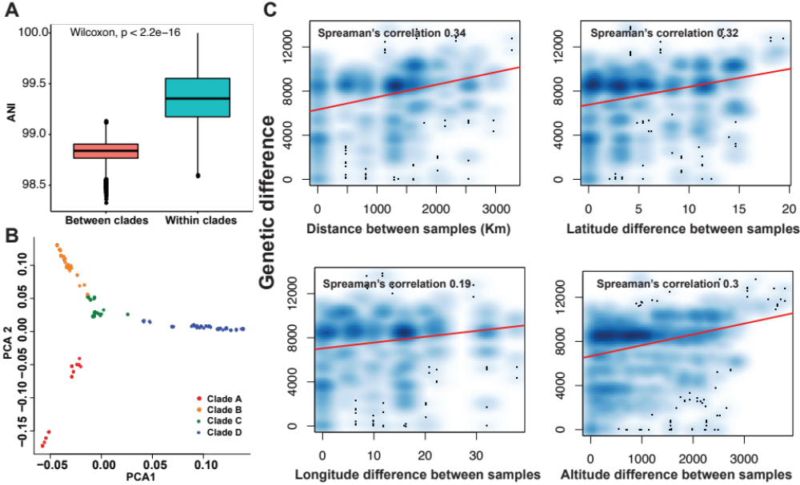

Figure S2. Genetic difference between 185 isolates. (A) Average nucleotide identity (ANI) between clades are significantly smaller than within clades. (B) Dimension reduction by principle component analysis for SNPs of 185 isolates. (C) Genetic differences (measured by the number of different SNPs between isolates) are related with geographical distance, latitude, longitude and altitude of sampling sites.

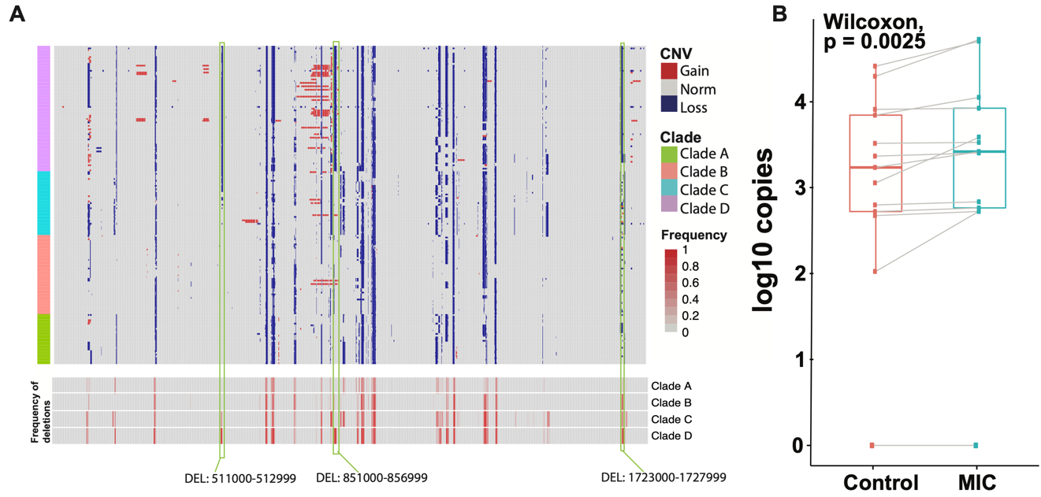

Figure S3. Genome decay of clade D and ddPCR result for CatB8. (A) CNVs for each strain (top) and the frequency of deletions for each clade (bottom). (C) Result of ddPCR for CatB8 genes of 13 samples.

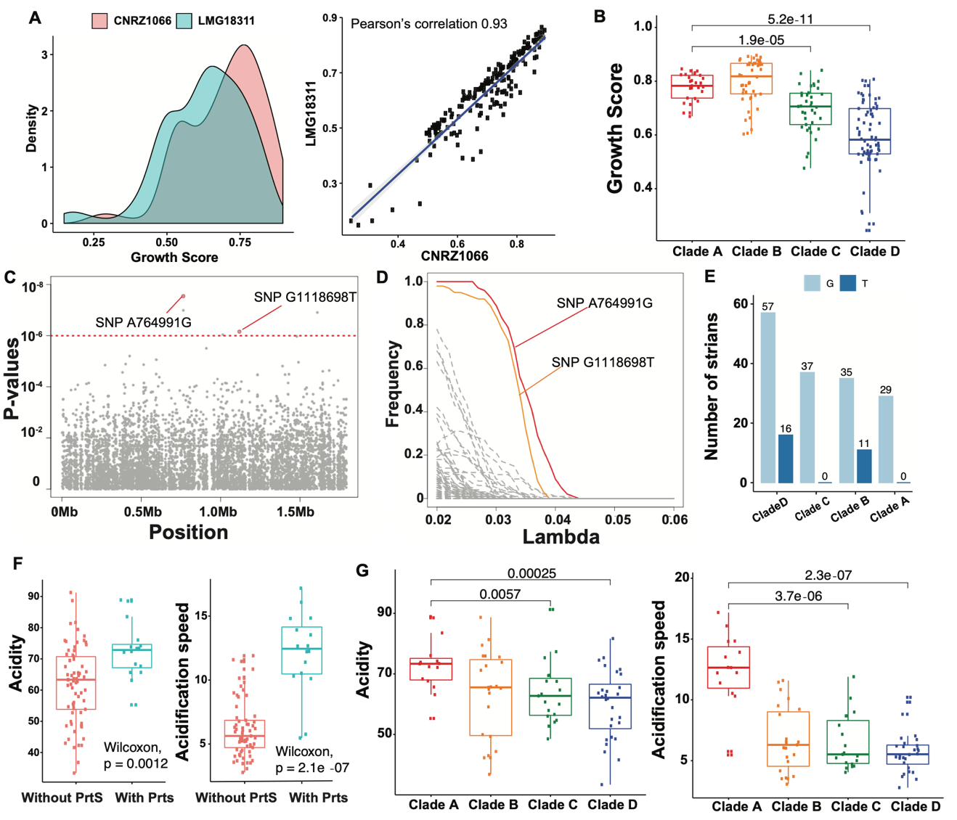

Figure S4. Growth score and acidification of Streptococcus thermophilus. (A) Growth score calculated with different references showed high similarity. (B) Boxplots of growth scores in different clades. (C) The Manhattan plot of the GWAS analysis. (D) Selection path from the stability selection. SNP A764991G and G1118698T had the highest selection probabilities. (E) Number of strains with/without the SNP G1118698T in different clades. (F) Boxplots of acidity and acidification speed between isolates with or without the gene PrtS. (G) Boxplots of acidity and acidification speed in different clades.

