Extended Data Figures and Tables
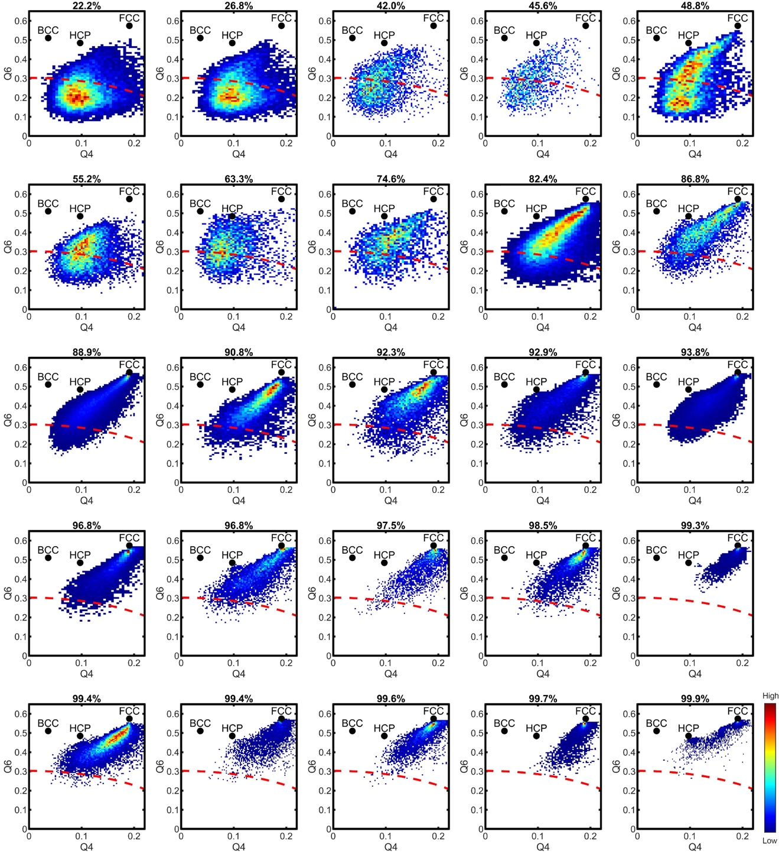
Extended Data Fig. 1 | Histograms of the BOO parameters for HEA1-25. The degree of crystallinity, defined as the percentage of atoms in each nanoparticle with BOO ≥ 0.5, gradually increases from 22.2% in HEA1 to 99.9% in HEA25. The red dashed curves mark the normalized BOO of 0.5.

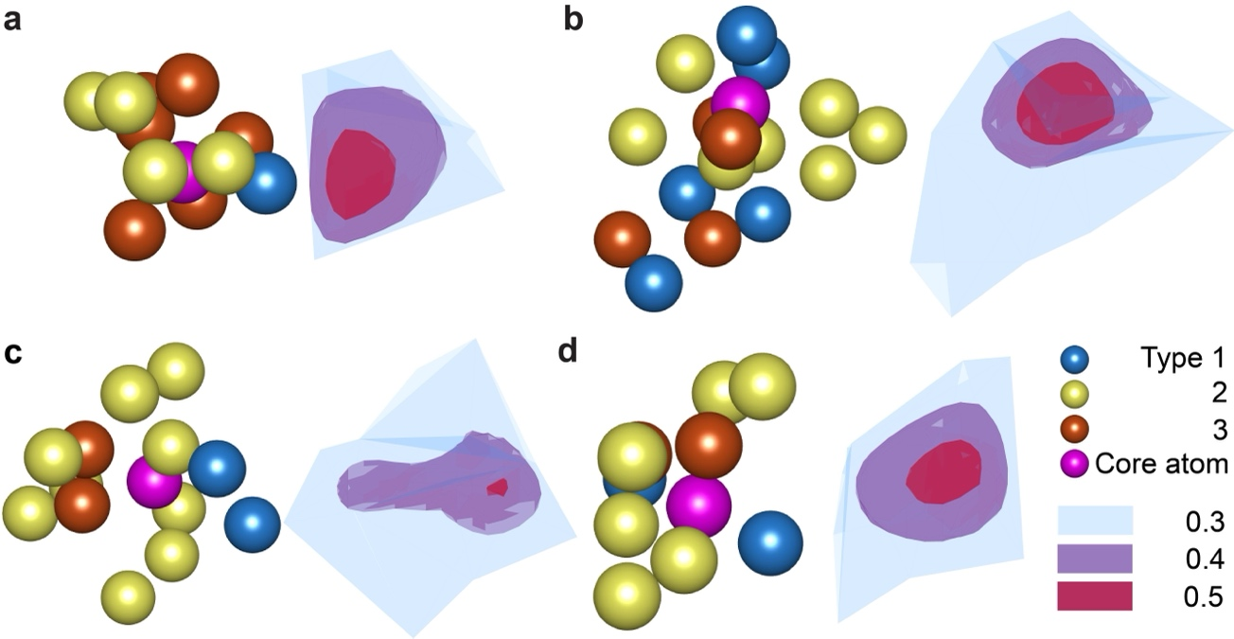

Extended Data Fig. 2 | Four representative smallest nuclei. a-d, Each nucleus consists of a core atom with BOO = 0.5, surrounded by atoms with BOO < 0.5. Iso-surface renderings illustrate BOO values of 0.3 (blue), 0.4 (purple), and 0.5 (red).

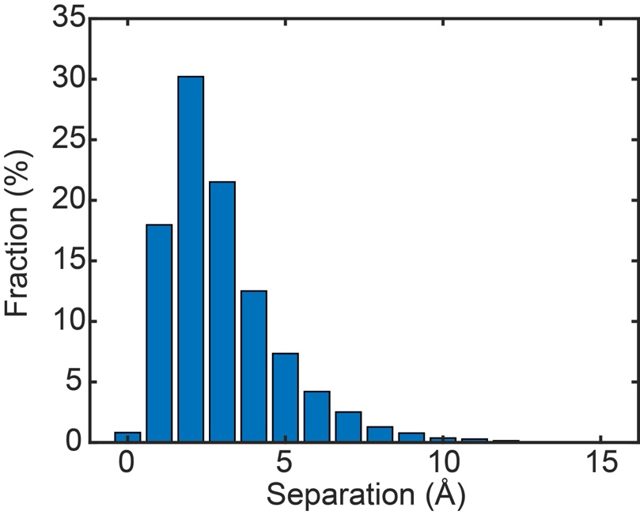
Extended Data Fig. 3 | Histogram illustrating the separation between nuclei cores and their geometric centers. While the cores are not necessarily located at the geometrical centers, the majority of nuclei (73.5%) have cores situated nearby, with separations less than the first nearest-neighbor atomic distance of 3.68 Å. Note that nuclei consisting of only a single atom with a BOO ≥ 0.5 were excluded from this analysis.

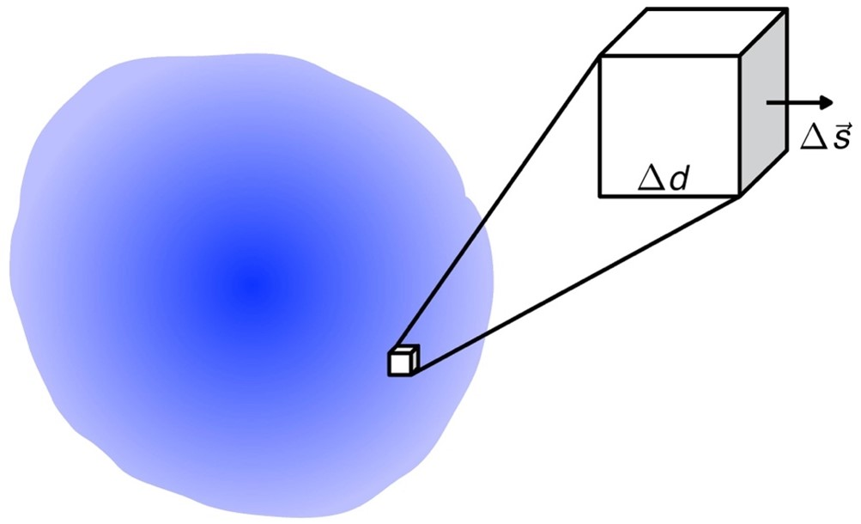
Extended Data Fig. 4 | Schematic of a nucleus with varying order parameter values. The nucleus is divided into many small volumes, each with an area Δs and a width Δd, for the calculation of the interfacial energy.

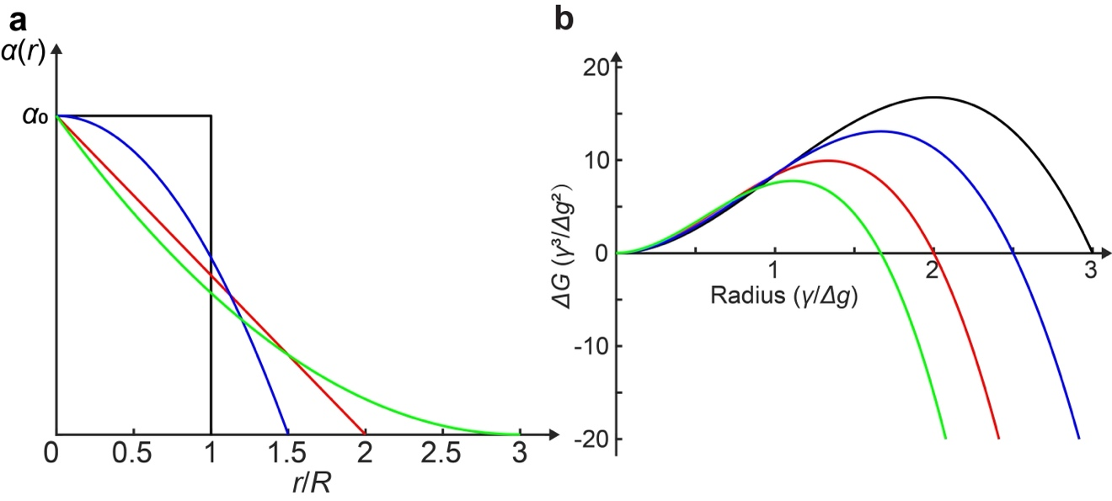
Extended Data Fig. 5 | Schematic of the nucleation energy barrier in GNP. a, Four specific cases of the order parameter distribution (α): the Heaviside step function (black), a linear function (red), and two parabolic functions (blue and green), where α₀ is a constant. b, Total free energy change as a function of radial distance, calculated from the Heaviside step function (black), the linear function (red), and the two parabolic functions (blue and green) in (a) using GNP of Eq. (1). As the order parameter distribution in (a) extends further along the radial direction, the nucleation energy barrier increases gradually from the green to the red, blue, and black curves in (b).
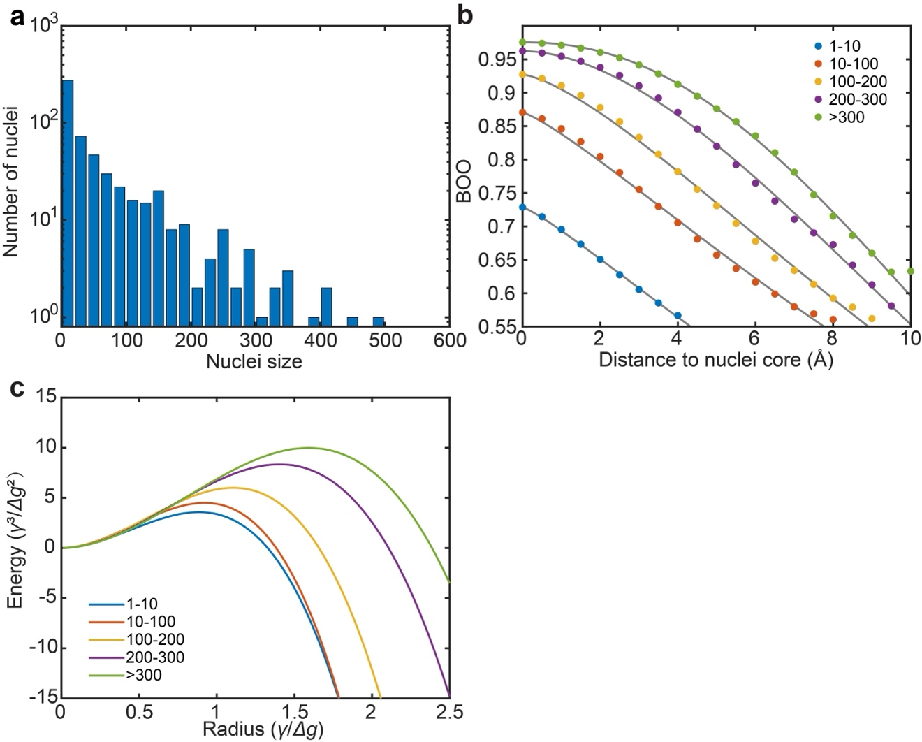
Extended Data Fig. 6 | Analysis of 498 nuclei from six NiPdPt MEA nanoparticles. a, Exponential decrease in the number of nuclei as their size increases. b, Radial average BOO distribution as a function of the distance to the nuclei core in five groups of varying nuclei sizes: <10 (blue dots), 10-100 (red dots), 100-200 (yellow dots), 200-300 (purple dots), and >300 (green dots). The solid curves represent fits to a generalized Gaussian distribution function. c, Total free energy change as a function of radial distance, calculated by incorporating the experimental data from (b) into Eq. (1), showing a gradual rise in the nucleation energy barrier.

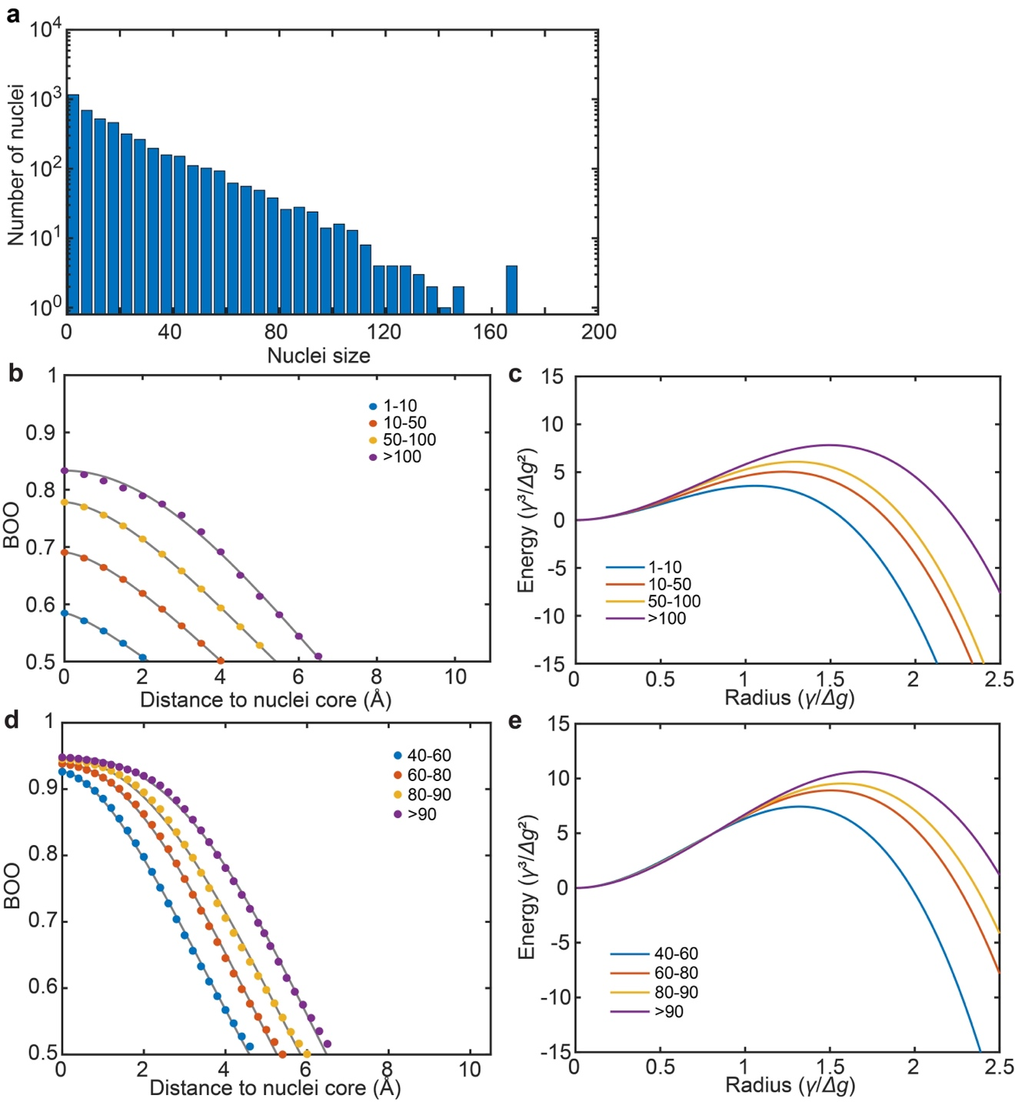
Extended Data Fig. 7 | AIMD simulations capturing the process of crystal nucleation in HEAs during cooling from 2300 K to 300 K. a, An exponential decrease in the number of nuclei is observed as a function of their size. b, Radial average BOO distribution plotted against the distance from the nuclei core, categorized into four groups based on nuclei size, with solid curves representing fits to a generalized Gaussian distribution function. c, Total free energy change as a function of radial distance, derived by applying the AIMD-simulated data from (b) into Eq. (1). d, Radial average BOO distribution, tracking the nucleus growth as temperature decreases from 1,300 K to 700 K. e, Total free energy variation as a function of radial distance from the nucleus, derived by applying the AIMD-simulated data from (d) into Eq. (1).

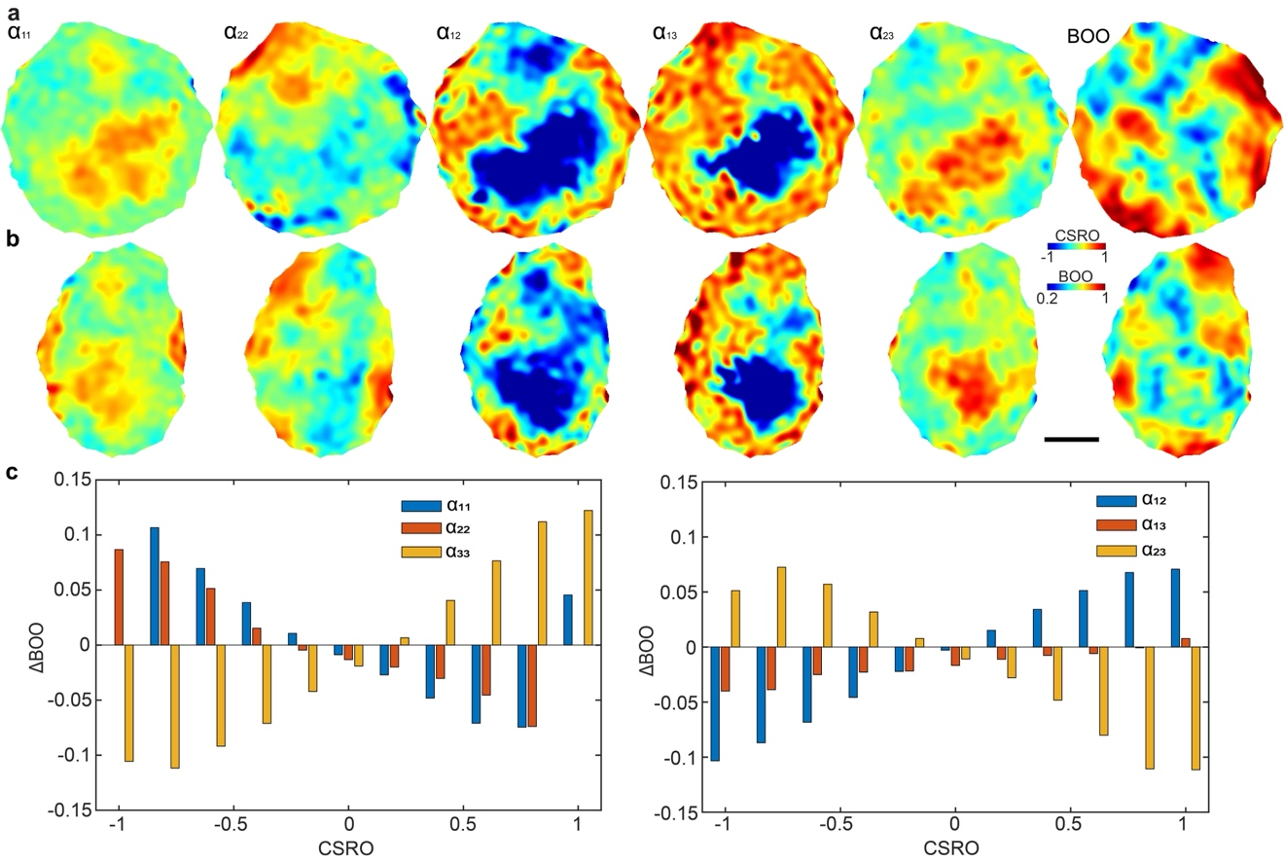
Extended Data Fig. 8 | Correlation between nucleation and local chemical order in HEAs. a, b, Representative slices in the XY (a) and XZ (b) planes, showing the distribution of five CSRO parameters ($α_{11}$, $α_{22}$, $α_{12}$, $α_{13}$, $α_{23}$) and BOO in HEA10. The other CSRO parameter ($α_{33}$) is displayed in Fig. 3. c, Relationship between BOO and six CSRO parameters, obtained by averaging the 25 HEA nanoparticles. Scale bar, 2 nm.
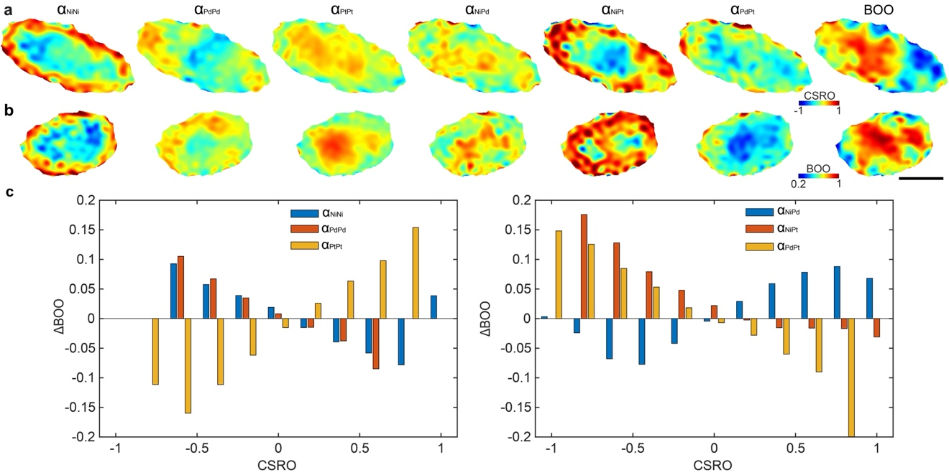
Extended Data Fig. 9 | Correlation between nucleation and local chemical order in NiPdPt MEAs. a, b, Representative slices in the XY (a) and XZ (b) planes show the distribution of six CSRO parameters ($α_{NiNi}$, $α_{PdPd}$, $α_{PtPt}$, $α_{NiPd}$, $α_{NiPt}$, $α_{PdPt}$) and BOO in an MEA nanoparticle. c, Relationship between BOO and the six CSRO parameters, obtained by averaging the six MEA nanoparticles. Scale bar, 2 nm
Extended Data Table 1 | AET data collection, processing, reconstruction, refinement, and statistics of the 25 HEA nanoparticles.
 | HEA1 | HEA2 | HEA3 | HEA4 | HEA5 | HEA6 | HEA7 | HEA8 | HEA9 | HEA10
Data collection and processing
Voltage (kV) | 200 | 200 | 200 | 200 | 200 | 200 | 200 | 200 | 200 | 200
Convergence semi-angle (mrad) | 25 | 25 | 25 | 25 | 25 | 25 | 25 | 25 | 25 | 25
Probe size (Å) | 0.8 | 0.8 | 0.8 | 0.8 | 0.8 | 0.8 | 0.8 | 0.8 | 0.8 | 0.8
Detector inner angle (mrad) | 38 | 38 | 38 | 38 | 38 | 38 | 38 | 38 | 38 | 38
Detector outer angle (mrad) | 190 | 190 | 190 | 190 | 190 | 190 | 190 | 190 | 190 | 190
Depth of focus (nm) | 8 | 8 | 8 | 8 | 8 | 8 | 8 | 8 | 8 | 8
Pixel size (Å) | 0.347 | 0.347 | 0.347 | 0.347 | 0.347 | 0.347 | 0.347 | 0.347 | 0.347 | 0.347
# of images | 55 | 54 | 50 | 51 | 52 | 46 | 54 | 54 | 55 | 54
# of frames/angle | 4 | 4 | 3 | 3 | 3 | 3 | 3 | 3 | 4 | 3
Tilt range (°) | -69.4 | -74.7 | -65.1 | -69.3 | -67.1 | -58.7 | -71.7 | -72.5 | -69.2 | -67.9
 | +72.6 | +63.6 | +71.5 | +63.4 | +69.2 | +74.9 | +69.4 | +63.4 | +72.1 | +70.7
Total electron dose (10⁵ e/Å²) | 9.5 | 9.3 | 7.0 | 7.1 | 7.3 | 6.4 | 7.6 | 7.6 | 10.2 | 7.5
Reconstruction
Algorithm | RESIRE | RESIRE | RESIRE | RESIRE | RESIRE | RESIRE | RESIRE | RESIRE | RESIRE | RESIRE
Oversampling ratio | 4 | 4 | 4 | 4 | 4 | 4 | 4 | 4 | 4 | 4
Number of iterations | 200 | 200 | 200 | 200 | 200 | 200 | 200 | 200 | 200 | 200
Refinement
R₁ (%)ª | 9.54 | 9.97 | 9.87 | 12.32 | 10.69 | 9.58 | 10.90 | 11.57 | 7.44 | 8.49
R (%)^{b} | 6.45 | 5.84 | 7.06 | 9.87 | 7.76 | 6.41 | 7.68 | 8.98 | 4.12 | 6.26
B’ factors (Å²)
Type 1 | 48.9 | 53.0 | 56.7 | 55.4 | 55.2 | 55.7 | 44.0 | 48.4 | 47.1 | 43.0
Type 2 | 46.4 | 54.6 | 56.6 | 47.3 | 46.3 | 54.4 | 44.0 | 44.3 | 53.8 | 49.7
Type 3 | 52.3 | 59.9 | 54.0 | 37.4 | 43.0 | 57.0 | 40.9 | 39.6 | 38.1 | 38.4
Statistics
# of atoms
Total | 18356 | 18483 | 4640 | 2063 | 9755 | 11055 | 4661 | 3447 | 31235 | 8065
Type 1 | 8322 | 7467 | 1339 | 648 | 3901 | 4206 | 1079 | 1116 | 8017 | 1962
Type 2 | 6896 | 6936 | 1865 | 937 | 4213 | 4490 | 1906 | 1327 | 13389 | 3180
Type 3 | 3138 | 4080 | 1436 | 478 | 1641 | 2359 | 1676 | 1004 | 9829 | 2923

Extended Data Table 1 | (continued)
 | HEA11 | HEA12 | HEA13 | HEA14 | HEA15 | HEA16 | HEA17 | HEA18 | HEA19 | HEA20
Data collection and processing
Voltage (kV) | 300 | 200 | 200 | 200 | 300 | 200 | 200 | 200 | 200 | 200
Convergence semi-angle (mrad) | 17 | 25 | 25 | 25 | 17 | 25 | 25 | 25 | 25 | 25
Probe size (Å) | 0.7 | 0.8 | 0.8 | 0.8 | 0.7 | 0.8 | 0.8 | 0.8 | 0.8 | 0.8
Detector inner angle (mrad) | 30 | 38 | 38 | 38 | 30 | 38 | 38 | 38 | 38 | 38
Detector outer angle (mrad) | 195 | 190 | 190 | 190 | 195 | 190 | 190 | 190 | 190 | 190
Depth of focus (nm) | 14 | 8 | 8 | 8 | 14 | 8 | 8 | 8 | 8 | 8
Pixel size (Å) | 0.469 | 0.347 | 0.347 | 0.347 | 0.469 | 0.347 | 0.347 | 0.347 | 0.347 | 0.347
# of images | 52 | 52 | 54 | 56 | 53 | 51 | 53 | 51 | 53 | 59
# of frames/angle | 4 | 3 | 3 | 3 | 3 | 3 | 3 | 4 | 3 | 3
Tilt range (°) | -72.6 | -70.3 | -69.6 | -69.6 | -72.6 | -69.1 | -69.6 | -69.3 | -71.7 | -66.6
 | +67.4 | +66.3 | +74.0 | +71.8 | +66.4 | +64.7 | +74.0 | +63.4 | +69.4 | +78.0
Total electron dose (10⁵ e/Å²) | 3.4 | 7.2 | 7.6 | 7.8 | 3.5 | 7.1 | 7.4 | 9.5 | 7.4 | 8.2
Reconstruction
Algorithm | RESIRE | RESIRE | RESIRE | RESIRE | RESIRE | RESIRE | RESIRE | RESIRE | RESIRE | RESIRE
Oversampling ratio | 4 | 4 | 4 | 4 | 4 | 4 | 4 | 4 | 4 | 4
Number of iterations | 200 | 200 | 200 | 200 | 200 | 200 | 200 | 200 | 200 | 200
Refinement
R₁ (%)^{b} | 7.43 | 13.02 | 8.46 | 7.61 | 6.81 | 11.79 | 9.38 | 9.95 | 7.62 | 6.10
R (%)^{c} | 4.39 | 11.19 | 5.89 | 5.10 | 3.95 | 8.77 | 7.46 | 6.48 | 5.66 | 3.16
B’ factors (Å²)
Type 1 | 33.9 | 33.7 | 45.8 | 53.8 | 42.1 | 31.0 | 35.5 | 33.9 | 55.6 | 51.8
Type 2 | 35.1 | 32.5 | 46.4 | 56.4 | 44.2 | 31.1 | 34.5 | 32.8 | 58.0 | 50.4
Type 3 | 31.6 | 33.9 | 40.9 | 39.1 | 36.0 | 30.7 | 34.6 | 29.9 | 42.1 | 45.2
Statistics
# of atoms
Total | 101881 | 11223 | 10053 | 12245 | 72680 | 12244 | 7739 | 3696 | 6648 | 28916
Type 1 | 23644 | 4737 | 2638 | 2547 | 15748 | 5055 | 2158 | 872 | 1579 | 5846
Type 2 | 46432 | 4206 | 3830 | 5264 | 32908 | 4639 | 2750 | 1735 | 2430 | 12227
Type 3 | 31805 | 2280 | 3585 | 4434 | 24024 | 2550 | 2831 | 1089 | 2639 | 10843

Extended Data Table 1 | (continued)
 | HEA21 | HEA22 | HEA23 | HEA24 | HEA25
Data collection and processing
Voltage (kV) | 200 | 200 | 200 | 200 | 200
Convergence semi-angle (mrad) | 25 | 25 | 25 | 25 | 25
Probe size (Å) | 0.8 | 0.8 | 0.8 | 0.8 | 0.8
Detector inner angle (mrad) | 38 | 38 | 38 | 38 | 38
Detector outer angle (mrad) | 190 | 190 | 190 | 190 | 190
Depth of focus (nm) | 8 | 8 | 8 | 8 | 8
Pixel size (Å) | 0.347 | 0.347 | 0.347 | 0.347 | 0.347
# of images | 53 | 56 | 56 | 53 | 52
# of frames/angle | 4 | 3 | 3 | 3 | 3
Tilt range (°) | -65.8 | -66.6 | -72.0 | -71.0 | -70.1
 | +72.5 | +75.8 | +72.0 | +73.0 | 66.1
Total electron dose (10⁵ e/Å²) | 9.8 | 7.8 | 7.8 | 7.4 | 7.2
Reconstruction
Algorithm | RESIRE | RESIRE | RESIRE | RESIRE | RESIRE
Oversampling ratio | 4 | 4 | 4 | 4 | 4
Number of iterations | 200 | 200 | 200 | 200 | 200
Refinement
R₁ (%)^{b} | 6.44 | 7.90 | 8.21 | 7.07 | 12.39
R (%)^{c} | 4.61 | 5.60 | 5.84 | 5.35 | 10.28
B’ factors (Å²)
Type 1 | 38.1 | 41.6 | 35.5 | 40.9 | 24.6
Type 2 | 37.9 | 37.6 | 34.5 | 39.5 | 25.5
Type 3 | 36.1 | 36.3 | 34.6 | 39.8 | 29.2
Statistics
# of atoms
Total | 21177 | 5672 | 6037 | 10232 | 4292
Type 1 | 4865 | 1124 | 1446 | 3138 | 1903
Type 2 | 8861 | 2356 | 2045 | 3898 | 1431
Type 3 | 7451 | 2192 | 2546 | 3196 | 958
ªThe R₁-factor is defined as Eq. (5) in ref. 50.
^{b}The R-factor is defined in Eq. (4) in ref. 37.

Extended Data Table 2 | Parameters for fitting experimentally measured BOO data to a generalized Gaussian distribution function.

 | Nuclei size* | $$α_{0}$$ | R | $$β$$
HEA | 1-10 | 0.63 | 9.8 | 1.27
HEA | 10-100 | 0.79 | 13.1 | 1.29
HEA | 100-500 | 0.89 | 14.9 | 1.33
HEA | 500-1000 | 0.96 | 14.6 | 1.64
HEA | >1000 | 0.98 | 13.5 | 2.66
MEA | 1-10 | 0.73 | 12.6 | 1.19
MEA | 10-100 | 0.87 | 14.7 | 1.22
MEA | 100-200 | 0.93 | 14.2 | 1.40
MEA | 200-300 | 0.96 | 13.9 | 1.81
MEA | >300 | 0.98 | 13.8 | 2.20
*Each number indicates the number of atoms in each nucleus with BOO ≥ 0.5.

