Supplementary Figures. Raw data of western blotting
- Drp1 of mouse ovary samples in Fig.2G
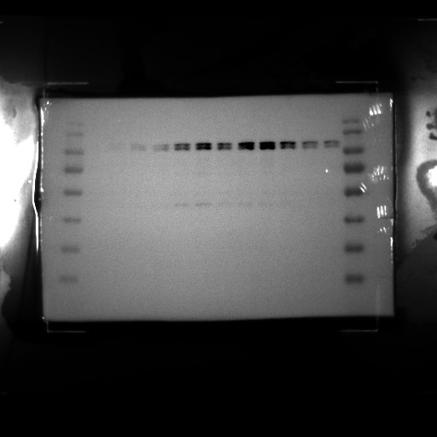

- VDAC1 of mouse ovary samples in Fig.2G
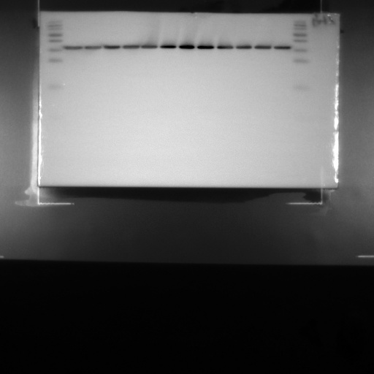

- Drp1 of KGN cell samples in Fig.3A
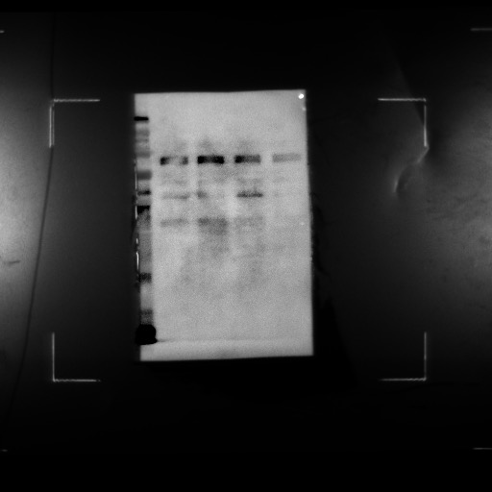

- VDAC1 of KGN cell samples in Fig.3A
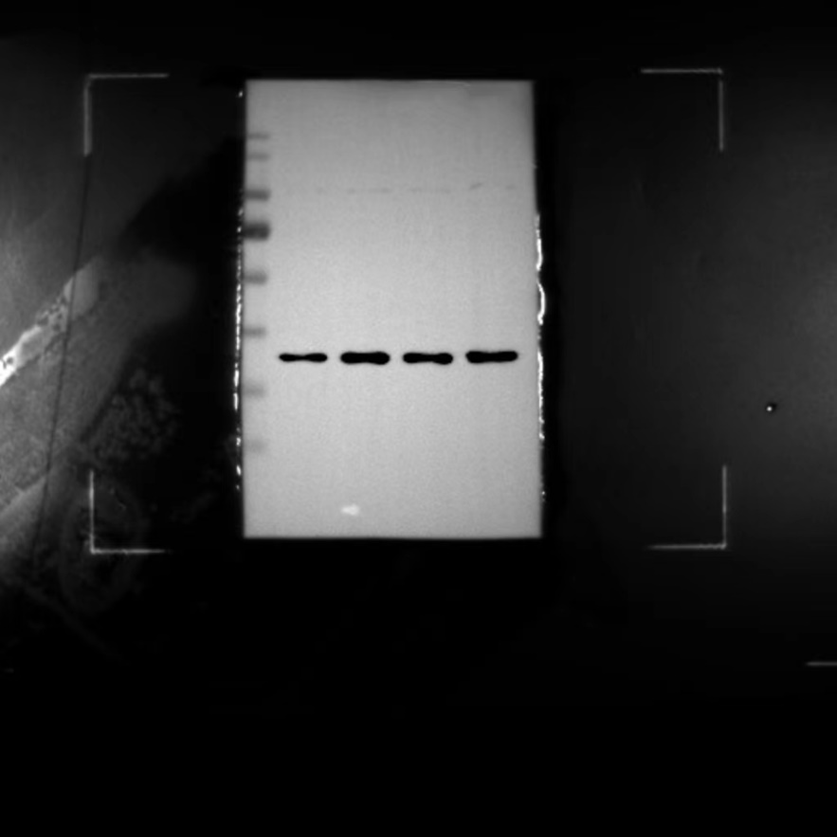

- Drp1 of mouse ovary samples in Fig.4D
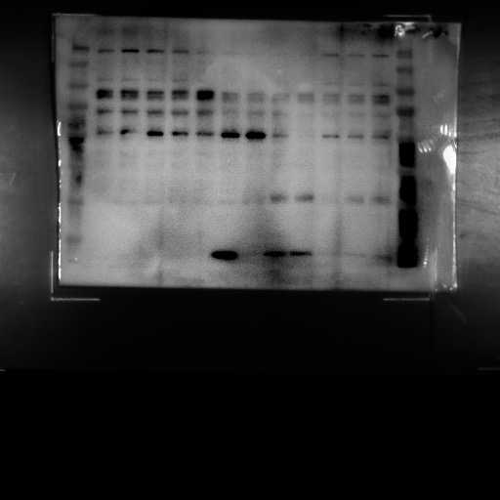

- VDAC1 of mouse ovary samples in Fig.4D
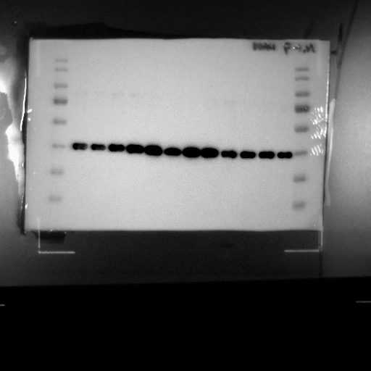

- SIRT1 of KGN cell samples in Fig.5A
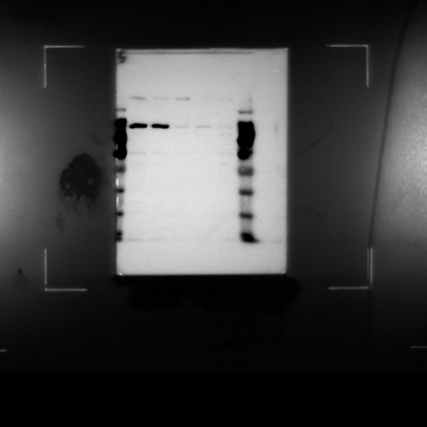

- GAPDH of KGN cell samples in Fig.5A

- SIRT1 of KGN cell samples in Fig.5B
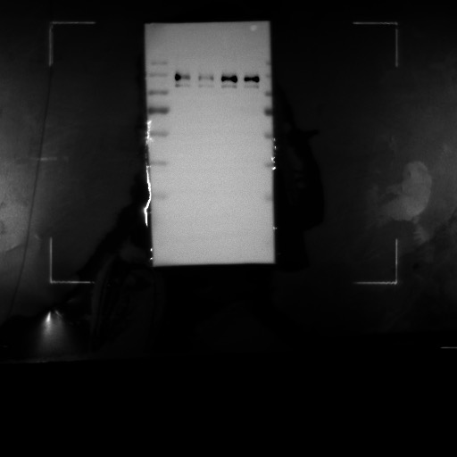

- GAPDH of KGN cell samples in Fig.5B
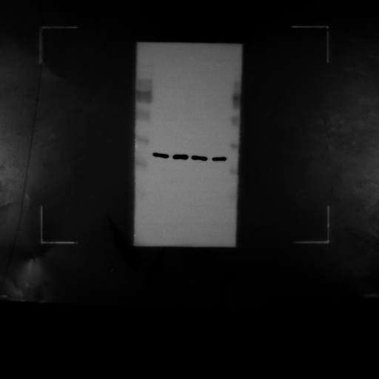

- Drp1 of KGN cell samples in Fig.5D
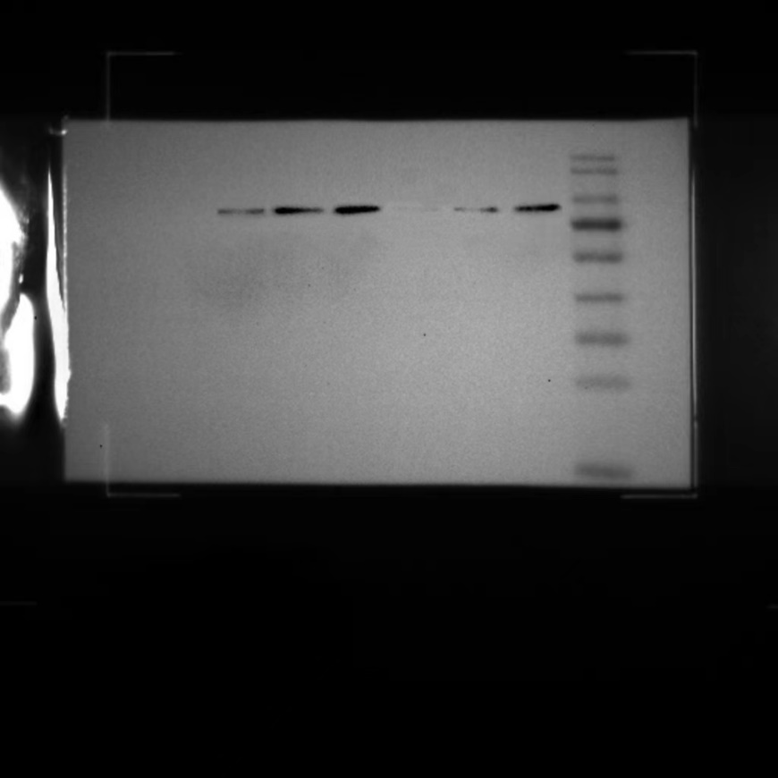

- VDAC1 of KGN cell samples in Fig.5D
