Internal Stress-Free Phosphoric Acid Doped Polybenzimidazole Membranes for High Temperature Proton Exchange Membrane Fuel Cells

Guoliang Liu, ^{1, 2, ⊥} Shiying Tu, ^{1, 3, ⊥} Ailian Wang, ⁴ Hongfei Pan, ^{1, 3, 5} Wenxi Ji, ⁴ Longgui Zhang, ⁴ Taoyi Zhang, ⁴ Haining Zhang, ^{1, 3, *} Haoling Tang ^{1, 3, 5, *}

1 State Key Laboratory of Advanced Technology for Materials Synthesis and Processing, Wuhan University of Technology, Nr. 122 Luoshi Rd., Wuhan 430070, China
2 School of Chemistry and Material Science, Hubei Engineering University, Xiaogan, Hubei 432000, China
3 National Energy Key Laboratory for New Hydrogen-Ammonia Energy Technologies, Foshan Xianhu Laboratory, Foshan 528200, China
4 Sinopec (Beijing) Research Institute of Chemical Industry Co. Ltd, Beijing 100013, China
5 Hubei Key Laboratory of Fuel Cell Technology, Wuhan University of Technology, Wuhan 430070, China

⊥These authors contributed equally

*Correspondence: haining.zhang@whut.edu.cn, thln@whut.edu.cn

SUPPLEMENTARY FIGURES
Figure S1 Characterization of polymer. ¹H NMR (a) and FT-IR (b) of poly(4,4’-diphenylether-5,5’-bibenzimidazole). Molecular weight distribution (c) and TGA (d) curves of the synthesized OPBI in this work and commercial OPBI.

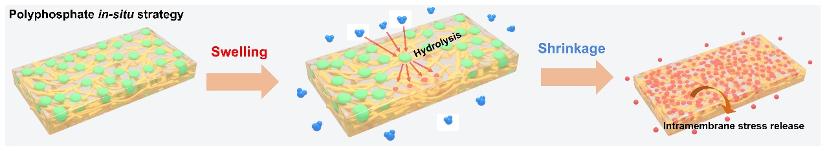
Figure S2 Phosphoric acid loss for commercial Celtec®-P membranes. Schematic illustration of spontaneous loss of phosphoric acid using polyphosphate in-situ strategy.

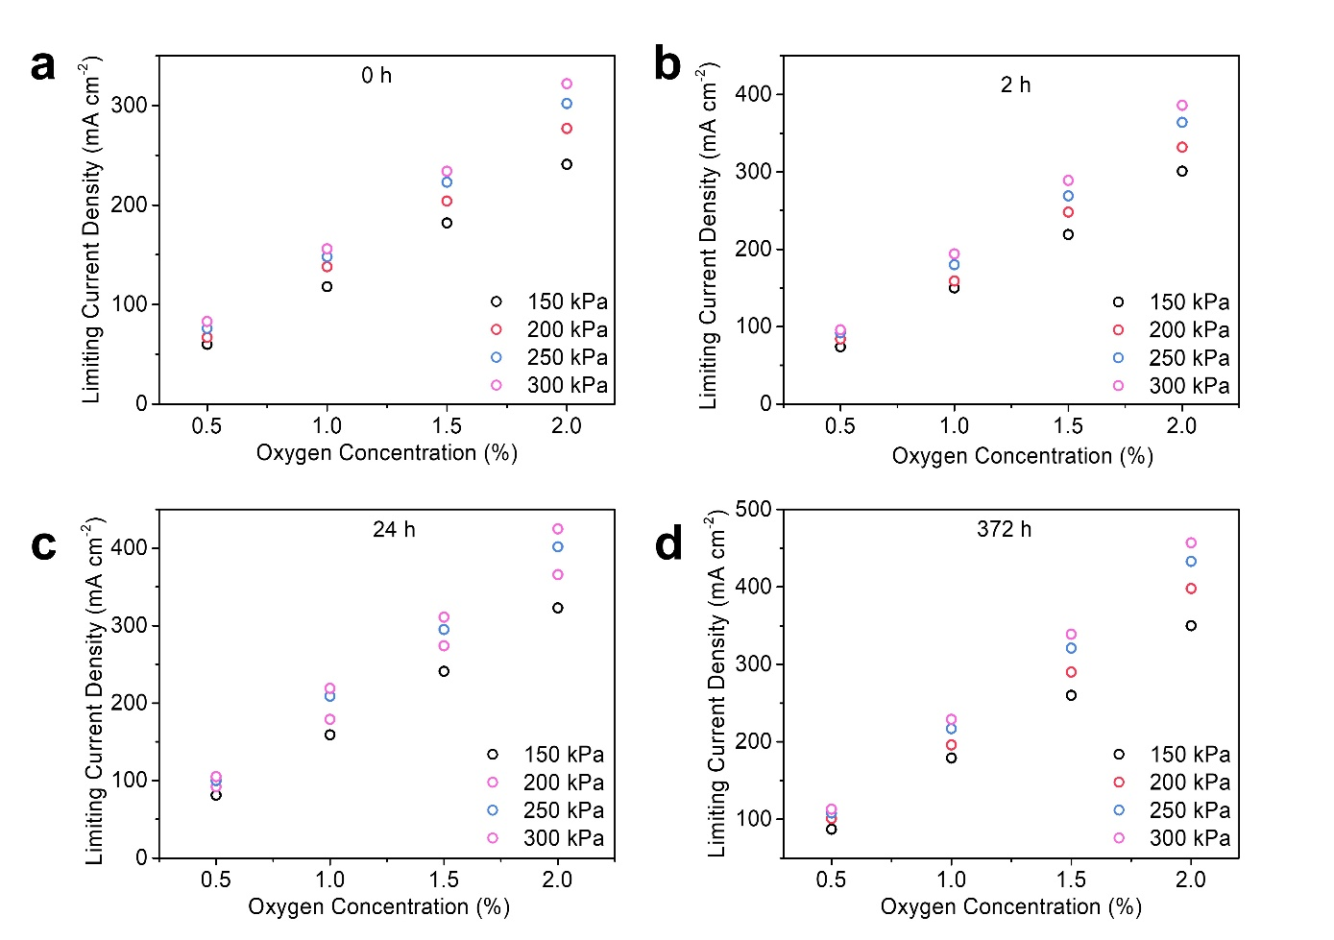
Figure S3 Limiting current density of MEA. Limiting current density during oxygen transport resistance testing of PA/OPBI membranes at intramembrane stress release time of 0 (a), 2 (b), 24 (c) and 372 h (d).

Figure S4 Polarization curves for calculation of limiting current density. Polarization curves under different back pressure with diluted oxygen as oxidant as indicated in the figure for MEAs assembled from membranes with various stress release time of 0 (a), 2 (b), 24 (c) and 372 h (d).

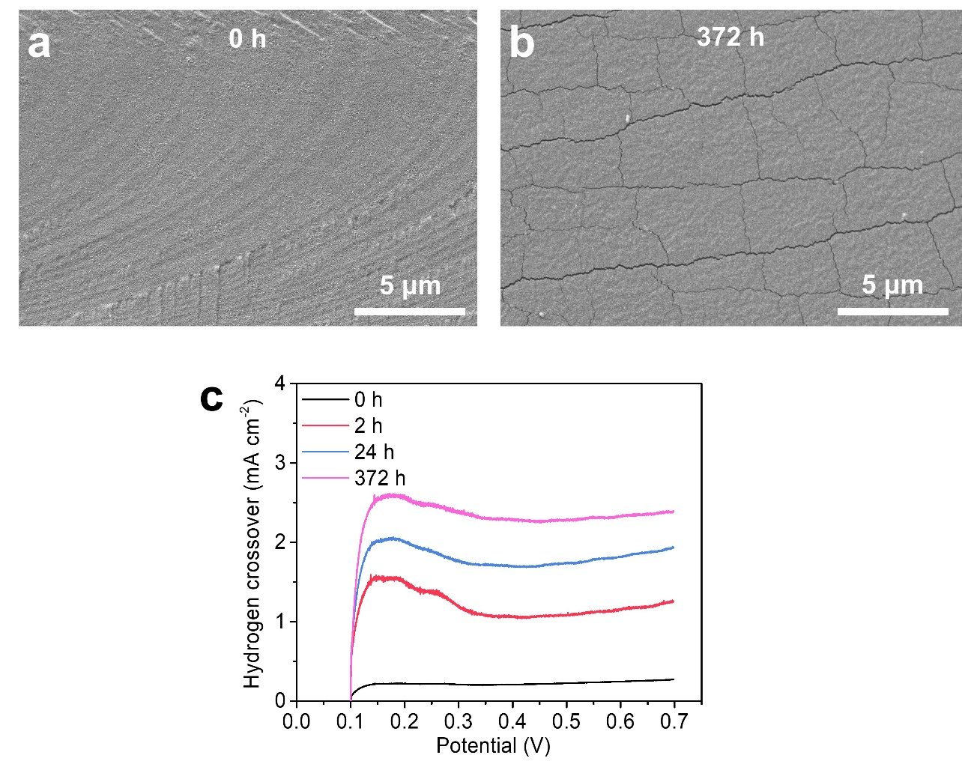
Figure S5 Morphology and hydrogen crossover of membranes. Cross-sectional SEM images of PA/OPBI membranes prepared by PA immersion strategy at intramembrane stress release time of 0 (a) and 372 h (b), .Hydrogen crossover current density (c) of HT-PEMFCs assembled with PA/OPBI membranes at intramembrane stress release time of 0, 2, 24 and 372 h.

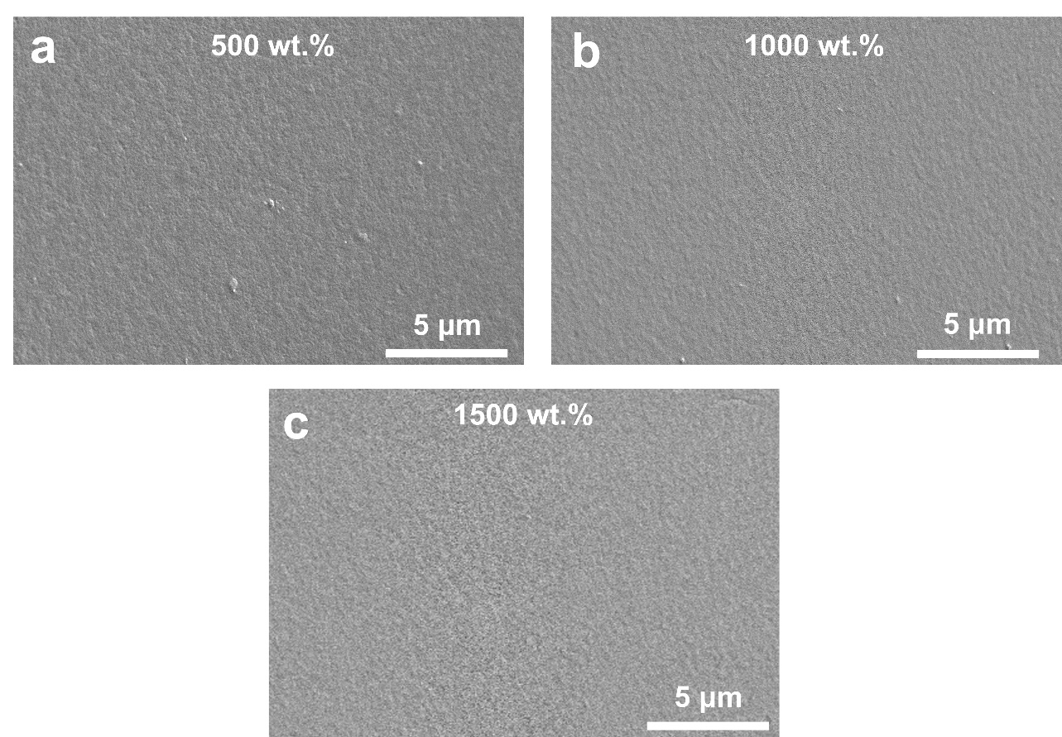
Figure S6 Morphology of Membranes. Cross-sectional SEM images of phosphoric acid-doped OPBI membranes prepared by in-situ solution casting strategy with phosphoric acid doping content of 500 (a) and 1000 (b) and 1500 wt.% (c).

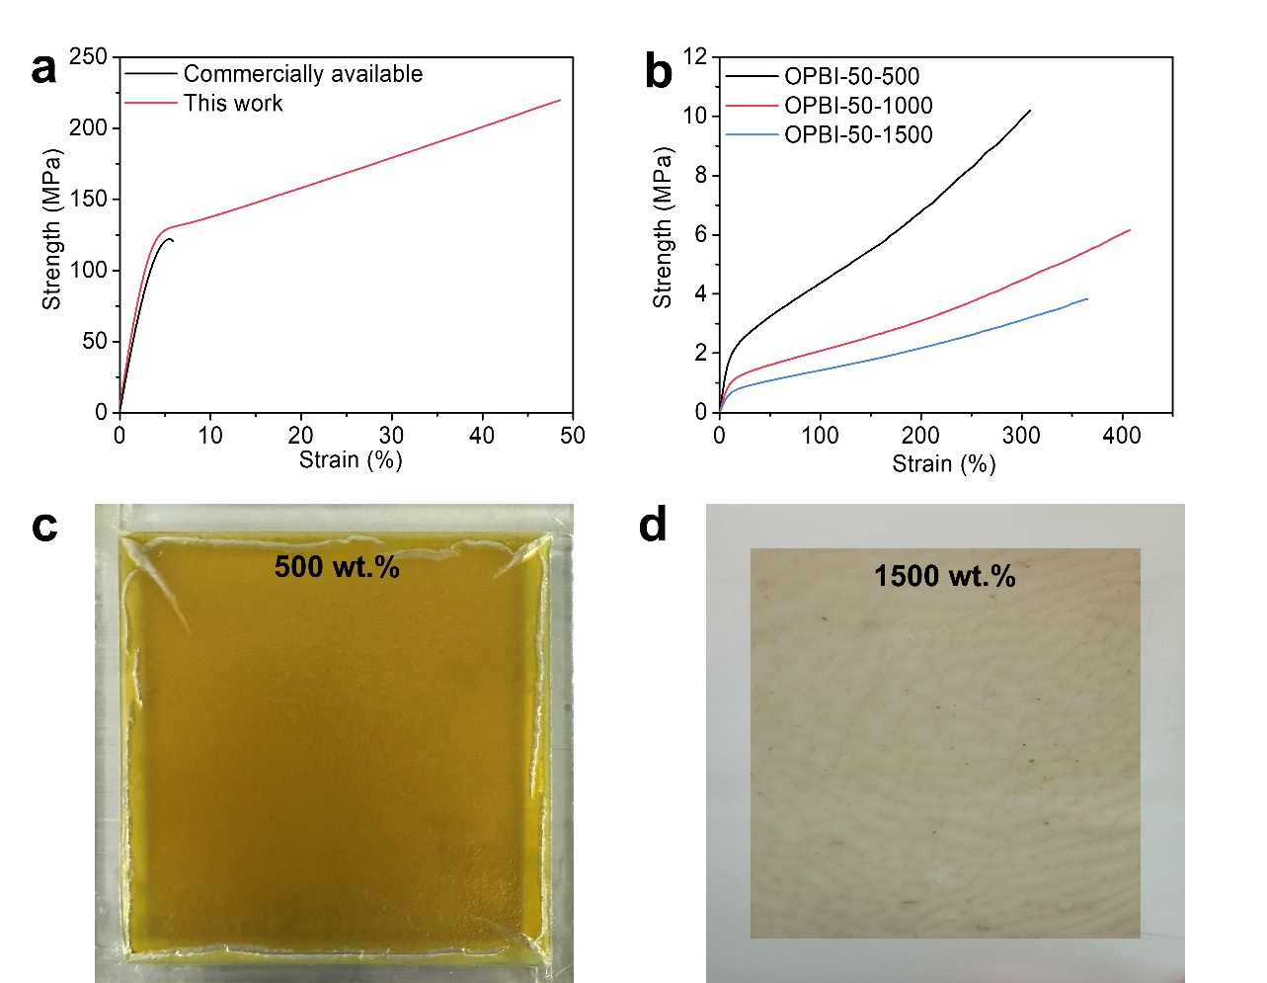
Figure S7 Properties of OPBI-x-y membranes. (a) Stress-strain curves of OPBI membranes using synthesized OPBI and commercial OPBI. (b) Stress-strain curves of OPBI-x-y membranes with similar membrane thickness and different phosphoric acid contents. (c) Optical photographs using commercial OPBI and ultra-high molecular OPBI (d) of phosphoric acid-doped OPBI membranes prepared by in-situ solution casting strategy.

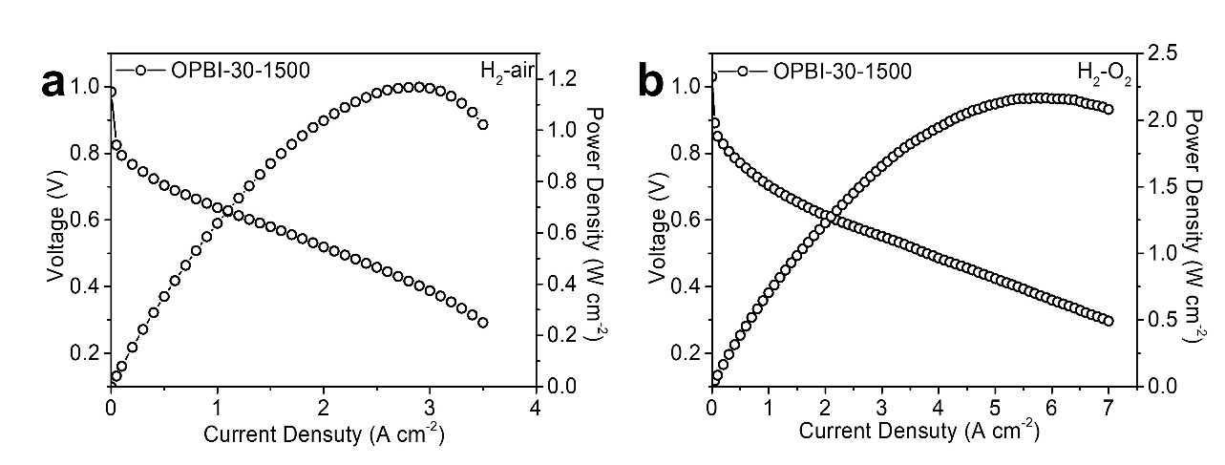
Figure S8 Single cell performance. Polarization and power density curves of the HT-PEMFCs assembled with OPBI-30-1500 membrane, depicted under H₂-air (a) and H₂-O₂ (b) fuel supplies at 160 ºC with backpressure of 200 kPa and stoichiometric of 1.5 and 2.

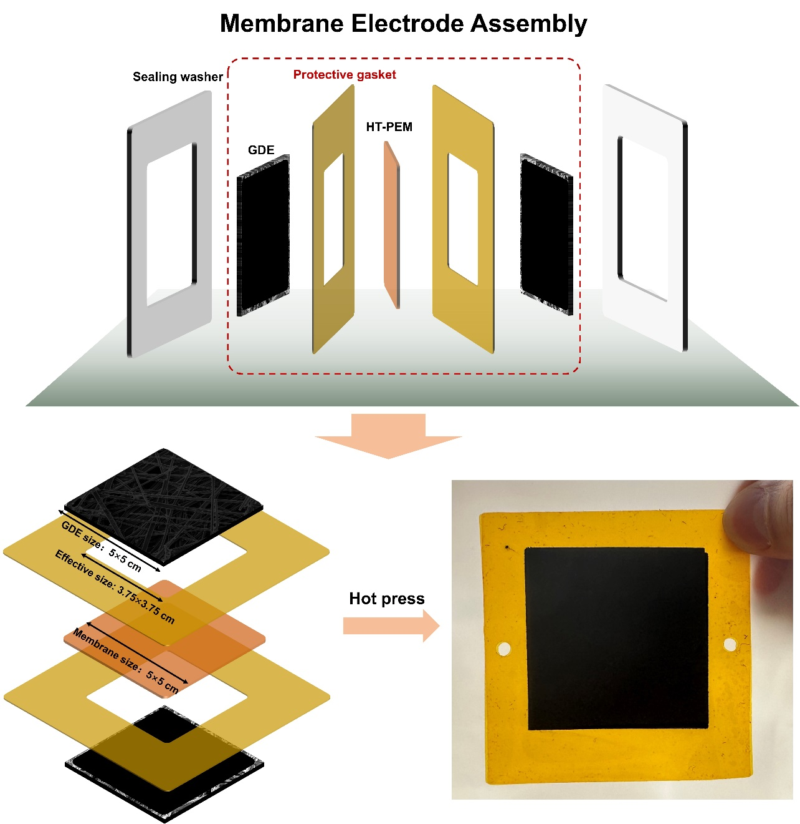
Figure S9 MEA fabrication. Schematic diagram and optical photograph of the composition and specific dimensions of the membrane electrode assembly in this work.

SUPPLEMENTARY TABLE
Table S1 | Molecular weight of commercially available OPBI and ultra-high molecular weight OPBI in this work.
Sample | Number-average molecular weight (g mol⁻¹) | Weight-average Molecular Weight (g mol⁻¹) | Z-average molecular weight (g mol⁻¹)
Commercially available | 66462 | 929362 | 3919173
This work | 177685 | 4347773 | 17107292

