Supplementary Information

CCDC120 Phase Separation Contributes to Desmosomal Integrity and Cardiac Function

Hui Meng, Wei Zhao, Yangyingzi Xi, Donghui Zhang, Xipan Han, Rixu Cong, Tianning Wang, Yingchun Hu, Yonglu Tian, Junlin Teng, Jianguo Chen, Ning Huang

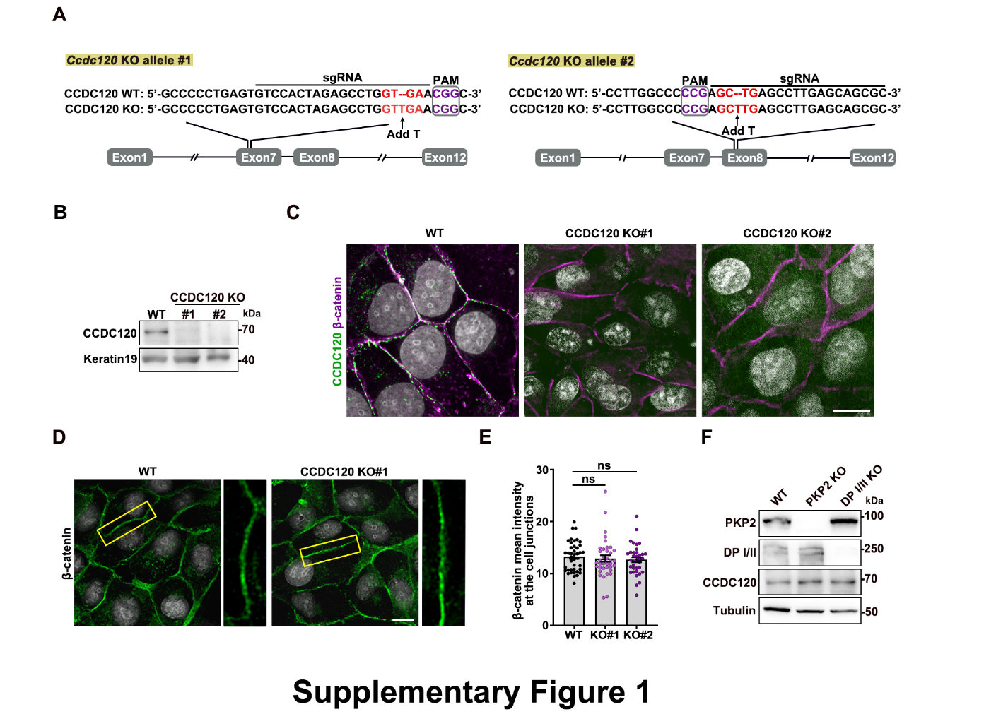
Supplementary Figure 1. CCDC120 is required for desmosomal component assembly. (A) Schematic representation of the genome sequence in wild-type (WT) and two different CCDC120 knock-out (KO) MDCK cells generated by CRISPR/Cas9. The sgRNA-targeting sequence is underlined, and the PAM sequence is labeled in magenta. The red characters and black arrows indicate gene editing sites. (B) Immunoblotting showing the total protein levels of CCDC120 in WT and CCDC120 KO MDCK cells. Keratin19 was used as the loading control. (C) Immunofluorescence of CCDC120 (green) and β-catenin (magenta) in WT and CCDC120 KO MDCK cells. Scale bars, 10 μm. (D) Immunostaining staining of β-catenin (green) in WT and CCDC120 KO MDCK cells. DNA was stained with DAPI (gray). Magnified views of the cell-cell boundary are shown on the right. Scale bars, 10 μm. (E) Quantification of the mean intensity of β-catenin signaling at cell borders from (D). More than 60 cell-cell borders from three independent experiments were analyzed. (F) Immunoblotting showing total protein levels of CCDC120, DP I/II, and PKP2 in WT, DP I/II, and PKP2 KO MDCK cells. Tubulin was used as a loading control. Data are presented as mean ± SEM. Statistical significance was assessed using one-way ANOVA with Dunnett’s multiple comparisons test. n.s., not significant.

Supplementary Figure 2. CCDC120 undergoes phase separation. (A) A representative image showing GFP-CCDC120 forming unique, large-size condensates (arrowheads) in the cytoplasm of HEK293T cells. Scale bar, 10 μm. (B, C) Time-lapse images (B) and quantification (C) of FRAP analysis of GFP-CCDC120 condensates (arrowheads) before and after photobleaching in the cytoplasm of HEK293T cells (n = 24 cells). Scale bar, 10 μm. Data are presented as mean ± SEM. (D) Live-cell imaging showing the dynamics of GFP-CCDC120 particles at cell junctions in HeLa cells. A magnified view of the cell-cell boundary is shown on the right. Fusion events are highlighted by arrowheads in different colors. Scale bar, 10 μm. (E) Schematic representation showing CCDC120 FL and its truncation mutants. (F) Expression of GFP-CCDC120 FL or its truncation mutants in MDCK cells. Scale bar, 10 μm. (G) Coomassie brilliant blue (CBB) showing different purified His-GFP-CCDC120 mutation proteins from E. coli. (H) Concentration-dependent phase separation assay of CCDC120-IDR1+2 in vitro. Scale bar, 5 μm.

Supplementary Figure 3. CCDC120 phase separation is mediated by IDR. (A, B) Representative images (A) and quantification (B) of HEK293T cells expressing GFP-CCDC120 FL or its truncated mutants. Arrows indicate condensates formed by GFP-CCDC120. Scale bar, 10 μm. More than 400 cells were analyzed from three independent experiments. (C) Expression of GFP-CCDC120 FL or DE10A mutant in MDCK cells. Magnified views highlight condensates in the cytoplasm. Scale bar, 5 μm. (D) Quantification of droplet numbers in GFP-CCDC120 FL- or DE10A-overexpressed MDCK cells. More than 100 cells were analyzed from three independent experiments. (E, F) Confocal images (E) and quantifications (F) of HEK293T cells expressing GFP-CCDC120 FL or DE10A mutants. Arrows indicate condensates formed by GFP-CCDC120. Scale bar, 5 μm. More than 100 cells were analyzed from three independent experiments. Data are mean ± SEM. Statistical significance was assessed using a paired two-sided Student’s t-test or repeated measures one-way ANOVA. **P < 0.01; ***P < 0.001. n.s., not significant.

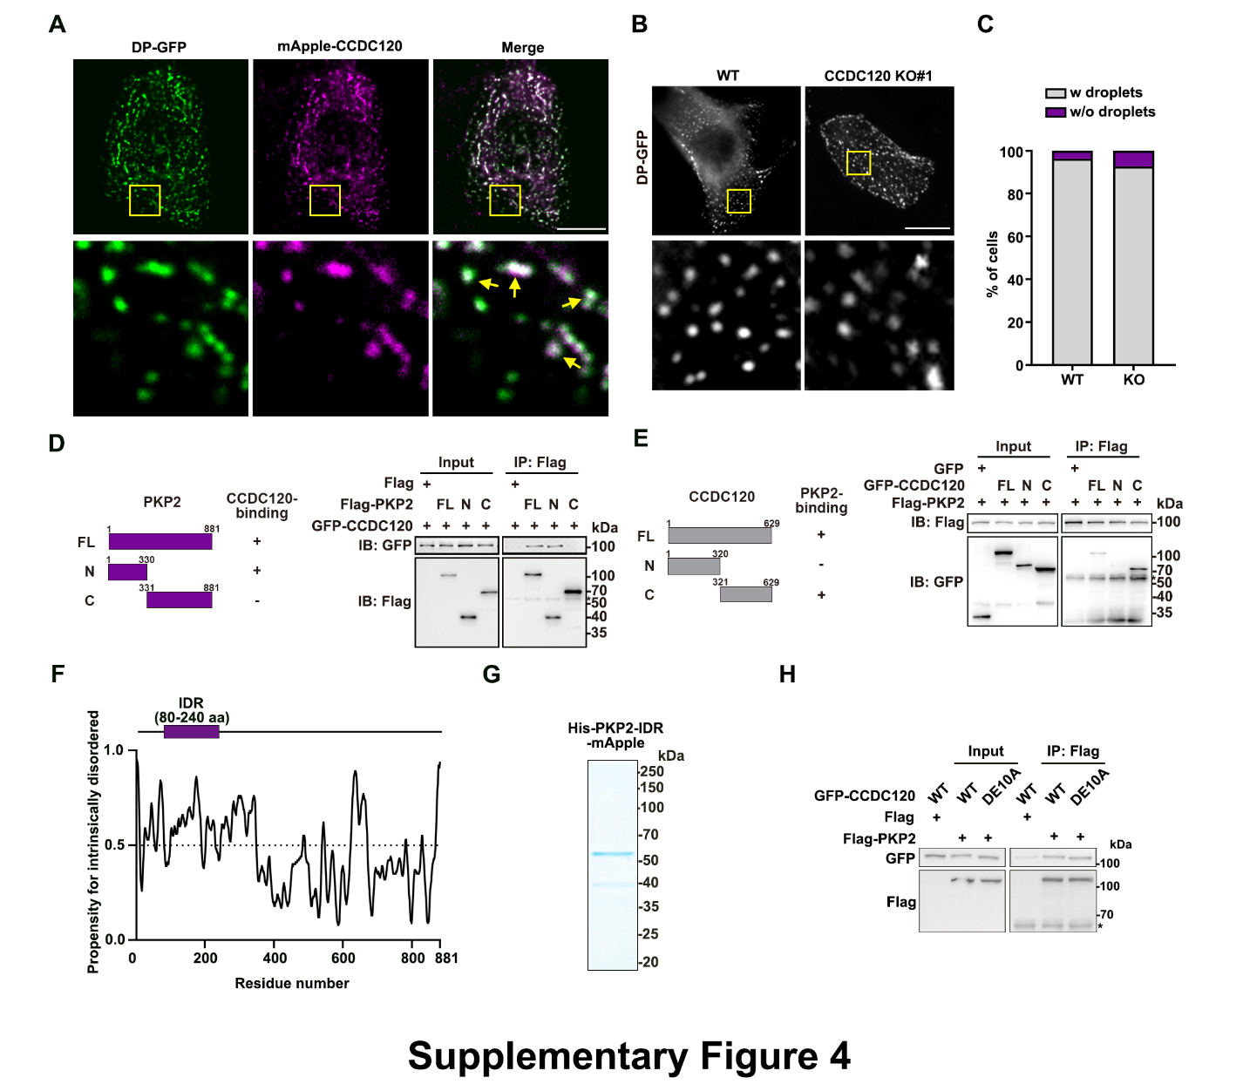
Supplementary Figure 4. DP forms lipid droplets in a CCDC120-independent manner. (A) Confocal images of HeLa cells expressing DP-GFP (green) and mApple-CCDC120 (magenta). A magnified view shows condensates in the cytoplasm (bottom). Arrows indicate colocalized condensates in the cytoplasm. Scale bar, 10 μm. (B) Representative images of DP-GFP in WT or CCDC120 KO MDCK cells (top). A magnified view shows condensates in the cytoplasm (bottom). Scale bar, 10 μm. (C) Quantification of the percentage of cells with (gray) or without droplets (magenta) in (B). More than 60 cells in different groups were analyzed from three independent experiments. (D) Schematic representation of PKP2 full-length (FL) and two truncates (N, C). CCDC120-binding ability: +, positive; -, negative (top). Lysates of HEK293T cells co-overexpressing GFP-CCDC120 and Flag-PKP2 FL or indicated truncates were subjected to immunoprecipitation (IP) and immunoblotted (IB) with anti-Flag and anti-GFP antibodies. The asterisk marks the IgG heavy chain. (E) Schematic representation of CCDC120 FL and truncates (N, C). PKP2-binding ability: +, positive; -, negative (top). Lysates of HEK293T cells co-overexpressing Flag-PKP2 and GFP-CCDC120 FL or truncates were subjected to immunoprecipitation (IP) and immunoblotted (IB) with anti-Flag and anti-GFP antibodies. The asterisk marks the IgG heavy chain. (F) Schematic diagram of the predicted intrinsically disordered regions (IDRs) of PKP2 based on PrDOS (https://prdos.hgc.jp). A score greater than 0.5 is considered to be intrinsically disordered. (G) CBB staining of purified His-PKP2-IDR-mApple. (H) Lysates of HEK293T cells co-overexpressing Flag-PKP2 and GFP-CCDC120 WT or DE10A mutant were subjected to IP and IB with anti-Flag and anti-GFP antibodies. The asterisk marks the IgG heavy chain.

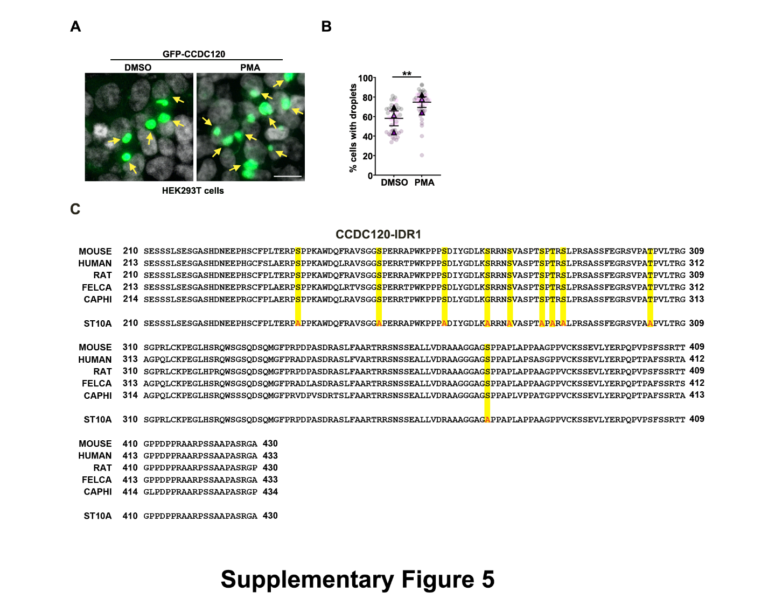Supplementary Figure 5. PKC promotes phase separation of CCDC120. (A, B) Representative images (A) and quantification (B) of HEK293T cells expressing GFP-CCDC120 and treated with either DMSO or 15 nM PMA for 30 min. Arrows indicate condensates formed by GFP-CCDC120. DNA was stained with DAPI (gray). Scale bar, 20 μm. More than 100 cells were analyzed from three independent experiments. (C) Multiple sequence alignment of CCDC120-IDR1. Phosphorylation sites are highlighted (top). Mutagenesis of these serine or threonine residues to alanine residues (ST10A) is listed at the bottom. Data are mean ± SEM. Statistical significance was assessed using a paired two-sided Student’s t-test. **P < 0.01.

Supplementary Figure 6. Generation of Ccdc120 KO and DE10A mice. (A) Schematic representation of the Ccdc120 deletion mutant in mice generated using CRISPR/Cas9. The sgRNA-targeting sequence is underlined, and the PAM site is labeled in red. A 50 bp depletion in exon 4 causes Ccdc120 depletion. (B) PCR assays to detect Ccdc120 deletion mutant mice. WT, wild type; Het, heterozygote; KO, knockout. (C) Immunoblotting validates the protein levels of CCDC120 in brain tissue from 2-month-old WT and Ccdc120 KO mice. GAPDH was used as a loading control. (D) Schematic representation of the Ccdc120 knock-in mutant (DE10A) using CRISPR/Cas9. The sgRNA-targeting sequence is underlined, and the PAM site is labeled in red. Mutant exons are highlighted in magenta. The Ccdc120 DE10A allele after homologous recombination is shown at the bottom. (E) Sequence alignment between CCDC120 WT and DE10A mice. The altered nucleotides and amino acids are highlighted in red.
Supplementary Table 1. Echocardiographic parameter in WT, Ccdc120 KO and Ccdc120 DE10A mutant mice

 | WT  n=10 | ccdc120 KO  n=13 | ccdc120 DE10A  n=8
LVEF (%) | 62.03 ± 2.57 | 46.48 ± 2.24 | 46.55 ± 3.80
FS (%) | 32.87 ± 1.87 | 22.79 ± 1.30 | 22.90 ± 2.11
LVEDV (mm³) | 49.20 ± 2.07 | 52.46 ± 4.19 | 49.68 ± 2.90
LVESV (mm³) | 18.50 ± 1.21 | 28.55 ± 2.99 | 26.88 ± 2.91
LVAW; d (mm) | 0.99 ± 0.06 | 1.02 ± 0.09 | 0.92 ± 0.04
LVAW; s (mm) | 1.37 ± 0.06 | 1.29 ± 0.09 | 1.14 ± 0.03
LVID; d (mm) | 3.48 ± 0.06 | 3.48 ± 0.12 | 3.46 ± 0.08
LVID; s (mm) | 2.31 ± 0.06 | 2.73 ± 0.12 | 2.17 ± 0.13
LVPW; d (mm) | 0.96 ± 0.06 | 1.04 ± 0.09 | 0.95 ± 0.06
LVPW; s (mm) | 1.28 ± 0.05 | 1.19 ± 0.07 | 1.11 ± 0.06
LVEF: Left Ventricular Ejection Fraction; FS: Fraction Shortening;
LVEDV: Left Ventricular End-Diastolic Volume;
LVESV: Left Ventricular End-Systolic Volume;
LVAW; d: Left Ventricular End-Diastolic Anterior Wall thickness;
LVAW; s: Left Ventricular End-Systolic Anterior Wall thickness;
LVID; d: Left Ventricular End-Diastolic Internal Dimension;
LVID; s: Left Ventricular End-Systolic Internal Dimension;
LVPW; d: Left Ventricular End-Diastolic Posterior Wall thickness;
LVPW; s: Left Ventricular End-Systolic Posterior Wall thickness.

Supplementary Table 2. List of PCR primers

Names | Sequences
Dog Ccdc120 genome #1-F' | 5'-AGTCATTACCGCTTTGC-3'
Dog Ccdc120 genome #1-R' | 5'-TCACCTCAGCAGGGCA-3'
Dog Ccdc120 genome #2-F' | 5'-AGGAGCTGGCTCTTGA-3'
Dog Ccdc120 genome #2-R' | 5'-TGGCGGTGGGAGTAC-3'
Dog Pkp2 genome -F' | 5'-GACATGGAGATGACTCTAG-3'
Dog Pkp2 genome -R' | 5'-TACATGGCCACCATAACAGA-3'
Dog DP I/II genome -F' | 5'-GAGCGCGCGCCGACAT-3'
Dog DP I/II genome -R' | 5'-GGGGACAAAGGGGTGCC-3'
Mouse Ccdc120 mutant-F' | 5'-GGTCCGAGTCAGTAGTCATTAGGC-3'
Mouse Ccdc120 mutant-R' | 5'-TGGTATCTACAGTCTTCCACCCTCA-3'
Mouse Ccdc120 genotyping-F' | 5'-CACTTACTACTGCCCTCCCC-3'
Mouse Ccdc120 genotyping-R' | 5'-GCAGACACACTTTCCTGAGC-3'

Supplementary Table 3. List of antibodies

Names | Source | Indentifier | Dilution for IF | Dilution for WB
Rabbit anti-CCDC120 | Home-made | N/A | 1:50 | 1:300
Rabbit anti-Desmoplakin | Proteintech | Cat# 25318-1-AP | 1:200 | 1:500
Rabbit anti-PKP2 | Atlas Antibodies | Cat# HPA014314 | N/A | 1:500
Mouse anti-PKP2 | Progen | Cat# 651101 | 1:10 | N/A
Mouse anti-DSG1/2 | Progen | Cat# 612128-02 | 1:50 | N/A
Rabbit anti-β-catenin | Proteintech | Cat# 51067-2-AP | 1:500 | N/A
Mouse anti-Keratin 18 | Proteintech | Cat# 66187-I-Ig | N/A | 1:1000
Rabbit anti-Keratin 19 | Proteintech | Cat# 10712-1-AP | 1:50 | 1:3000
Mouse anti-CEP170 | Abcam | Cat# ab72505 | N/A | 1:500
Rabbit anti-Thiophosphate ester | HUABIO | Cat# H681300058 | N/A | 1:500
Mouse anti-Alpha Tubulin | Proteintech | Cat# 66031-1-Ig | N/A | 1:10000
Mouse anti-GFP | Proteintech | Cat# 66002-1-Ig | N/A | 1:2000
Mouse anti-Flag | Sigma-Aldrich | Cat# F1804 | 1:200 | 1:4000
Mouse anti-GAPDH | Proteintech | Cat# 60004-1-Ig | N/A | 1:5000
Goat anti-Mouse IgG (H+L) Secondary Antibody | Invitrogen | Cat# 31160 | N/A | 1:5000
Goat anti-Rabbit IgG (H+L) Secondary Antibody | Invitrogen | Cat# 31210 | N/A | 1:5000
Donkey anti-Rabbit IgG (H+L) Highly Cross-Adsorbed Secondary Antibody, Alexa Fluor 488 | Invitrogen | Cat# A21206 | 1:200 | N/A
Goat anti-Mouse IgG (H+L) Highly Cross-Adsorbed Secondary Antibody, Alexa Fluor 488 | Invitrogen | Cat# A11017 | 1:200 | N/A
Goat anti-Rabbit IgG (H+L) Cross-Adsorbed Secondary Antibody, Alexa Fluor 546 | Invitrogen | Cat# A11035 | 1:200 | N/A
Goat anti-Mouse IgG (H+L) Cross-Adsorbed Secondary Antibody, Alexa Fluor 546 | Invitrogen | Cat# A11018 | 1:200 | N/A

