Appendix

Fig. 5 Length-weight relationship of Sakumo II fish samples

Fig. 6 Length-weight relationship of Faana fish samples

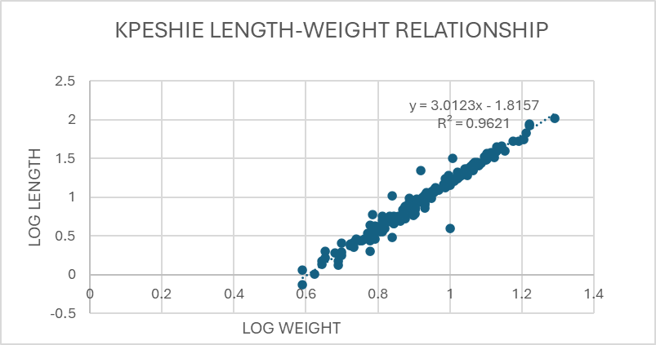
Fig. 7 Length-weight relationship of Kpeshie fish samples

Fig. 8 Length-weight relationship of Laloi fish samples

Fig. 9 Length-weight relationship of Sakumo II fish samples

Fig. 10 Length-weight relationship of Vaughan Dam fish samples

