Supporting Information
Room-Temperature Superparamagnetic FeCu Nanoalloys: Magnetic Behavior Insights from Synthesis and Simulation

Maryam Bahrami, Mehrangiz Bahrami, S. Jafar Hoseini, Mohammad Hadi Ghatee*
(Department of Chemistry, Shiraz University, Shiraz, 71946, Iran)
Email: mhghatee@shirazu.ac.ir ; mhghatee2@gmail.com
Tel: +98 713 613 7174, Fax: +98 713 646 0788

(b)
(a)
(c)
Figure S1. Comparison of RDF for (a) core⋯core, (b) core⋯shell, and (c) shell⋯shell atoms of different-sized FeCu NP at 300 K, simulated in the absence of an external magnetic field.

(b)
Janus (25,35)

(c)

Janus (25,45)

Figure S2. Comparison of RDF for core⋯core, core⋯shell, and shell⋯shell atoms of Janus FeCu nanoparticle of size (a) (25,25), (b) (25,35), and (c) (25,45) at 300 K simulated in the absence of external magnetic field.

Figure S3. The Fe$⋯$Fe RDF of FeCu-CS(35,50) simulated in the absence and presence of an external magnetic field at 300 K.

Figure S4. Changes in the magnetic properties of Janus FeCu nanoparticles as a function of the Fe/Cu atomic, ratio in the absence and presence of different external magnetic fields.

Table S1. Different components of magnetization vector for FeCu nanoparticles calculated under (A) no field and high field (1000 Tesla), (B) mid field (10 to 800 T) at 300 K.
(A)
FeCu NP | B_{ext}=0 |  |  | B_{ext}=1000 T
FeCu NP | Mag_{x} | Mag_{y} | Mag_{z} | Mag_{x} | Mag_{y} | Mag_{z}
CS (25,30) | -0.0486 | 0.4978 | 0.0726 | 0.0000 | 0.0000 | 0.6386
CS (25,40) | -0.0952 | 0.0284 | 0.0145 | 0.0000 | 0.0000 | 0.2444
CS (25,50) | -0.0186 | 0.0346 | 0.0177 | 0.0000 | 0.0000 | 0.1208
CS (30,45) | -0.0347 | -0.0482 | 0.1108 | 0.0000 | 0.0000 | 0.2934
CS (35,50) | 0.0681 | 0.1143 | 0.1257 | 0.0000 | 0.0000 | 0.3461
Janus (25,25) | -0.0474 | 0.0174 | -0.3333 | 0.0000 | 0.0000 | 0.4708
Janus (25,35) | -0.0176 | 0.1224 | -0.0210 | 0.0000 | 0.0000 | 0.2505
Janus (25,45) | 0.0229 | -0.0382 | -0.0407 | 0.0000 | 0.0000 | 0.1369

(B)
FeCu NP | B_{ext} = 10 T |  |  | B_{ext} = 50 T |  |  | B_{ext} = 150 T
FeCu NP | Mag_{x} | Mag_{y} | Mag_{z} | Mag_{x} | Mag_{y} | Mag_{z} | Mag_{x} | Mag_{y} | Mag_{z}
CS (25,30) | 3.0E-05 | -4.3E-5 | 0.5212 | 2.27E-05 | -1.4E-05 | 0.549712 | 2.75E-06 | -2E-06 | 0.579794
CS (25,40) | -1.9E-05 | 2.79E-07 | 0.1317 | 1.12E-06 | 5.46E-06 | 0.170794 | -5.35E-07 | -6.38E-07 | 0.202761
CS (25,50) | 2.43E-05 | -3.4E-06 | 0.0485 | -1.08E-06 | 1.26E-06 | 0.067131 | 3.01E-07 | -2.19E-06 | 0.09079
CS (30,45) | -1.9E-06 | 1.75E-05 | 0.165996 | 7E-06 | -8.8E-07 | 0.208452 | 1.38E-08 | 2.59E-06 | 0.244618
CS (35,50) | 6.19E-06 | -6.7E-06 | 0.250919 | 5.14E-06 | 4.18E-06 | 0.281317 | -2.27E-06 | -3.63E-07 | 0.306107
Janus (25,25) | 0.000109 | 3.95E-05 | 0.356217 | 1.94E-06 | 7.59E-06 | 0.389677 | 3.61E-06 | 1.40E-06 | 0.420081
Janus (25,35) | 1.07E-05 | 5.2E-06 | 0.151843 | 4.66E-06 | 1.86E-05 | 0.182521 | 1.46E-05 | 2.16E-05 | 0.211305
Janus (25,45) | 4.001E-06 | -2.8E-05 | 0.070924 | -5.6E-08 | 1.74E-06 | 0.089466 | 1.80E-06 | -1.14E-07 | 0.109684
FeCu NP | B_{ext} = 350 T |  |  | B_{ext} = 600 T |  |  | B_{ext} = 800 T
FeCu NP | Mag_{x} | Mag_{y} | Mag_{z} | Mag_{x} | Mag_{y} | Mag_{z} | Mag_{x} | Mag_{y} | Mag_{z}
CS (25,30) | -3.6E-05 | 3.74E-05 | 0.607092 | 2.05E-06 | 1.45E-06 | 0.624036 | -6.09E-06 | -1.1E-05 | 0.632475
CS (25,40) | 5.31E-06 | -1.18E-05 | 0.225385 | -6.01E-06 | 1.24E-05 | 0.23639 | -1.54E-06 | -1.48E-05 | 0.241193
CS (25,50) | 1.98E-07 | -1.78E-06 | 0.108099 | 2.14E-06 | -2.37E-07 | 0.115743 | -2.07E-06 | 1.69E-06 | 0.118819
CS (30,45) | -5.41E-06 | -1.12E-05 | 0.271361 | -9.58E-06 | 2.81E-06 | 0.28402 | -1.72E-06 | 7.52E-07 | 0.289635
CS (35,50) | -9.04E-06 | -1.16E-05 | 0.325939 | -3.14E-06 | -3.22E-06 | 0.337129 | 3.35E-06 | -2.17E-06 | 0.342416
Janus (25,25) | -3.57E-06 | -1.75E-05 | 0.444755 | 1.62E-06 | 9.15E-06 | 0.459088 | -2.83E-06 | 1.70E-06 | 0.465939
Janus (25,35) | -6.41E-06 | -3.09E-06 | 0.232313 | 6.96E-06 | 1.68E-06 | 0.242728 | 4.30E-05 | 7.06E-07 | 0.247356
Janus (25,45) | 1.87E-06 | 1.98E-06 | 0.12483 | 4.20E-06 | 4.96E-06 | 0.131926 | 1.61E-06 | -1.34E-06 | 0.134891

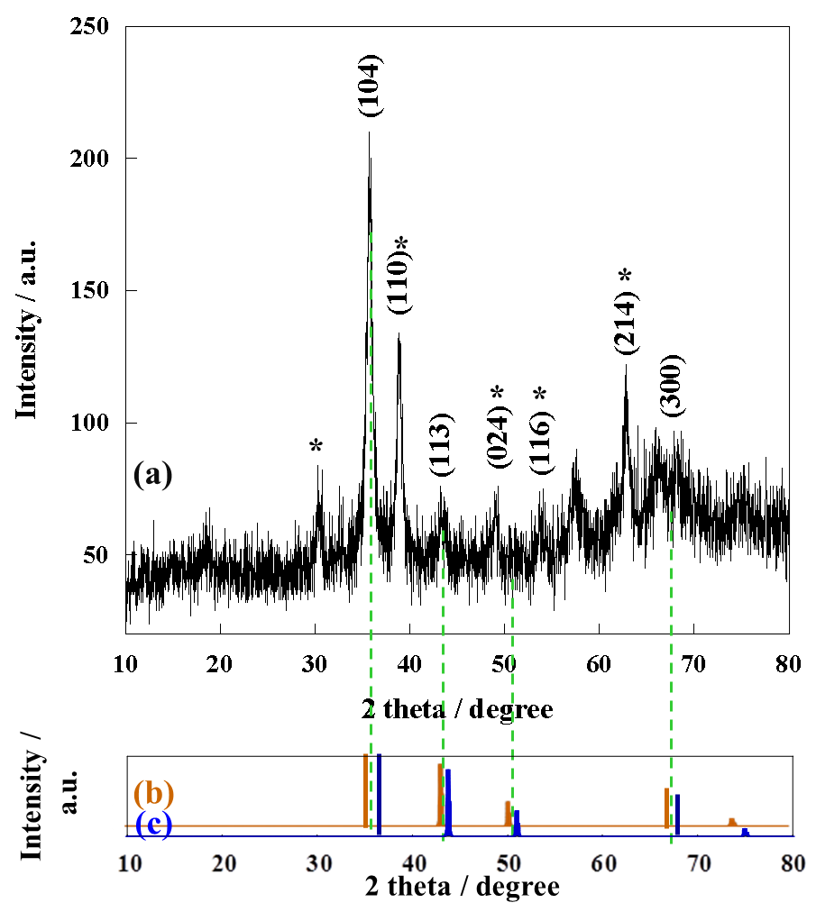
Figure S5. (a) XRD spectrum for the synthesized FeCu nanoparticles, (b) and (c) is the theoretical XRD analysis obtained from VESTA software (based on the experimental XRD pattern). These are standard for calibrations Cu(0) and Fe(0)
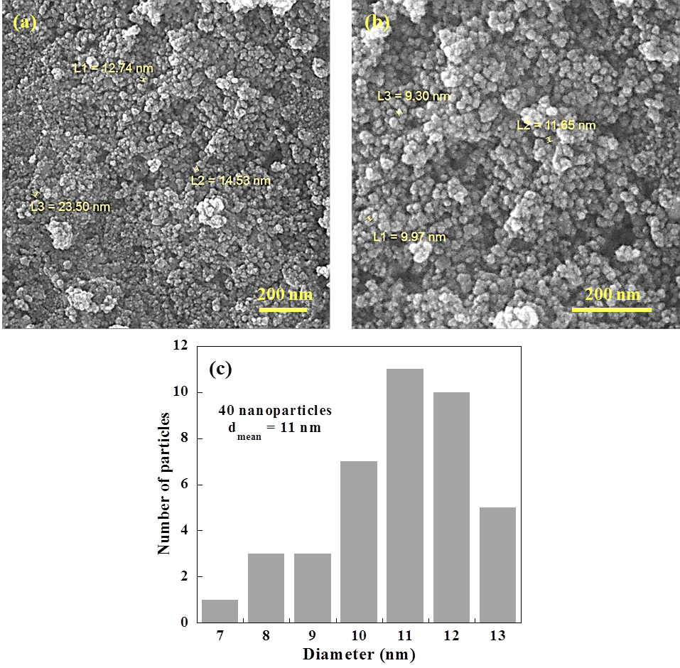
Figure S6. (a, b) FE-SEM analysis of synthesized FeCu nanoparticles, and (c) histogram illustrating the particle size distribution.

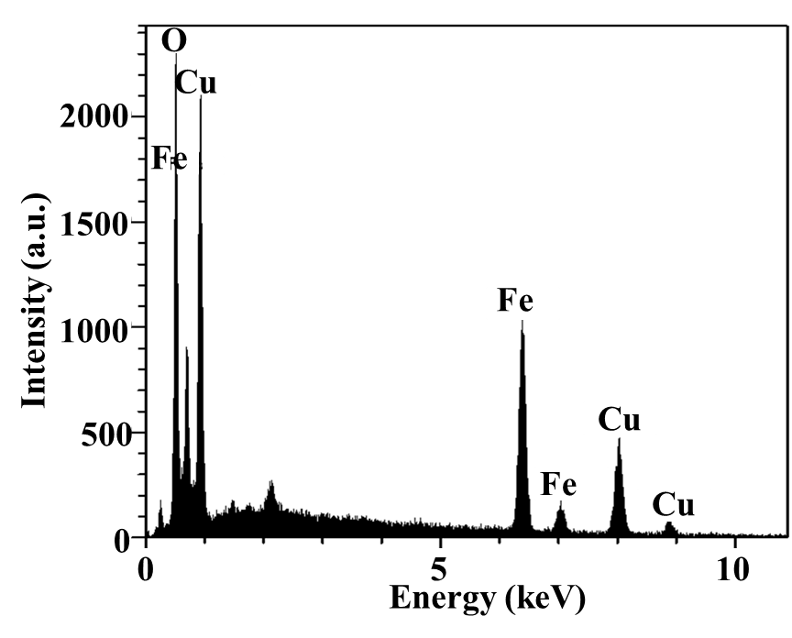
Figure S7. EDAX analysis of iron-copper nanoalloy by FE-SEM.
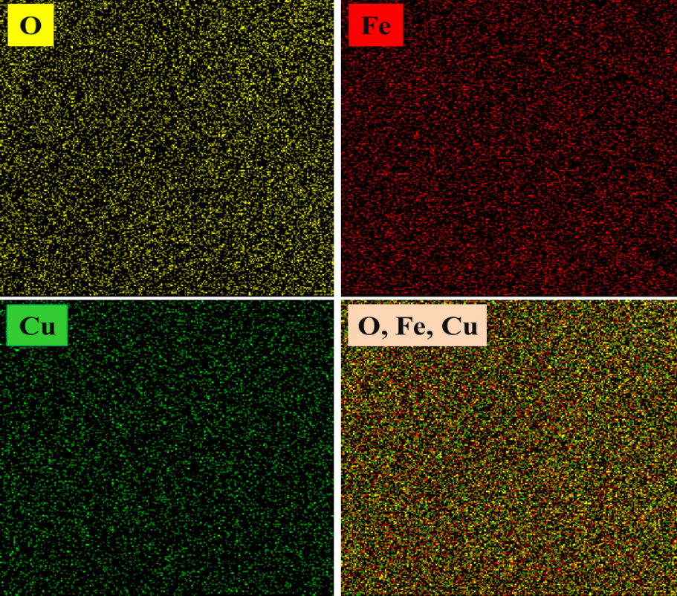
Figure S8. Elemental mapping analysis of iron-copper nanoalloy (Fe, Cu, and O elements).

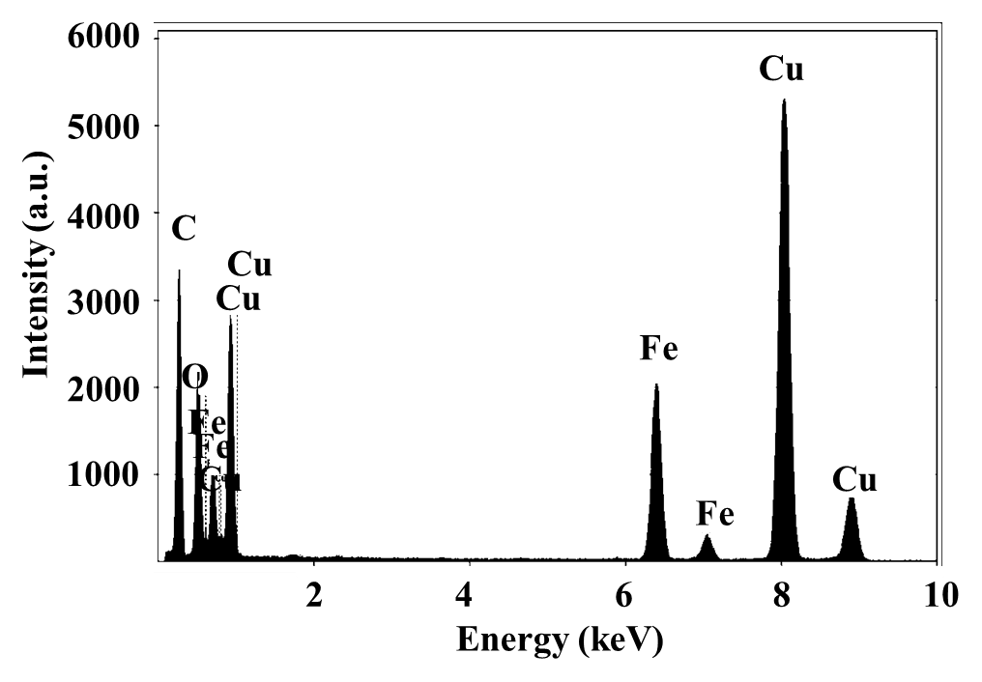
Figure S9. EDAX analysis of iron-copper nanoalloy using HR-TEM analysis.

