Supplementary Information

Laser-Guided Ion Dynamics in a Dual-Mode Memristor for Bioinspired Neuronal and Synaptic Integration

Yu Jin Jeong¹, Kyung Hwan Kim¹, Young Bin Kim¹, Hyera Shin¹, Jung Won Oh², Sang Hyeon Sung², and Keon Jae Lee^{1,}*

¹Y. J. Jeong, K. H. Kim, Y. B. Kim, H. Shin, and Prof. K. J. Lee
Department of Materials Science and Engineering, Korea Advanced Institute of Science and Technology (KAIST)
291 Daehak-ro, Yuseong-gu, Daejeon
34141, Republic of Korea
E-mail: keonlee@kaist.ac.kr

²J. W. Oh, and S. H. Sung
Semiconductor R&D Center, Samsung Electronics Co. Ltd.
129 Samsung-ro, Yeongtong-gu, Suwon-si, Gyeonggi-do
16677, Republic of Korea

Keywords: Laser-guided ion dynamics, Single coplanar memristor, Bioinspired neuronal and synaptic integration, Volatile and nonvolatile switching, Neuromorphic reservoir computing

This Supplementary Information contains the following materials:
Item | Page
Fabrication process of the laser-guided dual-mode memristor. (Supplementary Fig. 1) | 4
Schematic of the laser processing setup for the laser-guided dual-mode memristor. (Supplementary Fig. 2) | 5
Optimization of nonvolatile characteristics based on laser fluence. (Supplementary Fig. 3) | 6
Ultraviolet-visible (UV-VIS) absorption spectra of laser-guided dual-mode memristor before and after laser irradiation. (Supplementary Fig. 4) | 7
Energy Dispersive X-ray Spectroscopy (EDS) mapping of laser-guided dual-mode memristor. (Supplementary Fig. 5) | 8
Magnified TEM images and FFT analysis of the laser-guided dual-mode memristor before and after laser irradiation. (Supplementary Fig. 6) | 9
D-spacing of crystalline components in the TEM image. (Supplementary Fig. 7) | 10
X-ray Photoelectron Spectroscopy (XPS) depth profile of laser-guided dual-mode memristor before and after laser irradiation. (Supplementary Fig. 8) | 11
O/Si stoichiometry and O 1s spectra from XPS analysis of the laser-guided dual-mode memristor before and after laser irradiation. (Supplementary Fig. 9) | 12
Time of Flight-Secondary Ion Mass Spectrometry (ToF-SIMS) depth profile of laser-guided dual-mode memristor before and after laser irradiation. (Supplementary Fig. 10) | 13
COMSOL simulation of electric field formation between two nanoparticles under laser irradiation. (Supplementary Fig. 11) | 14
COMSOL simulation of electric field formation between two nanoparticles for different nanoparticle sizes. (Supplementary Fig. 12) | 15
COMSOL simulation of electric field formation between two nanoparticles for different interparticle distances. (Supplementary Fig. 13) | 16
Retention profile of the laser-guided dual-mode memristor. (Supplementary Fig. 14) | 17
DC-IV endurance test (100 cycles) of the laser-guided dual-mode memristor. (Supplementary Fig. 15) | 18
Retention tunning of the laser-guided dual-mode memristor through laser multishots. (Supplementary Fig. 16) | 19
Volatility control test of laser-guided dual-mode memristor via Rapid Thermal Annealing (RTA). (Supplementary Fig. 17) | 20
Schematic illustrating the nth voltage spiking in the laser-guided dual-mode memristor RC circuit. (Supplementary Fig. 18) | 21
Fitting of charging and discharging voltage functions of laser-guided dual-mode memristor RC circuit. (Supplementary Fig. 19) | 22
Tonic spiking (10 nF) and bursting (2.2 nF) behaviors in the laser-guided dual-mode memristor. (Supplementary Fig. 20) | 23
Inhibition-induced spiking and inhibition-induced bursting in the laser-guided dual-mode memristor. (Supplementary Fig. 21) | 24
Leaky integrate-and-fire (LIF) and all-or-nothing behaviors in the laser-guided dual-mode memristor. (Supplementary Fig. 22) | 25
LTP/LTD nonlinearity of laser-guided dual-mode memristor. (Supplementary Fig. 23) | 26
Schematic of conductance changes and symmetricity analysis in LTP/LTD. (Supplementary Fig. 24) | 27
Schematic diagram of square-wave voltage pulse. (Supplementary Fig. 25) | 28
Current response of volatile mode under different voltage pulse conditions. (Supplementary Fig. 26) | 29
Current variation of volatile mode reflecting the echo state property, based on the interval time between two consecutive pulses. (Supplementary Fig. 27) | 30
Current variation of volatile mode under various voltage pulses. (Supplementary Fig. 28) | 31
Datasets based on neural firing for 8 melodies (C, D, E, F, F#, G, A, B). (Supplementary Fig. 29) | 32
Voltage-pulse-based pitch configurations for neuromorphic melody recognition. (Supplementary Fig. 30) | 33
Time-dependent voltage spiking function in laser-guided dual-mode memristor parallel RC circuit (Supplementary note 1) | 34-35
Method for calculating nonlinearity from LTP/LTD curves. (Supplementary note 2) | 36
Method for calculating symmetricity from LTP/LTD curves. (Supplementary note 3) | 37
Energy consumption of laser-guided dual-mode memristor in LTP/LTD. (Supplementary note 4) | 38

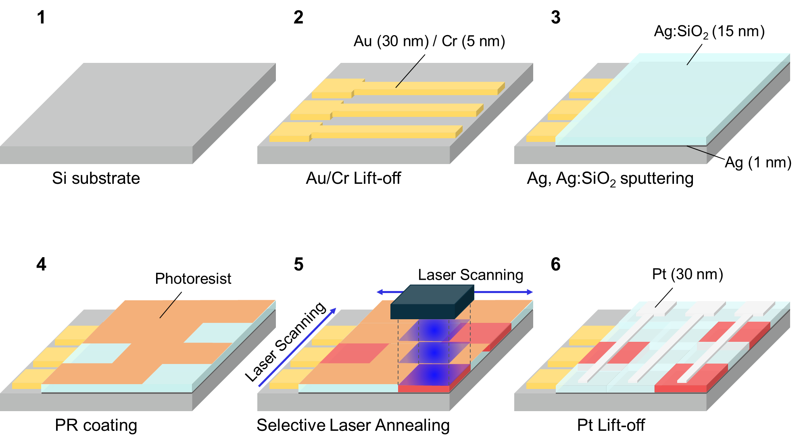
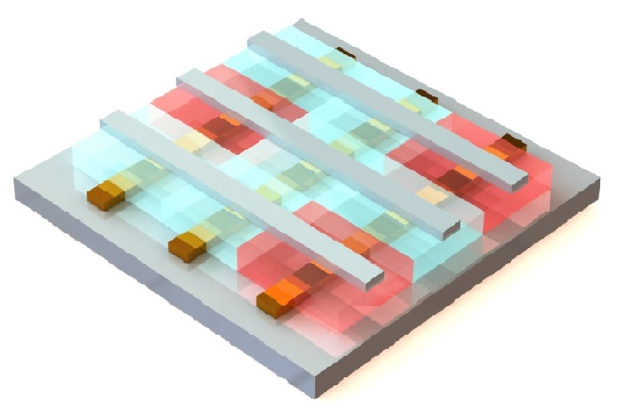
Supplementary Fig. 1 | Fabrication process of the laser-guided dual-mode memristor. First, a 5-nm-thick Cr adhesion layer and a 30-nm-thick Au bottom electrode were deposited on a Si substrate via e-beam evaporation. A bottom contact pad was then patterned through a conventional photolithography process, and wet etching was performed (Steps 1 and 2). Next, the volatile TS layer was formed by sequentially depositing a 1-nm-thick Ag layer and a 15-nm-thick Ag:SiO₂ layer via sputtering (Step 3). The Ag:SiO₂ layer was co-sputtered using Ag and SiO₂ targets in an Ar atmosphere (SiO₂:Ag = 150:3 W, 5 mTorr). Subsequently, NR9 photoresist (PR) was spin-coated onto the surface as a laser-blocking mask (Step 4). A XeCl excimer laser was then scanned across specific regions of the device on a moving stage for selective laser annealing. The scanning process controlled the volatility of the TS layer (Step 5). After the laser process, the PR was removed with acetone. Finally, a top contact pad was defined through a conventional lithography process. A 30-nm Pt layer was then deposited, and a lift-off process was carried out (Step 6).
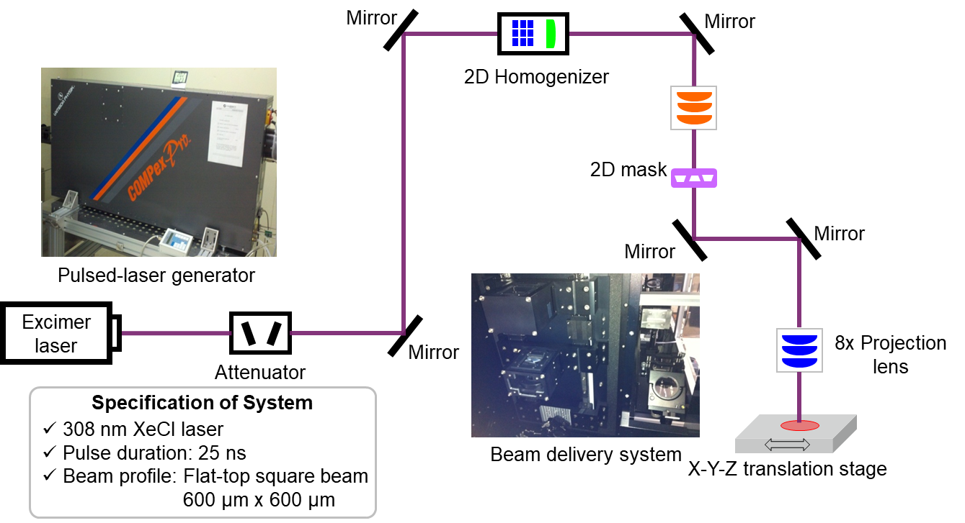
Supplementary Fig. 2 | Schematic of the laser processing setup for the laser-guided dual-mode memristor. The XeCl excimer laser (λ = 308 nm, 25 ns) fluence is controlled by an attenuator, and the beam passes through an optical system that includes a beam homogenizer, a mask, and a projection lens. The optical system converts the beam into a flat-top square shape with adjustable fluence, and the shaped beam irradiates the sample.

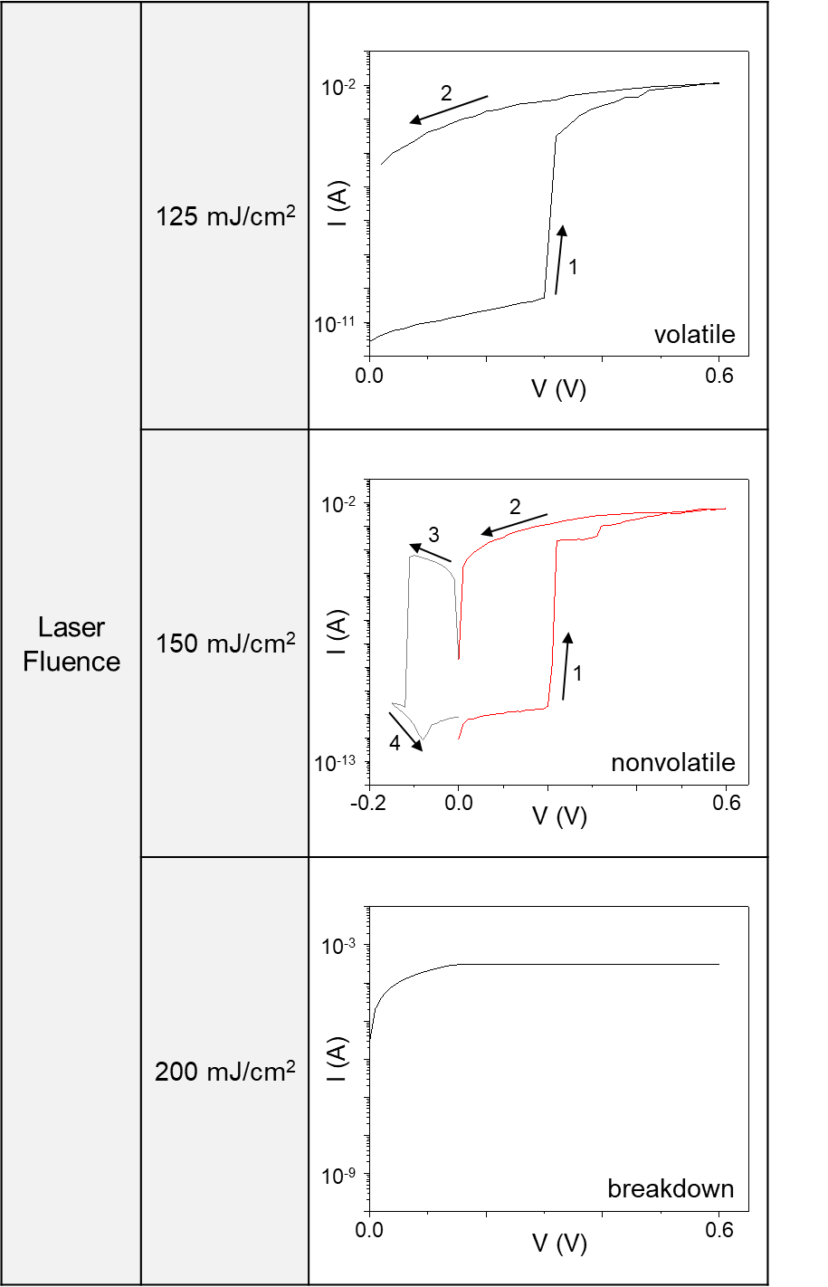
Supplementary Fig. 3 | Optimization of nonvolatile characteristics based on laser fluence. A laser fluence of 150 mJ/cm² provides sufficient energy for Ag nanoparticle aggregation and leads to a transition from volatile to nonvolatile operation. In contrast, at a lower fluence of 125 mJ/cm², the laser energy is insufficient to induce nanoparticle aggregation, and the device retains its volatile nature. When the fluence exceeds 200 mJ/cm², excessive energy leads to device breakdown and the loss of memory characteristics.
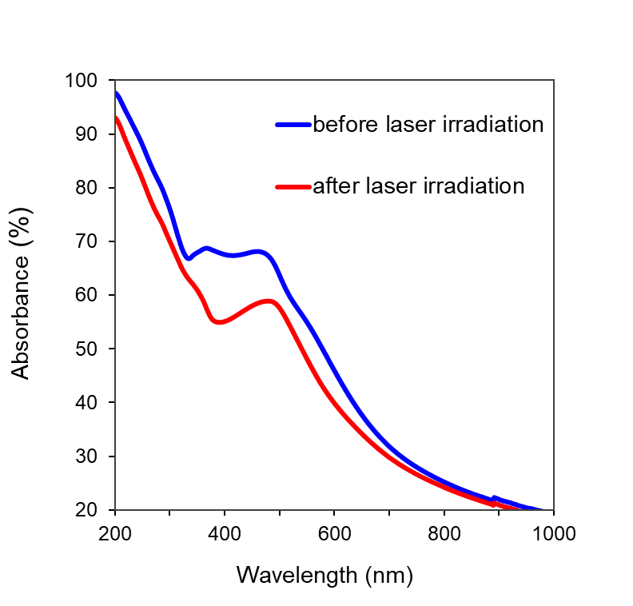
Supplementary Fig. 4 | Ultraviolet-visible (UV-VIS) absorption spectra of laser-guided dual-mode memristor before and after laser irradiation. After laser irradiation, the absorption peak of Ag nanoparticles clearly shifted to longer wavelengths (red shift). Larger nanoparticles exhibit an increased light extinction coefficient, which leads to reduced absorption intensity in the UV–VIS range^{1,2}. The observed decrease in absorbance and peak red shift following laser irradiation indicates that nucleation and growth of Ag nanoparticles are triggered by the laser process. Consequently, the nanoparticle size increases.

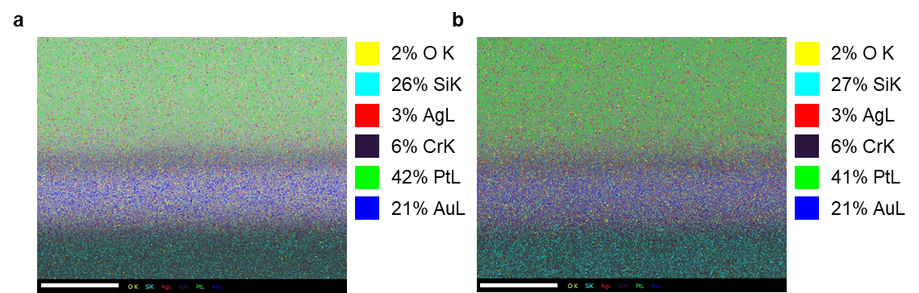
Supplementary Fig. 5 | Energy Dispersive X-ray Spectroscopy (EDS) mapping of laser-guided dual-mode memristor. A comparison of the EDS mapping results before (a) and after (b) laser irradiation shows no change in overall composition. Scale bar, 10 nm. The absence of compositional variation is consistent with Ag nanoparticle formation through redistribution, rather than a chemical reaction with the switching layer.

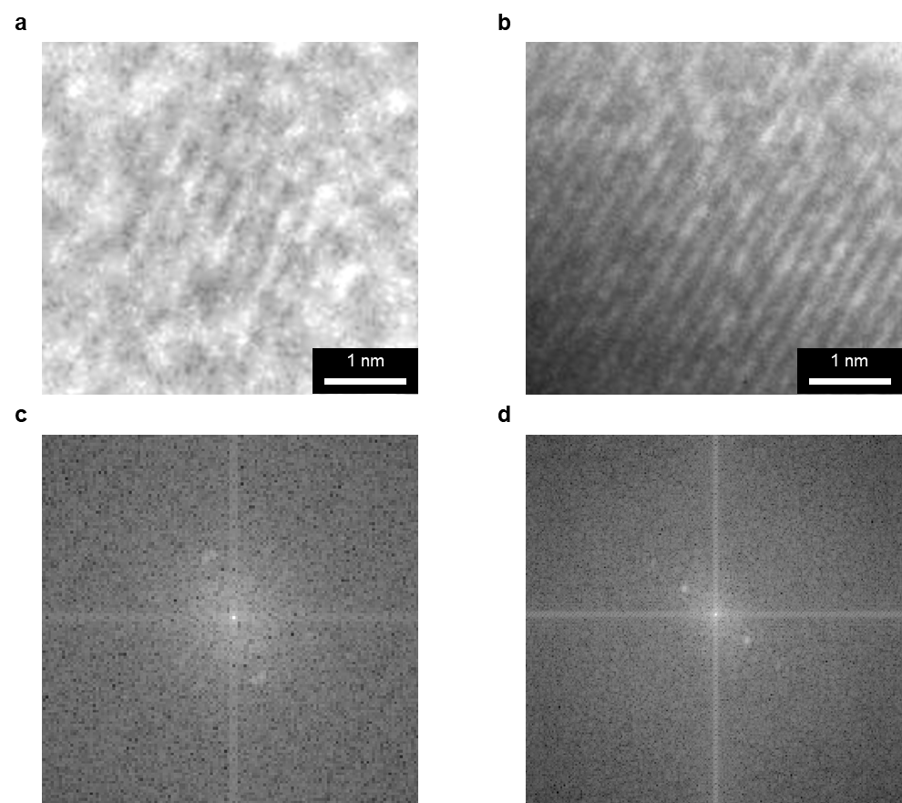
Supplementary Fig. 6 | Magnified TEM images and FFT analysis of the laser-guided dual-mode memristor before and after laser irradiation. (a) Magnified image of the Ag:SiO₂ layer before laser irradiation and (b) magnified image of the Ag:SiO₂ layer after laser irradiation. (c) Fast Fourier Transform (FFT) image for (a), and (d) FFT image for (b).

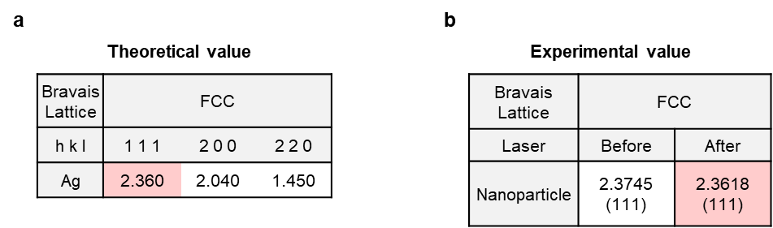
Supplementary Fig. 7 | D-spacing of crystalline components in the TEM image. (a) Theoretical d-spacing values for face-centered cubic (FCC) Ag³. (b) Experimental d-spacing values obtained from FFT analysis of TEM images. The measured value for aggregated nanoparticles closely matches the theoretical value of Ag. The close agreement supports the identification of the nanoparticles as silver.

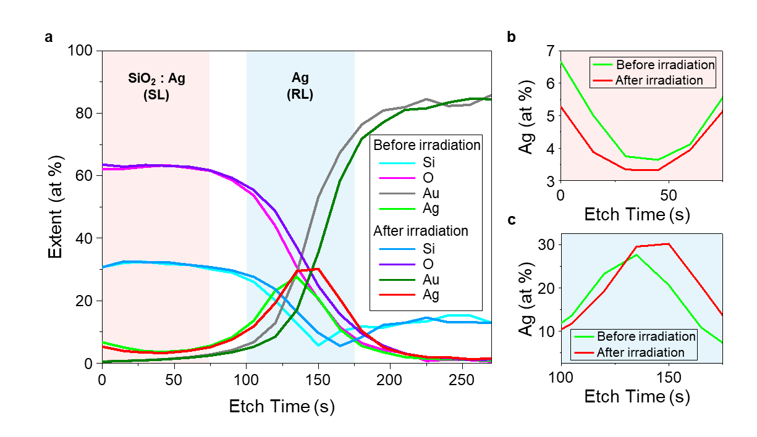
Supplementary Fig. 8 | X-ray Photoelectron Spectroscopy (XPS) depth profile of laser-guided dual-mode memristor before and after laser irradiation. (a) XPS depth profile of the device before and after laser irradiation. (b), (c) Enlarged Ag spectra from switching layer (SL) and reservoir layer (RL), respectively, where the green line corresponds to the device before irradiation and the red line corresponds to the device after irradiation. Ag concentration decreased in the switching layer and increased near the reservoir layer. The distribution shift reveals the migration of Ag nanoparticles from the switching layer to the reservoir layer under laser irradiation.

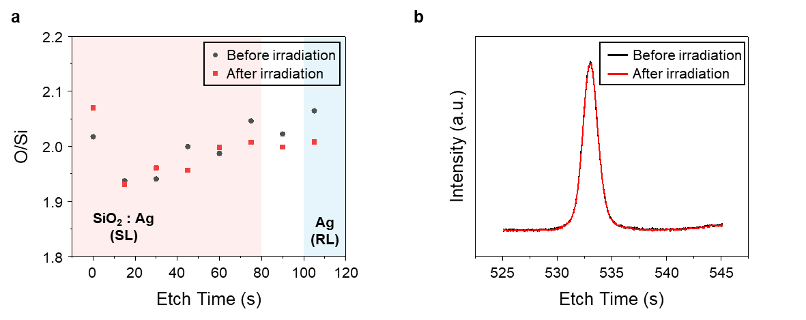
Supplementary Fig. 9 | O/Si stoichiometry and O 1s spectra from XPS analysis of the laser-guided dual-mode memristor before and after laser irradiation. (a) O/Si stoichiometry derived from XPS showed a slight (<5 %) variation between samples before (black circles) and after (red squares) laser irradiation. (b) O 1s XPS spectra measured before (black) and after (red) irradiation, with a peak center remaining at ∼532.9 eV. The minimal shift in O/Si ratios and the unaltered O 1s peak center indicate no defects are introduced into the SiO₂ matrix by the laser process.

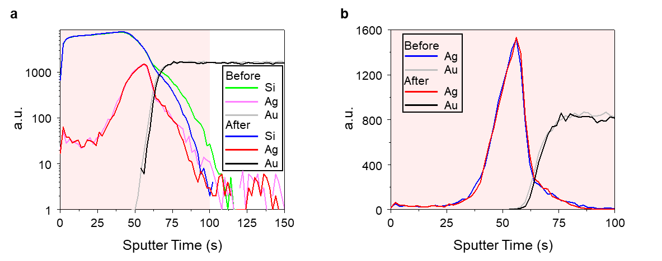
Supplementary Fig. 10 | Time of Flight-Secondary Ion Mass Spectrometry (ToF-SIMS) depth profile of laser-guided dual-mode memristor before and after laser irradiation. (a) ToF-SIMS depth profile of the device before and after laser irradiation. (b) Enlarged profile of Ag and Au elements in the switching layer. Note that negligible changes in Ag distribution between before and after irradiation conditions are observed. The stable distribution suggests the laser process does not alter the material’s intrinsic properties.

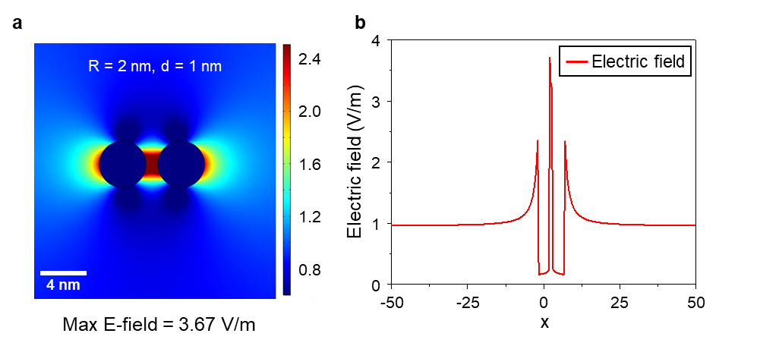
Supplementary Fig. 11 | COMSOL simulation of electric field formation between two nanoparticles under laser irradiation. (a) Localized electric field formation between two nanoparticles with a radius (R) of 2 nm and an interparticle distance (d) of 1 nm. The electric field strength reached 3.67 V/m in the interparticle region. (b) Electric field distribution along a vertical line. The COMSOL simulation reveals a strong localized electric field within the switching layer under XeCl excimer laser irradiation. Strong field enhancement triggers Ag nanoparticle aggregation through localized surface plasmon resonance (LSPR)¹.

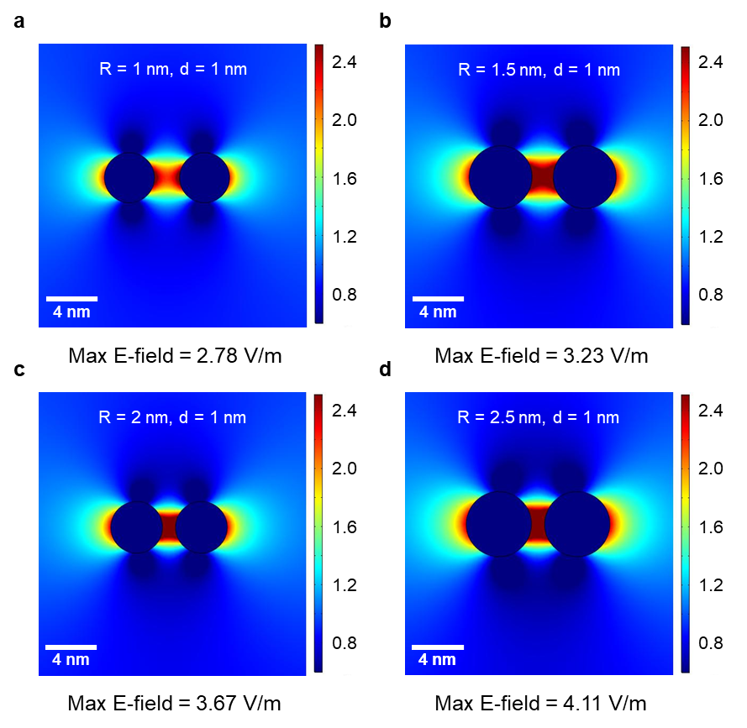
Supplementary Fig. 12 | COMSOL simulation of electric field formation between two nanoparticles for different nanoparticle sizes. (a) R = 1 nm, (b) R = 1.5 nm, (c) R = 2 nm, (d) R = 2.5 nm at constant interparticle distance. As the nanoparticle radius increases from 1 nm to 2.5 nm, the peak electric field strength rises from 2.78 V/m to 4.11 V/m .

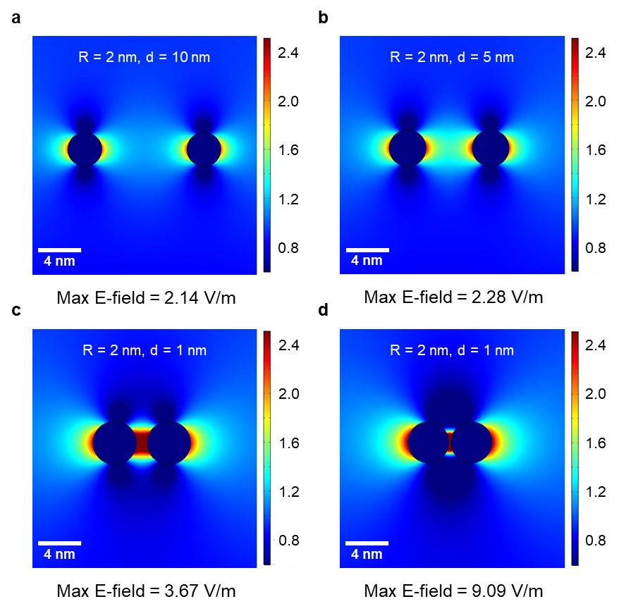
Supplementary Fig. 13 | COMSOL simulation of electric field formation between two nanoparticles for different interparticle distances. (a) d = 10 nm, (b) d = 5 nm, (c) d = 1 nm, (d) d = 0.2 nm at constant radius. As the interparticle distance decreases from 10 nm to 0.2 nm, the peak electric field strength rises from 2.14 V/m to 9.09 V/m.

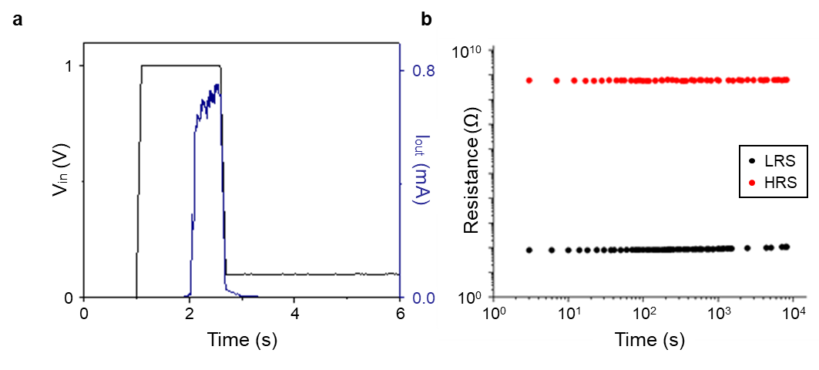
Supplementary Fig. 14 | Retention profile of the laser-guided dual-mode memristor. (a) Retention profile for the volatile mode and (b) for the nonvolatile mode. The volatile mode exhibits a rapid conduction state decay (~0.6 ms), whereas the nonvolatile mode maintains stable long-term memory retention exceeding 8,250 seconds.

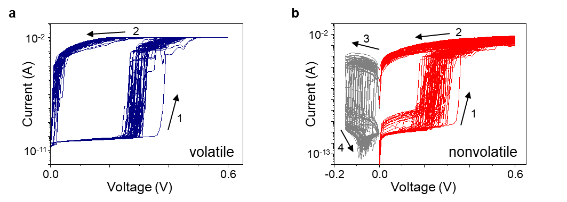
Supplementary Fig. 15 | DC-IV endurance test (100 cycles) of the laser-guided dual-mode memristor. (a) A series of 100 consecutive I-V sweeps in the volatile mode (set voltage: 0.6 V) and (b) in the nonvolatile mode (set voltage: 0.6 V, reset voltage: -0.15 V). The stable and repeatable switching response across 100 cycles demonstrates the reliability of both volatile and nonvolatile modes.

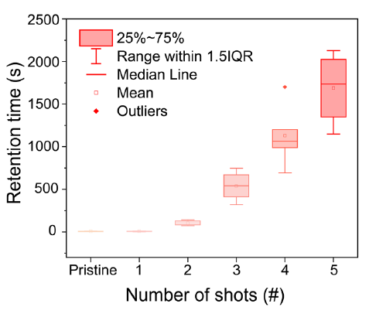
Supplementary Fig. 16 | Retention tunning of the laser-guided dual-mode memristor through laser multishots. Multi-shot laser irradiation significantly improves memory retention. Increasing the number of laser shots from 0 to 5 at a moderate fluence of 102 mJ/cm² extends the retention time from the millisecond range to over 2,000 s without excessive device damage. The box chart presents data from five devices tested under each condition and shows negligible changes in both the memory window and the threshold voltage of the initial SET process. A minimal variation in the measured parameters indicates stable performance even after repeated irradiation. By incrementally accumulating energy, multi-shot laser processing achieves retention tuning that cannot be attained with single-shot or standard thermal approaches.

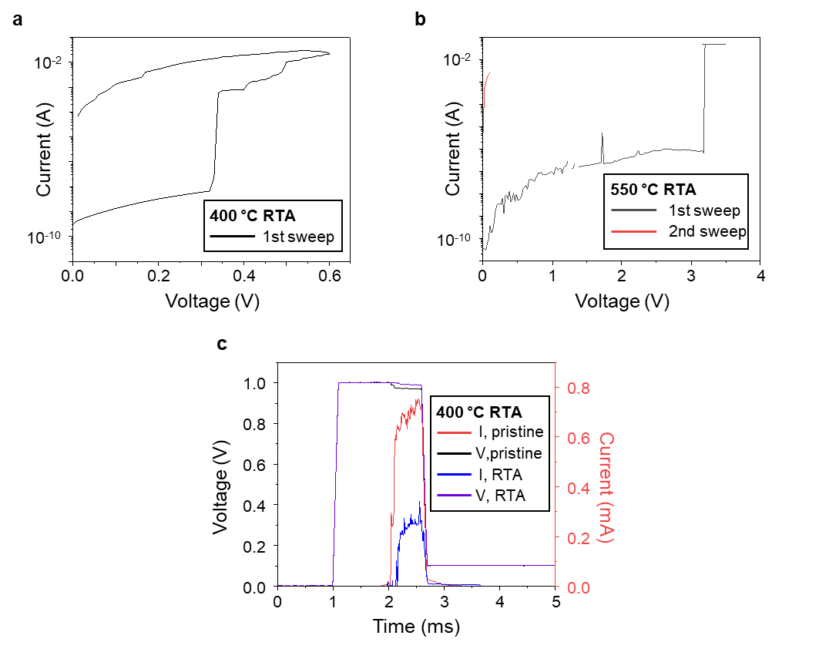
Supplementary Fig. 17 | Volatility control test of laser-guided dual-mode memristor via Rapid Thermal Annealing (RTA). (a) I-V curve after 400 °C RTA, (b) I-V curve after 550 °C RTA, and (c) retention test of the device after 400 °C RTA. The device retains its volatile characteristics after 400 °C RTA, and its retention property remains comparable to the pristine state. In contrast, after 550 °C RTA, material deterioration occurs, and filament formation does not occur under voltage bias. As a result, the device loses its memory characteristics.

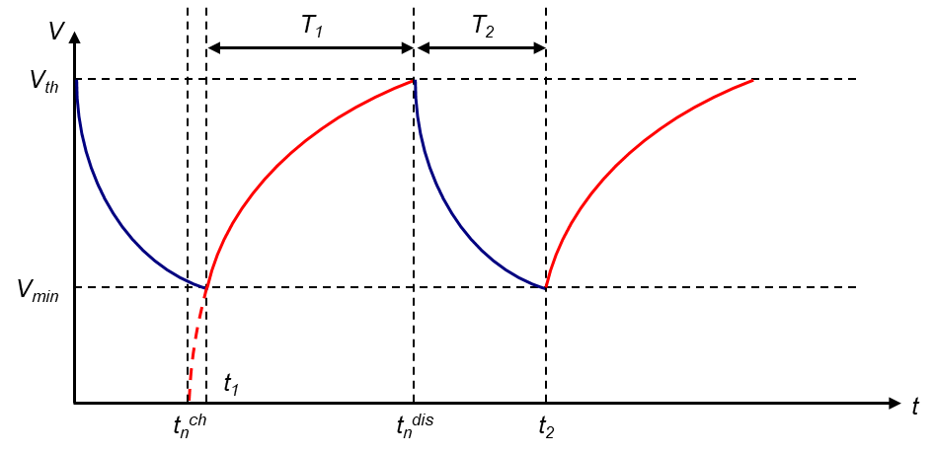
Supplementary Fig. 18 | Schematic illustrating the nth voltage spiking in the laser-guided dual-mode memristor RC circuit. Under constant current input, once the circuit voltage reaches V_{th}, the volatile mode memristor switches to the low-resistance state (LRS) and causes the capacitor to discharge (blue line). When the voltage drops to V_{min}, the device resets to high-resistance state (HRS), and the capacitor recharges (red line). This repeated charge–discharge behavior in the RC circuit leads to consecutive voltage spikes⁴. The corresponding charging and discharging equations are described in Supplementary note 1.

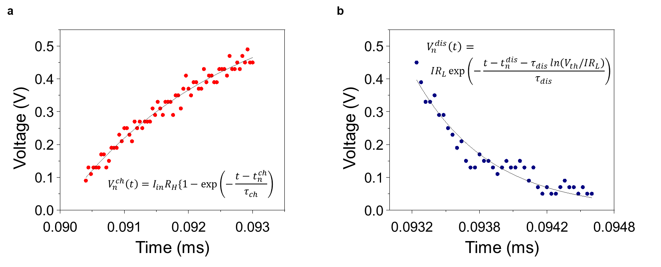
Supplementary Fig. 19 | Fitting of charging and discharging voltage functions of laser-guided dual-mode memristor RC circuit. (a) The charging equation and (b) the discharging equation are fitted to the voltage output during tonic spiking (2.2 nF) in the volatile mode. The charging and discharging voltage equations are derived and described in Supplementary note 1.

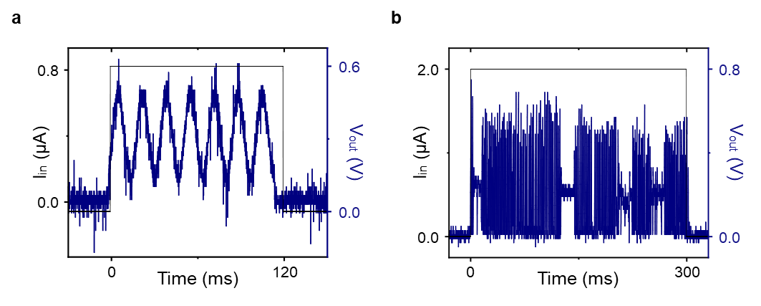
Supplementary Fig. 20 | Tonic spiking (10 nF) and bursting (2.2 nF) behaviors in the laser-guided dual-mode memristor. (a) Tonic spiking behavior measured with a 10 nF capacitor. Increasing the capacitance from 2.2 nF to 10 nF extends the average spiking period from 9.2 ms to 17 ms. (b) Tonic bursting behavior observed with a 2.2 nF capacitor at an input current of 2.0 μA. As the input current is increased from 0.8 μA to 2.0 μA, the device transitions from tonic spiking to tonic bursting mode. The explanation regarding the capacitance dependence of the voltage spiking period is provided in Supplementary note 1.

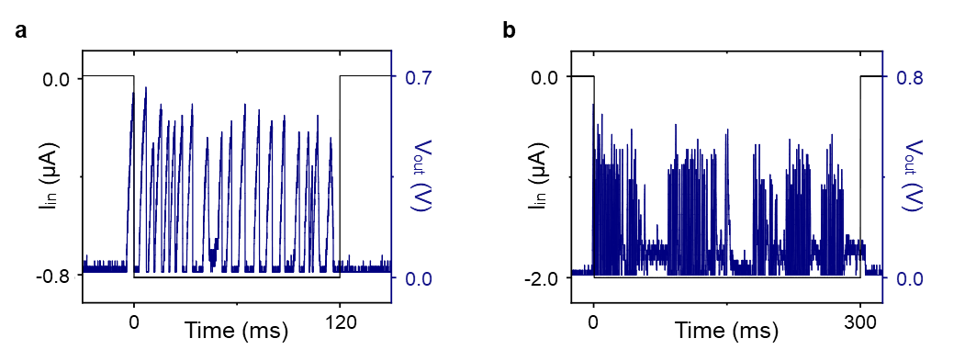
Supplementary Fig. 21 | Inhibition-induced spiking and inhibition-induced bursting in the laser-guided dual-mode memristor. (a) Inhibition-induced spiking under -0.8 µA current pulse and (b) inhibition-induced bursting under -2.0 µA current pulse. Inhibition-induced spiking and bursting resemble rebound firing in thalamocortical neurons, where negative current pulses activate T-type Ca²⁺ channels after hyperpolarization. The memristor-based RC circuit reproduces the inhibitory mechanism⁵.

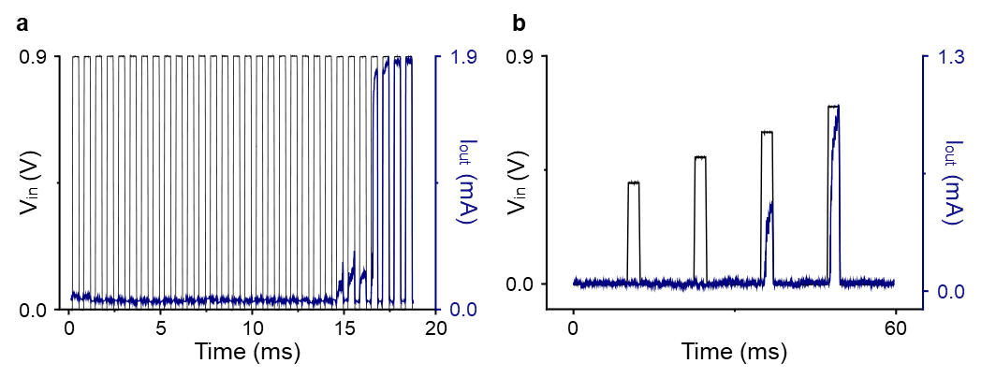
Supplementary Fig. 22 | Leaky integrate-and-fire (LIF) and all-or-nothing behaviors in the laser-guided dual-mode memristor. (a) A leaky integrate-and-fire (LIF) response of the laser-guided dual-mode memristor. Under consecutive short-interval voltage inputs, the memristor generates a current spike only after the cumulative input surpasses the firing threshold⁶. (b) All-or-nothing behavior of the laser-guided dual-mode memristor. When the applied voltage pulse exceeds the threshold voltage, the memristor produces a distinct current spike, whereas subthreshold pulses elicit no detectable output⁷ .

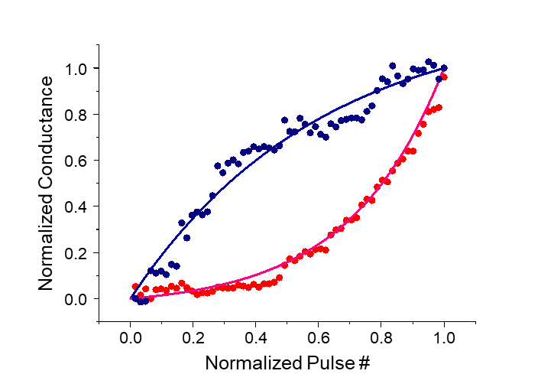
Supplementary Fig. 23 | LTP/LTD nonlinearity of laser-guided dual-mode memristor. The red line represents the normalized conductance for long-term potentiation (LTP) and the blue line represents the normalized conductance for long-term depression (LTD). According to the calculations in Supplementary Note 2, the nonlinearity values for the nonvolatile mode are 2.03 for LTP and 4.88 for LTD. Nonlinearity measures the uniformity of conductance changes under consecutive pulses. A lower LTP/LTD nonlinearity enables more predictable weight updates and leads to stable, precise memory operations⁸.

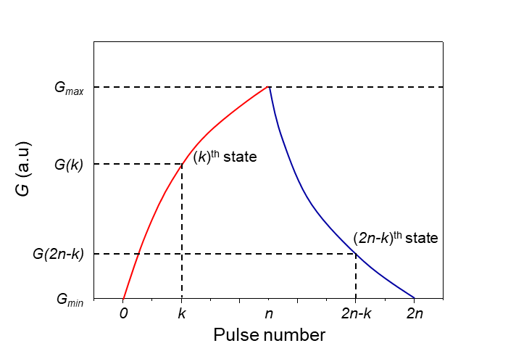
Supplementary Fig. 24 | Schematic of conductance changes and symmetricity analysis in LTP/LTD. Red and blue curves depict the conductance changes during LTP and LTD, respectively. Conductance values for the (k)^{th} and (2n-k)^{th} pulse number, denoted as G(k) and G(2n-k), are used to evaluate the LTP/LTD symmetricity. Further details on the symmetricity calculation are provided in Supplementary note 3.

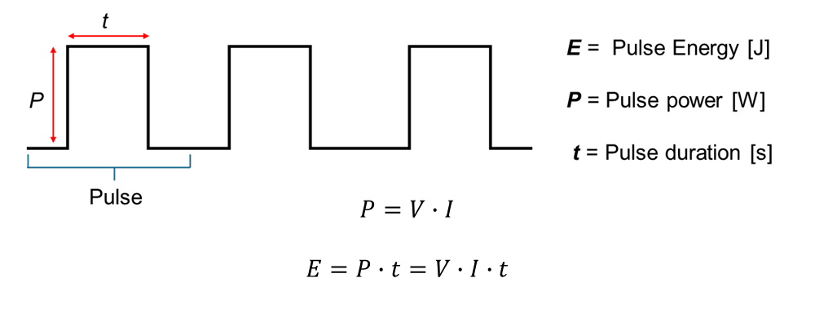
Supplementary Fig. 25 | Schematic diagram of square-wave voltage pulse. A square-wave voltage pulse illustrates the pulse power and pulse duration—key parameters for calculating the energy consumption of LTP and LTD in the laser-guided dual-mode memristor. The calculation of LTP and LTD energy consumption is detailed in Supplementary note 4.

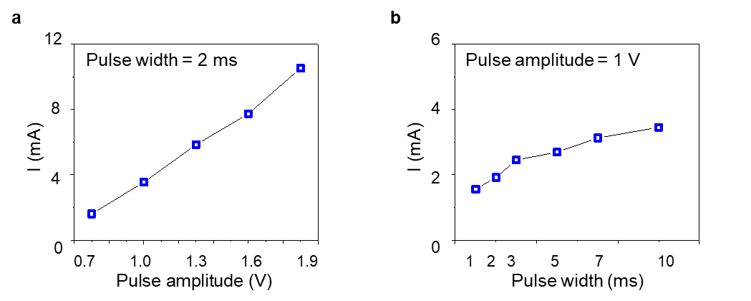
Supplementary Fig. 26 | Current response of volatile mode under different voltage pulse conditions. (a) Current response evaluated at a fixed pulse width of 2 ms, with pulse amplitude varying across 0.7, 1, 1.3, 1.6, and 1.9 V. (b) Current response evaluated at a fixed pulse amplitude of 1 V, with pulse width varying across 1, 2, 3, 5, 7, and 10 ms. Increasing either the pulse amplitude or width leads to a higher current in the volatile mode and emphasizes the sensitivity of device to pulse parameters.

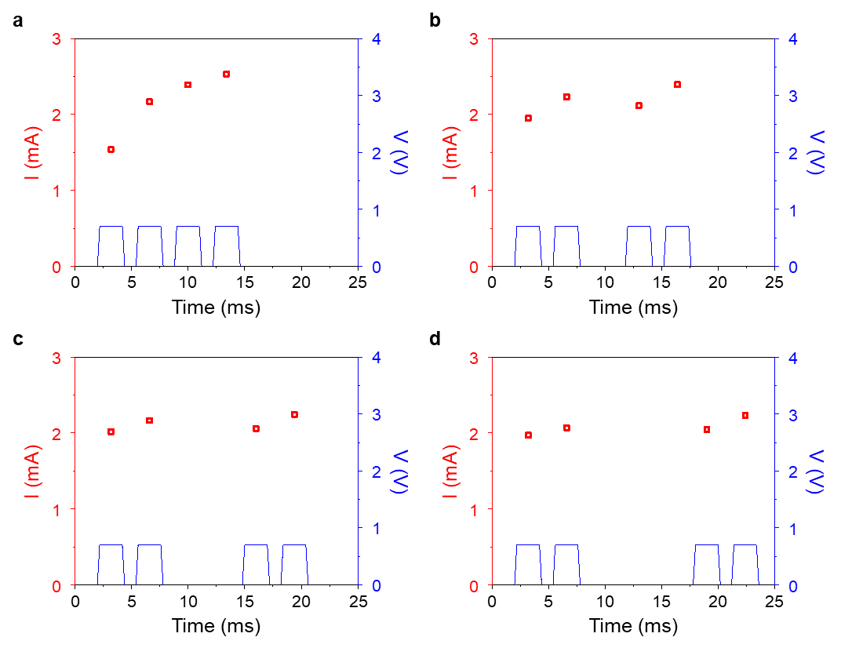
Supplementary Fig. 27 | Current variation of volatile mode reflecting the echo state property, based on the interval time between two consecutive pulses. Two consecutive pulses (0.7 V amplitude, 2 ms duration) were applied at interval times of (a) 1 ms, (b) 4 ms, (c) 7 ms, and (d) 10 ms. A shorter interval provides insufficient time for the device to reset. Therefore, the second consecutive pulse exhibits a higher current and retains partial memory of the prior input, a key feature of the echo state property in reservoir computing.

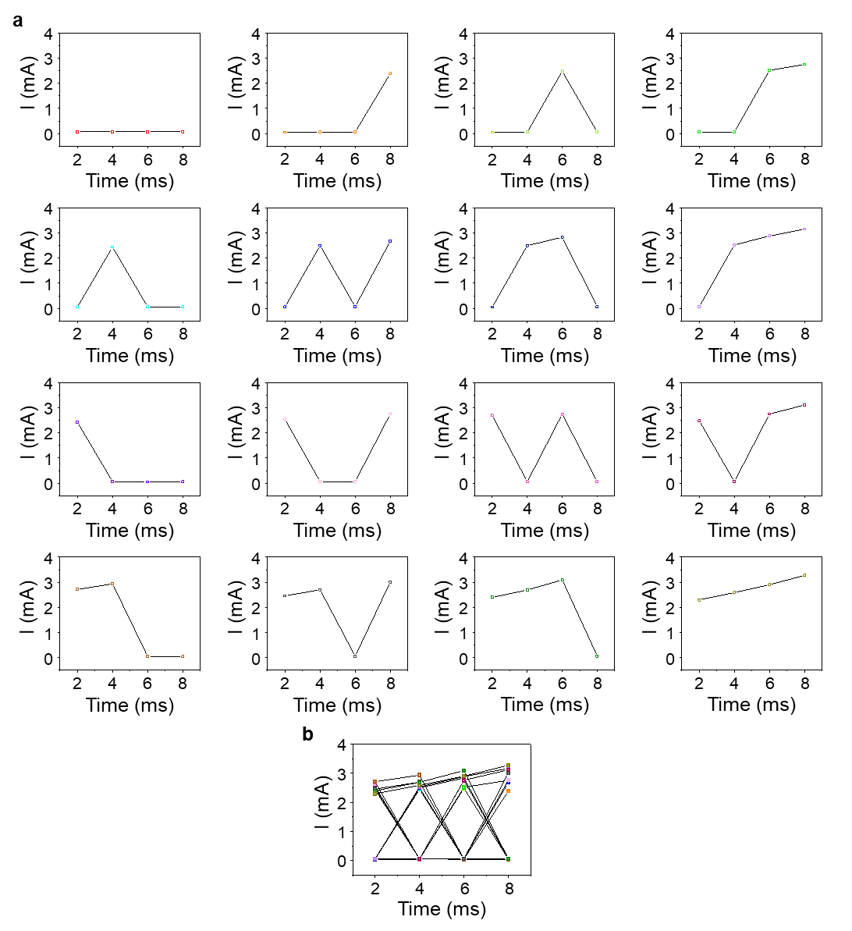
Supplementary Fig. 28 | Current variation of volatile mode under various voltage pulses. "0" indicates no applied voltage pulse, while "1" represents a voltage pulse with a 1 V amplitude and a 2 ms duration. (a) The current response for various voltage pulse sequences, ranging from 0000 to 1111. (b) Combined separability values depicting the variation in final current value. Different pulse conditions produce clearly distinguishable current responses and result in variations in the final current output.

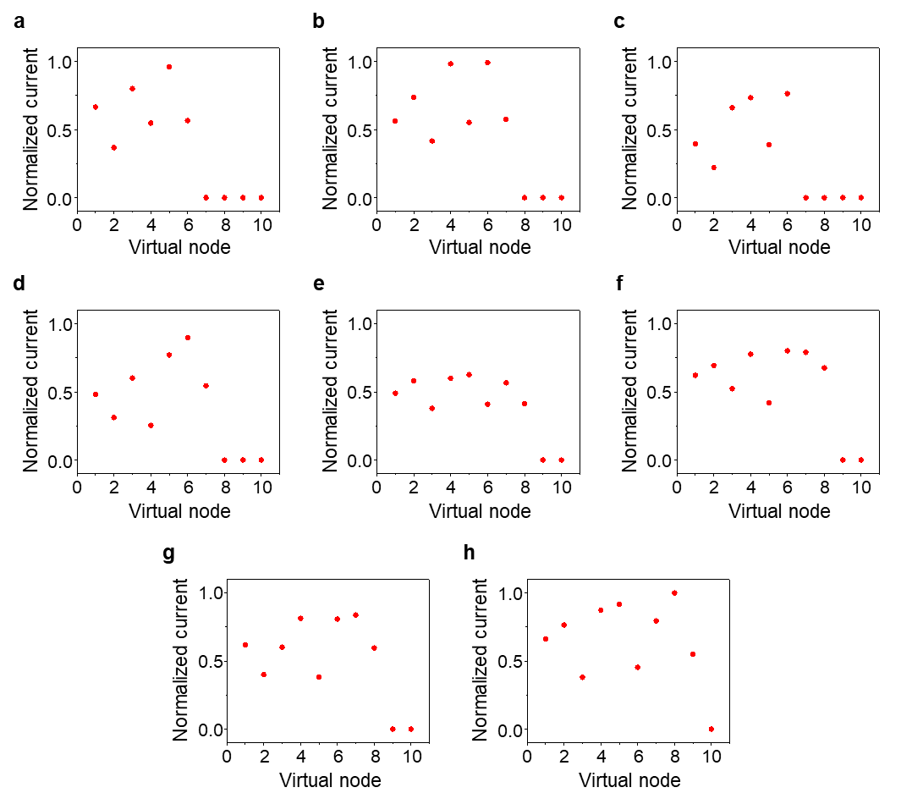
Supplementary Fig. 29 | Datasets based on neural firing for 8 melodies (C, D, E, F, F#, G, A, B). Normalized current response under the different voltage pulses. (a) 000, (b) 100, (c) 010, (d) 001, (e) 110, (f) 101, (g) 011, and (h) 111. Here, “0” represents a single pulse and “1” indicates two consecutive pulses. Each state from 000 to 111 corresponds to the solfège notes C, D, E, F, F#, G, A, and B. Distinct current responses for each input sequence generate data separation in a physical reservoir and facilitate melody recognition.

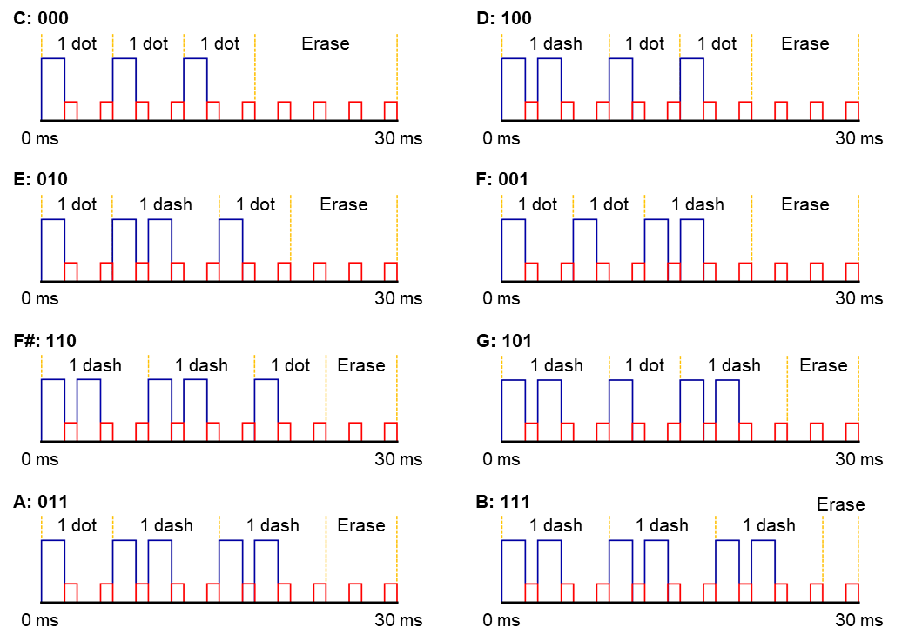
Supplementary Fig. 30 | Voltage-pulse-based pitch configurations for neuromorphic melody recognition. The pitch configurations from 000 to 111 correspond to the solfège notes C, D, E, F, F#, G, A, and B. A single dot (denoted as “0”) represents one 0.7 V, 2 ms pulse, whereas a dash (denoted as “1”) consists of two consecutive 0.7 V, 2 ms pulses separated by a 1 ms interval. 0.1 V, 1 ms read pulse is applied every 2 ms. Each voltage sequence is applied to the volatile mode to encode melodic data. Application of voltage sequences aligns with the results presented in Supplementary Fig. 29.

Supplementary note 1. Time-dependent voltage spiking function in laser-guided dual-mode memristor parallel RC circuit
A parallel RC circuit connected to the current source i(t) is shown in Fig. 3a, and the current i(t) in the RC circuit is given as follows:
$$i\left(t\right)= i_{C}\left(t\right)+i_{R}\left(t\right)=C\frac{dV(t)}{dt}+\frac{V(t)}{R}$$
For a constant current source i(t) = I, the voltage V(t) can be expressed by the following differential equation:
$$\frac{dV(t)}{dt}=-\frac{1}{RC}V\left(t\right)+\frac{I}{C}$$
Based on the above differential equation and the boundary conditions V(t_{n}^{ch}) = 0, V(t_{n}^{dis}) = V_{th}, the equations of the time-dependent charging and discharging voltage spiking are derived as follows⁴:
$$V_{n}^{ch}\left(t\right)=I_{in}R_{H}\{1-\exp\left(-\frac{t-t_{n}^{ch}}{τ_{ch}}\right)$$
$$V_{n}^{dis}\left(t\right)=IR_{L}\exp\left(-\frac{t-t_{n}^{dis}-τ_{dis}\ln\left(V_{th}/IR_{L}\right)}{τ_{dis}}\right)$$
Supplementary Fig. 19 presents the voltage profile corresponding to the above equations. Here, R_{L} represents the resistance value in the LRS state, while R_{H} corresponds to the resistance value in the HRS state. The charging and discharging time constants are defined as τ_{ch}=R_{H}C and τ_{dis}=R_{L}C, respectively.
The voltage spiking period (T) for a constant current input is defined by:
$$T=T_{1}+T_{2}=\left(t_{n}^{dis}-t_{1}\right)+(t_{2}-t_{n}^{dis})$$
By combining this definition with the time-dependent charging and discharging equations, the voltage spiking period can be expressed as follows:
$$T=C\left[R_{H}\ln\left(\frac{IR_{H}-V_{min}}{IR_{H}-V_{th}}\right)+R_{L}\ln\left(\frac{V_{th}}{V_{min}}\right)\right]$$
This equation demonstrates the dependence of the voltage spiking period on capacitance, consistent with the increase in spiking period observed in Supplementary Fig. 20 when the capacitance is raised from 2.2 nF to 10 nF.

Supplementary note 2. Method for calculating nonlinearity from LTP/LTD curves.
The nonlinearity of LTP and LTD was confirmed using Neurosim V3.0, an open-source MATLAB tool⁹. The fitting curves follow the defined formulas below, providing a quantitative basis for evaluating the device’s nonlinear synaptic behavior:
$$G_{LTP}=B\left(1-e^{-\frac{P}{A}}\right)+G_{min}$$
$$G_{LTD}=B\left(1-e^{-\frac{P-P_{max}}{A}}\right)+G_{max}$$
$$B=(G_{max}-G_{min})\left(1-e^{-\frac{P_{max}}{A}}\right)$$
G_{LTP} and G_{LTD} denote the device conductance under LTP and LTD, respectively, while G_{min} and G_{max} define the lowest and highest achievable conductance levels. The parameter P is the number of applied voltage pulses and P_{max} is the final pulse count used in the experiment. The constant A governs the exponential growth or decay rate, with fitted values of 0.6 for LTP and −0.4 for LTD. The amplitude-scaling factor B, derived from (G_{max} - G_{min}), P_{max} and A, normalizes the curve and sets the overall magnitude of the LTP/LTD transitions.

Supplementary note 3. Method for calculating symmetricity from LTP/LTD curves.
Symmetricity is determined as the inverse of the symmetric error^{10,11}, and it can be calculated by the following equation:
$$Symmetricity={\left(\sum_{k=1}^{k=n}{\frac{{\left(G_{N}\left(k\right)-G_{N}\left(2n-k\right)\right)}^{2}}{n} }\right)}^{-1}, G_{N}\left(k\right)=\frac{G\left(k\right)-G_{min}}{G_{max}-G_{min}}$$
$$={\left(\sum_{k=1}^{k=n}{\frac{{\left(\left[\left\{G\left(k\right)-G_{min}\right\}\right]-\left[\left\{G\left(2n-k\right)-G_{min}\right\}\right]\right)}^{2}}{n{(G_{max}-G_{min})}^{2}} }\right)}^{-1}$$
$$={\left(\sum_{k=1}^{k=n}{\frac{{\left(G\left(k\right)-G(2n-k)\right)}^{2}}{n×{(G_{max}-G_{min})}^{2}} }\right)}^{-1}$$
In Supplementary Fig. 24, G(k) and G(2n-k) represent the conductance values measured at the (k)^{th} and (2n-k)^{th} pulses, respectively, while G_{N}(k) denotes the normalized conductance at the (k)^{th} pulse. By substituting these conductance values into the equation, the LTP/LTD symmetricity can be quantitatively evaluated.

Supplementary note 4. Energy consumption of laser-guided dual-mode memristor in LTP/LTD.
The energy consumption for both LTP and LTD operations at a read voltage of 0.1 V was calculated using the following equation¹².
$$P=V∙I$$
$$E=P∙t=V∙I∙t$$
As shown in Supplementary Fig. 25, E is the energy consumption, P is the pulse power, t is the pulse duration, and V and I refer to the applied voltage and measured current, respectively. The total energy consumption, obtained by summing E over all pulses, is then normalized by the device area to yield the energy consumption per unit area.

References
1 Koirala, K. P., Sandireddy, V. P., Garcia, H., Duscher, G. & Kalyanaraman, R. Nanosecond switchable localized surface plasmons through resettable contact angle behavior in silver nanoparticles. Nanotechnol. 31, 355503 (2020).
2 Yu, H., Peng, Y., Yang, Y. & Li, Z.-Y. Plasmon-enhanced light–matter interactions and applications. npj Comput. Mater. 5, 45 (2019).
3 Rashid, J., Barakat, M., Salah, N. & Habib, S. S. Ag/ZnO nanoparticles thin films as visible light photocatalysts. RSC adv. 4, 56892-56899 (2014).
4 Sung, S. H., Kim, T. J., Shin, H., Im, T. H. & Lee, K. J. Simultaneous emulation of synaptic and intrinsic plasticity using a memristive synapse. Nat. Commun. 13, 2811 (2022).
5 Yi, W. et al. Biological plausibility and stochasticity in scalable VO2 active memristor neurons. Nat. Commun. 9, 4661 (2018).
6 Yang, J.-Q. et al. Leaky integrate-and-fire neurons based on perovskite memristor for spiking neural networks. Nano Energy 74, 104828 (2020).
7 Kim, S. J., Kim, S. & Jang, H. W. Competing memristors for brain-inspired computing. Iscience 24 (2021).
8 Wu, Z. et al. Diverse long-term potentiation and depression based on multilevel LiSiO x memristor for neuromorphic computing. Nanotechnol. 34, 475201 (2023).
9 Chen, P.-Y., Peng, X. & Yu, S. NeuroSim+: An Integrated DevicetoAlgorithm Framework for Benchmarking Synaptic Devices and Array Architectures. In 2017 IEEE International Electron Devices Meeting (IEDM) 6.1.1-6.1.4 (IEEE, 2017)
10 Seo, S. et al. Artificial van der Waals hybrid synapse and its application to acoustic pattern recognition. Nat. Commun. 11, 3936 (2020).
11 Kim, D. et al. Reconfigurable Resistive Switching Memory for Telegraph Code Sensing and Recognizing Reservoir Computing Systems. Small, 2402961 (2024).
12 Wu, C., Kim, T. W., Choi, H. Y., Strukov, D. B. & Yang, J. J. Flexible three-dimensional artificial synapse networks with correlated learning and trainable memory capability. Nat. Commun. 8, 752 (2017).

