Supplementary Table 1.
Dimension/Group | Parameter | Unit | Definition
Vertical Analysis | NL/ML (anatomic) | ° | The angle between the NL and ML
Vertical Analysis | SNL/ML (anatomic) | ° | The inclination of the mandible (mandibular inclination) relative to the nasion-sella line (anterior skull base, SNL)
Vertical Analysis | NL/NSL | ° | The angle between Sella-Nasion-line (NSL = SN) and nasal line (Spa-Spp)
Vertical Analysis | PFH/AFH | % | The ratio between posterior (SGo) and anterior (NMe) facial height
Vertical Analysis | Gonial Angle | ° | The angle between ML and line GoAr at Gonion
Vertical Analysis | Facial axis | ° | The angle between the lines NBa and PtGN’
Sagittal Analysis | Angle SNA | ° | The angle between Sella, Nasion, and point A
Sagittal Analysis | Angle SNB | ° | The angle between Sella, Nasion, and point B
Sagittal Analysis | ANB | ° | The angle between Nasion, point A, and point B
Sagittal Analysis | ANB( indl.) | ° | ANB_{ind} = (−35.16 + 0.4 · SNA + 0.2 · ML-NSL) according to Panagiotidis and Witt
Sagittal Analysis | SN-Ba | ° | Central saddle angle. It describes the extent of the skull base flexion
Sagittal Analysis | SNPg | ° | Theangle between Sella, Nasion and Pogonion
Sagittal Analysis | S-N | mm | The S-N line represents the anterior cranial base. It is constructed by connecting the points sella turcica and the Nasion
Sagittal Analysis | Go-Me | mm | The mandibular plane as a line connecting the points gonion and menton
Sagittal Analysis | Wits | mm | measures the extent to which the jaws are related to each other anteroposteriorly.
Growth Analysis | ML-NSL | ° | The angle formed between the ML and NSL lines
Dental Analysis | (+1/NL) | ° | The angle between upper incisors’ tooth axis and line NL
Dental Analysis | (+1/SN) | ° | The angle between upper incisors’ tooth axis and line SN
Dental Analysis | +1/NA | ° | The angle between upper incisors’ tooth axis and line NA
Dental Analysis | +1/NA | mm | the upper central incisor to N-A reading in millimeters provides information on the relative forward or backward positioning of the incisor teeth to the N-A line
Dental Analysis | -1/ML (anatomic) | ° | The relative anteroposterior angulation of the lower incisor teeth is determined by relating the most protruding incisor tooth to the mandibular plane (ML)
Dental Analysis | (-1/NB) | ° | The lower central incisor to N-B reading in degrees indicates the relative axial inclination of these teeth
Dental Analysis | (-1/NB) | mm | The lower incisor to NB line measurement in millimeters shows the relative forward or backward positioning of these teeth to the N-B line
Dental Analysis | Interincisal angle | ° | the inter-incisal angle relates the relative position of the upper incisor to that of the lower incisor

Supplementary Table 2.
Parameter | Group A _ Group B | Difference | Lower CI | Upper CI | Adj. P value
NL-ML angle | II_Female-I_Female | -2.17 | -4.25 | -0.08 | 0.04
NL-ML angle | II_Male-I_Female | -2.72 | -5.23 | -0.22 | 0.03
NL-ML angle | II_14<Age<20-I_0<Age<13 | -3.86 | -7.13 | -0.58 | 0.01
NL-ML angle | II_14<Age<20-I_Age>21 | -3.74 | -7.24 | -0.23 | 0.03
NL-ML angle | II_Female_14<Age<20-I_Female_0<Age<13 | -5.72 | -10.49 | -0.95 | 0.01
NL-NSL angle | II_Female-I_Male | 1.41 | 0.01 | 2.80 | 0.05
PFH/AFH | II_Male-I_Female | 2.21 | 0.19 | 4.24 | 0.03
Gonial angle | II_Female-I_Female | -4.58 | -7.07 | -2.09 | 0.00
Gonial angle | II_Male-I_Female | -4.10 | -7.09 | -1.10 | 0.00
Gonial angle | II_Female-I_Male | -3.20 | -6.24 | -0.15 | 0.04
Gonial angle | II_14<Age<20-I_0<Age<13 | -7.08 | -11.00 | -3.15 | 0.00
Gonial angle | II_14<Age<20-I_14<Age<20 | -4.77 | -7.96 | -1.59 | 0.00
Gonial angle | II_14<Age<20-I_Age>21 | -6.02 | -10.22 | -1.83 | 0.00
Gonial angle | II_Female_14<Age<20-I_Female_0<Age<13 | -8.05 | -13.79 | -2.31 | 0.00
Gonial angle | II_Female_14<Age<20-I_Female_14<Age<20 | -5.83 | -10.40 | -1.27 | 0.00
Gonial angle | II_Female_14<Age<20-I_Female_Age>21 | -6.83 | -12.41 | -1.26 | 0.00
Gonial angle | II_Female_14<Age<20-I_Male_0<Age<13 | -6.85 | -13.52 | -0.18 | 0.04
Facial axis | II_Age>21-I_14<Age<20 | -2.77 | -4.99 | -0.55 | 0.01
Facial axis | II_Female_Age>21-I_Male_0<Age<13 | -4.27 | -8.46 | -0.09 | 0.04
Facial axis | II_Female_Age>21-I_Male_14<Age<20 | -3.46 | -6.90 | -0.02 | 0.05
SNB angle | II_Female-I_Female | -1.73 | -3.26 | -0.19 | 0.02
SNB angle | II_Male-I_Female | -2.28 | -4.13 | -0.43 | 0.01
SNB angle | II_Female-I_Male | -2.42 | -4.30 | -0.54 | 0.01
SNB angle | II_Male-I_Male | -2.97 | -5.11 | -0.83 | 0.00
SNB angle | II_0<Age<13-I_0<Age<13 | -2.85 | -5.43 | -0.27 | 0.02
SNB angle | II_0<Age<13-I_14<Age<20 | -3.44 | -5.59 | -1.28 | 0.00
SNB angle | II_Age>21-I_14<Age<20 | -2.83 | -5.16 | -0.50 | 0.01
SNB angle | II_0<Age<13-I_Age>21 | -3.04 | -5.78 | -0.30 | 0.02
SNB angle | II_Male_0<Age<13-I_Female_14<Age<20 | -3.88 | -7.46 | -0.31 | 0.02
SNB angle | II_Female_Age>21-I_Male_14<Age<20 | -3.64 | -7.27 | -0.01 | 0.05
SNB angle | II_Male_0<Age<13-I_Male_14<Age<20 | -5.01 | -8.95 | -1.06 | 0.00
ANB angle | II_Female-I_Female | 2.05 | 1.50 | 2.60 | 0.00
ANB angle | II_Male-I_Female | 1.83 | 1.16 | 2.49 | 0.00
ANB angle | II_Female-I_Male | 2.44 | 1.77 | 3.12 | 0.00
ANB angle | II_Male-I_Male | 2.22 | 1.45 | 2.99 | 0.00
ANB angle | II_0<Age<13-I_0<Age<13 | 1.84 | 0.90 | 2.78 | 0.00
ANB angle | II_14<Age<20-I_0<Age<13 | 1.95 | 1.06 | 2.83 | 0.00
ANB angle | II_Age>21-I_0<Age<13 | 2.23 | 1.24 | 3.22 | 0.00
ANB angle | II_0<Age<13-I_14<Age<20 | 2.03 | 1.25 | 2.82 | 0.00
ANB angle | II_14<Age<20-I_14<Age<20 | 2.14 | 1.42 | 2.86 | 0.00
ANB angle | II_Age>21-I_14<Age<20 | 2.42 | 1.58 | 3.27 | 0.00
ANB angle | II_0<Age<13-I_Age>21 | 2.03 | 1.03 | 3.03 | 0.00
ANB angle | II_14<Age<20-I_Age>21 | 2.13 | 1.19 | 3.08 | 0.00
ANB angle | II_Age>21-I_Age>21 | 2.42 | 1.37 | 3.47 | 0.00
ANB angle | II_Female_14<Age<20-I_Female_0<Age<13 | 1.60 | 0.31 | 2.88 | 0.00
ANB angle | II_Female_Age>21-I_Female_0<Age<13 | 1.84 | 0.44 | 3.25 | 0.00
ANB angle | II_Female_0<Age<13-I_Female_14<Age<20 | 2.06 | 0.90 | 3.22 | 0.00
ANB angle | II_Female_14<Age<20-I_Female_14<Age<20 | 2.29 | 1.26 | 3.31 | 0.00
ANB angle | II_Female_Age>21-I_Female_14<Age<20 | 2.53 | 1.37 | 3.70 | 0.00
ANB angle | II_Male_0<Age<13-I_Female_14<Age<20 | 2.11 | 0.82 | 3.40 | 0.00
ANB angle | II_Male_14<Age<20-I_Female_14<Age<20 | 1.95 | 0.68 | 3.22 | 0.00
ANB angle | II_Male_Age>21-I_Female_14<Age<20 | 2.27 | 0.53 | 4.01 | 0.00
ANB angle | II_Female_0<Age<13-I_Female_Age>21 | 1.80 | 0.43 | 3.16 | 0.00
ANB angle | II_Female_14<Age<20-I_Female_Age>21 | 2.02 | 0.77 | 3.27 | 0.00
ANB angle | II_Female_Age>21-I_Female_Age>21 | 2.27 | 0.90 | 3.64 | 0.00
ANB angle | II_Male_0<Age<13-I_Female_Age>21 | 1.85 | 0.37 | 3.32 | 0.00
ANB angle | II_Male_14<Age<20-I_Female_Age>21 | 1.69 | 0.23 | 3.14 | 0.01
ANB angle | II_Male_Age>21-I_Female_Age>21 | 2.00 | 0.12 | 3.89 | 0.03
ANB angle | II_Female_0<Age<13-I_Male_0<Age<13 | 2.48 | 0.89 | 4.07 | 0.00
ANB angle | II_Female_14<Age<20-I_Male_0<Age<13 | 2.71 | 1.21 | 4.20 | 0.00
ANB angle | II_Female_Age>21-I_Male_0<Age<13 | 2.95 | 1.36 | 4.55 | 0.00
ANB angle | II_Male_0<Age<13-I_Male_0<Age<13 | 2.53 | 0.84 | 4.22 | 0.00
ANB angle | II_Male_14<Age<20-I_Male_0<Age<13 | 2.37 | 0.70 | 4.04 | 0.00
ANB angle | II_Male_Age>21-I_Male_0<Age<13 | 2.69 | 0.63 | 4.74 | 0.00
ANB angle | II_Female_0<Age<13-I_Male_14<Age<20 | 1.94 | 0.63 | 3.24 | 0.00
ANB angle | II_Female_14<Age<20-I_Male_14<Age<20 | 2.16 | 0.97 | 3.35 | 0.00
ANB angle | II_Female_Age>21-I_Male_14<Age<20 | 2.41 | 1.10 | 3.72 | 0.00
ANB angle | II_Male_0<Age<13-I_Male_14<Age<20 | 1.98 | 0.56 | 3.41 | 0.00
ANB angle | II_Male_14<Age<20-I_Male_14<Age<20 | 1.83 | 0.42 | 3.23 | 0.00
ANB angle | II_Male_Age>21-I_Male_14<Age<20 | 2.14 | 0.30 | 3.99 | 0.01
ANB angle | II_Female_0<Age<13-I_Male_Age>21 | 2.73 | 0.58 | 4.87 | 0.00
ANB angle | II_Female_14<Age<20-I_Male_Age>21 | 2.95 | 0.88 | 5.02 | 0.00
ANB angle | II_Female_Age>21-I_Male_Age>21 | 3.20 | 1.05 | 5.35 | 0.00
ANB angle | II_Male_0<Age<13-I_Male_Age>21 | 2.77 | 0.55 | 4.99 | 0.00
ANB angle | II_Male_14<Age<20-I_Male_Age>21 | 2.62 | 0.41 | 4.82 | 0.01
ANB angle | II_Male_Age>21-I_Male_Age>21 | 2.93 | 0.43 | 5.44 | 0.01
SN-Pg angle | II_Female-I_Female | -1.65 | -2.81 | -0.48 | 0.00
SN-Pg angle | II_Male-I_Female | -1.50 | -2.91 | -0.10 | 0.03
SN-Pg angle | II_Female-I_Male | -2.48 | -3.91 | -1.05 | 0.00
SN-Pg angle | II_Male-I_Male | -2.34 | -3.97 | -0.71 | 0.00
SN-Pg angle | II_Age>21-I_0<Age<13 | -2.16 | -4.22 | -0.09 | 0.04
SN-Pg angle | II_0<Age<13-I_14<Age<20 | -2.64 | -4.27 | -1.00 | 0.00
SN-Pg angle | II_Age>21-I_14<Age<20 | -2.93 | -4.70 | -1.17 | 0.00
SN-Pg angle | II_0<Age<13-I_Age>21 | -2.59 | -4.67 | -0.51 | 0.01
SN-Pg angle | II_Age>21-I_Age>21 | -2.88 | -5.07 | -0.70 | 0.00
SN-Pg angle | II_Female_0<Age<13-I_Female_14<Age<20 | -2.45 | -4.87 | -0.02 | 0.05
SN-Pg angle | II_Female_Age>21-I_Female_14<Age<20 | -2.69 | -5.13 | -0.25 | 0.02
SN-Pg angle | II_Female_0<Age<13-I_Male_14<Age<20 | -3.45 | -6.19 | -0.72 | 0.00
SN-Pg angle | II_Female_Age>21-I_Male_14<Age<20 | -3.70 | -6.45 | -0.95 | 0.00
S-N (mm) | II_Male-I_Female | 2.96 | 0.25 | 5.66 | 0.03
S-N (mm) | II_Female-I_Male | -2.82 | -5.57 | -0.07 | 0.04
S-N (mm) | II_Male_0<Age<13-I_Female_0<Age<13 | 6.38 | 0.28 | 12.47 | 0.03
S-N (mm) | II_Female_14<Age<20-I_Male_14<Age<20 | -5.05 | -9.86 | -0.24 | 0.03
Go Me (mm) | II_Female-I_Male | -2.85 | -5.24 | -0.45 | 0.01
Wits appraisal | II_Female-I_Female | 2.55 | 1.71 | 3.39 | 0.00
Wits appraisal | II_Male-I_Female | 2.40 | 1.39 | 3.40 | 0.00
Wits appraisal | II_Female-I_Male | 1.55 | 0.52 | 2.57 | 0.00
Wits appraisal | II_Male-I_Male | 1.39 | 0.22 | 2.56 | 0.01
Wits appraisal | II_0<Age<13-I_0<Age<13 | 1.82 | 0.40 | 3.25 | 0.00
Wits appraisal | II_14<Age<20-I_0<Age<13 | 1.82 | 0.47 | 3.17 | 0.00
Wits appraisal | II_Age>21-I_0<Age<13 | 2.19 | 0.68 | 3.70 | 0.00
Wits appraisal | II_0<Age<13-I_14<Age<20 | 2.00 | 0.81 | 3.19 | 0.00
Wits appraisal | II_14<Age<20-I_14<Age<20 | 2.00 | 0.91 | 3.09 | 0.00
Wits appraisal | II_Age>21-I_14<Age<20 | 2.36 | 1.08 | 3.65 | 0.00
Wits appraisal | II_0<Age<13-I_Age>21 | 2.48 | 0.96 | 3.99 | 0.00
Wits appraisal | II_14<Age<20-I_Age>21 | 2.47 | 1.03 | 3.91 | 0.00
Wits appraisal | II_Age>21-I_Age>21 | 2.84 | 1.25 | 4.43 | 0.00
Wits appraisal | II_Female_14<Age<20-I_Female_0<Age<13 | 2.14 | 0.19 | 4.09 | 0.02
Wits appraisal | II_Female_0<Age<13-I_Female_14<Age<20 | 2.37 | 0.62 | 4.13 | 0.00
Wits appraisal | II_Female_14<Age<20-I_Female_14<Age<20 | 2.75 | 1.20 | 4.30 | 0.00
Wits appraisal | II_Female_Age>21-I_Female_14<Age<20 | 2.72 | 0.96 | 4.49 | 0.00
Wits appraisal | II_Male_0<Age<13-I_Female_14<Age<20 | 2.70 | 0.74 | 4.66 | 0.00
Wits appraisal | II_Male_14<Age<20-I_Female_14<Age<20 | 1.92 | 0.00 | 3.84 | 0.05
Wits appraisal | II_Male_Age>21-I_Female_14<Age<20 | 3.35 | 0.72 | 5.99 | 0.00
Wits appraisal | II_Female_0<Age<13-I_Female_Age>21 | 2.61 | 0.54 | 4.67 | 0.00
Wits appraisal | II_Female_14<Age<20-I_Female_Age>21 | 2.99 | 1.09 | 4.88 | 0.00
Wits appraisal | II_Female_Age>21-I_Female_Age>21 | 2.96 | 0.88 | 5.03 | 0.00
Wits appraisal | II_Male_0<Age<13-I_Female_Age>21 | 2.94 | 0.70 | 5.18 | 0.00
Wits appraisal | II_Male_Age>21-I_Female_Age>21 | 3.59 | 0.74 | 6.44 | 0.00
+1/NA angle | II_Male-I_Female | -4.26 | -8.22 | -0.30 | 0.03
+1/NA angle | II_Male_14<Age<20-I_Female_0<Age<13 | -9.09 | -17.82 | -0.36 | 0.03
+1/NA angle | II_Male_14<Age<20-I_Female_14<Age<20 | -9.07 | -16.50 | -1.64 | 0.00
-1/ML (anatomic) | II_Female-I_Female | 3.90 | 1.17 | 6.63 | 0.00
-1/ML (anatomic) | II_Male-I_Female | 3.58 | 0.29 | 6.86 | 0.03
-1/ML (anatomic) | II_14<Age<20-I_0<Age<13 | 4.80 | 0.46 | 9.13 | 0.02
-1/ML (anatomic) | II_14<Age<20-I_14<Age<20 | 3.64 | 0.12 | 7.16 | 0.04
-1/ML (anatomic) | II_14<Age<20-I_Age>21 | 6.45 | 1.81 | 11.08 | 0.00
-1/ML (anatomic) | II_Female_14<Age<20-I_Female_14<Age<20 | 5.62 | 0.64 | 10.60 | 0.01
-1/ML (anatomic) | II_Female_14<Age<20-I_Female_Age>21 | 7.81 | 1.72 | 13.89 | 0.00

Supplementary Figure 1.
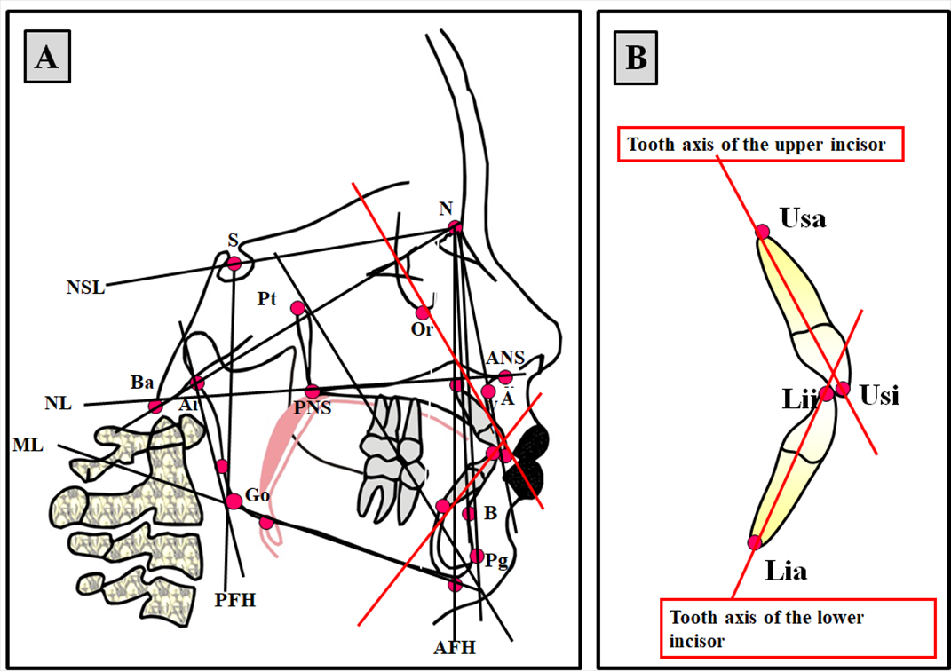

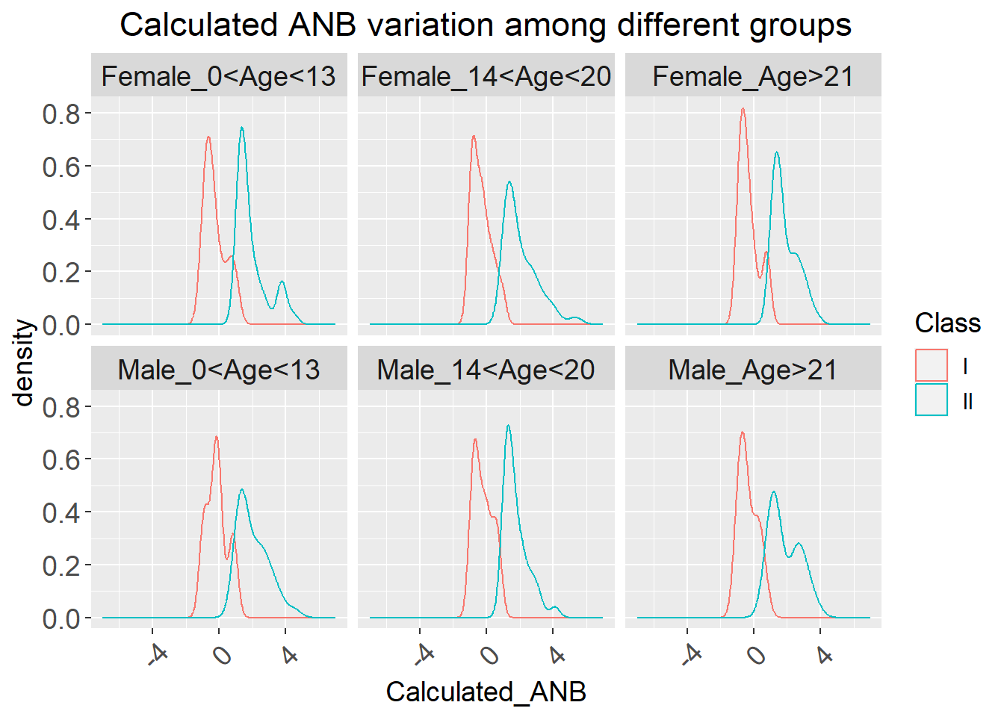
Supplementary Figure 2.

