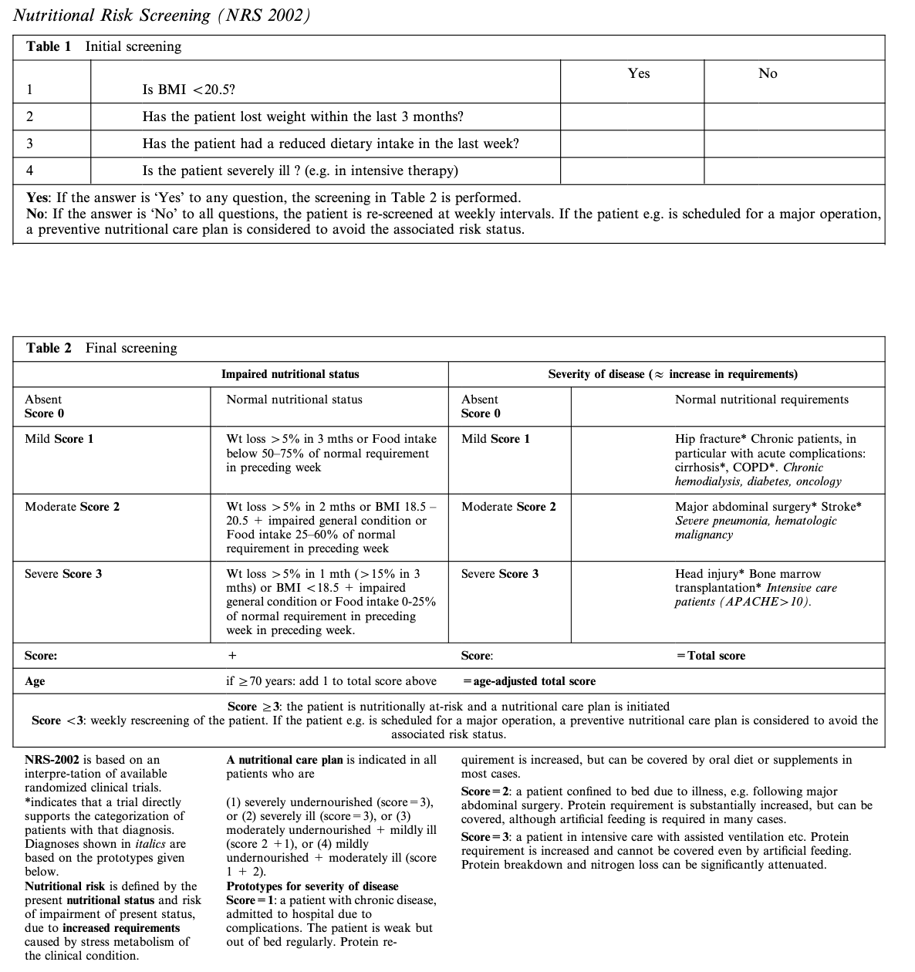
Nutritional Risk Screening (NRS 2002)

Reference
ESPEN guidelines for nutrition screening 2002, Clin Nutr. 2003 Aug;22(4):415-21.

