Supplementary Materials for

Three-Years Follow-up for Patients with Advanced Non‒Small-Cell Lung Cancer Treated by Autologous Cytokine-Induced Killer (CIK) Cell Immunotherapy in Combination with Sintilimab plus Chemotherapy: (NSCLC)-CCICC-002
Weihong Zhang, Yanping Chen, Li Zhou, Yanjuan Xiong, Fan Yang, Meng Shen, Shuzhan Li, Jia-li Zhang, Weijiao Du, Zhenzhen Hui, Xiao Tian, Ying Han, Yang Wang, Shunju Pang, Baozhu Ren, Xinwei Zhang, Shui Cao, Xiubao Ren, Runmei Li, Liang Liu.

Correspondence to: Liang Liu, MD (E-mail: liuliang@tjmuch.com)
Runmei Li, MD (E-mail: lrmfocus@126.com)
Xiubao Ren, MD (E-mail: renxiubao@tjmuch.com)

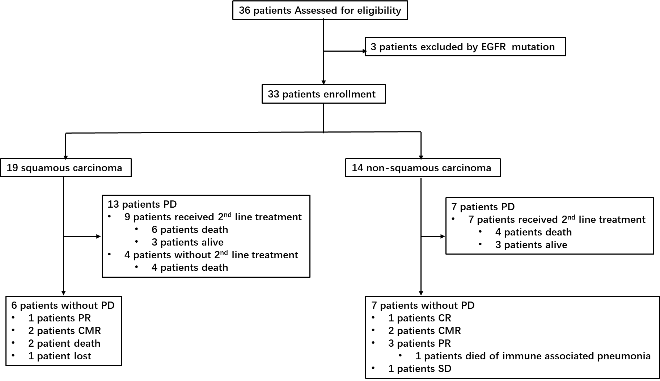

Figure S1. CONSORT Diagram for The Phase IB Trial of Autologous Cytokine-Induced Killer Cell Therapy in Combination With Sintilimab Plus Chemotherapy in Patients With Advanced NSCLC.

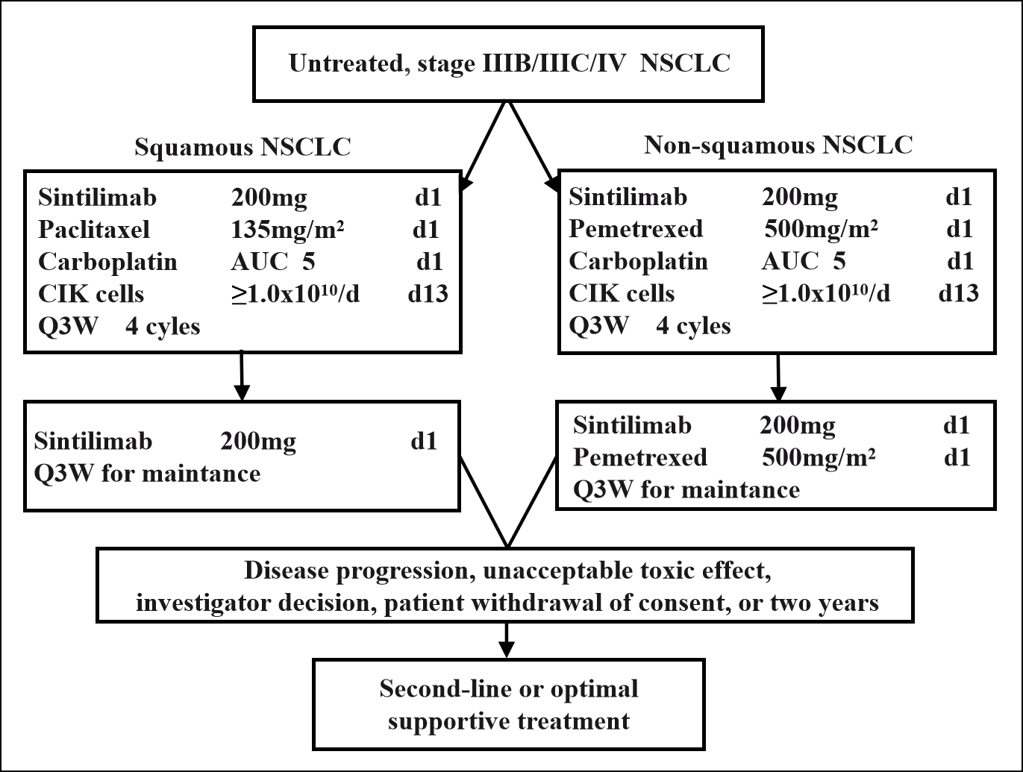

Figure S2. Treatment plan

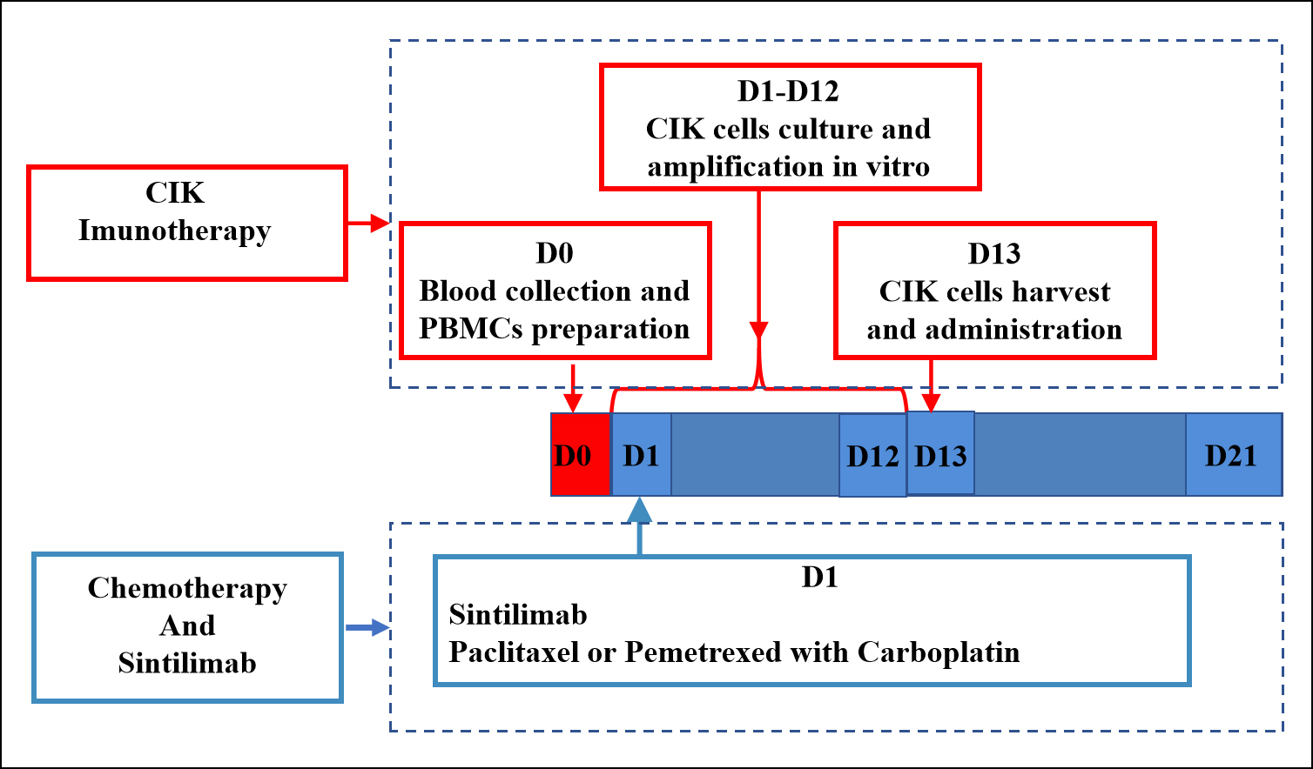

Figure S3. Treatment flow chart

