Supplementary
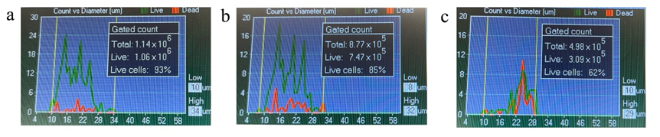

Supplementary Figure 1. Alive and dead cells of P8 (a), P10 (b), and P12 (c) were detected by TC20 (Bio-Rad). The original pictures from the machine were provided in Supplementary Figures 4, 5, and 6.
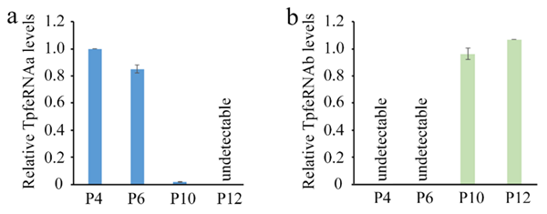

Supplementary Figure 2. The relative TpfeRNA expression levels across P4, P6, P10, and P12 were analyzed. Cycle threshold (Ct) values greater than 36 were considered undetectable. Data are presented as mean ± standard error of the mean (SEM).
Supplementary Table 1. Oligonucleotides and applications
Oligos | Sequence (5'-3') | Application
3' Adaptor | /5rApp/CTGTAGGCACCATCAAT/3ddc/ | ligation
5' Adaptor | TGAUACGGCGACCACCGAGAUCUACACUCUUUCCCUACACGACGCUCUUCCGAUCU | ligation
GSP | CAAGCAGAAGACGGCATACGATTGATGGTGCCTACAG | RT
pfeRNA R | CAAGCAGAAGACGGCATACGA | PCR
M13R | CAGGAAACAGCTATGACC | sequencing
Scrambled-Biotin | UGAUACGGCGACCACCGAGAUCUACACUCUGUCCCUACAC-Biotin | pull down assay
TpfeRNAa-Biotin | CAACUCAUGAGACCCACAACAAAUAGCCCU-Biotin | pull down assay
TpfeRNAb-Biotin | GUUUUUCAUAUCAUUGGUCGUGGUUGUAGUCCGUGCGAGAAU-Biotin | pull down assay
TERTF | AGGGGCAAGTCCTACGTCCAGT | qPCR
TERTR | CACCAACAAGAAATCATCCACC | qPCR
TpfeRNAa F | CAACTCATGAGACCCACAACAAAT | PCR
TpfeRNAb F | GTTTTTCATATCATTGGTCGTGGTTG | PCR
Scrambled-Me | UGAUACGGCGACCACCGAGAUCUACACUCUGUCCCUACAmC | activity assay
TpfeRNAa-Me | CAACUCAUGAGACCCACAACAAAUAGCCCmU | activity assay
TpfeRNAb-Me | GUUUUUCAUAUCAUUGGUCGUGGUUGUAGUCCGUGCGAGAAmU | activity assay
TpfeRNAa-MeASO | AGGGCUAUUUGUUGUGGGUCUCAUGAGUUmG | activity assay
TpfeRNAb-MeASO | AUUCUCGCACGGACUACAACCACGACCAATGATATGAAAAAmC | activity assay

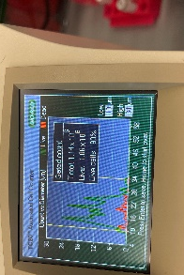

Supplementary Figure 4: Original picture for Supplementary Figure 1a.

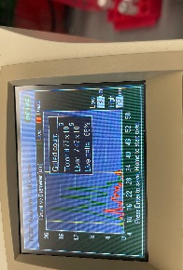

Supplementary Figure 5: Original picture for Supplementary Figure 1b.

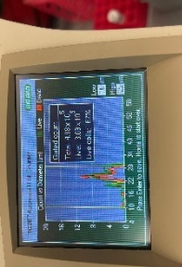

Supplementary Figure 6: Original picture for Supplementary Figure 1c.

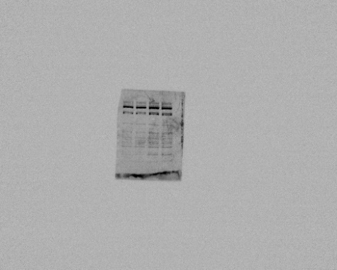

Supplementary Figure 7: Original picture for Fig. 2a TERT input. The target band was indicated by a line.

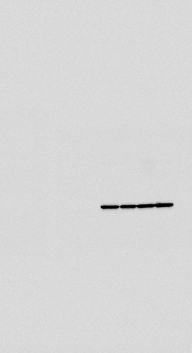

Supplementary Figure 8: Original picture for Fig. 2a β-Actin input.

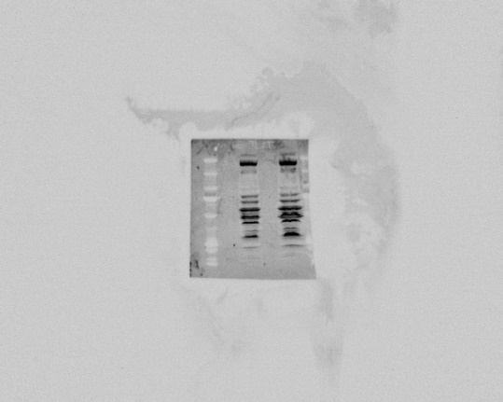

Supplementary Figure 9: Original picture for Fig. 2a TERT IP. The target band was indicated by a line.

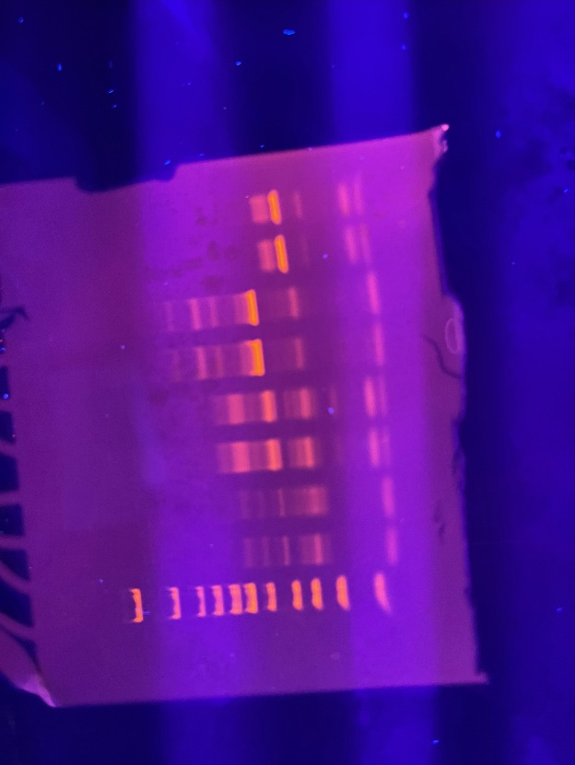

Supplementary Figure 10: Original picture for Fig. 3a, target band was indicated by lines.

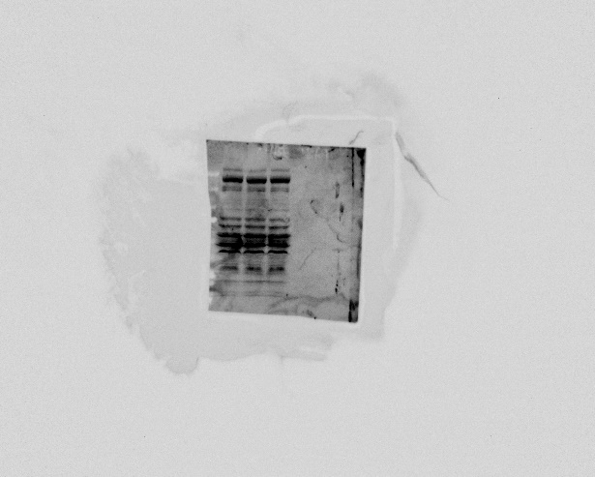

Supplementary Figure 11: Original picture for Fig. 4 TERT input. The target band was indicated by a line.

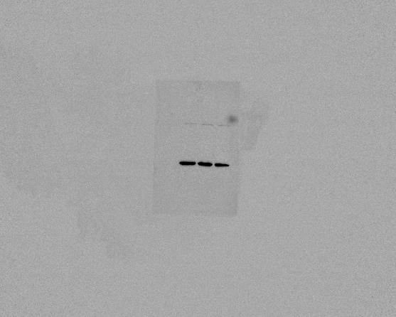

Supplementary Figure 12: Original picture for Fig. 4 β-Actin input.

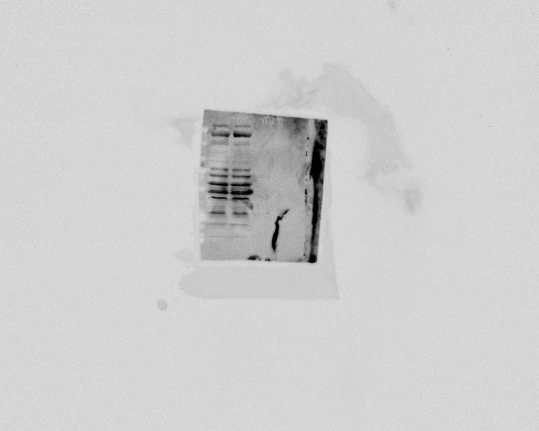

Supplementary Figure 13: Original picture for Fig. 4 TERT IP. The target band was indicated by a line.

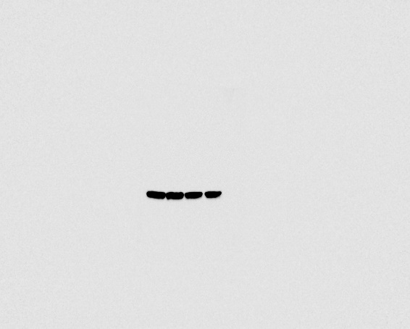

Supplementary Figure 14: Original picture for Fig. 6b.

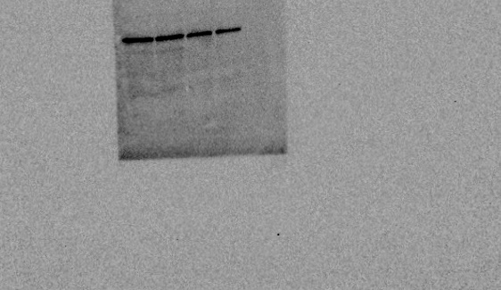

Supplementary Figure 15: Original picture for Fig. 6b.

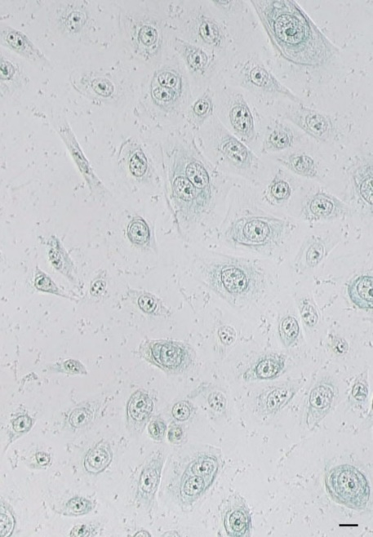

Supplementary Figure 16: Original picture for Supplementary Figure 3.

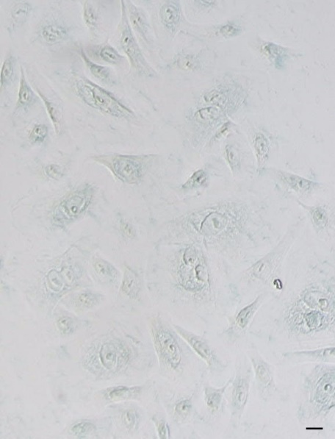

Supplementary Figure 17: Original picture for Supplementary Figure 3.

