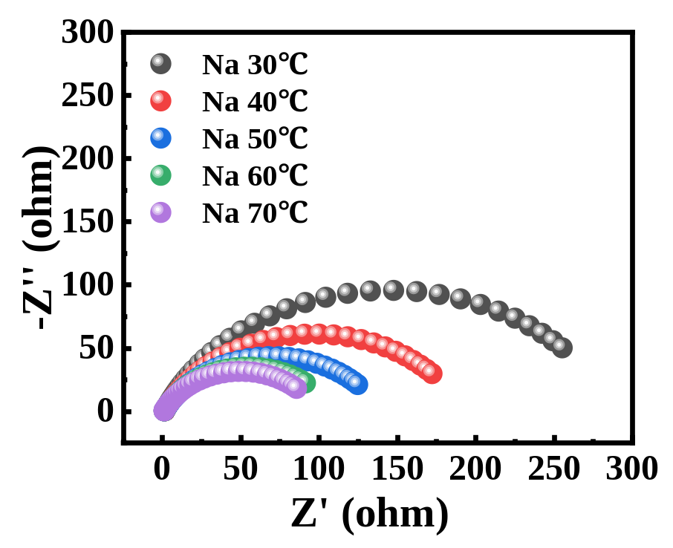
Fig. S1 Nyquist plots of the EIS measured at five temperatures for NaCl solution

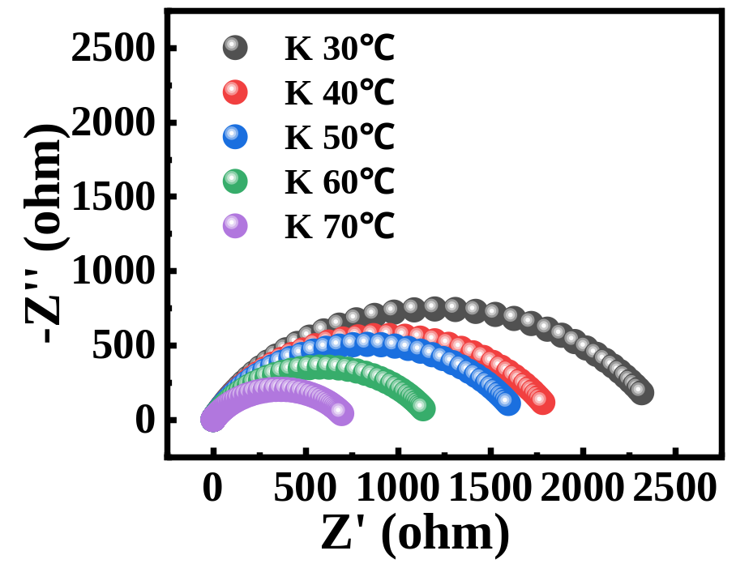
Fig. S2 Nyquist plots of the EIS measured at five temperatures for KCl solution

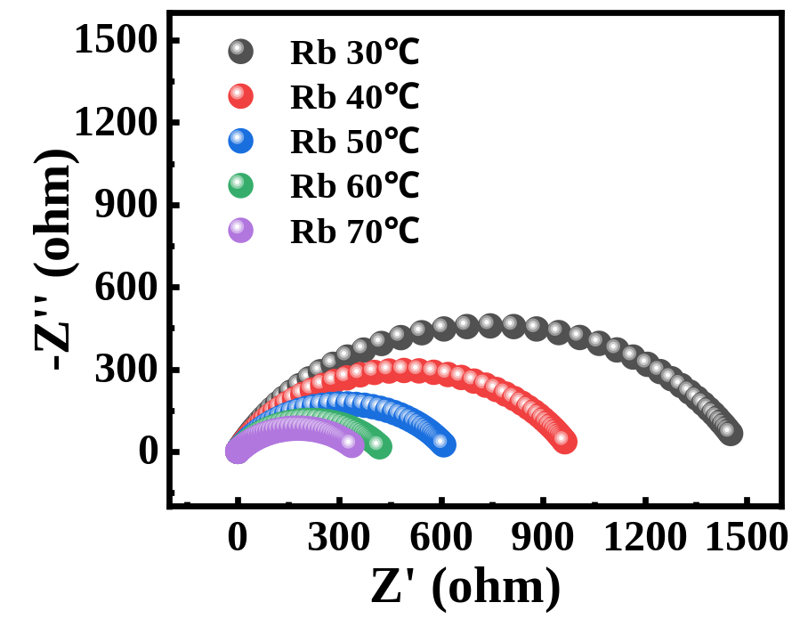
Fig. S3 Nyquist plots of the EIS measured at five temperatures for RbCl solution

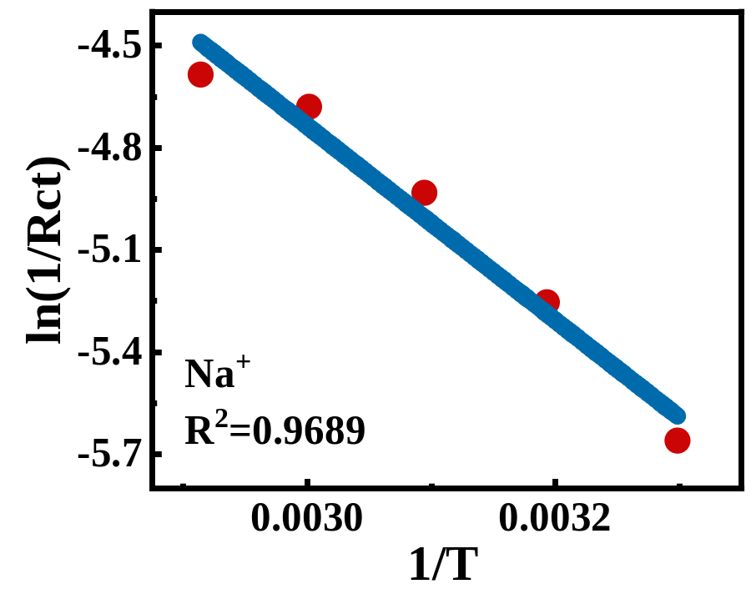
Fig. S4 Fitted images of ln(Rct⁻¹)-T⁻¹ for NaCl solution

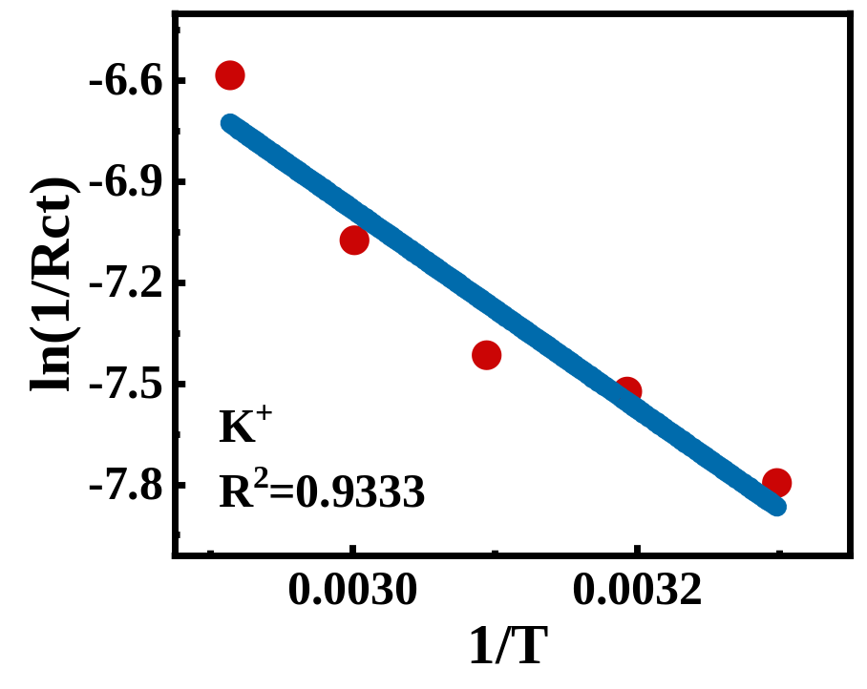
Fig. S5 Fitted images of ln(Rct⁻¹)-T⁻¹ for KCl solution

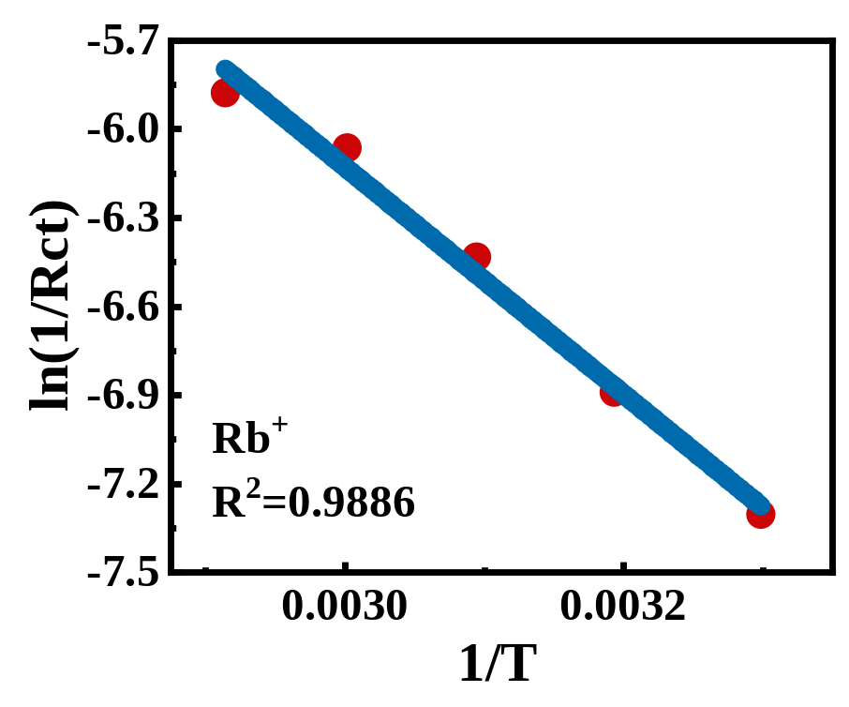
Fig. S6 Fitted images of ln(Rct⁻¹)-T⁻¹ for RbCl solution

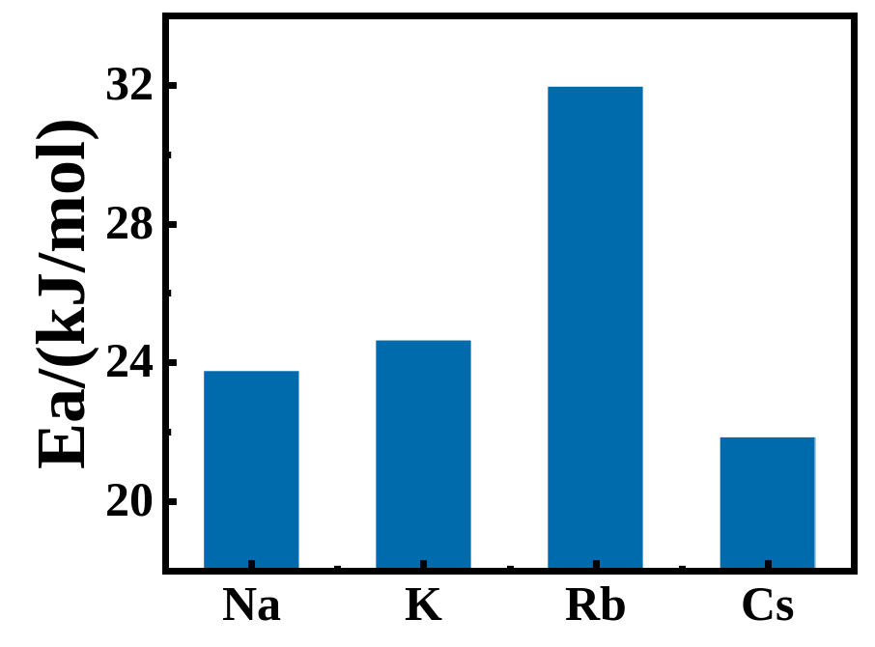
Fig. S7 Comparison of desolvation energies of four alkali metal ions, Na⁺, K⁺, Rb⁺ and Cs⁺

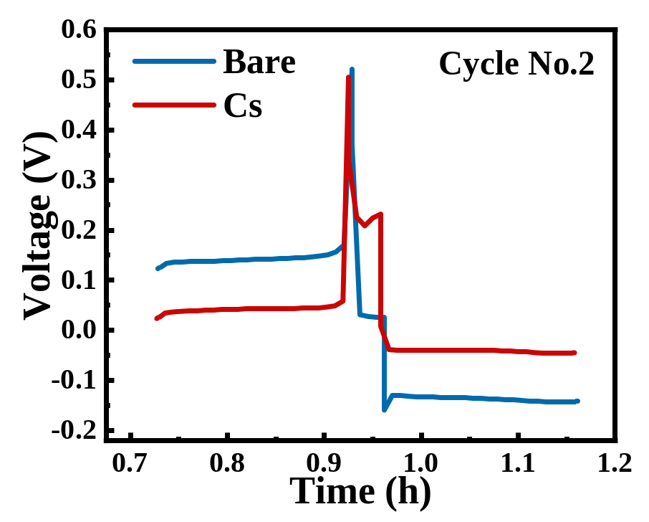
Fig. S8 Time-voltage image of the No.2 charge-discharge cycle of Zn-Cu half-cell at 5mA cm⁻², 1mAh cm⁻²

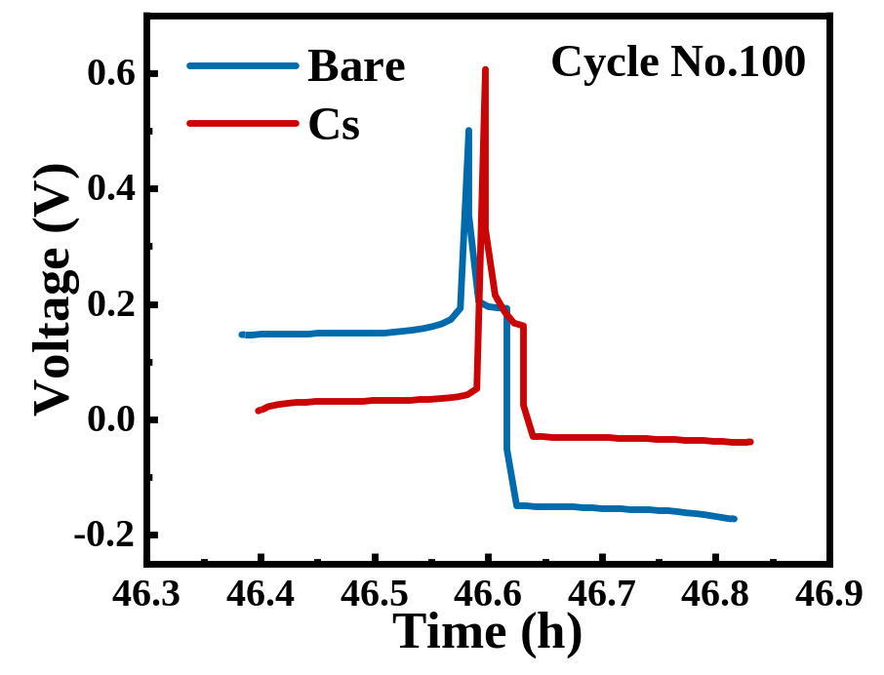
Fig. S9 Time-voltage image of the No.100 charge-discharge cycle of Zn-Cu half-cell at 5mA cm⁻², 1mAh cm⁻²

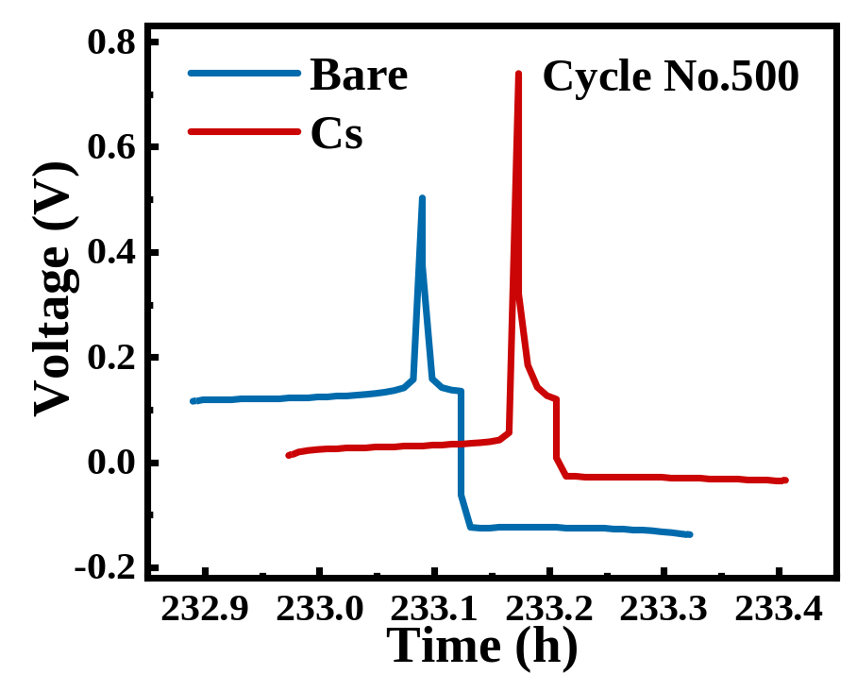
Fig. S10 Time-voltage image of the No.500 charge-discharge cycle of Zn-Cu half-cell at 5mA cm⁻², 1mAh cm⁻²

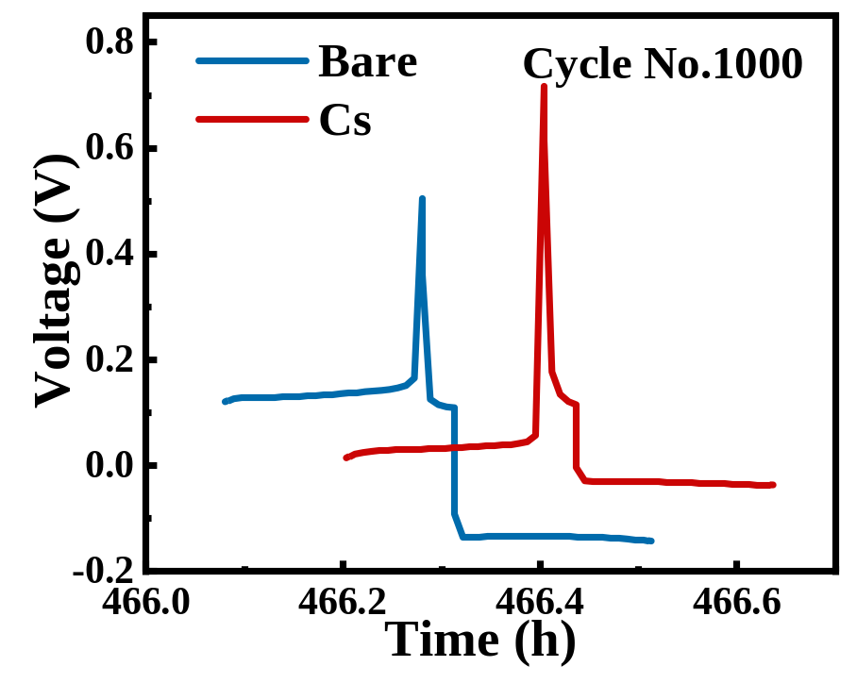
Fig. S11 Time-voltage image of the No.1000 charge-discharge cycle of Zn-Cu half-cell at 5mA cm⁻², 1mAh cm⁻²

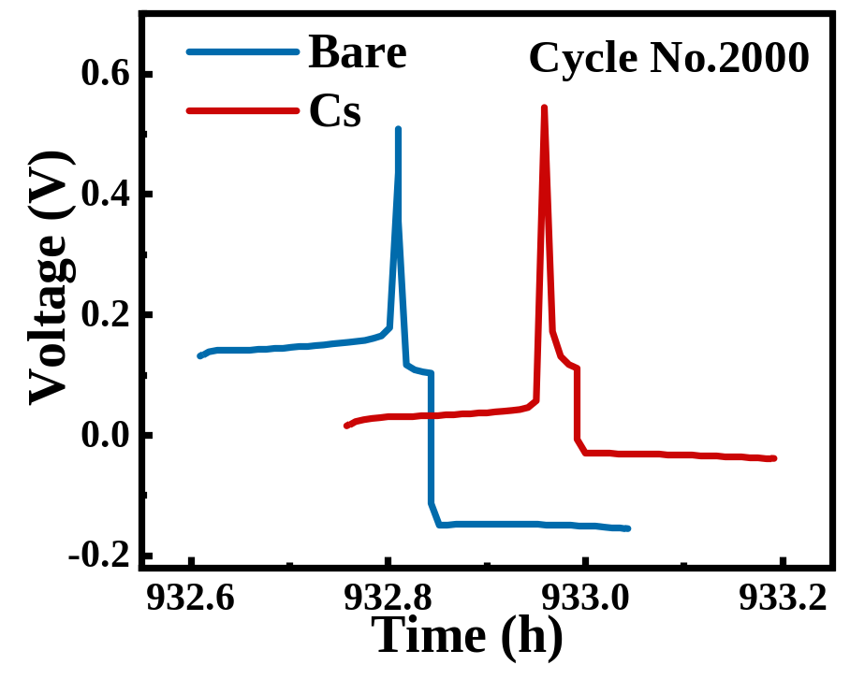
Fig. S12 Time-voltage image of the No.2000 charge-discharge cycle of Zn-Cu half-cell at 5mA cm⁻², 1mAh cm⁻²

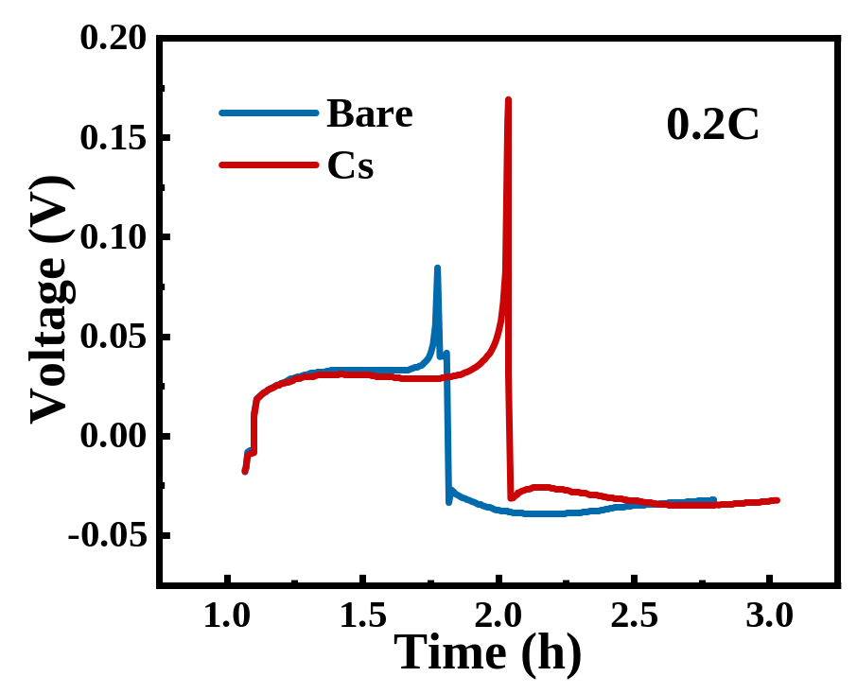
Fig. S13 Time-voltage curves for one charge-discharge cycle for Bare and Cs at 0.2 C

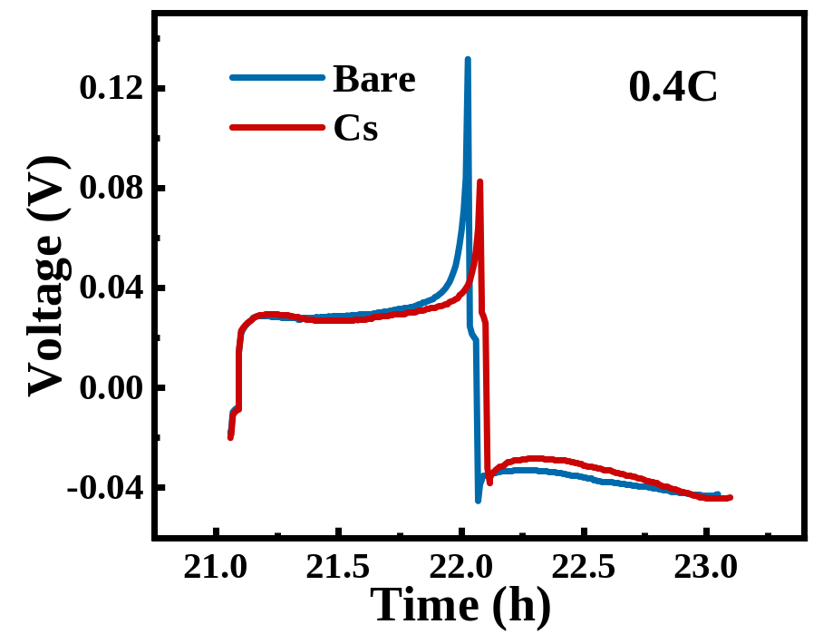
Fig. S14 Time-voltage curves for one charge-discharge cycle for Bare and Cs at 0.4 C

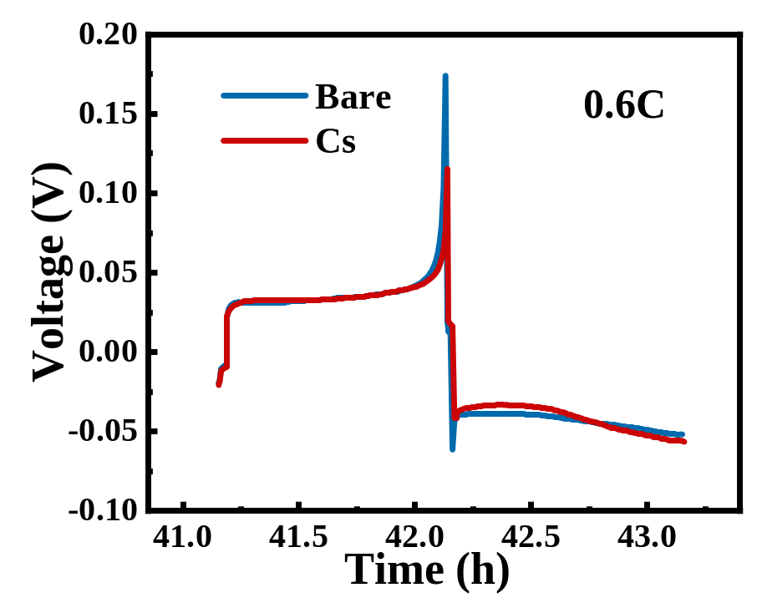
Fig. S15 Time-voltage curves for one charge-discharge cycle for Bare and Cs at 0.6 C

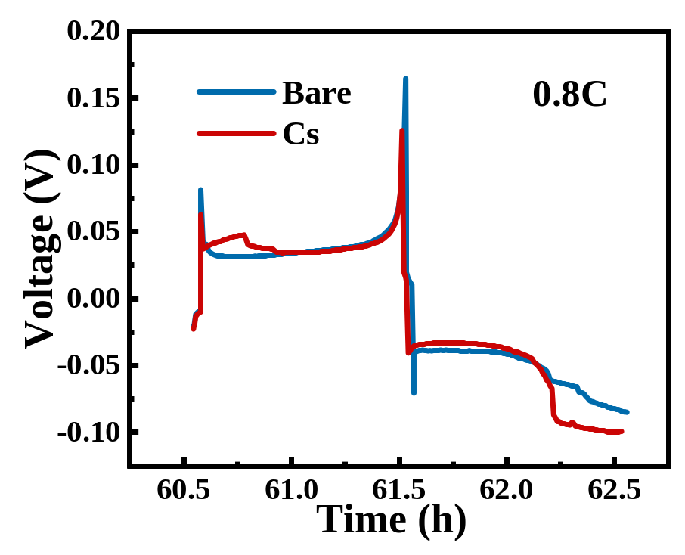
Fig. S16 Time-voltage curves for one charge-discharge cycle for Bare and Cs at 0.8 C

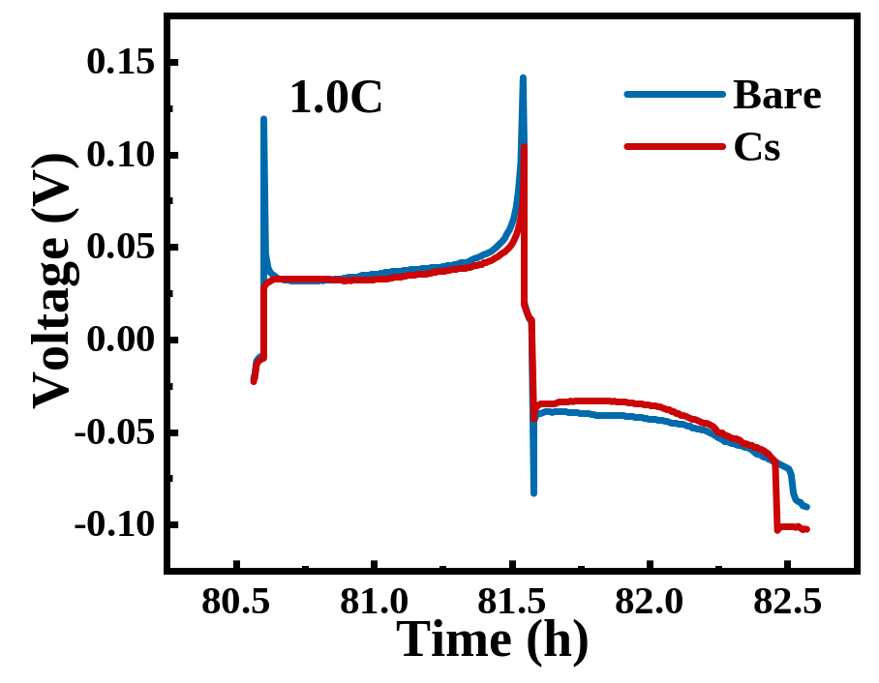
Fig. S17 Time-voltage curves for one charge-discharge cycle for Bare and Cs at 1.0 C

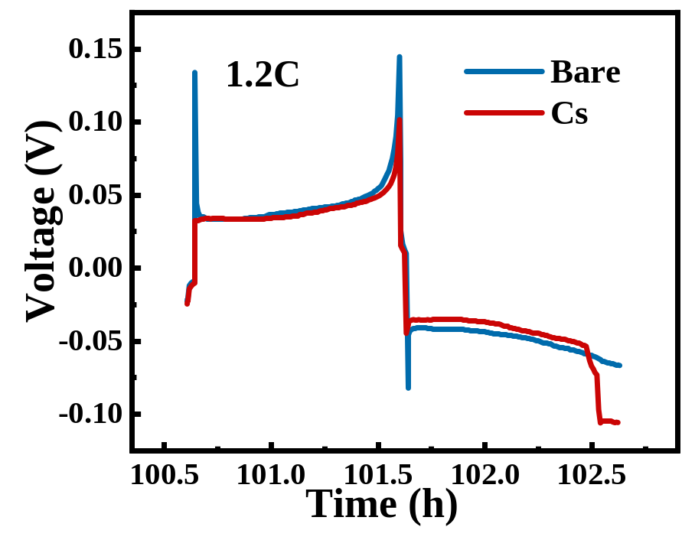
Fig. S18 Time-voltage curves for one charge-discharge cycle for Bare and Cs at 1.2 C

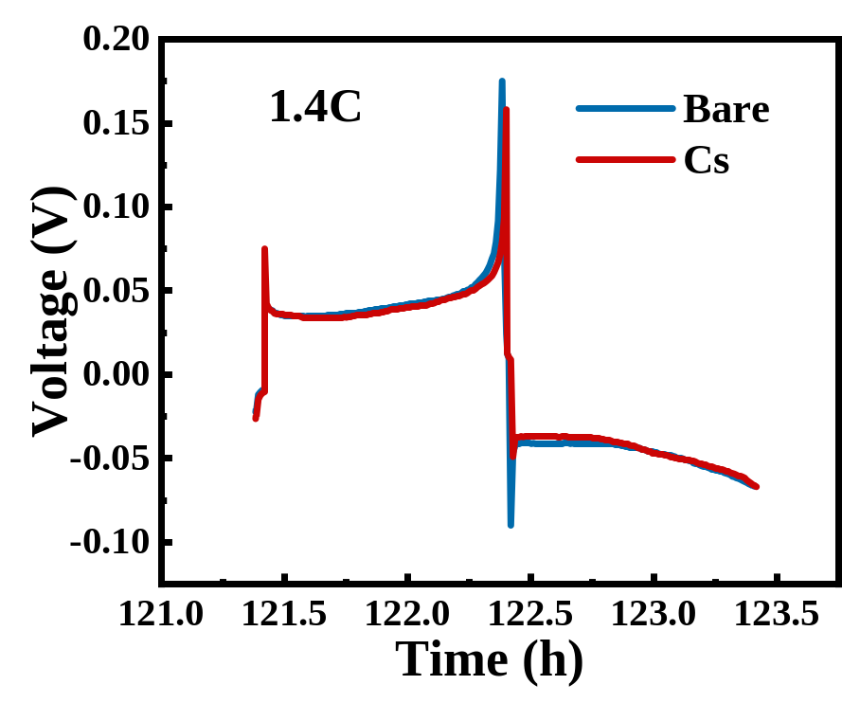
Fig. S19 Time-voltage curves for one charge-discharge cycle for Bare and Cs at 1.4 C

Table S1 Fitting results of EIS measured at five temperatures for NaCl solution
Protect | Rct/ohm | Error/% | Temp/K
NaCl | 287.5 | 3.3058 | 303.15
NaCl | 191.5 | 3.4282 | 313.15
NaCl | 138.8 | 3.6777 | 323.15
NaCl | 107.8 | 4.2404 | 333.15
NaCl | 98.03 | 4.3092 | 343.15

Table S2 Fitted knots of EIS measured at five temperatures for KCl solution
Protect | Rct/ohm | Error/% | Temp/K
KCl | 2878 | 1.8783 | 303.15
KCl | 1852 | 1.6247 | 313.15
KCl | 1663 | 1.9771 | 323.15
KCl | 1182 | 2.0171 | 333.15
KCl | 724 | 1.5269 | 343.15

Table S3 Fitting results of EIS measured at five temperatures for RbCl solution
Protect | Rct/ohm | Error/% | Temp/K
RbCl | 1487 | 3.9023 | 303.15
RbCl | 983.3 | 3.7714 | 313.15
RbCl | 622.6 | 3.9717 | 323.15
RbCl | 430.3 | 4.0809 | 333.15
RbCl | 357 | 4.4625 | 343.15

